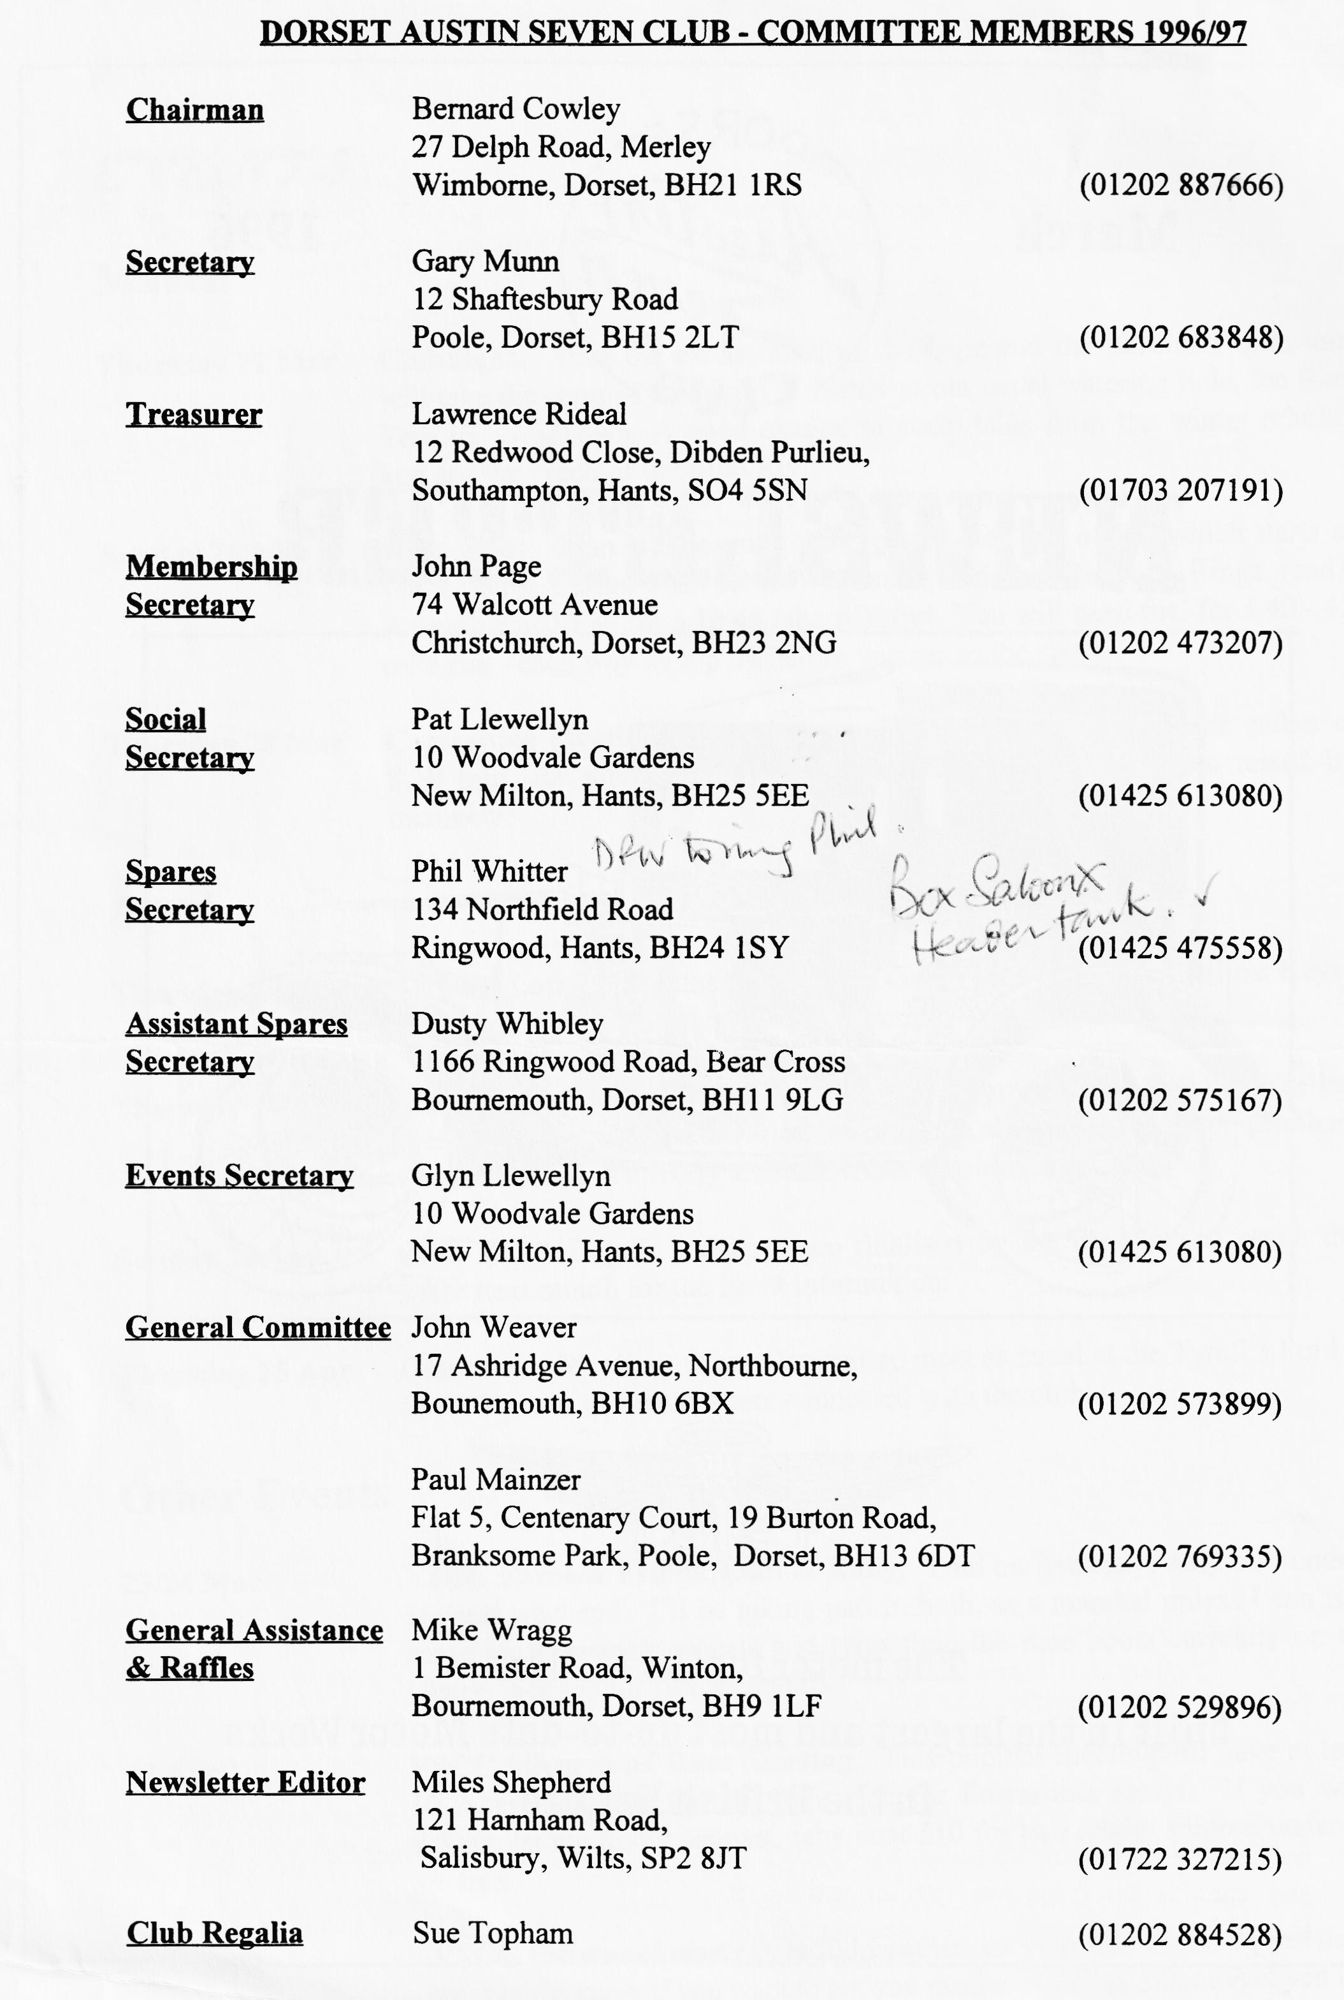

EDITORIAL
Hallo Everyone,
and we are very fortunate that he does! Results are on page 4
Oh Dear! Department - Ian Reekes did not win the year's subscription, as reported last month, that went to Paul Henwood as correctly mentioned in the January edition. Ian won a raffle prize which he can collect from Mike Wragg. Sorry all round!
The editorial archive is getting a little low. In particular, I am short of pictures so if you have anything that you think might be suitable, please let me know. Otherwise, I shall be forced to use more material from other clubs, like last month's cover cartoon which came from the Bristol Club newsletter.
See you at Clubnight. BFN, Miles
The year is only a couple of months old and already there is a great deal of motoring activity. I'm not sure if this is connected with the free Road Fund Licence or just the normal surge of activity in the Dorset Club . Either way, it seems that many of you enjoyed the Mud Run. Bob Stanley has written a report, and Dusty and Jane sent in details as well. I also have a note from Pat Llewellyn:
Well done Dusty and Jane, a super run on Sunday. It shows there is still life in the old Seveners yet, before we get out our Zimmer frames!
Pat Club Night was very well attended for another of Merv's popular quizzes. I am sure that you would all wish to join me in thanking Merv, and his two charming assistants, for a most enjoyable and entertaining evening. The effort that Mery puts into the compilation and production of these quizzes must be enormous
SECRETARIAL
Well Folks!
Bob Stanley's report). Terry Jefferies took some video footage which we hope to show during the Noggin and Natter Clubnight this month.
We have made further enquiries at the Elm Tree and as far as we can make out, our club room will remain safe after the Pub's refurbishment.
Pat Llewellyn tells me that entry forms are already available for our rally over the weekend of 13 - 14 July so if you have any colleagues who might be interested, or you know of any car clubs that would like some forms, please contact Pat.
See you at Club Night - Gary
I hope you all have antifreeze in your Austin's, its certainly been a bit chilly for working in the garage of late!
Many thanks must go to Mery Frampton and his assistants for an excellent quiz at the February Clubnight. I didn't realise how little I knew about Dorset and indeed the Austin 7. Well done to the winners, you certainly must have known your stuff!
Dusty's Mud Run was a great success, 15 cars at the start. It really shows that we must have a hard core in the club that don't mind using their cars. It was pretty hairy stuff at times, but as far as I am aware no cuts or grazes to any cars....I do hope we get an article, it should be worth a read. (Yes, see page 2 for

THE MUD RUN!!!!!!
Sunday 18th February, Breakfast over and the washing up done, the weather looking clear and sunny - down to the garage to give the Ulster (RT 7470) a quick check over, starting with all the things one should check: oil levels, engine, gearbox, and rear axle. Knowing what Dusty had prepared, further inspection of wheel, tyres, pressures and their nuts not wanting to lose a wheel later on. Now onto the steering: check the joints and arms, finding the nearside trackrod arm loose. It must be said that checking any vehicle regularly for safety and reliability is advisable.
Overalls off, wash and brush-up, into the warm flying jacket, off we go. Arriving at Wimborne, I spotted young Scott Whibley with his navigator Russell, I followed them to our meeting place at the Leisure Centre Car Park via the local garage to fuel up. Being the first two cars to arrive, we had plenty of time to chat about the day's run and the modifications done to our cars for the off-road sections. Scott had spent many hours making a complete under shield to protect the handbrake cross shaft and operating parts from damage (Nice job, Scott). Myself only moving the battery and its box from under the passenger seat into the Tail in front of the spare wheel, and adding Sticky Grip to the rear tyres for added grip, only available in very short supply and very expensive.
Other cars were arriving, 14 in all with Joe and Maggie Stalker in their rare Boat Tailed Two-Seater only to bid us farewell on our run. Following our Leader in his Off-Road Box fitted with ex-speedway knobbly tyres, thirteen cars now; maybe unlucky for some but soon en route we collected late corners Chris Biggin and his son Rupert in the Blue Box. A pleasant run through the back roads to Witchampton and on up to Cranborne Chase and then to Tollard Royal, pulling into the King John Hotel for a welcome stop for a warming cup of coffee - all pre-arranged by Dusty.
Now on to the real stuff. Leaving Tollard Royal behind, up onto the R.U.P.P. (Road used as a Public Path to some or Green Lane to others) leading up the hill to Berwick Down, passing an ancient earth settlement on our right. A minor problem soon appeared, Dusty and Jane had a puncture in the rear. With many eager helpers, the wheel was changed in an instant and is all on video thanks to Terry.
Continuing on our way, the going became slippery and rutted. This was to cause some problems through the sticky chalk and mud. Some less experienced off roaders needed a helping hand to keep moving on this difficult uphill section. Paul and. Gary had a big moment when their Box Saloon slid into a deep rut and nearly ended up on its roof with the offside wheels in the air. Once more eager helpers lifted it back onto its wheels and with a push, sent them on their way.
Various walkers stood and watched in amazement at our antics. I heard one of them say "they must be b----y mad!" Yes, well we were having great fun and after all, what is your Austin for? Carry on along the lane, the going now much easier to Win Green and back on to Tarmac. Time was getting on - it tends to fly by when you are having such a good time! So onward to find the Pub for lunch, the Compass Inn at Chicksgrove, a small village not far from Tisbury.

After being fed and watered, only ten cars continued to Stage 2. Those with other commitments said their farewells and we continued on to more green lanes only to find a Land Rover and tractor blocking our way. On investigation farm workers were cutting up a fallen tree, a victim of the high winds in the area. Once again, eager helpers lent a hand to move chopped up logs and undergrowth to clear our way.
Carry on once more. Some of us were to experience some carburetion problems, possibly due to the bumping around and the ungainly angles of lean disturbing the sediment in the bottom of fuel tanks. After several stops to clear blocked jets, we were held up again - this time by another but smaller tree half fallen across our path. Help yet again was required to get the Saloons under the fallen branch. At this point it was noticed that Scott and Russell were missing. Nowhere to turn round, we carry on to the end of the stage and meet Dusty returning to see what had caused the hold-up.
Finally, back onto Tarmac and the finish at Sixpenny Handley. Saying our farewells and time getting on, we all departed on our separate ways home. Our run home, though, was not to be trouble free. On reaching Ringwood, I thought to myself "She's going well considering today's abuse". Bad though - almost immediately the engine started to splutter. Stopping near a garage and not having a torch to inspect the problem, as I was lifting the bonnet, our Treasurer, Lawrence pulled up and offered to follow me home.
I was unable to make any repairs at the side of the road but I traced the fault to a semi-blocked jet, unusual for an S.U. type carburettor. Operating the choke and adjusting the advance and retard ignition controls, I managed to achieve a spluttery 30 MPH on the rest of the journey, downhill with the wind behind me. Lucky there was little traffic about, I got back safe and sound.
An excellent day’s adventure, I must congratulate Dusty and Jane Whibley and all the helpers in making this run one of the most memorable to date.
Bob Stanley
AND FROM THE ORGANISERS THEMSELVES …….
Thanks to the fourteen cars that participated in the outward leg from Tollard Royal via byways to Win Green and on via 'road' to the lunch stop. After lunch ten cars completed the afternoon section. Everybody enjoyed nine miles of 'off-roading', mounds and ditches, slimy 5 in 1 hills, the clay pit (150 yards of eighteen inch deep rutted, rain sodden clay) and the deep rutted tracks through overgrown ancient woodlands. No damage reported to date apart from 3 sets of blocked jets and one puncture. The following took part:
Joy and George Bob Glyn and Pat Terry and Barbara
Phil and Hillary Norman Paul and Emma Paul and Gary
Richard and Margaret Lawrence Chris and Rupert Bernie and Jackie
Scott and Russell Dusty and Jane
See you next year...
P.S. Thanks to Joe and Maggie for waving us off and to Marc and his Land Rover for help with the route

More about Petrol
The subject of petrol is continuing to cause confusion and controversy. There is a 'new' petrol available on some garage forecourts. It is called 4 Star Liquid Replacement Gasoline. This fuel contains no lead tetraethyl (lead) but instead has a sodium additive to provide protection for valve seats. Apparently, the pumps dispensing this liquid will not be displaying the BS 4040 designation, will be labelled 4 Star and will be coloured red.
Opinion on the merits of this new fuel seem to be divided as I gather that Sainsbury's have decided not to sell it after commissioning an independent test to determine its effects on older engines. According to a report in the VSCC's award winning Bulletin, the test was conducted by Biceri Ltd, a leading independent engine test house, in conjunction with the Rover Group. The Rover Group was selected as their older cars account for the highest proportion of cars manufactured in the UK with "soft" valve seats. The results of the tests indicate that an engine running on LRG (with sodium additive) suffered significant valve seat damage.
Shell were advocating this fuel a couple of years ago and, again according to the report in the VSCC Bulletin, carried out a PR campaign to the effect that the sodium additive would provide a lead equivalent for valve seat protection. However, a report in Which? magazine states that both the RAC and Rover Group claim that LRG would not have the same amount of protection as leaded fuel. I have seen no results from any studies in the USA or Canada. on the long-term effects of sodium or other additives. Leaded fuel is no available in either country.
To complicate matter further, there are the low lead fuels which have been available for some time now. These have the same octane rating as four star but have 50% less lead. Such fuel meets the requirements of BS 4040 and is labelled as such. Shell claim that all cars currently using four star can switch to their Low Lead without any adjustment. Has anyone tried this? If so, please share your experiences with the rest of the Club. Shell produces a useful booklet on petrol matters. Copies of the current version may be obtained by writing to Andrew Vickers at Shell-Mex House, Strand, London WC2R ODX, asking for their Fuel Guide for Classic Cars.
Various clubs, both Austin and others, have expressed concern over LRG fuel and many feel that it may be harmful to their engines. I do not know whether it is or not. In the absence of definitive proof one way or the other, I shall continue to use normal 4 star in my Ulster - but I am interested in the Low Lead option.
Miles
QUIZ RESULTS
Nine teams competed and the winners were the JAPANESE, Bernard, Jackie, Phil and Willie. They scored 142 points out of a possible 200. Other positions were:
2nd FINNS 127 points 6th GREEKS 116 points
3rd DANES 124 points 7th AUSTRIANS 115 points
4th BRAZILIANS 122 points 8th INDONESIANS 113 points
5th HUNGARIANS 119 points 9th CANADIANS 111 points
Full marks were awarded to those teams correctly identifying The Radetzky March and spelling
Diarrhoea!! Mervyn

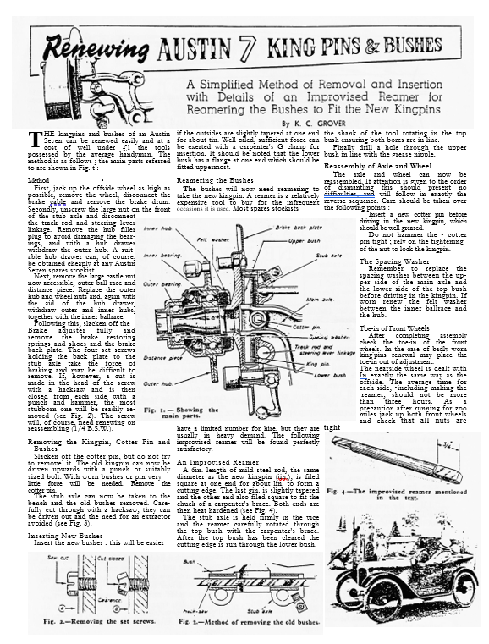

6
And now something for those of you who have put off making your New Year’s Resolutions
There are GOOD TIMES Coming!

I
T was appropriate, I thought, that at such a moment of national urgency the resolutions of the army of people who make up the pageantry of the Open Road should be gathered in the light of their New Year importance. After a protracted and careful scrutiny it is impossible to escape the happy realisation, with the
dance song, that " There are 1
good times coming . . ."
I found a ready response to 1 A Gala: my enquiries during this
NEW
prevailing Yuletide spirit. I i
began the attack upon the rather 1
i RESOL
untidy point-duty policeman in ₁ my home town. "Tell me," I
whispered, " your New Year ( By A. STA
resolution in its motoring ¹1,.
sense ? " He is rather hard of
hearing, but he understood. He smiled and said : " Well, I like it hot, with a nice, scented soap and a glass of something, also hot, with a dash of lemon, to drink down afterwards. That is," he added, " if it happens to fall on a Saturday." I whispered : " Pardon. I said RESOLUTION not ABLUTION ! " He inserted his thumbs into his belt. "Ah, yes, motorists," he said. " I'll treat 'em like brothers. I'll let 'em park where they like, drive how they like and say what they like."
Encouraged, I proceeded. The lady novice resolved . . . well, it would be discourteous to lay bare all she had to resolve and, anyway, there isn't room ! Isaac, who owns the garage under the spreading chestnut tree where once the smithy stood, rubbed his hands and put his first good resolution into practice at once. " Benjamin, my boy," he said to his son, " empty the petrol out of dose fire extinguishers and fire buckets . . ." An owner of a second-hand car whose motto was " I'll let the rest of the world go by," averred he would tell prospective buyers that the most he got out of his car was thirty times to the gallon.
The confirmed inebriate pathetically swore that every time he saw one from now onwards he would look the other way, and that never again would he take his pets out in the car, but would leave them at home, tightly corked, with the glasses, in a cupboard—and lose the key.
The First New Owner resolved to call his car Fishy " . . . because he had to kipper look out it didn't bloater pieces." The Second ditto, that next time he had a crash he would see that it didn't happen halfway through a police trap.
The small son and heir of the Brooklands speed-man resolved that next time his schoolmaster asked him what B.A. meant, he would say Baby Austin. The club bore averred he would never again relate how he did 600 miles in a day, how he climbed Rest-and-Be-Thankful on top, or how he averaged
eighty miles an hour for two
hours on the Great North
Road. The lorry driver said
y of j he would instantly pull over
YEAR at the first hoot of a car
behind. The charabanc driver, with tears in his eyes, confessed
UTIONS that he would never again exceed
twenty-five and would amble
iLEY BLICQ through the New Forest as
docile as a spring zephyr. The
picnickers all swore they would leave neither banana skins, cigarette packets, odds and ends nor tins, or bacon rinds, or broken glasses in beauty spots.
The accomplished (?) lady driver and her male counterpart resolved they would never, oh never, again signal that they were turning left when they turned right ; never put an arm right out to see if it was raining, never cut in, never sprawl all over the crown of the road, and never, oh never stamp on the starter when the car was in reverse.
George swore he would keep his instalments up. The pedestrian resolved he would train intensively at hopping out of the way so that the car owner should never be inconvenienced. The waiter resolved never to serve Shepherd's Pie with a piece of sporran in it as evidence, and swore that when a guest asked for the oldest wine and spring chicken he would not provide the oldest chicken and spring wine. A Coventry, Wolverhampton, and Manchester Barbers' Union resolved to adopt as their motto the motorists' slogan, " No cutting-in ! " A motoring organisation from Aberdeen have resolved to forego their time-honoured " Hoots " and to invest in motor-horns. The lip-sticked flapper promised-she would not be so fast ! The mathematician decided he would relieve humanity of its eternal puzzle and solve once and for all, not only the question of how the other half of the world lives, but how it drives and where it parks its cars !
It was a relief to know all these things ; they augur well for 1931 ; they usher in a new, an entirely new motoring era . . . yes, the song is right, " There ARE good times coming " • . . perhaps . . . !

For Sale
1938 Austin 7 Pearl Cabriolet. Maroon, a very original and sound car. Very good condition with
long MoT.
ALSO
1933 Austin 7 Box Type Opal. subject to much recent restoration, new MoT. Very nice
condition. Only £4995 each! One or other must go so call Gary on 01202 683848
1935 Ruby. Good body. Needs re-spray. Interior superb. Hydraulic brakes. Car in Essex. £2950, contact Bernard Cowley on 01202 887666.
A Request
Does anyone have a bit of land with a hill which the Club could 'play' on one Sunday afternoon? Perhaps we could take the Barbecue along as well. Your events secretary would like to hear from you if you can help, either with an offer of a hill or perhaps the name of someone else who might be able to help. Please contact Glyn on 01425 613080.
MURDER, MYSTERY
•
Dear Members,
Is anybody interested in coming to a MURDER, MYSTERY EVENING at the Avon Causeway Hotel, Hurn, near Christchurch. The evening would be a Friday or Saturday in April or May and consists of a 3-course meal and the Murder Mystery. The restaurant is in an old train which is decorated like the Orient Express. if we can get together 30 people, we can have the whole train to ourselves, which would be great fun.
If you are interested, please let me know as soon as possible so we can make the booking. These evenings are very popular. The cost for the whole evening is £10.95 per head and a £5 deposit will be need when booking. Please see me at Club Night or ring on 01425 613080. Once I have an idea how many people are interested, I will be able to set a date.
Pat Llewellyn

EVENTS
March
Thursday 21 Mar Clubnight. After the excitements of the Quiz and the Skittles Night, this will take the form of a Noggin n' Natter at our usual watering hole, the Elm Tree in iii7tfown. A good chance to swap tales from the winter rebuild and see the video of the Mud Run!
Sunday 24.Mar Club Run. Brian Willbourn is the organiser for this outing which starts at the Leisure Centre Car park, Wimborne (on the Badbury Rings road). Assemble at 10.30 for a 10.45 (sharp!) start. You will need fuel for a 40 - 45-mile run - each way so top up before you get to the start!
Thursday 28 Mar Committee Meeting. Just by way of a change, the Committee gather at 8.30 p.m. for their monthly consideration of weighty matters raised by members
April
Thursday 4 Apr 8 ish till Late. The gathering is at the Green Man (formerly the Lost Keys),
Wimborne. Why not start the Austin month with a social noggin
Thursday 18 Apr Clubnight. An Austin 7 Technical Night. Regulars will recall the excellent evening last year where a variety of common and not-so-common problems were discussed in a lively and informative fashion.
Sunday 21 Apr Club Run. Details had not been finalised by the deadline so watch this space next month for the latest information.
Thursday 25 Apr Committee Meeting. Your Committee meet as usual at the Tyrell's Ford at about 9 pm to discuss matters connected with the club.
Other Events
23/24 Mar VSCC Exmoor Fringe Trial & Rally. Trial on Saturday, rally on Sunday. A great weekend. I'll be taking part in both, as a marshal unless I can find some more suitable wheels and tyres than the race boots currently on the Ulster. See me for further details.
13 April VSCC Silverstone Race Meeting. This popular meeting will have at least 10 races including the GP Itala race for Edwardian racers. If you want tickets, let me know soonest, the cost £10 for two adults, children under 15 are free.
20 April VSCC Colerne Sprint. Dreadful weather last year didn't spoil a great day
out. Let me know if you want to go, you need a VSCC member to get you in!

