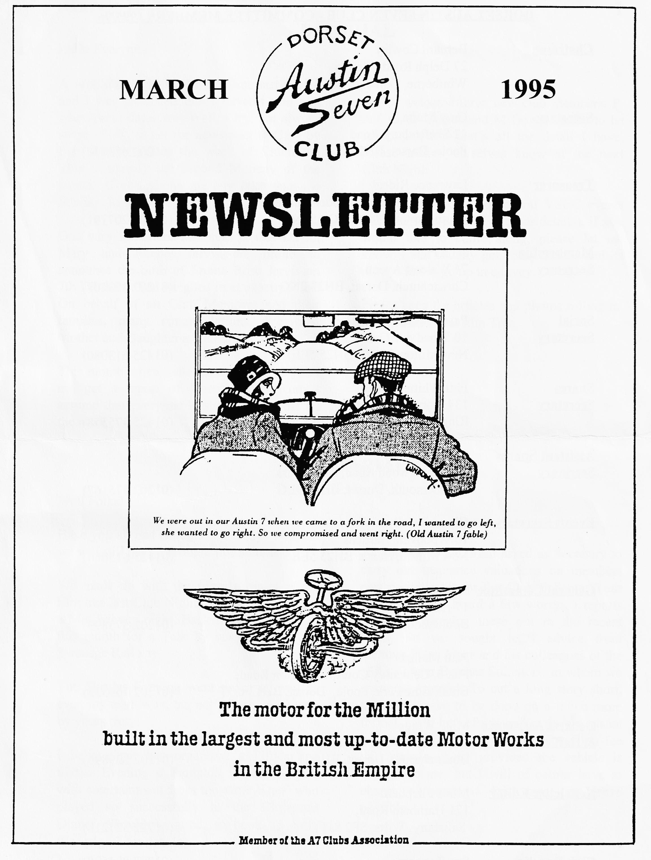

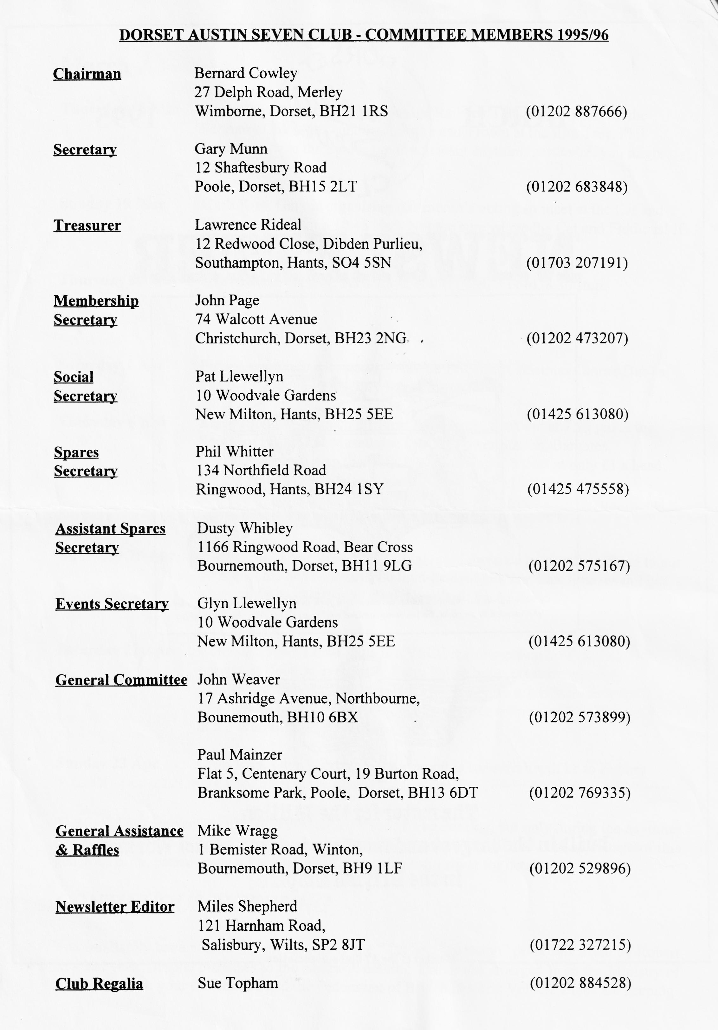

March 1995
EDITORIAL
Hallo Everyone, A few items missed the deadline last month and I was reminded that I haven't told you when press dates are! Well, I try, not always successfully, to get the newsletter to Gary by the Monday before the week of Clubnight This is usually the second Monday of the Club Night. If you phone me any later than the Sunday, it’s too late!
One very important late item is that David, Mary and Rachel Jervis are proud to announce the birth of Emma Rose Jervis on 7th February. See weighed in at exactly 9 lbs. On behalf of all Club Members and their families, many congratulations. We trust Mother and Daughter are all doing well.
This month's newsletter is a bit thin as I did not get a report of Dusty's Mud Run. I assume that everyone is still cleaning off all the mud!
Please welcome three new club members. P. Alford, D. Power and M Gower. Sorry to be so formal, but that's all the detail I have.. Please make yourselves know at the next Clubnight
Lastly, I am going to several VSCC events this year (see pages 7 & 8 for details), if you would like to come along, please let me know. I can usually get cheap tickets and it’s always fun to go up in convoy.
Please keep the articles and photos rolling in, See you all at the Elm Tree
BFN
Miles
SECRETARIAL
Well Folks!
Have you all had enough rain lately? I expect we will still have a drought this summer! We made do with the room upstairs at the Elm tree last Club Night, quite cozy really for a Mid-winter’s night. Back to the usual room this month for a talk by our friends at the Swanage Railway.
The Skittles Evening went down as well as ever, my team won, but not helped very much by yours truly!
I believe Pat has organised a Fifties and Sixties Evening at Pamphill for early April, with entertainment from the same 'Duo' who played so successfully at the Christmas Dinner. Should be good, so book up early (See page 7 for details).
As you are aware, I am asked as Secretary to carry out insurance valuations on members cars periodically for the Club Scheme. Your Committee has heard a few worrying reports regarding carrying these out in the recent Press. So we sought legal advice from member Peter Jones and his colleagues of the Otis Fowler Belcher Solicitors, to whom we are most grateful. To cut a long story short, these will have to be done on a much more formal basis henceforth and a purely visual inspection carried out be me. The Club fee will remain at- £5 provided the vehicle is brought to me, but I will of course have to charge expenses if this does not prove possible.
As a reminder, we still offer members the facility of attempting to obtaining age related registration numbers for Austin 7s, and where possible with proof of original registration, will try to retain the original number for you if your vehicle does not have a V5 registration document. These services are charged at £15, once again payable to the Club. Swansea DVLA remain, I am pleased to say, very helpful and sympathetic.
PS. Did you hear the one about the club member who punched a hole in a cylinder. bore even after reading my Technical Tip last. month?
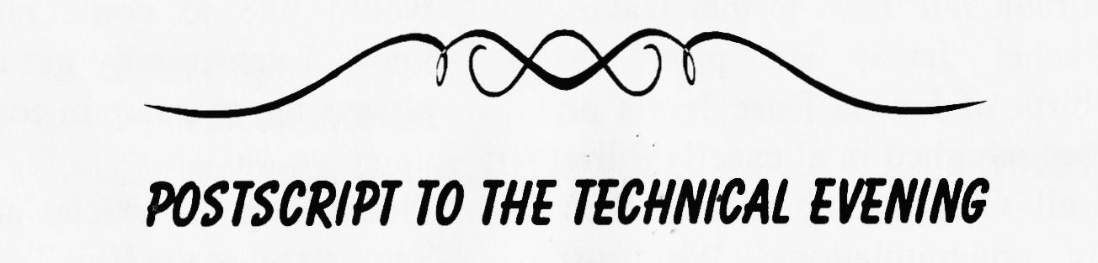
See you at Clubnight, Gary
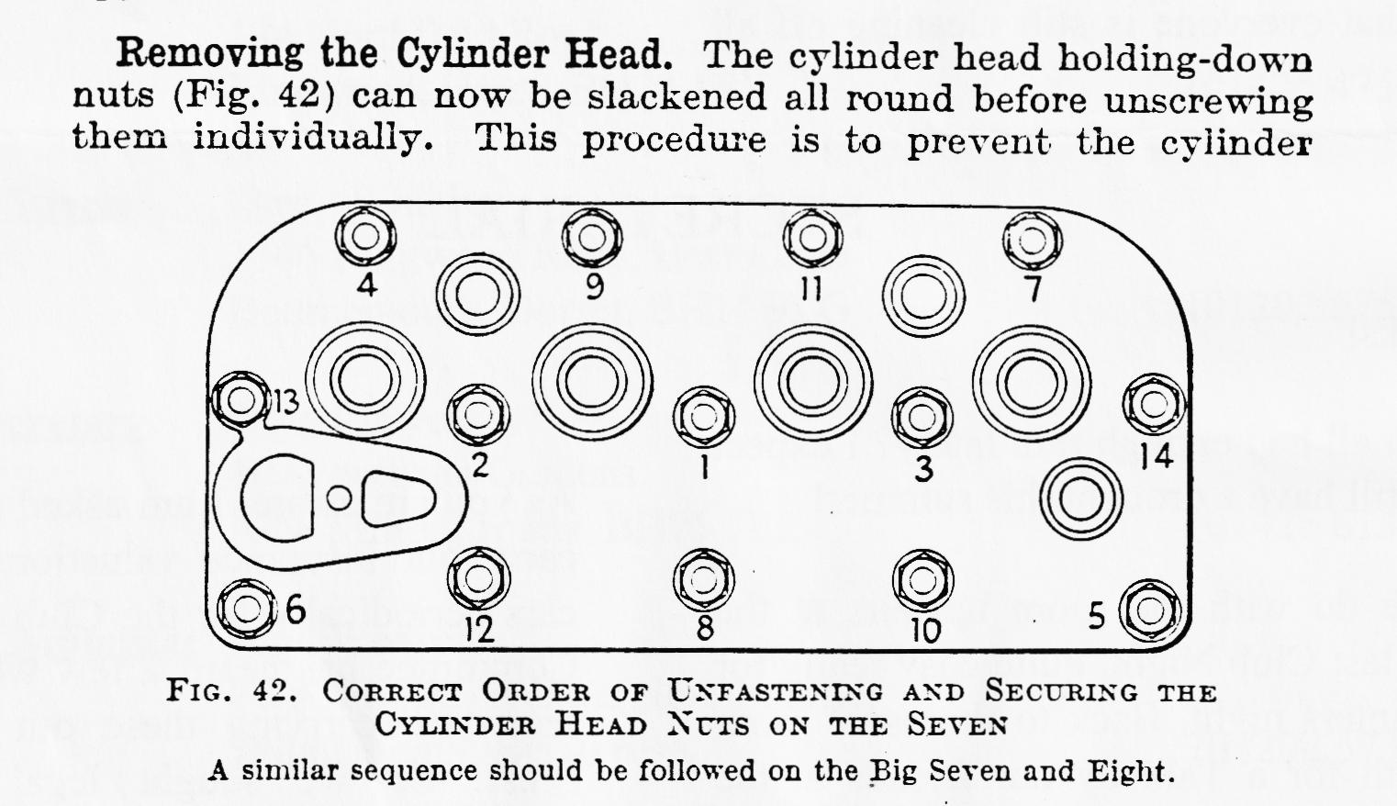
At the January Club Night, our Technical Question and Answer session, a member asked for details of the sequence of tightening cylinder head nuts. There was no room last month so here is the information, plus the bonus of explaining how to remove the head as well.. The extract is from my very late copy of Pitman's Book of the Austin Seven and Eight.
head from being strained. The two special lifting screws should now be screwed into the two outside plug holes. These screws are obtainable from an Austin dealer. By grasping the handles of these screws firmly and pulling up with a slight rocking motion the head will normally be withdrawn off its holding-down studs with little trouble. In the event of the head proving obstinate, however, one or two judicious mallet blows may loosen it but this should be done with caution.
. An alternative method of overcoming difficulty in removing the cylinder head is to refrain from unscrewing the sparking plugs until the head has been withdrawn. In which case, by rotating the crankshaft with the starting handle (with the ignition switched off, of course), after the holding-down nuts have been removed, it will be found that the compression of the engine will break the joint and free it enough to enable it to be drawn off the studs by hand.
When actually withdrawing the head, note carefully if the joint washer or gasket is stuck to the cylinder head or to the cylinder block, or if it is stuck to both. In the latter case, free it gently from either surface and then lift the cylinder head clear.
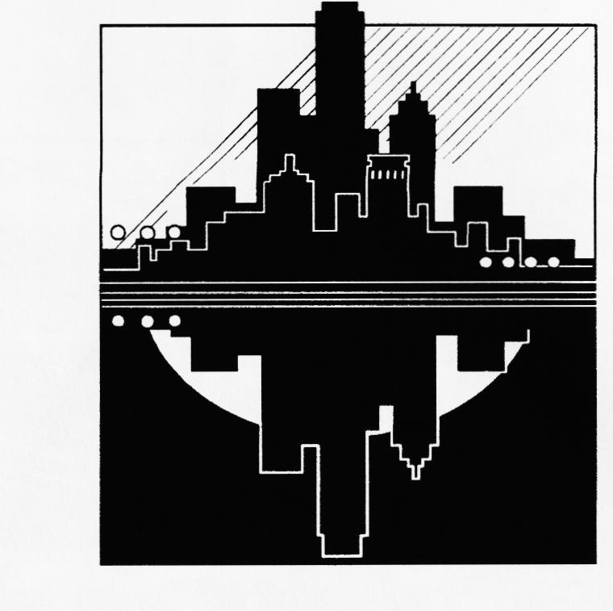
The Old Car Scene Down Under
Strangers in Paradise -
continuing Gordon and Biddie's adventures in Aussieland.
Every day for a week after the Bay to Birdwood Run, we went out on various excursions sponsored and arranged by different car clubs from South Australia. We visited an old mining town, sampled delicious Australian wines at Chateau Yaldara in the Barossa Valley, and enjoyed a cops and robbers Treasure Hunt, masterminded by Peter Stopford who has a sister living in Sway, near us! (Each outing had a different cost and a separate booking arrangement)
We made very good friends during the week in Adelaide and can thoroughly recommend this lovely city to and DA7C visitors. We can, by the way, provide addresses of old car buffs for most parts of Eastern Australia.
It was with fond memories that we left Adelaide and headed into the hills, with Bob and Joan Lawrence, our Canadian friends. We were making for a weekend Village Car Rally at Waikerie, about a hundred miles east of Adelaide along the Sturt Highway, in orange growing country. This gathering reminded us a little bit of Breamore, except that it lasted from Friday night to Monday morning and that every half hour or so we seemed to have a delicious meal placed in front of us. Al Australians, whether at car rallies or not, have the custom of morning and afternoon tea. The former is taken at about 11 a.m. and the latter at about 4 p.m. Both consist of tea or coffee with a delicious selection of cakes and pastries.
At the Waikerie rally we met a delightful couple who drive a 1928 Bean; by coincidence its engine number immediately precedes that of the Bean donated by my uncle to the Beaulieu National Motor Museum. When leaving Waikerie after a cooked Monday morning breakfast, provided by the host club, we were urged to take with us a sack of freshly picked oranges, but unfortunately there was only room for two in the hire car we were sharing with the Lawrences! The entrance fee for the meet was around £45 for two, excluding Motel accommodation.
Driving through the Grampian Mountains towards the Great Ocean Road and Melbourne, we were struck by the vastness and emptiness of Australia [Ed - so was Herbert Austin, hence his desire to provide the Motor for the Millions] We saw wild Emus stalking the plains, and tame kangaroos with their little 'Joey's' peeping out of their pouches. How could we have eaten Emu and Kangaroo steaks only the night before!
Melbourne has a wonderful tram system and the heritage tram which travels round the square mile of the city centre is absolutely free. In this beautifully laid out city we were to see our first Duck Billed platypus and find the men serving the tea at the local Austin Seven Club! Gordon Brown ( to be continued )

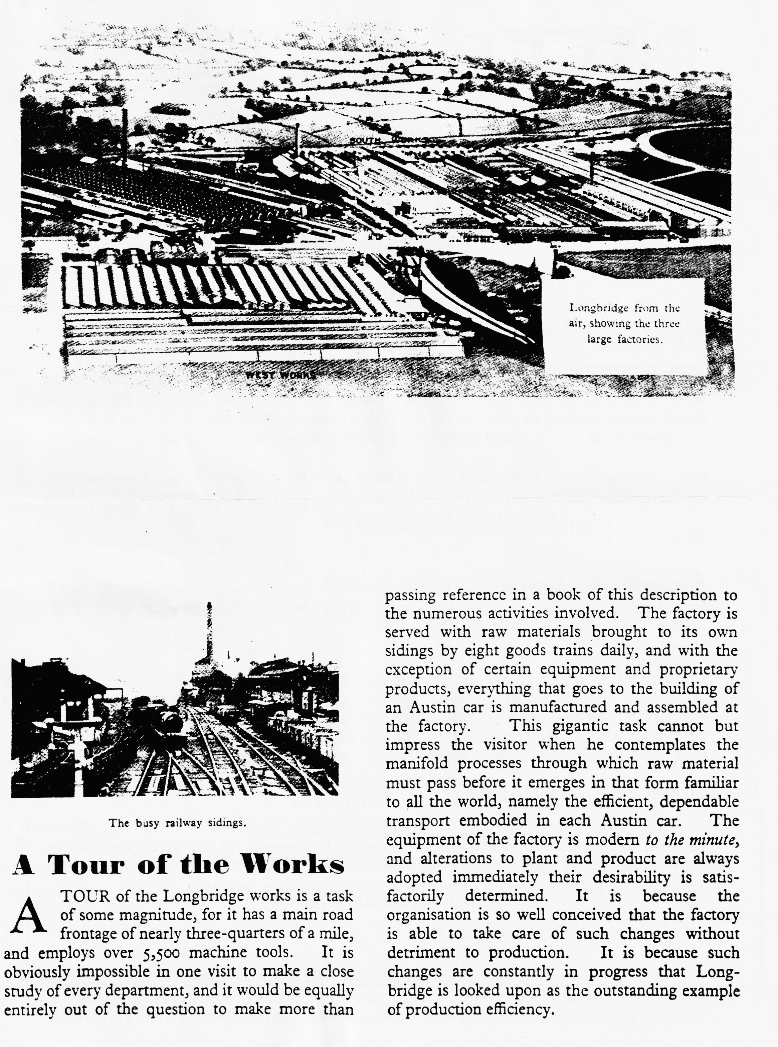

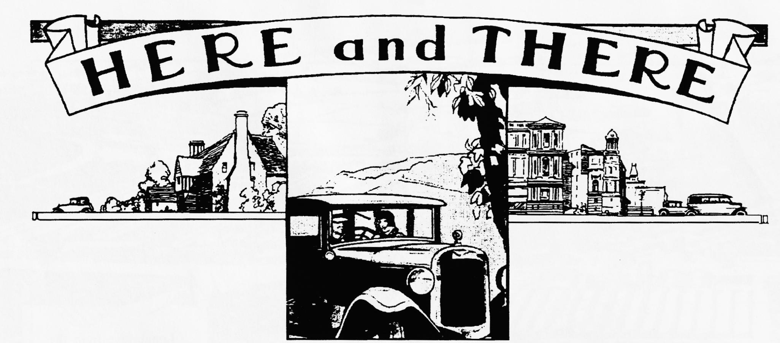
HERE'S A CHALLENGE FOR YOU! ,
Phil Whiner asked members a question at the end of the January Technical Session, and no one answered him! So for those who weren't there, can anyone tell Phil what the correct setting is for slotted brushes as found on early starters and CAV dynamos? All the brush holders on these item are adjustable - not just the Third Brush. And the answer needs to be practical, not theoretical!!
P.S. Look out for the little elderly trolley Man at Tesco in castle lane - he was a tool maker at the Austin before the War and is very knowledgeable (take your Austin with you!)
WANTED
David Whetton has sold his Opal and is looking for a new project. He is on the look out for an A7 Special for restoration or an unfinished project. If you can help, please ring David on 01202 848743.
FOR SALE
Phil Whitter has a limited stock of new tyres and tubes. 350/375 X 19" (6 ply) £22:50 each, tubes are £5 each. Also 400 X 17" including tube are only £3.7:50 each. Rim tapes for both 17" and 19" are £1 a set. Contact Phil on 01425 475558.
VISIT TO HAMWORTHY ENGINEERING
The Club has received an offer of a visit to Hamworthy Engineering, but only during the daytime! The proposed time is 2 p.m. on a Tuesday afternoon. If you would like to take advantage of this generous offer, please contact Pat Llewellyn, see inside front cover for details.
CONTINUOUS LICENSING
You can hardly have missed the stir caused by the "Tax on Possession" proposals made by Robert Key last year. Despite promises to the contrary, nothing further has emerged from the Ministry of Transport. Both your Committee and the Federation of British Historic Vehicle Clubs are keeping a wary eye on the situation. A consolation document is promised "early in the New Year" and we expect to receive a report from the FBHVC and will comment accordingly. It appears that the proposals should more correctly be called Continuous Licensing. Bob Olive (from the DVLA in Swansea, not the A7CA Secretary!) attended the AGM of FBHVC and gave a summary of the situation as he saw it. A summary of his talk will appear next month The main point to note, though, is that Mr. Olive receives a large number of Club newsletters and is well aware of the reactions of the old vehicle enthusiast!
AROUND THE NEWSLETTERS
Many readers may not be aware that we, as a Club, receive newsletters from many other clubs in the A7CA. I always bring these to Club Nights for members to read so if you would like to cast your eye over what clubs such as Bristol, Essex, A7OC, Scottish, Welsh, Midlands, 750 MC, Solent and Cambridge, please come and see their magazines. One of the advantages of belonging to the Association is that we are able to reproduce items from these newsletters - with due acknowledgements.
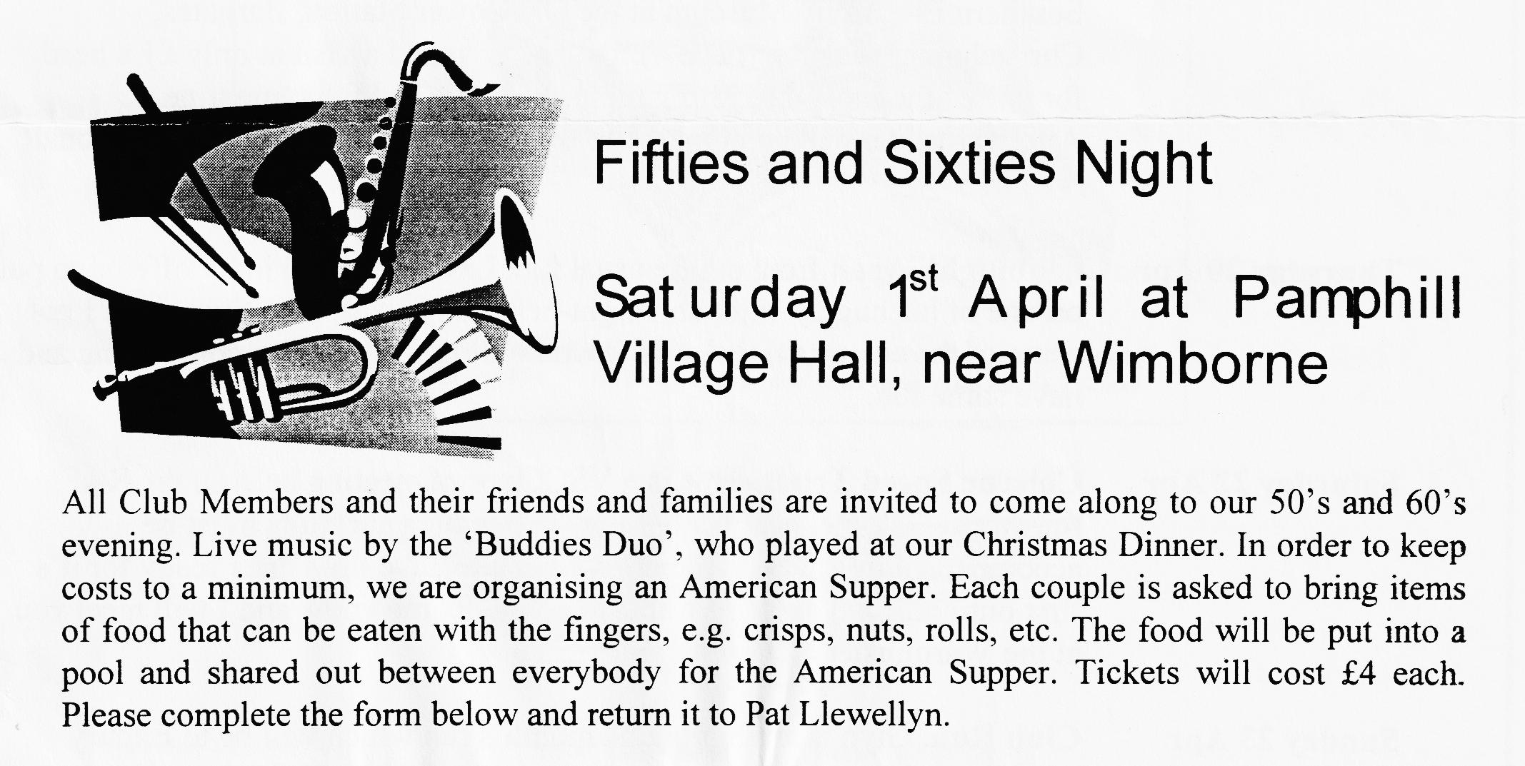

EVENTS
March
Thursday 16 Mar Clubnight. Hopefully, the Swanage Railway Talk postponed from the February Clubnight - and back in the usual room at the Elm Tree. Phil expects to have the Spares but if you want anything particular, you might ring first.
Sunday 19 Mar Club Run. Gary is organising this month's outing so meet at the Cat and Fiddle at 10.30 for a 10.45 start. Not too sure where the Cat and Fiddle is! If you have similar problems, ring Gary.
Thursday 23 Mar Committee Meeting. As always, at the Tyrell's Ford, 8.30 start.
April
Saturday 1 Apr Fifties and Sixties Evening. With the Buddies (Christmas Dinner Duo) at Pamphill Village Hall. Entry format.
Thursday 6 Apr Eight till Late. A touch different this month! Start out at 7.15 pm at the Southern Electricity Museum at the Old Power Station, Bargates, Christchurch, see map (page 4). Pat has arranged a visit at only £1 a head for one of the most interesting nights we have had for some time. Afterwards, we will be going on to the Avon Causeway for the traditional noggin.
Thursday 20 Apr Clubnight. Apart from all the usual fun, Lawrence has kindly offered to put on one of his hugely enjoyable light-hearted quizzes. Last time, even I got some of the answers right! And it won't all be A7 trivia so come along and have some fun.
Saturday 22 Apr Colerne Speed Trials. This is a VSCC sprint meeting held on the RAF runway at Colerne, near Bath. Entry is free but spectators must be accompanied by a VSCC member. I hope to have my Ulster ready for its first outing. If anyone else wants to come, let me know and I will meet you at the Warminster service area
Sunday 23 Apr Club Run. Glyn is arranging this month's run which will be to Exbury

