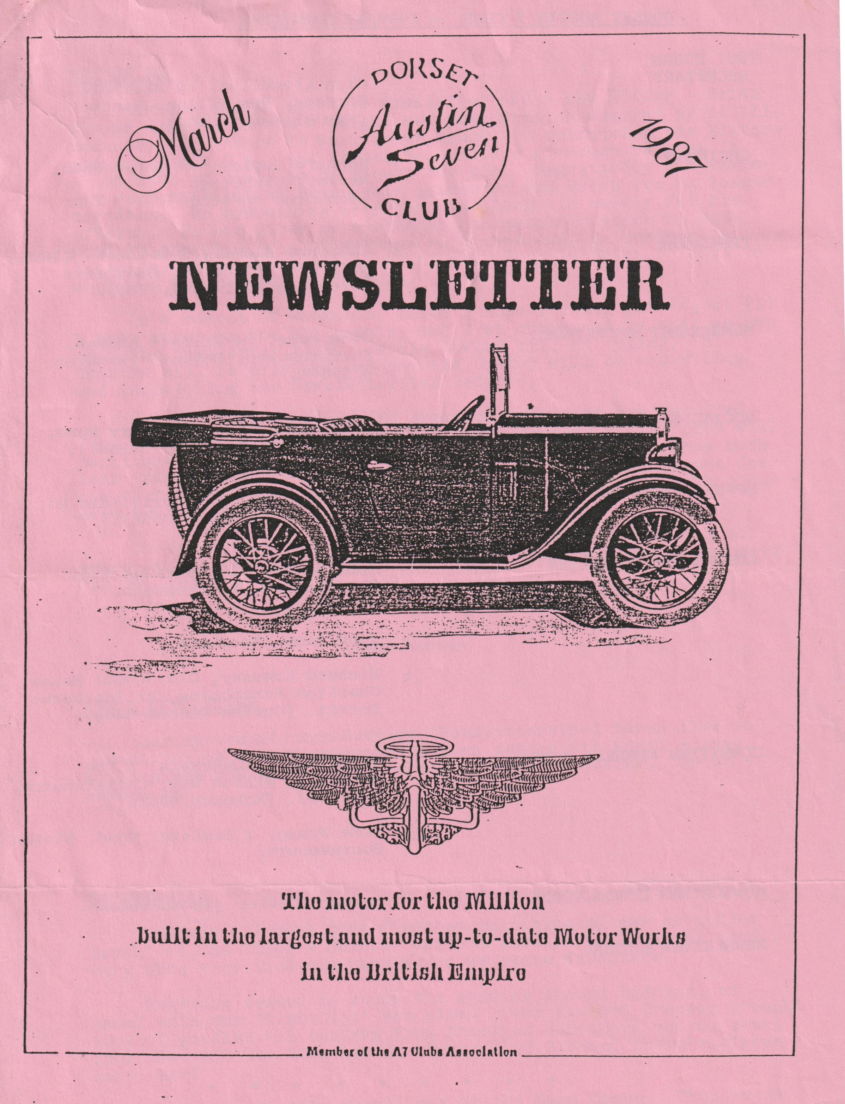

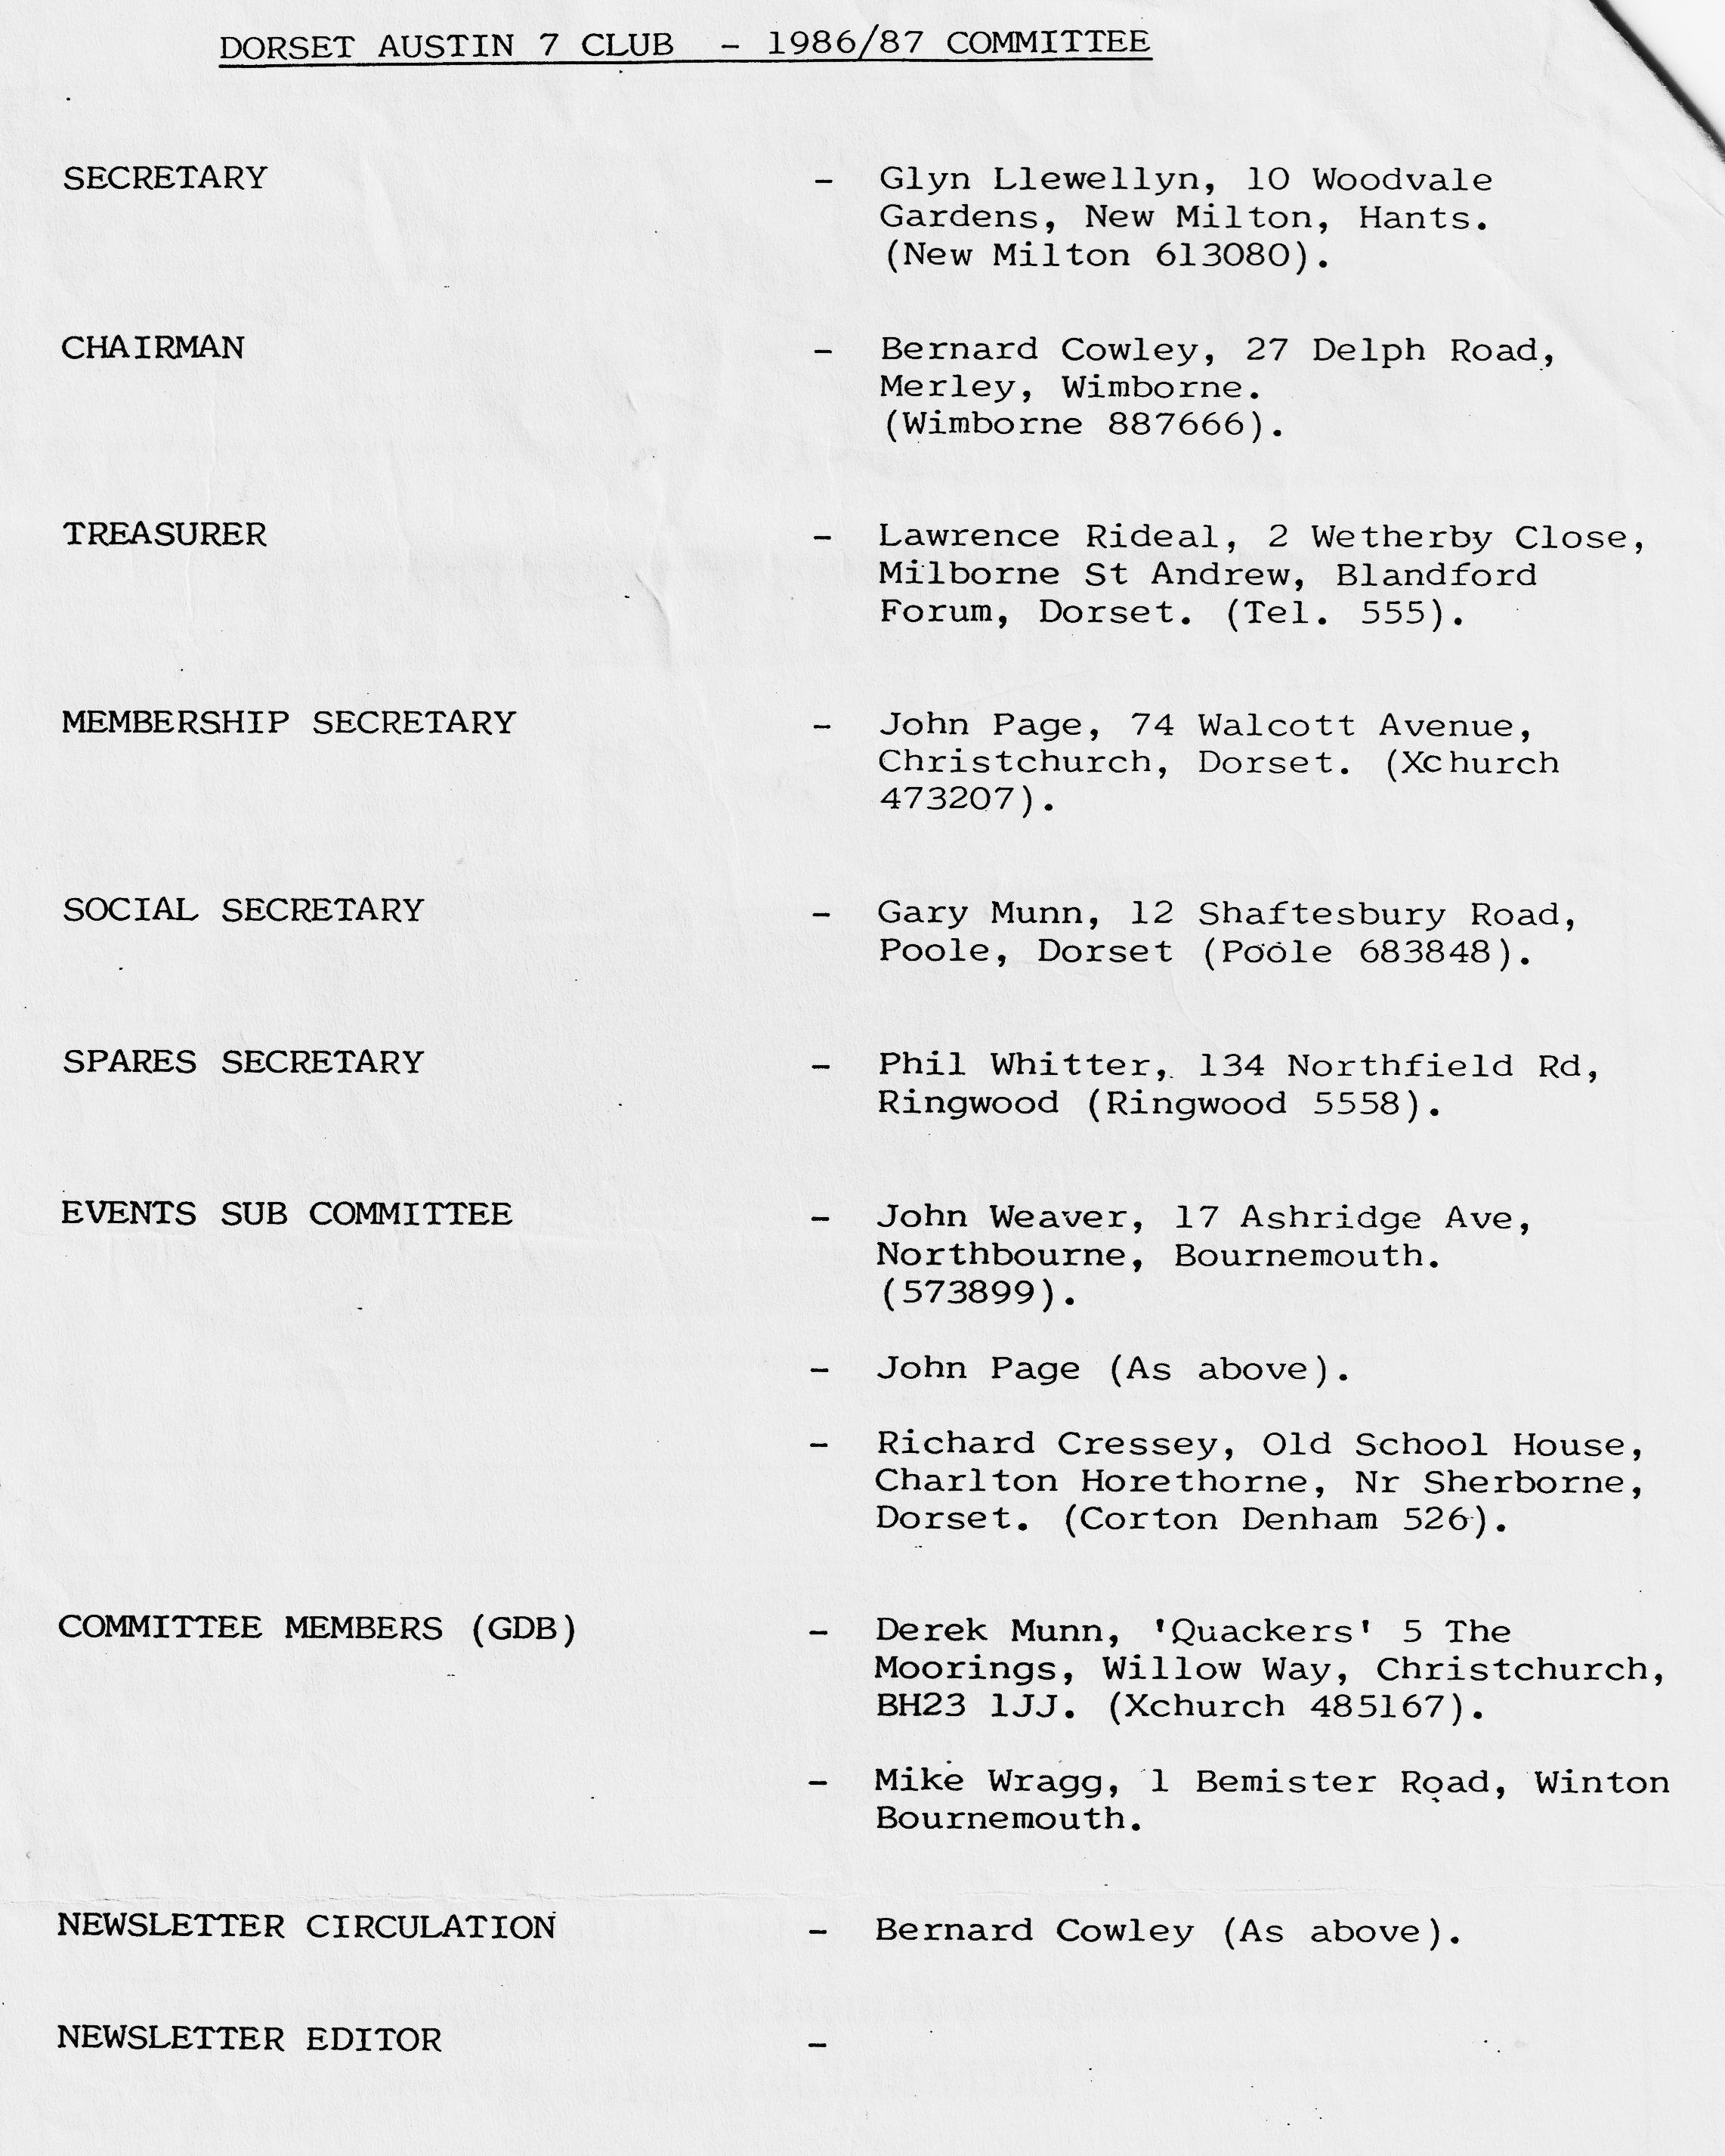

EDITORIAL MARCH 1987
Sixteen months ago this Newsletter had a new Editor - Brian Hooper - and with him a bright new presentation admired by us all. Because of pressure at work Brian sought to relinquish the Editorship at the A.G.M. but agreed to continue although he made it plain that it would be difficult for him. Regrettably, his workaday responsibilities have again increased, and Brian can no longer continue. We sympathise with him end thank him warmly for his efforts. He has given us a standard to maintain which we hope will be possible if club members will continue, or preferably increase, their written contributions. Happily, Brian intends to continue his general membership.
In a moment of weakness, which I hope I shall not regret (!) I have taken on the Editorship, but I am supported by whet we can call the Newsletter Team. Jackie Cowley will be typing, Phil Whitter will be printing and Bernard Cowley will be assembling and dispatching the Newsletter (as before).
General contributions and Austineering items are required. They need not be long or learned. Newer members of the club will particularly welcome useful tips or ideas. Many of us know much less than we are usually prepared to admit. One good reason for the club's existence is to share our ideas and benefit each other even by our mistakes.
It see that there will be plenty of outside activity to enjoy in the coming months so consult Forthcoming Events and keep 'em rolling.
Help:
John Weaver
APRIL NEWSLETTER
Our system of reproduction (Newsletter-wise) takes time so please let us have your contributions before 5th April - this still gives you Q fortnight in which to get cracking. Go on have a go:
SECRETARIAL MARCH 1987
Hi Gang. I have just finished polishing my new portholes bought at the "Mike & Bernie" Auction Show last Clubnight, and very nice they lock too hanging on my stone fireplace.
Everyone seemed to enjoy the evening though bidding, as usual with our 'tight lot' was slow. Poor Richard Cressey brought tons of goodies all the way from Charlton Hawthorn and as usual took most of them back again. Never mind Richard there's always next year!
What a great time we all had at the Barn Dance. This event gets better every year. The ladies had decided that we should have optional fancy dress, and this certainly added to the fun. There were some fabulous ideas for costumes. The new venue at the Avon Country Club seemed very popular with everyone, it was nice to have the bar (no Whitbread I'm afraid) and the Ploughman's was good. I dare say there will be a report somewhere in this newsletter.
As you may have already heard, The National Motor Museum and 750 Motor Club are joining forces to 'actively promote' the 25th National Austin 7 Rally at Beaulieu on Sunday 5th July. They hope to make this the largest ever gathering of Austin Sevens and ask if it is too much to hope for 750 of them. Details of the event can be obtained from the Events Dept., National Motor Museum, Beaulieu, Hants. (P.S. I understand that The Solent A7 Club are to revive their pre-Beaulieu Barbeque for this Special event).
Another event I have details of is the Wessex Vehicle Preservation Club's Motorcade held at Breamore House, nr. Fordingbridge on Sunday 7th June. I am told that we can enter as a Club and your Committee have accepted the idea. Let us know if you wish to be included. This is cheaper than entering individually apart from anything else.
I am informed that 20th May 1987 is the 60th Anniversary of the first Swallow bodied car and that Geoff Walker of the Swallow register is planning a rally exclusive to Swallows sometime next May. If you are interested contact Geoff Walker at The Scheel House, Great Haseley, Oxon.
Did you know that Practical Classics is, ruining a series of articles on the Austin Seven? So far covered has been the overhaul of the rear axle, followed by engine overhaul.
Finally, I have received from the Austin Seven Clubs Assoc. events section a list of A7 events for 1987 which 'I have handed to the Editor for inclusion. See you all Club Night.
Glyn
FORTHCOMING EVENTS
The Austin Seven Clubs Association
The calendar of events for 1987 contains over 100 rallies and events organised by individual clubs throughout the land. We can't list them all, but apart from the Beaulieu and Breamore House events locally, that the Secretary has mentioned you might like to note that the Spye Park Rally (Bristol A7 Club) is to be held on 20th/21st June.
If you fancy the Brooklands Trial in April, the Mallory Park Austin 7 Race in May, the Longbridge Rally in August, the Stonehenge Run in September, or wish to see the complete list of events let me know. I will bring the Calendar to the next Club Night for keen types to see.
Other Local Events
The Andover Veteran and Classic Road Run to be held on Sunday 5th July would welcome 'all kinds of vehicles'.
The Hampshire Veteran, Vintage and Classic Club are holding their Cavalcade of Transport on 30th and 31st May.
Entries are also requested for the Woodford Country Fayre on 3rd End 4th May. I believe some members always support this event.
We have the details of entry to all of these.
Ed.
CLUB BARN DANCE
Rain was falling softly leaving a shine on the roads and roofs as Wonder Woman And Superman hurtled over Bransgore village en route to a very important engagement. Just below, Superman spied a Hippy and a Teddy Boy in a sports car and he could see that they were about to be involved in a crash with an XR3 and a Landrover so, together, he and Wonder Woman lifted the sports car to safety. They did not stop to talk as the Hippy and the Ted looked a motley pair.
Onward at the speed of light to Ringwood Country Club where the company were gathering, a nervous looking, shifty lot thought Superman as he shook hands with a large chested Aunt Sally who was accompanied by some scruffy yob called Worzel Gummidge. Billy the Kid and Annie Oakley were stood eyeballing Sherlock Holmes at the bar as Superman stepped between them and demanded a pint of Whitbread to break the tension. Just then a roar of motorcycle engines reached his sensitive super hearing and in walked the scruffiest Hell's Angel in town. Must be a member of the North Bournemouth Chapter thought Superman as he watched the lout wipe his nose on his sleeve. Wonder Woman remarked that she thought it strange that a character such as this should be accompanied by such an attractive wench in a swimsuit. It was obvious that she must be in some pain and Superman realised that she was being attacked by a large crustacean. He was about to go to the maiden's aid when the Vicar sidled up saying "My boy, want to buy some dirty photos?". He was then saved any embarrassment as the Bishop arrived, teeth and all. Superman and Wonder Woman decided to keep a low profile for the moment and made their way to a point where they could watch these weirdos. He saw a Cowboy with whiskers, must be Gabby Hayes he thought. Gabby was in earnest conversation with Al Capone and his charming wife, who was trying to swat this damned Bee that kept flitting about between Napoleon, Josephine, and a large carrot: Just then two Turks arrived. One of them had obviously been in a fight as he was .supported by pair of crutches. Perhaps he had done battle with the Arab by the bar who kept fiddling under his robe. Superman wondered if he was going to pull his gun out, but thought not when he noticed he was talking to a pupil of St. Trinian's School.
Just at this moment the band struck up and in marched an Officer of the German Reich who demanded that we all dance. Everyone joined in, not wishing to incur his wrath.
We were soon all having a terrific time, and after a ploughman's supper, the winners of the fancy dress were announced. They were the Carrot and the Bee.
Thanks, Gary for organising a fantastic evening, definitely the best yet.
Glyn
THE FEBRUARY RUN ON MARCH 1ST(!)
The final destination being Southampton, our assembly point for the 'February' run was Ringwood. The day had started with heavy showers but it was dry enough for the usual pre-excursion natter. This seemed to continue for longer than usual but was interesting as it covered all aspects of the club's interests, functions and activities and Jo's purchase of a 1978 Morgan 414 with a personalised number plate but more of that next month.
Eventually we realised we had no leader. We knew our lunch-time stop so Gary led seven Austins and the Morgan on an indirect route through the very wet, fast becoming wetter, forest to the New Forest Hotel, Ashurst. Not very imposing from the outside but offering plenty of parking, we found the inside very suitable. A good menu and pleasant atmosphere were just what was needed. We were joined by the Shaftesbury Ruby and a few other club members in moderns. A good turn-out all told. .
The weather had improved but although there were attractive walks nearby we all felt satisfied with the fresh air in the car park and continued on our way to the Mitchell Museum in Southampton only to find plenty of parking in the area at which we had arrived but no museum. It had been re-sited elsewhere, in Kings Bridge Lane near a large marina.
No parking fee and reduced rates for our party, which by now numbered about twenty-five, were an added attraction to the very interesting static display of a Spitfire, its history end development and, amongst other aircraft and engines, the famous Sandringham Flying Boat. The latter we could tour and were all impressed by its controls, size and the cabin which bore a strange resemblance to a first-class railway carriage.
This museum is still being established and is due to receive three more aircraft shortly. However, it was an interesting and pleasant display well worth a visit.
The weather had improved throughout the day end with only light showers to contend with, we contentedly made our various ways home.
Gay
DID YOU KNOW THAT ....
Not all early Austin Sevens were 747cc.. The original 1922 Chummy was 696cc.
NICE TO SEE ....
George Mooney back in Vereinigtes Konigreich after his latest sojourn in Germany.
AMAZED TO SEE ....
Mike Wragg joining the latest run in a diesel-powered Grenada. Only a temporary direction we hope.
THANKS TO ....
Derek Munn for unfailingly providing a raffle at every club meeting. It's a nice feature and helps club funds. All prizes are donated (hint, hint)
CONGRATULATIONS AND SYMPATHY TO ....
Jill Toalster who completed a Walking Marathon with Brian despite suffering a fractured leg on the way.
YOU WHAT?
"What chance have I got", said Paddy, "of selling my car with 85,000 on the clock?"
"You could turn it back", suggested Mike.
They met again three weeks later.
"Have you sold your car now?"
"Sell a car with only 500 on the clock: I'm. keeping it you fool".
FOR SALE-AND WANTED
WANTED Chummy Radiator together with Nickel Plated Cowl. Contact Paul Mainzer B'mth. 769335 or 303521 during office hours.
WANTED New member Steve Caine from Poole (nice to see you end the family at club night) is urgently locking for a rolling chassis to build a Special. Steve lives near Gary at 55 St. Mary’s Road, Poole. Tel 681320
FOR SALE One pair cf brown Size 8 Dec Martin's Safety Boots. Steel toe caps - 200 Joules. Hardly worn. £6 Apply Stuart Weaver B'mth 515663
FOR SALE Reg. 1922 RN Saloon, original condition. Can be purchased as is or M.O.T.'d. Gearbox noisy (good gearbox supplied with car). Brakes need sorting. We feel car should be run as is. Mr. Tait told us he drove the car to the 1972 Longbridge Rally where he won best unrestored car still in use. Has been garaged ever since. Price as is with spare gearbox £1,500. Price with M.O.T £1,750
Reg. 1927 Ruby painted matt grey (Yuck!!) Metal wise very good condition. All instruments etc. still there. For some unknown reason Mr. Tait has taken the engine out. Very cheap restoration to get back on the road. Price as is to include engine etc. £800. Car to be sold guaranteed complete, any parts missing will be supplied.
1 Ashley body C/W hard top and modified A/7 chassis. Price as is £50; I Falcon body C/W hardtop and modified A/7 chassis Price as is £50. Both can be purchased with Swansea Registration document. We have a container full of S/H A/7 spares. If you're looking for anything, come and have a sort out. Further details phone John Downs (Engineering) Ltd. Malden, Essex. (0621) 772096
Various Austin Seven Ruby parts available including body panels, wings, doors etc.., a rolling chassis (Mk 1) with engine, gearbox, back axle, glass and window fittings, seats, instrument panel and numerous other parts. Full list of parts available on receipt of s.a.e. Contact Paul Vickers, 78 Gillhurst Road, Herborne, Birmingham B17 SPA or Phone 021 429 1850 after 6 pm.
FOR SALE 1948 Morris 8 Series E. M.O.T. and Taxed until June - £1500 Phone Jo, Tel. New Milton 621689
FOR SALE Austin 7 trailer approx. 3 x 2 tyres reasonable - £50 Contact Comm. Ladbroke 0258-840309
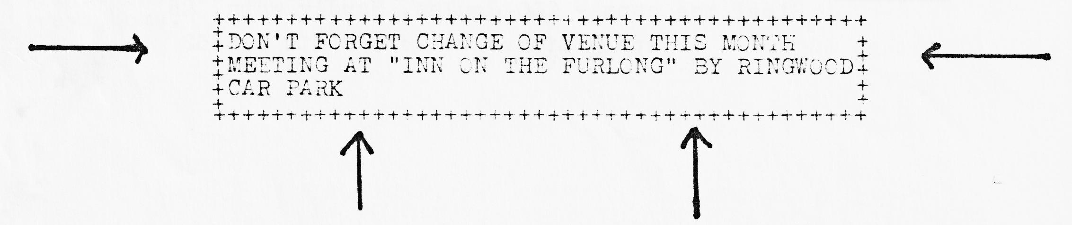

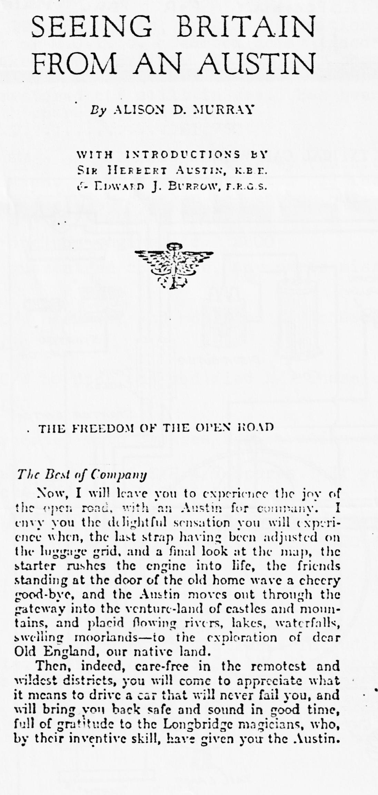

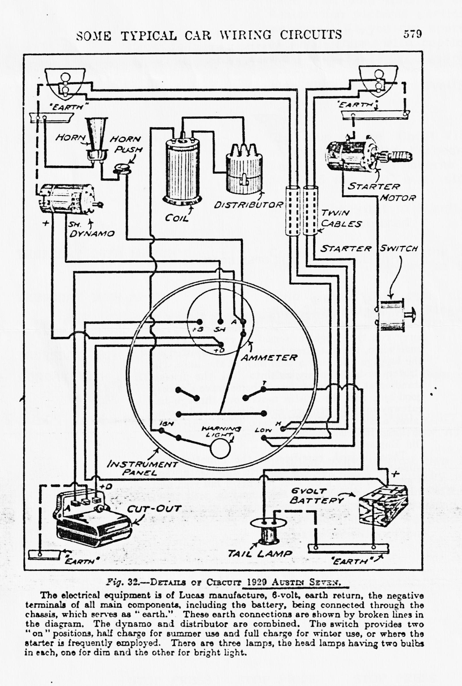
EVENTS
THURSDAY 19TH MARCH Club Night, 8.00 p.m. at The Inn On The Furlong, Ringwood.
PHOTO NIGHT. Please bring along for display any photographs you have from your motoring experiences. Restoration pictures particularly welcome. If you can spare time to mount them, with captions, all the better. Also SPARES will be available from Phil.
SUNDAY 22ND MARCH Club Run to the 'Ghost Village' of Tyneham on the Purbeck Army Range. Meet in Wimborne Square at 10.45 for 11.00 a.m. start.
NOTE The visit to Sherfield English is postponed.
THURSDAY 26TH MARCH Committee Meeting at the Tyrrells Ford, Avon, Ringwood at 8.30 p.m.
THURSDAY 16TH APRIL Club Night. 8.00 p.m. at The Elm Tree, Hightown, Ringwood. Details next month.
MONDAY 20TH APRIL Easter Club Run to Guernsey.
SUNDAY 26TH APRIL SHERFIELD RUN AND VISIT TO THE NICHOLSON COLLECTION AT RINGWOOD.
Hidden away in Hightown is a collection of exotic cars owned by Mr. Nicholson for the past thirty years or so. More details next month (the date is provisional as we need to agree it with Mr. Nicholson).
STOP PRESS STOP PRESS STOP PRESS
MARCH MEETING
Due to the Elm Tree being closed for redecoration, the meeting has been changed to The Inn On The Furlong, Meeting House Lane, Nr Ringwood Car Park.

