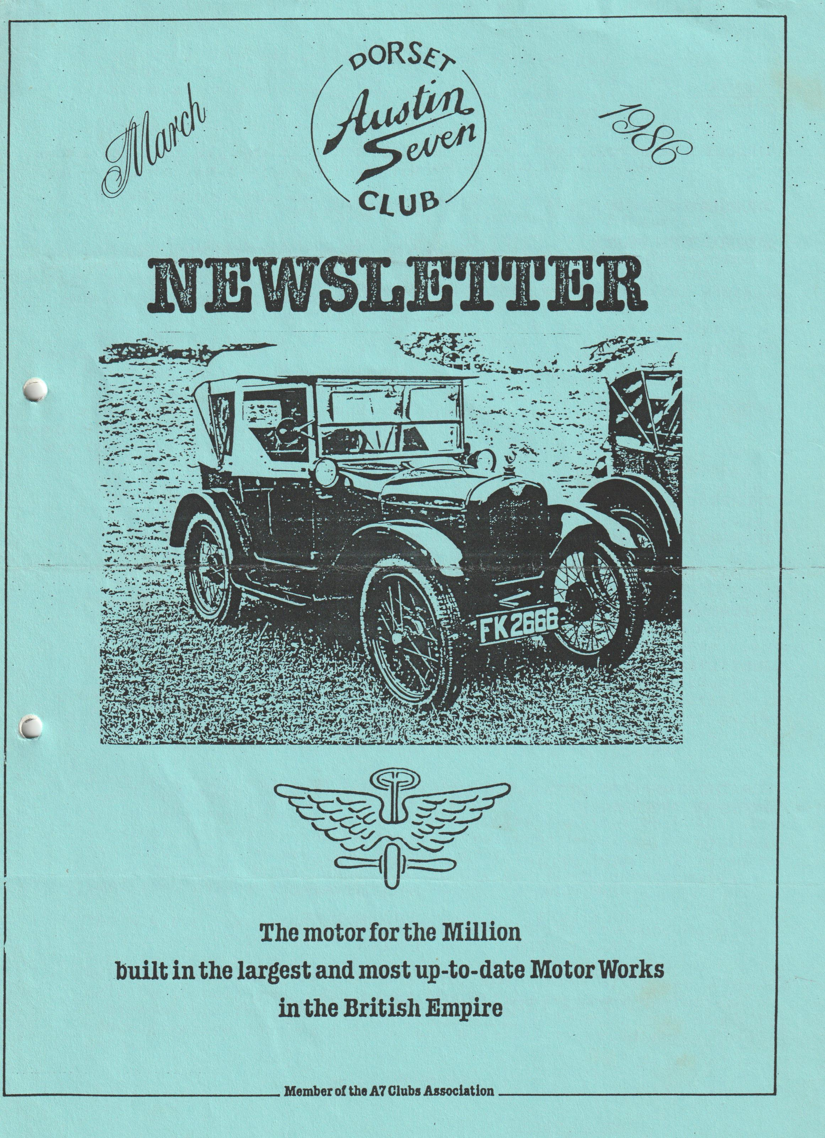

This month's Front Cover is of Bernard Cowley's 1925 Chummy
EVENTS
THURSDAY 20TH MARCH - Club Night at the Elm Tree, Hightown, Ringwood (Noggin & Natter).
THURSDAY 27TH MARCH Committee Meeting.
SUNDAY 30TH MARCH - . The "March Hare Run" (Easter Sunday) Meet at Co-Op Car Park, Christchurch (End of By-Pass) at' 10.45 a,m. for 11.00 am start for a visit.to the Ealing Tide Mill.
THURSDAY 17TH APRIL - Club Night at the-Elm Tree, Hightown, Ringwood. Talk & Film by the RNLI.
SUNDAY 20TH APRIL - - Club Run to the Hawks Conservancy,'Weyhill, Nr Andover. Meet in Ringwood Cattle Market 10 am for 10.15 start.
THURSDAY 24TH APRIL Committee Meeting.
THURSDAY 15TH MAY - Club Night.
SUNDAY 18TH MAY Club Run to Bath.
SATURDAY 7TH/SUNDAY 8TH JUNE Andover Vintage Club' Rally.:
JULY 17TH - 19TH SPYE PARK RALLY
- 0 - 0 - 0 - 0 - 0 - 0 - 0 -
FOR THOSE OF YOU INTERESTED. IN A7 RACING, LISTED BELOW ARE THE DATES OF MEETINGS:-
MAY 26TH - SNETTERTON
JUNE 22ND - MALLORY PARK
JULY 19TH - SILVERSTONE
AUGUST 17TH - LYDDEN
SEPTEMBER 14TH - MALLORY PARK
OCTOBER 11TH - CADWELL PARK

EDITORIAL MARCH 1986
I drafted this editorial over the weekend of 1st - 2nd March, at which time I was feeling very sorry for myself, for having set a deadline of March 3rd for contributions, I found that all I had was a front cover, back page and a couple of Sale & Wants, plus my own editorial. Still, like the weather, things changed rather rapidly, so I have had to edit out nearly all of my winging and get on and do the job.
I came across the enclosed Autocar Road Test of the 1931 Austin Seven Sunshine Saloon, and having contacted the Editor of Autocar, he responded by giving permission for us to reprint it in our Newsletter.(I would add that it is necessary to contact the publishers of any article before inclusion in any other media, when permission will normally then be given after checking out that there are no legal or copyright problems). A big thank you to the Editor of Autocar, I know that our members will enjoy reading the relevant article.
With regard to club runs, no opinions have been expressed to the return run (see last month's Newsletter), so presumably there will be no change to the previous practice of 'doing your own thing'.
Again, whilst on the subject of club runs, I'm sad to say that for the second month running, no report has been received, this time relating to the run to Powerstock, I must admit that I infrequently attend runs, but in the past I always enjoyed reading the reports. Is it that no one can be bothered, or am I alone in enjoying reading the reports? Your views please.
I don't think that the 10th Anniversary Barn Dance can go without mention, for those of you who came, I'm sure you will agree that it was a fabulous success. John Weaver has captured the mood in a huge batch of photographs, but unfortunately as they were printed in a matte finish, reproduction is difficult in this Newsletter, although I've tried a few. Thanks must go to Gary for organising the event, various members for their behind the scenes activities, specifically Hilary and Barbara who produced the excellent buffet and to the Old Pull & Push who tried to keep us on our toes, only to find most of us falling about the floor with laughter.
From an events point of view, apart from those detailed in our events calendar, and some others referred to in George's secretarial, I see that the Solent Club are holding the Paultons Park A7 rally on Sunday June 1st, the National A7 rally at Beaulieu is on Sunday 6th July and I believe the Bristol A7 rally at Spye Park is to be on Sunday 20th July. We will probably get these events/dates confirmed nearer the time.
The W.V.P.C. are holding their Motorcade '86 at Braemore House on Sunday June 15th.
Well that's about it for this month, apart from my appeal - please help me to help you, 'the club' by letting me have Newsletter contributions for April by MONDAY 7TH APRIL latest. (I cannot for administrative reasons include any material received after this date).
Regards,
Brian Hooper

SECRETARIAL MARCH 1986
Hello,
Where to start? Well it seems as though the Secretary's report is yet again going to be a chronicle of things to happen in coming months.
Hill Climb Event
The local event at Gurston Down, Salisbury has events taking place on 24th/25th May, 22nd June, 27th July, 31st August and 5th October. It is planned to have a club run to Gurston Down, further details later.
The Yellow Bus rally takes place on 6th July at the Mallard Rd depot, Bournemouth. Interested parties to apply to the Bournemouth Passenger Transport Association, 148 Corhampton Rd, Boscombe East, Bournemouth.
A reminder - entries for the Woodford Country Fayre close on 24th March. I have entry forms for the event which is on for 4th - 5th May.
Several members attended the small event held by the Christchurch Model Railway club last year. The event is being run again on 14th September, let me know if you wish to attend - I have entry forms.
A reminder about the Old Wheels Exhibition in June (see last month's Newsletter). If you intend to go by coach, please let me know by the end of March.
I have received a letter from the editor of the A7CA magazine complementing our club on our Newsletter - well done Brian. ‘Pinocchio' may get some coverage in the 1986 B magazine - watch that space.
A mail shot letter arrived from Mercury Publication Service Ltd, P.O. Box 10, Otley, West Yorks LS21 3NH, offering reprints of Castrol Lubrication charts for the Austin 7 at £2.75 each incl P & P. If you fancy one, please write direct and don't forget to tell them the year of your car.
That's it for now, see you on Club Night.
George

AUCTION NIGHT
I didn't make any notes on the night, so when I was asked at the committee meeting to provide a few lines for the Newsletter, I winced. However, although struggling (how is your memory?), here goes:-
Every year Bernard is brave enough to take on as auctioneer, usually with the help of Jackie, however this year we had a barker in the shape of Mike Wragg who added a lot of human energy and noise to the proceedings.
Bidding, as usual, was slow to start, but once moving some surprising levels were reached with a very nice small vintage cycle lamp with an £8 reserve fetching £15. For once I resisted buying the spot lamps that always seem to turn up, but I did get a fine pair of axle stands and a Ruby wheel.
Glyn Llewelyn bought enough leather skins to re-upholster his Opal, and there were so many items sold I couldn't list them.
The evening was well attended and as far as I could see, everybody was enjoying the evening, although Phil didn't get much chance to participate as he was continually keeping people supplied with club spare parts.
Another great event, thanks to Club Members support and in particular Bernard and Mike, well done.
GEORGE
-0-0-0- 0 -0-0-0-0-0-
WANTED
Body of special, or similar suitable for a 1933 chassis. Contact: Hugh Knott, Wareham 3635
WANTED
1932/34 Box - cheap for rebuild. Contact: Paul, Bournemouth 769335
FOR SALE
1935 Austin Ruby. Excellent Condition, keen to sell to an enthusiast. Price £2,500. Tel. Marnhull 820446.
WANTED
1934 A7 Box. Must be "on the road" and in good condition. Any information leading to a successful purchase appreciated. Contact: Brian (0202) 888397

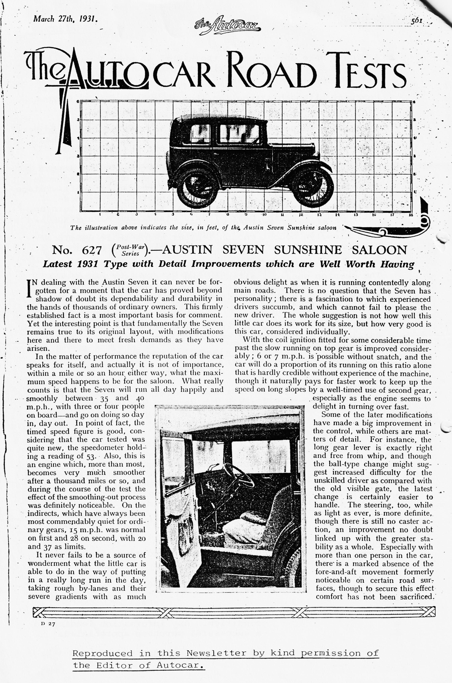

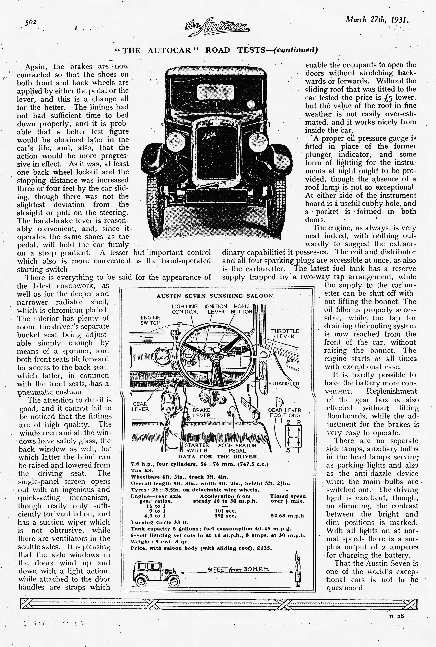

Dusty has been reading some old motor magazines, and came across the following rather amusing article on the "STEYR PUCH PINZGAUER", which he says is not related to the Austin 7, but does have similar qualities!
VE HAFF VAYS
Gott in himmel! Vot iss diss folken? Iss itt der plane, iss itt der bird? Nein, itt iss der Steyr Puch Pinzgauer mitt sixen veels unt der eight gears for der going upen dowen der offroad bits unt pieces. Steyr Puch iss maken der Pinzgauer for der carrying Ostereich troops to der vars, but wen dey vantent to maken a commercial proposition itt iss goot for der landed gentry also. Mitt ein 2.5 litre 92 bhp powervagen unt der top speeden of 100 kph, it climben der moutains and forden der rivers like nobody's business. Ven der staffen off automagazine gotten der greasy hands on it, dey make it do der nasty tinks - like climben der muddy banks, jumpen der rocky roads unt generally fall abouten all over der place. Iss goot, say all der staff - but der pricen at almost 8000 maken for der hesitation ven der Deutschmark layen down time comen. Nothink dat der Britischer army could throw at it would stoppen der Pinzgauer - sure of foot, robust of der mechanicals unt powerful of der motor, it bashen unt smashen der vay through all der obstacles at der testen track (offroad typen). Steyr Puch maken der Pinzgauer as der biggen broder off der Haflinger - unt vill sell you one fur 7800 off der greenies. Mein gott, you could buy der secundhant Porsche for diss money! Mitt der one-unt-der-half ton carrying capacity unt der 60 degree uphillen climbing, it vill tow der tings also. Okay Dermot! Steeren for Stalingrad unt no stoppen on der vay::
Dusty
-0-0-0-0-0-0-0-
Club 'T' shirts are now being ordered at £4.00 each, available in small, medium, large and extra large sizes. There are a variety of colours, let Pat Llewelyn know your requirements.

