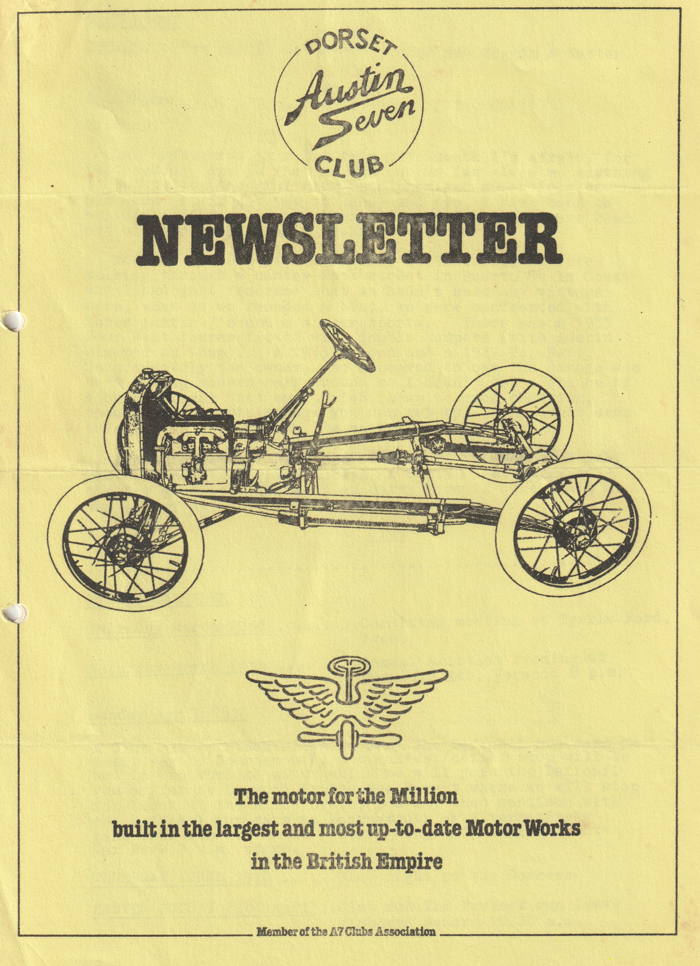

DORSET AUSTIN 7 CLUB NEWSLETTER MARCH 1984
CLUB NIGHT
THURSDAY 15th MARCH a spares evening and Noggin & Natter
EDITORIAL
Hi Gang,
The newsletter is a bit thin this month, I'm afraid, for two reasons, one is that no one has so far given me anything to put in it (though I have been promised an article on the club run, it is not yet to hand) and two, I have been on holiday and after arriving home caught flu, so I have been out of circulation for 3 weeks.
Towards the end of our holiday in Tenerife, we were walking through a narrow back street in Puerto de la Cruz, and I had just remarked that we hadn't seen any vintage cars, when as we rounded a bend, we were confronted with three Austin 7's and a singer sports. There was a 1933 four seat tourer fitted with double bumpers (with Austin stamped on them). A 1933 Saloon and a 1927 Top Hat. Unfortunately, the owner, who appeared to own the garage was busy moving modern cars around, so I didn't get a chance of a chinwag, not that my Spanish is up to much chatting, though its surprising how you can get by. One can't seem to get away from Austin 7's no matter where you go!
Don't forget our skittles evening at the Monmouth Ash, Verwood on Saturday March 24th at 8 p.m. But hurry as closing date is 17th March an entry form is once again at the end of this newsletter.
Glyn
EVENTS CALENDAR
Thursday March 22nd Committee meeting at Tyrrells Ford, Avon.
Saturday March 24th Skittles evening at Monmouth Ash, Verwood 8 p.m.
Sunday April 15th A Club run to Stockbridge to see the Daffodil run cars on their way to Bournemouth, a breakfast/coffee stop will be had in Stockbridge after which we will join the Daffodil run as far as Lynwood in the New Forest where we will stop for lunch at the Alice Lisle, you may then continue with the Daffodil run cars to Bournemouth or alternatively make your own way home. Leave Ringwood Cattle Market Car Park 9a.m. sharp.
THURSDAY APRIL 19th Club night at the Dormers
EASTER SUNDAY 22nd April Club run The Purbeck run leave Wimborne square 10.30 a.m.

SALES AND WANTS
For Sale
Creighton Binns Double Top 6 berth trailer tent, storage brackets (to allow storage on its side), cooker, spare wheel, toilet and toilet tent. £650 ono Mr. Hunt New Milton 610697
For Sale
1935 20/25 Rolls Royce Doctors Coupe needs BIG restoration job. Ring Ringwood 78066
A7 Special. Kit of parts includes New Boat Tail body, (needs scuttle) New lamps, 1933 Chassis complete ready for assembly, Engine (needs a rebuild). Two very good tyres. Numerous wheels (19") sundry other parts. Cost £350 a few weeks ago. Project abandoned. Best reasonable offer secures. Registered at SWANSEA. (Just right for you know who Dave Ed.) Jim Clenaghan Highcliffe 5753
WANTED
Indicator arms, sliding roof lock, plans or patterns for sliding roof, off side headlamp shell, Rist horn, special hollow bolts for fixing wiper motor to screen. All the above required for an early Ruby by Paul Williams Telephone Martock 824130
WANTED
Information leading to the purchase of a tidy Austin 10 Chrome rad for restoration or similar for up to £750 maximum for a great friend. Ring George Mooney. Work 0202 571111 Home 0202 425989
Avon Valley Amble Club run report
It was really a sort of a Curate’s Egg sort of a day. It didn't snow and it wasn't cool, but it definitely rained - all the morning until we (finally) arrived at the pub. Emma and I got to Wimborne a little early and would not have been surprised if nobody else had turned up on such a day but the notion of 'Rain stopped play' does not exist in the Dorset A7 Club and in the end we had what proved to be, especially for us personally, a splendid turn out.
Mike and Pam showed up, quickly followed by Jim and Mary, George and Joy, Gary, Peter Daphne and Mum in a modern, Bernard Jackie and family in the Chummy, Phil and Hillary, and John and Cynthia.
We set off Northwards through Cranborne, beautiful country and pouring rain in the general direction of Salisbury. Unfortunately, “Blue Belle" decided the day was right for a play-up and came to a stop, I think 3 times, everyone else says at least 5 times (perhaps we will settle for 7!! Ed.) and the full resources (mobile) and knowledge of the club elders. (Gary? ED.) were brought to bear on the problem - not after all petrol starvation (although thanks Phil for the new line and to the others for a quick service on the carburation) or the fact that the filter had been fitted upside down, but finally solved by George in the pub car park as being due to the rotor arm being badly bent and making virtually no contact. Thanks George. Thanks All, although Bernard was becoming ever more convinced we would never make it, we did and what a super hostelry the Wheatsheaf proved to be. Warm, welcoming, good beer and the biggest ice creams I have ever seen.
After lunch, the stalwarts motored on, we turned for home escorted by George and Joy without a moments trouble.
A great day and grateful thanks Bernard for organizing what was a very good Curates egg of a day after all,
Paul Mainzer
Whilst talking to Paul Williams the other day, he mentioned that Lucas have now an archivist and that if one sends a foolscap stamped addressed envelope along with the model and year of your car, they will send wiring diagrams and descriptions of equipment used, specification lists and any original leaflets pertaining to relevant Lucas equipment.
I wrote, and I was extremely pleased with the great wad of very useful interesting literature received. I will have it with me on club night. If you are interested write to: - "Group Archivist, Lucas Industries, Great King Street, Birmingham.
TECHNICAL TIPS
With the coming of the warmer weather many of us will be uncovering our Sevens from their winter hibernation and will be faced with the annual ritual of the MOT test. One of the points of interest to the tester is the drag link ball joints in which there should, of course, be no discernable play.
You can test this for yourself by getting someone else to turn the steering wheel a little bit (not enough to turn the front wheels significantly) while you look for relative movement of the steering box drop arm and the drag link tube at one end, and between the drag link and the steering arm at the other. If there is some play you must get rid of it, and my advice to you is that you do not try to do this with the drag link on the car.
The rectification of play in the joints is usually simple unless the balls have become oval (in which case a new ball and cups should be flitted. The problem is usually in the spring which holds the outer cup against the ball. A good clean up and grease may solve the problem, but if the spring has become compressed or weakened you can put a suitable number of washers behind it to keep the joint tight. The snag then is getting the end caps back onto the drag link - which is not too bad with the link tube in a vice on the bench but trying to compress the springs and line up the bolt holes whilst groveling under the car usually results in much swearing, damaging of hands and general loss of cool.
The drawback to the scheme is of course that you have to remove the balls from the arms on the car, and as they are on tapers this is sometimes difficult. I suggest the following method: -
l. Remove split pins from retaining nuts - they are not always obvious if the balls have not been removed for many years, but they should be there somewhere.
2. loosen nut until it is level with the end of the thread.
3. turn steering wheel to a position where you can get a good bash with a hammer on the nut/bolt end.
4. Put a large screwdriver or bar between the drag link tube and the arm with the ball joint and pull hard in a direction which will tend to prize the ball out of the arm (it won't come out I expect - if it does you're in luck)
5. With this tension on the taper joint, a good bash with a hammer will free the ball from the arm. (Leaving the nut on during the bashing phase protects the thread so that you can get it all back together again)
6, Remove nut from thread and retire to bench to fix joint play.
While you are feeling keen and generally fondling the steering mechanism anyway, I would advise also that this is a good time to clean up your kingpins. Removing the pins once or twice a year gives you a chance to check that grease is getting down to your bottom bush, and cleaning of the salt and grot from winter motoring will ensure that when the time comes to renew your pins bushes, the pins are not irrevocably stuck in the front axle beam. This makes changing the king pins a nice easy job instead of having to dismantle half the car and take the whole front axle to your local blacksmith.
Acknowledgements to Solent A7 Club.
Lighting Requirements as they affect the Austin Seven
All Sevens registered after 1st Jan. 1931 must have two head lamps, capable of emitting a dipped or main beam. Prior to this date you need have lamps which emit only one beam.
All Sevens must have two tail lights. They must be fitted not more than 2'6" from the edge of the car and must not be closer than 1'9". The light must be red and not exceed 7 watts.
Two side lights are required on Sevens. They can be incorporated in the headlamps provided they say on when the headlamps beams are on. The lights must be white and not exceed 7 watts.
Only one stop light is required. It must show a red light not exceeding 21 watts. All Sevens must be fitted with two rear reflectors. They may be included in the rear lamps. If not, they must be mounted separately. All Sevens registered after 1st Jan. 1936 must be fitted with some sort of direction indicator. If you use flashing indicators you may have white to the front and red to the rear, amber all round, amber front and red rear, white front and amber rear. Maximum power of each lamp not exceeding 21 watts.
A reversing lamp can be used to a maximum power of 21 watts. (This is the only white light you can show to the rear. Under no circumstances can you show a red light to the front.
Acknowledgments to Midlands A7 Club.
SECRETARIAL
Hello there, no secretarial last month, who's a naughty secretary then.? So, up with pen and down to work. I have a few things for you this month.
1. When we reached the Wheatsheaf at Lower Woodford and whilst I had my head buried in a certain magneto I was approached by a fine-looking gentleman called Graham Rand, He invited the club to take part in the vintage section of the WOODFORD COUNTRY FAYRE on 7th May from 1 - 5 p.m. at Woodford. It sounds like a visit many of us would like to make. Hope to get entry forms shortly. Interested parties contact me.
2. There is a National Classic Motor Show recently announced. Sounds a fantastic show. This is reckoned to be 3 times the size of the Brighton Show which it apparently replaces but I am not altogether certain of that. The show will be held from 5-7th May 1984. Trade Shell stands cost £400! What about it Bernie?
3. Saturday 28th April a friends evening at Beaulieu "The Museum Collection" 8pm. Various speakers - usually a good evening.
4. The Bean Car Club have announced the Daffodil run for April 15th., entry £5. Knowle Hill for a plaque.
For those of you who missed an evening with Stuart Turner at Beaulieu, it was a very good evening.
That’s it for now folks. It is nearly time for the box to go back on the road I look forward to that. I hope soon to start on the special, I am well on with the conservatory and the little lady is happy.
What are you giving up for Lent? All the best, See you around.
George
DON'T FORGET FOLKS --- NO MODERNS ON CLUB RUNS FROM APRIL.
ANNUAL SKITTLES EVENING
TO BE HELD AT THE MONMOUTH ASH, VERWOOD, ON SATURDAY EVENING 24th MARCH AT 8 p.m.
WE HAVE ONCE AGAIN RETURNED TO THE MONMOUTH ASH, BY POPULAR DEMAND, FOR OUR YEARLY LIGHT-HEARTED SKITTLES EVENING.
THERE WILL BE A CHOICE OF FOOD AND HAVE ARRANGED BAR FACILITIES IN THE PUB'S ALLEY. AS USUAL WE WILL HOLD A RAFFLE WITH MANY GOODIES TO BE WON.
ALL FRIENDS ARE MOST WELCOME REGARDLESS OF THEIR SKITTLING EXPERTISE.
PLEASE COMPLETE THE FORM BELOW AND RETURN IT AS SOON AS POSSIBLE TO AVOID DISAPPOINTMENT. CLOSING DATE 17th MARCH
Reservation form for DA7C Skittles evening on 24th March 1984
Please reserve me ……………….. places for the annual skittles evening. I would like
………………..Chicken in the basket @£2 each
…………….......Sausage and Chips @ £1.30 ea.
………………..Ploughman’s £1,15 ea.
I enclose a cheque for £……………… payable to the Dorset Austin 7 Club.
Name …………………………………………………………….
Address ……………………………………………………………………………….
…………………………………………………………………………………………
Telephone No. ………………………………………..
Please return form ASAP to Gary Munn, 17a Munster Rd, ' Lower Parkstone, Poole, Dorset.

