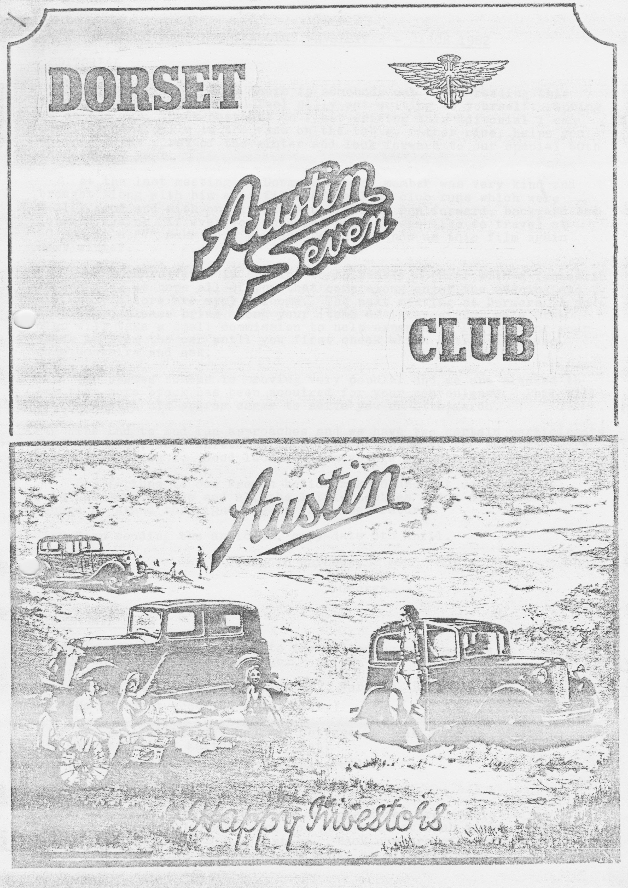

DORSET AUSTIN SEVEN CLUB NEWSLETTER MARCH 1982

EDITORIAL
Hello there! I hope there is somebody out there reading this load of …….. You would feel silly sat writing to yourself. Spring is on the way, thank heavens! As I sit writing this Editorial I can smell the daffodils in the vase on the table, rather nice, helps you to forget the worst of the winter and, look forward to our special 60th Anniversary year.
At the last meeting at Dormers a past member was very kind and brought along with him some films of earlier club runs which were really good and with one in particular being run forward, backward and forward again. If ever a crow wondered what it was like to travel at 90 mph in an A7 make sure you ask David to show us this film again next winter.
The Dormers venue is proving to be really popular with fantastic attendances we hope all of you that come along enjoy the evening and any new visitors are very welcome. The next meeting at Dormers is an Auction so please bring along your items of interest for sale, the club will take a small commission to help expenses. Don't bring your items in from the car until you first check which entrance to use, come upstairs and ask.
The spares scheme is proving very popular and we are pleased to say that more stock has been acquired for your convenience. Phil will be there with his spares eager to serve you on 18th. March.
The End to End run approaches and we have two certain participants from the club: Phil Whitter with Willie McKenzie in the Ruby and Mark Tudge in the Big 7. Good luck and bon voyage to both of them.
Bon fortune to our French holidaymakers and let us hope that John and Janet Stone and all the little pebbles enjoy Australia and manage to stand the right way up when they return.
Keep sending the articles, copy date 5th April.
Yours in Harness,
George.

MEMBERSHIP NEWS
A hearty welcome is extended to the following new members who have both been members some time ago:
Mr. David Delaney, 6 Willow Way, Wareham, BH2O 4RX (He has just acquired a 1937 Ruby)
Mr. Paul Williams, Woodbury Cottage, Middle Street, Bower Hinton, Martock. Somerset.
(Paul has a 1934 Ruby to be restored)

ASSOCIATION MAGAZINE
Indexes for the first ten years magazines are available now at 40p. each. Please make sure you get yours at Club Night or write to Phil Whitter with 40p + postage. Back numbers of most years are available, let Phil know what you want, he will get them for you.

LETTERS TO THE EDITOR
Dear George,
As promised at the last DA7C meeting, I have at last put pen to paper, as it were, with a few thoughts on Austin Sevens which you may like to use in the newsletter.
DISCONNECTED JOTTINGS: There I was, trundling along in the Big Seven the other day, with the sunshine roof and the windscreen open, and my thoughts started ticking over, thinking of Summer. Admittedly it was only February and the wind whistling through the car was a little chilly but it won't be long before things (hopefully) warm up and Austin Sevens will start to sprout along the roads like daisies do along my lawn in April.
It occurred to me that one does not very often see an Austin Seven towing a caravan (one used to be seen at Beaulieu, anyone remember? Ed.) At first that seems a little absurd anyway, when you take into account the fairly low power output of the engine (I almost said compared with a Big Seven but!!!). However, can anyone tell us what the recommended maximum towing weight for an Austin Seven - or for a Big Seven, for that matter - I know that fairly modest lightweight trailers can be hauled along quite happily by a Seven but what is the upper limit?
Another question. which I have often wondered about is how many Austin Sevens survive? Does anyone know, and is there, anywhere, a register of vehicles that are left? I would find that particularly interesting, as I would like to find out whether the 1932 saloon that my parents once owned, and the 1937 Ruby that my grandparents owned, still survive.
Yet another question that I find difficult to answer is why there are apparently so many surviving Austin Sevens, as a percentage of those produced, compared to, say, Morris Eights, Ford Eights and so on. Apart from the 'obvious' answer that they were better built than their counterparts, perhaps it's the appeal of the Seven which persuaded many people to keep, rather than scrap them? Nevertheless, there were an awful lot of Sevens turned into 'Specials' and driven into the ground not very many years ago... this makes it all the more surprising to me that you see more 'Sevens' than any other model and make.
If any member can answer the above question, I should be grateful.
Unfortunately, for the moment at least, I've had to close the sun roof again, at least until the sun comes out again, so I'll forget towing that caravan....
Finally, George (for the moment), can anyone tell me where I can get an overhaul kit for a 'T' type fuel pump (for the Big Seven)?
All the best,
Yours sincerely,
Kim Henson

I know this will prompt a stream of correspondence, hint hint! Can anybody help Kim quickly with his pump parts? I'm not able to help not driving such modern machinery. Ed.

THREE MONTH CALENDAR
19th March. Thursday Club Meeting, Dormers, Wimborne.
21st March. Sunday MOTHERING SUNDAY Run to Corfe Castle and Kingston. Start at Wimborne Square 10.30am sharp. Luncheon at the Scott Arms, Kingston.
21st March Hastingwood Autojumble, Essex Club
25th March. Thursday Committee meeting
27th/28th March Gorgeous Run, Bristol A7C
4th April. Sunday SPECIAL TREAT! CLUB RUN TO KING, ALFRED’S TOWER AND STOURTON WOODS-FREE!! Or STOURHEAD GARDENS IF DEMAND IS THERE. Pay to enter here. Wellies advisable!! please note. Meet at Henstridge traffic lights at 11.50am.
9th/12th April Easter Rabbit Run, Bristol A7C
9th/12th April Easter Trip to Devon, Solent A7C
10th/14th April John O'Groats to Lands End Run
8th/13th April French Trip - Thursday to Tuesday
15th April. Thursday Club Night, Dormers, Wimborne.,
18th April. Sunday Club Run
22nd April Thursday Committee meeting, Tyrells Ford.
25th April A7 Trial, Brooklands
1/2/3rd May Stone Henge Hun, BA7C
1/2/3rd May Joint run S.Wales/Solent
9th May Snetterton A7 Racing - 750 Club
20th May Club Night, Dormers.
23rd May Lydden Hill A7 Racing, 750 Club.
23rd May Club Run, details in newsletter
27th May Committee meeting, Tyrells Ford
29/30/31st May Scrumpy Run, BA7C
6th June Woolaton Park Rally, Nottingham. A really fantastic rally - PWA7C

Other Notable Dates
13th June - Motorcade, WVPC
12/13th June - Caldicot Castle Rally
19th/20th June - Berkeley Castle Rally
3rd July - pre-Beulieu Barbecue
4th July - National Rally, Beaulieu
10th July - Silverstone VSCC Racing
11th July - Shelsley Walsh MAC Hill Climb
28/29/50th August - Longbridge Diamond Jubilee Rally

*****
SALES/WANTS
1934 Ruby. Beige interior, good condition, good wings and body. Needs bonnet, front bumper and seat squab. Straightforward restoration £400

1937 Ruby. Maroon. Original leather seats. New door linings. No rust in body – good wheel arches, floor and wings. Four new Avon tyres. Needs new kingpins, otherwise road-worthy...£990

To fit Austin Ruby:- Rack £8
Rear bumper irons £3 pair.
Pair grey front seats (quite good condition). Backs only £10 pair

1931 Austin 7 Tourer-windscreen (no glass) £50 ono

1930/31 Rear wing (rough but useable) £8

1922 Warwick Lady's cycle. 28" wheels. One lady owner from new £20

R. Cressey, Old School House, Charlton Horethorne, nr. Sherborne, Dorset. Tel. Corton Denham (096 322) 526

WANTED: "Float on Air" front seat inners, two repairable specimens please. George Mooney, B'mth. 425989

FOR SALE: Oil, good 30 SAE oil - £2 per gall. Chris Smith, Ringwood 78066

SERVICES: Austin 7 mechanical work undertaken. Reasonable rates, discount to DA7C members. Engines/gearboxes/axles. Telephone: New Milton 613080 or Ringwood 78795

Amesbury Metal Finishers Bead and grit blasting, polishing, spraying, stove enamelling, powder coating. S. L. Bax, South Mill Road, Amesbury. 0980 23665
SALES/WANTS/SERVICES (cont.)

TO LET IN CORNWALL - 2-bed bungalow-near Truro. Reduced rates to DA7C members Contact Roger or Rosemary Ballard. Salisbury 23570

********
CLUB RUN TO HAMBLE
Six hardy sets of people turned up for our Sunday run to Hamble, it was a bright day but very cold, or was it me.
We had a run through beautiful countryside and finished up at the Bugle Inn at Hamble for a delightful lunch.
It was so cold that Joy and I sat and snatched the view from the car, the others, them!, threatened to push us down the slipway but I had my own back. We passed three of them on a steep uphill run during the afternoon. Now they know it was a missed gear the last time they had us on a hill.
Quite a long run enjoyed by all but not very nice weather. Thanks to Gary for his arrangements and for finding that lovely hill.
George

JOHN O’GROATS TO LANDS END
This is the text of an article by The Green Man in the local Ringwood paper about Mark Tudge:
According to your point of view, Ethil is glamorous and built for comfort. She has flared wings, modern wheels minus spokes and is about to make a comeback on Britains roads. She is a 1938 Big Austin Seven about to undertake the most exacting journey of her life. Ethil and her 24-year-old owner Mark Tudge, of Strides Lane, Ringwood, who is a railway guard at Salisbury, are planning to hit the road to celebrate 60 years of Austin Seven motoring.
Tudge's car started life as a motor show model at Olympia and, like all the 20,000 Big Austin Sevens produced, carries the nickname of Ethil.
Mark, with the aid of fellow Austin Seven owner Kevin McGrath who looked after the electrical work, has restored the Austin Seven at a cost of £500. He now faces a solo journey to complete the strenuous route from John O'Groats to Lands End in the diamond jubilee four-day rally in April. But before he can take part in the spring race, Mark is looking for sponsorship to back him in his bid to keep the 44-year-old car in the rally.
The car has spent much of its life in Ringwood. It was bought for £100 in 1966 by Mark's brother Robin from the grandson of the original owner.
Mark has the original handbook - priced at one shilling - of the last Austin Seven model to be built before they were superseded by the Austin Eight at the outbreak of the second World War.
Ethil has not been on the road for several years, but nine months ago Mark decided he had the time and the money to get her running for the diamond jubilee rally.
“It's our London to Brighton run, if you like"-, explained Mark but we don't hold a race every year. The last one was ten years ago and attracted 70 competitors with about 60 finishing".
"When my brother bought her she had 44,000 miles on the clock and was one of the most immaculate Austin Big Sevens in the country", said Mark.
"I want to get her looking that way again but I need sponsorship to help me complete the aim", added Mark.
He is planning to drive from Ringwood to Scotland picking up other Austin Seven competitors on the way and driving in convoy. After the event, he is hoping to drive home from Cornwall on the last lap of the nationwide run.

*******

HINTS
Mr. R. Brimley in Olney, Bucks, has written in the A7OC mag. that the weather strip for windscreens is not so good, as it folds in at the corners.
Can I suggest that he does the following and that any of our readers try the same?
- Don't cut the rubber short, to ensure it is not pulled tighter on corners than it needs to be.
- Cut some 3/16" square modeller’s elastic rubber approx. 4"/5" and stick it between the frame and tile rubber strip on the corner. You will find this will push the rubber out to the body making an adequate seal! It looks OK on mine but it hasn't been out in the rain yet.
George Mooney

It was noted by Mike Hodgson that the Lands End – John O'Groats run in 1972 knocked seven bells out of dynamos and condensers! I suggest you carry adequate spares you braves who are having a go! Thanks to A7OC for this tip.

The new John Platts spares catalogue and the Seven Workshops catalogue are well worth having! Write to them and see what a host of goodies are available.

******
On the End to End Willie and I are raising money on a sponsorship form for PHILB (Physically Handicapped and Able Bodies) an organisation which assists and encourages physically handicapped children and adults to mix in the community.
The sponsorship will be over ten stages of the journey and all money will go to the charity.
In the Ringwood area, the children at the local school are sponsoring the car to raise money for emergency equipment for local doctors and ambulances.
Please support our charity run - see you club night!
Phil Whitter

CHAIRMAN’S CHAT - written on behalf of Derek who is ailing at present - nothing serious. Gary.

With spring rapidly approaching, although you wouldn't think so by the weather, I expect you are_aIl busy tidying up your Austins ready for the 60th Jubilee season ahead! Let’s hope that we will see as many as possible of 'Dorset' club cars on the road to fly the flag for this memorable year.
Glyn Llewelyn and George Mooney are neck and neck on their Box saloon restorations which promise to be complete by April, both of which should raise a few eyebrows for one reason and another! Several other members are burning the midnight oil to complete restorations, how about an article for the newsletter on your progress. I'm sure we would all appreciate it, especially the Editor.
Our Easter French trip is now planned and paid for and will all be over by your next newsletter - let’s hope it is the success it should be.
Thanks to David Delaney for some excellent films at the last club meeting and to John Stone and his helpers for a very lighthearted and enjoyable Barn Dance, here's hoping for many more, John!
See you all next Club night for an auction of any unwanted old car bits you can find - should be a laugh, if you can afford the petrol and road tax to use your cars!!

SPARES REPORT
I am pleased to report that at 19/2/82 our stock value at present prices is £260 against an original cash outlay by the club of £112. Members are charged current list prices for spares and the "profit" comes from discounts which we have negotiated together with 10% going to the club from any personal spares I sell.
Added to this "profit" there are the spares made and/or donated and the sale of donated magazines such as A7CA.
In order to improve stocks, I have had a further injection of £50 from the club funds taking us over the £300 mark and the following are additions to existing stock:

Complete LWB. exhaust system
Silencers -
Exhaust clamps + straps
+60 rings (+40 to follow)
T type pump diaphragms
Starter brushes
Rad hoses
Radius arm socket bolt + spring
Spring pins + bushes (we're out of stock)
Heavy duty clutch springs
Head stud sets with nuts + washers
Side water stud sets
High tensile little end/flywheel bolts + washers
Nyloc end nuts

Remember the more you support the scheme the more we can keep in stock.
P.S don't forget your A7CA 10-year index at 40p each.
PHIL WHITTER

SWEAT SHIRTS
The club has a good stock of grey and red sweatshirts with large and small motifs so get yours at the next club night.

JOHN O’GROATS TO LANDS END RUN - EASTER
I recently took my engine out to check it over and reline the clutch only to find that disaster had struck, the big ends which had been lapped to fit and were breaking up after 10,000 miles hard use. As a result of this, I have totally rebuilt another engine with all new bearings and block, etc.
I now have a tight engine which I need to run in before the event, the other engine was clapped out but at least it was fast. Following cars will now notice the absence of smoke (I hope).

Well that’s it for this month folks. Anybody who has ideas for newsletter contents let me know I will be most grateful.
Thanks,
George.

