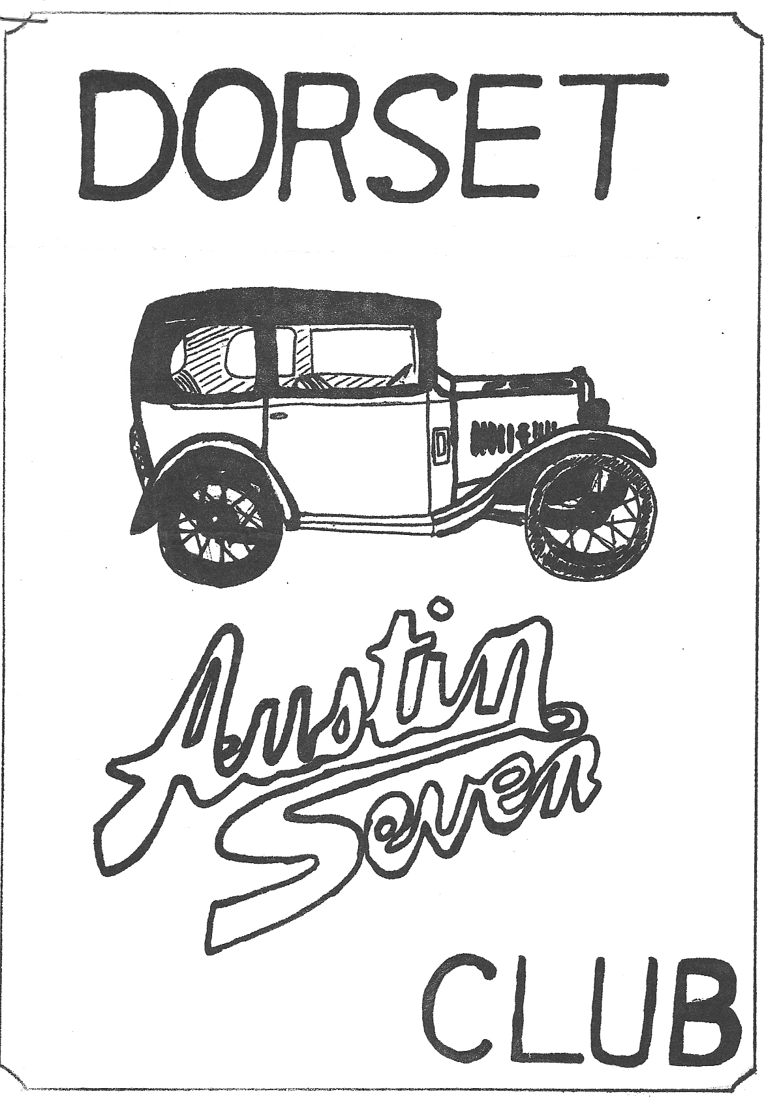
MARCH 1981 DORSET AUSTIN SEVEN CLUB NEWSLETTER

MARCH CLUB NIGHT Thursday 19th March at The Nags Head Ringwood. A7 parts failures, bring in your broken bits etc. Also, Gramophone evening, if you have any period 78 r.p.m. records, or a gramophone, bring them along.
APRIL CLUB NIGHT Thursday 16th April at The Nags Head Ringwood Film Night bring any slides you have of rallies, runs or restorations etc.
NEXT COMMITTEE MEETING Thursday 30th April at the Nags Head Ringwood 8.30 p.m.

EDITORIAL
Hi Gang. I have not much news this month. The Barn Dance was a
great success, and was attended by about 40 people; and we are booking the hall and the caller again for next year.
I have got the Ruby back on the road again after a week’s overhaul, ready for the coming season. I have fitted new rings and an air filter to the carburettor in the hope that it will prolong
piston ring life. I took an axle into Turners of Old Bridge Road
Iford, who closed the King Pin eyes for me for £4 + vat. You have to reamer them back to 1/2 inch yourself though. See you on the March Hare Run.
Glyn

NEW MEMBERS
A warm welcome to two new members this month: _
Keith and Heather Roach, Whitemoor Lane, Ower
Mark Tudge 17, Strides Lane, Ringwood.

BERNIE’S BIT
We all gathered on Valentine’s day evening for the D.A.7 Club Barn Dance - well actually it was a square dance with a cockney caller
The turnout was very good with over 40 attending. The hall was decorated earlier in the day with various hearts on the walls and candles on the tables so the atmosphere was very good.
I must admit I didn’t get quite so confused as last year on the floor except when I was unfortunate enough to join the square with a certain committee member!
After having a break for the food and raffle (many thanks for all the prizes donated) the dancing went on to nearly midnight.
Our thanks go to John and Janet Stone for all the organization of the hall, food and caller, and to Phil Whitter and Jackie Cowley for setting up the hall.
All too soon it came to an end and hopefully we will do a similar event next year.
Bernard

LETTER TO THE EDITOR
Dear Glyn,
I have had made a chassis plate and a car No. plate for my Box saloon by Jim Blakely of 28, Tullymore Park Ballymena BT42 2AN
N. Ireland. They are very good copies, and the work is fast and
efficient, about 1 week return of post. They cost £1.25p. each +
14p. postage = £2.64p. which includes VAT. They are correct for
my 1932 Box Saloon and look very good but they are a little different from Ruby type but look good all the same.
Jim has a friend in Northern Ireland who has some Sevens for sale. He has sold 3 so far but still has the following:
1928 A7 Taylor 2 seater sports, pointed tail (immaculate)
1928 Brooklands replica
1930 Swallow with sliding roof (good condition)
1931 Single seater supercharged racing
193- Ulster
1933 Sports (a very nice car)
1937 Ruby. (good condition)
1929 Chummy (v.g.c.)
1929 Gordon England (v.g.c.)
He has other cars but has problems looking after them. Unfortunately, he bought them at high English prices over the past 4 years. His asking price is fairly high.
Richard Cowell

EVENTS REMINDER
SUNDAY 15th MARCH .... DA7C March Hare Run to Swanage Area. THURSDAY 19th MARCH .. Club night at The Nags Head Ringwood.
SUNDAY 5th APRIL DA7C .. New Late FOREST RUN and Pre-France meeting, all welcome, start at The Nags Head 12.30 p.m.
THURSDAY 16th APRIL .. Club Night at The Nags Head, Ringwood.
THURSDAY 16th APRIL .. Solent A7 Club French Trip.
SUNDAY 26th APRIL .. Daffodil Run. Dorset members wishing to join the run at Stockbridge meet at Ringwood Cattle Market Car park at 10 a.m., or at the Alise Lisle P.H. at 1 p.m.
SUNDAY 3rd MAY .. DA7C Visit to Brownsea Island meet at View Point top of Constitution Hill, Parkstone 10.30 a.m. Moderns accepted. Bring a picnic.
15th/16th/17th MAY Note change of venue .. DA7C Camping weekend at CHARMOUTH Dorset leaving lay-By just over bridge on Dorchester Road outside Wimborne at 6 p.m. on Friday 15th May. A run will be organised on Saturday for further details telephone John Page on Christchurch 473207.
THURSDAY 21st MAY .. Club night.
MONDAY 25th MAY .. GRAND TRANSPORT RALLY AND COUNTRY FAIR ask any committee member for entry forms and information.
SUNDAY MAY 31st DA7C Run to Cheddar. Leave Wimborne Square
9.15 a.m.

EVENTS CONTINUED
SUNDAY 7th JUNE SWA7C CALDICOT CASTLE RALLY
SATURDAY 13th JUNE DA7C Run to The Wagon & Horses at Lymington. Meet at The Cat & Fiddle, Hinton at 6.15 p.m.
SUNDAY 14th JUNE Museum in Action Day at the National Motor Museum, Beaulieu.
THURSDAY 18th JUNE Club Night.
SATURDAY 20th JUNE EDITORS BIRTHDAY
SUNDAY 21st JUNE BA7C Berkley Castle Rally.
WEDNESDAY 24th JUNE Little Gore Farm Evening Rally, Little
Gore Farm, Gore Road, New Milton.
SATURDAY 27th JUNE .... Solent A7 Club Bar-b-que.
SUNDAY 28th JUNE … National A7 Rally Beaulieu.
SATURDAY 4th JULY DA7C Evening Boat Trip to The Isle of Wight. Meet at The Gun, Keyhaven 7 p.m.

TRANSPORT RALLY AND COUNTRY FAYRE
PILFORD FARM, PILFORD, NR. WIMBORNE. BANK HOLIDAY MONDAY 25th MAY
Well, as the advertising says, this will be the biggest one day
show in the area. The Rotary Club of Ferndown are organising it
and the DA7C are running the complete transport section. This
means that we will need all the help we can get both on the day and the day before to get the site set up. In other words, on these two days YOUR CLUB NEEDS YOU for the biggest event we have handled since we started.
We have circularized sixteen car clubs at the present time and quite a few entries have been returned, although only four Austin
Sevens are entered so far and two of these are Gary's. Please
get your entries in as quickly as possible, it would be rather embarrassing if our turnout was low.
So far, the 23-acre field has been booked and the complete
ground plan set up. We will have the Spreadeagles Parachute Club, the Wessex Corps of Drums and a hot air Balloon as main arena
attractions together with the usual vehicle procession. These
will also be an all-day Gymkhana going on in two separate arenas. The Young Farmers Club are bringing along a variety of animals
for the children to look at. On top of all this there will also
be numerous Country Crafts exhibits, trade stands and of course a
Beer Tent. The car park at the moment will take 2,000 cars
without any overflow facilities and with a bit of luck and fine weather we are hoping for an estimated 6,000 plus attendance, especially after the media advertising has bitten.
As I have said before please bring along your cars and yourselves your club's reputation is at stake, especially mine as I suggested this to the Rotary Club as a money spinning project.
The proceeds of this event by the way will be going to the Disabled in our local area as this is the year of the Disabled Person.
See you all on the day,
Derek

HELP WANTED
Derek is looking for a narrow-gauge train layout to give children
rides at our Transport Rally at Pilford on Monday May 25th. Any information would be welcome.

In January 1935 "The Austin Magazine and Advocate" (price 4d.) ran a competition entitled "Are You a Good Detective?". A selection of the most amusing entries was published in the February issue, three of which are reproduced below.

That Petrol Tap
In February 1931, I became the proud owner of a Seven saloon, and about one week later I called for a friend and took him along for a run. The car ran without trouble for about 60 miles and we were both full of praise for her, when, without warning, the engine
petered out. After several unsuccessful attempts to start it, I
lifted the bonnet and found the carburettor was empty. I tapped on
the tank and that seemed to be empty also and yet I had put in four gallons at the start.
It was dark by this time and we were on the Yorkshire moors about two miles from the nearest garage, so pushed the car there and asked for three gallons of petrol. She took just two gallons
and then overflowed; so we had not been short of petrol. Then I
decided to look at the petrol tap, which on this model was a cock
under the dash on the passenger's side. It was off. My friend,
unaware of its location, had pushed it off with his foot.

Bump to Stop
We had taken delivery of a new "Baby" Austin (our second) on
September 1st 1930. About the middle of the month we took a
friend out for a run, hoping, incidentally, to impress her with
the marvels of our new car. We were gaily sailing along in the
beautiful country of Derbyshire, when the engine stopped.
An examination followed. Petrol was there in plenty; moreover,
a touch on the electric starter and the engine was humming as
smoothly as could be. We restarted and in a few hundred yards the
car stopped again due to engine failure. Again, we restarted easily,
only to go through the same experience. On a third stopping we
felt that a close examination was necessary.
Then I remembered that the involuntary stopping occurred when we went over a bump in the road, and this set me looking at wire
connections. In a short time I discovered that the screw which
kept in position the high tension wire from the distributor coil
was missing. Thus every time the car bounced, the wire was jerked
out of its socket, the engine stopped, but the wire returned to its place as the car came to a halt.
We soon secured the wire with an ordinary paper clip, and all was well for the rest of the journey.

Find the Rattle
A couple of months ago, after I had covered about 12,000 miles in my 1934 Austin Seven, a very annoying rattle developed which seemed to come from all sorts of places under the car only on acceleration or at speeds of over 20 m.p.h. I spent hours trying to locate the trouble but without success. I went over all the bolts and nuts on the chassis, thinking it might be a loose washer, but they were O.K. I oiled and then taped-up all the control-rod joints so as to prevent any undue play, but still the rattle persisted.
I gave the two washers on the scuttle-dash a turn so that the throttle and starter wires were not rubbing against the metal frame where the washers had worn through; I thoroughly greased the inner rim of the bonnet with tallow; but all to no effect.
At last, while giving a veteran motorist friend a lift one day, he listened carefully to the rattle for a few minutes and then said "Starting handle".
It seems that at certain engine speeds the starting handle grip
spun round violently on its spindle to cause the noise. A few
drops of oil worked into the handle-grip from both ends solved the problem.
Sent in by Richard & Margaret Cressey

Around Europe in An Austin 7 Final Part - The Return Trip

We left the South of France at ten o'clock, after filling up with petrol to prepare ourselves for the 220 mile trip up to Lyon
which we hoped to arrive at before dark.
The first forty miles were spent on an atrocious 'D' road through bleak 'Spaghetti Western' type hills, then the road surface improved as we approached Grenoble and we crossed the so-called French Alps, which consisted of a very slow climb with a tremendous head wind followed by an extremely long decent behind a petrol
tanker which, by the time we reached the bottom was almost alight. Its rear brakes got so hot, we could hardly see through the trailing smoke.
On the other side of Grenoble, the terrain flattened out considerably, and we were confident We had finally seen the last mountains of the trip. With some twenty miles to go to Lyon it began to get dark, I was exhausted and the motorway which we were on was packed solid, so I decided to pull off, and try to find a campsite. Some hope - finally in desperation we decided to pull into an empty field and set up camp hidden behind a clump of trees. The whole evening we were watched by someone peering out of a distant window, but I was too tired to care.
We arose early before we were caught, but unfortunately just as
I was priming the carburettor to leave, a Police car turned into the field. My heart sank; I hurriedly flooded the carb and explained that we had just broken down, they had a good lock round the car and astonishingly then bade us farewell. Somewhat relieved we drove away feeling that we had got off rather lightly.
We spent the day on excellent roads and after a couple of hundred miles found a campsite which was full of fairground people, so we drove on a further 10 miles and found a lovely national campsite in which we were the only people!
We left the next morning in fog hoping to drive to the outskirts of Paris some one hundred miles away, camp and spend the afternoon sightseeing.
At four o'clock in the afternoon and a hundred miles past Paris we finally found the first campsite we had seen all day! We decided therefore to revise our plans and take the train back to Paris the following day and spend the day sightseeing. We would then drive the remaining 50 miles to the ferry in time for the night crossing. We did this, and after an enjoyable day using public transport for a change, we arrived at Le Havre three hours early for the ferry at 8 p.m. We had a very good three course meal on the boat and arrived home on Monday morning at 8.30 a.m. before anybody was even up.
We had had a marvelous time, the weather had been superb with only 1 hour’s rain over the entire two weeks, and our biggest and only problem over the entire 2,292 miles was a punctured tyre. I really will have to get myself a more reliable car.
Gary

WANTED
Does anyone have an old crankcase, any year, any condition, as long as the top half of the flywheel clutch housing is O.K. Wanted to weld to another engine.
FOR SALE
Ash Wood suitable for car frame building approx. size 6ft x 2" x 2" about £2 per length. RICHARD COWELL, 10, The Laurels, Mead Park, Gillingham 4102
FOR SALE - 1936 Ruby (complete except for body) ideal basis for RTC Special. Phil Edwards, 7, Copse Road, Burley. Tel. Burley 2441 or Southampton 23855 Ext.442/3
EXCHANGE
- 1931 chassis, pre-coupled brake type. Screw-in torque tube back axle. Radiator core and surround. Petrol tank. Short
steering box. Front and rear wings. Five "Austin" centred wheels. All to fit 1930/31 Chummy. Log Book, registered at D.V.L.C.
- Ruby chassis, front and rear axles. Four 19" wheels. Gear
box. Steering box. Swallow windscreen. Log book. Suitable for Special.
- 1934 Ruby. Beige body and interior. Log book. Straight
forward restoration job.
ALL OR ANY ONE OF THE ABOVE (depending on condition) FOR -
1933/34 Chrome Rad. open tourer. Any condition - just body and
chassis will do. Cash adjustment either way. R.J. Cressey, Old School House, Charlton Horethorne, Nr. Sherborne, Dorset. (Tel. Hazelbury Bryan 225 during working hours.)

