MARCH 1977
DORSET AUSTIN SEVEN CLUB

SECRETARIAL We are publishing a little earlier this month as our printer is going to America - looking for Bantams, no doubt!
Gary Munn's box is now going faster - the valve timing was out. Peter Treliving's Ruby is now a glossy red and Willie McKenzie has at last found a car - a '34 box in pieces.
Many thanks to Margaret and Richard Cowell for a very entertaining competition at our last club night. I think we made a couple of pounds for the club.
I thought I would mention again two events. Firstly, Motorcade 77 at Breamore House near Fordingbridge on Sunday 10th July. I think it will be worthwhile running an Austin 7 section at this rally and autojumble. Anyone wishing to enter and/or help on the day, please contact Bernard. Secondly, the Daffodil Run on the 17th April. If anyone is interested in joining me on the run up to Maidenhead I think a suitable meeting place would be the lay-by on entering Ringwood at 5.45 - 6.00 a.m. Please let me know. Whilst we are on the subject of events, the North Devon Run has been cancelled (4/5th June), also I have been notified of an event called the Glorious Cavalcade of Historical Transport at the Biggin Hill Air Fair on the 14/15th May - I hope to have entry forms at next clubnight.
NEXT CLUBNIGHT - 17th March, Nags Head, Ringwood. 8 p.m. We hope to have a guest speaker – subject unknown at present.
TECHNICAL TIP
Coil Polarity by Roger Ballard
Regardless of the polarity of the chassis of a vehicle i.e. positive or negative earth, the polarity of the H.T. (high tension) of the coil should be negative, so that electron flow is from the tungsten centre electrode to the earth electrode.
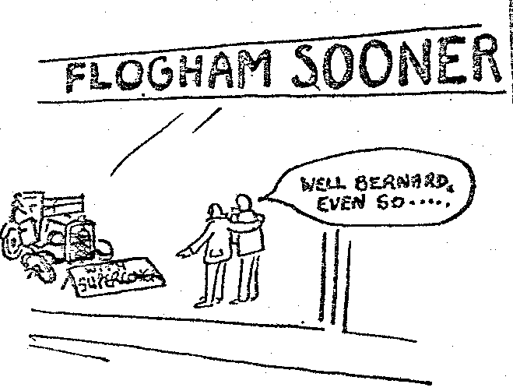
The H.T. polarity is governed by the polarity of the primary connections (S.W. and C.B.) on the coil.

If a coil designed for a positive earth system is used in a negative earth system and S.W. is connected to the ignition switch and C.B. to the contact breakers a positive spark will result. This can cause hard starting, misfiring during acceleration, short spark plug life and erosion of

the earth electrode.
This situation can easily occur if you use a Ruby coil on an early box or late Chummy with negative earth.
A simple method of checking that you have a negative spark at the plug is to remove the H.T. lead from the spark plug and with the engine running form a spark gap between the plug terminal and the H.T. cable. The point of a soft lead pencil should then be placed into the spark path. This will cause the spark to flare in the direction of the electron flow, towards the plug is correct, towards the cable is incorrect.
To correct the polarity simply reverse the L.T. connections on the coil. This also applies in more modern cars which are converted from positive earth to negative earth to facilitate the fitting of a radio, etc.
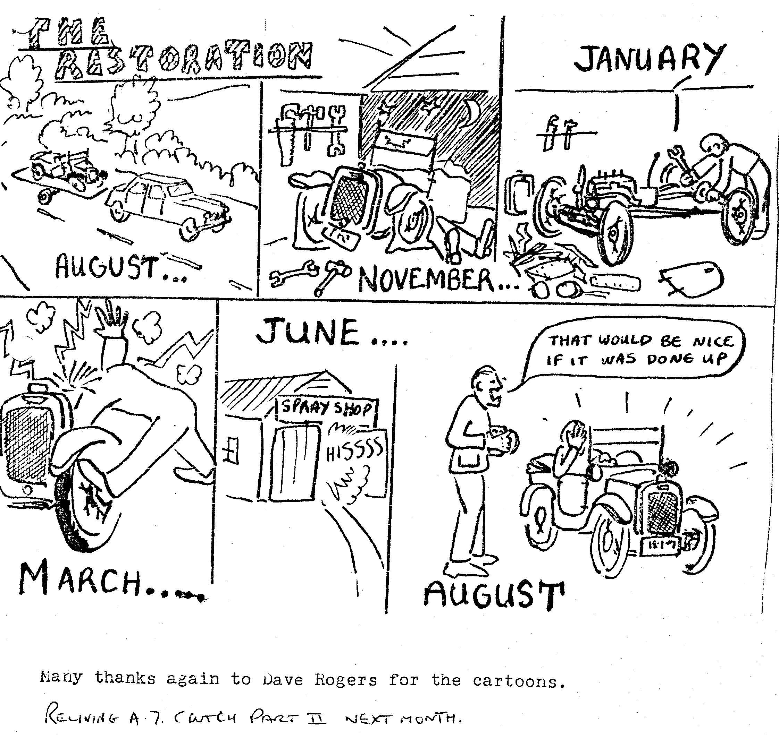

AUSTIN SEVEN
JUNE, 1935 113
Relining the Clutch
TO reline the Austin Seven clutch, it is first necessary to remove the gearbox as fully described in the March issue of The Austin Service Journal.
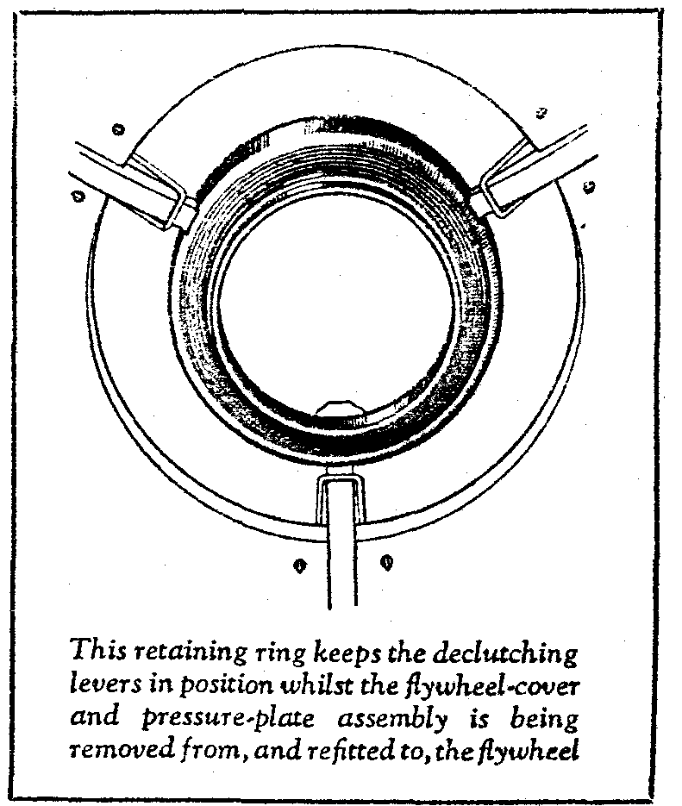
Assuming that the gearbox has been removed, the flywheel cover, secured by six setscrews, will be fully disclosed to allow the special retaining ring to be placed over the three declutching levers (see illustration). This prevents the small "mousetrap" springs from being strained by the pressure of the clutch springs as the flywheel cover setscrews are undone for dismounting the cover and pressure-plate assembly.

To remove the flywheel, which is necessary for relining, unscrew its securing nut while stopping it from rotating by placing a bolt in one of the holes in its periphery. Then the extractor, illustrated herewith, can be secured to the two tapped holes in the flywheel, which can then be pulled off its keyed taper by turning the centre screw of the tool.
To remove the declutching lever springs, place the clutch assembly (with declutching lever retainer in position) on the special jig as illustrated on page 99, and compress the assembly by the three clamping screws.
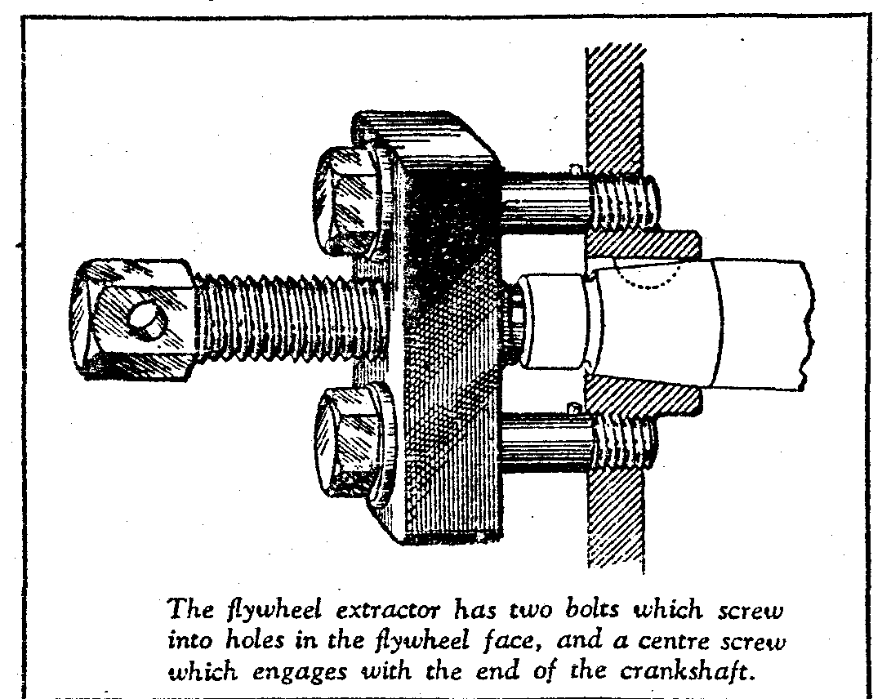
When released from the jig, the flywheel cover can be separated from the pressure-plate by threading the declutching levers through the holes in the cover. While the clutch is dismantled make quite sure that the declutching lever withdrawal pins are free in their holes in the flywheel cover; just a trace of oil on each will help in this respect. Both the pressure-plate and flywheel linings are held by twelve rivets all of which should be well below the working surfaces when fitted. Further, as the lining on the pressure-plate holds the declutching lever withdrawal pins in place, the pins must be in position before riveting up the new lining.

