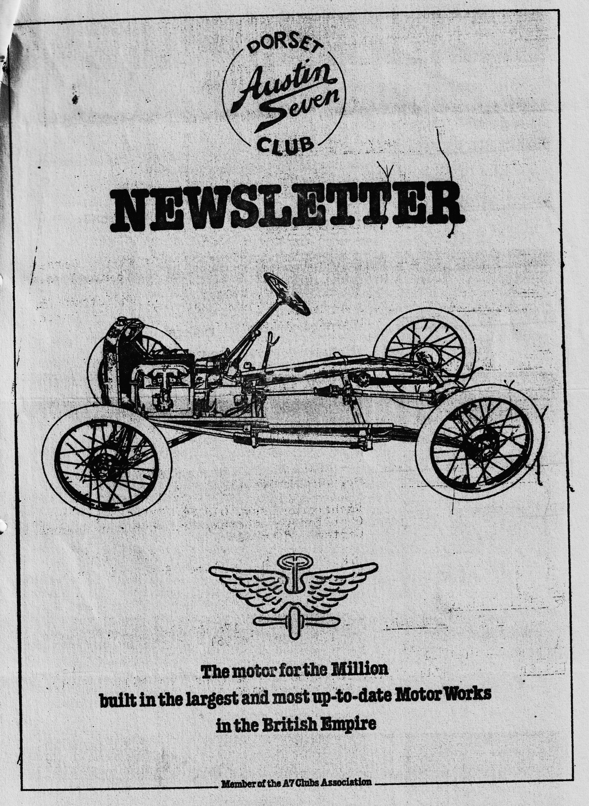

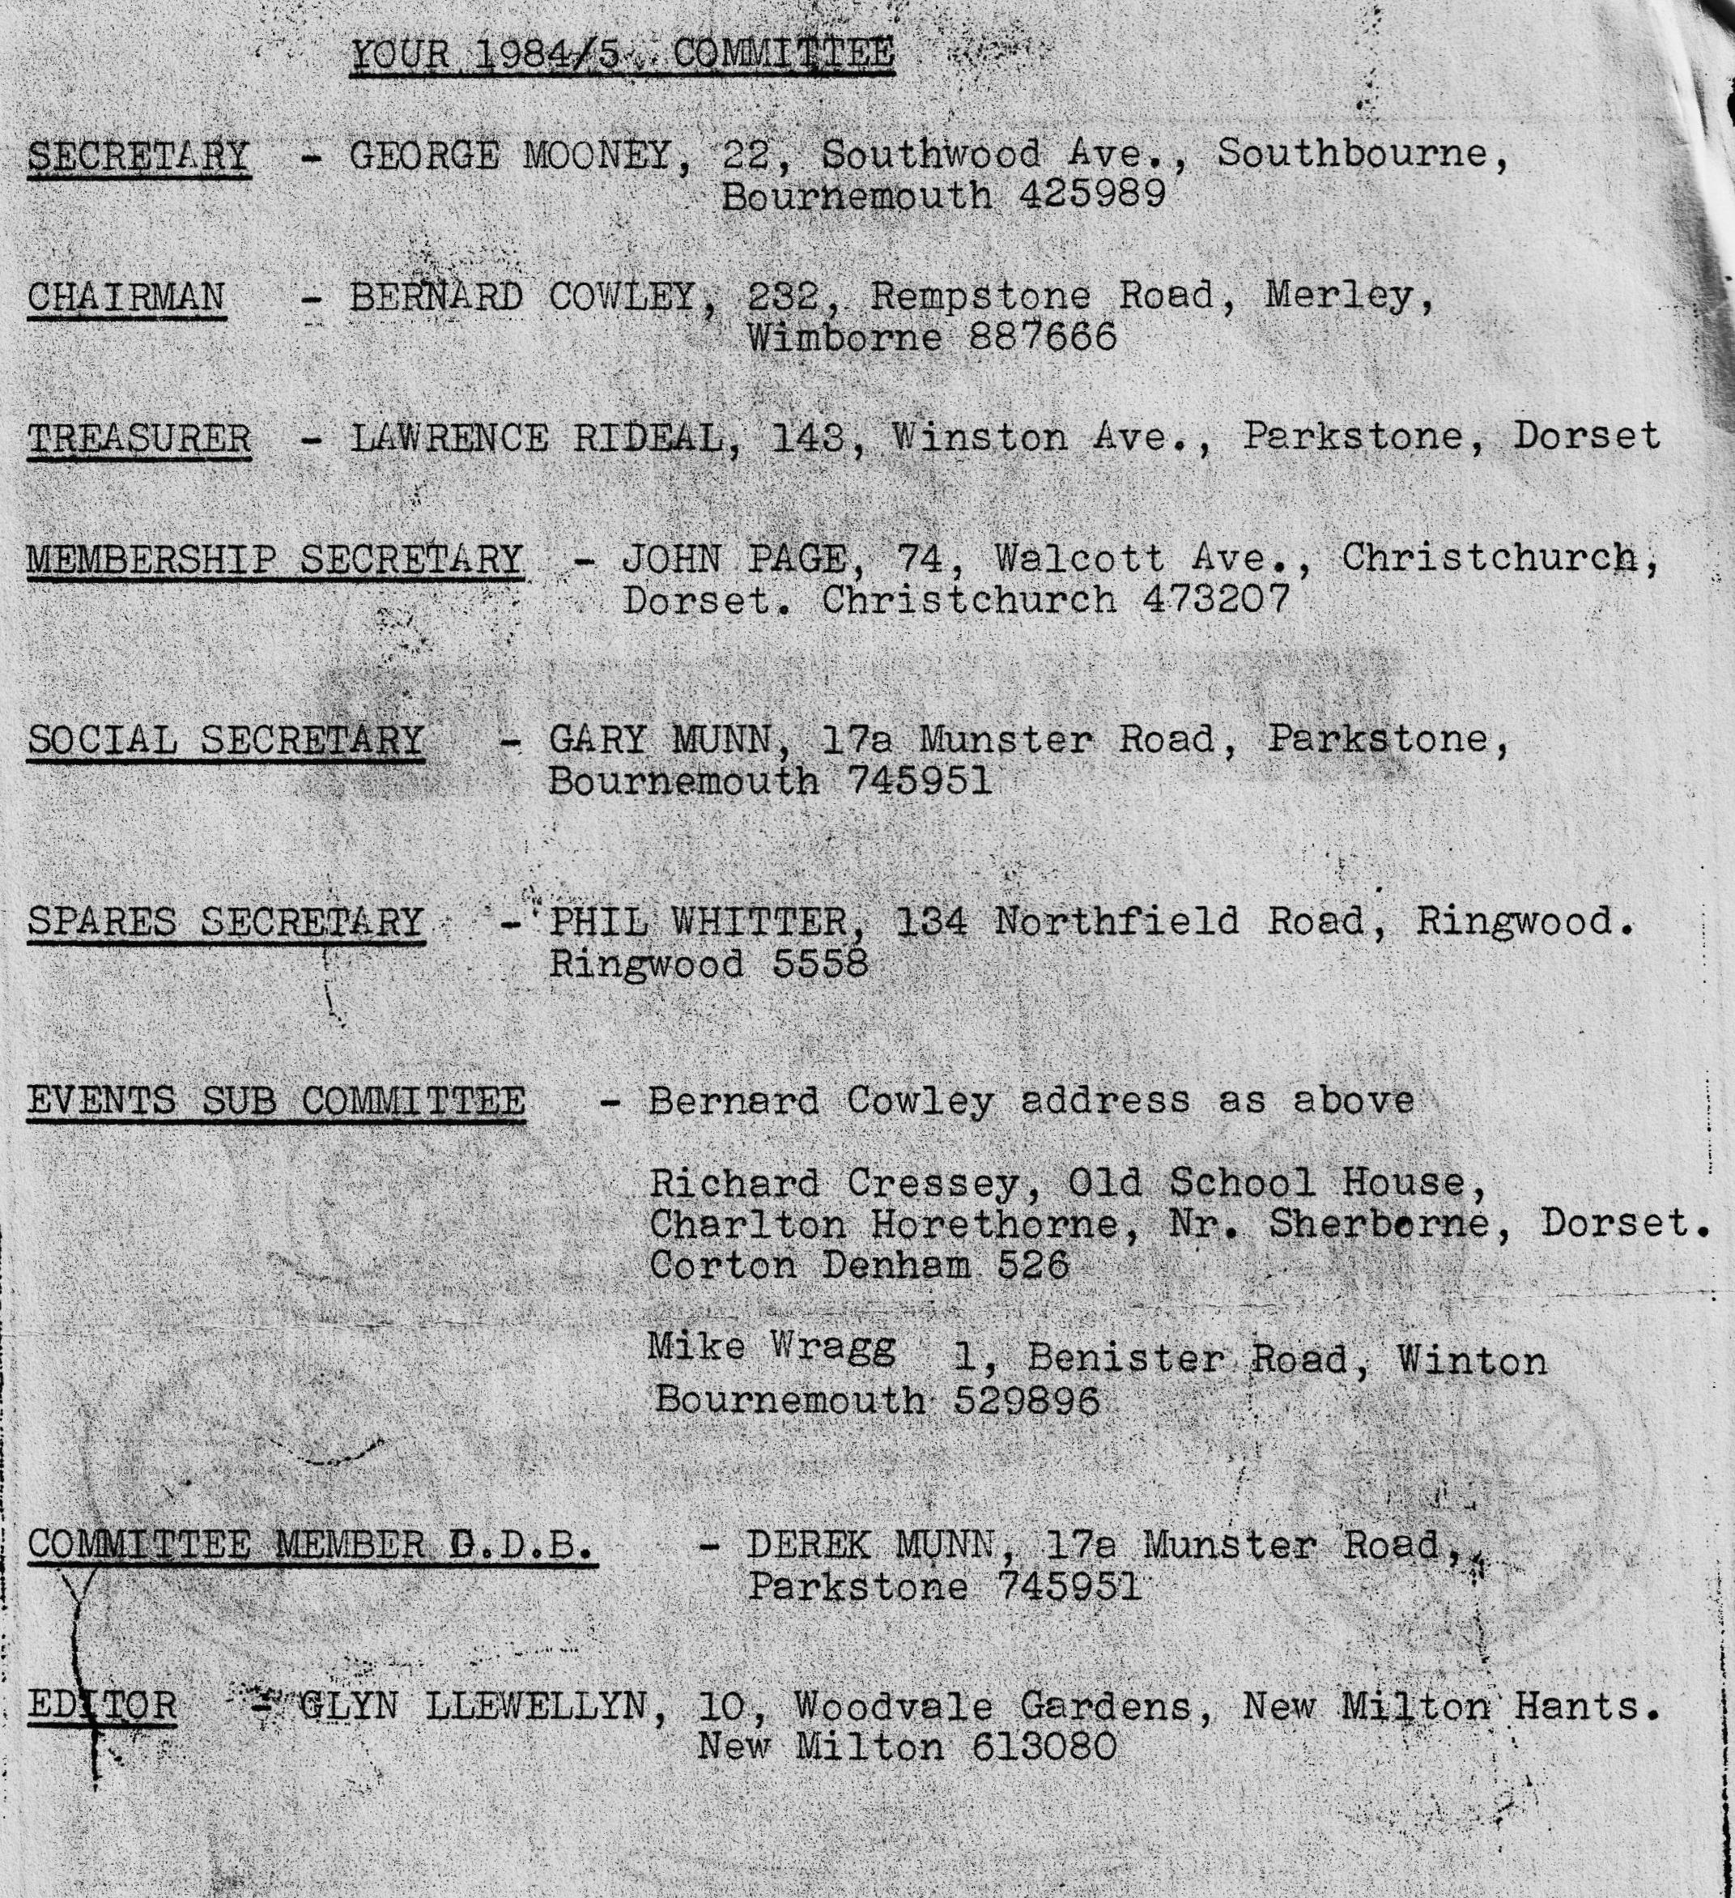

DORSET AUSTIN 7 CLUB NEWSLETTER MARCH 1985
CLUB NIGHT
THURSDAY 21st MARCH - A FILM AND TALK BY ROUND THE WORLD AUSTINEER TOM NEWSOME (YES THE MAN WHO TRIED TO GET THE RUBY DOWN THE SIDE OF HIS HOUSE ON A HOME MADE BRIDGE) TOM IS OVER HERE FROM AUSTRALIA AND HAS KINDLY AGREED TO COME ALONG AND TELL US ABOUT HIS JOURNEY THERE IN AN AUSTIN?. SO A GOOD TURN OUT PLEASE, SHOULD BE A GOOD NIGHT.
EDITORIAL
Hi Gang,
I have just dashed up from the garage after working furiously on the Ruby, trying to get her ready for the coming season. April is a bit doubtful, but I certainly hope to have her back on the road for May. By the time you get this newsletter, I should have the paintwork finished. It really is all go. When the Ruby is finished I have to rebuild the engine in the Special, start restoring the Opal and decorate the kitchen, no time to go to work!
The Barn dance was an even greater success this year, the band, called The Old Pull & Push were excellent, and very amusing, the leader stomping around in a war time German storm troopers uniform with a machine gun, shouting "Ve Haf Vays of making you dance"'. He also dressed up as a Vicar, and a Morris dancer, and of course our own intrepid Austin Morris Man put on his usual, excellent, and I might add, energetic display. Well done Phil, I don't know how many Philisan tablets that took, but I was sweating watching you. Many thanks to all those who put in such a lot of hard work to make the evening such a great success.
Our last committee meeting was held at the Bournemouth flying club at Hurn Airport, with a view to perhaps holding club meetings there, we were made very welcome and spent a pleasant couple of hours talking and enjoying their hospitality. It was decided however that it was not a practical proposition as we could not have a room on our own for talks, films etc.
I had a telephone call from Mary Clenaghan the other week. Mary said that although she does not drive, her daughter Fiona would like to learn to drive Jim's Tickford, and could Munwellyn's look over it, and get the car M.O.T.'d. This we did of course and duly showed Fiona the ropes on driving an Austin 7. We look forward to seeing Mary and Fiona whenever they can make it on our runs etc.
I understand that two of our members have not been too well of late, Richard Cressey of Charlton Horethorn and John Page of Christchurch I hope both of you are now 'on the mend'.
See you Club Night.
Glyn.
EVENTS CALENDAR
SUNDAY 31st MARCH - Club run to Army Flying Museum at Middle Wallop. Leave Ringwood Cattle Market Car Park at 10.45 a.m.
THURSDAY 28th MARCH - Committee meeting at The Tyrrells Ford, Avon.
SATURDAY 30th MARCH - Beaulieu Friends evening at the National Motor Museum. FILM NIGHT.
SUNDAY 14th APRIL - Daffodil Run organised -by The Bean Car Club.
THURSDAY 18th APRIL - Club night a talk by the Swanage Railway
SATURDAY 27th APRIL - Beaulieu Friends evening. Surprise Evening.
SUNDAY & MONDAY (BANK HOLIDAY) MAY 5th & 6th
A fete in the Salisbury area. Evening barn dance and road run. I hope to have details next month.
THURSDAY 16th MAY - Club night.
SATURDAY, SUNDAY, MONDAY 25th 26th 27th MAY Dorset Camping Weekend. Details - next month.
SUNDAY 2nd JUNE - Wollaton Park Autokarna P.W.A7C.

Life and Times of an Austin 7 owner 1964-75
To sell the special I put an ad in the Exchange & Mart and got a reply from the Hatfield area. I was living in north London at the time. The chap couldn’t or wouldn’t come to see the car so I had to drive it to, him. Luckily, he decided to buy it for the grand sum of £120. I think it must have known it was going to be sold for it really went well! After a break of a year a friend of mine who was trying to put a T.R.3 engine in a 7 told me about an A.7 van that he had sold to someone and they didn’t want it anymore and was going free. He had found it under a pile of coal behind a shop. It still had only one seat and a toolbox. It was residing about 5 miles away and had now been modified to 100 E Ford front seats and it didn’t go. Well we decided to pick it up at night and, you’ve guessed, it didn’t have any lights or M.O.T. or insurance - I don’t know how we got it back without being stopped. It was a very late A.7. being manufactured in 1939 the chassis No. was around the 293000 mark, it had rod brakes -to the rear and a big 7 rear axle. I painted it bright red and got it going but alas I wanted better things and I sold it for £20. I now had a gap from Austin 7's until one-day in 1969 I saw an ad in the Exchange & Mart for an A.7 for spares. This was the Saturday and it was still for sale. I was working in N. London and the car was in Southend on Sea 40 miles away. So that afternoon, without telling Jackie, I zoomed down there. The car was a non-runner with no radiator or headlights, had been damaged in the rear and all the tyres were u/s. He wanted £25 for it and after a haggle I bought it for £22.10s.0d. He also had 2 other rather nice cars for sale - a Riley Lynx tourer and an XK 120. The next problem was getting the car back home the 40 miles. Luckily my brother lived about 6 miles from Southend, so we decided to tow it to his home. A very precarious journey on a car that had been standing for a few years - luckily the brakes were working after a fashion. This of course is my famous? Box saloon which I completed just before the Longbridge rally of ‘72, but first back to 1970. The saloon was at my mother’s garage in North London and I was living at Romford about 20 miles away so it was a slow process but I had itchy feet and wanted a 7 to drive about in again. My brother had heard of one in Barton on Sea., I was told the engine was seized and a fiver was wanted 'for the car. I had been going to the Essex A.7. meetings and there I had met Mike Christy and he had a mini and a trailer. So one Saturday we drove down to Barton and picked the car up. The reg. no. was AMR 79 which is now owned by the Hoods of Bristol A.7.C. When I got it back Mike said I could buy an engine for a fiver. I checked the brakes and I was on the road. By this time, it was 1971 and I entered Beaulieu with it and also had an interview for a job in Bournemouth that weekend. Well I turned up in the Ruby and got the job!! It was a great car I did a few thousand miles in it all for a tenner When I moved down here I had a problem - 2 A.7s, Jackie’s car and the Company. car. The box was still with the body off as well! .It wasn't until early 72 that I had a house with a garage so unfortunately the Ruby was sold - at a profit of course!
The next problem was to re-assemble the box and bring it 130 miles to Bournemouth. Luckily the chassis and running gear were ready to assemble to the body so I had a week’s holiday to do it. I also had another problem - transporting it to Bournemouth! It was lucky a friend of mine had a V.W. pick up specially designed for A.7's. What I had to do was drive to London in Co. car, pick up the V.W., drive down, take pick up back the next night – simple! but no, things didn't work out that smoothly. First of all it didn't have a winch and V.W.s are high off the ground. Secondly it was absolutely tipping down and there was only me to load it. With a lot of consternation and thought I drove round to everyone I knew pleading with them to come out on a dark wet night to push an Austin 7 on a pick up! Eventually I had 2 or 3 helpers and we got it loaded. The next night when I took it back. I thought I would go to a 750 meeting at the Goat at Heartford Heath - not to be recommended. After a few drinks, then a drive of 120 miles at night - never again. So that just about brings us up to date. There were a few more A.7's which will be another story.
Bernard Cowley
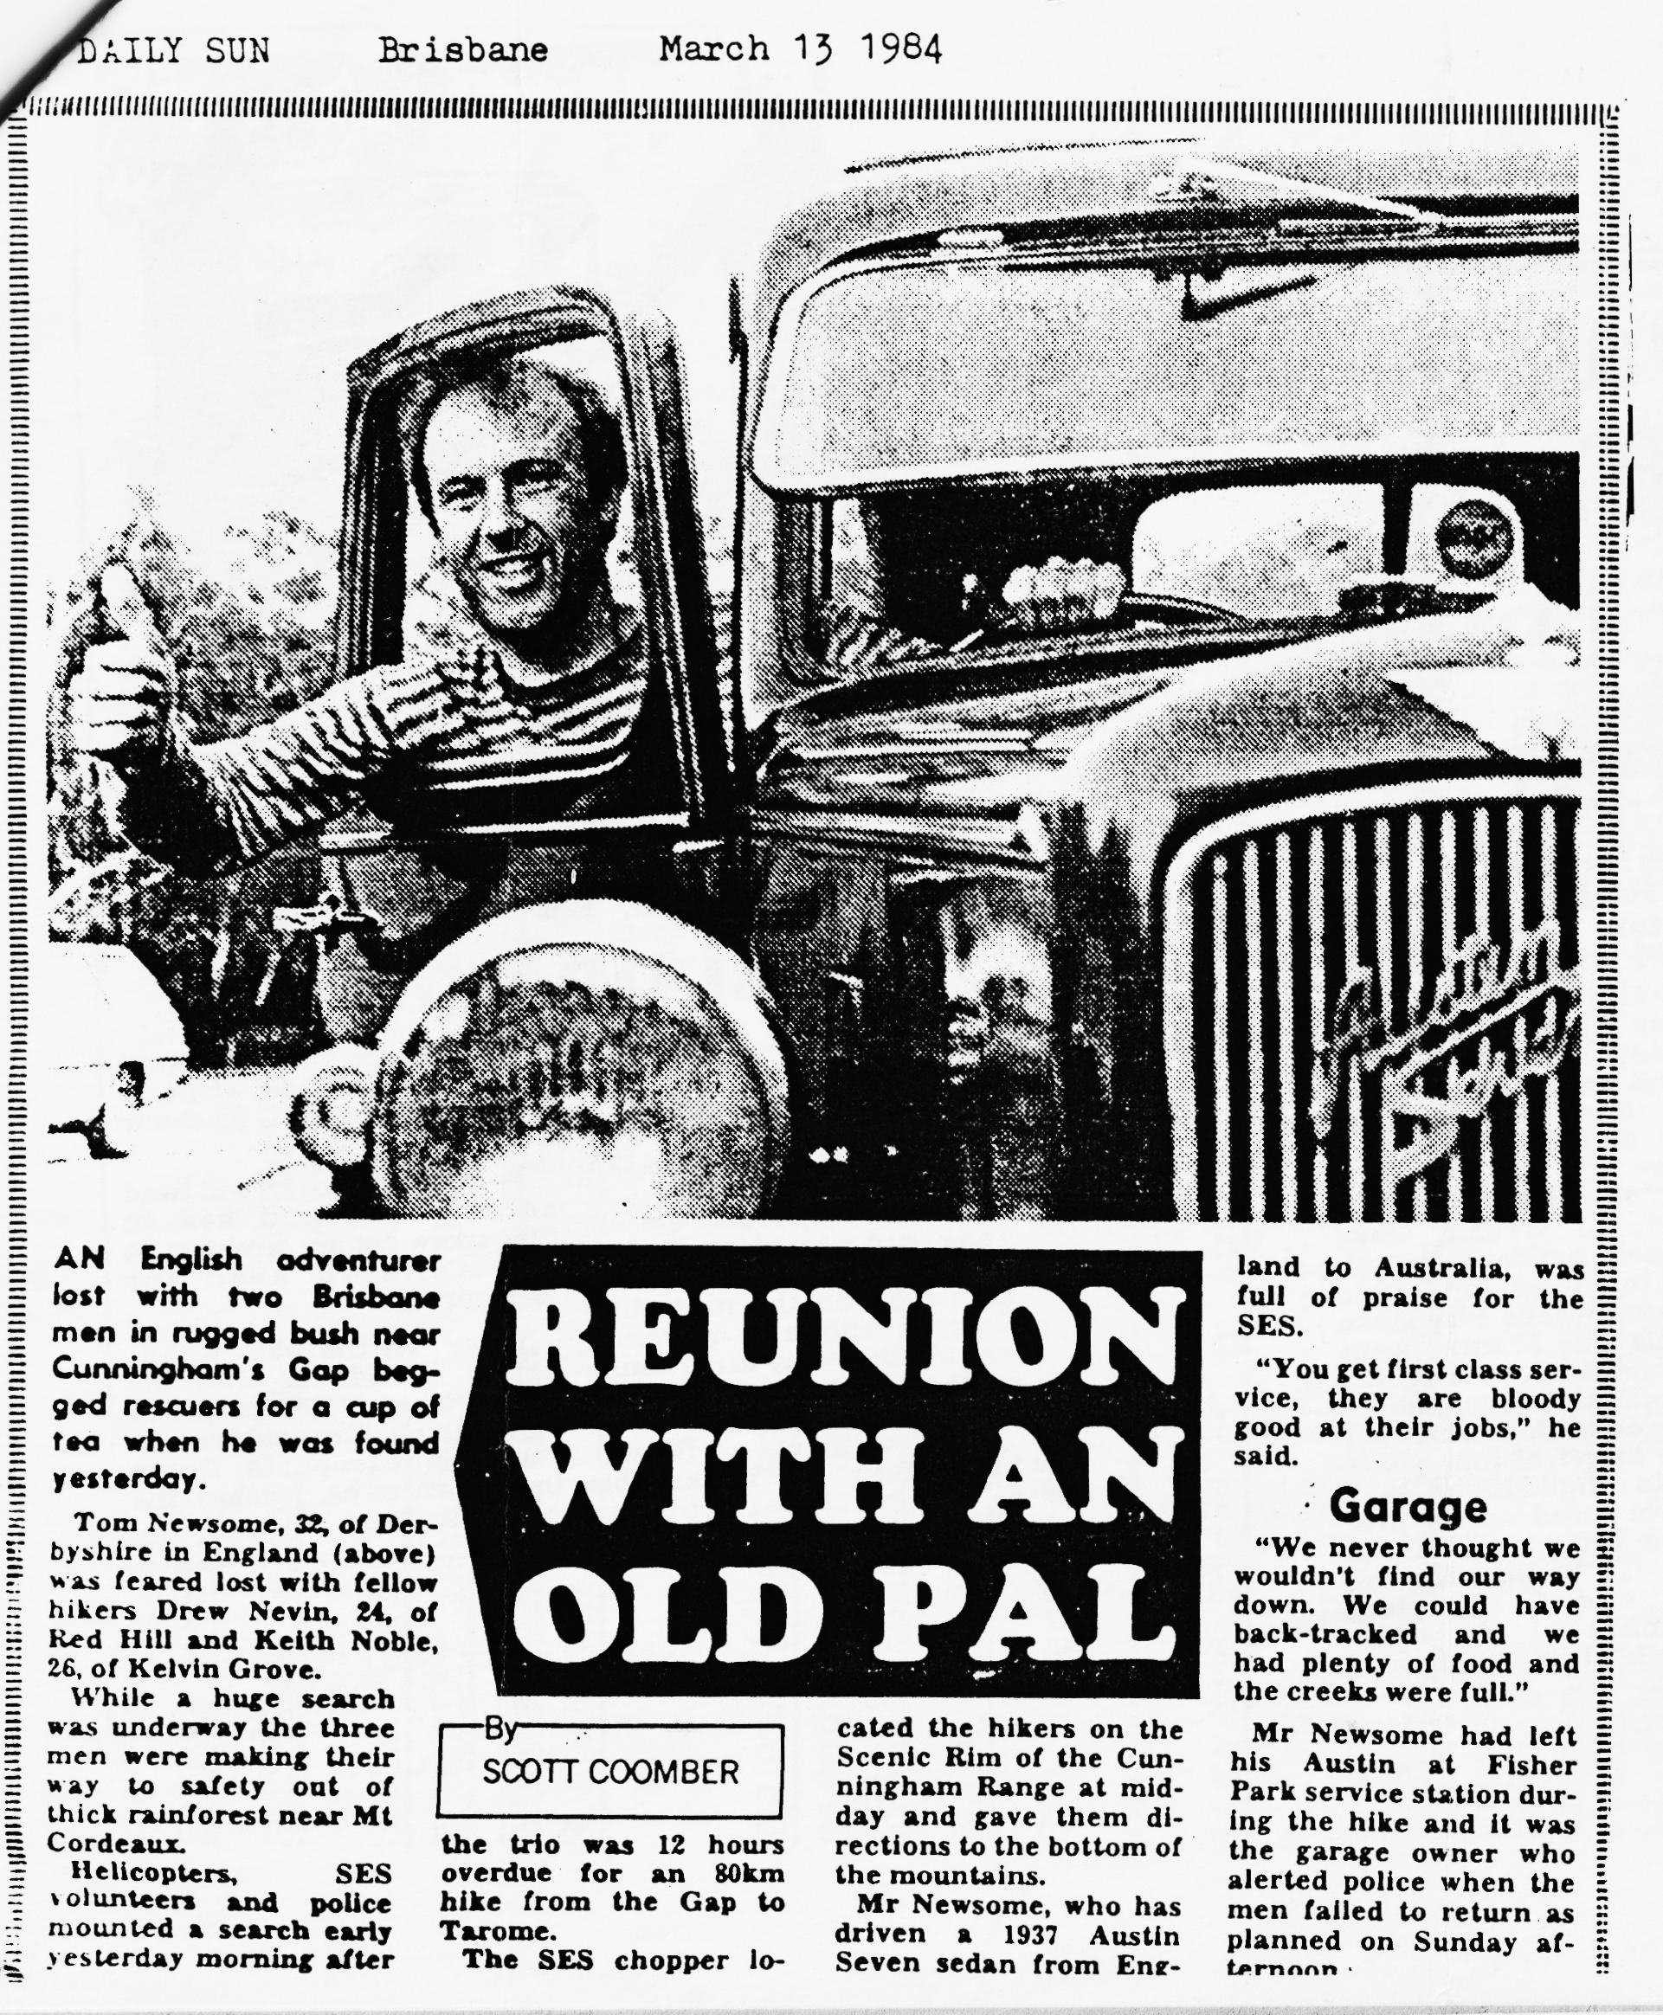
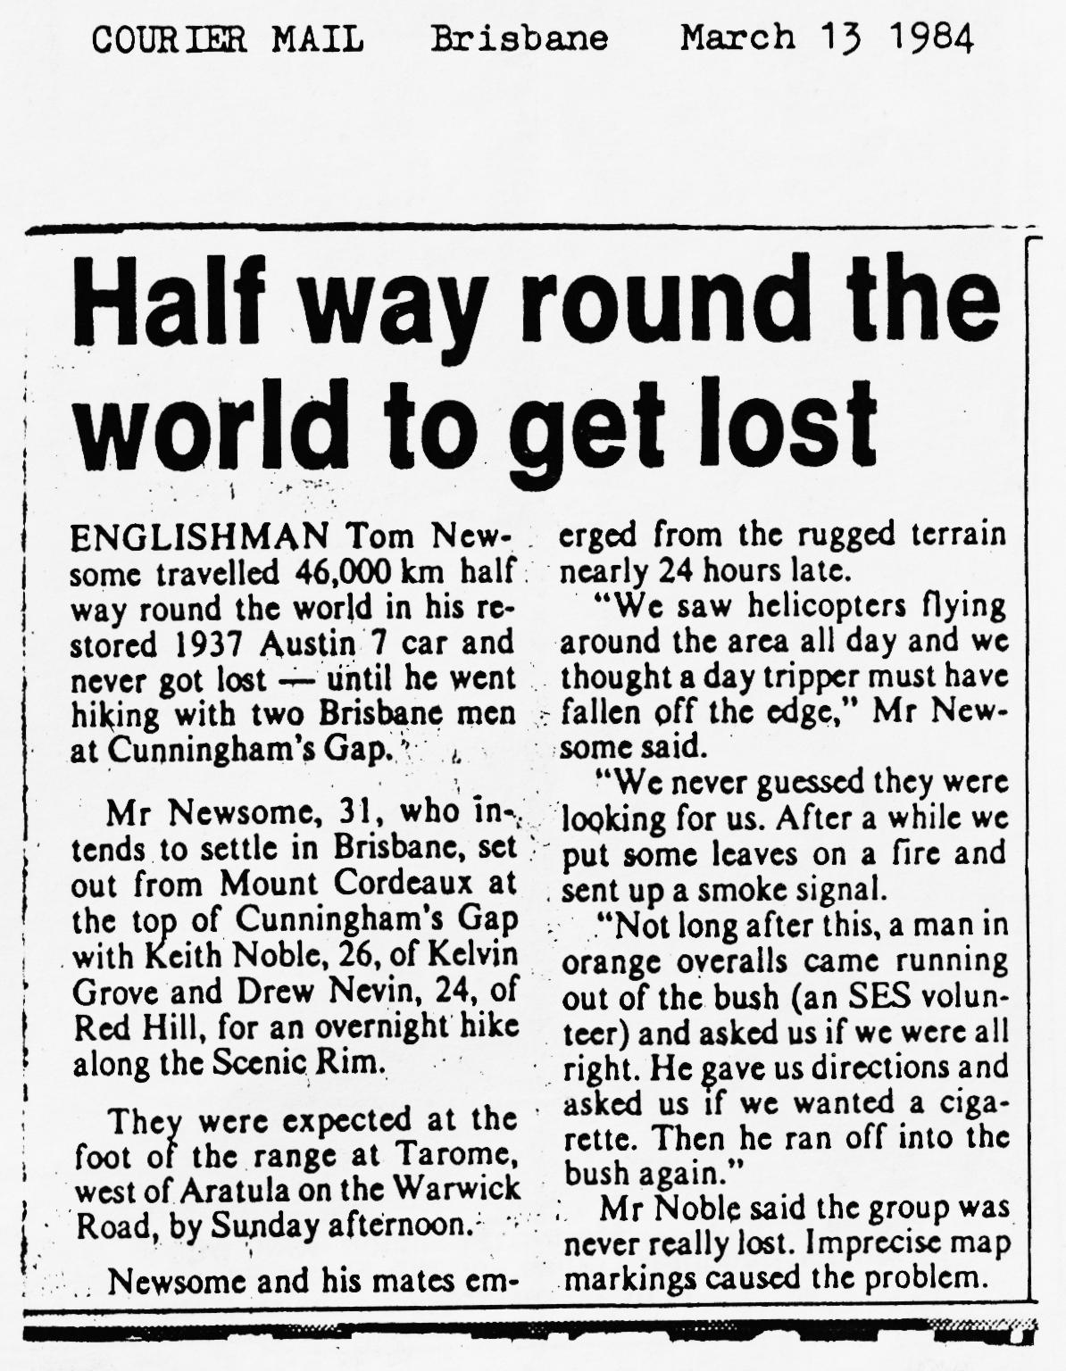
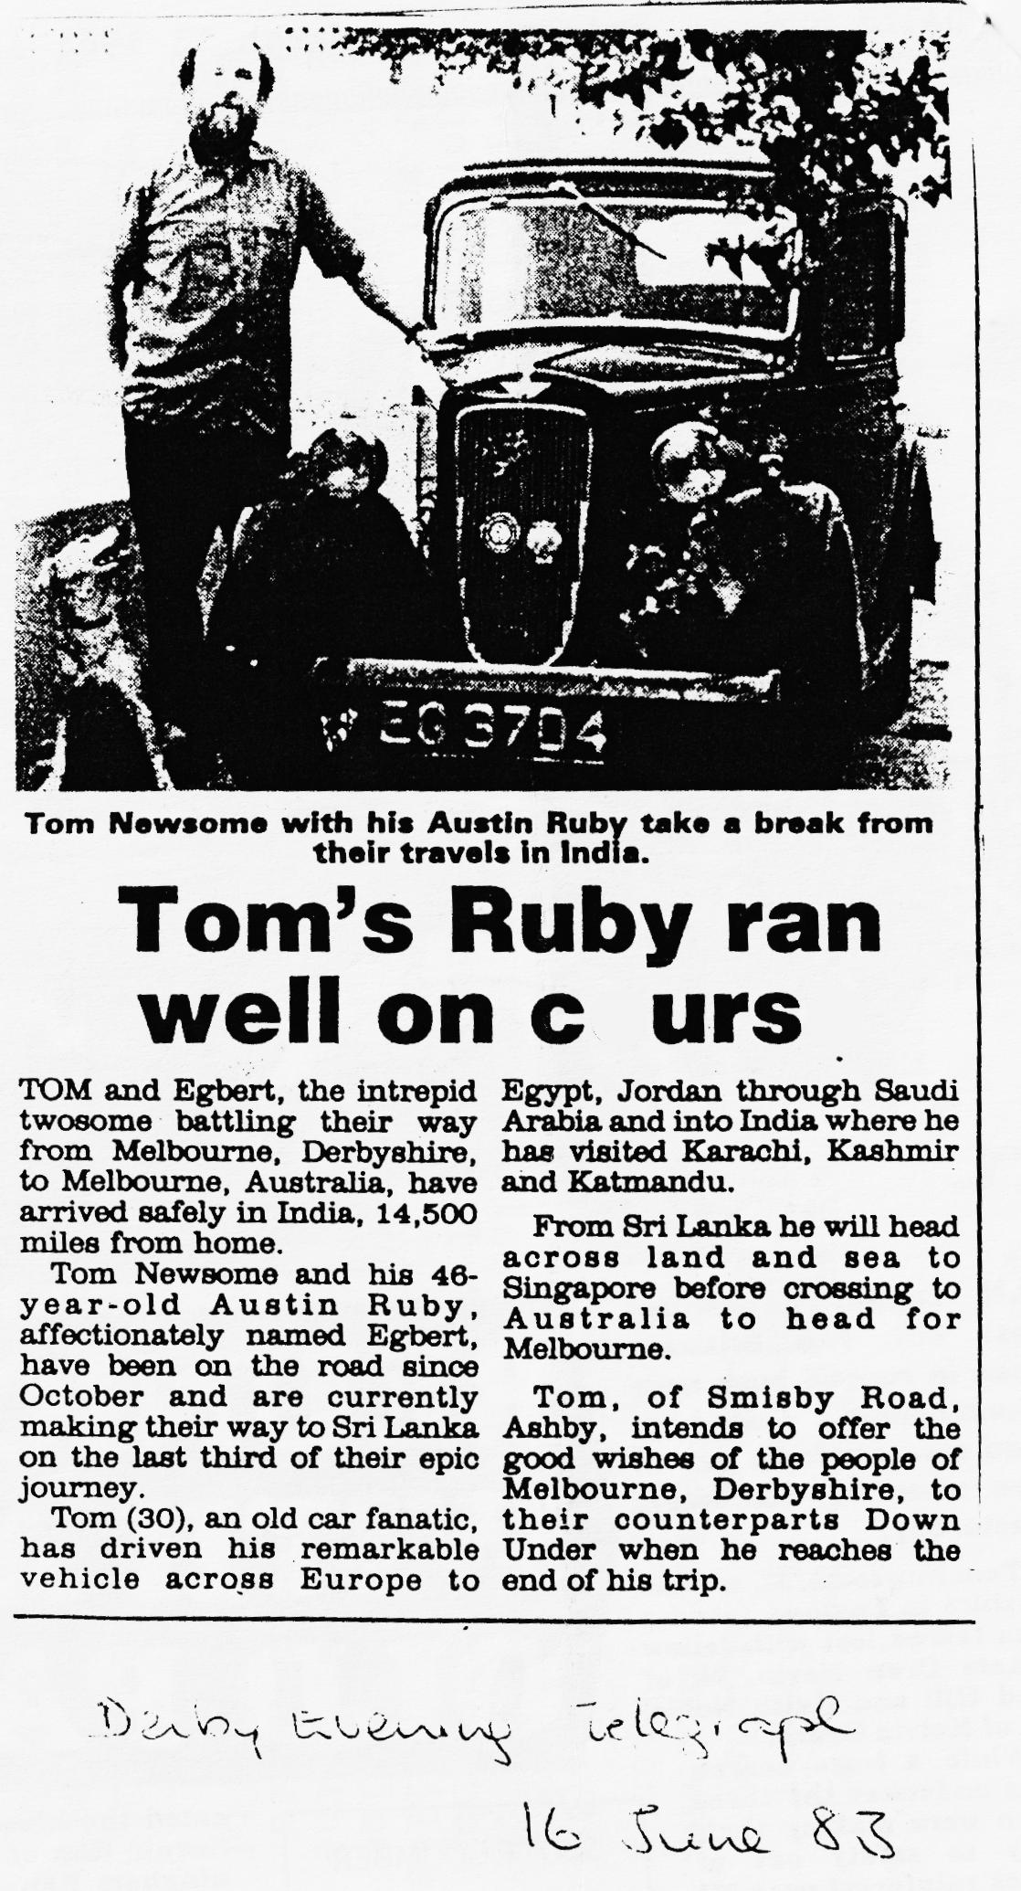
Secretarial March 1985
Hello out there, as I sit to write this my third secretarial of the year, I have to start without my February copy, I have put it somewhere but heaven knows where.
I note in the Midlands A7 Club newsletter that Brian Purves of Canterbury (63416) will build Ruby, braid covered wiring harnesses at £20 + postage. Brian will apparently make looms to fit anything, just as long as you provide the old loom. Sounds like a useful man to know about.
I note in the S.Wales newsletter that loads of original pistons and liners have been found in the Southampton area £4 the lot, I hope somebody buys them up and they become available to the clubs.
A good friend of mine, and I know he is an acquaintance to some of you, rang me last week. I couldn’t believe my ears. It was Tom the Pom! - Tom Newsome to those of you who don’t know him.
Tom set of from Melbourne Derbyshire October 1982 to drive to Melbourne Australia in his Austin Ruby 1936 model and he made it, getting there in November 1983. His adventures were terrific and mind boggling. The problems encountered and the way he overcame them are just fantastic to hear about.
He had fantastic help and encouragement from John Platts and Ian Dunford to keep him moving, even when he rang for parts from Saudi Arabia or somewhere thereabouts. He got all the way there then got lost in Australia in a rain forest.
The good news for you is that Tom is taking time out during his holiday break back here in Blighty to come and see the DORSETS and bring along some fantastic films for your entertainment. You will most probably never get this opportunity again, so don't miss out on this opportunity, come along, he would like to see 40 or 50 people to make the evening worthwhile.
Tom is driving down all the way from Lincoln to entertain us and in what else but an Austin Ruby on loan with thanks from John :Barlow.
This is a change of programme and the Swanage Railway people will be coming in April. Do come along tell your friends who might be interested, let’s make a:special effort for a rather special person.
That’s it from your secretary for this month see you club night.
All the best,
George Mooney

Salisbury - Woodhenge
We had the first touch of spring as we followed Bernard and family through the lanes towards Salisbury. Vic rode his 350 Triumph motorcycle, Gary & my family in boxes, and Glyn & Pat in their Opal. Also with us were Keith & Lesley Marriner and daughter Helen from the Midlands Austin 7 club, who were staying with Pat & Glyn for the weekend.
We arrived for dinner at the Wheatsheaf in Woodford, an unusual pub having a small stream running through the lounge. We were joined there by Roger and Rosemary Ballard and Edward in their Austin 10. After all being tempted by delicious puds loaded with calories and promising to re-start the diets next day, we left the pub and made our way to Woodhenge. Very little there except concrete posts in place of the original wooden ones, the idea being similar to Stonehenge. While the older members of the party sat on the ,posts enjoying the sunshine, the kids decided that these were great for a game of leapfrog.
As it was still such a lovely day, we stopped on the way home for a look around Salisbury Cathedral.
John Page

SERVICES
'MUNWELLYN'S for all Austin 7 mechanical and electrical repairs and restorations. Phone Gary on Poole 683848 or Glyn on Now Milton 613080.
BRAKE AND CLUTCH LININGS - Phone Bernard Cowley, Wimborne 887666 for 24 hour service. 8 shoes £16 Clutch linings £10.
REGARS ENGINEERING - Columbia Road, Bournemouth for Crankshaft regrinding and Con rod remetaling. Blocks rebored and general machining.
SHOT BLAST AND STOVE ENAMELLING - Spray Finishers, Nuffield Industrial Estate, Poole £35 for 5 A7 wheels (Cash) Mention the club.
UPHOLSTERY AND TRIMMING - Colin Morris, Bournemouth 524671 RADIATORS - Repairs or your radiator re-cored. Hants and Dorset Radiators 77, Stanley Road, Bournemouth 301277
RESPRAYS - George Mooney Bournemouth 425989
STARTERS & DYNAMOS - Overhauled P.A.MacCarty, 35, Warwick Rd. Boscombe Te1.421556 Mention Bernard Cowley or club.
FOR SALE
R.T.C. SPECIAL BODIES COMPLETE WITH WINGS £500 GORDON ENGLAND CUP BODIES £550 27 SERIES CHUMMIES £550 John Barlow 7, Larch Crescent, Chilwell, Beeston, Notts.
FOR SALE
ROUGH BOX SALOON PJS FERNDOWN 897268
WANTED
DOES ANYONE HAVE CHILD SIZE DA7C SWEATSHIRTS IN REASONABLY GOOD CONDITION THAT I COULD BUY. SIZE ISN'T REALLY IMPORTANT AS THE CHILDREN WILL EVENTUALLY GROW INTO THEM. MARGARET CRESSEY, OLD SCHOOL HOUSE, CHARLTON HORETHORNE. TEL. GORTON DENHAM 526

