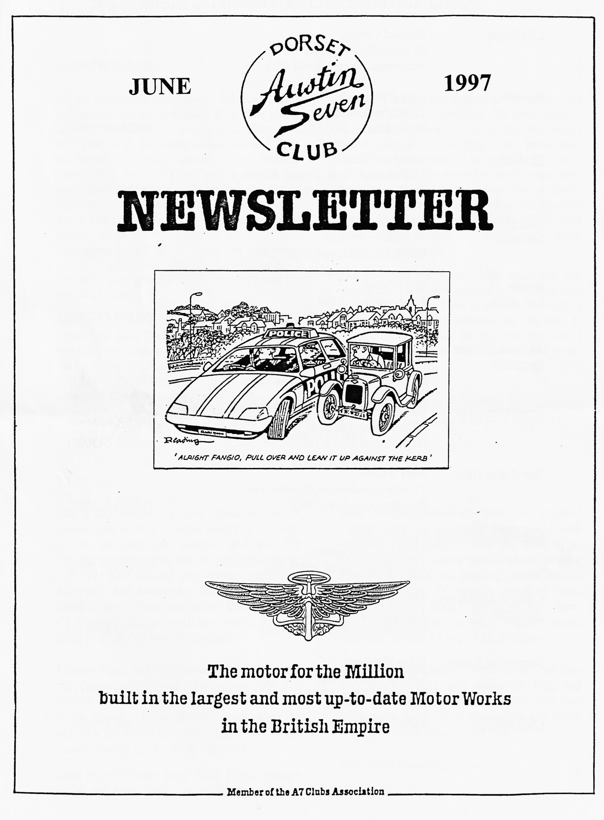

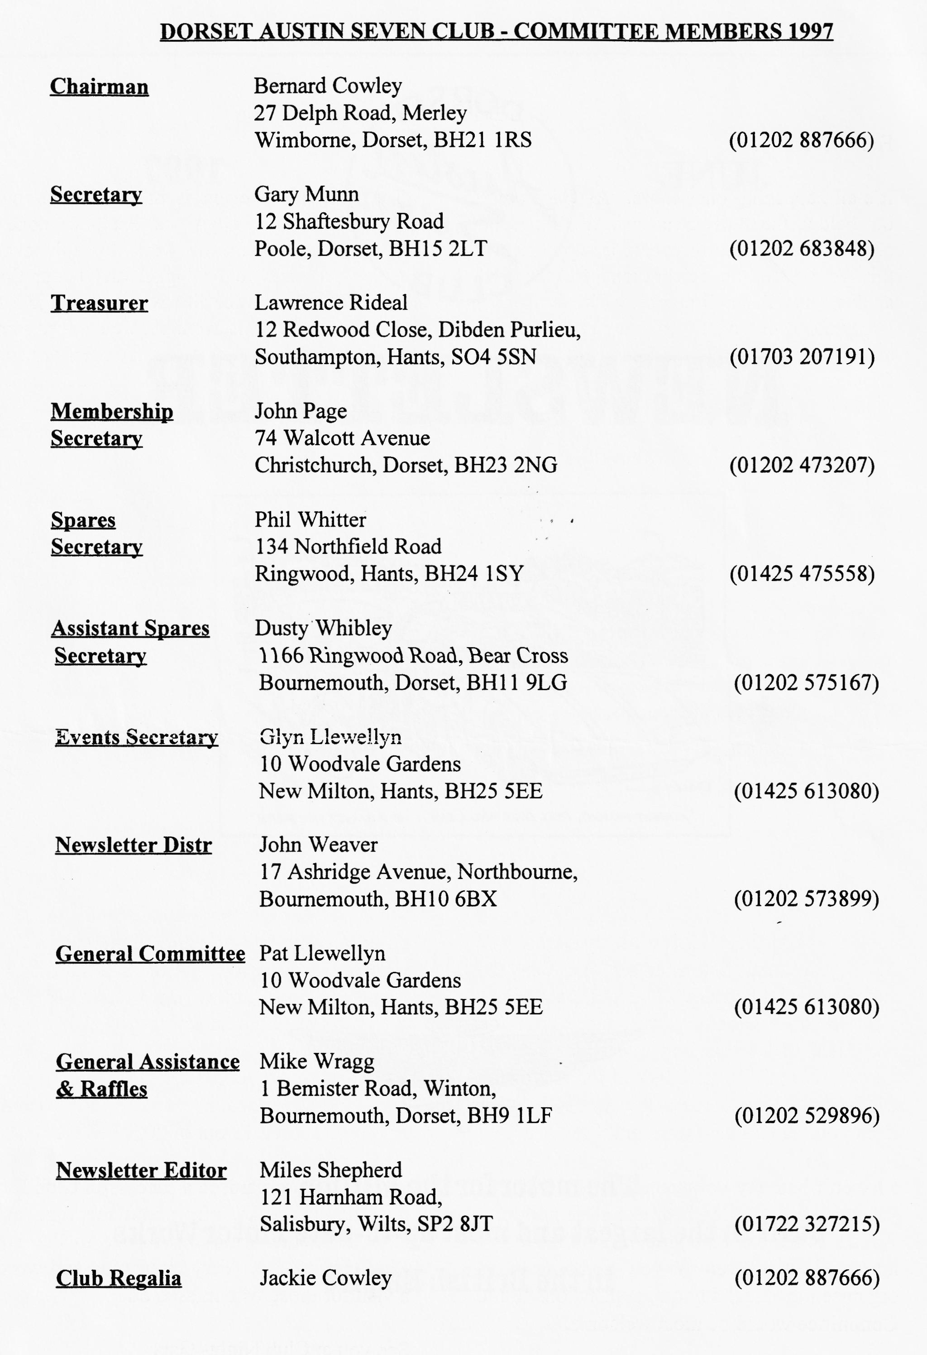

EDITORIAL
Hallo Everyone,
The next major event is of course, our own Swanage Rally. Glyn and Pat have done a tremendous amount of work for this event which promises to be bigger and better than ever. The Committee all have their own jobs to do in support of this event but we do need some help. Mostly we just need some pairs of hands for a few hours on the Saturday and Sunday. Rather like the old Army advert, YOUR club needs YOU! Please help if you can. More details are on page 2.
The post bag has been a little more full this month and I am very grateful to all those club members who have sent in stories. Not all of this will fit in this month so some will have to be held over. Don't let this put you off, I always need more so keep up the good work. See you at Club Night!
BFN, Miles
It's all happening once more. As Gary points out below, the Rally Season is in full; swing and the usual round of events is supplemented this year with the celebrations for the 57th anniversary. A small number of hardy Dorsets (sorry about that one!) took part in the JOGLE and a somewhat larger number made the trek to Gaydon for the main rally. I am very glad to report that Phil Whitter took the time during his holiday to pen some notes of the festivities. These appear on Page 3. If any one took some photos during their stay in the Midlands, I would be very grateful for the loan of some for the Newsletter.
Speaking of events, it is particularly pleasing to report that Spye Park will be taking place. If you have not entered yet, there is still time - see the back page for details. For those who are not camping at the venue, a convoy to Spye can be arranged. Contact me for details.
SECRETARIAL

Well, folks,
The Rally season is now upon us and a special one at that. I hope plenty of 7's will be on the road this summer and that the various special events will be well patronised. I'm sure that should you attend something enjoyable and interesting over the next few months, Hon Editor and indeed the rest of the Club would like to see a few words in print from you. Go on bear it in mind!
I haven't had any volunteers for Sunday runs yet, there must be loads of excellent pubs and venues out there that your committee don't know about. Even if you don't want to organise the actual day out, suggestions to the Committee would be most welcome.
John Page's "Feely Bag" Club Night seemed to go off very well. It really appeared to
bring members, especially new ones, together I must admit to not doing particularly well with the Feely Bags. After all, most of us bachelors don't know much about sewing machine bobbins and knitting needle storers but the Ladies, of course, excelled here. Many thanks to John Page for all his efforts and congratulations to tying winning teams who each scored 13 out of 20, I believe.
Glyn and Pat organised a successful Club Run over the Purbecks, pity about the fog„ and onto the Scott Arms and thence to the Toy Museum at Arne. Very interesting and worth a visit for those who missed out.
See you at Club Night- Gary

CLUB RUN TO THE TOY MUSEUM AT ARNE
Glyn and Pat organised the run to the Toy Museum at Arne, via the Scot Arms at Kingston which was well supported considering there were other runs on the same day. We had 4 Ulsters with Bob, Brian and Jean, Dusty and Jane plus Scott and Jo. Lawrence, Ben and Marion and John were in Box Saloons while Bernard and Jackie, and Phil and Hillary were in Chummies. Last but not least, the organisers were in their 1928 Fabric.
We set off from Wimborne, through the lanes to Sturminster Marshall, Bloxworth, Sleep, Lulworth and through thick fog over the Firing Ranges to Corfe Castle. Our route then took us up the steep winding hill to Kingston and Church. We have used this Pub for 20 years and have seen many changes of owners and styles. At the moment it is excellent, offering very good value for money. The view from the Pub across the valley to Corfe Castle is, of course, free and unique. After lunch we went to the Toy Museum and had our memories jogged of the toys we once owned. A wide variety of toys were on show, from dolls to Dinkies and boats and trains. The museum also has a workshop which renovates anything from a 19th century music box to vintage motorcycles. The owner was very happy to give us a conducted tour of his workshop. After tea and cakes we had a good walk across Arne nature reserve to the shore of Poole Harbour.
All in all, a very pleasant day
[I am very grateful to the author of this article but as it was unsigned, I am unable to tell you who so kindly put pen to paper! Many thanks Anon. Ed]
SWANAGE RALLY
Don't forget to send your entry form in to Pat for our annual rally at Swanage over the weekend of ll^{th} to 13th July. Can anyone spare an hour or so on any of the days to help? We need marshals to show exhibitors where to park, we also need help for Phil Whiner to keep an eye on the toilets, to make sure they are clean. Dusty needs some assistance with organising the campers. If you can spate even just an hour it would be a help. Let Pat know at Club Night or phone 01425 613080 or speak to any Committee Member.
Thanks, and have a great Rally

75th Anniversary Rally, Gaydon
There are some "once in a lifetime" rallies that are worth visiting because of the sheer number and diversity of cars attending - and this was certainly one of them. Unfortunately for Hilary and me it clashed with a previously booked caravan holiday in the Derbyshire Peak District so the best we could manage was a look in en route to Derbyshire!
Following a previous All Austin Rally at the venue some five years ago where many of us suffered on a cold stark rally site and poor farm camping conditions, a lot of people were discouraged from attending - but this year, the on-site facilities were available for camping and caravanning, and landscaping had made some improvements, but it is still on top of a hill and very exposed!
But enough of the negatives and let’s look at the positive aspects. Saturday opened with bright weather, lively business in the autojumble and a steady stream of Austins of all shapes and sizes arriving to fill the Rally area. In the museum, Phil Baildon and Co had put on a superb show of Austin Seven related items including many unique and rare exhibits including period accessories, racing related items of interest and a fantastic display of handbooks and factory drawings and records. Adjacent to this, the cinema was showing period Austin films. The 75th Anniversary Theme was repeated in all the main access areas of the museum with the Science Museum prototype of 1922 forming the centrepiece of the display.
Sunday heralded a wonderful show of everything Austin from 7 to 20 and the sheer variety was mind boggling. The Dixi Club of Germany put on an excellent show of about 15 cars - sheer enthusiasm and support! The amazing thing was to see so many cars still in the car park at 6 p.m.! Even Monday retained a good show worth seeing.
Particular congratulations to Gordon and Biddy Brown who had each driven up in their cars and to many other Dorset members who made the worthwhile trip - and it was good to see our chairman's Chummy in the line-up complete with pictures of Dusty's Mud Run!
All in all a very big thank you to everyone who had taken part in the organisation of the rally. It was a super event, well worth visiting in spite of any reservations about the venue.
Regards, Phil Whitter
Afternote: The Rally received some interesting coverage in the national press. Did anyone see the half page article in the Daily Telegraph Motoring section on Saturday 31 May? I gather that there were more than 600 cars of various types and that the Dinner was particularly well supported. There was also a good take up for the chance to take a run on the Rover Test Track next door.

Remember the deal we had a couple of months ago when we bought the latest Austin 7 book? The distributors ave sent me a copy of their catalogue of motoring books which may be of interest to members. Bay View Books offer a range of books about vintage and classic cars. These fall into two main ranges: the Collectibles Series and the Original Series.
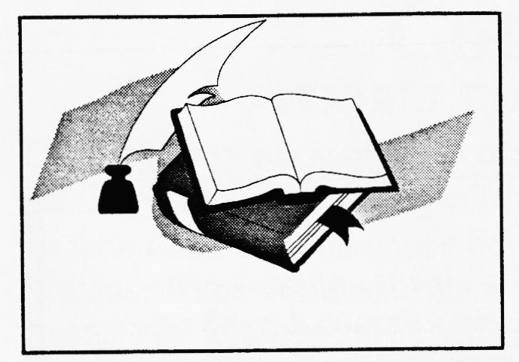
The Collectibles is just starting and there are two books covering MG and Jaguars respectively. The books are aimed at the marque enthusiast and cover models, sales catalogues, books and memorabilia such as badges, ties, post cards and so on. Books in this range cost about £20.
The Original series tries to present correct and precise information concerning a variety of cars and motorcycles. They are picture format, using specially commissioned colour photos so the chances are that you won't have seen the pictures before. The Austin Seven book, which was very well received, is typical. Other models covered include' the Vincent motorcycle, AC Ace & Cobra, Aston Martin DB4/5/6, Austin Healey 100, 100-6 and 3000, Ferrari V8, Corvette, plus 18 other Jaguar, MG and Land Rover models.
There is another series, the 'Essential' which covers more modern cars such as Minis, Ford Capris and TRs. The difference between this series and the 'Original' series is the size (slightly smaller) and number of pages (about 80 as opposed to 120). They also have the 'A - Z' series of compilations from The Automobile, covering Cars of the 20's, Cars of the 30's and so on up to the 80's. There are also books on works rally cars and sports cars. Prices vary from about £10 up to £25. If you would like to know more, see me at Club
POST CARD FROM LYDDEN HILL RACE CIRCUIT
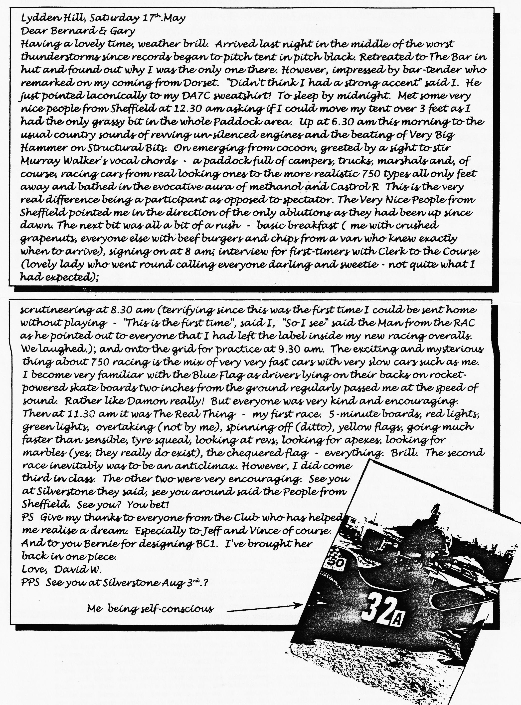

Competition Corner
Dave Whetton has started the sporting ball rolling with his post card from Lydden where he had his first competitive outing in his recently completed Special. I have hopes that he will provide us all with more information on how he constructed his vehicle and keep us up to date with his exploits. There has been a lot of motor sporting activity on the Austin front over the past few weeks. There was a very good turnout at a rather wet Wiscombe Park for the VSCC sprint meeting on 16 May. I didn't spot any Dorsets, either they were all at Beaulieu or I was too busy at my marshalling spot on the Essess.
Sports fans may recall that the Pre War Club run a championship exclusively for Austin Sevens in memory of Bert Hadley. The Championships consists of a number of events scattered up and down the country. Events range from sprints at venues such as Curborough, race meetings, sporting trials and hill climbs. The first round was a hill climb and it took place at Gurston Down, just outside Salisbury at the end of last month. Unfortunately, I was abroad at the time and could not get to the event. Geoff Roe, the organiser, wrote the following report of the event in the PreWar Magazine:

THE 1997 CAMPAIGN - PART 1 ROUND ONE saw eight drivers participate in our first visit to Gurston Down Hillclimb, near Salisbury. Situated at a working farm, the venue has been steadily developed over the years and efficiently administered by our hosts, B.A.R.0 (South West).
All the Sevens and drivers were in last year's series. As usual, Clive Neale and Julia Constinos had driven down from Northants in the Swallow Special, unchanged from last year and still extremely standard, i.e. 19" wheels, normal 1930 transmission. They are gathering bits for something more dramatic, but first have to build a motor-house for it.
Graham Beckett had his `cream' car as usual. This has a refurbished original Ulster bodyshell mounted on period running gear, so may be fairly described as "half genuine" (The original sports is now up in Scotland with a new body.) Reg Nice's car is `almost' genuine having been re-bodied some years ago but including some of the original parts onto the Ulster chassis and running gear owned by David Cope in the 1950s. This year it's in blown form with all correct period Cozette/Solex bits in place. Peter Pearson has changed the axle ratio on his immaculate Wragg based single seater (also blown but with a modern repro unit.) Mike Gilbert's low slung car now looks very svelte, thanks to a new bonnet and tail plus a repaint.
Although running with wings it's still in `track' trim. All the Sevens were put in one class so we had a 3rd supercharged car on hand, Mike Fitzmaurice's single seater, looking very purposeful with front mounted blower and sporting twin rears, running on methanol and blow-off valve adjusted to undisclosed heights, it was obviously a potential class winner.
Finally, we had Gary Clare's alloy bodied car, a simple and very effective P.V.T. Special, apparently unchanged.
The course is undulating countryside and is affected by ever changing patterns much like Harewood. Early practice runs were held in drizzle, but a cool breeze cleared this up and it remained dry, if `parky' for the day. The start actually runs downhill to the first left-hander and then climbs sharply before the next turn. The Sevens really enjoyed themselves and the venue was voted a hit. Fitzmaurice’s best time was 43.58 seconds which compare; well with 28.64 secs set by a 4-litn Pilbeam-Cosworth...
By our unique scoring system Reg Nice has 16.36 pints, Mike Fitzmaurice 13.9 Gary Clare 12.0, Mike Gilbert 11.0, Graham Beckett 10.87, Clive Neale 9.5, Pete] Pearson 9.4 and Julia Constantinos 8.12 We should be returning to Gurston in '98. ROUND 2 Oliver's Mount on May 5th what a wet bank holiday, so times were no spectacular. Stuart Riley was due to run
the formidable "D&S" but it blew up comprehensively at Cadwell so he is without a drive for a while. However, most of the Seven starters were returnees - Alan Fairless in his unchanged Ulsteroid, and Geoff Harrison (modified Ulster) also unchanged, in that the short winter had pie-eluded changing the original matching crank and rods for modern replacements.
A welcome newcomer to the ranks was Malcolm Parker, debuting the interesting Shorrock-blown "son of Mrs. JoJo" Road Special, which possesses torque of an un-Seven like nature.

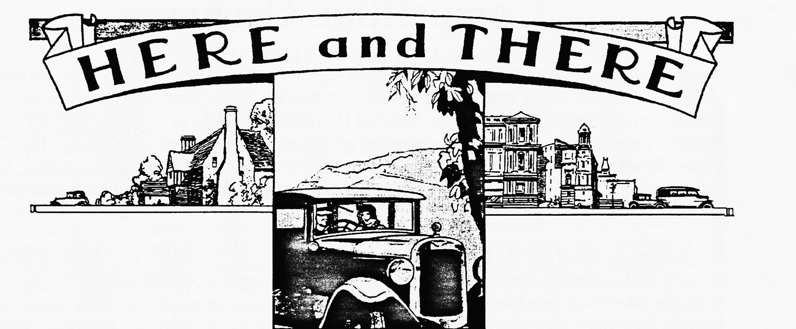
FOR SALE
Pair late Chummy front mudguards (V/G), SWB chassis frame, Box Saloon 0/S front mudguard, Ruby Mk 1 front mudguards, `Speedex' Ali body shell, Nippy headlights, 'Sports' front axle, 3 brg Sports cam, 14" race wheels, 16" rear wheel, Chummy/Ruby handbooks, lots more! PLUS Rare and interesting 1931 "Swallow Special" Attractive Ali body with Bumblebee tail, original Swallow cowl, lowered front axle, hydraulics, fold flat windscreen, nicely trimmed, V5, new MoT. Drive away in something different for £3,250- Ken Medlicott 01963 440604
WANTED
In any condition! Austin 7, 10, 12, 16 and 20 hp models and Austin based "Specials", abandoned projects, W.H.Y - Ken Medlicott, phone no above.
SERVICES
You may recall an excellent spring repair service in Poole, called Hawkins Springs. They were off Sterte Road, but have joined forces with Fenix Leaf Springs of Tiverton. It is possible to arrange collection & delivery via the old address by telephoning Fenix on 01363 866532. Fenix can repair many types of leaf spring including tapered leaves, pipped and slotted or clamped, they can build custom springs for vintage cars.
WELCOME to two new members! G. Rashleigh and J. Bishop both joined at least a month ago but I mislaid the note! On behalf of the members, welcome to the Dorset Austin Seven Club.

EVENTS
June
Thursday 19 June Clubnight. Bring your Car Night! Now that the evenings are almost as late as they get, this is an excellent chance to bring your car to Club Night. Rumour has it that the Editorial Chariot may be seen. Come to the Elm Tree and check it out.
Thursday 26 June Committee Meeting. This month's meeting is starting early - the Committee gather at 8.30 p.m. to ponder the events of the past month and plot those for the next.
July
Thursday 3 July Eight till Late. The Crowd will be meeting at the Manor, Parley Green at about 9 p.m. so why not have a pleasant evening among friends?
11 - 13 July Swanage Rally. Our own rally. See the enclosed entry form for further details.
Thursday 17 July Club Night at the Elm Tree. Wind Up Gramophone Night! Bring your gramophone and records. Phil will be acting as M.C. A night not to be missed.
Sunday 20 July Club Run. Richard Cressey's Run. Meet at the car park at the Queen Elizabeth Leisure Centre, Wimborne at 9.30 a.m or for the late risers, at Sturminster Newton Mill at 10.30 a.m.
Thursday 24 July Committee Meeting at the Tyrell's Ford. Another early start, your Committee assemble at 8.30 p.m.
Other Events
Sunday 22 June Spye Park Rally. This is one of the most enjoyable rallies on the circuit. Run by the Bristol Club, contact Trevor Turpin on 0125 864934 if you want to come along. Many Dorsets make a weekend of it and take in the well-known barn Dance on the Saturday and camp over night before the rally proper on the Sunday.
Sunday 29 June Michael Sedgewick Run. Organised by the National Motor Museum, Beaulieu, this year's event is on the Isle of Wight. Details from Emma Crossley at Beaulieu, S042 7ZN or phone 01590 612345
Sunday 5 July Shelsley Walsh Hill Climb. Another fine traditional weekend event, run by the VSCC at the famous course near Worcester. A good run to a lovely venue. Details from Hon Ed.

