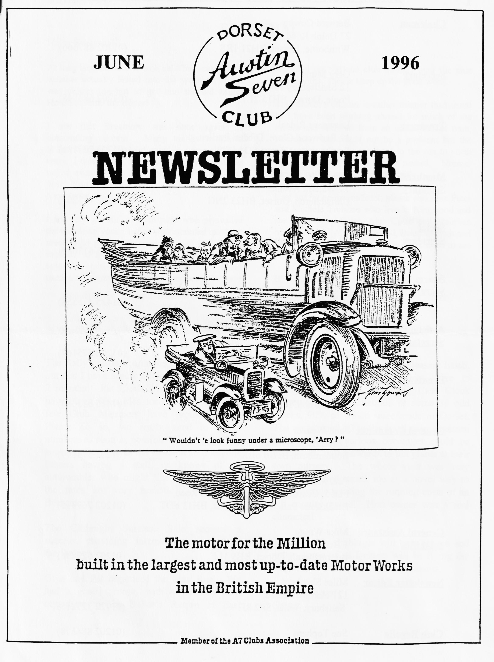

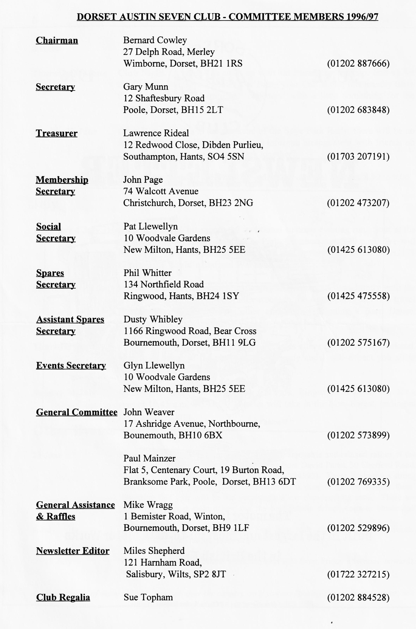

EDITORIAL
Hallo Everyone,
recorded the various club outings over the past
few months. Please keep up the good work.
This month's edition is rather thinner than usual as I have been working abroad for much of the month and suffered from an acute lack of time. Normally, this would not be a problem but the production team are involved in the run to north Spain so everything is rather rushed. Normal service will be resumed next month.
Last but by no means least, please welcome Peter and Michele Trebilco who live in Ringwood and are restoring a Ruby. Also Colin and Maureen Masters who live in Bearwood, Bournemouth and have a Pearl. Welcome to you all. I hope to see you at Clubnight.
BFN, Miles
At long last, summer is with us! The week of fine weather actually lasted into the weekend and it was almost too hot to get into the old Motor House to fettle the Ulster!
I see that Breamore was once again an outstanding success. Many thanks to David Whetton for all his hard work in organising our entry. I was hoping to get along this year but was called away at the last moment. Perhaps next year! You can read all about the show later in the Newsletter.
I am very grateful to John page who persuaded the charming young ladies who attended our May meeting to put pen to paper to tell us of their exploits in a chummy in France. Clearly an enjoyable trip. Speaking of thanks, I am particularly grateful to all the scribes who have
SECRETARIAL
Well Folks!
Chaldon, where we enjoyed a pleasant lunch. This was followed by a short drive to Owermoine to visit the Long Case Clock Museum, with a collection of some 30 odd clocks, 90% of which were made in Dorset. The we trooped off to the small cider museum on site, where various beverages could be purchased, then onwards to but plants at their own nursery. The whole visit was very interesting and struck me as a novel way to help towards meeting the running costs of an old country house. Hon owner was a real character!
This month's Clubnight will be a noggin and natter, some of us Dorsets will be flying the
flag in northern Spain with our Austins,
Adios Amigos! Gary
The Rally season is upon us, I've just worked out that I have hardly a free Sunday for about 2 months! Pat Llewellyn tells me that we have about 80 entries for our rally but very few Club Members have registered yet. Please do so, we really need to gauge numbers as soon as possible The Autojumble side is rather slow at the moment so if anyone fancies having a stall, or knows of an autojumbler who might like to come along,
the rates are very realistic. Please see
Bernard.
The Clubnight Suitcase Sale seemed a success, providing interest for the whole family.
Glyn and Pat organised the May Run. We had a good turnout, with a treasure hunt organised to the Sailor's Return at East

TWO GIRLS IN A CRUMMY
Although I myself don't have a vintage car, I'm fortunate enough to have a friend who does, and on Friday April 26, 1996, 1 took up my position alongside my friend, Jenny Thomson, as navigator of her green 1926, Austin 7 Chummy. Our destination was Normandy, France on the Inter-Register "Tour de Normandie". She obviously thought my navigating would be a safe bet, having studied geography 'A' Level with me at school last year!
I really didn't know what to expect as I'd never been on a rally before, Jenny had never driven abroad before (let alone with all those rascal French drivers!) and she hadn't had that much practice at driving the Chummy! Jenny's parents, Frank and Sue Thomson who took their 1928, brown and black Alvis TG 12/50 saloon, had warned her not to strain the engine too much going over 30 mph (- we wished!) as they had just had to replace the crankshaft the day before!
We joined the rest of our party of 16 cars - 6 Alvis, 3 Riley, 2 Austin, 2 Morgan, 1 Crossley and 1 Humber - at Portsmouth, to catch the 2.30 p.m. ferry to Caen. There was also Mr McGee in his Capri (!) - otherwise known as 'Merlin Man' because he was from Merlin Promotions, the organisers, and Pauline Gubbins from Merlin with her husband Peter, in their Daimler. We were car number 1 - the oldest and smallest car there with the slowest speed and the youngest drivers (18 and 19 years), and the jocular comments started on the ferry! A delicious and very large buffet meal in the ship's restaurant passed the time, and we docked at Ouistreham Caen after an extremely calm crossing at about 9.30 p.m.. Brothers Bernie and David Mulvany experienced their first and only problem of the trip when their 1932 Alvis TL 12/60 saloon wouldn't start trying to leave the ferry! The petrol-lift was not feeding petrol to the engine properly, so Bernie primed it and replaced it with a reserve petrol-lift pump the following day.
A short drive of 4 miles, in the dark, in convoy brought us to our first hotel - the hotel 'La Glycine' in Benouville. We didn't go wrong following the tulip map Oust) and Jenny managed to remember to drive on the right side of the road! We put the cars to bed in a sealed-off car park opposite the hotel which was modem and clean.
The next day was lovely - sunny and warm after a misty start, and after a traditional French breakfast and having bought our 'elevenses' from the patisserie, we set off at 9 am for Honfleur where we were all due to meet at about 10.30am. It was a lovely scenic drive through the countryside, passing through places such as Cabourg, Houlgate, Villef and Deauville, and being passed by many of the others in our party! Still, we weren't the last to arrive at Honfleur at 11 am and we parked in the designated parking area outside the town hall, and promptly got out our elevenses!
We wandered around the market, had a delicious crepe for lunch while some of the others visited the Eugene Boudin Museum. We set off for Louviers - our home for the next 3 nights - at 2 p.m. and drove with the hood down in the beautiful warm sunshine, through Beuzeville (where all the drunks live!), Lieurey, Brionne and Amfraville. It was about time something went wrong, and after stopping in Brionne for an ice-cream at 3.30pm, Frank and Sue Thomson's car wouldn't start because the magneto was not sparking properly. Jenny and I drove on, saying that they'd soon catch us up, and then we encountered our first minor problem - we ran out of petrol going up a hill! We filled the tank with the spare gallon in a petrol can in the back of the car, and stopped at the next garage, where, as predicted, Frank and Sue caught us up - just in time to pay for the petrol!

Jenny and I left Frank paying for the petrol and drove off - that was the last we saw of Frank and Sue until 10 p.m. that night! Jenny and I reached the hotel 'Le Pre Saint Germain' at Louviers at about 5.45pm and parked (Charlie) Chummy in the secure car-park at the front. We were meeting the rest of the party for dinner in the restaurant at 8pm but Jenny was unable to change out of her jeans because her luggage was in the Alvis! In the meantime, while we were all enjoying our delicious meat Frank and Sue Thomson, Keith McGee, and Peter and Pauline Gubbins were all 15 miles down the road at the petrol station where we'd left them at 4pm still trying to get the car to start!
An old lady who lived opposite the garage offered for Frank to leave the Alvis parked in her back garden overnight. Keith McGee took the ladies back to the hotel at 10 p.m. to have something to eat, and then returned to the garage with a spare magneto provided by Peter Brown (with his 1927 Alvis TG 12/50 Tourer). They decided to try Peter Brown's magneto the next day in the daylight and left the car with the old lady (known as 'Grandma'), saying they would return at 9 am the following morning.
On Sunday morning, while the rest of the party set off for the Chateau de Bizy at Vernon, and Monet's house and gardens, Frank and Peter returned to 'Grandma's.
"She insisted that before we did anything we had coffee and Armagnac," said Frank. Meanwhile, her son had charged the car battery overnight and he helped Peter and Frank with a connection which need soldering. Frank said: "With the help of the Armagnac and some good daylight the Alvis started at once! To celebrate, Grandma invited us in again after which we had to try a selection of wines, ports and more coffee eventually we left at 12.330 p.m. So it sounds as if Frank didn't have such a bad time of it after all. "No," he said, "the problem was compensated for by meeting the French people in their own home and the hospitality which was given." In the end, Frank cleaned and re- set his own magneto and the Alvis ran well for the rest of the trip.
For those of us who made it to the chateau and Monet's house and gardens at Giverny, it was a wonderful day. The weather was again, very warm and sunny, and we were driving around with the hood down. Jenny and I were, as usual, going round the tight bends and roundabouts at 25mph going, "Wh000aaah" because it felt as if the car was going to topple over. The highlight of the chateau visit was seeing a red squirrel in the grounds.
The visit to Monet's house and gardens was the highlight of the whole trip for people like Stephen Weld, who went, in his 1930 Crossley 2 L Sports, with 3 pupils from his art class at Hordle House School in Lymington. Peter and Gina Higgins and their .2 children, who took their 1931 Humber Snipe, spent the whole day there. We took over a hundred photo's," said Gina, "as a painter I appreciate him very much."
After a delicious picnic lunch, Jenny and I continued along the scenic route back to Louviers, passing through Les Andelys, Ecouis and into the Foret de Lyons. We stopped for a walk around the grounds of the Abbye de Mortemer and then stopped a little later for a drink in the beautiful and historic town of Lyon la Foret. I think it was when we were driving through Fleury that we nearly squashed a woman against her moped as she was standing in the road! She did look a bit worried when we came around the corner at speed for a Chummy!), going, "Whoooaaah!"
Frank and Sue were not the only ones to experience car trouble on Saturday evening - the Higgins family were left stranded 3km from the hotel with a flat tyre - and no jack! However, the

opportunity for some photographs with a vintage car was enough to ensure the assistance of a French farmer and his wife! They actually insisted on changing the tyre for them!
Jenny and I got back to the hotel at about 7pm and 20 minutes later we all piled onto a coach which was to take us to a golf club some 5 miles outside the town for dinner. It was owned by the hotel and they said they would put on a private party for us because the hotel restaurant was closed.
The next day was our longest drive - 160 miles to Dieppe. The usual 16 cars dropped in number to 4 for this trip! - as people wondered whether their cars would make such a long journey when they had to ensure they could get to the ferry the following day. Jenny and I were confident the Chummy could do it though and there were many witty remarks and wishes of "good luck" at breakfast that morning! At 9 am we were on the road again, enjoying the beautiful scenery surrounding the Seine (which we had to cross by ferry). The weather, though much cooler, was still dry and sunny and we were able to enjoy a very pleasant lunch outside by the harbour when we got to Dieppe. We couldn't stay long though, else we wouldn't have made it back to the hotel in time, as it was such a long journey.
In fact, we didn't stop once on the way back - not until we ran out of petrol going up a hill 3 miles from our hotel. Unfortunately, we'd already used up our spare gallon of petrol earlier in the afternoon when we were driving up another hill! We'd been looking out for petrol station but hadn't seen one. We were just trying to turn the Chummy round so we could free-wheel it back to the village at the bottom of the hill, when a French man stopped in his car and offered to take us down there and back again with the can.
We eventually arrived back from Dieppe victorious at about 7.30pm! Jenny kept beeping the horn as we drove through the hotel gates to mark our home-coming! (Peter Gubbins said to Frank: "Does it always make that noise?"!). Everyone was very impressed because they (of little faith!) thought we'd never make it! That night called for a celebration meal at one of the local restaurants and I was already beginning to feel a little sad that it would soon be time to go home. The next day, Tuesday April 30th, we set out a little later in the morning (after a photo session outside the hotel) on the drive back to Ouistreham. Jenny and I were singing songs to the Chummy - period songs, such as "It's a Long Way to Tipperary" was a favourite! We continued our usual hooting at cyclists and people standing by the side of the road, and of course, anyone in the rally who decided to overtake us (in other words, everyone!). The French people were surprisingly friendly and patient with us - they kept flashing their lights, beeping and waving throughout the whole trip!
Some people stopped at the motor museum in Chateau de Brette-Ville near Pont L'Eveque. I sampled a Pont L'Eveque cheese crepe for lunch, and then Jenny had to put her foot down and we sped-off (at 30/35mph!), thinking that we weren't going to make it to the ferry in time! In fact, we got to Ouistreham in plenty of time to make one last trip to the patisserie. Back on the ferry, and the thought hit me that it would be back to college tomorrow! Still, the holiday wasn't over yet, the end-of-tour dinner in the ship's restaurant, accompanied by some live music was, I'm sure, enjoyed by all. And - an extra surprise - when the 3-piece orchestra retired at the end of the meal, Peter Higgins took to the piano for his unscheduled performance of the "Polonaise"! It was sad saying goodbye to everybody when we docked at Portsmouth - everyone was going their separate ways - let's just hope we can all meet up again on another such trip, and let's hop c it will be just as memorable and enjoyable as this one!
Fiona Griffiths

BREAMORE MOTOCADE JUNE 1996
A bumper turn-out this year in spite of the conflicting weather forecasts. The highlight of the day for the second year running was the WHIBLEY DOUBLE in the Driving Competition - but this year Young Whibley was beaten by friend Jo and the Old Man regained his natural superiority in the over-50s class, (1 note that in order to make the competition fairer, men are given their own class).Once again lunch was a happy, family affair with our resident entertainer on the STRAEDELLA. Please look this up as I have been unfair to Gay over the years by describing her as an accordionist . This is like calling Yehudi Menuhin a fiddler However, whatever the game, the music is a memorable and unique contribution to the Breamore car show and many, many thanks to Gay. I Bill & Mary Quayle bravely made their way to the show in The Modern since their old Nippy has started to dribble a little and wasn't fit to be seen in public. This year there was no trailer-ed Austin 7 Bitza, no Price-when-New, no cranky engine or broken crankshafts - we went back to basics for the MINIMALIST APPROACH - a good day out amongst friends and blow the rest of the show. And, as usual, a jolly good day it was too. Well done everyone and a special welcome to the first-timers Adrian, Harold & Rodney (see below).
Traditionally, there now follows a definitive list of Members Attending -
Harold (who was that woman you were with?) Seal & Rodney LLoyd-Denman'28 Chummy OT 927 1; Norman & Jane Whibley '30-based Ulster replica special VU 4916; Maggie (where was she all day?) Stalker'31 Open 2-seater BOAT TAIL CG 671; John & Gay Weaver'32 LWB Box FK 5382; Marion & Ben Trimby & Gina, Mark., Mia, Shari, Adrian, Christopher, Adam and Leah '33 LWB Box YD 8341; Adrian Wiltshire 33? LWB Box ALY 256; Fred Bailey'33 LWB Box OW 2751; Gary Munn & Lucy 33 Open 2-seater Tourer AUU 325; Scott Whibley & Jo '34 Ulster replica special GSK 253; Biddy Brown '35 Opal RV 7609; Gordon Brown '37 Pearl Cabriolet SH 5475; Gordon & Lena Pope '38 Mk.11 late Ruby (FOR SALE at a snip) FAU 742; Marion & Kevin Wissett in a'37 Austin 7 Eight series 2 tourer ETT 635. Plus Arthur Cox in his 1930 Austin Heavy 7 PL 355 1; an Austin 7 1977 Fire Engine; Bill & Mary Quail sans Nippy which isn't.
Also in attendance were Enticem 'n Trapem (Purveyors of Quality Goods to the Gentry) with helpers plus many friends and fellow Club members with ring-side seats. For the second year running we notice the absence from the autojumble arena of Mr. Books himself.
David Whetton
EVENTS IN OUR AREA
21 - 23 June Festival of Speed, Goodwood. See Press for details.
6 - '1 July Downs Steam Show, Froxfield, near Petersfield
26 August New Milton Centenary. Contact Paul Boxall on 01425 619790. Glyn and
Pat may have more details.
13 - 15 September Rosengart Rally, Near Cologne, Germany. Let me [Ed] know if you want details of this one, it sounds good value.

June
Thursday 20 June Club Night. A chance to catch up with old friends and perhaps link up for the Club Run to Spye Park. It's a 'Bring your Car' night; this usually takes the form of a highly informal `concours' with a little something for the `winner'
Sunday 23 June Club Run. As this is the weekend of the Spye Park Rally, there will be no formal Club Run. Why not make an informal arrangement with friends on Club Night to drive up to Spye Park together?
Thursday 27 June Committee Night at the Tyrell's Ford. Meet as usual at about 8.30 to 9.00
July
Thursday 4 July 8 ish till Late. This month the traditional summer evening run. Start at the Queen Elizabeth leisure Centre Car Park, Wimborne at 7.30 p.m. We will be making our leisurely way to the Cork and Bottle, Morden, on the B3175 between the World's End and Wareham.
Sat/Sun 13 - 14 July Swanage Rally. Our annual gathering at Harman's Cross, jointly with the Swanage Railway. Entry includes access to the Autojumble and free travel on the steam trains. Many other attractions, including a Barn Dance. Entries to Pat Llewellyn. Offers to help to your Editor!
Thursday 18 July Club Night. A social night to compare notes after our rally at the weekend. Hopefully, some of the photos will be ready and I will expect you all to regale the editor with your tales!
Sunday 21 July Club Run. Gather at the Furlong Car Park, Ringwood at 10.30 a.m. for a start at 10.45 a.m. SHARP! The run will take in the New Forest, ending at the Butterfly Farm.
Other Events
23 June Spye Park. Bristol A7C run one of the most enjoyable and relaxed rallies of the year at Spye Park near Lacock. Entry forms from David Parks, 30 Sherford Road, Haydon Wick, Swindon, SN2 3PR (tel 01793 724592). There is always a strong turnout from our members, so there will be a number of old friends there! Returning this year will be the very popular car manoeuvering tests. There are prizes for the best male driver and the best female driver - spares blushes all round!
6 July VSCC Shelsley Walsh Hill Climb. Near Worcester. See me if you want tickets,
I can get £2 off the normal price of £9.
27/28 July VSCC Prescott Hill Climb. Camping available from Friday afternoon onwards. Jazz Band on the Saturday.
I have details of many old car events all over the country, so if you are looking for an event to enter, or
simply to attend, please see me at Club Night - Miles

