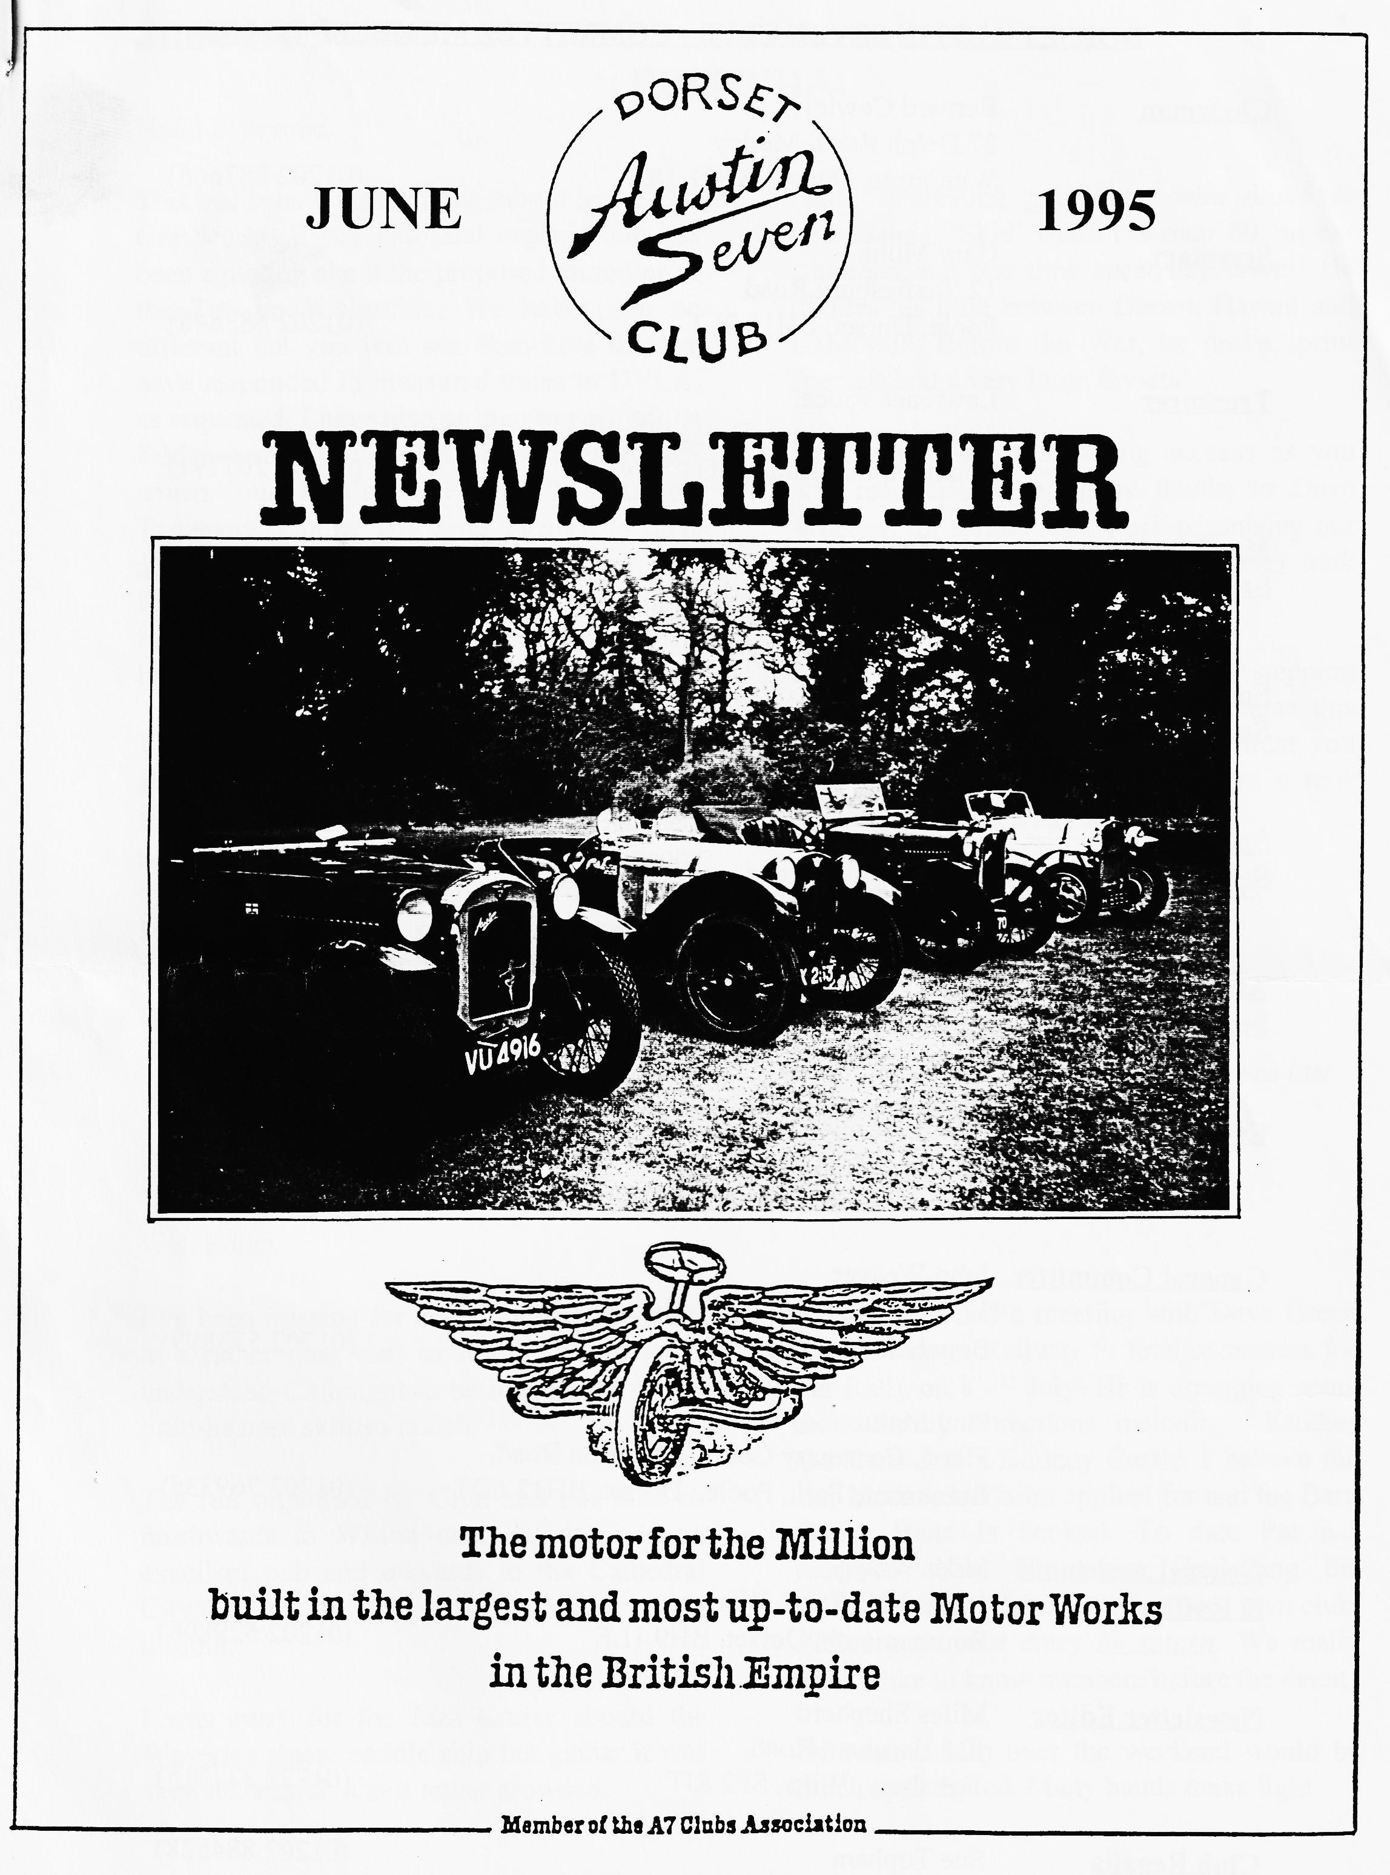

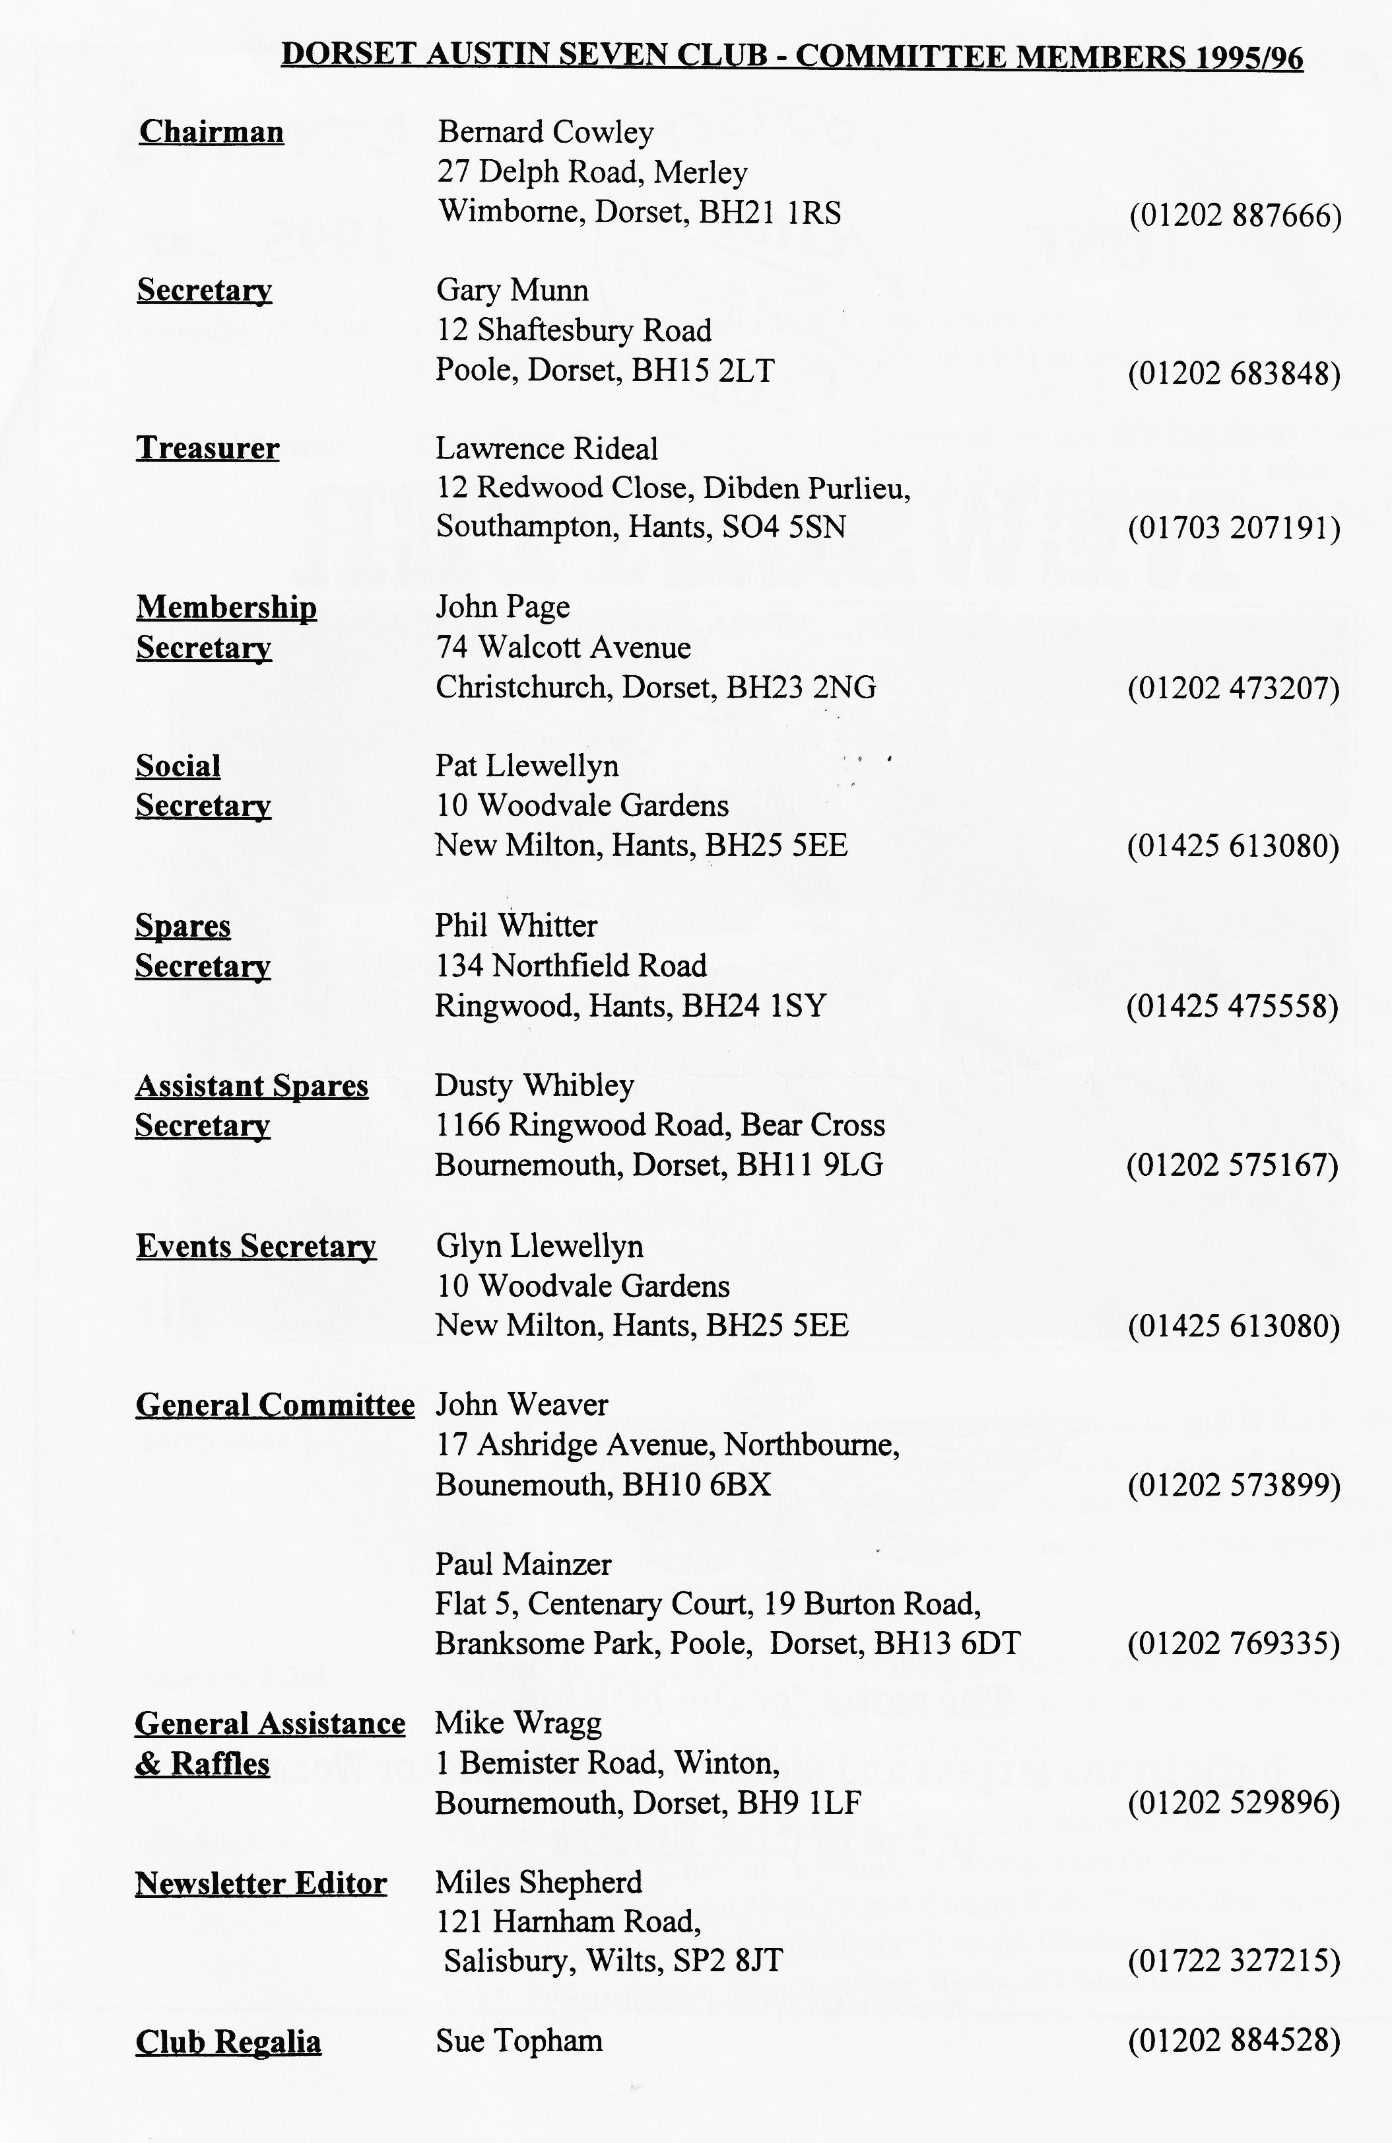

June 1995
EDITORIAL

Hi everyone
This has been a momentous month in the Old Car World! Every club and organisation has been agitating about the proposed iniquities of the Tax on Possession. We have been no different but you will see elsewhere that we have responded in measured tones to DVLA, as requested. I have also written to each of the 8 Members of Parliament whose constituency covers 'our' area as well as the Minister for Transport. I hope you have written to your MP too! It's not too late to make your feelings known, the address is in the phone book. I can let you have the bones of 'our' letter if you need a starter for 7!
With the rally season well under way, I am able to report that the Editorial Chariot is on the road and had its first outing at the Romsey Show over the Bank Holiday. I only managed the first day and have not heard how the Monday went but the site allocated was quite good, well placed and lots to see. I met a

really interesting gentleman who drove at Brooklands. 'Skid' Martin is over 80, an ex-stuntman and one time speedway driver! He divides his time between Dorset, Hawaii and California. Before the War, he drove sprint specials and a very large Invicta!
Breamore was a resounding success as you will read elsewhere, many thanks to Dave Whetton for all his hard work organising our entry and to the many members who took part.
I note that Paul Henwood is kindly stepping into the breach by offering to organise this month's run, many thanks Paul, I trust you will have a good turnout! We have a new starting place, see Page 2 for details.
See you all at Club Night or Spye Park!
BFN, Miles

Deadline for the next issue is 8 July - hand it over at the Rally!
This month's cover photo shows 4 specials - 3 Ulsters and a Cambridge at Exbury Gardens last
month. Many thanks to Jane Whibley
SECRETARIAL

Well Folks!
I've been missing for a while this month due to a rather nice visit to Rhodes, however, I understand Clubnight to be interesting with a light-hearted skittles match.
The run organised by Glyn and Pat took us northwards to Wilton near Salisbury to an excellent pub and onwards to the Cathedral City, 14 cars I understand. Another good turnout.
I was away for the Jazz Cruise aboard the Waverley steam paddle ship but gather it was very successful, albeit rather crowded
We recently had a meeting with Dave Green from Swanage Railway to finalise matters for our Rally on 8 - 9 July. He is arranging some extra family attractions including Kiddies Go-Karts and a Bouncy Castle. I believe the Bar Licence has been applied for and the Barn Dance Band is booked. To date Pat has received about 50 entries [Including the Editor!] but not that many from our own club. Please post your entry by return. We really would like to know numbers before the event.
Of course, help over the weekend would be much appreciated. Many hands make light

Secretarial cont 'd
work so please let Pat know when you can help. It really can be a little tiring rushing up and down the hill all day, thank goodness for the Beer Tent. Pat has some advertising posters - if you are able to display one, see her on Club Night. Finally, we are a little short of Autojumblers so if you
want to bring some gear along, it's only a fiver a pitch. For those who think they do not have enough for a pitch of their own, the Club will have a stall where members can sell gear on a commission basis.
See you - Gary

LIBRARY After a successful launch, the Committee has decided to make the Club Library available every Club Night. Paul Mainzer brings along the books, pamphlets and videos so please see him to borrow some of the really useful material we have available. We are looking to expand the service so if there are any books you think we should have, please let either Phil or Paul know. We hope to get the Mercury Workshop Manual shortly and perhaps some more videos, too.
WELCOME to new members, Christian Lauffs who lives in Belgium, and Mr. D Suter of whom I have no further detail! We hope to meet you both soon.
CLUB STALL As mentioned elsewhere, there will be a Club Stall at Swanage to let members sell A7 related parts. If you have anything you wish to sell, please label it clearly with your name and price you want and hand it in at the rally field. The marshals at the entrance to the field will tell you where the stall is located. As usual, a 10% commission on all goods sold will go to club funds.
REGALIA Sue Topham tells me she has some new lines for the summer. New Stock T Shirts, many colours. Still only £4.50. Also, polo shirts £9.50. FREE COPY of the Ten Commandments for the Car Collector with every purchase at Swanage Classic Car Weekend!
START FOR RUNS The lay-by in Magna Road has proved unsuitable so Wimborne runs will start from the Leisure Centre car park by Queen Elizabeth School on the Badbury Rings road on the way out of Wimborne. You may not see cars from the road so do not be shy, turn into the car park and all will be revealed!

BREAMORE MOTORCADE JUNE 4th 1995
A bumper turn-out this year in spite of the threatening weather. The early birds were treated to a spectacular hailstorm and the late arrivals were full of tales of derring-do in trying to arrive in one piece. Lunch nearly reached the high point of the Good Old Days, but the little children seem to have all grown up. However. many of the grownups behaved like children so I suppose we've just come the full circle. Some of the many welcome visitors included Bill Quayle for whom a Nippy in the rain has lost some of its old magic. Jo Moss (?) who won the car-of-the-show prize in her Invicta, Keith Whitter & Leanne who couldn't fool the marshals with the Austin 7 Beach Buggy, Mark Whibley who won the prize overalls in the Driving Test in his Austin 7 Robin. a little refugee from an autojumble stall and our "want to swap an Austin 7 for a Jeep?" friend from last year. Whilst we did not win the Club Stand prize yet again, (what on earth do we have to do? - ring bells?) there was a magnificent display of old tat plus the obligatory car-in-bits on an impressive trailer built and supplied by J Bridge Esq. (Available for hire at a very small premium to Club Members). Unfortunately, this year. piped muzak defeated our own People's Entertainer, darling to the Austin 7 world. the lovely Gay. Please come back next year and I’ll pull their plugs out. The highlight of the day was the DOUBLE WHAMMY in the Driving Competition - brothers Whibley in both pole positions, Mark winner of the golden overalls and Scott winner of the under 50s. Beat that, Daddy-o.
Traditionally, there now follows a definitive list of Members Attending -
Gary- Munn & Paul '30 SWB Box YD 890 (FOR SALE): Norman & Jane Whibley '30-based Ulster replica special VU 4916; Bob Stanley & Colin Chalk '30 Ulster T1' RT 7470; Jeff & Marilyn Bridge '31 SWB Box WP 2201; Maggie (it really is original) Stalker '31 Open 2-seater BOAT TAIL CG 671; John & Gay Weaver '32 LWB Box FK 5382; Marion & Ben Trimby & Sylvia '33 LWB Box YD 8341; Fred Bailey & Jackie '33 LWB Box OW 2751; Willy McKenzie '34 LWB Box BPD 827; Scott Whibley '34 Ulster replica special GSK 253; Joy & George Mooney '34 Cambridge special; Biddy Brown '35 Opal RV 7609; Don & Reg Pardy '36 Ruby ESK 255; Gordon Brown '37 Pearl Cabriolet SH 5475; Gordon & Lena Pope '38 Mk.II late Ruby FAU 742; Vince Leek '38 Pearl Cabriolet FXN 285 and Marion & Kevin Wissett in a '37 Austin 7 Eight series 2 tourer ETT 635. Plus Terry Jeffries and partner who shot off too early for your intrepid reporter to catch make and number of vehicle. Was it a Ford Popular?
Also in attendance were Enticem 'n Trapem (Purveyors of Quality Goods to the Gentry) with helper plus many friends and fellow Club members with ring-side seats. Noticeable by his political absence from the autojumble arena this year was Mr. Books himself.
David Whetton
Many thanks, David, not only for organising such an excellent day out but also for penning the words to bring the day alive to those of us who could not be there. Ed

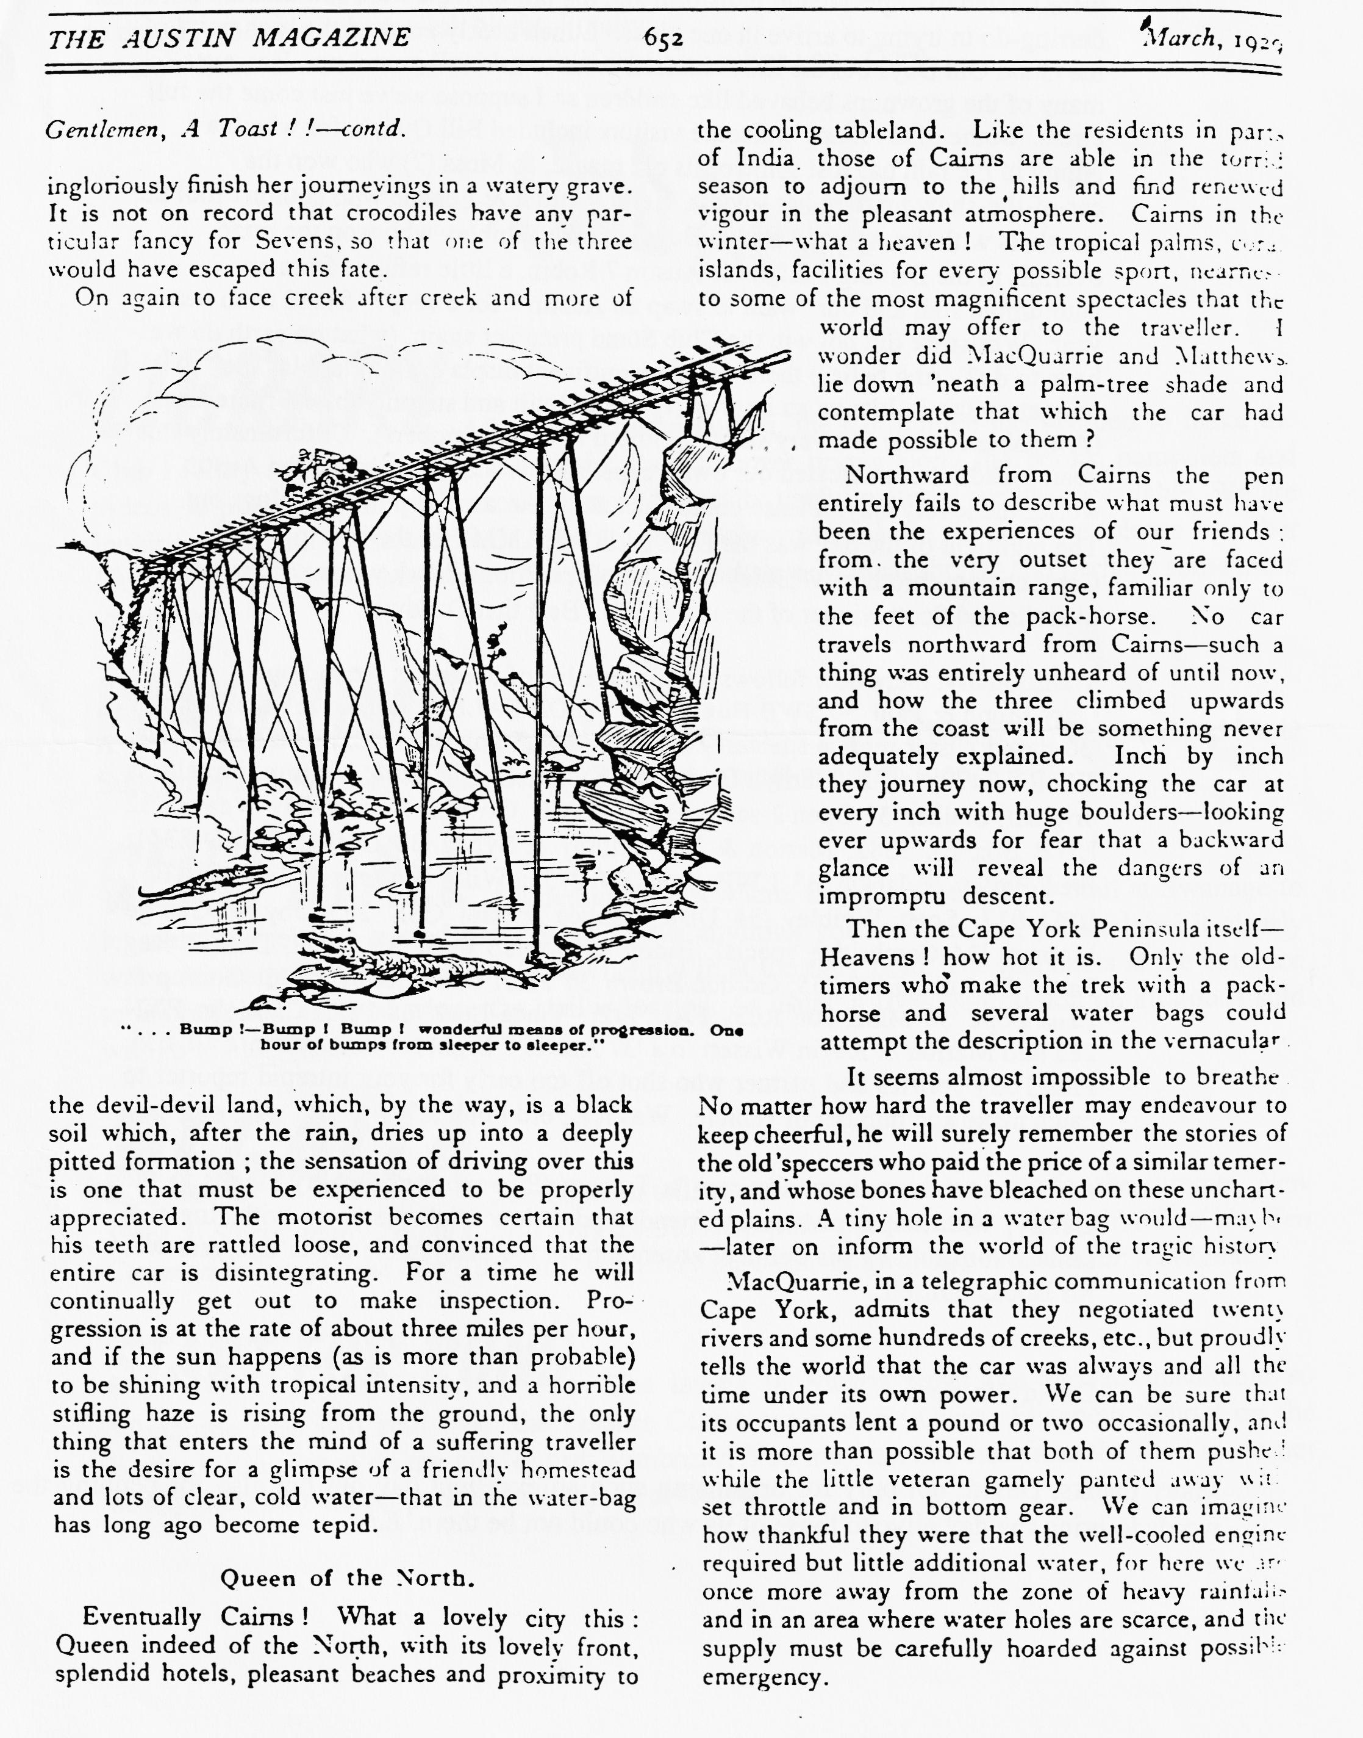
GENTLEMEN, A TOAST!! Concluding the story of an intrepid pair of travellers in Australia. See the April issue for the first part of the story or get hold of a copy of Hector MacQuarrie's book, perhaps from the Club Library!

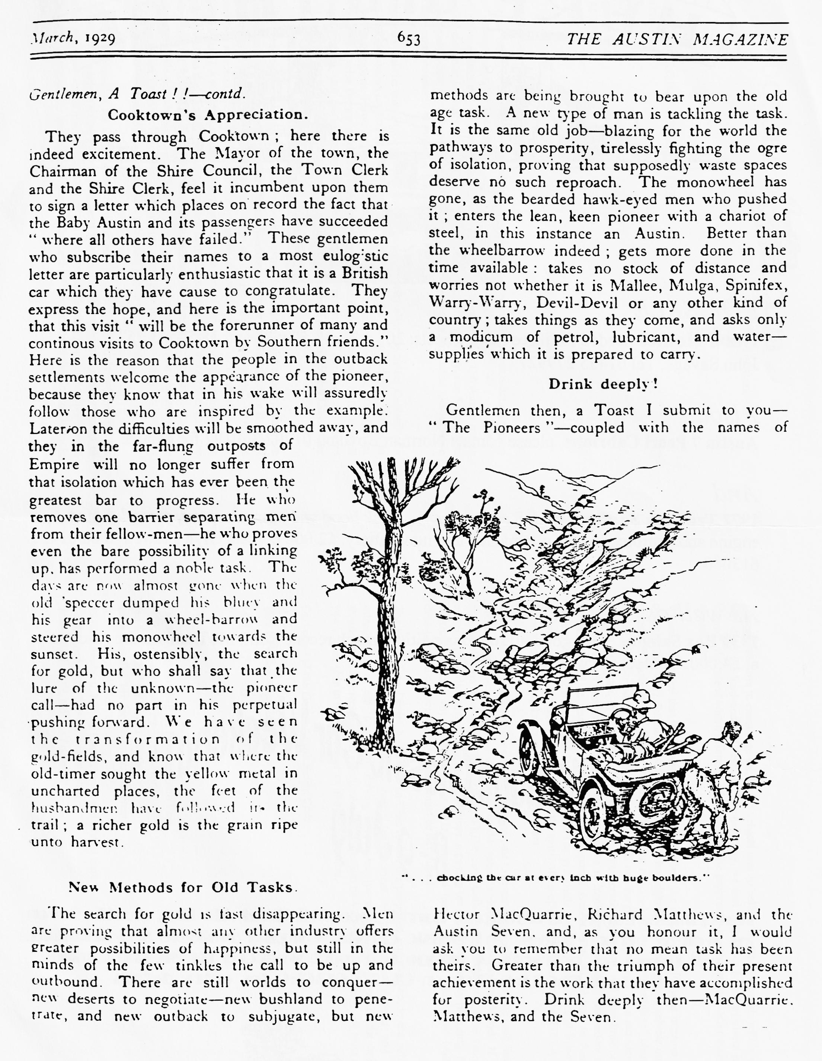

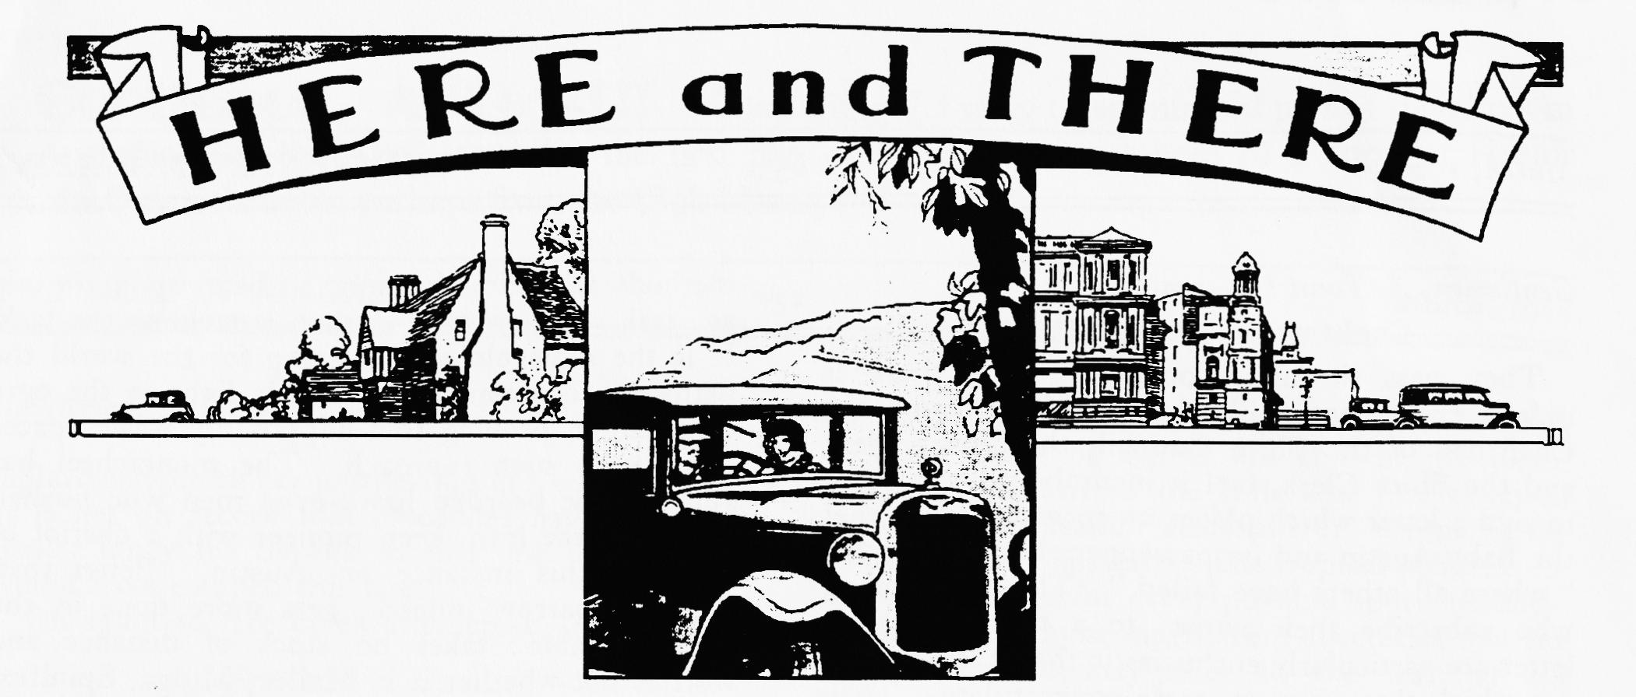
FOR SALE
Good Homes needed for three rusty wheels; 20" x 3", 18.5" x 3" and 18.5" x 3.75" John Savage, Tel 01425 279927
Also....
Austin 7 Pearl Cabriolet, please contact Norman Boyd on 01202 300192 for details.
And
1972 Triumph Spitfire Mk 4. Red paintwork, black hood and tonneau cover, reconditioned engine and gearbox, brakes overhauled and new battery. £2,000 contact Glyn Llewellyn on 01425 613080
As well as
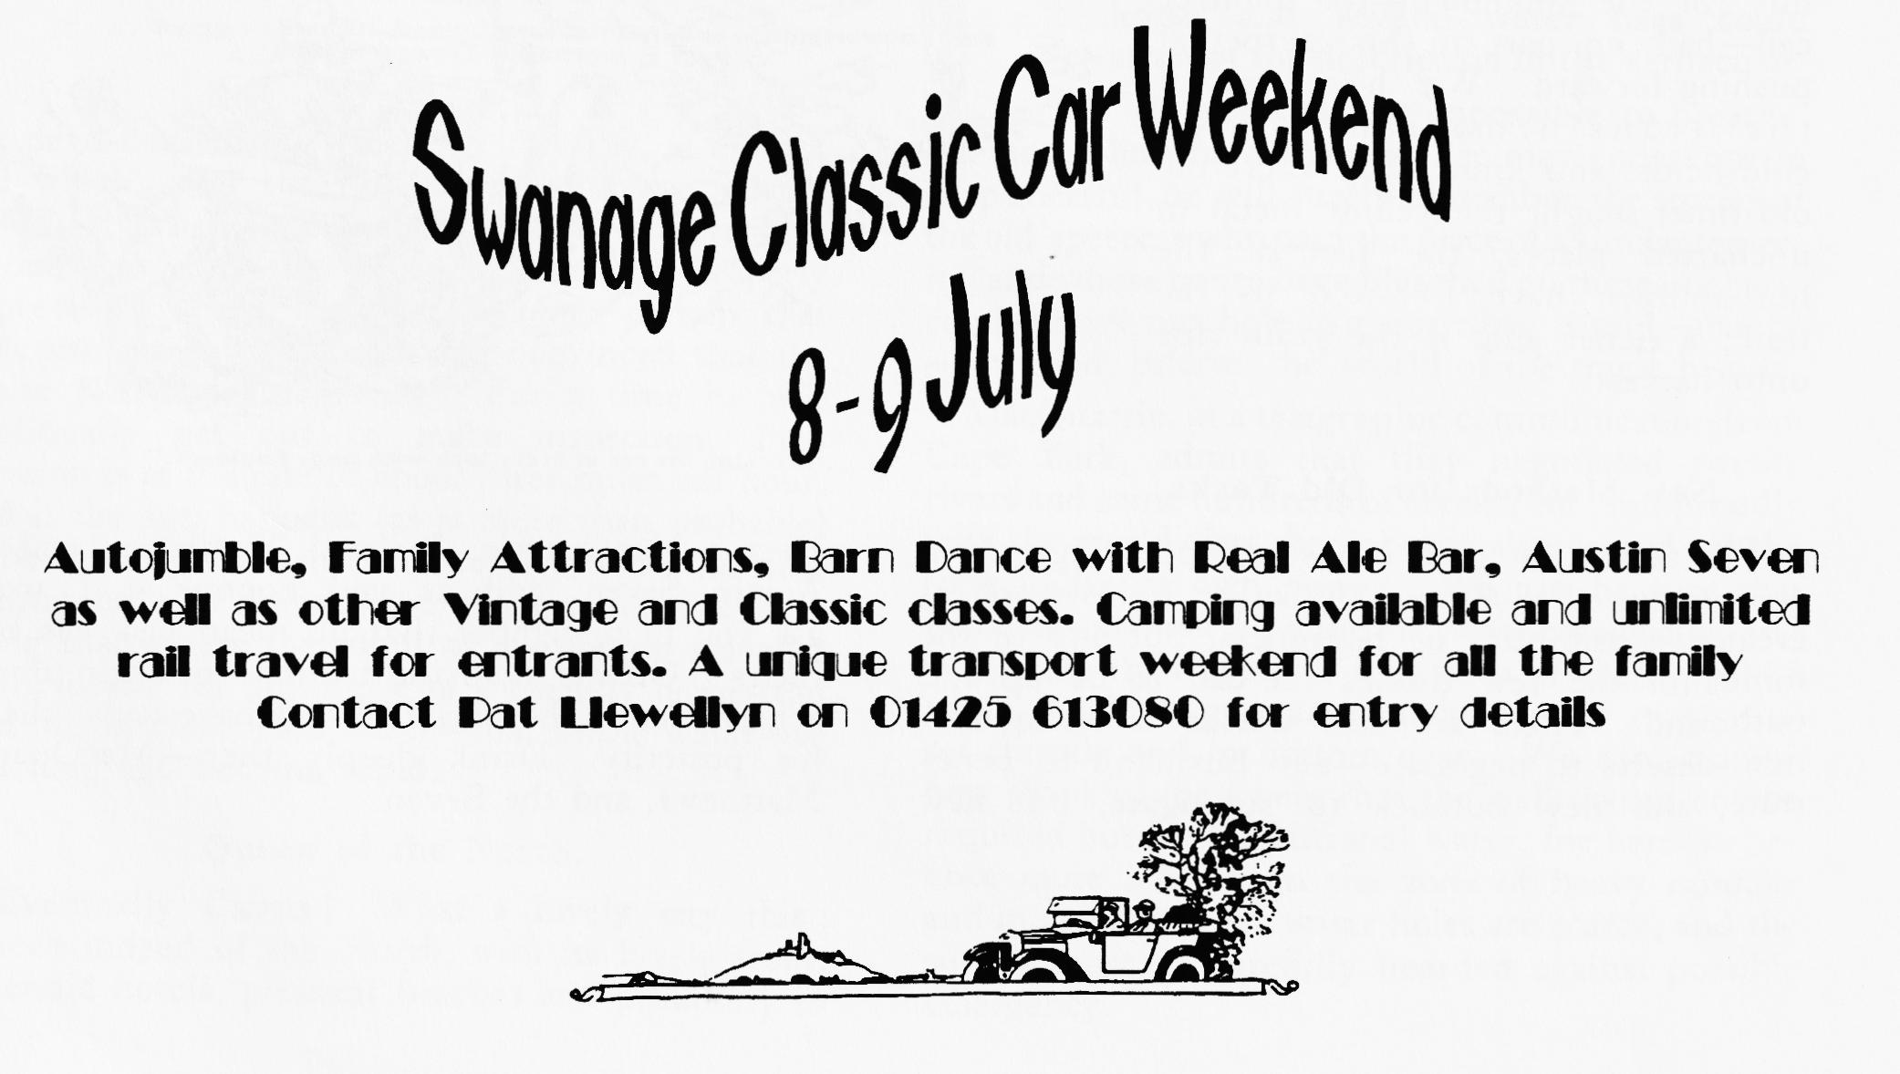
1930 Box Saloon. Very good all-round condition, much recent work, MoT and on the road. Snip at £4,000. Contact Gary on 01202 683848

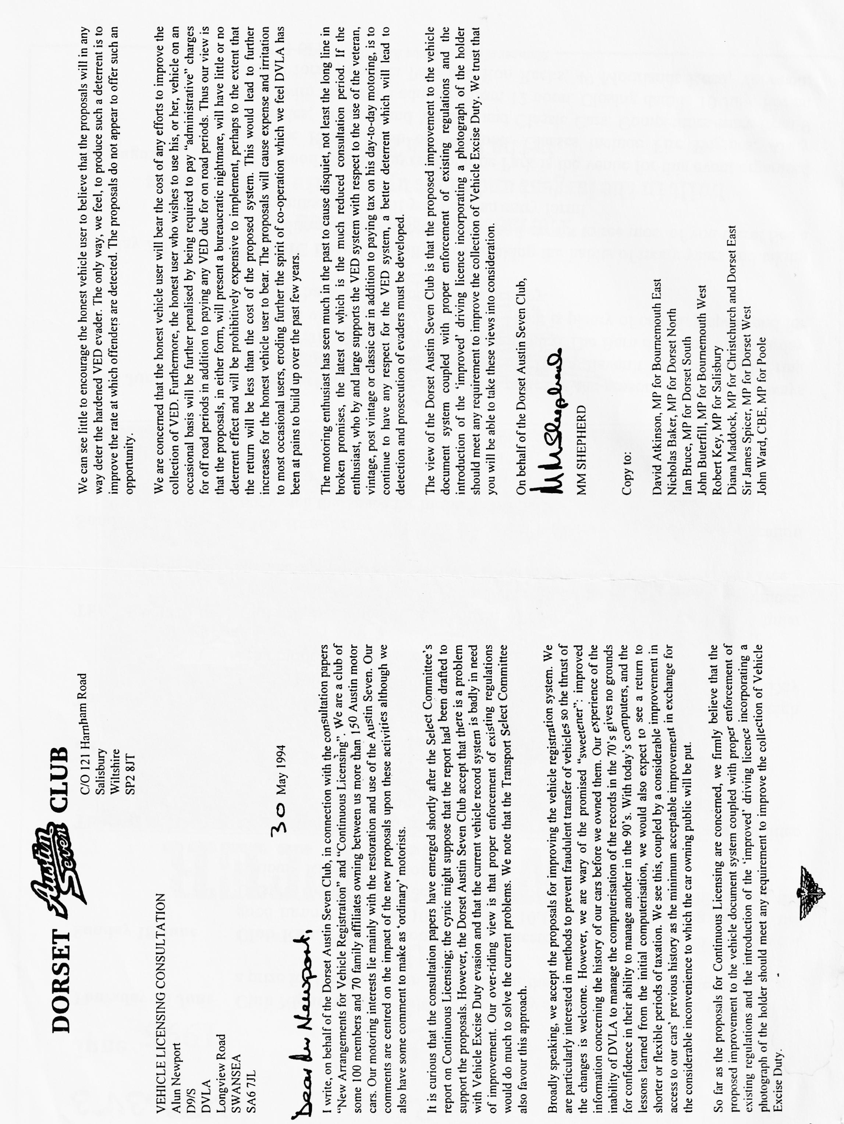

EVENTS
June
Thursday 15 June Club Night All the usual fun of the early summer, this evening there will be a prize for the bar Person's Choice (car that is!) so bring your Seven.
Sunday 18 June Club Run. Paul Henwood has volunteered to lead this run so let's have a good turnout. Meet at 10 a.m. for a 10.15 start. The meeting place is the Leisure Centre by Queen Elizabeth School, Wimborne. This is on the Badbury Ring road out of Wimborne.
Thursday 22 July Committee Meeting. Once more unto the Tyrell's Ford! Your committee gather to put the Austin World to rights at about 9 ish each month.
July
Thursday 6 July Eight (ish) till Late. The venue this month is the Winston Churchill, Leigh Road, Wimborne. Sounds a good choice for the year of VE Day celebrations!
Thursday 20 July Club Night. After the excitement of the Club Rally, we'll have a quiet Noggin 'n Natter. For the ,more energetic, one of the hardier committee members is organising a: walk in the local area. See you all at the Elm Tree.
Sunday 23 July Club Run. Terry's Run! Details are a bit thin as we close for publication but watch this space for further information.
Other Events
24/25 June Spye Park This is one of the best rallies of the season and Dorsets always have a good turnout for the weekend. If you haven't booked already, ring David Parks on 01793 724922 for an entry. The Barn dance on the Saturday Night is worth the trip on its own! There is plenty of camping space and for the less hardy, some good B&Bs near by.
Sunday 2 Jul 750 MC Beaulieu Rally. I'm breaking the habits of many years and taking the Editorial Chariot to this event so I expect to see most of you there! See a committee member if you need an entry form!
28 August Verwood Rustic Fayre. Potterne Park is the venue for this event organised by the Rotary Club of Verwood. Classes include Fire Engines, Army vehicles, Tractors and Vintage and Classic Cars. Competitors entry from 9 a.m. with the public admitted from 12 noon. Closing date is 10 July. For an entry form , contact Pam and Ron Reeks, 49 Moorlands Road, Verwood, BH31 6PD.

