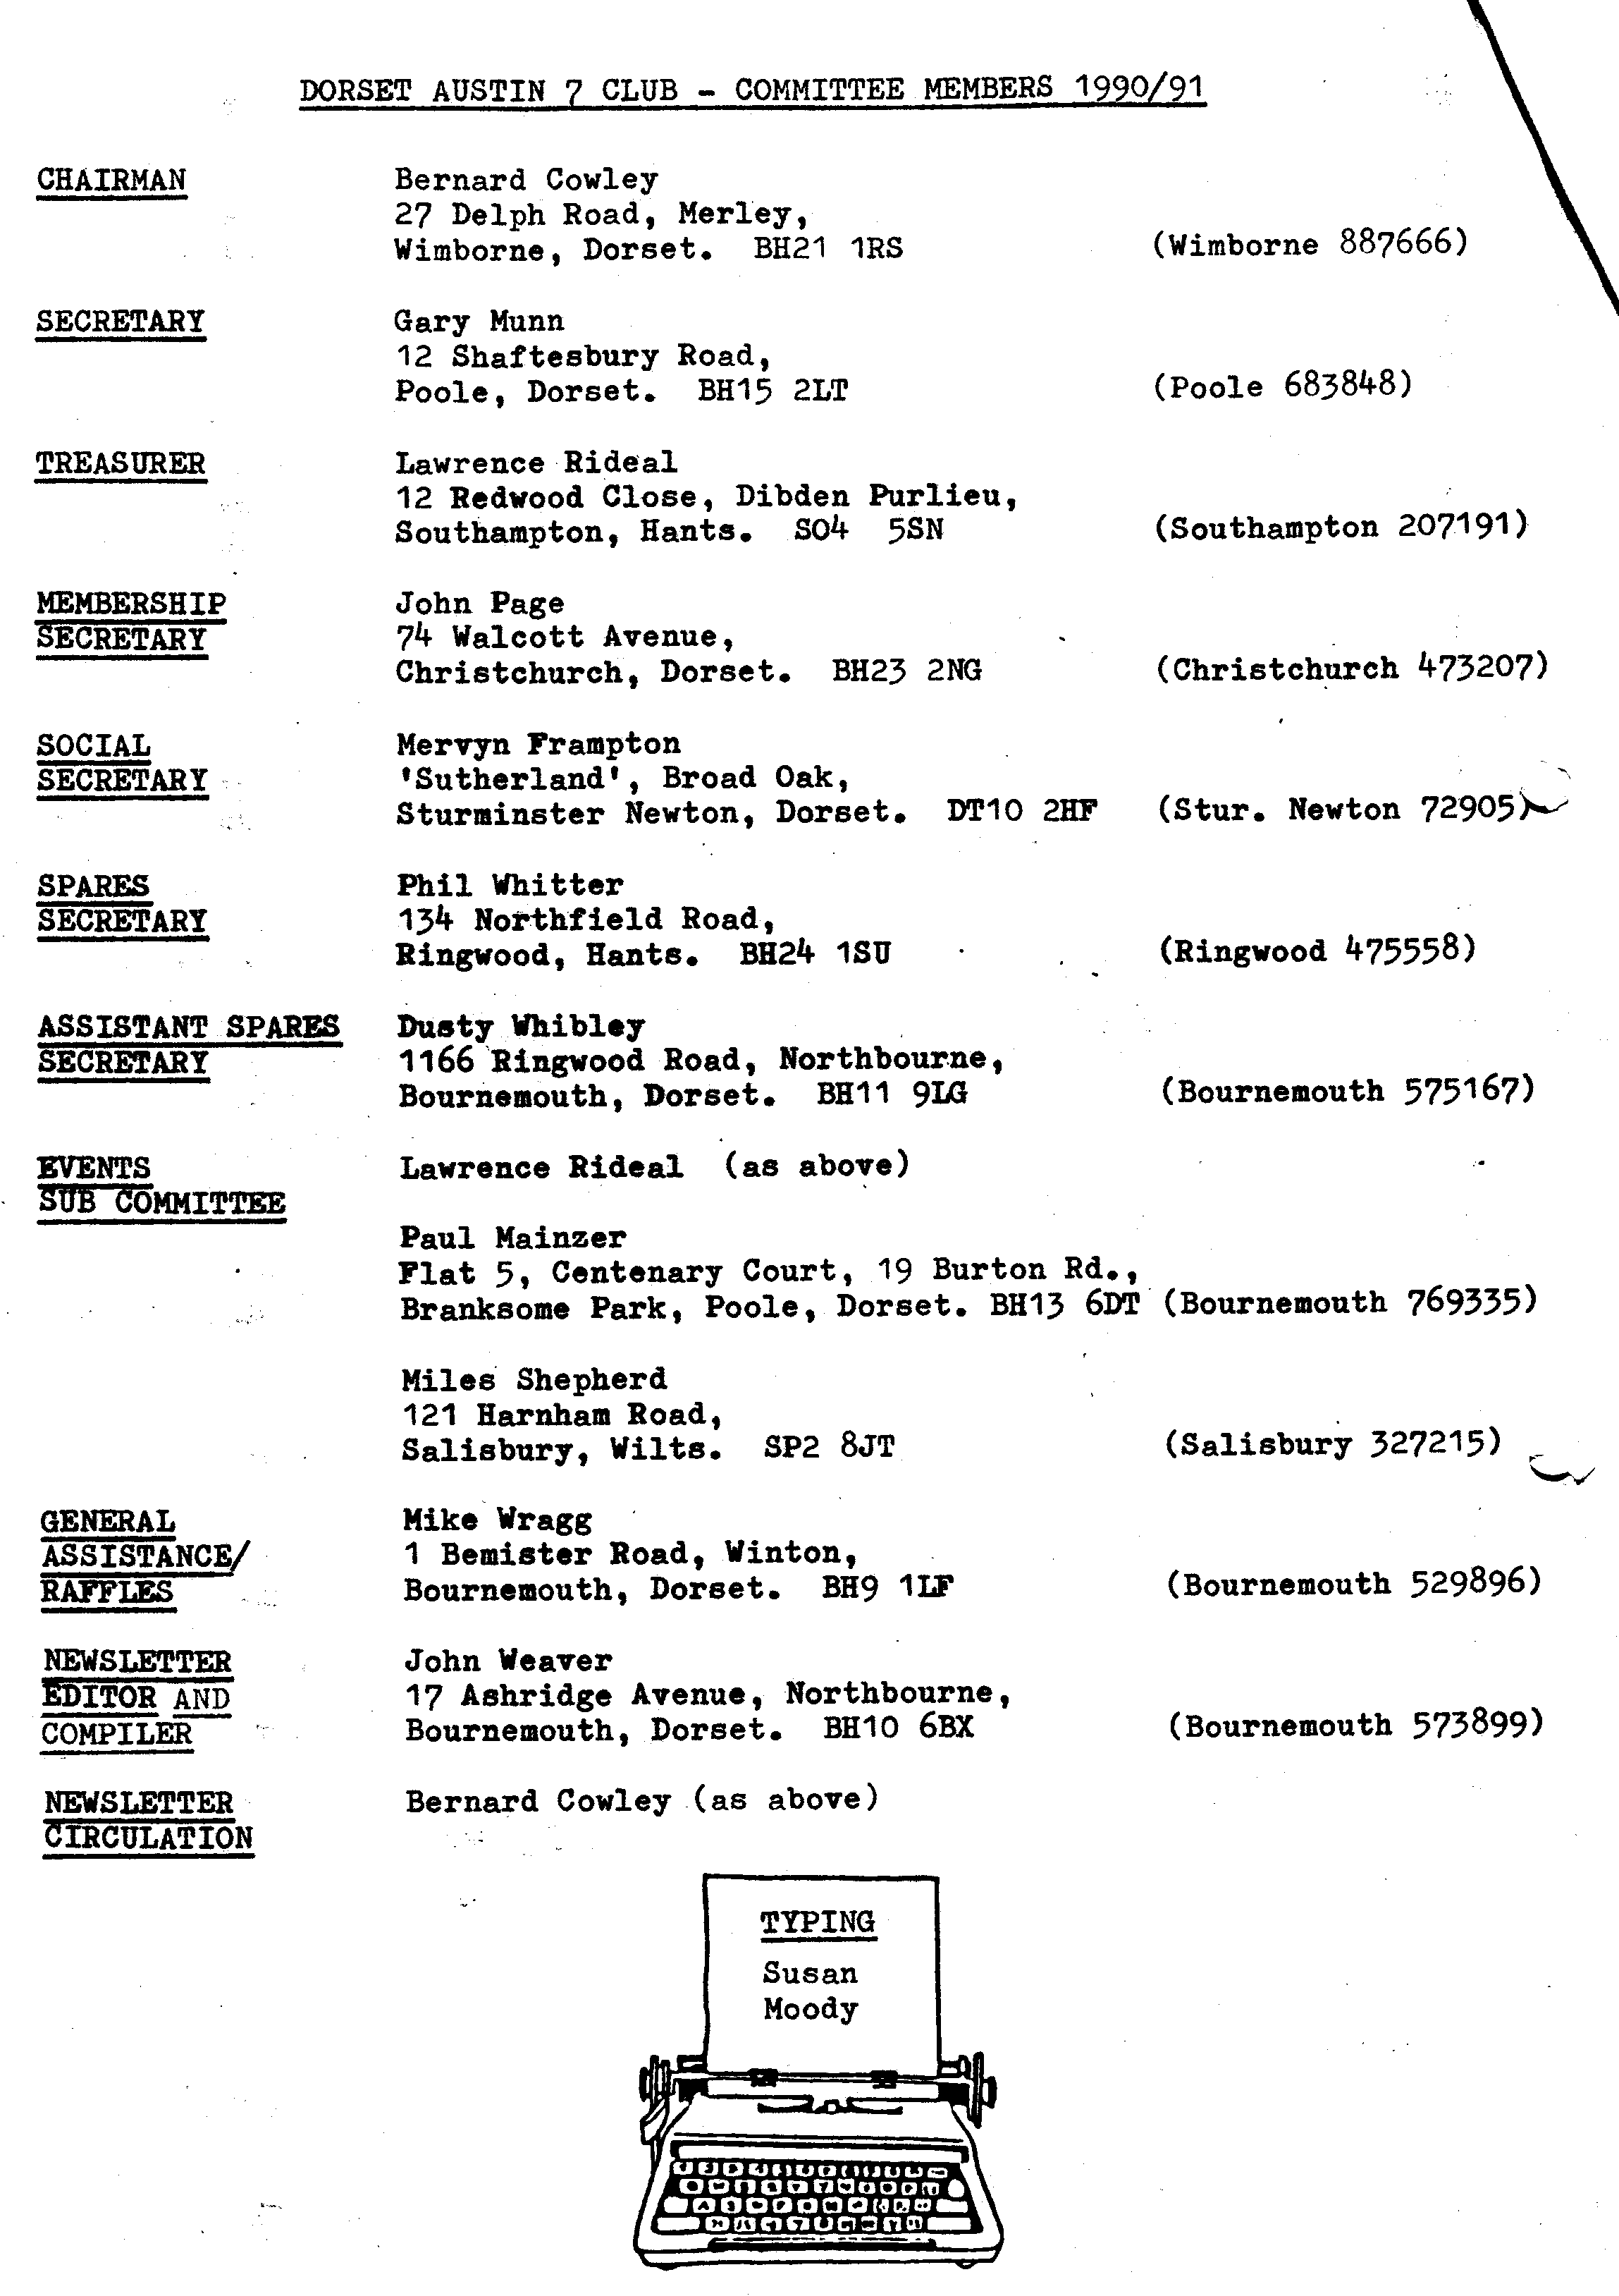
EDITORIAL JUNE 1991
This month's Newsletter once again gives the names of new Club Members. This seems to have become a regular feature in recent months as the Club has
grown steadily in size. The general enthusiasm was evident at the May meeting when more than sixty Members were present. It is also of interest that at that meeting Phil set out the biggest display of spares that the Club has ever seen. What a great job he does.

If you missed the DA7C driving tests you missed a great day out. See an account within, also Biddy's latest profile, Newsletter news and how to re-register your genuine restorations - not to mention the first publication of the 'Munstars'.

Looking ahead, be sure not to miss the Club Barbecue at Studland and let Merv have your booking at the earliest opportunity. Mike has promised to be there!
John.

THIS MONTH'S COVER PICTURE is of Dave and Audrey Thorne's recently restored Ruby which is now gracing Club Runs.

SECRETARIAL
Well Folks,
The first meeting back at the Elm Tree, Ringwood, seemed to go very well. The vote was strongly for staying there and they even opened the bar in the room for us ... we'll see if this continues - I hope so!

Those of you who were at the Meeting will have seen the two cups which have been left to us in the memory of Vic Steele. They are both trophies which he was given in far off lands whilst attending distant rallies, so your
Committee has decided to award one annually at the AGM to the person considered to have used his/her Austin the most during the year, or who has achieved some substantial feat with his car. The other cup we would like to offer annually to the lady we feel has given the most to the Club.

My survey of the hostelries of Poole is coming along well, 22 down, 6 to go. Hopefully finishing tonight. What a martyr, eh? (See the unique result within - Ed.) -

Well my Ruby is just about restored now, I reckon from start to finish it has taken me about 260 hours, that is doing everything except machining and chroming myself. I hope that might prove a reasonable guideline for anyone contemplating a first restoration. Mine was what I would call a full, but fairly straightforward job. Obviously there is more work involved in later cars, as there is a lot-more to them. If you work out roughly how long each task should take you and double it you should be somewhere near the mark.

Must sign off. Now off to Greece - it's a hard life, Gary.
THE DA7C DRIVING TESTS - BLANDFORD CAMP - SUNDAY, 26TH MAY

The Run to Blandford was uneventful, the main body arriving just after 11 am. Although the Camp sentries were a bit taken aback when we arrived in force, together with Paul Nunn's Bullnose van, they allowed us through after a few searching questions.

Already on the old parade ground were Miles, Glyn, Pat, Brian, Bob, Phil, Hilary and Keith. Their early arrival meant that the course was already set up, together with the barbecue and loo tent. The tests were not altogether easy, but nor were they impossible. Thanks to Miles, who had devised the course and the recording of marks. The day went with a swing and plenty of fun.

Over all winner was Dusty, with Jane and the runner-up was Jeff with Marilyn. Well done you lot:

The enormous hard surface available allowed the rising generation to do some serious driving too. Keith Whitter's rolling chassis was busy most of the day giving joy-rides and giving Keith the opportunity to burn some rubber. Scott Whibley's A7 was also finished in time for him to put it through its paces and Daniel Cowley proved how at home he was in the Ulster. Meanwhile, young Edward Ballard tootled around in his little battery operated job.

Grateful thanks to Miles who fixed it for us to use this super venue and planned the event, to those who prepared the site from an early hour and to Club Members who did the judging. It worked out well and was a very enjoyable family event.

George Mooney's latest Seven attended its first event on this occasion. It's a bit classy and was much admired - more detail on this another time.

NOTICE TO CLUB MEMBERS Re-registration of Restored Vehicles.

As you will know, the DVLC is reluctant to re-register the original number plates of vehicles of which registration has lapsed over the years.

Our Club Secretary, Gary, is now empowered to authenticate vehicles which can be proven to match log books, with original numbers and ready to go on the road.

Because of the legal implications, we ask Members who may seek such authentication to only present genuine vehicles with genuine corresponding log books.

The fee for inspection and authentication is £25 for a non Club Member with a discount of £15 for Club Members.

IF YOU DIDN'T SEE Roger Nunn's James van at last month's Club Night you missed a rare vehicle. This three-wheeler is Roger's latest restoration and must be fairly difficult to drive. It's thought to be the only one of its kind on the road. Let's hope that it appears again before long.
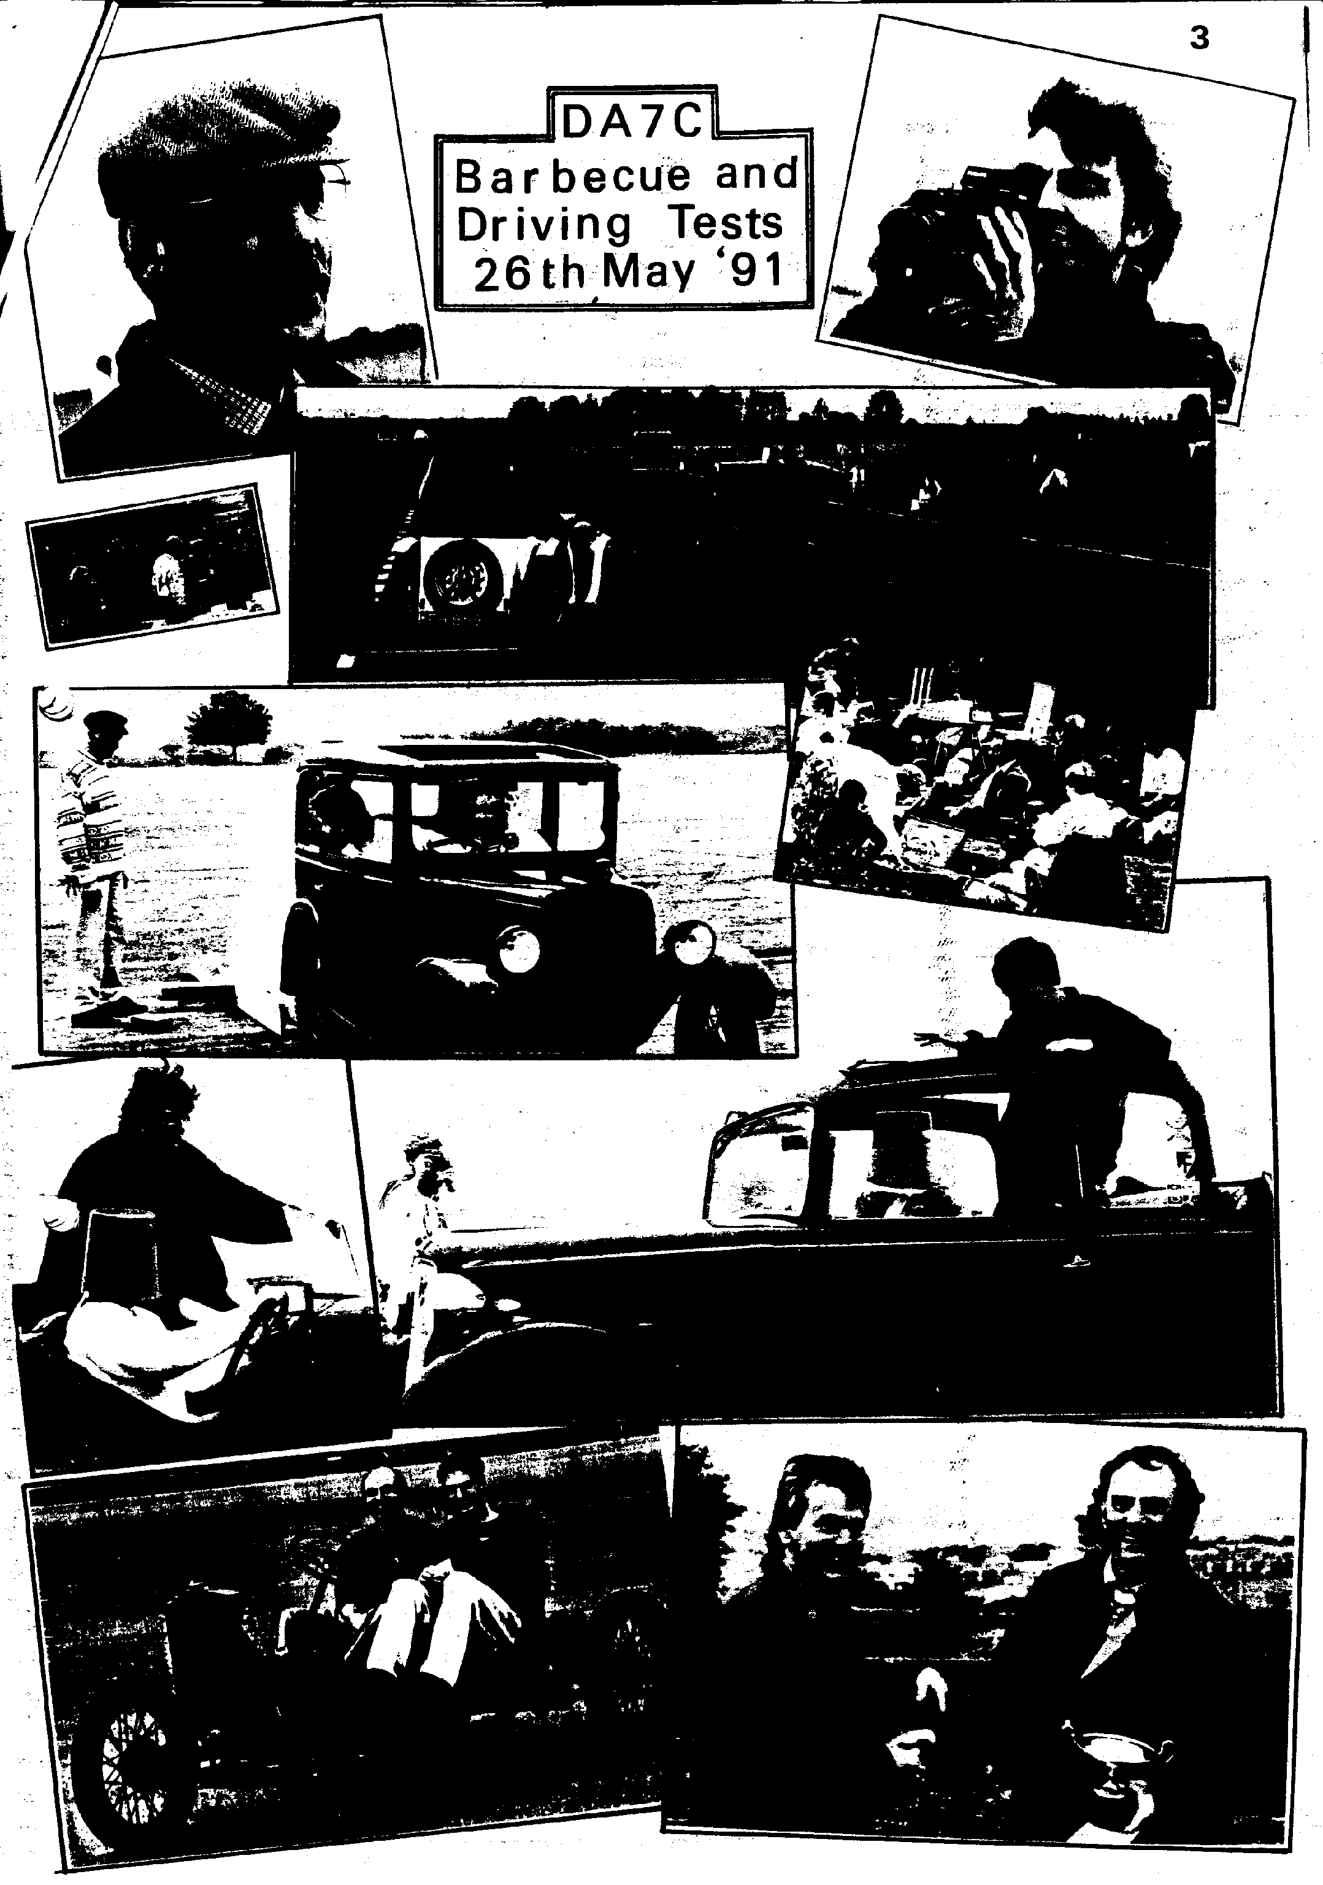
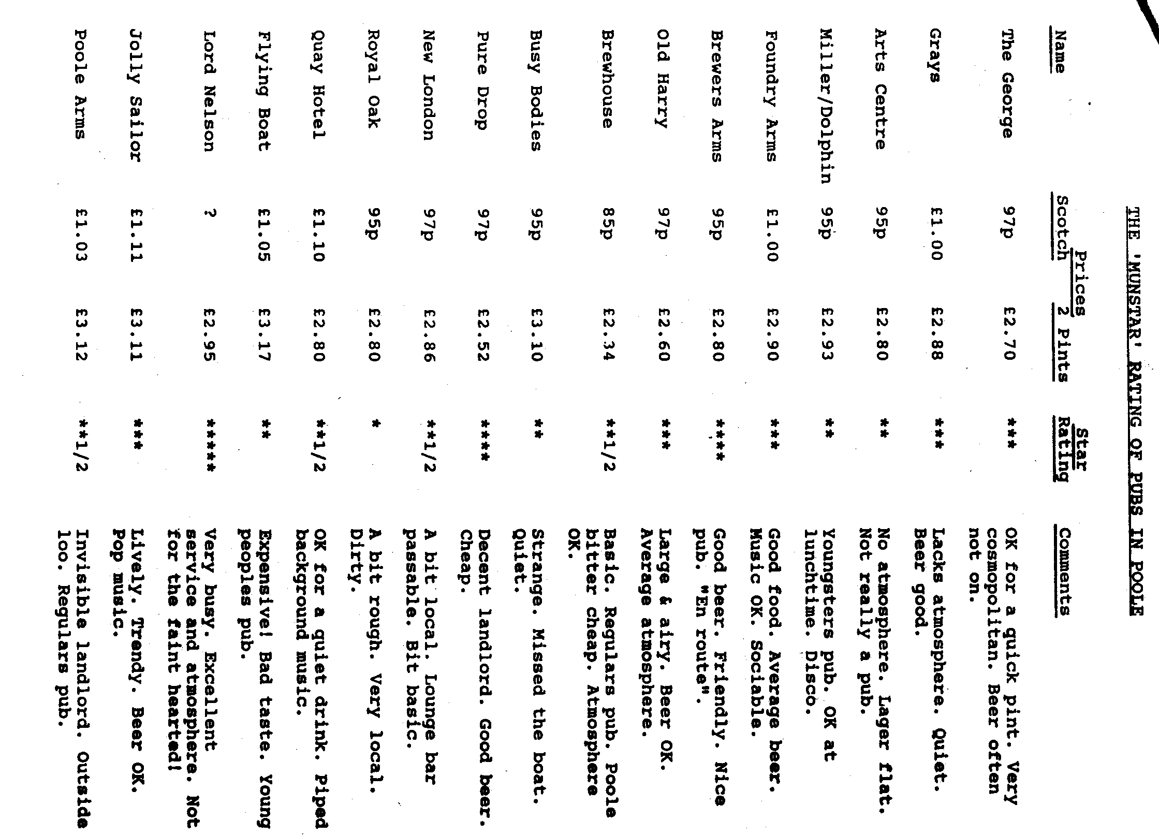
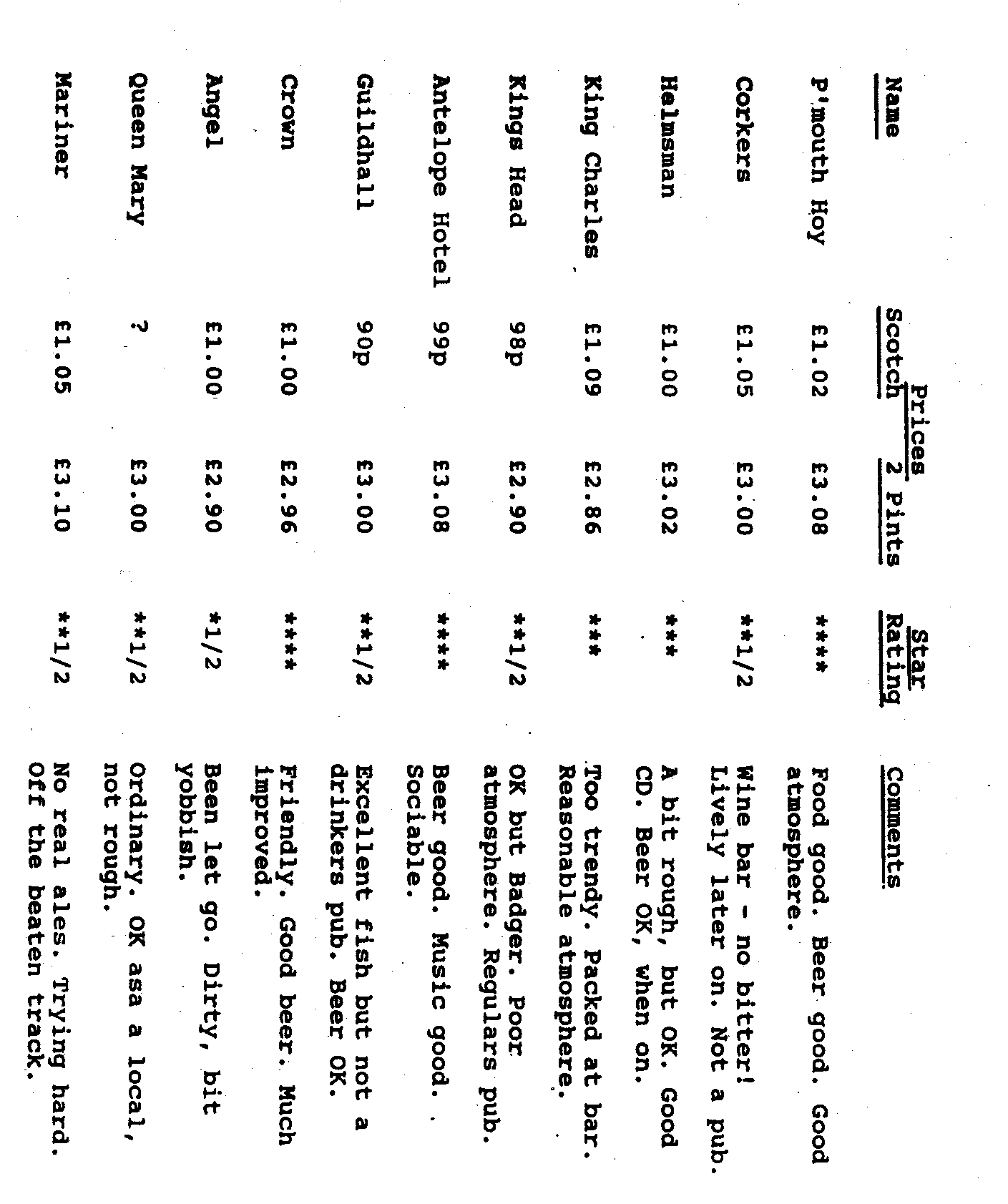

SUMMARY :

The Nelson is an excellent lively pub but should not be considered as a quiet drinking pub. If you feel like a lively night out - OK.
The most surprising hostelry was the Pure Drop, in Lagland St. New landlord very keen to promote his ales - even thinking about a beer festival in September.
If you fancy a good quiet night stick to the 4*'s, if you fancy a good fight try the Royal Oak & Gas Tavern.
For a good fish meal try the Guildhall.
Mine's a large one, but I'm sure you all know that! GARY
AUSTIN 7 BEGINNINGS - 10 - A story of Austin folk. David Whetton.

`I'm one of those people we all hate ' (David's own words!); he goes on.. "my first car was an A7" type'.
I, with the rest of you out there, whose first car also was an A7, say, and I misquote the Bard, 'Me thinks yon lad doth protest too much'. No one, surely no one could possibly hate, (Envy, maybe, but never hate) anyone whose first car was an A7? Could they?.
Without more ado I'll begin again at the beginning.
Not so long ago at the tender age of Seventeen, nay, on his Seventeenth birthday, David was the proud driver - around the empty car park of John Thompson Water Tube Boilers, Bilston. (Is that factory still there I ask?) Later after the necessary, though in David's case barely needed driving test, David the 'brash Boy Wonder continued into hill-starts with the Dreaded Clutch' learning about the peculiarities of A7 brakes. How do you learn about these? - by,,.' ploughing into rear tail pipes of an E-type parked outside the Wolverhampton Art Gallery.'
A driving expert at large, our David then had a spell of taking girls out for a spin into the open countryside. When asked for more detail, David lapsed into.... 'girls; freedom; countryside; girls; independence...'.!
It wasn't all girls; for on one memorable Sunday when proudly driving his Mum, and Dad up Orton Hills, they had to get out and walk. (A quick peek into a reference book shows Orton Scar to be near SHAP, the gateway to the Lakes. I'm presuming that to be the right Orton of course.) Another time trying to get the wipers to clear snow proved impossible: it had to be removed manually. Even this remarkable Austin 7 took up ballet dancing! it 'gracefully pirouetted all the way down Lloyds Hill.'
Sadly this good fun became just a phase as Shap Fell proved too steep for continuous trips to Glasgow University. Sold for the princely sum of £10!
We all know David by his Dark Blue Opal. How did that come about?
Doggedly determined, David waited outside the local paper shop at 6 a.m. in order to be he first to get to the 'Car For Sales' bargains out of Exchange and Mart. He got the owner out of bed to be told that the 'Bits' (another failed project), were to be sold to the firstcomer.. Hastily, taking a total chance, David hired a trailer, drove poste haste to Horsham and bought the wreck back home to rebuild. Here he has a note of advice for all those would be 'do-likewisers'; 'join a club immediately'. David waited until he was on the road in 1986, only to find that on his first club run he had put various engine bits on completely wrong!
He found only the club by chance; for having phoned round and around trying to find information on Austin 7 clubs someone casually commented 'by the way there is a DORSET club'. How to make contact?..'Go to the Daffodil Run and look out for the Pink Austin Seven'. He did just that as no doubt George well remembers.
Now of course through the Mathematics books written by David, Austin Sevens are well to the fore. Practical problems concerning true statistics on Breakdowns, Breaking Distances etc. of Austin Sevens, form part of the exciting and popular material that lucky youngsters of today are working on. (Thinks - A7 Mathematics evening led by David?) -
B.B. May 1991,

MOTORCADE_91 (2nd June)
BRAEMORE is becoming only second in popularity to the Great Blandford Camp Barbecue and Driving Test as an outing for the Dorsetshires and the '91 event has topped all records with 22 "vehicles". Although the day appeared dull and, at times, decidedly chilly, my beetroot face gives a contradictory testimony. The auto-jumble and ticky-tacky stalls were the usual tacky jumble (except for Bernie's Books, the ubiquitous Enticem and Entrapem and the elegant florist from Merley of course) and even Phil-the-Spares could only come away with a box of bulbs of doubtful utility. While I'm in an untypically critical mood, members of the WVPC might like to pass on to their Committee several comments received about how Motorcade is getting a bit samey, even without the authoritative performance of the Commander. It would be easier to list those who were not there, but here goes (in chronological order) :'23 Austin Bullnose (Paul Nunn); '28 Chummy (Paul & Emma); '31 Tickford (Glyn, Pat & Grandson Joe); '31 swb Box (Dusty & Jane); '31 RM Box (Jeff & Marilyn); '31 swb Box (Merely Roger); '31 swb Box (Len & Mabel); '32 lwb Box (John & Gay); '33 lwb Box (Ben & Marion); '34 lwb Box (Alan & Margaret); '34 Chassis 1938038 (Keith); '34 Ulster (80% Scott & Michelle); '34 Nippy (Bill & Norma); '35 Opal (Biddy); ‘37 Ruby Mk.1 (Gordon); '37 Ruby Mk.1 (Gary & Sylvia); '37 Cabriolet (Peter & Jane); '37 Grasshopper (Vic Nunn); '37 Opal (Jane, Rebekah & Loo Brush); '38 Ruby Mk.2 (Gordon & Lena); '38 Opal (David); '39 Austin James Handiman Van (one wheel missing Roger Nunn). And many others who were at the event but sailing under other colours.
I was approached by an enthusiast from Andover who wants to join the Club. "There must be a club nearer", I said. "But not as friendly", he retorted. That's what it's all about.
David Whetton.
,
RINGWOOD JUNIOR SCHOOL in Parsonage Barn Lane is holding a fete from 1•30 to 4•30 p.m. on 29th June and would like some A7s on display. If you can attend please inform Chris Smith (Ringwood 619212) who will also have further details.

...In the Beginning

In the first book of the Bible, Guinesses, Adam and Eve were created .from an apple tree. Pharaoh forced the Hebrew slaves to make bread Without straw. Moses led them to the Red sea, where they made Unleavened bread which is bread made without any ingredients. Afterwards, Moses went up on Mount Cyanide to get the ten commandments. David was a Hebrew king skilled at playing the liar. He fought with the Philatelists.... Solomon, one of David's sons had 500 wives and 500 porcupines.

CONGRATULATIONS to Merv Frampton who has recently received an award for giving 50 pints of blood over the years to the transfusion service. Those who know him will not be entirely surprised for he is well known for his selfless efforts on behalf of others, nevertheless this is quite an achievement. He declares that he gave his first pint as a student when he heard that the reward was a pint of beer. Even though it turned out to be a cup of tea he continued to be a donor. Who knows, if you've ever had a transfusion you may have Merv to thank.

THERE WILL BE NO NEWSLETTER in August this year, to give those involved some relief during the holiday month. The July Newsletter will therefore be a July/August edition. Committee Members please note - it will be necessary to plan events for July, August and early September at the June Committee Meeting. Please come prepared.

NEW CLUB MEMBERS, Welcome to B Baldwin, D Rogers and S Dean. Don't be afraid to make yourselves known at Club Meetings.

THANKS to Jane Whibley who has again supplied addressed labels to make the dispatch of the Newsletter easier. _

JUNE Thursday 20th June. CLUB NIGHT at the Elm Tree. 8.00 p.m. Bring your car for a lighthearted CONCOURS D'ELEGANCE. Spares only available by prior request this month.
Sunday 23rd June. CLUB RUN. 'Way out west' with the Framptons. Meet at the Safeway Car Park, Wimborne at 10.30 for 10.45 a.m. Note: There will be some rough farm tracks involved in this Run. (But not car wreckers!)
Thursday 27th June. COMMITTEE MEETING at the Tyrrells Ford. 8.30 p.m. Committee Members see note within.
JULY Thursday 4th July. '9 to Late' (for those who want to meet for a natter) at The Dormers, Wimborne.
Sunday 7th July. 750 Motor Club NATIONAL A7 RALLY, Beaulieu. Saturday 13th July. CLUB BARBECUE, Studland. Details within.
Thursday 18th July. CLUB NIGHT. Details in the July/August Newsletter.
Saturday 27th July. Worth Matravers Village Fete. Details in the April Newsletter (when the incorrect date was given).

FUTURE PROGRAMME

In the winter months Phil is aiming to organise a talk (or talks) on rebuilding your engine and other mechanical problems. If you have had any unusual problems or have useful tips to contribute for the benefit of other Members please tell Phil on Club Night.

