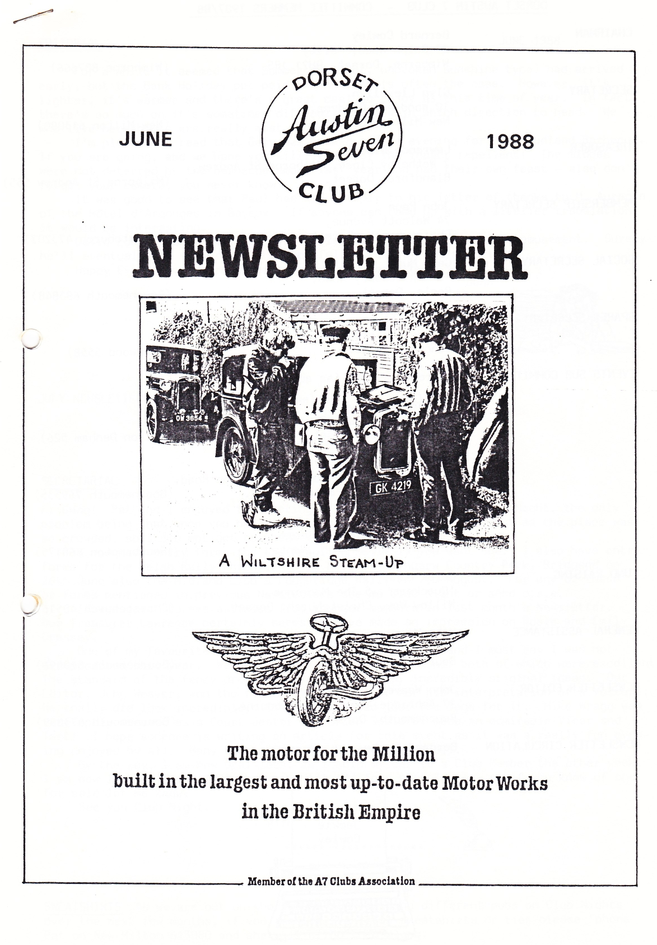



EDITORIAL JUNE 1988

For a while it seemed that Summer (the hot, unbroken sunshine type) had arrived early, but the Bank Holiday put paid to that, as is often the case. However, it's lighter, it's warmer and there's a great deal to enjoy at this time of year. In fact there's so much on it's sometimes difficult to know in which direction to head. We who live hereabouts are really most fortunate.

I'm pleased to read that Gary has booked a fine evening for the Studland Barbecue. If you are going, and we hope you will, remember the insect repellent! The midges were not deterred by the barbecue smoke last year and had their own feast - also don't forget your camera; you never know!

It was good to see that Paul had had a reply to his letter of thanks to M. Auregan of the Hotel d'Argouges in Bayeux. If anyone can come up with a livelier translation it would be interesting.

David continues to describe his foibles for our instruction and amusement. Surely he'll eventually be victorious and, hopefully, full of satisfaction. Happy Eventing, and remember to use that grease gun.

John

SECRETARIAL

Hi Gang! Pat and I enjoyed the meeting at the Cross Keys last Club Night, the only problem being that once you had seated yourself, you had to stay put as the place was so crowded, so I did not get to speak to many Members.

I now have entry forms for the Beaulieu Rally if you want one. I also have entry forms for the Welsh Rally which is to be held at Bryngarw Country Park, Bridgend on 26th June also the Midland Club's Longbridge Rally on 7th August. For any of these

or forms mentioned in previous Newsletters see me Club Night or send s.a.e..

It was great to see articles from younger members in last month's Newsletter. Our Treasurer Lawrence certainly seems to have made an impression on Rosie and Emily Cressey.

One of my favourite social events is the Barn Dance, and I must say I was not disappointed this year. We had a new venue and a new band, both of which were excellent. The standard of the fancy dress was amazing with may incredibly original ideas. Our Editor, John Weaver, won the first prize this year for his interpretation of a Vulture. He really did look incredible; I thought he had just the legs for it. Mike Wragg was very aptly dressed as a Court Jester and Brian Toalster made an admirable Vicar and Tart! I hope someone is writing an article for this event as it was a really fun even­ing enjoyed by all. Many thanks Gary for organising it all.

By the way, I am now Opal-less, as I sold my car to a Club Member the other week. I am now looking for a 1930 Chummy or '31-'33 four seat Tourer, so if you know of one for sale let me know.

See you Club Night.

Glyn

SWEATSHIRTS As we are out on short runs and visiting different pubs on Club Nights over the next few months, if you require T-shirts, sweatshirts or ties please 'phone Pat on New Milton 613080 and she will bring them along.

APRIL CLUB RUN TO YEOVILTON AIRCRAFT MUSEUM

A really good turnout of Austin Sevens set off from Wimborne Square on a bright and sunny morning en route for Sturminster Newton Mill to pick up our leader, Richard, and several other club members.

Richard had plotted a really pretty scenic route and we all arrived

without mishap - apart from losing Gordon for a purpose we won't mention - at a pub in Corton Denham. Here we enjoyed a very good meal on rather

novel tables; large wagon wheels topped with glass - no having a good scratch or playing kneesies under these!!! The publican seemed very pleased to have us there arid took photographs of all the cars lined up outside. I trust this will be displayed in the bar for posterity.

It was only a short drive from the pub to the Aircraft Museum and we were able to negotiate our usual party rate - the cost of which included an Airjumble! Some of our party got quite excited at the prospect of surveying used khaki long johns, old pieces of engine and jackets with bullet holes plus numerous pictures of airplanes. Yawn! Yawn! We eventually got into the museum proper and this kept our male members happy for quite a time although I got the impression that they were in the middle of rebuilding the place - it seemed somewhat in disarray!!

Thanks Richard and Margaret for an enjoyable day out.

Jackie

THE RUN THAT WAS NEARLY TO THE AMERICAN MUSEUM AT CLAVERTON - SUNDAY 22nd MAY

That excellent service offered by Gary and Glyn to keep our cars on the road included delivery of Gabrielle J. on the morning of Sunday May 22nd in time for us to make the run. The French roads had shaken our tank bracket loose and the clutch had required attention. Gary continued in his own Box, collected from our garage, and when Pat joined us at Wimborne in the Ruby, the final shuffle was completed. Mike arrived in his Special, Jill and Brian in their Box, Rob in his Ruby, Jackie and Bernard, whose Wedding Anniversary it was, arrived to lead us in the Chummy - hood down - and Jo joined us in her Morgan. All in all a modest but pleasing turnout.

Avoiding as many main roads as possible, we travelled directly north overlooking Cranborne Chase with one stop while Gary attended to his own steam up. We passed a 'Steam Party' near Shaftesbury into which a policeman attempted to direct us and arrived at Farleigh Hungerford - or was it Charley Hungerford? - for lunch where the Cressey family were waiting for us. Also in the car park were two fantastic 'Gold Wing' motor bikes - complete with tow bars and stereo equipment!! The weather was gorgeous; we benefited from the sunshine and happily escaped the wind. That goes for our after lunch comfort also.

We had a good meal in pleasant surroundings overlooking Farleigh Castle around which we walked before departing. Jill and Brian left us to visit Brian's father in Bath and by that time no one fancied a visit to a museum, so we drove to the Kennet & Avon Canal aqueduct and enjoyed a picturesque walk along the canal for some distance until we came to a tea gardens.

There we refreshed ourselves and conversed about cars, the weather, cars, holidays, cars, cameras, families, cars and cars, then reluctantly left to commence our two hour journey home.

When we reached the 'Steam Party' it was dispersing so our little convoy became interspersed with steam engines!! As we all negotiated the large roundabout to head for Blandford along the 'top' road, the manoeuvring became an-absolute work of art, but with our usual panache all went well, we lost the steam engines and a delightful run came to a very satisfying end.

Thanks Bernie and Jackie, we hope you enjoyed your anniversary.

Gay

THE BARN DANCE '88

Expectations were running high prior to the DA7C Social Event of the Year and

were certainly exceeded in the event. This year's Barn Dance even outshone last year's and must be rated a Great Success. Thanks to the Diggory Venn's lively music and calling that even the flat-footed and beer laden could understand, the dancing went with a real swing.

As for the fancy dress costumes - every one was a winner! The ingenuity and imagination displayed was amazing, ensuring an evening of memorable fun and frolic.

Where else could Sister Glyn dance with Pongo the spotted dog, or Wolf Cub Pat with Cruella de Ville? There were various other transvestites, a Nurse and Patient, Punks, a Vicar/Tart with angelic (?) Choirperson, Compo, Romans, Cowboys, Country Cousins, Andy Capp and Florrie, a menacing Flasher, a real Mummy, a French Connection, a recumbent South American Gaucho plus Squaw, a lady Referee (unfortunately with a red card), a Parrotical Pirate, Clowns, a Waitress, Ladies in various finery and a Madman riding a Vulture. Congratulations to all those in costume; the standard was terrific. What about a 100o costume turn-out next year folks?

None of this would have happened without Gary's determination to find a good

venue and a suitable Band; plus a date convenient to both. It wasn't easy this year.

, Thanks Gary and we know that you must feel that your efforts were well rewarded.

..,Thanks also to Derek for another good raffle and to those who donated prizes. It was a marvelous evening.



BODGERS CORNER - THE OPAL SAGA VIII : THE STORY TAPERS OFF *44

At the end of the last gripping instalment, our intrepid hero/idiot had taken his Preciousness to pieces for the second time only to be left with Yet More Knocking. His state of mind was no longer suicidal but definitely murderous. There was-.nothing left now but to resort to the final solution, to visit the Shrine of All Knowledge, to ask He Who Knows All. After much sucking of teeth and puffing out of cheeks, He Who Knows All said he hadn't seen anything like that before but turned the starting handle once or twice and gave his pronouncement - "I've known crankshafts break immediately they've been replaced. I should go home very slowly." However, he had put me on the right track. With the flywheel cover off it was quite clear that when one turned the handle at the front, the big wheel at the back didn't go round in unison. Either the crank was broken again or the flywheel had come loose.

Out came the floor. Out came the gear box (after removing the prop shaft, triangular bracket that holds part of the floor to the cross chassis and gets in the way of the oil filling bit, the speedo cable and clutch pedal). Off came the clutch and flywheel. Total time one and half hours. The mess told the story. Clearly, when I had tightened down the flywheel (see confident article Opal Saga II) it had run up its taper until it was tight against the rear bearing. All seemed well of course until a

few miles of wear at which time the flywheel went slack and, not being snug on its taper, started to wobble a lot. A few phone calls to the wrong people convinced me there would be no other flywheels north of the equator. (It's only afterwards that the right people say 'You should have rung me - I've got three hundred in the garage!') and there was N,.,) way I was going to replace the crank all over again. So this is where true Bodging

comes into its own - remove the bit of the flywheel that is rubbing against the bearings, (the Boss). This then allows the flywheel to come forward along the taper. Now remove the new bit of the flywheel that is rubbing against something else. Repeat step two until (a) there is nothing left of flywheel or (b) all is clear. An alternative ploy is to grind down those annoying little bolts that stick out of the crankcase. A true Bodger will have a go at everything so that the end product is an amalgamation of several strategies. Being fully satisfied that any further work will destroy your amateur status, replace clutch, gear box, tighten all bolts, replace bracket, prop shaft, clutch pedal and floor. Try clutch. Realise that you left the speedo cable dangling down and it's got trapped behind the gear box. Undo floor, bracket, prop shaft, bolts, remove gear box. Tie speedo cable out of the way. Replace gear box etc.. etc.. Try clutch. Smile. Total time 12 hours.

However, the question still remains - when one tightens down the flywheel how can you be sure it is on the taper and not on the bearing? But that's someone else's problem now. Mine works! Until the next time. -

David Whetton

P.S. It was lovely to see so many new cars out on the first Thursday run.



6

EVENTS

JUNE Thursday 16th June - Club Night. Evening Run to Rockbourne. Meet at the Elm Tree at 8.00 pm.

Sat/Sun 18th/19th June - Week-end Club Run to the Spye Park Rally. Meet at the Furlong Car Park, Ringwood on the 18th at 9.15 for 9.30 am.

Thursday 23rd June - Committee Meeting at the Rising Sun, Bashley, following the Pennington Junior School Fete (6.00 to 8.00 pm)

Saturday 25th June - Charlton Horethorne Feast Day (See April Newsletter and within). Merv and Fran Frampton have kindly invited those attending to have tea at their home at Broad Oak nearby after the Event.

Thursday 30th June - A Casual Tennis Evening A7 v Morgans at the home of Bob Wright (near the Elm Tree Inn) All welcome but we need a team

of ten Tennis Players for a lighthearted match. Further details from Bernard or Chris Smith.

JULY Saturday 16th July - Club Barbecue, Studland. See details within. Thursday 21st July - Club Night. Evening Run to Milton Abbas. Meet at Wimborne Square at 8.00 pm.

Sunday 24th July - DA7C Vintage Picnic Tea Run - with Strawberries and Cream! Meet at the Furlong Car Park, Ringwood, at 11.30 am. After

a pub lunch there will be an afternoon run ending with a forest picnic. BRING YOUR OWN PICNIC - but Strawberries and Cream will be provided.

Thursday 28th July - Committee Meeting at the Tyrrells Ford at 8.30 pm.

WIDER EVENTS

Sunday 3rd July. National Austin Seven Rally - Beaulieu. Entries before 21st June. (Glyn has forms).

Sunday 17th July. Solent Austin Seven Club Summer Rally - Marwell Zoological Park. (Glyn has details).

19th/20th/21st August. Purbeck Rally and Autojumble - Ridge Farm, Wareham. Entries by 31st July to K.Ford, Elm House, 50 Mill Lane,

<

Wareham.

25th September. Austin Seven Owners Club Autumn Amble. This is from Reading to Bognor Regis. The Run can be joined at Reading, Hindhead or Midhurst. (Bernard has details).

Some late news has just come in that we are pleased to add to this month's Newsletter.

Mervyn Frampton is planning a marathon cycling adventure and he writes as follows :­

"I intend to cycle alone from Land's End to John 0'Groats. I will have no support (or truss :) or back-up. I aim to complete the ride in

about 17 days, starting on Saturday 23rd July. I am hoping to raise money for two charities, Leukaemia Research Fund and Cancer Research Fund.

British Rail have already sent me free tickets to Penzance and back home from John O'Groats. If any Club Member would like to sponsor me I

will have forms with me at Club Meetings. Alternatively Chris and Linda Smith will be collecting on my behalf. I know one of the charities is very important to them."

This sounds like a brave project which really deserves our support.

CHARLTON HORETHORNE FEAST DAY - 25th JUNE

We hear from Margaret Cressey that plans for this are going well. As she told us in the April Newsletter she and Richard would value the support of Club Members for the classic and vintage car display.

Although there is an over-all Victorian theme it would be appreciated if any Club Members who can do so would arrive in costume, but appropriate to their cars.

' There will be a lot of things going on in the village of interest. We thoroughly enjoyed it last year. This year's attractions include competitions, among them one for costume, one for ladies' large and incredible hats and one for knobbly knees. Hopefully this will be judged by Patricia Greene (Jill Archer of Radio 4) who knows _ her knobbles you can be sure.

Perhaps those of us who are going could join up for the Run and can fix something on Club Night.

Ed.

A N N U A L B A R B E C U E

STUDLAND - 7 p.m.. - SATURDAY 16th JULY

Arrangements have once again been made with the National Trust to hire the site on Studland Beach. Your Chefs are all prepared and of course we'll even offer a free glass of wine or a soft drink. Remember your swimming gear - although not mandatory. We've booked a fine day so there will be no worries about getting wet, although as usual, if our request has been forgotten, turn up at my house!

Hurry and book now; and remember this is a great event for the kids.

Please return application to: Gary Munn, 12 Shaftesbury Road,

by 3rd July 1988 Poole, BH15 2LT

Remember to bring a bottle and a glass, swimming gear and perhaps a chair.

---------------------------------------------------------------------------------­

Please reserve me places, including supper and free glass of refreshment.

I enclose x £3 Adults  
 x £2 Children  
Total £ payable to the Dorset Austin 7 Club.  
Name Address   
...............................

