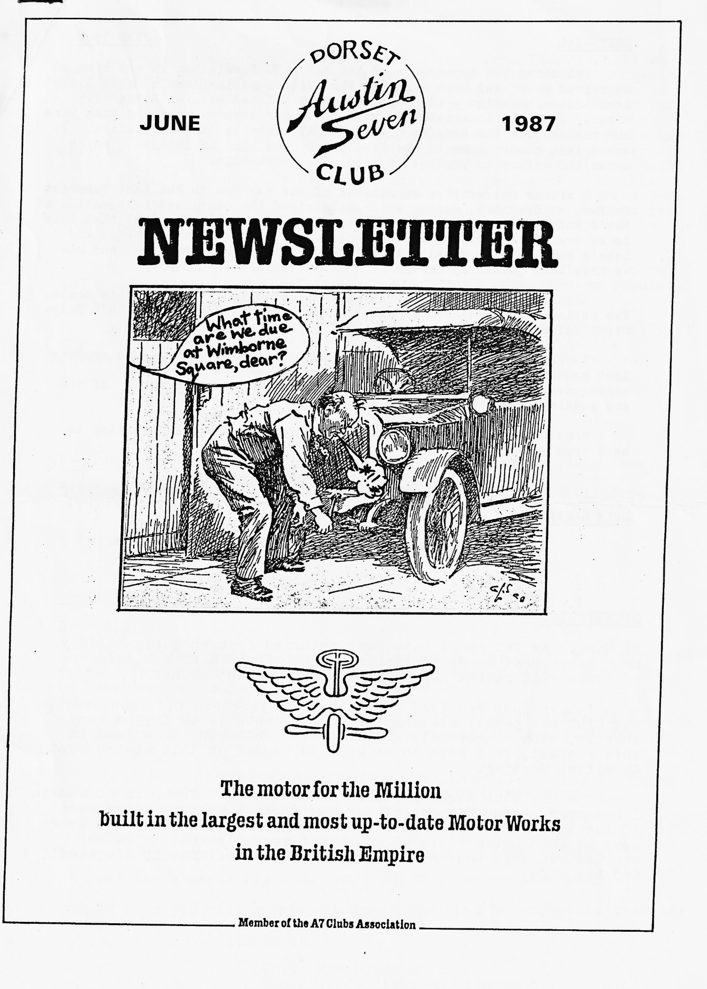

EDITORIAL JUNE 1987
Following the appearance of the May DA7C Newsletter it was nice to hear from Geoff and Daph Canning, the Editors of the Austin Seven Clubs' Association Magazine - the professionally printed mag. with the grey cover. They are interested in publishing our item on renewing kingpins and bushes, for the benefit of all the A7 clubs in the Association. It seems that other items in the Newsletter were also of interest, which makes the effort to produce it even more worthwhile.
Lawrence has written an account of the May run to the East Somerset Railway at Cranmore, during which we admired the continued restoration of Rob's Ruby. The spotless front axle and engine belie the fact that this is no trailer car by any means. Rob rarely misses a run. Gordon and Lena's Ruby is also usually in evidence, plus Glyn's stalwart, and now we have been joined by Mervyn F.'s newly restored red Ruby.
All this made me think that we could spotlight the Ruby this month. Two articles are included concerning the specification of the 1936 Ruby. Fifty different metals – incredible!
As Phil is on holiday in Greece and the machine he used to produce last month's Newsletter is still cooling off we must make other arrangements for this issue. Bernard thinks he can make them. If you are reading this, he did.
Many thanks to this month's contributors. Am I still waiting to hear from you ?
John Weaver.
+++++
JULY NEWSLETTER
Your contributions are needed - by 4th July please.
+++++
SECRETARIAL
Hi Gang. As Pat end I have just returned from on early holiday on a Narrowboat in Hertfordshire, I am afraid I am a little out of touch with recent happenings on the 'Seven' scene.
I have just received a letter from Filaspun Ltd. concerning our Club car badge, stating that an estimate is to follow very shortly, club member Bill Quale is also following up a lead in this respect, so I hope to be able to report on this at the next Committee Meeting.
The May club night produced one of the best turnouts of Austin 7s I remember seeing for one of our meetings, I believe there were 16 Austins, a Morris, a Ford and a Morgan on the run to the Cross Keys at Mannington where we all had s very pleasant if rather crowded evening and where we were made very welcome by the Landlord and his wife.
Now that the rally scene is really underway again, I hope to see many of you at the various events held both locally and by other A7 clubs. It would be nice to see a good turnout at the National Rally at Beaulieu in particular as this is the 25th Anniversary of this rally. Spye Park Rally, run by Bristol A7 Club is another very popular event for the Dorsets, and quite a number of us will be camping there again this year; end doing the "Stone's and Pebbles" run on the Saturday.
By the time you read this Breamore House Rally will have come and gene and also our own Barbeque at Studland, always very popular. I do hope that the weather is kind to us again this year.
Our neighbours, Solent A7 Club, are holding their annual rally at Marwell Zoological Park at Winchester in conjunction with the Eastleigh Vintage Machinery Preservation Society, on 19th July.
See you Club night, Happy Rallying.
Glyn
Stop Press Good news. I have just discovered that Andrew Lowe, sided by Keith Mariner, will be able to Produce a DA7C car badge for us in cast aluminium. The material will come from melted down old A7 castings and the price will be reasonable.
Glyn
+++++
CORRESPONDENCE
Dear All,
Due to the great response and support to the Charity Party/Disco held last year, and the fact that everyone had such a good time, we have decided to have another one.
We hope that we will be celebrating the fact that Rachel (our 2nd daughter) has finished her two-year course of treatment for Leukemia.
Last year our Party/Disco raised just over £1,000 and it .would be nice to think we could reach a similar total this year.
You have good notice this year for the party is being held on 24TH OCTOBER 1987 from 8 pm - 1 am at AVON COUNTRY CLUB and the tickets are still only £1.50 (same as last year)
We hope you will support us again and have an enjoyable evening. Thank You.
Chris and Linda Smith
Brookfield, Hightown, Ringwood.
Another letter I have just received come from Stuart Phillips of the South Wales A7 Club. He informs me that they have changed the venue of their Notional Rally from Llandewi to Park Mill, which is also in the Gower, 1 mile past Swansea Airport. I have entry forms.
sided by Keith Mariner, will be able to produce a DA7C oar badge for us in cast aluminium. The materiel will come from melted down old A7 castings and the price will be reasonable.
Glyn
+++++

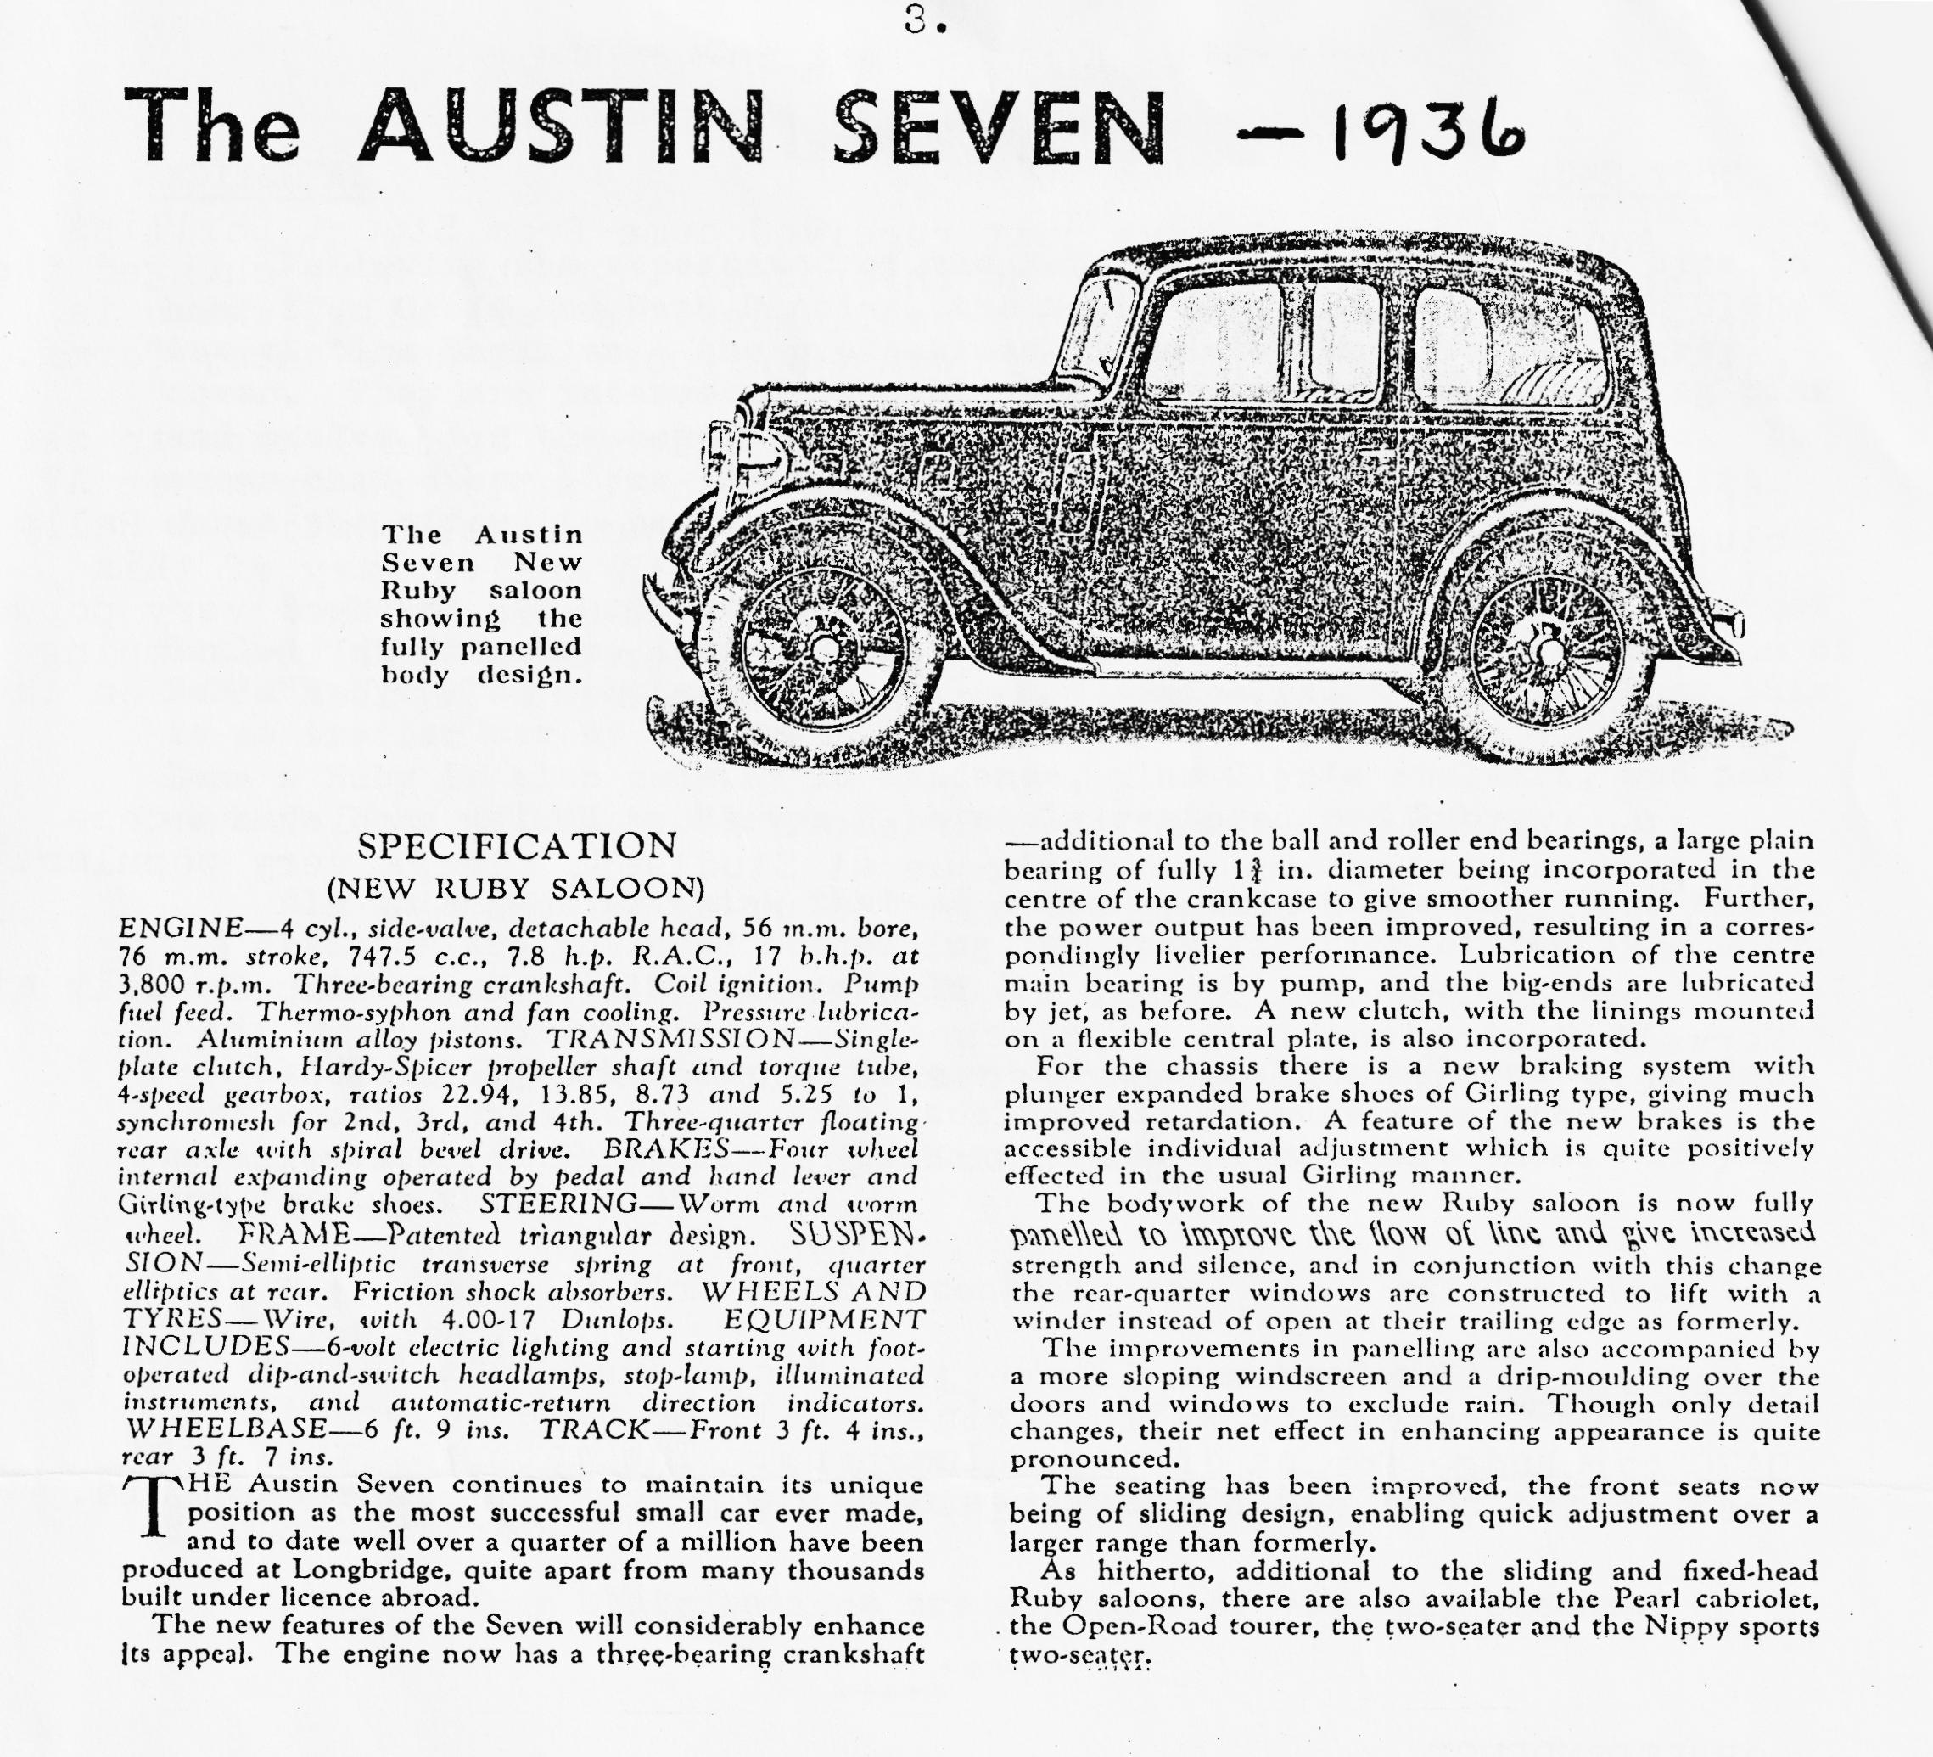
++++++++
Bournemouth and Poole Preservation Club Road Run 1987
This was run in conjunction with the 'Bournemouth 30’s Festival'.
The DA7C was well represented by Brian & Jill's and John & Gay's Boxes, Dave's Opal (with fair daughter Rachael), Nick in his Nippy and by Bernard, Jackie & Daniel in the Talbot. Bill Q. also appeared at Ringwood plus Nippy.
The run was from Bournemouth Station to Ringwood via Lymington and then, after a lunch break, on to Bournemouth Pier Approach for display and inspection by the Mayor. The South Hants Car Club joined the throng at Ringwood, together with their French exchange motor club members driving some pretty exotic and rarely seen French cars. The crush at the Pier Approach was inevitable with some two hundred cars and motorcycles.
The highlights of the day, apart from the amazing range of veteran, vintage and classic vehicles were the Thirties costumes (Brian T. looked superb - and ghastly - those knees!) - the wind-up gramophones (Come back Geraldo), live accordion music from Gay at Ringwood, the DA7C 'reception committee', the usual good humour of the 'Dorsets'
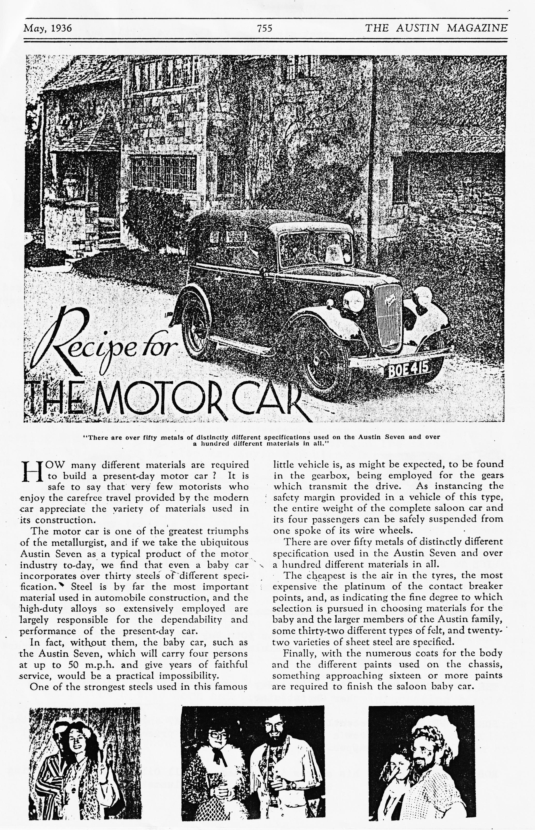

THE NIGHTMARE
I know, I know. The great migration of the Five Little Austins took place at Easter and now already Whitsun has been and gone and still not a sign of grovel. This certainly could not have happened of yore. Oh, for the good old days, long gone, of grovel and yore.
Two pairs of dirty hands, me always in the way, Glyn's Ruby having to put up with the indignity of a singing Sage in the back for the duration; not to mention Mrs. guttural Sage being ennobled in the Gary Box. And then the greatest shame of all - towing a silenced 'Cardinal' all the way back to Bournemouth
"SILENCE!” The word boomed across the court room. "This muttering will not be tolerated", bellowed the Judge. All was deathly quiet, save for the laughter of the court mice, who stood peering from their little doorway situated in the skirting-board below the table of the Counsel for the Defense. Never had they seen anything remotely like it. "How does the accused answer the charge ?" rasped the Judge. Then came the words that, still to this day, give me terrible and unimaginable nightmares "GUILTY M’LUD!"
There was an awful silence as the Judge, after long deliberation and having carefully placed a small black cap on the back of his head, rose very slowly. Even the court mice were now stilled. I began to wonder if I was standing before an even higher court. It seemed an age. Time enough and more for the whole of my life as a Dorset Austineer to pass before my mind's eye and wish to Dear God that I too was a mere court mouse. "SILENCE!" Sentence was about to be passed. The Judge again looked down at the massive tome, which lay before him, to make quite sure that the difficult wording of this so rarely used sentence was correctly fixed in his cruel mind before uttering the terrible words:
"MUGA BEERUM GARYAE ET GLYNAE!"
Thank you both.
Paul M.
+++++
NICE TO SEE .. new members Nigel and Jenny Stacey at Mannington.
ALSO NOW ON THE ROAD .. Mick and Sue Topham in their Pearl Cabriolet.
AND BACK ON THE ROAD .. Paul and Emma. Trust that Paul is sleeping better
THE TALBOT .. became a bridal car on 30th May while the Chummy took the bridesmaids. Congratulations to the newlyweds and to Bernard and Jackie.
THE BERIBBONED BOX .. of John and Gay conveyed grandchild number six to her Christening.
SOMEONE WE KNOW .. recently acquired a complete A7 engine plus carburettor from a farmer at a knock-down price. So it does still happen.
ROB WILL NOW SELL .. his shares in Duckhams, Shell Oil and Essolube having caused their sales to plummet.

The-Cranmore/East Somerset Railway Run
Locking directly at me, John Weaver said "I’ll need somebody to do a write-up for the Newsletter". Well, after a couple of pints on an empty stomach (read on for details) what could I say - not a lot - so somehow I found myself committed.
Gathered in the warm sunshine of on early June morning, with just a hint of a breeze wafting across the ancient buildings of the historic town of Wimborne - I think this is known as waxing lyrical, but doubtless Sir will correct me (Well, I suppose. Ed.) - was a number of gleaming pre-war motorcars. In or around them were: Paul & Emma Mainzer, Brian & Gill Toalster, John & Gay Weaver, Gary Munn & guard dog, Dave Whetton & daughter Rachel, Rob & Jo, Self & son Guy. Apologies for any omissions. A pint will be forthcoming by way of compensation for any substantiated claims of attendance:
I think, and I am sure most will agree, that the meeting in Wimborne Square gives a very good start to the day, and I would advise all members to come early, or at least well on time, for this reason alone. Always a very sociable occasion.
Anyway, having exchanged the usual niceties we set off out of Wimborne on the Badbury Rings road and even managed to keep our convoy intact in the process, despite the quite heavy traffic in town. We headed on round Blandford and towards Sturminster Newton, and most will recall a hump in the rood about c mile south of Shillingstone - This can be a bit heed-bashing in a modern but in the Sevens we hardly felt a thing. Probably something to do with our unequal fight against gravity on the way up:
In Sturminster Newton we were pleased to see Merv and Fran Frampton waiting for us - Merv managed a splendid Le Mans type start from the opposite side of the road and joined up without anybody stopping: We continued fairly uneventfully, but enjoying the convoy spirit and the fine weather, to the Wincanton flyover where we had a pre-arranged meeting with Richard Cressey who was to mastermind the second stage of the journey. There we also met Kevin & Pauline Barnes and family who had wended their way over the hills from Shaftesbury, and some friends of Richard in a very nice M.G. Roadster.
From here the journey became somewhat tougher, but real Austineers country - narrow lanes, tight bends, steep hills and glorious Somerset views. All very testing for oily clutches and brake linings. However, the Austins stood the test well and were only let down by the M.G. The driver suffered a problem quite the opposite, and unknown, to those of
A7 owners - persistent brake seizure: At one stage .we all enjoyed an enforced halt along a lovely stretch of unfenced country lane -whilst Richard went off with his tow rope, for realization had dawned that the M.G. was no longer with us. Whilst we basked in the sunshine it became evident that the hunger pangs were marching on, for slowly luncheon baskets began to appear and there was the odd "poof" (Well, how would you describe the noise?) to be heard as trembling fingers tried to cope with the ring pulls. Meanwhile Guy tried to see how many Austin 7s he could take out with one swipe of his newly occulted Aerobic!
Eventually we were under way again (the M.G. having been found and made better) and a trip down and around some more interesting single
track roads led us to our lunch time watering hole close to Cranmore, - which we reached at about 1 o'clock. The bar was busy with about four regulars and an extensive menu was nr offer - however it was explained to us, and we fully understood, that the sudden arrival of fifteen or

so people all wanting lunch together would create an overload situation in the kitchen, so we agreed to choose from a menu of five or six items order to hasten matters-. Even this threw the gentlemen proprietor: in
a flap. Charles insisted that we ordered drinks first, because he just couldn’t manage drinks and food together, whilst Philip hovered
around behind, waiting to show off his prowess in the kitchen. Once the food orders were lodged we waited and waited and waited, the drinks flowed and we waited and waited and waited and the drink flowed and we waited and then John mentioned the write up and I agreed. Just like that: Oh the demon drink:
Came 2.15 the first lunches - the ploughmen’s - began to appear followed several minutes later by the hot food. Why the delay? speculation was rife. Philip and his friend certainly looked flustered. Was it a tiff? Most likely bad organisation as both parties demonstrated
propensity for tripping over one another at regular intervals. Jill Meister put it down to no woman in the kitchen!. It is, however, only fair to relate that one the lunches arrived we did enjoy them.
Cranmore Railway Station was only a few miles down the road and we soon found ourselves in the station car perk reedy for a ride on the second last train of the afternoon. The treasurer negotiated a party booking at £1.50 a head and enjoyed a brief moment of glory as railway ticket clerk handing our children’s tickets to adults and vice-verse: Somehow the cash balanced and we were allowed through on to the platform.
The railway line is about three miles long and we enjoyed a trip to nowhere and back again behind a steam tank engine of 1920s vintage. There are plans to build a station at nowhere in a year or two when
presumably nowhere will become somewhere
When we descended from the train some of us were lucky enough to be taken on a conducted tour through the railway workshops where they were rebuilding a Great Western Railway loco of 1920's vintage and an even older locomotive which was built by and for the London Brighton & South Coast Railway at its Brighton works in 1877. If you think you've got problems getting an Austin 7 together you don't know nuffink! The work and money involved in restoring these old locomotives is quite incredible - £600 was quoted to us as the cost of a set of piston rings, size 16" or to younger members about 40 cm. What’s more, that’s for only two cylinders. The owner of the older locomotive did nevertheless assure us that there were fewer moving parts in his engine than in an internal combustion engine, but in spite of this the general sentiment emanating from the A7 Club was 'Sooner you than us, chum'.
We then drifted back out into the sunshine, explored more fully the splendid Victorian cast iron edifice (Clochemerle, Somerset style) at the end of the platform and gathered in the car park to say our farewells prior to embarking on the long haul homeward. 'A really enjoyable day which I am sure left us all somewhat richer in experience. As for delays and holdups they were all part of the day’s enjoyment, for time passes very quickly when you're in good company.
Special thanks to all and to those who welcomed Guy on his first proper A7 run which we all thoroughly enjoyed.
Lawrence

CORRESPONDENCE
Charlton Horethorne Feast Day
Thank you to those who have said they will bring their cars to our village fete on 27th June. The afternoon starts at 2 pm and will finish at about 5 pm.
Charlton Horethorne is on the B3145 midway between Sherburne and Wincanton.
The cars will be displayed on the forecourt of the local garage which is situated at the centre of the village.
If anyone else is interested in joining us on the day, perhaps they could contact us on Corton Denham 526.
Richard and Margaret Cressey
++++
EARLY NOTICES
With the arrangements for the Barbeque now in hand our ever-dependable Social Secretory has already turned his attention to the late Summer. Gary's notes are as follows:-
Thursday evening, 7.30 pm, 3rd September - Brewery Visit Hall & Woodhouse, Blandford - with refreshments and snacks in the Brewery afterwards! Numbers will be restricted to 35 and the visit will be free: Details nearer the time.
Saturday evening, sometime in late Summer/early Autumn a 50's & 60's Evening at the Avon Country Club - optional fancy dress (to suit) - ploughman's supper. Featuring Chris Redwood, an excellent musician/singer, with all the backing gear, who specialises in the period. Details later. The more the better!
If previous events ere anything to go by these will be well worth supporting.
+++++
EVENTS
JUNE
Thursday 18th June. Club Night. Meet at Safeways
car park, Wimborne at 8.00pm for a run to Damerham.
Sat/ Sun 20th/21st June. Spye Park Rally
Wednesday 24th June. Little Gore Farm Rally
(opposite Arnewood School),
Gore Road, New Milton. 7.30pm Club cars welcome.
Thursday 25th June. Committee Meeting at the Tyrrells Ford at 8.30 pm.

Saturday 27th June. Charlton Horethorne Feast Day
(details within)
Sunday 28th June. PLEASE NOTE the run to Weymouth Sea: Life Centre has been POSTPONED.
JULY
Sunday 5th July. 25th National A7 Rally, Beaulieu.
Saturday 11th July. Evening Run to the Drovers Inn
north of Wimborne. Meet at 7.30 pm in Wimborne Square.
Thursday 16th July. Club Night. Meet at the Elm Tree at 8.00 pm for a run to the Brockenhurst area.
Thursday 23rd July. Committee meeting at the Tyrrells Ford at 8.00 pm.
AUGUST
Saturday 15th Aug. Evening run to The Greyhound,
Corfe Castle. Meet at Wimborne Square at 7.30 pm.
Friday 21st - Sunday 23rd Aug. Purbeck Rally & Autojumble.
SEPTEMBER
Thursday 3rd Sept. Visit to Hall & Woodhouse Brewery Blandford (see within)
Sunday 20th Sept. Visit to Barnes family at Shaftesbury.
OCTOBER
Saturdy 24th Oct. Charity Party/Disco in aid of Leukemia Appeal. 8pm - lam - Avon Country Club.

