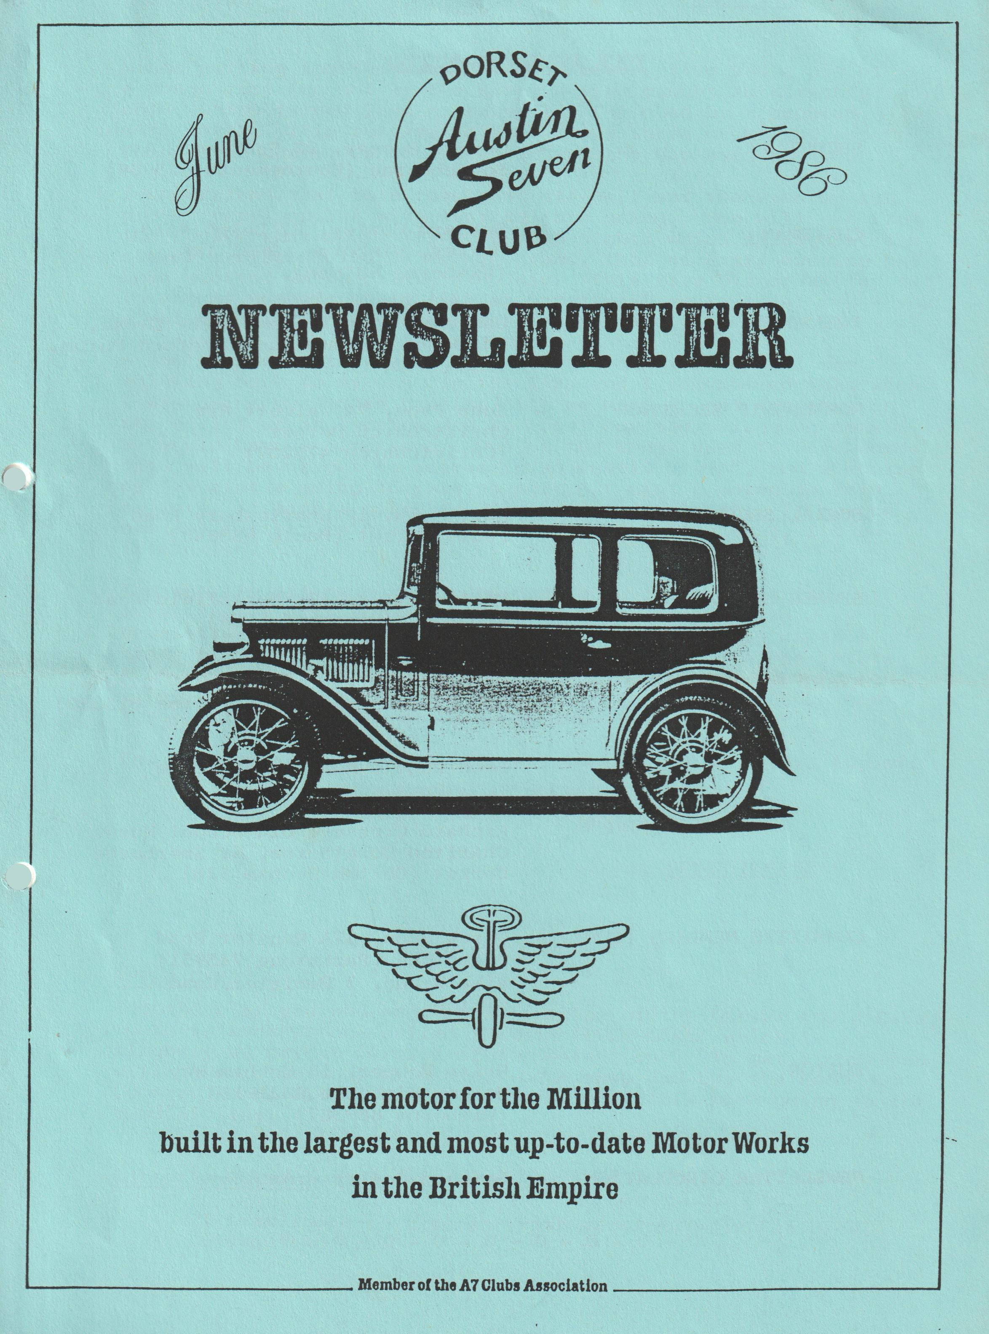

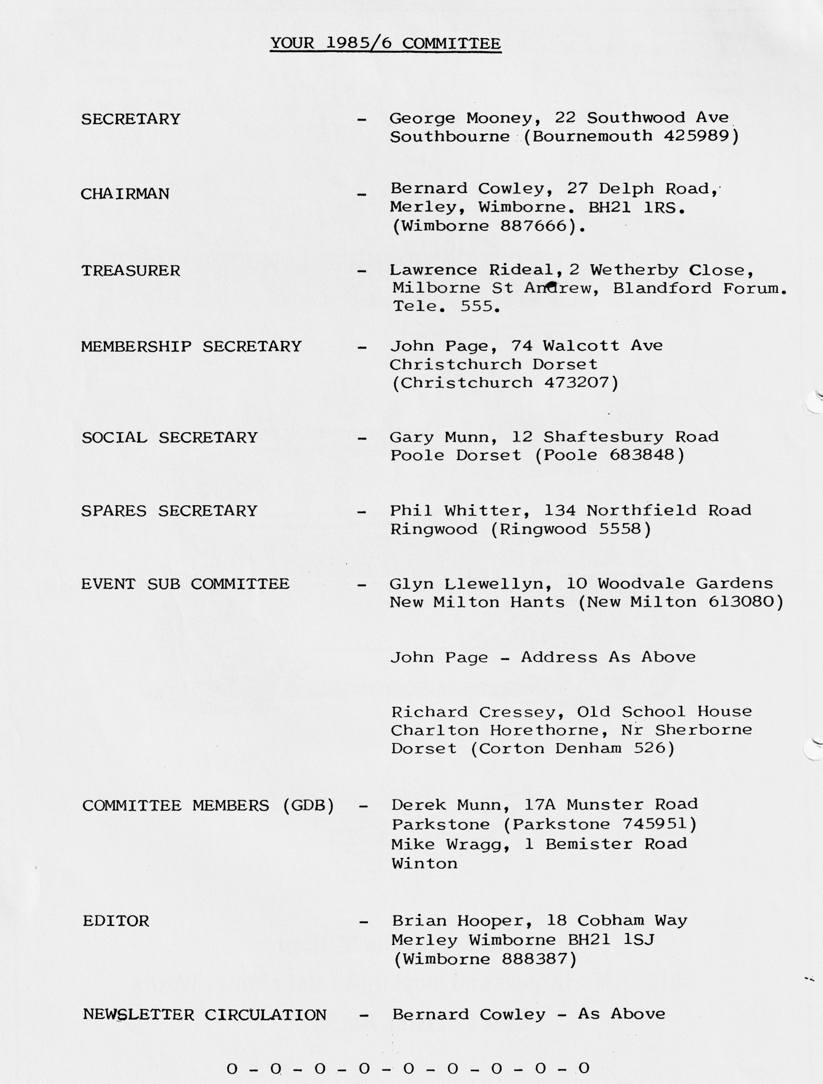

EDITORIAL JUNE 1986
Since putting together the May Newsletter, I've had a bit of a rough ride (no not in the Ruby) having caught an almighty cold, which turned into a heavy flu, followed by a problem with teeth.- This lot lasted over about three weeks and put paid to me coming on the Bath run and the May evening run.
I understand that both runs went off well and the evening run proved very popular with over 20 cars going. You will see from the events that apart from the club nights which throughout the summer are scheduled as evening runs, that an extra evening has been slotted in on Friday 4th July. This is a bit of a 'try out' to see if members would like an occasional extra local run - you might care to let any committee member have your views.
I don't know what prompted it, but the other evening I was thinking back to my days in the RAF, and I remembered that when I was doing my square bashing bit, we used to get together in the billet of an evening and to boost our sadly lagging morale we would have a sing song. One of the songs used to have words "you will never get to heaven in an Austin Seven", and a chorus of "it ain’t a going to rain no more, it ain’t a going to rain no more, it ain’t a going to rain no more my lord". If anyone has any further information on this sing-along song, I'd be interested.
I'm shortly off on holiday and due to my clever planning, it means that I will not be able to edit and compile the July Newsletter, which will therefore fall into the very capable hands of Bernard & Jackie. I will be able to do a bit before I go, so if you have anything for the copy, please let me have it up to 25th June, but anything after then to Bernard, whom I suspect will have a deadline of about 4th July.
For the August Newsletter please send copy to me by 6th August.
Regards
BRIAN HOOPER
APPLE CAKE
For those of you who enjoyed the recipe of the Dorset Apple Cake, there is another one called 'GERMAN APPLE CAKE' which is a slightly up-market version of the Dorset one. To get a copy you will have to go to your nearest book shop and buy the Food Aid Cookery Book, all proceeds of the sale of this book going to the band aid charity.
JOY MOONEY
Editor's Comment
I hear there is also an Irish version, which is made without Apples!
SECRETARIAL JUNE 1986
Sorry to disappoint you,-but this page was held open-to the last minute for George's secretarial, which unfortunately didn't arrive. In hastily looking ,around for some .sort of fill-in, all I could find was the following bit of American nonsense, which is not so informative as George's secretarial, and I trust will not offend.
FATHER MURPHY'S ASS.
Father Murphy was a priest in a poor parish, looking for ideas on how to raise money for his church. Friends pointed out that horse owners had money; so Father Murphy went to a horse auction, but made a very poor buy. as his horse turned out to be a donkey.
Nevertheless, he thought. he might as well enter the donkey in a horse race and try and raise the money. The; donkey came third and the next day the headlines in the paper read:
"FATHER MURPHY'S ASS SHOWS"
The Archbishop’s office saw the newspaper and was displeased. The next day the donkey came first, and the headlines read:
"FATHER MURPHY'S ASS OUT IN FRONT"
The Archbishop was up in arms. Something has to be done, he decided; about Murphy's entering The donkey in the race . The following day the donkey came in second. Now the headlines read:
"FATHER MURPHY'S ASS BACK IN PLACE"
That was too much for the Archbishop, who had Murphy on the mat, extracting from him a promise the donkey would be withdrawn from all further races and never entered in a race again, which inspired the editor to write:
“ARCHBISHOP SCRATCHED FATHER’S ASS.
When the Archbishop read this, he ordered the father to get rid of the donkey. So poor Father Murphy gifted the donkey to sister Agatha as a pet. Now the headlines read:
"NUN OWNS BEST ASS IN TOWN"
The Archbishop had a fit on reading this and immediately ordered Sister Agatha to dispose of the donkey. So the sister sold the donkey for ten dollars. . Next day the headlines in the newspaper read:
"SISTER AGATHA PEDDLES HER ASS FOR TEN DOLLARS"
THEY BURIED THE ARCHBISHOP THE SAME DAY
THE CONTINUING SAGA OF MY TALBOT 7.5
I have at last virtually got it ready for the road, after owning it for about four years.
During the process of renovation, I had the radiator repaired (to a fashion) by Hants & Dorset Radiators, but one of my first problems when I started the car and got it up to running temperature for the first time - the radiator leaking like a sieve!
I had seen a company mentioned in the Talbot Newsletter, that had repaired a radiator similar to mine and a good job had been done, so I phoned them and explained the position. About a week later I took it to the company who are in Southampton, they remembered my telephone call and said they didn't think the leak was too serious, hoped I didn't want it back the same day!, and in fact repaired it in two days.
Needless to say, the cost was very reasonable and they had tidied it up and it looked good. In this day and age, where shoddy workmanship abounds, and companies have an off-hand attitude it was so nice to meet a firm that were not only interested in doing the job but did it well at reasonable cost.
I mentioned our club while I was there, and they said that they would welcome any repair or re-core provided all 60 members didn't enquire at once!
For your reference therefore, the company is:- KINGSTON RADIATOR REPAIR SERVICES LTD., 20 Kingston Road, Southampton. Tel 0703 225959 (Please mention my name and the Club if you are contacting them).
BERNARD COWLEY
- 0 - 0 - 0 - 0 - 0 - 0 - 0 - 0 - 0 -
EDITORS FOOTNOTE
By coincidence, I was delivering the May Newsletter to Bernard for circulation, when I met Bernard thundering down the road in the Talbot. Once 'around the block' on his own and I was invited to go for a quick spin. For those who haven't seen it, it is a huge monster, and my congratulations to Bernard for getting it back together - it does look good and certainly goes like a bat out of hell!
As regards the radiator leak, when we returned to Bernard's, water poured out like a bath tap - so quite an achievement to effect the repair.
Ed.
CLUB REGALIA
Pat Llewellyn advises that she has both Sweatshirts and 'T' Shirts in stock:-
SWEATSHIRTS £7
SIZE
Maroon Ex. Large
Maroon Large Small Motif
Maroon Medium
Navy Blue Ex. Large
Navy Blue Large Small Motif
Navy Blue Medium
Denim Blue Small
Small Motif
Bottle Green Small
Grey Large Small Motif
Grey Medium Large Motif
T. SHIRTS £4
White Small
Navy Blue Large
Maroon Large Small Motif
Light Blue Medium
Pink Small
Denim Blue Small
Please ring Pat on New Milton 613080 if you would like any of these items, and Pat will bring them along to Club Night for you.
* * * * * * * * *
WANTED
A pair of rear 'Flap' type windows or window frames for an early Ruby. If you can help, please telephone:- (0202) 671759 (Poole) Or (0547) 528136 (Wales)
'SNIPPETS'
I know from several calls received that members have been trying to get hold of Phil Whitter for spares. Phil has been away on holiday but is now back, so you should be able to contact him. -
- * * * * * * *
Bill Quale is going on holiday shortly and has kindly offered to pick up, for members, any bits they may require from either A7 Service at Kirby Wiske, Yorkshire or The Seven Workshop(North) in Staffs, both of whom he will be visiting whilst on holiday. If you have any requirement, please let Bill know by contacting Canford Cliffs 709326.
- * * * * * * *
I hear that Gary Munn received an award at the Solent Club Paultons rally for the car travelling the greatest distance to get there - what have you got Gary - a faulty mileometer or did you get lost on the way?
- * * * * * * *
Esmerelda (my Ruby) passed the M.O.T. a few weeks ago, and for fun, the testing station put her on the brake test rollers - they and myself were amazed to find that the breaking performance was about the same as a modern Mini, yet the breaking system is the original cable/early Girling. Ed
Nice little turn out at Burton on Saturday June 7th, to support the R.N.L.I. fete, there were about ten cars there which created a lot of attraction. I loved the comment passed to Glyn when asked by one of the elderly visitors as to whether we all went out on runs together, when Glyn replied yes, the elderly visitor replied "I see, another bloody hippy convoy!".
- * * * * * * *
I'm still looking for a good 'Chrome Rad' A7, preferably 1933/34 either a saloon or 'open' 2 – 4-seater. Any information leading to a successful purchase would be appreciated. Brian (0202) 888387
- * * * * * * *
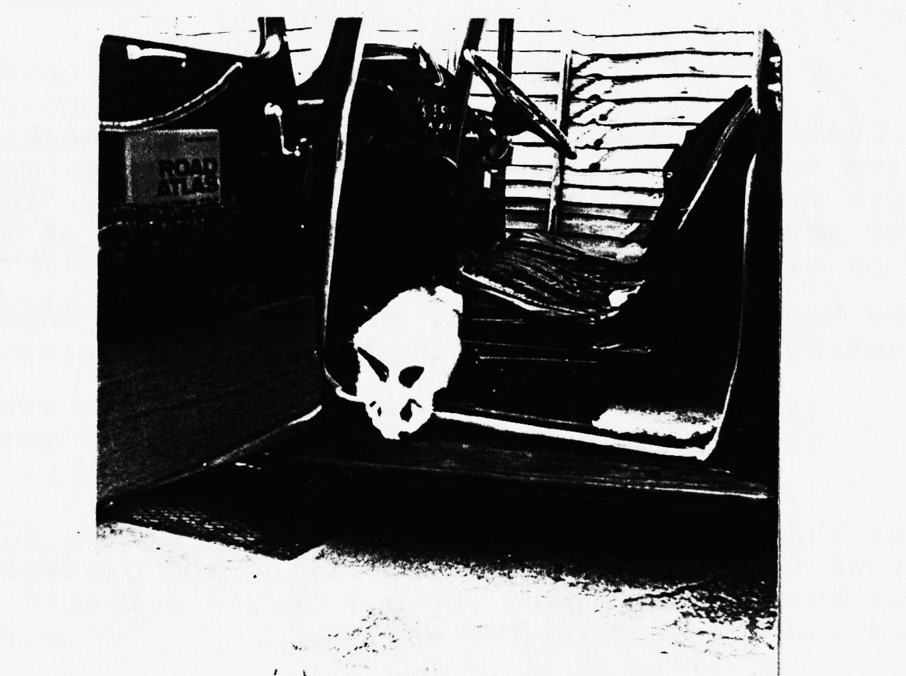
Joy Mooney has sent in this delightful photograph of a rabbit aboard the Ruby as they were preparing to go on holiday:-

Joy didn't tell me what else George takes on holiday with him - plastic duck, water wings and a kite?, or may be this just proves the saying that an A7 is about the size of a rabbit hutch!
- 0 - 0 - 0 - 0 - 0 - 0 -
BATH RUN
On the 18th May, a club run to Bath
A Newsletter report to be the aftermath
Who was it who volunteered to write and tell?
To the best of my knowledge - Lawrence Rideal.

At the committee meeting on the 22nd of May
Lawrence was press-ganged to report on the day
Did he forget, or do we have to thank day to day pressures of working in a bank.
Too late now to report on this one
But guess who’se expected to do the next run
To Wookey Hole or the Barbecue
The choice is yours, now over to you.
Ed.
SATURDAY 28TH JUNE Club Barbecue
We have decided once again to return to our old favourite, the National Trust site at Studland Beach, at 7.00 p.m.
The prices have again been held at £2.00 for Adults and £1.00 for children, which will provide for Beef burgers, Sausages, afters and a glass of wine.
Let's try and make it a good turnout, come early if you want to get in some swimming before the festivities commence.
Don't forget to bring your booze, and something to drink it from. Hope to see you, and if you don't know where it is, go over the ferry to Shell Bay, proceed to Studland Village and look for the club marker signs.
Gary
- 0 - 0 - 0 - 0 - 0 - 0 - 0 -
P.S.
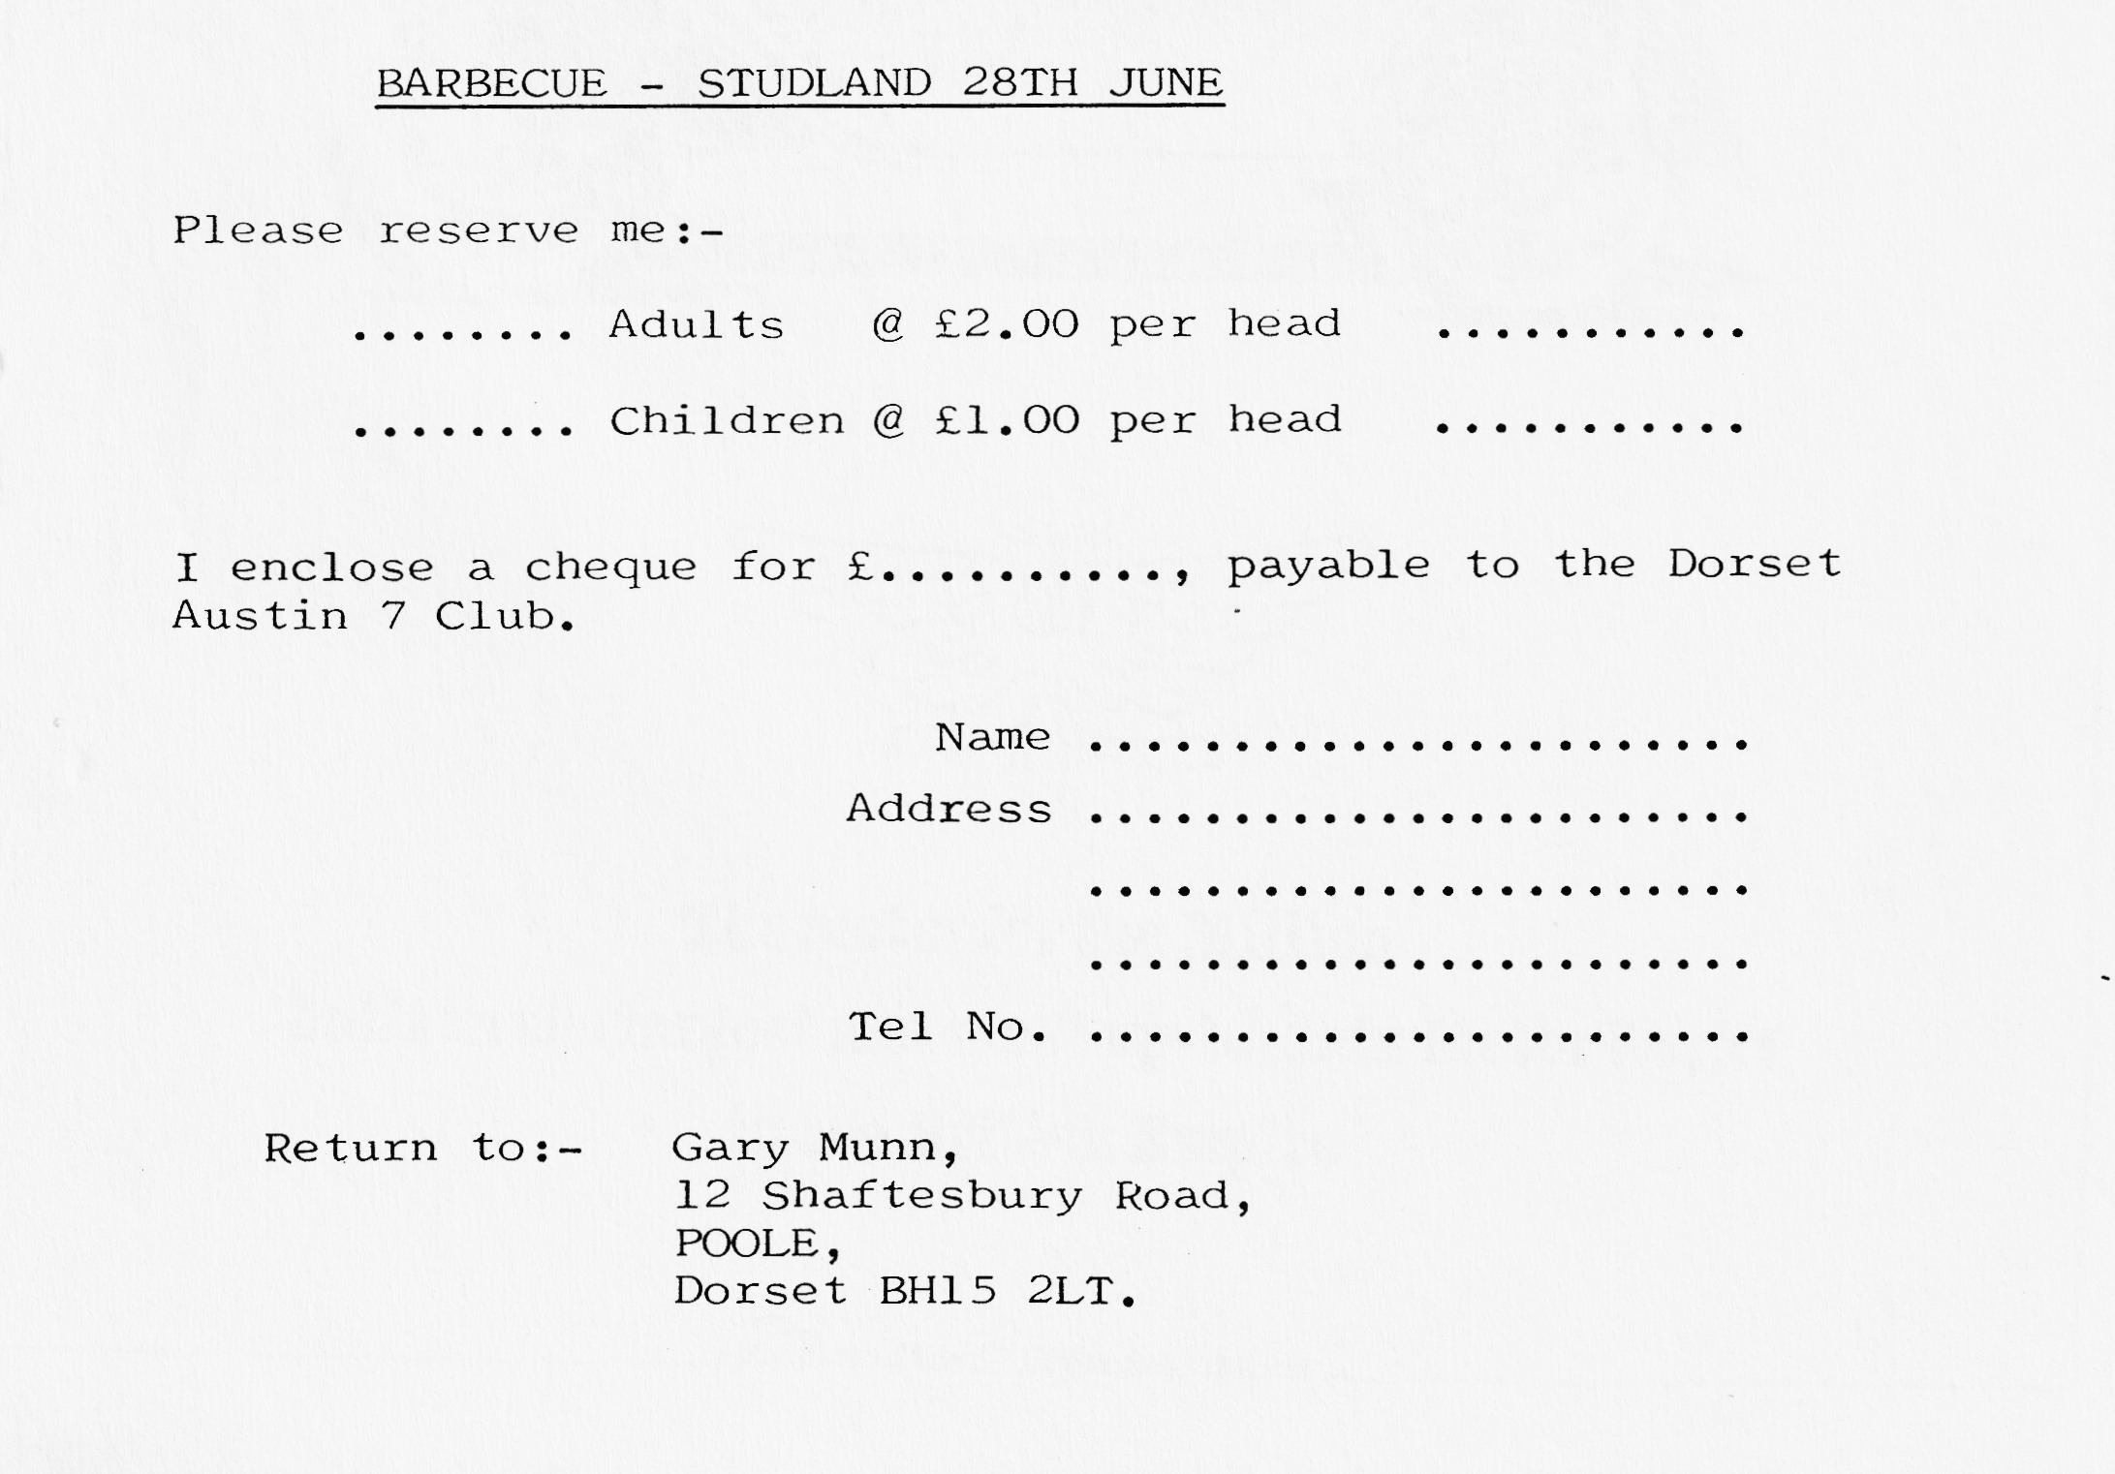
As this Newsletter only precedes the Barbecue by about two weeks, please return your 'booking' immediately in order that we know how many to cater for.(or phone Gary or let him know on June Club night). ( N.B. In the event of heavy rain, the venue will transfer to Gary's house).
I don't know whether any of our members or friends are going to America for their holidays, but if they are they may be interested in some of the delights they may expect as shown on the recently received postcard.

