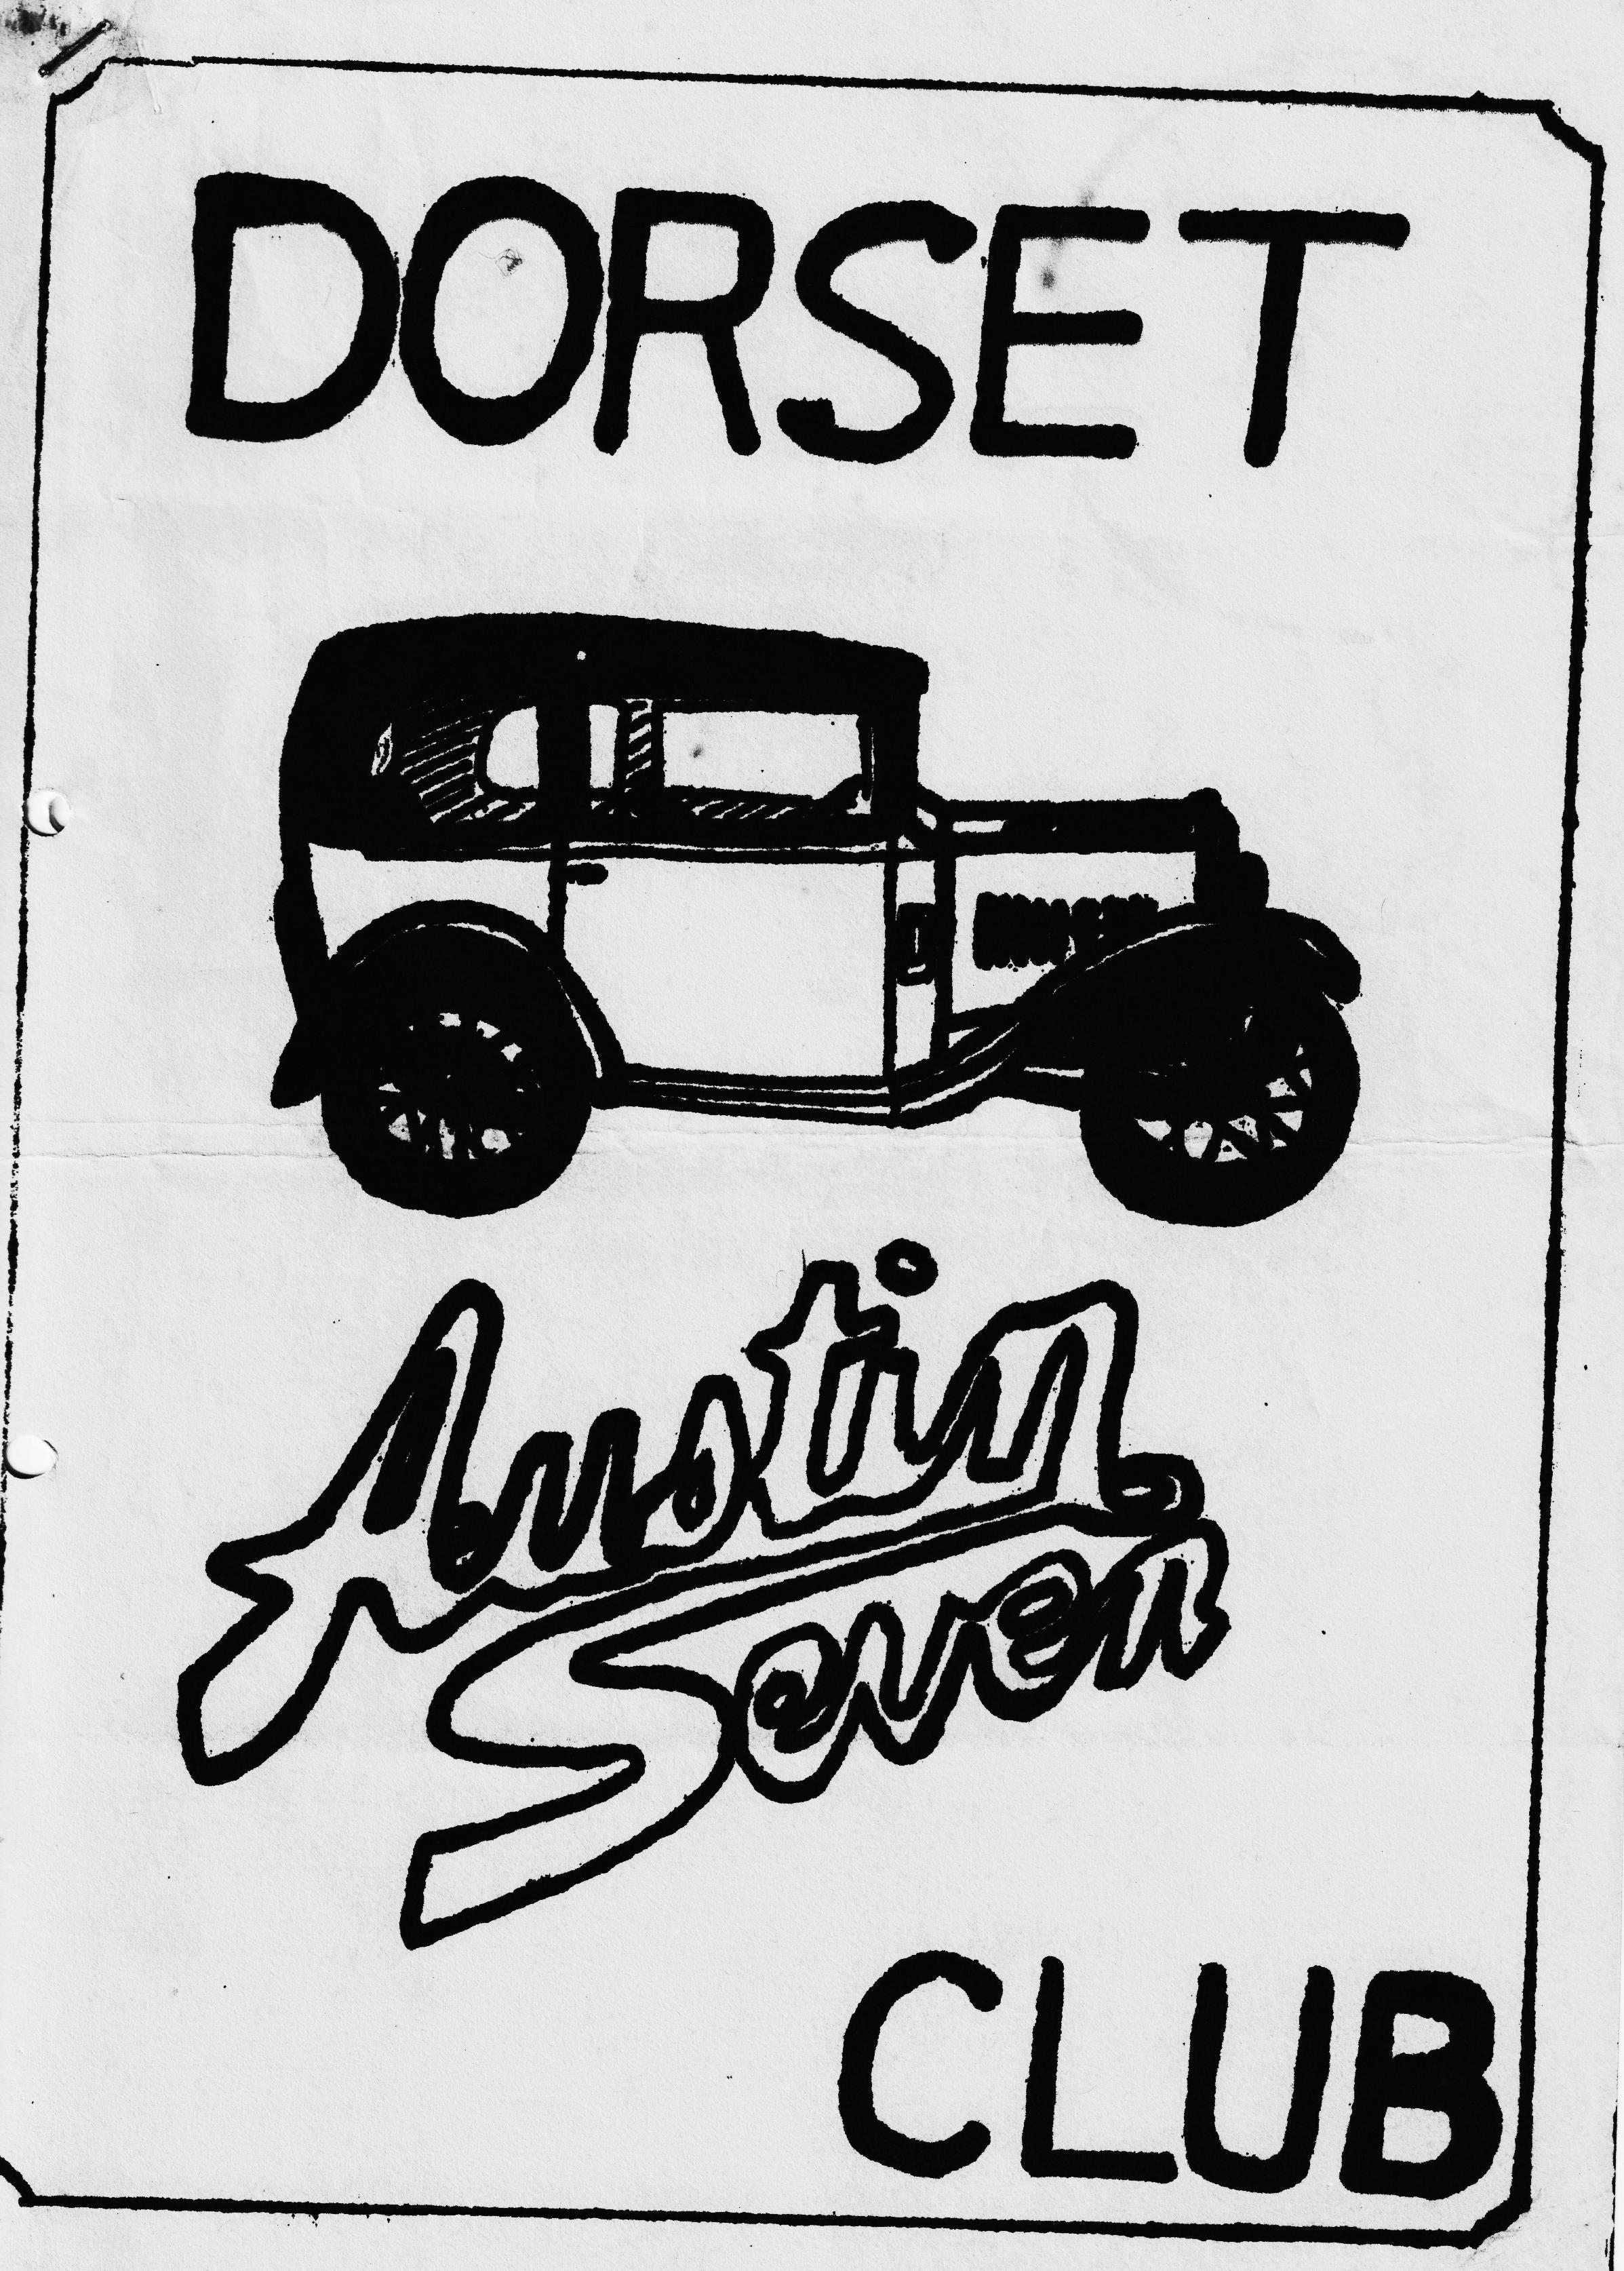

DORSET AUSTIN 7 CLUB NEWSLETTER JUNE 1985
CLUB NIGHT
THURSDAY JUNE 20th - Starting at 6 p.m. till 7 p.m. at Pennington Junior School, Priestlands Road, Pennington and after at The East Close Hotel on the A35 at Hinton, about a mile past the Cat & Fiddle on the Southampton Road.
EDITORIAL
Hi Gang,
Dorset members have been invited to join the Bristol Austin 7 club for their 20th Anniversary run on the 22nd/23rd June. The run includes a run in convoy through Bristol and a guided tour of the S.S. Great Britain. This is on the Saturday and in the evening there is a celebration dinner, but tickets for this are limited to he first 100 and cost £9.50 per head. On Sunday in company with 'the vintage Austin register their-will be a visit to Blaise Castle and the Trym Gorge. Entrance fee for the event is £3 which includes a special plaque etched with the registration number of your Seven. Should be a super do, if you are interested phone George Mooney B’mth. 425989 for an entry form.
Pat and I in the Ruby along with Gary in his box traveled down to the South Wales Rally at the Golden Grove Arms near Carmarthen last weekend, and whilst the weather was not so kind to us as last year, we enjoyed the rally very-much. The Welsh members made us very welcome and we did quite well in the competitions and concours. I managed to win my class with the-RUBY, Pat won the ladies driving tests, and Gary won the .men’s in a closed car, Pat and I won the long-haul award. for the 2nd year running and the three of us won the inter-club driving tests for the fourth or fifth year, I can't remember which. So all. in all we had a very enjoyable and successful weekend.
The stencil for the newsletter cover is still not ready I'm afraid so I have had to make do with the old ones again, it should be ready for next month issue, however. I hope to see as many of you as possible at Pennington Junior School on club night, but if you can't make it there see you at the East-Close Hotel.
Glyn
EVENTS CALENDAR
THURSDAY 20th JUNE Club Night at The East Close Hotel, Hinton.
SATURDAY/SUNDAY 22nd 23rd June Bristol A7 club's 20th Anniversary run. Ring George Mooney B’mth. 425989 for details (see editorial)
THURSDAY 27th JUNE ......... Committee Meeting at Tyrrells Ford.
SUNDAY 30th JUNE . Solent A7 clubs Paulton Park Rally & Autojumble. Dorset members welcome.
SATURDAY JULY 6th 1.30 p.m Wentworth/Milton Mount Summer Time Fair. You may have noticed in last month’s newsletter an invitation to this event. The Dorset A7 Club has been specifically asked if they can bring along some cars, anything pre 1960 is welcome. There will be events throughout the afternoon, side shows, stalls, and a free raffle for all entrants. The venue is easy to find, it is- just off the Southbourne Overcliffe in College Road. We are asked to arrive by 1.30 p.m. if possible. The organisers are very keen for us to go, so do come along and help to make it a good display. If you need any more details phone Gary Munn on Poole 683848.
SUNDAY 7th JULY - . 750 M.C. National A7 Rally at • Beaulieu.
SUNDAY 14th JULY . ..... ..... CHANGED DATE:. CHANGED DATE'. 'STRAWBERRIES & CREAM, RUN. Owing to Strawberries not being.at their best; this run has been switched to Sunday July 14th. Departing Ringwood car park 10.30 a.m. prompt with run to the Red Shoot at Linwood (how under new management with games room, children’s meals etc.,). After lunch, there will be a picturesque run ending at Phil & Hilary’s at 134 Northfield Road, Poulner at approx. 4 p.m. for Strawberry & Cream tea. IMPORTANT: We need to know numbers (for tea) Please let Phil know if you are coming either on club night or ring Ringwood 5568 by July 7th.
THURSDAY 18th JULY Club night details next month.
SATURDAY 27th JULY Bashley Flower & Country show. Ring Glyn on New Milton 613080 for details.
SATURDAY 27th JULY Dorset A7 Club Barbque.in The New Forest.
SUNDAY 11th AUGUST ....... Bristol A7 Club Spye Park Rally
SECRETARIAL
June -already! Where is the year going to? Oh, and can it really be summer? I have a few things for you this month which may interest you. Firstly, I noticed in the Scottish club May newsletter an advert which read as follows:-
2 BEARING RUBY ENGINE, REBUILT; new bearings pistons clutch etc. exchange for equivalent 3 BEARING ENGINE phone FRASER WALKER 0417-942-3521. Well done Mr. Walker, you know which is the smoothest A7 engine, good luck with your advert. Any of you 2 bearing buffs interested?
I have a few entry forms for a GRAND VINTAGE GATHERING/AUTOJUMBLE and CAR BOOT SALE to be held at the. Stocklands Equestrian Centre in Liphook, Hants on 14th July 11 a.m.-to-5-pm. Anybody interested?
Several of you know that the Christchurch Model Railway Club are .seeking our support at an exhibition of model railways to take place at the West Hampshire Water Co. Social Club, Mill Rd., Christchurch 10.30 a.m. - 4.30 p.m. on Sunday 15th September. Space is limited so please let me know as soon as you can. I will send you an entry form or get one club night.
Poultons Rally entry forms arrived late, if you didn’t use the autojumble form as a temporary document see me for your form on club night. I have already warned Solent we will be late entering.
We have been invited to the Winterslow Show on Saturday 10th August taking place at Winterslow near Salisbury. I have made a club block booking for up to 6 cars. If you would like to join in just let me know, no further action required. I will give more details nearer the time but let me know now if you can.
Anybody wanting a longer distance rally is invited to contact Alan Martin 61, Manor Road, Caddington, Luton, Beds. They are having a rally on Sunday 15th September at Stanborough Park, Welwyn Garden City. Attractions for all the family, Autojumble, Gymkhana. Entry forms available July.
A very interesting technical tip seen in the A7OC newsletter and borrowed with thanks was about wheel bearings, thus:-
When. replacing wheel bearings fit sealed type bearings and save all that hub greasing; spend more time driving and less time fixing! Enjoy your Austin 7 and keep the grease off your brake linings. SO, pop along to your local bearing man and ask for LJ 1¹/₄” 2RS (TWO RUBBER SEALS) and LJ ¾” 2RS. John England
Another one, that caught my eye was an advert in the A7OC newsletter (thanks again) for STAINLESS STEEL exhausts. Available from Mr. Swiffen of JS Exhausts, Queens Road Mills, Gibbet St. Halifax, West Yorks. Tel. 51314. Complete system for A7 £68 including VAT & Carriage. Please specify exhaust box to be original pattern or straight-through.
I noted in a recent letter from the DVLC to Mike Norris Hill of Solent that you should beware when purchasing old vehicles with attractive registration marks. If there is no DVLC registration document contact the DVLC enquiry unit 0792 72134 to see if the number is still valid. It may of course be re-allocated or no longer available. Details of transfer of numbers can be found on form V317 from the D of T or your local vehicle licensing office.
Well folks, that’s it from me for this month, see you around. George M.
Murder by Choking From the booklet for B.F.s
Of all the toys provided (unintentionally) by a well-meaning manufacturer for a B.F. to play with, the choke, or carburettor strangler, takes the prize. The complete-B.F. loves to pull a knob out - especially if he can .choose a time when by all the rules it should be pushed in and left in.
The choke is provided to make it easy for you to start a cold engine: A label on the vehicle tells you to push it in again as soon as possible. The instruction book tells you to push it in again as soon as possible. The Bedford Driver's Handbook tells you the same thing. Common sense should tell you - but maybe it isn't as common as we thought.
Let us explain what the choke does and why it has to be used intelligently. A petrol engine operates by burning a mixture of petrol and air. The mixture is composed of so many parts of air and so many parts of petrol, and the "ingredients" are measured by weight. Just a minute, we can hear you saying. Air doesn't weigh anything. Are you telling us, or are we telling you? The office in which this book being written is twenty feet square and twenty four feet high. If it were possible to cram all the air from it into a sack, do you think you could carry it? Come up and try sometime, it weighs just over 700 lbs. or, as near as maybe,-a third of a ton. But that is by the way. For full throttle performance, the mixture should consist of about 13 parts of air (by-weight) to one part of fuel. For part throttle performance in an efficiently designed carburettor, the ratio can be thinned out to 16 or 17 parts of air (by weight) to one part of fuel. These mixture ratios are satisfactory after an engine is warmed up. That is why we make use of various devices to shorten the warming up period. Take a look at your Bedford if you don t believe us. The inlet manifold "hot spot" and the thermostatically controlled cooling system will give you an idea of what we mean.
But during the warming up period, and for cold starting, these mixture ratios are much too lean. The colder the mixture, the richer it must be to burn. When the outside air temperature is at zero, a one-to-one mixture ratio is required. In other words, if you wanted to burn up the air in the office we mentioned just now; and the temperature was at zero, you would need 700 lbs. of petrol.
Talk about being wet, that's wet with a vengeance. All the same, if you mean to start an engine at this temperature, you must have a one-to-one ratio. Only for an instant, of course, but you must have it and we give it to you by the choke. We also make it impossible for you to carry on running with this very wet mixture by fitting a device which automatically changes the ratio and makes it much leaner as soon as the engine starts to run. If we didn't, the engine would peter out almost immediately, anyway.
The leaner mixture thus automatically provided while the choke is still pulled out is about 4 or 5 to one. And that is still very wet. So we arrange that, when you push the choke half-way in, the ratio thins out a bit more - this time to about 8 or 9 to one.
So far, so good; but even at 8 or 9 to one, cylinder bore wear is excessive, and we dare not leave the choke in the half-way position longer than necessary. This, unfortunately, we've said.it now and we won't go back on it - this, unfortunately, is where we have to rely on you. You have to push the coke in - right in - with your own fair hand. And if you mean to graduate from the "utter B.F." class, you'll learn to do it at. the right time which is as soon as the engine will run on the proper mixture.
Remember, with the choke half out, the mixture ratio is 8 to 1 for full throttle and 9 to 1 for part throttle. With the choke pushed in, it is 13 to 1 for full throttle and 17 to 1 for part throttle. There's a lot of difference, as the absent-minded professor said when he took hold of the wrong end of the poker. And the result of that difference, if you misuse the choke, is to increase engine wear by between two and three hundred per cent.
The moral is, don't experiment with the choke control. If you can't stop playing with it, ask the sergeant to hand your vehicle over to someone else. Maybe he can find you a job making little stones out of big ones. That's an occupation where destruction is a virtue.......
HAND CRAFTED CAR BADGES
THE HAND PAINTED WOODEN CAR BADGES HAVE ARRIVED FROM NORTH WALES AND-WILL BE AVAILABLE FOR THOSE OF YOU WHO ORDERED THEM FROM HILARY AT £1 EACH (zero profit :) YES EVEN A PINK ONE!
SEE YOU .CLUB NIGHT. PHIL
FOR SALE
1930 CHUMMY IN PIECES, BODY NEEDS ATTENTION. £400 phone Mr. Long, Christchurch 474726
1935 A.7 RUBY - BLACK IN GRADE 1 CONDITION ORIGINAL AND READY TO RALLY - SPARE ENGINE AND GEAR BOX £2,000 or V.N.O. M. Holland, 8, Milton Common, Oxford (Gt. Milton 278)
AN EXTRA EVENT
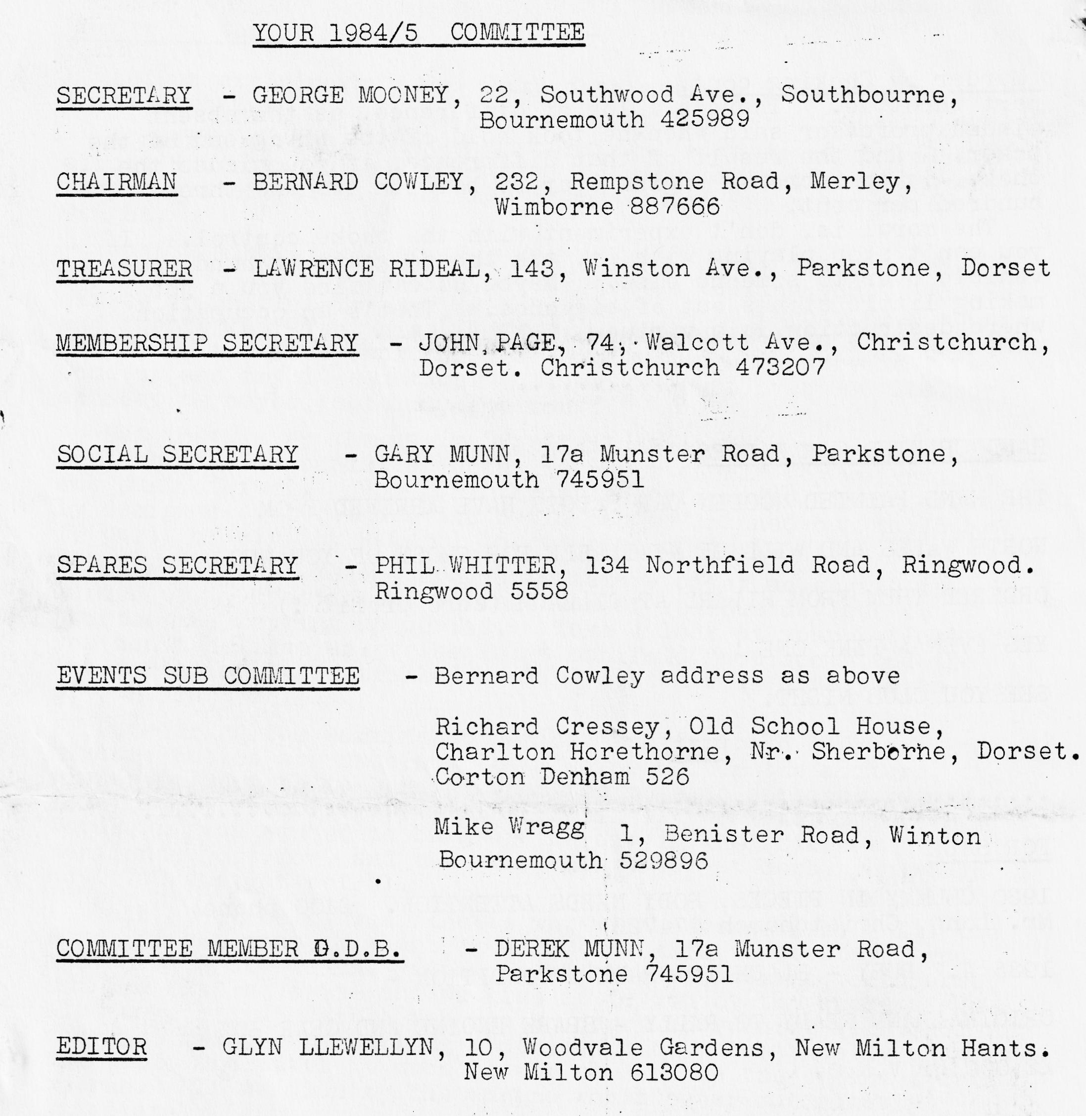
WEDNESDAY 26th JUNE - LITTLE GORE FUN EVENING RALLY IN GORE ROAD, NEW MILTON. OPPOSITE ARNEWOOD SCHOOL.

