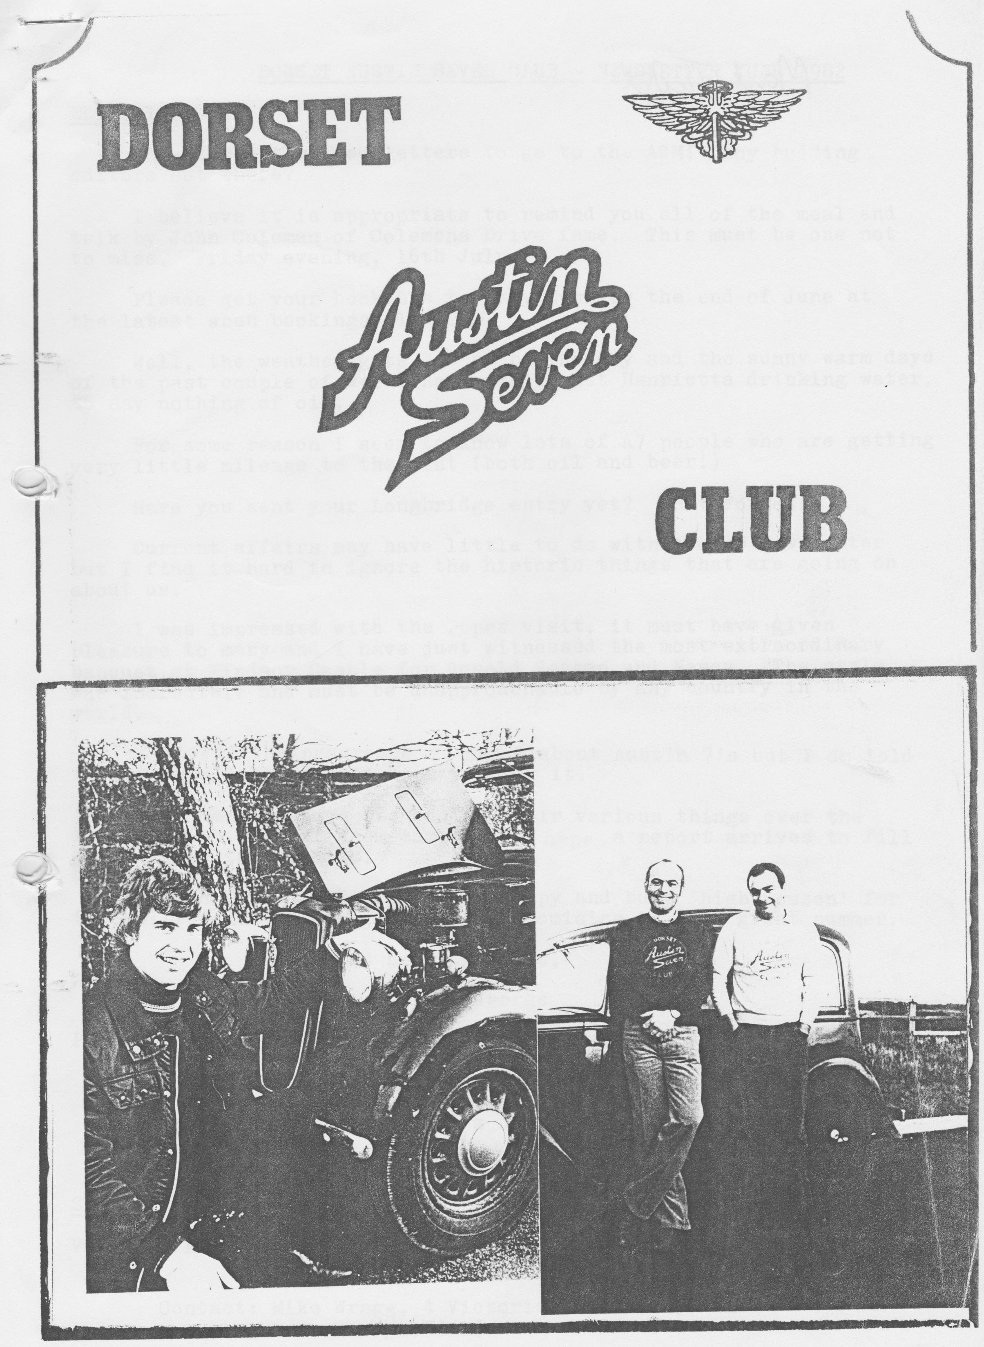

DORSET AUSTIN SEVEN CLUB - NEWSLETTER JUNE 1982
EDITORIAL
Only three more newsletters to go to the AGM. Any budding editors out there?
I believe it is appropriate to remind you all of the meal and talk by John Coleman of Coleman’s Drive fame. This must be one not to miss. Friday evening, 16th July. Please get your bookings to Gary Munn by the end of June at the latest when bookings close.
Well, the weather gets better by the day and the sunny warm days of the past couple of weeks have really got Henrietta drinking water, to say nothing of oil. For some reason I seem to know lots of A7 people who are getting very little mileage to the pint (both oil and beer!)
Have you sent in your Longbridge entry yet? Don’t Forget.
Current affairs may have little to do with a club newsletter, but I find it hard to ignore the historic things that are going on about us. I was impressed with the Pope’s visit, it must have given pleasure to many and I have just witnessed the most extraordinary banquet at Windsor Castle for Ronald Reagan and Nancy. The style was incredible and must be unapproachable by any country in the world.
I missed the programme on BBC 2 about Austin 7's but I am told it was excellent, I just hope you saw it.
Club members have been doing their various things over the holiday with some of them camping, I hope a report arrives to fill you in with the details.
Enough from me, I wish you a happy and busy 'high Season' for the rallies and summer runs, it is promising to be a great summer.
Yours, smoking a lot,
George
PS I met a guy the other day described. as the doyen of English comedy. When I asked the little Irishman what he meant he said "Well listen to him out there, he's doyin!"
Groan... ......
SERVICES
VICTORIA PARK GARAGE - Servicing Sales, Modern Cars, Good Selection, Keen Prices.
Contact: Mike Wragg, 4 Victoria Park Road,
Winton
B'mth. 519148

MEMBERSHIP MATTERS
We can't stem the flow, we have more new members to welcome this month.
Mr. John Humphrey, Dairy Farm House, Avon, nr. Christchurch. John has a 1935 Opal now on the road.
Mr. K. Plummer, 192 Marsh Lane, Henstridge, Templecombe, Somerset, BA8 OTG Ken has a 1929 Top Hat
Mr. G. Brown, Walnut Tree Cottage, Wootan Road, Tiptoe, Lymington, Hants. Mr. Brown has just bought a 1938 Ruby.
Both Ken and Mrs. Plummer and Mr. and Mrs. Brown were at the last meeting, I hope they enjoyed it.
Now we are up to 66 members.

FROM ONE EXTREME TO THE OTHER (continued)
Friday was spent looking around Thurso where we met some very hospitable members of the Caithness Vintage Car Club and had a look at all the local shops. I bought some Molyslip gear oil and
this was poured over the timing gears to protect them when the crank drifted backwards. On the way back to John O’Groats we explored the coast and had a look at the most northern lighthouse. When we arrived back at the farm the oil was changed again and soon after this Keith and Pete arrived in Keith's Chummy having had a good run up from Ower.
In the evening we all went up to the John O’Groats Hotel where a good time was spent talking Austins with the varied and large gathering of enthusiasts. We were particularly amused by the exploits of Geoff Walker and his resultant physical disasters.
After breakfast on Saturday we made our way to the start but only after I had rescued our rotor arm from the evil clutches of the Roach who was intent on getting me wound up!
For some of the starters the event was more like an assault on Everest - there were trailers and support care all over the place and it must have cost them a fortune. Keith and Pete were to be first away with the oldest car and Willie and I managed to be ninth in the line.
At midday Viscount Thurso waved off Keith and Pete to a cheer from the large crowd gathered and nine minutes later we were off as well. The first stage was to Inverness and we had a good time dicing with Chummies up some of the hills and in some cases the superiority of the three-speed box became apparent. We eventually passed Keith and Pete when they stopped for petrol and as we approached Inverness our average was already nearly 40 mph.
On the other side of Inverness Keith and Pete suddenly appeared from nowhere and there was some friendly bantering for the next few miles. Eventually on the long drawn out hills we pulled away from the Chummy and we found ourselves out in front but not for long. Just north of Inverness we ran out of petrol going up hill but were fortunate to have a reserve in our jerry can.
Soon after this we were overtaken by Terry McGrath. and Geoff Walker in their 65 Sports and shortly after by Vince Leek going very fast in his Ulster. About a hundred miles further on we were surprised to catch up with Terry and Geoff again, but they must have seen us in the mirror because they suddenly took off and the next time we saw them was at Lands End.
I carried on driving to Carlisle and then Willie took over for the marathon drive through the night to Exeter. We kept the speedo hovering at around 50 mph and we still had 5 mph in reserve. The only incident was when at one stage Willie flashed a lorry and the ignition key fell out. I was frantically looking through twenty keys on the floor of the Austin while we drifted downhill at 50 mph on sidelights!
Later in the night we were overtaken by Andy Storer in his much-modified 65 Sports and in fact Andy eventually got the fastest time of 18 hrs. 10 mins.
As we pushed further south we could see our average getting better and better until when eventually we reached Exeter we knew we had beaten the previous record time and if we could do the last 130 miles to Lands End in 3 hrs. we could even get under 20 hours.
Willie was glad to get into the passenger seat and I took over for the last stretch to Lands End. The Ruby was driven harder and faster than ever before in its life, at times reaching 65 mph downhill but a combination of the hilly terrain and our heavily laden car meant we eventually reached Lands End 20 hrs. 11 mins after we left John O’Groats. We were welcomed by Terry McGrath and Andy Storer and a bottle of 'sponsorship' Highland Whisky was passel round by Terry.
At the time, we felt somewhat disgruntled by the apparent lack of organisation at the finish but realised it did not officially open until 9 am and in fact Terry and Geoff had been 'signed in' soon after 6 am by an Indian gentleman exercising his dog!
We thought it would be a good idea to drive back the ten miles to Penzance to buy some Pomagne to celebrate our arrival, but it was not until we arrived that we realised it was Sunday morning and you can't buy anything until midday! Making do with an ice lolly we had not gone far down the road back to Lands End when the starter switch caught fire! (this is a major hazard if you use your car a lot as muck and oil accumulates around the contact until it goes short circuit) We carried out our first roadside repair in 2000 miles and continued back to Lands End to find that no other cars had yet arrived.
At 10.30 Keith and Pete arrived in the Chummy having driven all the way with the hood down and not only did they have the fastest Chummy but also the fastest oldest car. After a good welcome from our families who had arrived by now and were surprised to see us, we made our way back to the caravans at Perranporth for a well-earned rest.
In conclusion, it was all great fun and Willie put up with my company very well during the trip. We were pleased to have done such a good time in a totally standard car and in fact can claim a new record for a saloon as we were beaten by a Pearl Cabriolet with the later more powerful engine doing a fantastic time of 18 hrs. 55 mins.
The trip raised nearly £1000 for local charities and Willie and I were pleased to be able to present Poole PHAB club with cheques for £370 towards their new bus. Many thanks to all of you who supported us.
Phil Whitter
PS The Ruby is still being driven with a broken front bearing flange 3000 miles later!!

SPA RES REPORT
Spares available and in stock as previous newsletters and recent additions include the following:
Complete SWB and LWB exhaust systems
Shock absorber star spring
26VA spindle and bushes
T pump diaphragm
Pin and collet valves
Oil strainer gauze
Rear hub retaining nuts
Rear bearing retaining nuts
Distributor caps
Coil and mag. patent plates
Special Offer: Sets of head studs, nuts and washers normally £3.50 + postage ....£3 a set
Phil wants to know if there is a volunteer to pick up about a dozen 450 x-17 tyres from Watford (£19 + vat each) Phone Phil on Ringwood 5558 if you are passing by on company petrol, or if you can re-route that way. Thanks.

EVENTS CALENDAR
12/13th June Caldicot Castle Rally, S. Wales camping weekend.
15th June Motorcade WVPC Butchers Coppice.
17th June Club Night, Short treasure hunt starting and finishing at Dormers.
19/20th June Berkeley Castle Rally BA7C camping weekend.
24th June Committee meeting, Tyrells Ford.
3rd July Pre-Beaulieu Barbeque, Ceilidh & Disco, 6 - 12 pm Whitmoor Lane, Ower, Romsey. £1.50 (children 50p) Solent A7C
4th July Beaulieu Open Day and National A7 Rally

10th July Silverstone VSCC Meeting
11th July Shelsley Walsh Hill Climb
15th July Club Night, Dormers. Activity to be finalised.
16th July An evening with John Coleman.
19th July Club Run to Warbarrow Bay ... there is no Pub stop so bring your own picnic and drinks. Depart Wimborne Square 10am.
22nd July Committee meeting, Tyrells Ford.
15th August Club Run to Marwell. Depart Ringwood 10.30am. Marwell is a good zoo!
19th August Club Night Dormers.
22nd August Competition Afternoon in New Forest with Solent Club. Possibly a cricket match. Maximum. turnout please - full details July.
26th August Committee meeting Tyrells Ford.
27/30th August Longbridge Rally Diamond Jubilee Event.

CHAIRMAN’S CHAT
Well, you can tell that Summer is here - beautiful weather, beautiful girls wherever you look. I know, my works foreman backed his Transit into my car when he was looking at a girl in a miniskirt last week. Took the smile clean off his face, mine too, I might add!
I hear that the lads who went on the North Devon camping weekend thoroughly enjoyed themselves around Watchet, Minehead, Lynton and Lynmouth. Gary brought back a gallon of Scrumpy
I hope the weather stays fine for Caldicot and Berkeley Castle rallies, both of which are pretty notorious for rain.
See you next meeting.
Derek

MEAL, SLIDESHOW & TALK BY JOHN COLEMAN, AUTHOR OF 'COLEMANS DRIVE'
We have finally been able to arrange a definite date – FRIDAY EVENING 16th JULY for John Coleman, author of 'Colemans Drive' to give us an illustrated talk on his memorable trip from Buenos Aires to New York in his Austin 7 Chummy.
There will be a three-course roast meal first in the Nook & Cranny Restaurant adjoining his home at Hook village, near Warsash, Southampton commencing at 8 pm. (Take A27 towards Fareham, after crossing the river Ramble turn Right, signposted Warsash)

The price is £3.50 each including the meal.

Please send your cheques payable to Dorset Austin 7 Club as soon as possible to: Gary Munn, 36 Avon Avenue, Avon Castle, Ringwood, Tel: Ringwood 78795
We will meet at the restaurant at approx. 8 pm, any queries please ring Gary.

ALL FORMS AND CHEQUES MUST BE RETURNED BY 30TH JUNE

John Coleman Evening

Please reserve places. I enclose a cheque for
payable to Dorset Austin 7 club.
Name
Address
Telephone No:

An article seen in March newsletter Midlands Club and reproduced for your education and amusement! and with acknowledgement to Peter Lowe and the Midlands Club.

This is not about Austin Sevens but it's about starting engines. In those dark days of the 1940's when Hitler hammered at the door, the rest of the world was in chains but Churchill and me, plus some others, were not defeated, Bloody scared Yes! With my 22/6 per week (£1.12½ p) plus half-price NAAFI rations and a few spark plugs flogged on the side, the RAF was ready.

Whilst learning the noble art of Flight-mech engines, I thought the best way to approach the job was be first to volunteer, then when you had dropped a few clangers you were invariably told to sod off. This meant you could sit back, have a crafty drag, or sneak off to the NAAFI and chat up the NAAFI bints.
However, my first and only try at his routine was a shambles. Whilst I was genned-up and had worked on single engine planes, I thought that twin-engined planes just had two of everything, so know-it-all Ac/2 Lowe was ready and willing.
We are now at an airfield in Herefordshire, about 20 of us and a Flight Sergeant. He, looking in awe at a Beaufighter - all 66 ft wingspan 2 Bristol radial engines, 4 cannons and 4 m/guns. This was the tank buster! the scourge of the Panzers! and the biggest fright of my life.
Right you clever lot, who will show me how to run her up? bawls the F/S. Being pushed forward I shout 'I will Flight'. The object of the exercise is to determine my ability to carry out all the cockpit checks, run-up the engines etc. without wrecking the property of HM Government, and also that I don't have to pay for loss or damage of equipment. (Now you know why a Captain goes down with his ship).
To enter the B/F the door is in the belly and pivots down to form a ladder to the cockpit. I climbed up and into the pilots seat followed by the F/S, standing on the top of the ladder and leaning on the back of my seat ready to observe my efforts.
At this time the aircraft is securely picketed down; chocks under all wheels, both wings held down by wire rope to concrete blocks about 3 feet square, and a wire and blocks over the tail section.
O.K.." says Flight "Carry on". I can't remember all the checks, but here goes; flaps check, brakes check, air pressure, drain bottom engine cylinders, prime engines, switch on, contact, start up. We are away (I didn't know that later I was literally away) Run each engine to 1,000 rpm check oil pressure and mag. drops. All O.K. so far. Check CSU (vary the prop pitch) from coarse to fine pitch. Both CSU levers to coarse pitch, both engines throttles to 1000 rpm. WHAM! With a roar and a surge of power we were off. There was a shout from the back of me as the F/S went backwards down the ladder. The plane went over the chocks for about 50 yards dragging the picketing blocks behind. All the lads doing the engine priming scattered in all directions. I had visions of taking off to Berlin all on my own - plus the concrete blocks.
After I had cut the engines and stopped trembling I knew I had done wrong! -with both CSU's at full coarse I had opened both engines throttles wide instead of one engine at a time at 1000 rpm.
I climbed out to survey the damage. What a sight! The F/S covered in dust shouting obscenities, the Beaufighter with a distinct droop in the wing due to the concrete blocks and the wire over the tail unit had cut in about two feet. The lads were picking themselves up off the grass shrieking with laughter.
But I had lived to try another day. (No charge... just a good b---ll--g). There was a day when I set a Typhoon on fire. But that's a story for another time.
I know this is not an A7 tale but it is something to read when the weather is too cold to go in the garage to work and it might answer Mike's pleas for some letters from members.
I think I have learned a lot about engines since then, that was ... years ago. Ah well, the All Clear has gone. Back to the NAAFI
Peter Lowe
PS When I wrote this I didn't have my tin hat on, it's somewhere in the loft. When Andrew reads this, he will say 'The old man's rambling again!"
Thank you, Peter. I think we should get together and form a special club. As a pilot in the RAF I was given the Wingco's plane to use in an aerobatic display test. Having performed as requested, and with the C.O.'s praises ringing in me ear'oles I executed a superb landing rather in the manner of a Tom & Jerry cartoon with the result that me, the wings, and engines went one way and the rest of the machine from the rear of the cockpit backwards went another! The language that assailed my eardrums made paint stripper obsolete... but, happy days.

TECHNICAL TIP (Borrowed with thanks from the Bristol Club Newsletter)
Two strips of old foam backed carpet about six feet long by one foot wide got me out of slippery snow on several occasions... I find best to put the foam uppermost, position the strips in front of the driving wheels with a handful of salted sand thrown under each tyre. It helps to have someone else to pick up the carpet and chase after you!! (Yes, and it’s usually the wife that is honoured with that little job! Ed.)

Now, as promised in the last issue, two of William House's tips: -
- Fit roller bearings at ends of brake cross-shaft when original plain bearings have developed too much play. A very easy and effective modification apparently.
- To replace steel channel on bottom of winding windows, use aluminium channeling available from Stanley’s Alloys (Bowlers Engineering) in Bath - it fits perfectly with some rubber such as from an old inner tube and Bostick.

William also describes a grease retaining boot he made up for his Carden (pin and block) housing using leather, wooden collar and homemade retaining clip which was successful. However, I remembered a replacement tip I'd heard years back and told Tim Reynolds recently when he was telling me that his had split. A BLMC Mini grease-retaining boot from a front drive shaft fits perfectly - ask Tim he's tried it.
Finally, this month, for those of you needing the spade type ignition key used on early Rubies etc. try your local motor cycle shop as these are still available from Lucas! (or were until recently).

ACCOMMODATION: Seen in Solent newsletter the following advert:
Holiday House to Let - It is a slightly tatty farm house nr. Fishguard within ½ mile of three beaches (1 sand, 1 slate, 1 rock) Sleeps 10 in comfort or up to 19 at a considerable pinch. It is in a lovely area and now the M4 is complete it can be reached in about 4 hours from this area (in a modern). The owner would like to see it used more and would charge very reasonably varying slightly with the time of year.
For further details contact Barry Clarke, The Long House, Woodgreen, Fordingbridge. Tel. Breamore 371

Well that’s it from me for another month folks, no input from members this time to entertain you, you know where I live, write to me!
Cheers,
George

CAMPING WEEKEND IN NORTH DEVON
Thirteen Austineers, twelve children and one dog all took over a corner of a lovely camp site overlooking the sea at Watchet on 31st May. The turnout was very good, it was nice to see seven .
Austins, one modern plus assorted trailers.
By Saturday afternoon everyone had arrived at the camp site and we decided to visit Dunster, a very picturesque village. After having a good look round and sampling the ice-cream and cider we headed back to the carpark and made our way back to the camp site, that is everybody except Bernard, who came to a grinding halt, a valve spring had broken.
He was subsequently towed by John Stone and Brent Gillard in his Ruby with a little help from the passengers. That evening Glyn and Gary put new timing gears in Gary's car and Bernard and John Page replaced Bernard's valve spring, this was much to the amusement of the other campers. Later in the evening some of us went to visit the Butchers Arms which belongs to the sister of one of our new members, Gordon and Biddy Brown. We were given a warm welcome and had a very good meal.
After spending a cold night in our tents, we awoke to another lovely day and after breakfast we went on a hill climbing expedition. Our first destination was Porlock Hill which we decided to ascend at
two-minute intervals, so as not to delay the grockles! One by one the 'sevens' disappeared around the hairpins it was our turn to follow Gary up the hill. Screaming around the second bend in first gear we came across Gary, stopped at the side of the road. When he saw us racing towards him he managed to get the box going again and we went up together. When we reached the top of the hill, John Page was mending a modern car, but not only had the modern stopped, so had John's Ruby!
We found a convenient lay-by so that we could let the radiators cool down before continuing our journey to Lynmouth and some more 1 in 4 hills.
On reaching Lynmouth we stopped to look around. We visited Lynton and sat on the beach. At 3.00 pm we all met in the car park and Bernard led us on a very picturesque run back to the camp site.
On Monday morning we all followed Bernard again on a run around the lanes which were very pretty but narrow and in one place we came upon a most unusual ford. The road disappeared into a small river for about 50 yards, and cameras were out ready to take pictures. After all this excitement we ended up at a market in Minehead, and had a look around. After buying a few bargains we went to Porlock Weir and had lunch and sat on a very rocky beach in the hot sun. By early afternoon some of us decided to make a move as we had a long journey back, so we left Bernard, John and their families on the beach and went back to the camp site to take down the tents.
By 4.30 pm we were on our way, leaving John and Cyn Page, who were staying one more night and Bernard and Jackie who were staying for the week. We had a good trip home without any mishaps. It was a very enjoyable weekend and we are looking forward to Caldicot and Berkeley and let's hope the weather will be as good.
Special thanks to John Stone for finding the super camp site.
Glyn & Pat.

