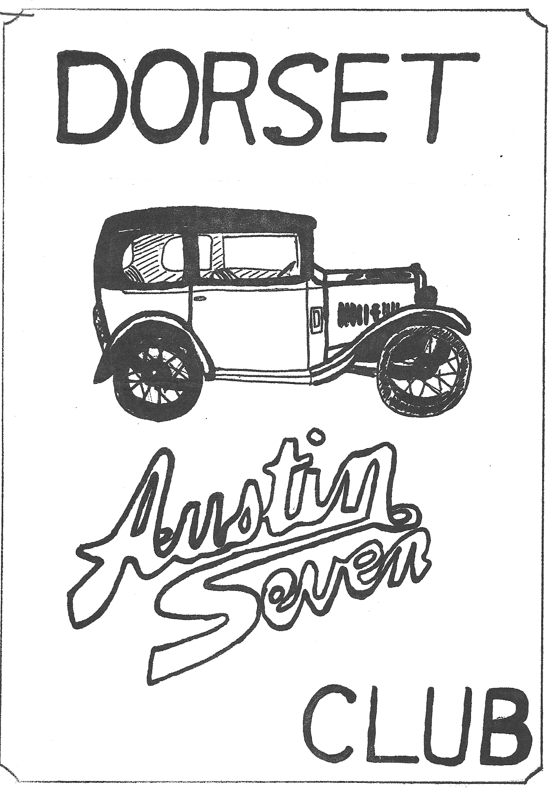DORSET AUSTIN 7 CLUB NEWSLETTER JUNE 1981

THIS MONTH'S CLUB NIGHT
THURSDAY 18th JUNE, MEET AT 'THE NAGS HEAD' RINGWOOD, FOR A RUN TO THE THREE LIONS AT STUCKTON (LEAVE 'NAGS HEAD' 8-15 p.m.)

JULY CLUB NIGHT
MEET AT 'THE CLAY PIPE' SANDFORD, NEAR WAREHAM. FROM THE A 351 WAREHAM ROAD TURN RIGHT AT HOLTON HEATH GARAGE, S.P. ORGANFORD, 'THE CLAY PIPE' IS ON THE LEFT.

NEXT COMMITTEE MEETING
THURSDAY 25th JUNE AT 8.30 p.m. TYRELLS FORD, AVON.

EDITORIAL
Hi Gang,
I think I shall remember the last month primarily with camping in pouring rain and high winds. First there was our camping weekend at Charmouth, where the weather couldn’t have been worse, though I hasten to add a merry time was had by all. This was closely followed by the Caldicot Castle Rally, where several 'Dorset' members camped over the weekend. Articles on these events appear later in this newsletter.
On a more serious note, details have been published concerning cherished number plates, and from what I can understand, if you have an old car awaiting restoration, and you have not registered it on the computer at Swansea, you risk losing the registration number because it may be sold as a cherished number. So let Swansea know about any vehicles you have, if they are not already on the new style registration sheet.
Finally, our boat trip to the Isle of Wight on 4th July is off. The owner of the boat tells me it is too difficult to moor at Yarmouth on a Saturday evening, due to the number of yachts using the harbour. If another date can be arranged I will let you know.
Glyn

EVENTS REMINDER
FRIDAY 19th JUNE - 'Dorset' Camping weekend at the Berkley Castle Rally. Leave Ringwood Cattle Market Car Park 7 p.m. sharp.
SUNDAY 20th JUNE - B.A.7 Club's Berkley Castle Rally.
WEDNESDAY 24th JUNE - H.C.V.C. Evening Rally at Little Gore Farm, Gore Road, New Milton. (opposite Arnewood School)
SATURDAY 27th JUNE - Solent A7 Club Bar-b-que, a must for all keen A7 owners, some of us plan to camp here and then go on to the A7 Rally at Beaulieu on Sunday.
SUNDAY 28th JUNE - National A7 Rally at Beaulieu.
SATURDAY AND SUNDAY 11th & 12th JULY - Joint Dorset/Solent A7 Clubs Camping weekend near Crofton. For details see bottom of pace 4 this newsletter
THURSDAY 16th JULY - Dorset A7 Club Night at 'The Clay Pipe' Sandford.
SATURDAY JULY 25th - Dorset A7 Club evening run (details next month).
WEDNESDAY 29th JULY - THE WEDDING DAY, a parade through Wimborne, we have been invited to take our cars (more details next month).
DOUNE RALLY A couple of us have decided to take a week’s holiday based on the Scottish A7 Clubs Doune Rally on the 1st and 2nd August. Anyone interested in joining us contact me on New Milton 613080 or Gary Munn on Ringwood 78795.

CAMPING WEEKEND AT CHARMOUTH
In spite of the ominous rain clouds, we set out in high spirits for the camping weekend at Charmouth, me in the Chummy, and Daphne driving our "mobile home". On arriving at Julian’s Bridge we found that the Dorset County Council had very inconveniently roped off the appointed lay-by meeting point, so we moved on to the next pull-in. After a time, we were relieved to see Gary hurtling along in his box, and the delectable Debbie in hot pursuit in her Chummy. After a further wait, and much debating, the gathered few decided that the other members must have gone on, so we set off into the gathering gloom and arrived at the camp site to find Glyn and John with their tents already erected, and although the ground was wet and soggy, the others deemed to have their shelters up in no time at all. As we were about to settle down for the night, John and Janet arrived with their caravan and Cortina to make up the party. The next morning, we were relieved to see that the rain had stopped, so after breakfast we set off in convoy towards Devonshire, going through Lyme Regis, and Seaton, through Beer, and up onto the headland, we stopped to admire the view, before setting off towards Sidmouth. Our expedition was not without incident, however, on climbing a notoriously steep hill, my Chummy started to boil merrily, and on examination I found a broken fanbelt, but with Glyn's ingenious idea of lacing up the broken belt with wire, and some water provided from John's container, we were on our way again. We fortified ourselves at a pub for lunch, and moved on to Sidmouth, where the rain came down, and only the brave set off in search of a cuppa, and to do some shopping.
Returning to the campsite John and Gary decided to liven the journey up, by taking us through a deep ford. I've seen Amphibious Triumph Heralds before, but never Amphibious Austin Sevens! We all got through safely, Daphne having her fingers crossed, and commenting "We ought to have been in an "Ark" not an Austin". The thrills and spills were not yet over, as the Chummy was boiling again, as we climbed one of the steepest hills of the trip. Having ground to a halt, John's Cortina towed us to the top (saved again! Glad we belong to a club.)
We arrived back at the site without further mishap and, after a meal, we all descended on the bar where we had a good old noggin and natter. Bedtime came, and we were lulled to sleep by the sound of dustbin lids being blown about by the gale that had sprung up and we were very relieved to draw our curtains the next morning to see three tents, and occupants still on terra firma
As the weather was so uncertain we decided to drive homeward, calling at the "Silent Women" (that’s a pub!) for lunch. At this point the sun made a rare appearance, so we decided to take advantage of it, drove to Wareham, and walked by the river towards Arne. On the way back, most of us enjoyed a large icecream, before setting off for the short journey home.
We thoroughly enjoyed our weekend - Here's to the next one, hoping for better weather next time.
Peter Holmes

CHEDDAR RUN
Pat and I were the first to arrive at Wimborne square on a Sunday morning which had begun cloudy, but was now clearing. Lawrence was the next to arrive, followed by Peter and Daphne Holmes, John & Cynthia Page and the children, Gary and Debbie Munn, and Phil & Hilary Whitter and children.
We all set off behind John Page's Box via the "pretty route" to Henstridge, where we were joined by Roger and Rosemary Ballard and after a chin wag we pushed on to Wincanton. Richard and Margaret Cressey and Brent and Wendy Gillard joined us for the remainder of the journey making a convoy of nine A7s. We stopped at the 'Queen Victoria' near Priddy, between Wookey Hole and Cheddar where we all had a good lunch and partook of liquid refreshment, in the beer garden.
Suitably refreshed, we split into two groups, the main group moved off to Cheddar, whilst Roger and Rosemary, Pat and I decided to visit Wookey Hole. We had all arranged to meet in the Wookey Hole car park at 4.30 p.m. for the homeward journey, which was broken for tea at Henstridge.
Thanks John & Cynthia Page who were our leaders for the day.
Glyn
CALDICOT CASTLE RALLY
Glyn, Trevor and I met Gary, John and Janet Stone with their children Peter and Karen at Wimborne square on Friday evening for the drive down to South Wales. After a wet start (it always rains on our camping weekends!) it had dried up by the time we arrived at Caldicot at 10.15 p.m. It was John's first long run with his newly acquired '35 Ruby and it went very well.
The tents went up in record time as 'closing' time approached. Needless to say, we made it in time and spent an hour recovering from our long drive.
The following morning, we woke early and breakfasted on bacon, sausage and eggs. Appetites appeased we all set off on a run to Simonds Yat, where we climbed to the top to take in the lovely view, where upon it teemed with rain. We returned to the village and had lunch. By this time, the sun had come out and we decided to go for a walk along the river Wye. After about 1½ miles we came to a suspension bridge like the ones you see in the jungle and we crossed this with some trepidation and returned to the cars along the other bank. When we arrived back at Caldicot we had tea and welcomed Brent and Wendy Gillard and Richard and Margaret Cressey who had just arrived after a rather hair-raising crossing of the Severn Bridge as it was now blowing a gale.
That evening we went to the Barn dance arranged by the S.W.A.7.C. and had a great time. Brent Gillard excelled himself as a barn dancer as he had never been mad enough to try it before.
We had a rather hectic night as after we had all retired to our sleeping bags some local hooligans began to invade our camp site. John & Glyn armed with camping mallet arrested what they thought were the 'baddies' but they turned out to be Venture Scouts looking after the marquee. The police arrived and at last it went quite at 3.00 a.m. Needless to say, Gary & Trevor slept through all the commotion.
Sunday morning came all too soon and cars started arriving every few minutes. By the afternoon there were about 70 cars present. A few items were bought at the Auto Jumble stands and we watched Gary do the driving tests. At 4.00 p.m. the prizes were given out and the 'Dorsets' did very well. Brent Gillard came 1st with his Ruby, Dave Simonds 2nd with his Box and Richard Cressey came 1st in the best car with trailer. The children did well as Peter Stone won the drawing competition.
It was pouring with rain by now and we set of for home at about 5.00 p.m. We had a trouble-free journey and arrived home tired after a very enjoyable and eventful weekend.
Pat Llewellyn

DORSET/SOLENT CAMPING WEEKEND AT CROFTEN 11th &12th JULY
LEAVE RINGWOOD CATTLE MARKET CAR PARK AT 10.30 a.m. SATURDAY, TO RENDEZVOUS FOR LUNCH WITH SOLENT MEMBERS AT THE CROWN INN, CHOLDERTON ON THE A338 SALISBURY/MARLBOROUGH ROAD. AFTER LUNCH ON TO THE FORESTRY COMMISSION CAMP SITE AT POSTERN HILL IN THE SAVERNAKE FOREST. ADULTS 70p CHILDREN 5yrs-15years 30p.
AMENITIES: MAINS WATER, 2 TOILET BLOCKS, ELSAN DISPOSAL POINT. At 7 p.m. SATURDAY EVENING THERE WILL BE A BAR-B-QUE IN AN ADJACENT FIELD BRING YOUR OWN DRINK AND SAUSAGES. ON SUNDAY THERE WILL BE A RUN TO PLACES OF INTEREST INCLUDING WITTON WINDMILL, CROFTON BEAM ENGINE AND THE KENNET CANAL

FOR SALE
MOVE OF HOUSE REQUIRES THAT NO REASONABLE OFFER BE REFUSED FOR 1936 RUBY (COMPLETE EXCEPT FOR BODY) WHICH WOULD FORM THE IDEAL BASIS FOR AN RTC SPECIAL. PHIL EDWARDS, 7 COPSE ROAD, BURLEY TEL. BURLEY 2441 or SOUTHAMPTON 23855 Ext. 443

A FEW SIMPLE RULES FOR GEAR CHANGING
An owner of even an early Seven is proud of its wonderful reputation and is pained when prejudiced and ignorant friends refuse to agree that it is perfect, They admit that it is reliable, but they suggest that it wants more coaxing than a full size car. The better informed argue that gear changing is not always easy, yet a little attention will soon put it beyond adverse criticism.
The short gear leaver of all but the latest models needs lengthening. An extension may be bought for a few shillings, but it looks clumsy and there is a better way which, incidentally, is cheaper. For about 2s. 6d. a mechanic will cut the lever near the gearbox and weld or rivet it to an extension - say three inches in length - so that it forms an obtuse angle, pointing backwards, with the knob near the driver’s hand. Then good-bye to stooping and crouching.
The rod operation the reversing catch may be removed and replaced with a longer rod (cost about 2d.) Changing down to second is really quite easy. Rude boys have no excuse for remarks about dentistry - suggested by gnashing teeth - if two points are remembered: - (1) The engine must be allowed to accelerate sufficiently; (2) it cannot if the valves are sticky. When decarbonizing, clean valve stems and guides with a paraffin rag. That helps to make the baby lively.
Now suppose one is doing just over 20, and traffic, or an approaching corner makes second gear advisable. A common, but very bad plan, is to press hard on both brake and clutch pedals.
The better way is to declutch and put the lever in neutral and then to push the accelerator smartly and firmly right down.
The engine joyfully sings whoop! Declutch again and snick the lever into second. It goes in like silk and the driver beams proudly.
If doing less than 20 miles per hour, the accelerator need not be pressed down so far, but in any case, move the gear lever gently. The little ball at the end of the lever may be broken off by rough usage, and fall into the gearbox. A smashed gearbox is a heavy blow to one's bank balance and a new gear change rod will probably not fit without being "set" at a garage - a difficult and costly job. A lively engine, gear lever comfortably placed, and gentle handling make the risk infinitesimal, and the certainty of being able to change into a lower gear at any speed makes for confidence at all times. It gives one a feeling of superiority, for hundreds of drivers never learn to do it.
Taken from Light car & Cycle Car Feb.1930
