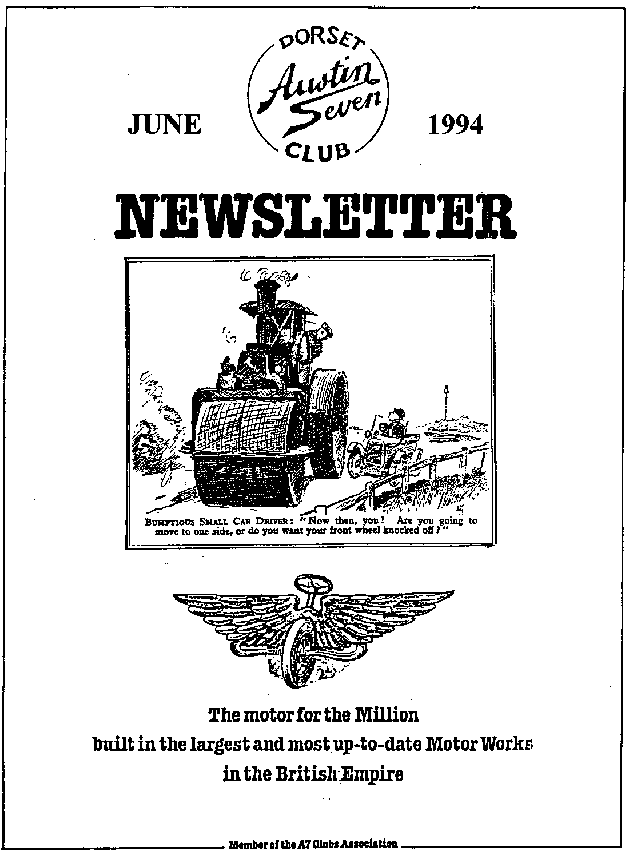

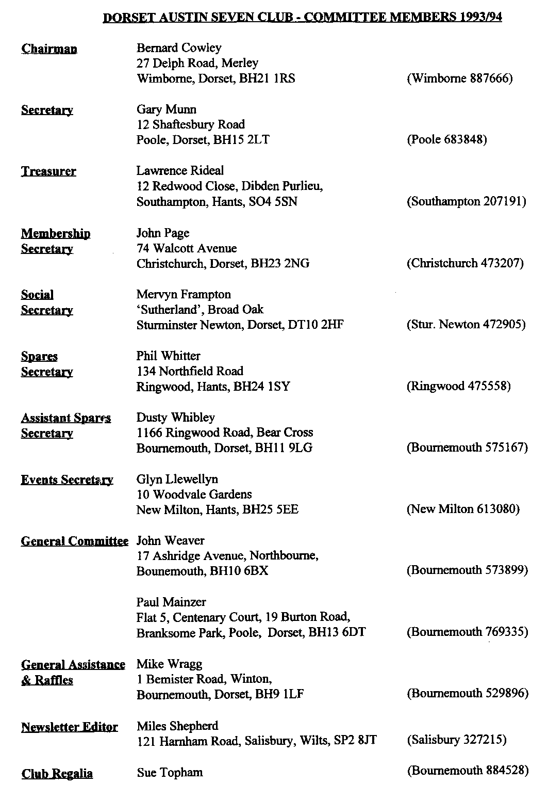

June 1994
EDITORIAL

Hallo Everyone,
Another month crowded with events has flown by. I have not had a report on the evening run to the Hambro Arms but I am sure it was enjoyed by all participants. For a variety of reasons I have been unable to get to many events this year. Please do not think I am avoiding you! All should return to `normal' by the end of next month but I really could do with a few more reports of club events, especially those I don't get to.
Sadly, I was unable to get to Breamore, one of the Club highlights of the year. Saturday boded ill with the wind and rain but the Sunday dawned bright and almost warm! Hopefully everyone had a good time. Many thanks to David Whetton once again for all the organisation
Considering the weather we have been having, the turnout for the Driving Tests at Blandford Camp was particularly good and the event went off well, with not too much waiting around. There is a separate report elsewhere but many thanks to all who took provided equipment, marshalled or took part.

Speaking of the weather, I note that the Secretary and sundry other stalwarts have fled to Spain in their Sevens, thus missing much of the D-Day Celebrations and our soggy, rain-filled skies. Hopefully, they will enjoy some sunshine as they No doubt a report will appear in due course.
There are two key events taking place between now and the time the next Newsletter will appear. The first is Bristol A7C's Spye Park Rally, held over the week end of 25 -26 June. This is an excellent family weekend and usually attracts a strong contingent from Dorset. The other, and much the most important event of the Austin Seven Year, is our own Swanage Railway Rally over the weekend of 9 - 10 July. Further details on the Events page.
See you at Club Night?
Miles

SECRETARIAL

Well Folks!
May Club Night saw a traditional Noggin and Natter. I must say that these informal evenings seem to be as popular, if not more so, than organised club evenings. However, if anyone has any strong feelings either way, please let a Committee Member know!
Thanks are due once again to Miles for arranging for us to hold our Driving Test Day at Blandford Army Camp. For those who didn't make it, we all had a good day, with a nice barbeque - and thank goodness the weather was kind to us. Congratulations to Richard Cressey for being the overall winner.
The Rally Committee recently held a meeting with Dave Keen of the Swanage Railway to sort out
final rally plans. Everything seems to be progressing well. You should find further details inside (Ed - see page 7). Please come along and tell your friends as well. Last year's weekend was great fun, this year will be even bigger and better!
Finally, a request. We urgently require people to help out on the Rally field. Pat Llewellyn has a rota, please ring her if you could spare an hour or two to give a hand. A reminder as well, any goodies for the Tombola would be much appreciated - however large or small!
See you at Club Nite, Adios,
Gary

AUSTIN SEVEN BEGINNINGS 44 A STORY OF AUSTIN FOLK
MARC WHIBLEY
Marc, eldest son of TV STAR, (live- from- Beaulieu), and Dorset Club Spares Co-Manager Dusty, and Jane, darling-of-hats, driving-test and smiles - fame; elder brother of Clubman-of the-year- 1992 - Scott. Whew! I'll say that again; well maybe I'll pause while you re-read. Sorry to confuse you all but, well, a Whibley is a Whibley, if you know what I mean. (You can see why the Association Magazine said when offered these profiles some years ago, well two; 'Space is short for us, so if you could condense several into one small article we might be interested'. There's a let out for you Miles.)
Marc, from a youngster (well, yes, I know he's still a youngster), I should say a youngster of some 6 years of age, loved cars and given the chance would have happily lived in one. His car at that time was a Go-cart from which he could not be parted. Even pedalled, amongst other events, all the way to the Spillers Public House. How far? Forgot to ask didn't I? (Marc let us know in the next Newsletter please- thanks). Anyway it's one of those major family stories that will get better and better with the telling over the years.
A Triumph Herald was Marc's first car, bought for £110 at the age of 16 (not sure whether the famous go-cart was sold to raise this princely sum or not.) However, after some work on it and his driving test successfully taken, he was on the road within a year. Not for long though: driving through a ford in the Ibsley area (in true Whibley fashion), the wiring got wet through and within minutes set on fire!
Out rushed the local village Post Master to the rescue, and saw what he had long been searching for: a cheap wreck with a chassis. In fact he had had a lifelong passion to build a special on a chassis. Triumph Heralds were, of course, the last cars to be built with a chassis, and here one had appeared like the Biblical Burning Bush in the deepest depths of the New Forest: an omen our good Postmaster could not ignore. £500 was the cash price he offered on the spot. 'SOLD' said Marc, 'and do you mind if I use your phone to ask my Dad to rescue me.' Home being a bit too far for a young lad to walk clutching £500 of the proverbial 'readies'. And he needed to keep fit for filling in the insurance claim didn't he? Fair makes you weep doesn't it? (Marc, I hope you remember the poor old aged pensioner who's writing this when you get, as you most surely will, into the vast wealth of the millionaire stakes).
Wealth of £500 plus, found Marc purchasing another 1971 Triumph Herald NTK 471J, a flash, convertible, in very good condition. Super car and what does he go and do with it? Write it off. Again? Yes. In a ford? No.
Oakdale Flyover jumped up and hit him. More cash? No, just hard work: a two-year rebuild followed by much, justified, 'proud ownership' driving around. Oh! and winning the Driving Tests at last year's Firemen's day at Brockenhurst. (Incidentally this year's similar event is on September 18th AND it is an excellent entertainment day out and more important it is to raise funds for Firemen's Benevolent Fund. A plaque for the showing and no charge for attendance. End of advert!)
1994 finds this beautiful Triumph, NPK 47IJ on sale for £1,500 (Offers to Tel. 0202 575167). Marc ending his love affair with cars? Never! For, as a family member of the Dorset club since he was ten years old, he's at long last beginning to realise his life-long ambition of becoming an Austin 7 owner. At Breaker last year he bought a rolling 1932 Box Saloon Chassis. Chassis, Engine and Running Gear all for £1,350. Eat your heart out all you folk who have seen similar to this tossed onto rubbish dumps in 'the good old days'. (Tell me that story again, Granddad!) Marc is right there slowly bartering his way: purchasing wings at Beaulieu, bonnet, scuttle (Birmingham), rear wings at Spey, '93 and front and back lights at the recent Spring .Beaulieu Jumble. Actually, he's swapped the bought scuttle with the one from Dad's car, that happening to be the right one for Dad's car.

Many bits! Where are they? As I asked, I noted Mum Jane fairly blanche and take another sip, raise her eyebrows and say 'You may well ask, Biddy!' At which Scott, Marc and Jane, (all three had by now gathered to add flavour to this report) volunteered between them that the Chassis is on the patio, engine in the Greenhouse 'Not any more', put in Marc, `It's in a safe, locked place', some things are important. Dashboard and instruments are in the bedroom. 'His', says Jane - another sip! Seats? I venture.' None yet 'but I've made the Floor Pan', enthused Marc. What is this famous Special to be called?
Well it's a 1932 Chassis, the body colour is going to be Brown and Cream. 'So', I was asked, 'what else started life in 1932 and was Brown and Cream'. Many of us, may well have started off life that illustrious year. He wasn't thinking of a person... 'A thing'. I gave in! `TWIGLETS!" Delighted, not to say delightful, Marc informed. SO, that may just be the name - a TWIGLET SPECIAL.
(A number related registration Marc is searching for.) It could be something like TW I, or mayhap MW 1932 or since he's designing the body with DOG Benson in mind (he acted as midwife to this bounding pup, while parents were on the famous EuroTour. Any suggestions on dog/twiglet/Marc/1932-ish registration numbers?
I hope, like me, you can barely wait for this long 'Heralded' Special to appear. Next Year. Watch the car park at Club Nights. Fords in the backwoods, Postmasters, Flyovers and maybe passenger Dog Benson munching Twiglets ....from a packet, of course.
Good luck, Marc. BB May 1994
P.S. Don't try the Ford trick: the Postmaster has moved.
BLANDFORD DRIVING TESTS - 22 MAY
The Advance Party assembled in the lay-by near the Camp Entrance at a particularly unearthly hour! The day had dawned windy, cloudy but no rain for the time being so we hoped for a good turnout. Once the Team were assembled, we made our way in convoy to the Guardroom where we were ushered straight through to the old airfield. This is the fifth year we have held our tests at Blandford so the setting up routine is well known to all concerned.
The motley convoy unloaded and set up the barbeque and wind break, the later usually a vital component; however, this year the wind was not so strong, just enough to blow the smoke away. While this was going on, the rest of the Team set out the tests. Just as we were finishing, we noticed that the markings on the tarmac showed that the Army also used the area for driving tests, and we were able to use some of their tests. Sadly we could not use them all as the size of an Austin 7 is somewhat smaller than the Bedford 4 Ton load carriers they use!
The main party arrived at the Camp entrance at about 11 o'clock and again were ushered straight through. Soon a gaggle of Sevens lined up at the side of the runway, everyone made a beeline for the BBQ so it seemed a good idea to actually light it. Once the cooking was under way, several drivers had a look at the course and two hapless members were invited to have a test run for the benefit of the marshals. This allows everyone to understand the course, marking and penalty system. Afterwards, we all adjourned for lunch.

Some while later, suitably refreshed, drivers lined up for the tests proper. There were 6 tests in all:
1 Garage The aim here was to see how well competitors could manoeuvre in a confined space against the clock. Three 'garages' were set up. Drivers were required to drive forward into the first garage, reverse and turn right into the second and then drive forward into the third, all in 30 seconds.
2 Parking: This is an old favourite. The intention is to test ability to park in the High Street. For the older viewers, this is also called the Reginald Holehusband Award! Distances from the 'kerb' and other cars front and rear are measured, for every 3" out, a mark is lost.
3 Weight and See; This test emphasises slow speed control. The aim is to drive in a circle round a post whilst tied to it by a length of line weighted in the middle. Points are lost for stopping, touching the ground with the weight or pulling the pylon over.
4 Bucket Shop: The driver has a bucket placed over his/her head and manoeuvres around a course against the clock. Points are lost by going over time or over the markers.
5 Slalom- Drivers have to drive between a set of cones. Marks are lost by biting cones, stopping or reversing. This is a much harder test than it sounds, as the scores will show!
6 Height Judgement Drivers are invited to adjust a horizontal (well, almost) bar supported between two uprights from a position some 45 yards away. They then drive up to the bar and lose points for each inch between the bar and the top of their car.
A wide variety of cars were entered and it was good to see many families entering. Several of the younger generation had an outing and several of the ladies took part, another welcome sight. After a close contest, Richard Cressey was found to have won the Murray Pacey Trophy with Willie McKenzie, Phil Whitter and Dusty Whibley in joint second place; they have worked out a rota for holding the Runner's Up Trophy! The full results are shown in the table on the next page. My thanks go to everyone who took part in what turned out to be a very pleasant day out, particularly the setting up team and all those who marshalled so well. Even the weather smiled on us and we had the sunniest day for many weeks, although not quite as good as last year, at least it was not raining!
 | RESULTS - BLANDFORD DRIVING TESTS |  |  |  |  |  |  |  |  |  | ,.._
 | Driver | Car | 1 | 2 | 3 | 4 | 5 | 6 | Total | Place
 | Richard Cressey | PG 6457 | 10 | 10 | 10 | 18 | 10 | 9 | 67 | 1 ^{gr}
 | Gary Munn  , | LVS 303 | 10 | 10 | 10 | 16 | 10 | 7 | 63 | 5
 | Ben Trimbey | YD 8341 | 10 | 5 | 8 | 10 | 10 | 10 | 53 | 8=
 | Lawrence Rideal | JT 106 | 10 | 8 | 10 | 0 | 10 | 9 | 47 | 12
 | Stan Warburton | CXL 153 | 10 | 5 | 10 | 0 | _ 10 | 8 | -  43 | 13
 | Keith Whitter | OICR196G | 10 | 8 | 10 | 5 | 10 | 5 | 48 | _ 11
 | Scott Whibley | GSK 253 | 10 | 10 | 10 | 9 | 10 | 10 | 59 | 6
 | Willie MacKenzie | PD 827 | 10 | 10 | 8 | 17 | 10 | 9 | 64 | 2=
 | Jane Whibley | KX 6553 | 9 | 10 | 10 . | 10 __ | 10 | 9 | 58 | 7
 | Phil Whitter | OT 6068 | 10 | 10 | 10 | 17 | _ 10 | 7 | 64 | 2=
 | Dusty Whibley | KX 6553 | 10 | 9 | 10 | 15 | 10 | 10 | 64 | 2=
 | Hilary Wflaitter | 0T6068 | 10 | 8 | 6 | 12 | 9 | 7 | 52 | 10
 | Mike Topham | FH 8124 | 10 | 8 | 10 | 0 | 10 | 4 | 42 | 14
 | Sue Topham | FH 8124 | 9 | 10 | 10 | 6 | 10 | 8 | 53 | 8=

SO WHAT’S NEW?
Reproduced by courtesy of the Essex Austin Seven Club
As I sit here again in the beautiful garden of the Longbridge Home for the Bewildered, it occurs to me one of the particular bees I have in my bonnet concerns motoring writers. It annoys me intensely when I read a motoring magazine in the day room to have some juvenile hack writer try to ram down my throat how no one could possibly live without the latest foreign turbo charged boxmobile with all its gimmicks and whatnots. What they never admit of course, is that all those totally unnecessary appendages always go wrong - at great expense - the minute the thing goes out of warranty. What is even worse is the way these know-nothing adolescents even claim world 'firsts' for so-called new features that Austin Seven owners have been enjoying - totally free - for decades.
Consider for a moment some of the so-called new inventions and modem features, and compare them with the 'Seven'. I am sure you will agree that the modem 5 cylinder 17 valve rot box from the land of the rising yen is but a poor and expensive imitation of those classic Sevens we all know and love. Well, know, anyway.
Let’s go through a typical advert for a modern car and compare. There's one here in Sisters copy of Psycho Analysis Weekly'.
Anti-lock Brakes
The Seven undoubtedly has those. On my '28 Chummy where the brake pedal only operates the rear brakes, they are even more anti-lock than those coupled systems favoured by the 'Box' and slightly strange 'Ruby' fraternity. Where the modem car achieves the anti-lock feature by complex and expensive electronics, or by the clever little mechanical modulators used on the smaller Fords, Sir Herbert Austin archived his anti-lock design at no cost by a clever cats' cradle of cables and levers incorporating lots of lost motion, mechanical disadvantage and system wind-up.
Rear Wheel Steering.
These hack motoring writers would have us believe the Japs invented this novel idea in 1987, though of course us 'Seveneers' know different. Again Sir Herbert didn't need complex electronics, hydraulics or even 'thinking' suspension. He achieved his goal by a wickedly contrived rear suspension geometry guaranteed to flick his tiny car from one side of the road to the other at the first sign of a bend or bump. The way Sir Herbert designed his rear wheel steering by the way, he gained an extra advantage in that it keeps you ever so alert! Austin Seven drivers never fall asleep at the wheel. In fact after a long run in the Chummy it's sometimes days before I can sleep.
Complete Engine Management System.
No modem car is considered complete without at least one 'black box'. My view is if you can't take it to pieces and oil it, it can't be any good and it certainly won't last long. How could any modern engine management system be more complete than the Austin's anyway? With simple levers you can vary the Austin's timing between 'bearing knock' and 'no go', the hand throttle between 'stall' and 'valve bounce', and with a curtain ring on a wire (the choke on the Chummy), you can change the mixture from 'black smoke' to 'normal' - which is blue smoke on my car. I can't see what else you would need, except perhaps to pacify those environmentalist wimps who don't like oil and unburned hydrocarbons pouring out of the exhaust pipe. The car's exhaust doesn't seem to harm the marigolds beside my drive, so they're probably wrong about that as well.
Variable-speed Wipers
The early Austin with the vacuum motor certainly have those. On my Chummy the speed varies between 'stationary' - which I admit it favours most of the time - to beating hell out of the windscreen frame, which it does when coming down Maldon hill in second gear. How much more variability do you want for goodness sake?
Good Fuel Economy
Now the Austin really has got the Japs beaten here! How many of them will achieve 45-50 mpg when their turbo-charged multi-valve fuel-injected engines are sixty years old? and I can take my little bronze Zenith carburettor to pieces on the kitchen table (when Gloria is out) without wiping the memory off the microchip. Gloria once came home and wiped the main jet into the sink, but that's another story.
Sun Roof.
By sun roof, does the advert for the modem car mean the fiddly little pillar box slit of toughened glass or tin you can only open wide enough to get your hand through? On the Chummy, release two little clips at speed (they sometimes do it on their own!) and twenty two square feet of canvas is billowing in the road behind, sucking out road maps, the dog, and my flat cap. Now that's what I call a sunroof!
Headlamp Cleaning.
Again Sir Herbert's brilliant brain has defeated the Japs! No need for electric pumps, motors, gallons of water and silly little wiper blades on the Austin. Sir H solved the problem by mounting the Chummy headlamps beside the windscreen frame, so you can reach them with your hanky from the driving seat. They're `automatic' too. The lights are so bad you 'automatically' keep wiping them just in case you can persuade one more candle power to come out at the front.
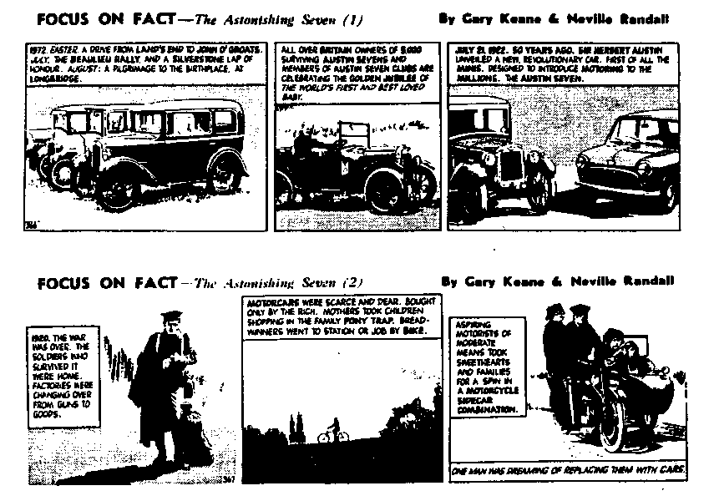

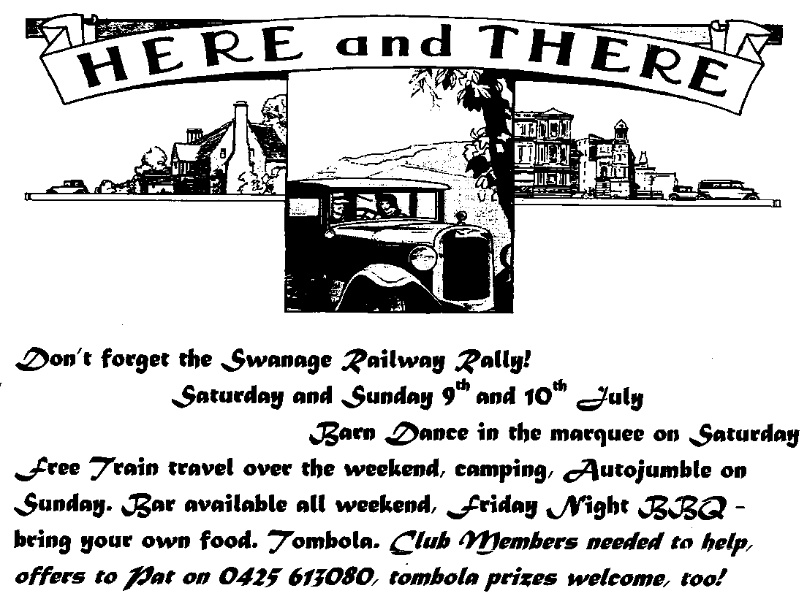
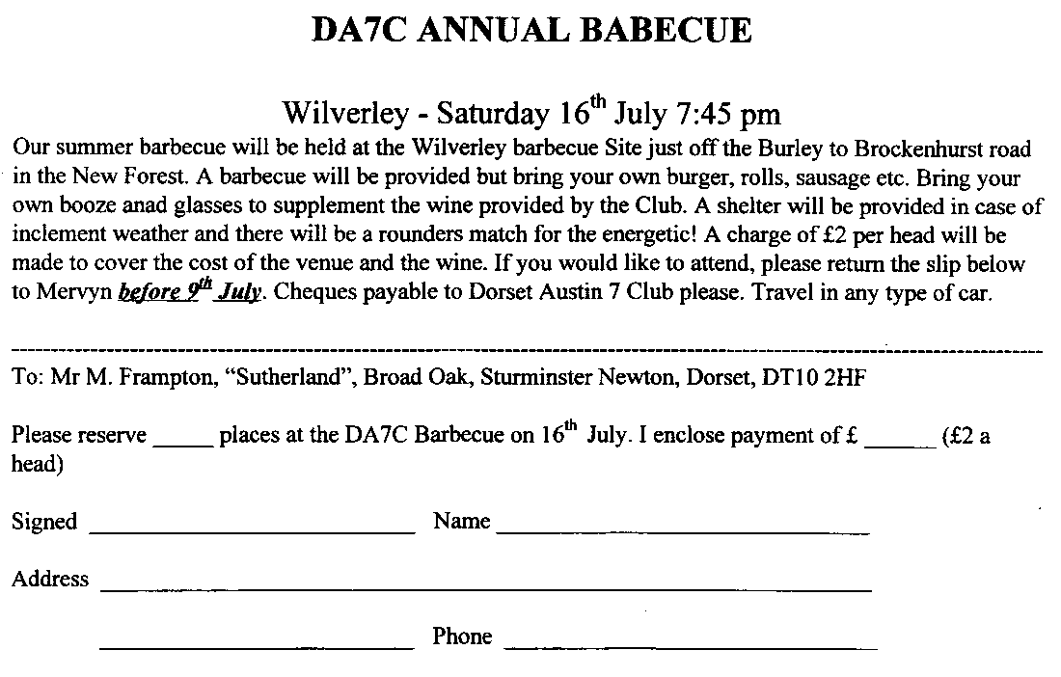

Club Events
June
Thursday 16 June Club Night. Landlord's Choice. Bring your Seven and the landlord will choose the one he likes best. There may even be a small prize!
Sunday 19 June Club Run. Paul Mainzer's run to Frome. Visit the Whatley Vineyard and Herb garden after a Pub lunch. Meet at the Safeway's Car Park Wimborne at 9.30 am for a 9.45 start.
Thursday 23 June Committee Meeting. Another gathering at the Tyrell's Ford, 8.30 prompt start!

July
Thursday 7 July 8-ish till Late. Lost Keys, Wimborne, at the start of the road to Badbury Rings. We haven't been here for ages, so make a special effort and you will be rewarded with a splendid gathering!
Sat/Sun 9/10 July Swanage Railway Rally. Don't miss this event, full details on page 7. Your support is needed!
Saturday 16 July Barbecue. Wilverley barbecue site, 7.45pm. Full details on page 7.
Thursday 21 July Club Night. This will be a chance to catch up with all the Club activities! Another night not to miss!
Sunday 24 July Club Run. West Dorset area, full details at Club Night. Meet at Wimborne Safeways Car Park at 9.45 am for 10 am start.

OTHER EVENTS
Weekend 25/26 June Spye Park Rally. It is not too late to join the party. See a Committee Member at Club Night if you want to come along.
Sunday 26 June Michael Sedgewick Run. Organised by the National Motor Museum, there may just be time to enter if you ring Anne Reynolds at Beaulieu.
Saturday 30 July Butterboy Bonanza, Oakford Fitzpaine Recreation Field. Beer or light refreshment tickets for those attending. See Mervyn for further details or the June Newsletter.
Saturday 30 July Damerham Country Fair. This super county show is held every other year and those who attended in 1992 will remember what a nice day out it was. Please let Phil know on 0425 475558 if you want to attend.

