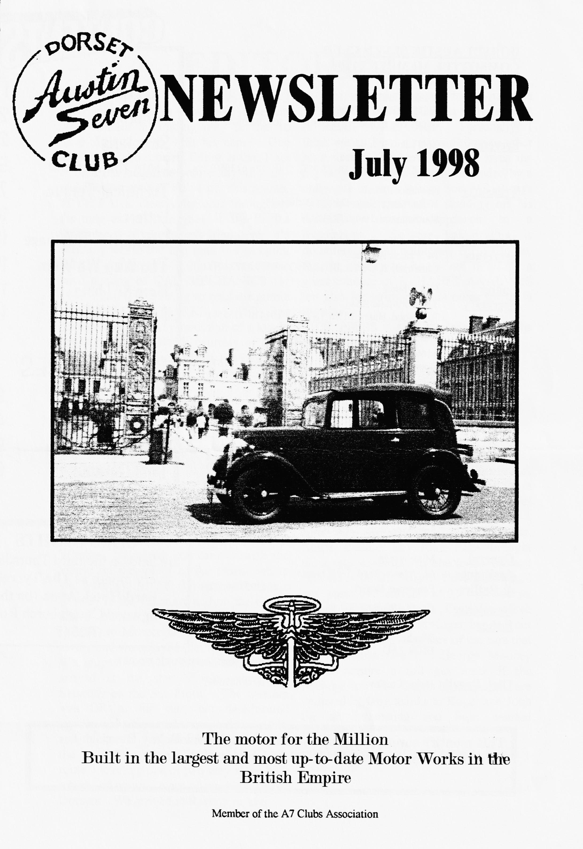

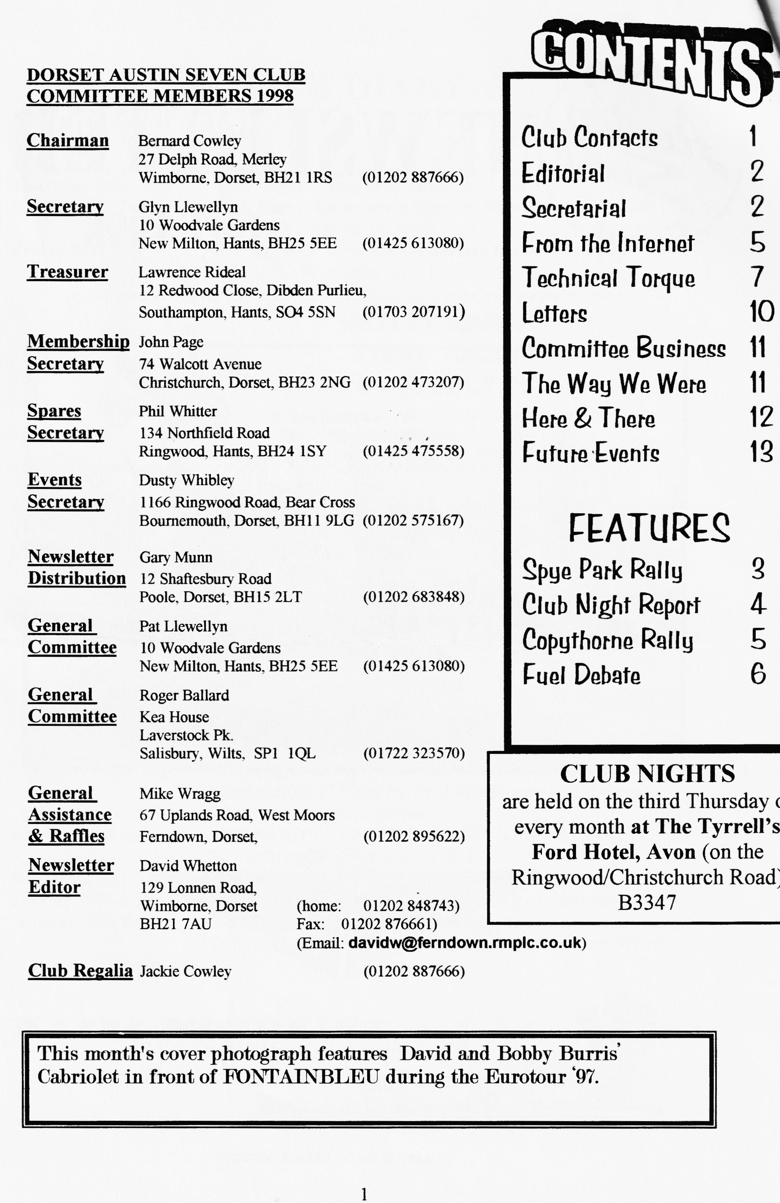

EDITORIAL
_{F}irst, an apology to PETER Treliving who wrote us those two excellent articles on. trialing only for me to have a brainstorm with his name. One good thing about being Editor is that I get to read the magazine before any of you and another cracker we've got this month. SPYE PARK clearly features throughout the mag as so much goes on for such a little place_ If you haven't tried it yet, it's certainly worth the trip (and the camping is NOT obligatory!). Colin Masters let me have a copy of CAR MECHANICS for 1959 and it's interesting to read the article on PENALTY MARKS. Phil has provided us with an impression of a lovely day at COPYTHORNE courtesy of Dave & Bobby Burris and whilst the biro was
still hot, penned a response to this month's TECHNICAL TORQUE on the mysteries of REAR AXLE DRIP. Personally, I think we all have a responsibility to other road users NOT to drip oil all over the highway as I am constantly reminded by a colleague at work whose son will always be in a wheelchair after skidding off his motorbike at the approach to a roundabout. So the hole-drilling is definitely not the politically correct to do. Finally, thanks to Roger not only for a great evening of EXHAUST ANALYSIS but also for writing up his notes for us in the mag,
STOP PRESS A lovely letter from `The Duchess" on page 8. David

Deadline for the next issue is 24/7/98. Please send material to me by post, fax or Email or pass it over at Clubnight
SECRETARIAL

HI GANG
Pat and I have recently returned from a trip to Yorkshire, where we took part in the 'Coast to Coast Run which starts at Morecambe and finishes at Ravenscar, nr Whitby. We took our camper with the Fabric on the trailer to Ravenscar where we were joined by Bernard and Jackie Cowley in the Chummy and on the Friday drove across the country (the run in reverse) to Morecambe. The weather was lovely, and we enjoyed the trop very much. We stayed B & B at Morecambe and arrived at the start 9 a.m. sharp on Saturday on the Sea Front. The weather was OK at the start but deteriorated rapidly and we passed through driving lain and thick mist. We saw brief glimpses of the lovely scenery that was along the route, including one or two very steep hills which, of course, were no problem to the Dorsets. We arrived at Ravenscar at 6 p.m. to be presented with our 'Certificate'. It was a great run, but such a shame about the weather. We did a total of 350 miles there and back.
June club night proved very popular. Roger Ballard and John Page brought along gas analysers to check the exhaust emissions of our Austin 7's. Most would not pass the current M.0,T of course, except for Phil Whitter's Chummy which came out very well. Roger handed out smog masks for the owners of the cars that did not do so well. George Mooney would require a full gas mask if the readings on his Cambridge special are believed! Many thanks to Roger and John for an interesting and lighthearted evening. Enough from me for now see you all at Club night
GLYN
SPYE PARK 20/214. June 1998

N
othing seems to change at Spye except perhaps the potholes get bigger and bigger. After we
arrived on Saturday afternoon the campsite started to fill up with tents springing up like toadstools. All the gang were there - the youngsters in their tents, us oldies in campervans. The afternoon was soon passed in warm sunshine and pleasant A7 chat and it was time to go for dinner in Laycock. Unfortunately, our first choice, The George was fully booked so we went on to The Carpenters and were soon joined by Glyn & Pat, Hilary & Phil, George & Joy, Janet & John, and many of the Bristol Club. Soon the truth was out it was Glyn's birthday and we just had to have a celebratory drink (or two).
Before we knew where we were it was 10 o'clock and time for the barn dance back at the site. It was in full swing by the time we got back with the youngsters enjoying themselves in true DA7C style. Traditionally, there is some harmless 'fun' between our youngsters and the Bristol lads and despite some of them being in full Scottish gear and showing us what a real Scotsman wears under his kilt, I think our lads outshone the others. It was 2 am when we made our weary way to bed and I honestly can't remember too much else to tell you!
The morning broke too early with the arrival of Jacky & Bernard, Richard Cressey, Dusty & Jane, Dave Burris, Paul & Gary and David Whetton. The morning was generally spent on coffee, autojumbling, coffee, autojumbling ... and soon it was time for a picnic in the sun in pleasant DA7C company. In the afternoon, on Dusty's advice, we went exploring round the house and gardens which we didn't even know existed — with Hilary and Harry. It was just like stepping back in time even coming across a village cricket match and a scene straight out of the fifties.
On returning to the rally field, we were greeted by the sight of Dusty doing his Pied Piper impersonation with a shoebox full of orphaned pheasant chicks and a load of little children in pursuit. It transpired that the mother had been killed and Jane & Dusty had rescued the chicks and were taking them to the keeper's cottage for safe rearing.
All too soon it was time to say goodbye and as we left so did the sunshine. Soon the heaven's opened and with expert timing the trailer burst a tyre. However, a very nice man in a van stopped to help and we were soon on our way again. Thanks to our Bristol friends for organising another lovely weekend.
Marilyn & Jeff Bridge

and thanks for an evocative write-up that captures the magic of Spye exactly - Ed.
DORSETS DONE GOOD AT SPYE
ALL THE LATEST RESULTS
Dave Burris — first in class for Mk.1 Pearls '34/36
George Mooney - third in class for Specials '23/39
Richard Cressey — first in class for Saloons '31/32 (RN)
Bernard Cowley — first in class for 4-seat tourers '23/25 (Chummies)
Phil Whitter — third in class for 4-seat tourers '25/28 (Chummies)

EXHAUST GAS TESTING AT CLUB NIGHT

13.Austin 7s were tested during the evening. This caused much interest, merriment and some light hearted ribbing when some cars produced some very high readings.
Many people asked "what should the readings be"?
We were testing for the amount of carbon monoxide (CO) as a % of total exhaust gas and unburned hydrocarbons in parts per million, (HC).
In perfect combustion, air (oxygen and nitrogen) is mixed with petrol (hydrocarbons) which burns producing heat and carbon dioxide, water and nitrogen.
As the A7 engine is not very efficient it has a tendency not to burn all the fuel, hence high HC readings, typically 2,0004,000 ppm indicating that 10-20% of the fuel consumed is remaining unburned. A well-maintained modern fuel injected engine will have a reading of 50-150 ppm (without a catalyst).
HIGH HC IS PRIMARILY DUE TO IGNITION FAULTS.
Carbon monoxide (CO) is a colourless, odourless gas which is formed when burning takes place with insufficient oxygen. This is normally associated with over rich mixtures.
Most A7s were in the range 2.5-9 % average 5.0%. A modern will be in the range 0_5 -/5 %_
HIGH CO READINGS
ARE GENERALLY DUE TO CARBURATION FAULTS.
Several participants had a go at adjusting their carburettors during the evening and several other members who watched the event but had not brought their A7s wished they had. This may be an event worth repeating a later . I would like to thank John Page for his help with the digital meter.
WINNERS AND LOSERS ON THE NIGHT.
All the readings were taken at engine idle speed and do not necessarily represent performance on the road.
Joy Mooney's pink box produced the dirtiest readings of the evening followed by John Cheeseman and Vince Leek with CO readings around 9%. Julian Wilde's box had an average CO reading but an off-the-scale HC reading in excess of 5000ppm. They were all awarded face masks to keep the fumes at bay.
It was interesting that the non-standard carburettor cars put up a better than average performance, but Phil Witter's standard chummy came out the winner with an amazing CO reading of 0.21% with standard bronze updraught Zenith and the HC was a good average. Phil's prize was a green bottle of wine.
Roger Ballard

and many, many thanks to you Roger for a very different and instructive evening - Ed.
GLYN'S WRINKLE — well, one of them!
Heard at Spye — when one owner was very worried about clonks and grumbles from down under. Remove plugs and take the suspect piston just over TDC with the starting handle so it has just started to descend in its bore. Then try to push down on the top of the piston crown with a screwdriver or biro. If there is any play in the big end at all you will feel the piston go down with a click. Not only was Glyn right, but he even suggested try number 3 first - and it was!! Well done that man.

COPYTHORNE VINTAGE & STEAM RALLY
Sunday 7th. June

Four Sevens and a VW Beach Buggy set off from Ringwood, via Fritham and Nomansland, to The Red Rover at West Wellow to be greeted by Dave & Bobby Burris. A passing local who had had an Austin thirty years ago, on seeing the cars, had popped home to his garage and re-appeared to present David with a rusty but restorable Rist horn straight of his workbench
During an excellent lunch we were joined by the Hon,Ed_ in his racing special having suffered a heavy downpour we'd all missed and, as we were leaving, Dusty & Jane and Scott & Jo arrived for the second sitting, so we all set off for them to join us later.
No sooner had we arrived at the fair then yours truly had a microphone thrust into my hand to give a commentary on our cars over the public address system!
Formalities over, we were able to look around the event and I don't think I have seen so much variety in such a small area - everything from vintage buses to clog dancing! Later we were joined by Team Whibley just in time for the highlight of the afternoon - breathing in Castrol R from a 1948 un-silenced speedway Jap.
At the end of the event, Dave & Bobby invited us all back to their place for refreshments and to celebrate Hilary's birthday.
Thanks to you both for your kind hospitality.
PS. On the way home the throttle spring broke on my Chummy. Imagine the scene — one lifting the accelerator pedal with a piece of wire whilst the other changes gear, signals and steers!
Thanks for a very good day Phil & Hilary

and thanks to you, Phil, for the write-up. Special thanks to Hilary for phoning round to remind us of the event in the week before - Ed
At the moment, I'm in communication with the Sec. of the Big 7 register to find out what was shared with the construction of both cars. At the moment, I need some internal (cliff case) oil seals, which are not available through the likes of the Workshop. The Big 7 man is trying to find out from a Pal who is rebuilding an axle currently about the diff seals and has offered to try and track some clown for me if I can supply the dimensions. I know that there were slight changes in the late Heavy axle as some call it, but don't know exactly what. I certainly didn’t think there were changes to the diff case, for example.
I guess they would be perfect for you racers as they have heavier half shafts with increased taper on the ends and larger woodruff key (the hubs are slightly different as well to cope with the increased taper length. The downside is the internals are, I believe, quite different from the earlier cars. Ian Dunford mentioned that everything is to a metric measurement for example. Anyway, I'm looking for a late Girling rod-brake rear axle if anyone has one.
From Hugh Barnes [ hb10001@admin.cam.ac.uk]

THE FUEL DEBATE
THE TRUTH ABOUT VALVE SEAT RECESSION ?
EXTRACTS FROM A PAPER BY VSCC

Concerns over phasing out of
leaded petrol has raised the question about the vintage period 1919 — 1930 with exclusive use of unleaded fuels." Evidence is given of valve seat recession in the thirties, but it was generally confined to the USA with the sustained high speeds possible by trucks on the new freeways. By 1932, many USA manufacturers were fitting seat inserts to counteract the problem. Leaded petrol first appeared in UK in 1927, sold by Anglo American (later Esso) but its sales were relatively small. Wear and corrosion difficulties were generally lumped together and were not felt to be caused by unleaded fuel - rather, a problem that just happened to some blocks probably as a result of weak mixture, oxidisation, overheating and a flaking-off of iron oxide layers. Excessive spring compression was thought also to contribute to wear in heavier engines and valve inserts were recommended before WW2 for heavy duty commercial petrol engines e.g. Rolls Royce. It seems highly
probable, in the UK., that the combination of a horsepower tax which encouraged indifferent performance and the absence of roads where sustained high speeds were possible, prevented valve seat recession becoming a widespread problem before WW2.
Having read the whole of their report, I was left with the strong impression that valve seat recession will only be a problem for cars built in the 40s — 60s who are now 'travelling faster and longer on modern roads than nature and their designers intended. The main factors that contribute to increased valve seat wear are — high engine revs, high exhaust temperatures and sustained hard work. So, as long as you aren't going to race your Austin Seven, just de-coke regularly and keep an eye on the valves, seats and tappet gaps and enjoy the cheaper petrol.
The original report is available in the Club Library.
David Whetton

PENALTY MARK SYSTEM

Like most organisations, the Pedestrian's Association has a nucleus of members carrying a chip on their shoulder anyone who wants to travel more than 5 mph on wheels.
But I must confess that when I attended the Association's recent annual conference in London, I also found evidence of many, sound, sensible approaches.
On the basis of 30 years' experience of driving, a noted Oxford surgeon, Dr. Ritchie Russell proposed a "black mark" system for all drivers. He suggested that all motorists should be given an "offences
and accidents" log-book with their driving Licenses. In it would be entered penalty marks for road offences graded according to their seriousness. When drivers had Logged a specified number of "black marks" they would be compelled to undergo a fresh driving test or even Ordered to take a course in driving instruction.
Harry Loftus
From CAR MECHANICS 1959 with thanks ro Cohn Masters

KEEP THE OIL OFF YOUR
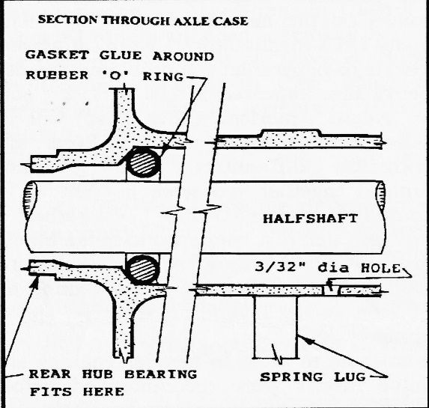
REAR BRAKE LININGS

Many Austin Seven owners find it difficult to stem the flow of rear axle oil onto their brake linings. Some resort to modern type oil seals and a few even claim success. But by assembling the components with a little care and a little cheating, this problem can be overcome.
1] THE FELT OIL SEALS
The felt oil seals either side of the differential must be greater in width than the "top hat" containers, otherwise they will not compress against their lids and be held in place. If this happens, the felts will grip the half-shafts instead, and rotate with them. This will cause the felt seals to polish up their containers and allow a good deal of oil through them. It will also enable the flat lids to spin behind the large circlips as they will not be pushed out to make contact. Many circlips have polished flats on them where this has been happening for many years!
Make sure when re-assembling the circlips into the axle eases that they stop the lids of the oil seals from spinning. Most felts that I have bought recently are too thin, — an easy remedy is to buy an extra felt seal and slice off the necessary amount to add to the narrow felt and enable them both to pack into their container and just compress when their lids are fitted. Soak the felts in oil, and when you think they are right, try them in their containers and slide them over the half-shafts to roughly the positions where they will be. Now by holding their caps on and turning the half-shaft, you will be able to determine if the felts are gripping too tightly onto the half-shafts and rotating with them, or if the
half-shafts are spinning nicely inside the felts.
2] DRILLING THE AXLE CASING An extra safety device to stop oil creeping down the axle tubes is to drill a ³/32" hole at the lowest point of the axle cases just inside the flange that supports the rear spring pin and bush.
The internal diameter of the axle tubes usually increases at this point, allowing a small reservoir of oil to build up.
There will be times when the oil misses the drain hole altogether and will proceed towards the hubs. This situation may be rectified by pushing a rubber "0" ring the same diameter as the inside of the axle tube with some gasket glue around its circumference to a point a couple of inches down from the outside flange of each axle case. Now any oil which manages to get this far will simply accumulate behind the "0" ring and

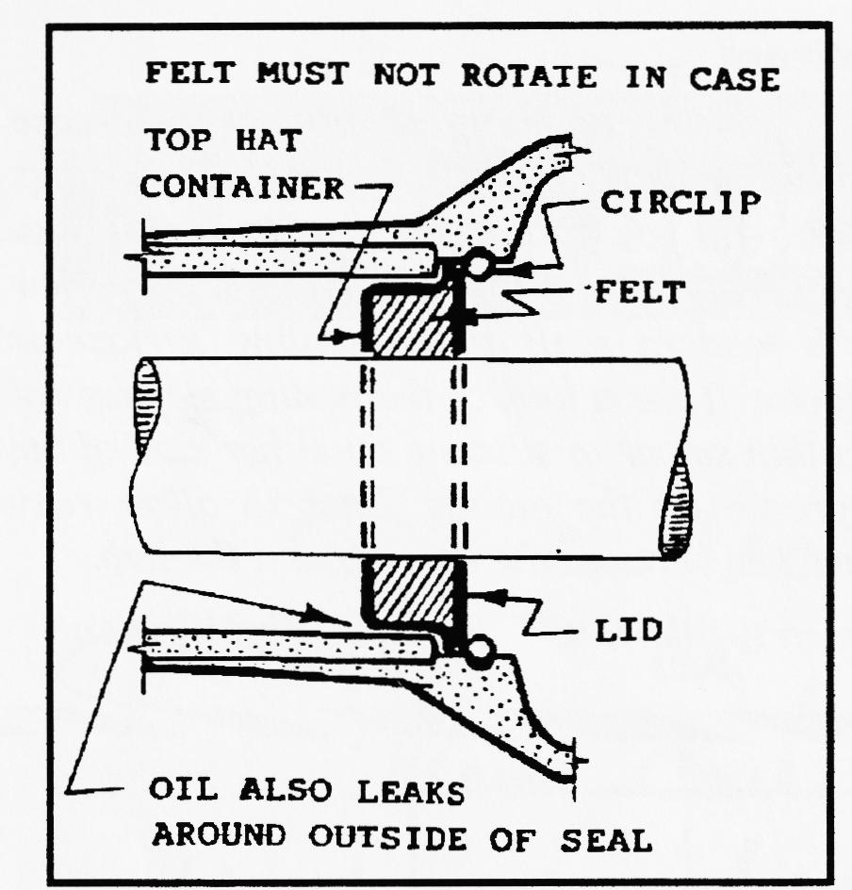
eventually drip out of the drain hole on the underside of the axle case and help to lubricate your rear spring-pin bushes!
This modification will also dispose of the rear axle oil that tends to leak around the outside of the oil seals between their containers and the axle cases and bypasses the felts altogether.
3] REAR AXLE OIL
I find a quart of Hypoy 140 grade mixed with a quarter-pint of STP most suitable.
4] NOTES
As oil can also leak around the outside of the oil seals. it helps to have the gaps in the circlips at the top of the case. The rubber "0" ring can be replaced by felt. Ideally, a felt seal located (glued) in the case and making contact with the half-shaft would be best. These modifications can only be carried out when the rear axle is dismantled - i.e. when the half-shafts are not fitted to their casings.
Bill Williams thought it unnecessary to drill holes in the rear axle cases as he assumed most of the oil ran down the half-shafts.
An excessive amount of oil will also be allowed to reach the felt differential seals if earlier half-shafts are used in conjunction with later differential carriers which have larger diameter bushes for the half-shafts to pass through! - or if the bearing adjusters are not fitted correctly and there is excessive clearance between the half-shaft and the scroll-type oil throwers on their inner surfaces.
BARRIE ARGENT

This article first appeared in the SOUTH WALES AUSTIN SEVEN CLUB MAGAZINE in February 1995
Club Disclaimer - The Dorset Austin Seven Club, the author, or the Editor, especially the Editor, cannot be held liable for any damage or injury caused as a result of following the advice or instructions in any article. Only attempt jobs you are confident you can do SAFELY.
PHIL WHITTER COMMENTS:-
Felt Oil Seals - Before even starting I find the circlip extremely difficult to remove and usually resort to a small very hard screwdriver to prise the end out - beware - it is quite dangerous! The felt seals I have used recently have been so oversize when soaked in oil that I have had to resort to shaving a thin sliver off the thickness otherwise it has been impossible to compress them enough to get the circlip back in. The advantage of using modern seals is that they seal around their outside diameter as well.
Drilling A Hole - My concern here is that if you are losing too much oil you may forget to top up the axle (check at least once a month) or you may simply have put too much oil in the axle in the first place. Oh! - and don't forget that in the later axles with adjustable pinion thrust, the adjusters are marked RH and LH in respect of the oil return thread - put the wrong one in and the axle oil will soon disappear!
'0' rings - I would find it difficult to ensure that the ring had gasket glue still in place having been pushed down an oily axle tube. continued

REAR AXLE - PHIL'S COMMENTS continued
The Hub End - Here you can take steps to prevent any escaping oil diluting the grease in your hubs and ending up on the brakes. First you can use sealed LJ 1¹/4 bearings which do not need lots of grease in the hub (f you follow the Austin Motor Co. recommendations for lubrication - where does it all go?) Next you can either use new felt seals in the hubs or replace them with modern seals if the sealing surface is unscored. I use a modern seal and half a felt one! Take a look at the mating surfaces of the bearing carrier - if all is true here, use a thin smear of silicone on either side of the paper but also put a very fine smear of grease on the mating faces to allow easy dismantling. And then finally, I put silicone rubber between the hub nut and the hub.
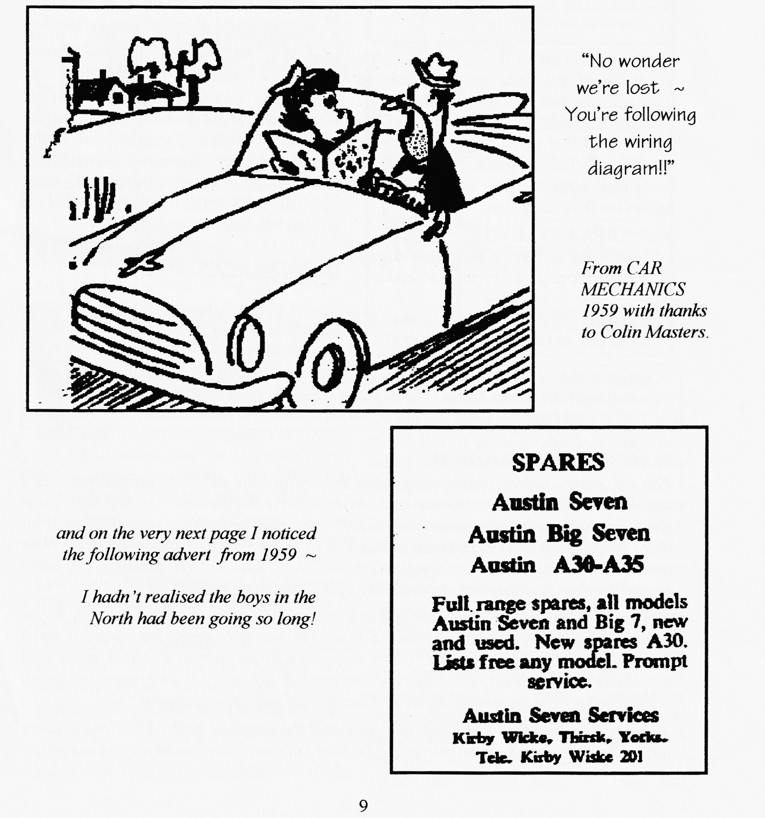
Surely Austin did not have all these problems in the thirties?? Regards, Phil Whitter.

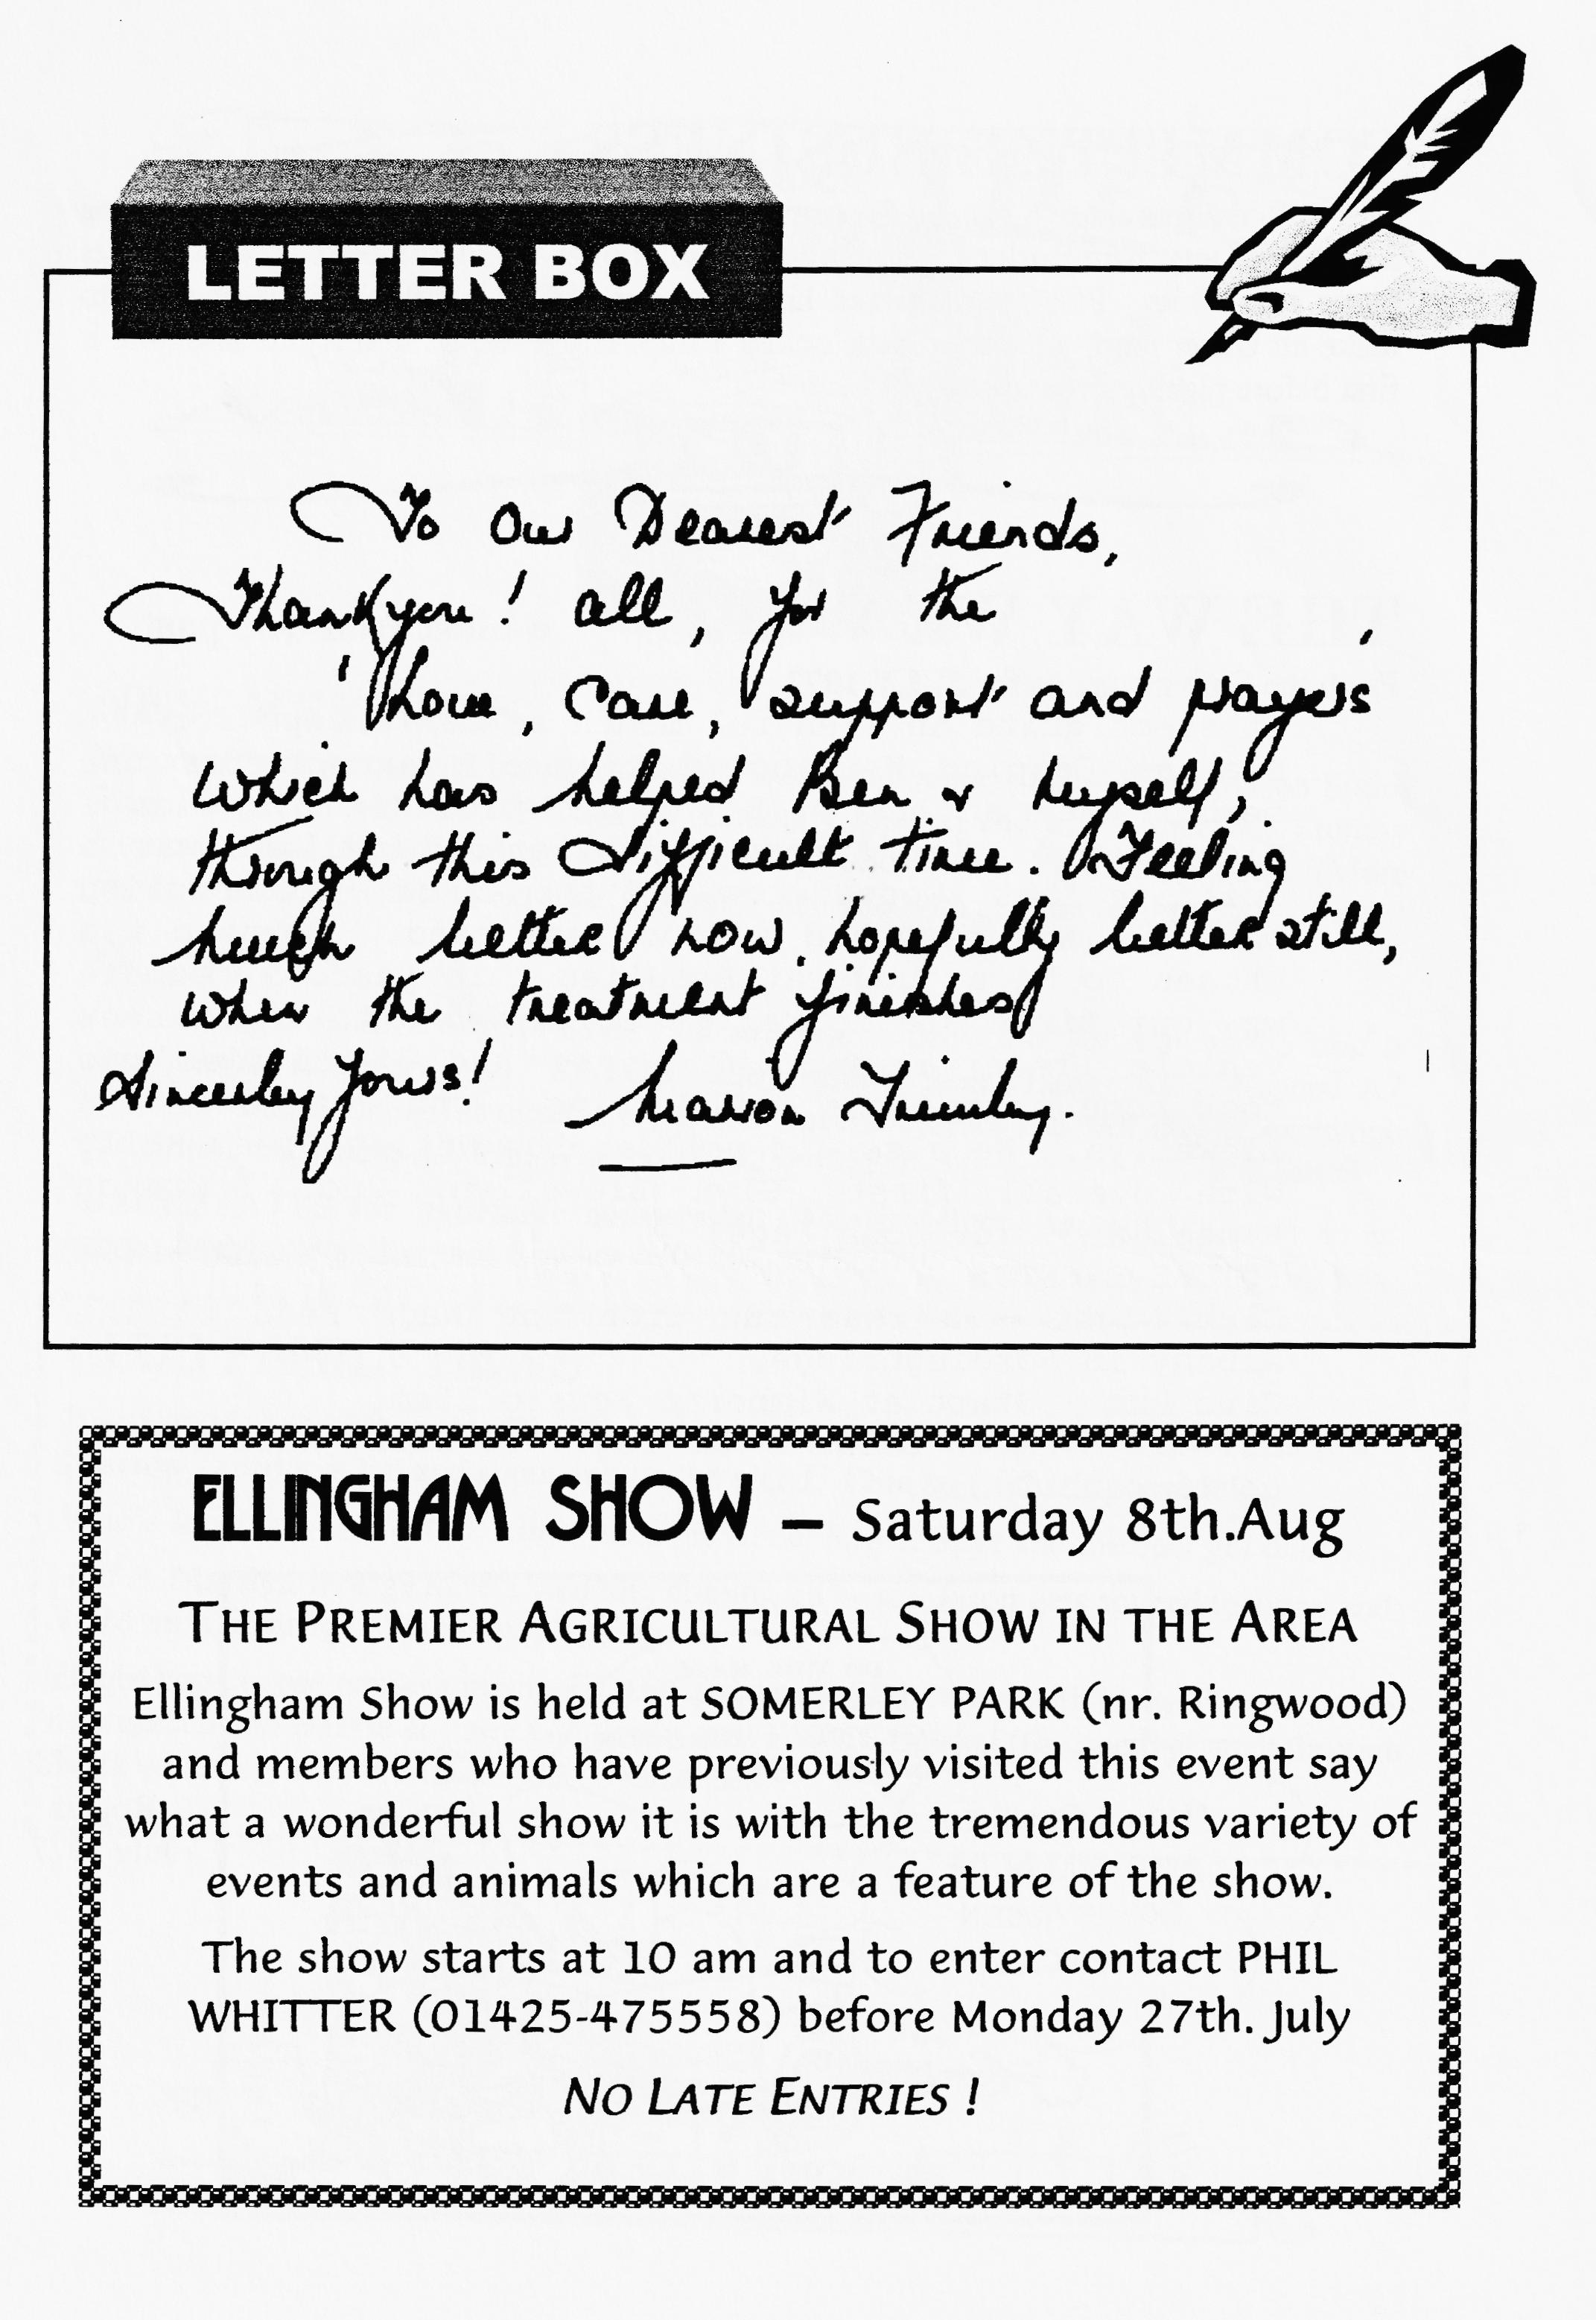

COMMITTEE BUSINESS
The Club will purchase a gazebo for use at fetes and rallies; Roger will be investigating a supply of jets from Burlen’s following the results of the emission tests as well as fuel pump repair kits. Phil demonstrated his latest purchase — a complete kit of parts to make an Ulster seat. At only £35 it looked a snip. However, let him try to assemble it first before placing orders!
THE WAY WE WERE - a blast from the past
From the Club magazine for JULY 1977
It seems quite an eventful month so far except for the Swanage Camping Weekend that wasn't except for one member with an Austin 8 who had promised his kids a night away! The Ferndown Jubilee's highlight was a Spitfire that swooped low arid the annual pre-Beaulieu barbeque and camp had a good jazz band. Bernard was chosen to be a judge at Beaulieu this year. Breamore was our first static rally (organised with the Wessex
Vehicle Preservation Club). We had 15 entries and took home three cups - C.Herring, John Page and Glyn Llewellyn. We also did well at the Netley Steam Rally with overall first, Glyn Llewellyn; 2nd. Lawrence Rideal and 3rd. John Page!
FUTURE EVENTS:
Club Night - a road run from the Nags Head to The Albany in Fordingbridge.
Club Run - Start at Wimborne Square 11 am.
31.8.77 - DA7C Wimborne Air Day. £1 entry will partly go to Club funds.
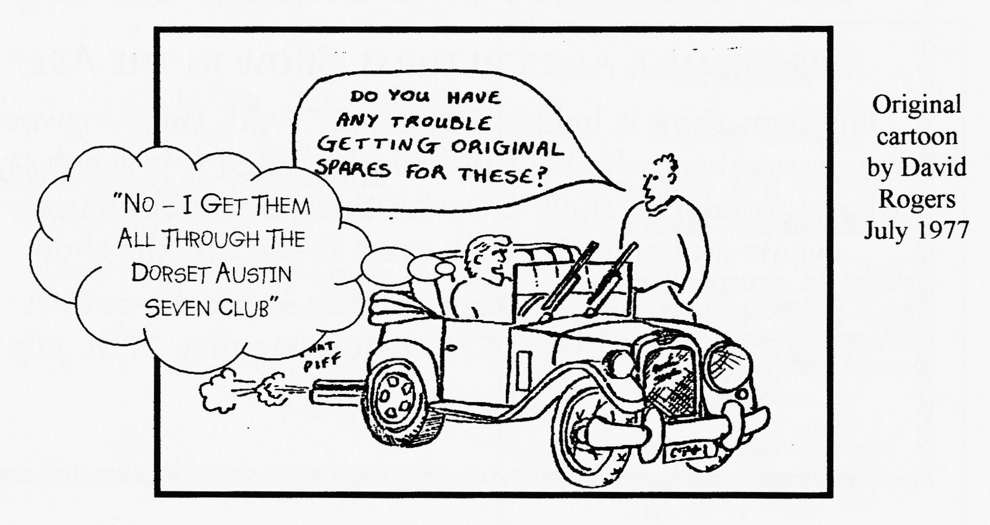

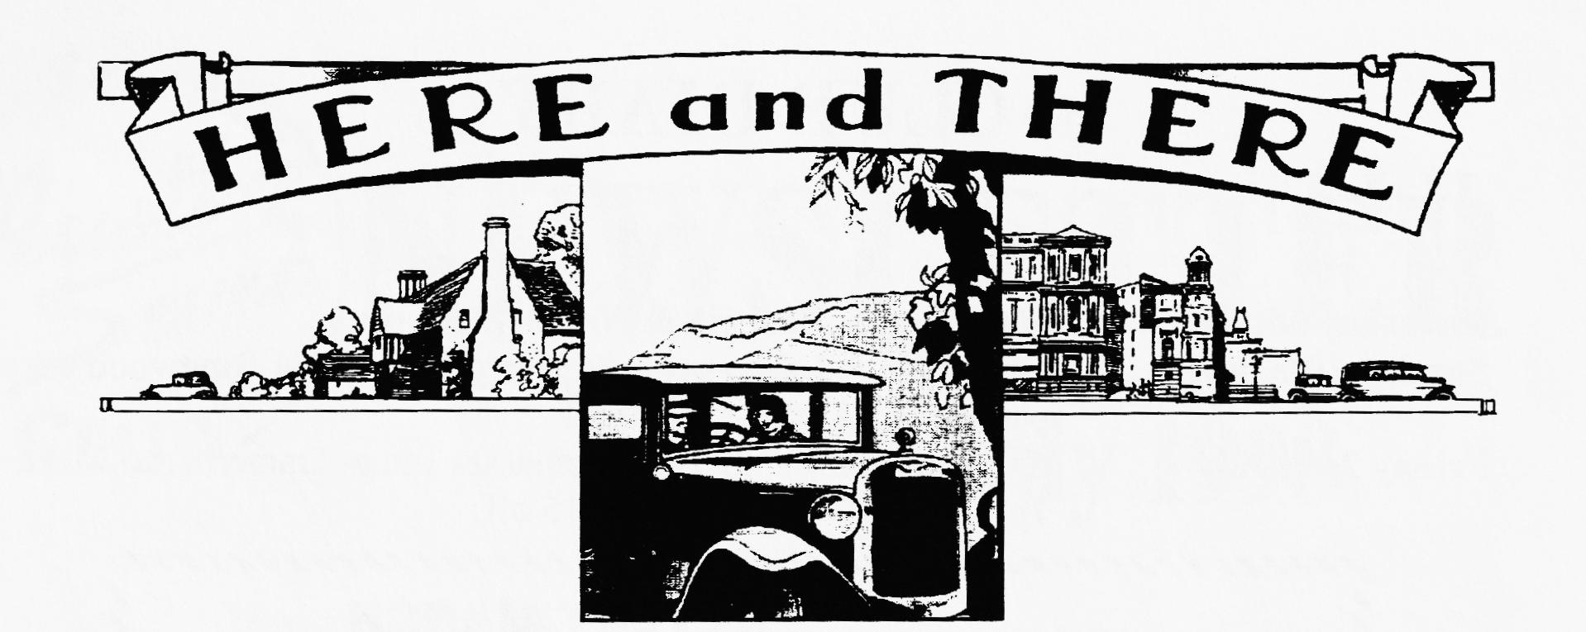
NEW MEMBERS
Welcome back to two old members (John's words not mine — Ed) Dr Ian Mason Smith from Ringwood with his 1932 Saloon (Chummy replica) and a '59 Special. Yummy Yummy. And Alan Wiseman also from Ringwood with a 1931 RN Saloon. (More prizes to take home from next year's Spye?). See you both at Club Night.
WANTED
I'm running this advert again since Phil saw one at Spye (not for sale sadly) and it nearly broke his heart. An "ELTOS" alloy remote gear change for a 4-speed A7 gearbox. I am looking for one for my Ulster Special project and will buy or exchange for virtually anything A7. Phil Whitter- (01425) 475558.
BACKPLATES for hydraulic conversion. Morris Minor, but not bothered about shoes or cylinders. Bernard Cowley — (01202-887666)
CLUB FAMILY NEWS
It was good to see Margaret Rideal at Club Night mostly in one piece and we hear that Marion Trimby is out and about and on the mend. Chin up (if that's possible!)
Who's sorry now - Scott Whibley sold his Ulster Rep at Spye and the beer got diluted.
Jeff & Marilyn Bridge have a wedding coming up - son Jason gets spliced to Jinny and J&M miss Swanage. Planning, planning.
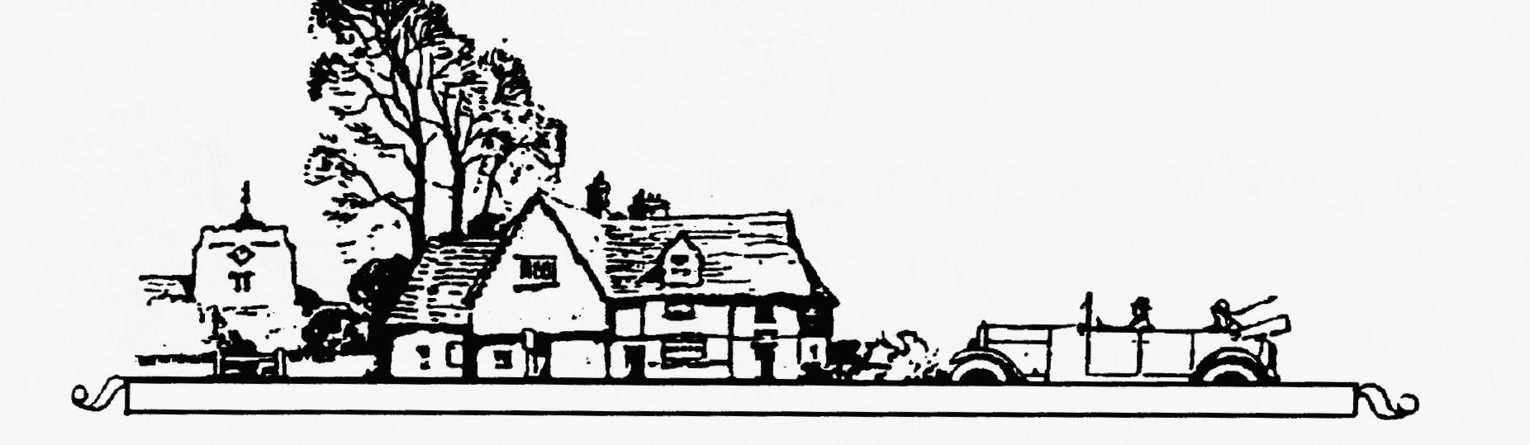
It was good to see new-ish member Geoff Savage at Club Night with his well-used yellowish Special and Barrie & Jane Goodman sans 750MC Special (the one that went through Glyn's hands). - Write-up for DA7C promised.

oo CLUB DIARY oo
JULY
Thursday 16th July Club Night — Noggin & Natter plus spares.
Sunday 19th July Club Run — Lawrence's Mystery Run: meet Ringwood carpark at 10.15am for 10.30 off
Friday 24th July Evening Run - to The Compasses Inn at Damerham. Meet 7pm at QE Wimborne for 7.15 off.
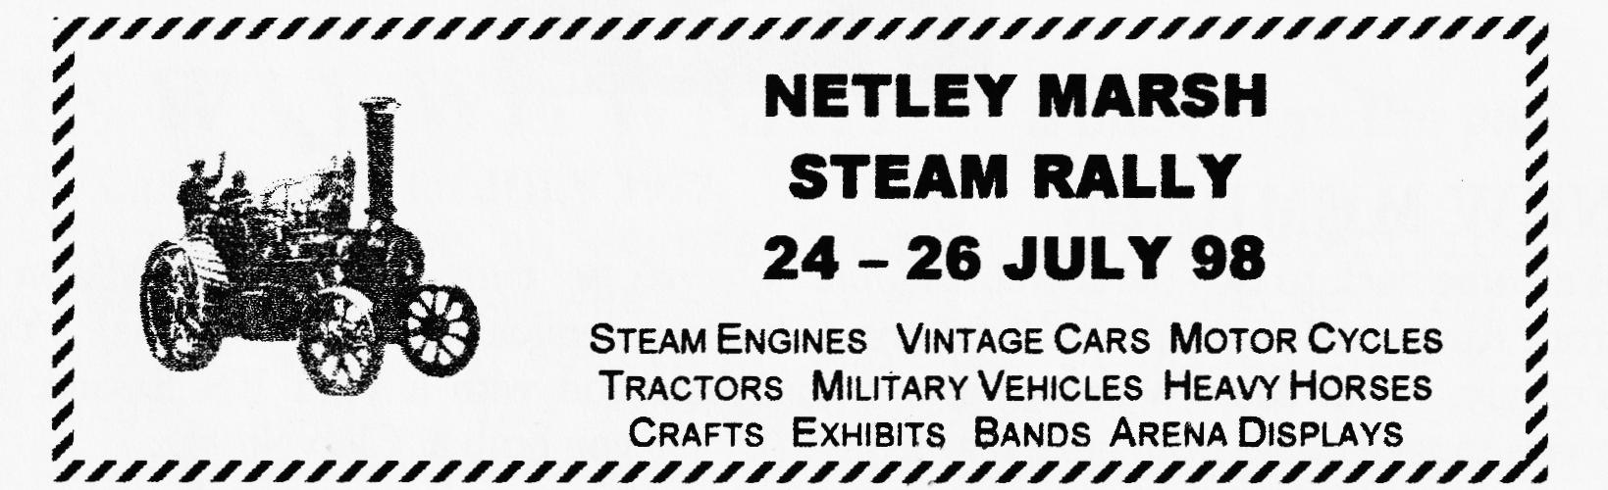
Sat/Sun 1/2nd Aug VSCC Prescott Hill Climb - details from Dusty
Thursday 6th Aug 8-til-Late: The Avon Causeway Hotel, Hurn.
Sat/Sun 8/9th Aug Yeovil Festival of Transport £4 vehicle entry - details from Dusty
Saturday 8th Aug ELLINGHAM SHOW See display ad on page 10.
Sunday 9th August Luccombe RNLI Country Fair nr. Milton Abbas- free entry in aid of RNLI 11 am start. Ring 01258-857449 to enter but entries accepted at the gate.
00 FUTURE EVENTS 00
Sunday 16th Aug Ashover Rally (VAR) - details from Dusty
Thursday 20th Aug. Club Night: Bring your SWANAGE PHOTOS plus presentation of slides by Paul Mackenzie (official event photographer) plus spares.
Sunday 23rd Aug BERNARD'S ANNUAL KITE RUN & PICNIC to Cranbourne Chase (change of date).
Sat/Mon 29/31 Aug Piddle in the Hole Run: BA7C- details from Dusty
Sunday 30th Aug A Grand Gathering of Cars: West Bay - details from Dusty
Sunday 20th Sept. The Essex Austin Seven Club cavalcade of Austins to Great Ormond Street Hospital for Sick Children. Ring 01268-771297

