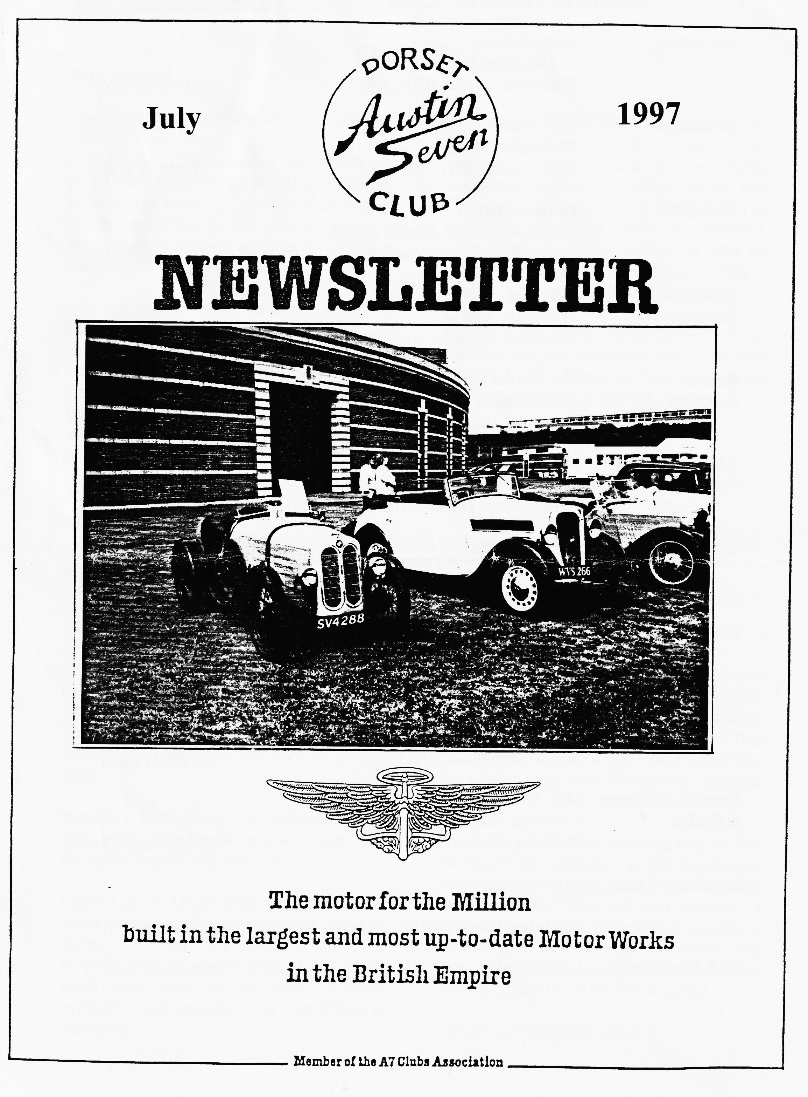

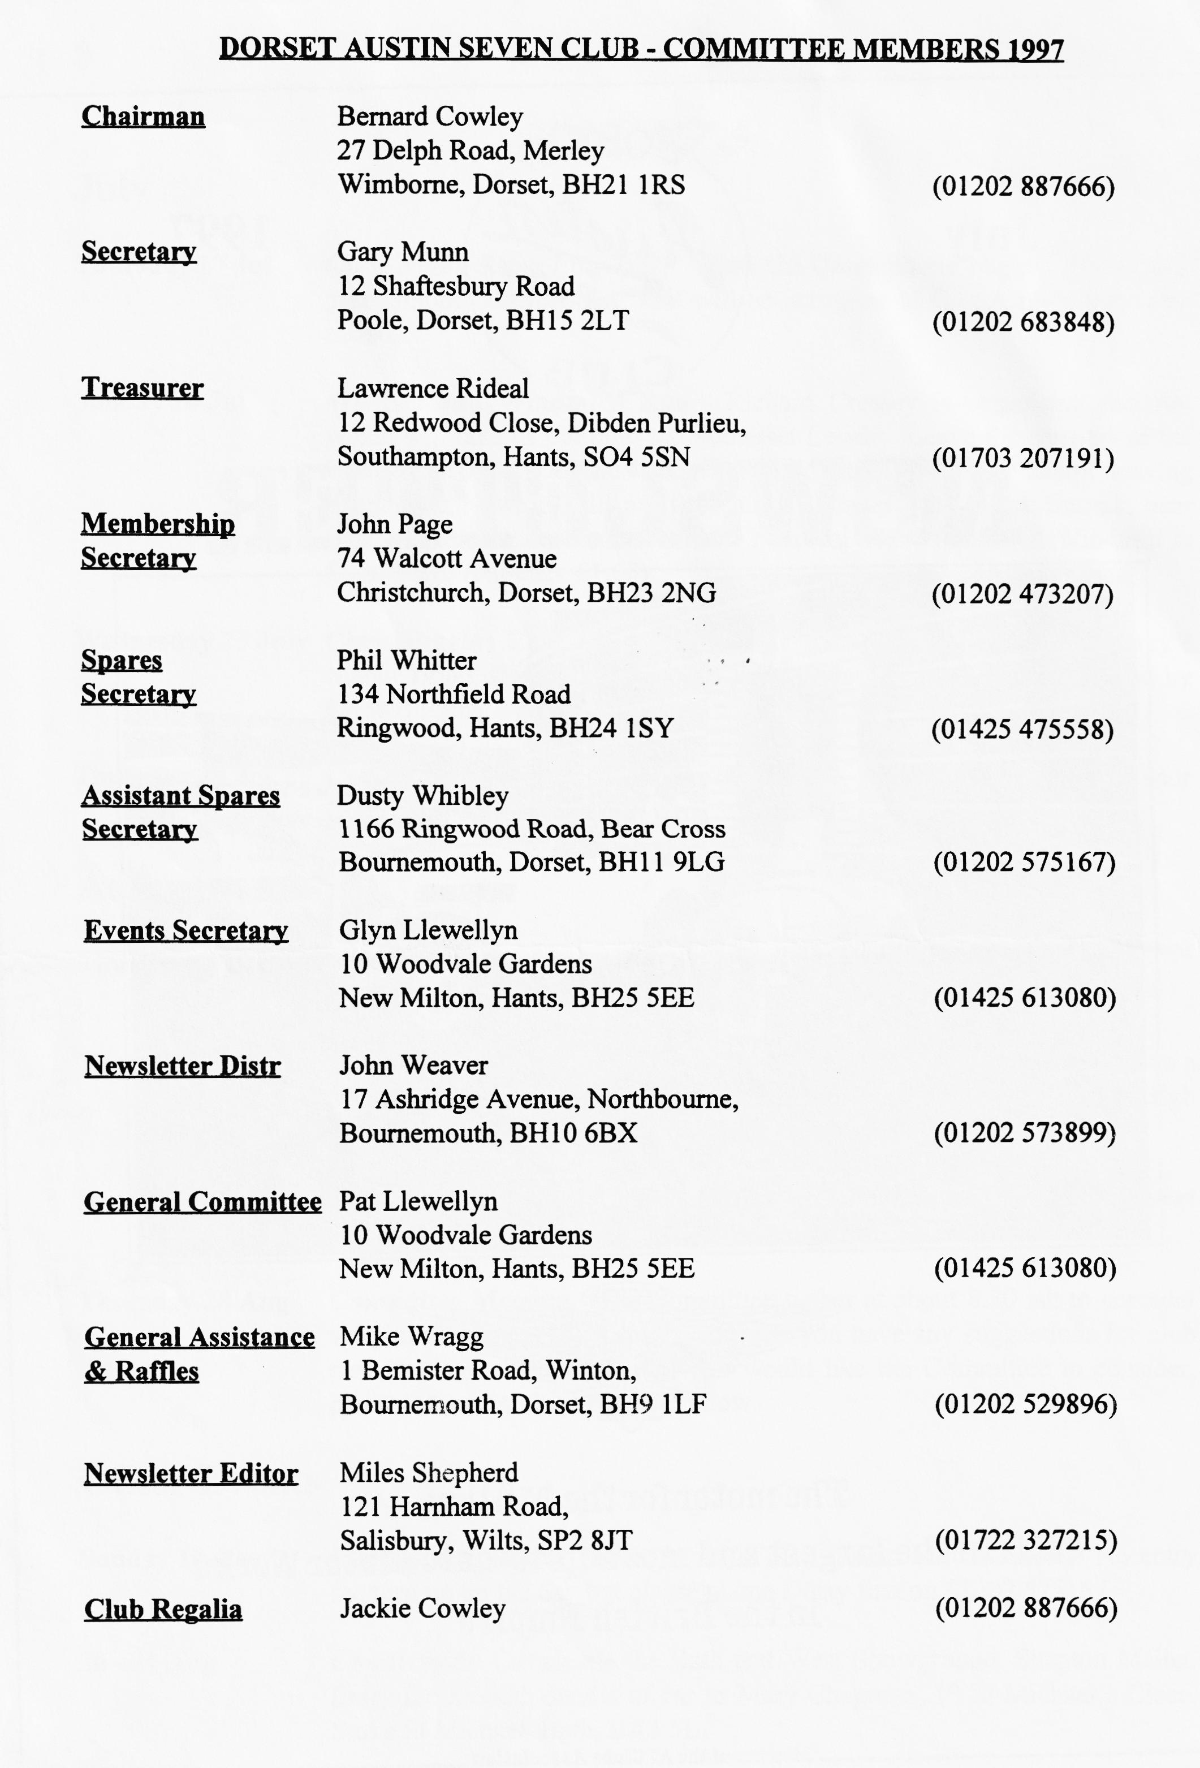

EDITORIAL

Hallo Everyone,
I am sorry that we got a double dose of Dave Whetton last month, my fault for not checking that I had taken his draft article out of the main copy when I sent it all off to the printers. To make up, you will find another article from Dave on the joys of racing, it might even encourage someone to join him and make an Equipe Dorset!
Although there are notes on last month's club run, see page 2, I had a chat with our chairman who felt it had gone quite well. Bernard tells me that the kite flying was so popular, and the venue so peaceful, that the trip to the Larmer Tree was abandoned. That means that we can go there on another occasion!
Once again, Phil Whitter has come to my rescue and put pen to paper once more. You can read his impression of the Spring Autojumble at Beaulieu, as well as the Kite Flying. For the more technically minded, he has also provided an article on gearboxes. Many thanks for all this material, it make the editor's job much easier. Anyone willing to put pen to paper to record the Club Rally?
I shall be on holiday from 28 July so the Deadline for the Newsletter has to be very early - 25 July! Please send me your articles and photos as soon as you can.
See you at Club Night BFN - Miles

As I go on holiday next month the deadline for the next issue is 25 July. Send material to me or
pass it over at Clubnight. The cover picture shows John Harris' Dixi at Gaydon
SECRETARIAL

Well Folks!
So much for Flaming June! As I sit here the rain torrents down and the forecast doesn't look much better for the week. We can only hope that it brightens for our rally, which by the time you read this will be over for another year.
Bernard's Kite Flying run seemed a great success, by all accounts a lovely, lazy day. No doubt a report will reveal all.
I didn't get to Gaydon but I believe several members did, all returning with glowing reports. Thanks very much to all those involved with the organisation. I know how much more satisfying an event is when everything goes smoothly and a good time is had by all.
Last month's Club Night was an informal `Bring your Austin' evening. Luckily the weather held fine and we managed to gather some two dozen cars. Pity the Elm Tree didn't supply us with a bar. I must admit they are starting to try your committee’s patience somewhat!
Spye Park provided us, as usual, with a value for money fun weekend. A pity the Dorsets were a bit thin on the ground, maybe because we all thought it was off until recently. I haven't heard of any volunteers to organise a club run, or provide your committee with ideas. Please let us know if there is anywhere you would like to see us visit on a run!
See you at Club Night- Gary

COME FLY WITH ME
Sunday, 8th of June saw eight Austins and two moderns leaving Wimborne on Bernie's Kite Flying Run. We were seen off by Gary who was unable to join us because of work.
With the rain in pursuit, we trundle through pretty villages including Milton Abbas where we noticed that there is a street fair there on 26 July, and on through Woolland and Ibberton. En route we were joined by Richard, Margaret, Emily and her friend Holly, all in the well-travelled RN Saloon.
With the weather improving, we arrived at Turnmouth (I hope that is correct! Ed) Down for the kite flying. This turned out to be a good laugh - running through the wet grass with shouts of "Get it up higher!" and "Oh, no, mine's crashed!" The kites came in all shapes and sizes with some good, home-made efforts including Glyn's Box kite and Pat's DA7 Devils Kite. Dusty's black plastic model used the plans published in the newsletter and caused him to be up until 2 a.m. making it! Bernie and Jackie were flying another home-made job and Dave Whetton had a vintage WD Box kite. John's was full of holes and Ben showed great determination to keep his in the air and Scott and Jo did well with Snoopy! Well done to everyone that turned up, and particularly the homemade efforts.
By now the sun was shining well and we spent a relaxing afternoon eating our picnic and nattering. On the way home, we went through some new territory not previously seen around Childe Oakford and Iwerne Minster. Bernard was unfortunate to have a puncture but with the help of human 'jacks' was soon mobile again but not before a little old lady who "learned to drive in one of those" had her photo taken with Bernie (pulling the birds again!). Who owns the blue Four-Seater Tourer FH 8124 seen going the other way near Spread Eagle?
On reaching Ashmore, we split up for the trip home. Thanks to Bernie and Jackie for a "different" and enjoyable day and perhaps next year will see the improved Mk II kites in action??
Happy Cranking! Hilary

It was good to see new member Joe Bishop at the June Club Night. Joe travelled all the way from Shrivenham which is near Swindon! (It is also where your Editor spent his last year in the Army but that's another story! Joe bought Gary's Two-Seater and is seen as a "defector” from 2 CVs by his fellow 2CV Club members! Welcome to the Club, we hope to see you at many more Club Nights!

COMPETITION CORNER
Miles invited me to say a few words about how I started in 750 Motor Racing. So, if you're sitting comfortably....... Once upon a time, I had a big birthday. A very big birthday. And the very big birthday present to go with it was a day at the Nigel Mansell Racing School at Brands Hatch. Absolutely brilliant and it started an itch that wouldn't go away. But you know how it is, one thing and another, work, home, money, lack of opportunity... Then, at one dark and wet Club night Vince Leek explained how Austin Seven engines could be made indestructible and to go very, very fast and the penny dropped. Shortly afterwards, in the interests of research, Jeff and myself had a day out at Silverstone to watch Vince race, look at other 750 machines and talk to some very interesting people who were doing some very unusual things to Austin Sevens. So, how does one start? There are two, distinct things to do - one, get a racing car ready and two, get yourself ready. As I am no expert at all (understatement of the year!), I will not embarrass you, Vince (who's been doing this for years and years, and winning the 750 Trophy in the process) or myself by talking technical and will simply relate what one has to do to become a RACING DRIVER (Me and Damon!).
The end product has to be - a National 'B' racing licence, membership of a nationally recognised organising club, a set of overalls, and a helmet. To this has to be added practical details such as a trailer, accommodation and a car. The FIA delegates responsibility for administration and control over motor sport in UK to the RAC who have set up a special division, the RACSMA, for the purpose. In turn, the RACSMA delegates responsibility for organising actual race meetings (except the Grand Prix) to officially recognised clubs and it is at this level that concerns us. First, decide what type of event in which you are going to compete - Autocross, Rallying, Karts, Circuit Racing an then join the appropriate club. In our case, all 750 circuit racing is organised by the 750MC or the VSCC and this means you have to join. At the same time you need to apply to the RACSMA to take The Test and win the Lottery as this is where people start to take large amounts of money off you. Firstly, send off a cheque to the RACMSA to get a "Go Racing" starter pack - a video, the rule book and a medical certificate; secondly, send an additional cheque to the 750MC to join their racing section (or the VSCC); thirdly, write a cheque to your GP to give you a (private) medical and complete the certificate; fourthly, send a cheque to Demon Tweaks for a set of racing overalls ( and helmet if you weren't a boy/girl biker); and fifthly, send a cheque to the driving school of your choice to book a one-day RACSMA course/test. I did mine at Thruxton in a BMW M3 group N left hand drive race-prepared monster with a nutter of an instructor who only spoke two words of English - "Go faster, go faster". This was totally unnecessary since just touching the accelerator pedal resulted in the car leaping up to 140 mph in first gear! Thank God for the Brands Hatch de-sensitising session. I also found out why they recommend washable racing overalls!!
The 750MC eventually send you the technical regulations for the cars and their programme for the year and you pick which ones you can afford to go to. To save a few pennies (why bother - it's a drop in the ocean?), I chose three events where there are two 750 Trophy races on the same day - Lydden Hill, Silverstone in August and Pembrey in September. However, in planning any such events, we all know that everywhere is a long way from Bournemouth and this entails overnight accommodation of some sort - does anyone have a campervan for sale? Finally, send cheque to 750MC to enter your races and start to re-arrange your life around a new, addictive love affair. Thanks to Jeff for the loan of his A7 trailer, at least some additional expense is spared.
Is it worth it? I haven't stopped grinning yet! But, there again, I haven't broken the car yet.
David Whetton. Racing Driver
RACSMA: Motor Sports House, Riverside Park, Colnbrook, Slough SL3 OHG.01753-681736

NOT A QIUCK CHANGE GEARBOX!
When I restored my 1927 Chummy, the only part left untouched was the gearbox and having tolerated permanent oil loss and increasing noise ever since, I decided the time had come to do something about it.
Rather than wait until the Box was removed, I decided to sort out my best 3 speed Box and give it an overhaul ready for a quick change (pardon the pun!)
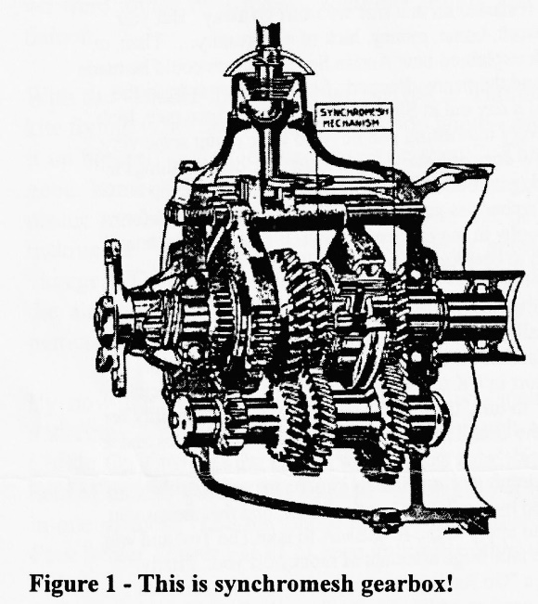
All my gearboxes were of the speedo drive variety (up until September 1927, the drive is off the prop shaft) so having picked out the one with the best teeth, I set about dismantling and bearing removal.
Problem Number One! The one I had chosen was the rare reversed gear position which ran from October 1929 to July 1930. So that meant robbing another Box of its change forks and rods - anyone looking for a conversion kit including lever to fit their car?
In the course of overhaul, the only real problems encountered were the usual broken large key on the lay shaft (made a new one) and a jammed selector spring - amazing how much metal dust you can get out of the spring hole with the correct sized drill!
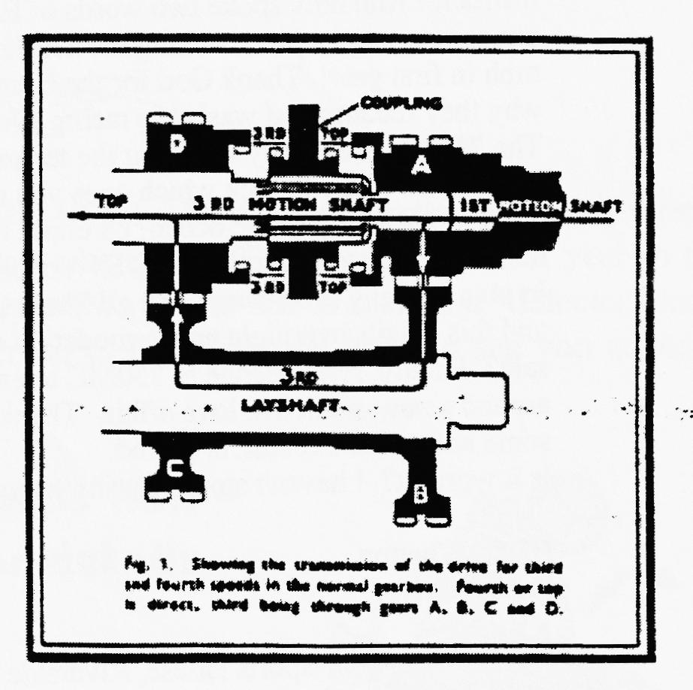
At least with a later gearbox you don't have to worry about oil seals - all that is taken care of by reverse helix threads returning the oil.
Oh, I nearly forgot about the problems of removing the taper pins from the clutch withdrawal levers on the cross shaft - I have never been able to get them out without resorting to careful drilling in spite of applying heat and using a pin punch when they are flushed off on the rear face - too much bashing will smash the gearbox shaft housing! The new pins go in from the front (with the arms upright) and don't forget to cut off any excess over a quarter of an inch or it will foul the flywheel when it is all back together (Thanks for the reminder, Bernie)
Problem Number Two! - Early cross shafts are longer than late ones and poke out of the housing as the external moulding is different on the gearbox - but it is only a visual problem and you can still use it!
The overhauled gearbox was to retain the use of a later 4-speed thrust and fingers (we will make that the subject of a technical forum one club night) so required the vertical moulding removed on its backstop.
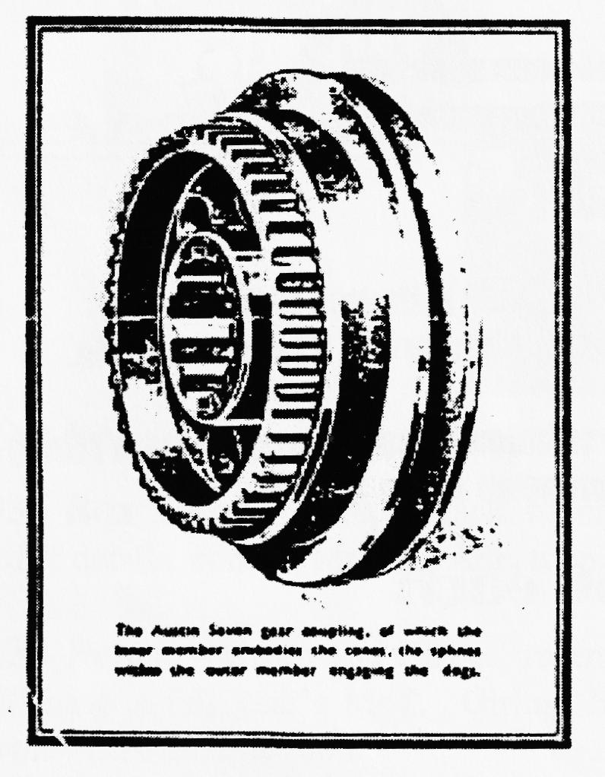
Problem Number Three! - With the overhauled Box, installed I had to lever the front fabric coupling back into place - the later gearbox is '/2" longer than the early type and also requires a shorter propshaft! You can only tell if you have got the correct one by ensuring that the Carden pin sits halfway in the pot at rest. What was it, Vince, 20½ " for an early Box, 20" for speedo drive versions and 19¹/₂ " for screw in torque tube? Many thanks for the information, even if I have got the measurements wrong
Problem Number Four! The handbrake pulley crashes into the fabric coupling. Need to use later ratchet pivot screwed into the gearbox with its extended nose to stop the handbrake.
Problem Number Five! Still fouls the coupling. Needs a small blob of weld on the pivot end to give the final clearance.
Well, that's about it - the saga of putting a 29/30 gearbox into a '27 car. The oil loss has gone, the gearbox changes well, it is a lot quieter in the intermediate gears but the idler chunters on light load in top. Any tips on preventing/recognising this before the rebuild?
Happy changing, Phil Whitter

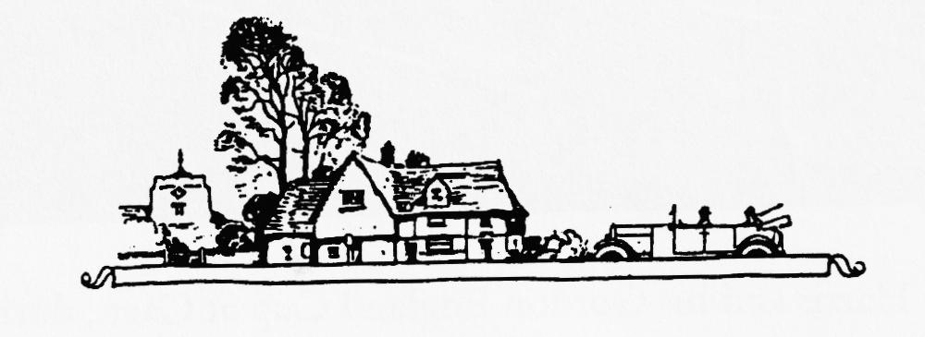
Many thanks, Phil, for a very interesting tale. I, for one, will look forward to hearing about fitting the later clutch thrust gearing to the early gearbox. The savings are worth the effort! Ed.

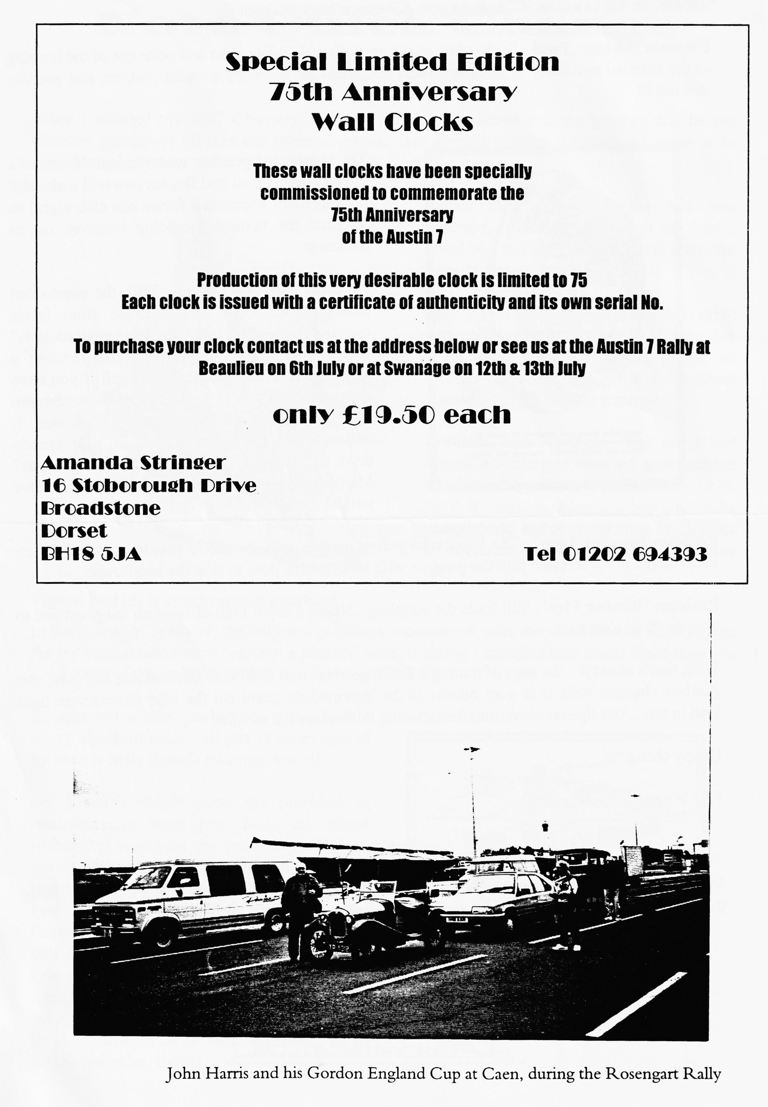

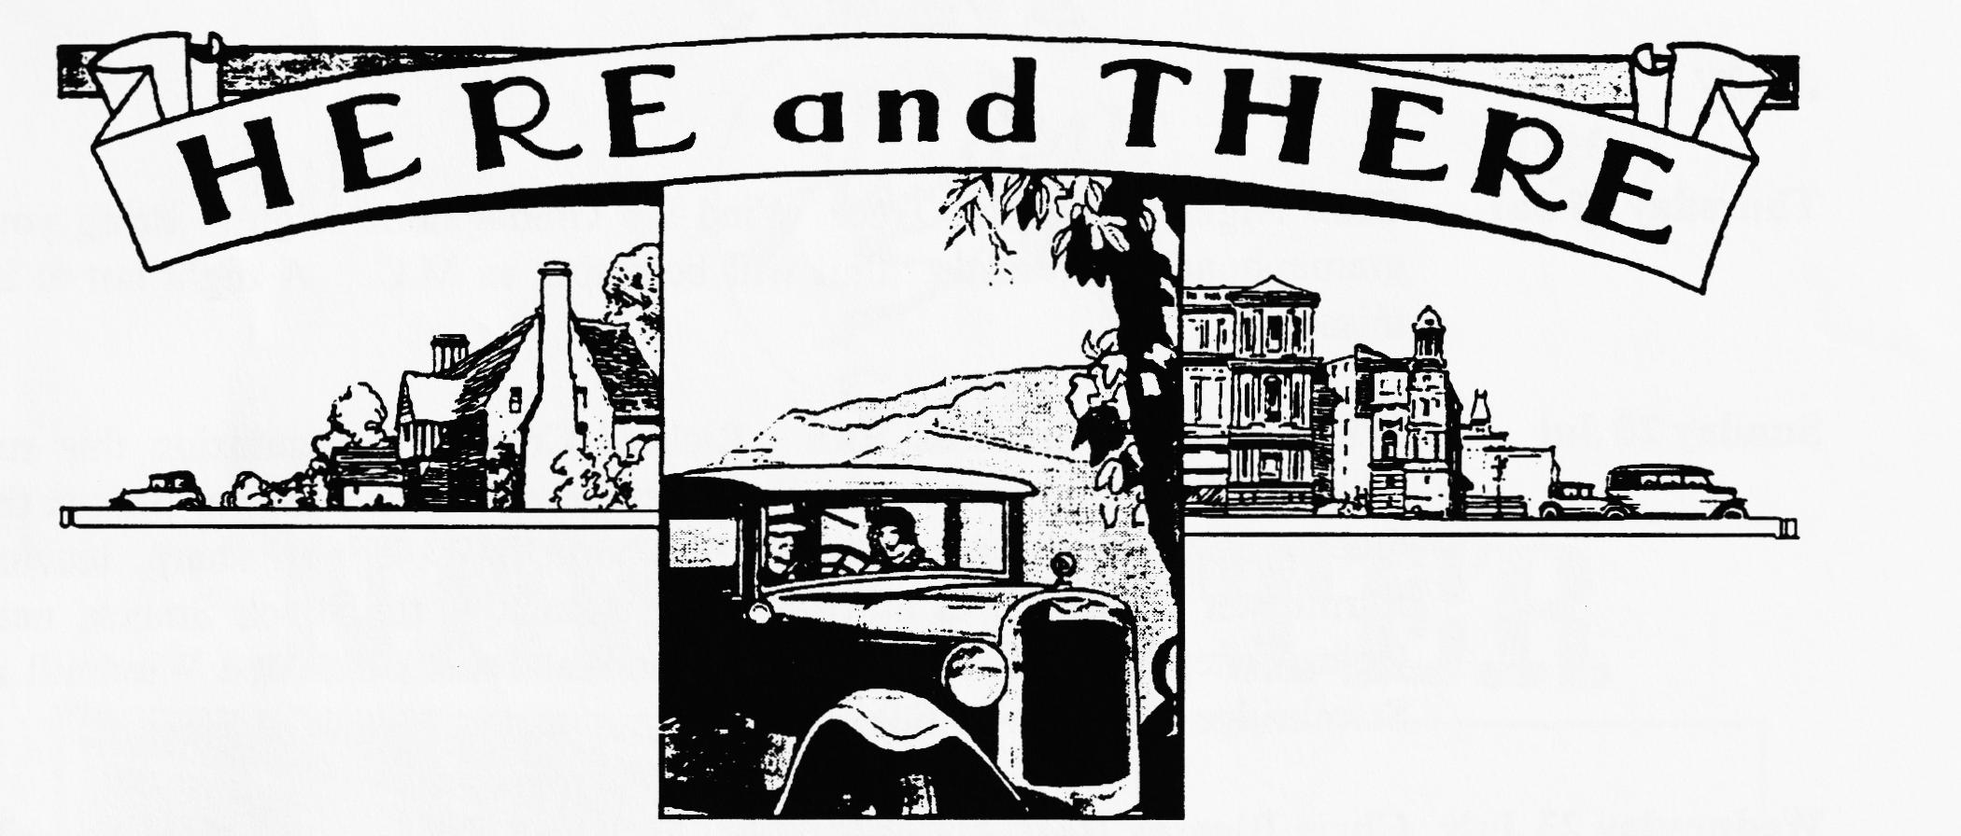
FOR SALE
1933 Box Saloon - Green/Black, running and in very good condition with MoT. £4,200. For further details, contact Mr. John Adnett on 01202 741296.
1936 Pearl - Green and Black. recent crank regrind & white metalling. New wiring loom. Will have a full year's MoT. Girling Brakes, original late wings. £3,750. Contact Bernard Cowley on 01202 887666.
My own 1937 Opal Tourer. Good quality older restoration, original nice interior, excellent hood and side screens. Some history, old logbook, V5, original registration, long MoT. A charming car to drive in excellent condition. £4, 850. Also -
Unused old stock! King pin sets, pistons (Std + 30, +60) Brake cables/linings 400 & 450 X 17, 16 X5.25 tyres, Re-silvered Ruby reflectors, big valve block, 1929 rolling chassis, 1927 chassis frame, re-metalled con rods, re-chromed Ruby cowl bezel, excellent Ruby radiator, Ken Medlicott, Tel 01963 440604.
WANTED
URGENT REQUIREMENT! I badly need a cam shaft from an un-supercharged Ulster for my rebuild project! These are the ones with the extension to run the rev counter from the front of the shaft. If you can put me on the track of one of these, I will be suitably grateful! Contact your Editor on 01722 327215.
Special Event
The Ellingham Show is held at the Sommersby Park in Ringwood and this year they celebrate the Golden Anniversary of the premier agricultural show in this area. Everyone who took part last year said what a good show it is and how they had enjoyed the variety of events which are a feature of the show. It starts at 10 a.m. To enter, please contact Phil Whitter on 01425 475558 before 27 July - ABSOLUTELY NO LATE ENTRIES!

EVENTS
July
Thursday 17 Jul Club Night at the Elm Tree. Wind Up Gramophone Night! Bring your gramophone and records. Phil will be acting as M.C. A night not to be missed.
Sunday 20 Jul Witches and Windmills Run. Richard Cressey is organising this run which will take us out onto the Somerset Levels. Leave the car park at the Queen Elizabeth Leisure Centre, Wimborne at 9.45 a.m. sharp, leaving Sturminster Newton Mill at 10.15 a.m. Lunch at the Black Smock, near Oath. After lunch, we will visit the National Trust's thatched Windmill at Stembridge (entrance £1:60)
Wednesday 23 July Chris Biggins Real Ale and Thunder Run. Start 7 p.m. from Carey's Manor Hotel, Brockenhurst. I am told this is a treasure hunt organised by Chris Biggins!
Thursday 24 Jul Committee Meeting at the Tyrell's Ford. Another early start, your Committee assemble at 8.30 p.m.
August
Thursday 7 Aug Early Meeting. The White Hart Wimborne Corn Market. -8ish to late. - between_ the Minster & the square)
Thursday 21 Aug Club Night. After all the excitement of the previous month, we will have a kit,t,w4, plain old Noggin n' Natter. Bring your rally snaps to the Elm Tree at High
Town near Ringwood, starting at about 8.30 p.m.
Sunday 24 Aug Club Run. Lawrence is organising this month's run. Full details next month
Thursday 28 Aug Committee Meeting. The Committee gather at about 8.30 ish to consider weighty matters at the Tyrell's Ford. If you have any suggestions for club runs, outings or anything else you would like the Committee to consider, please let a committee member know.
Other Events
Sunday 10 Aug Luccombe Country Fayre, in aid of RNLI, near Milton Abbas. No entry fee turn up on the day but please phone Dusty first on 01202 575167
30 - 31 Aug Countryside Cavalcade the Bath and West Showground, Shepton Mallet. Entry fee £1 with details of car to Mary Chapman, 10 St Michael's Close, Stoke St Michael, Bath, BA3 5LF
Saturday 9 Aug Ellingham Show, see page 7 for full details.

