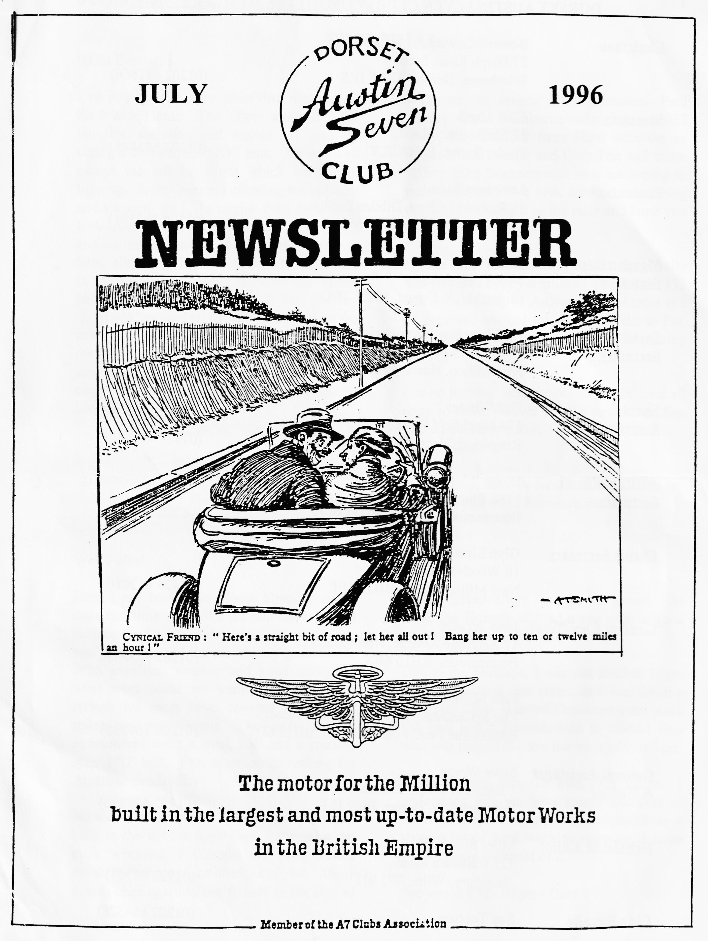

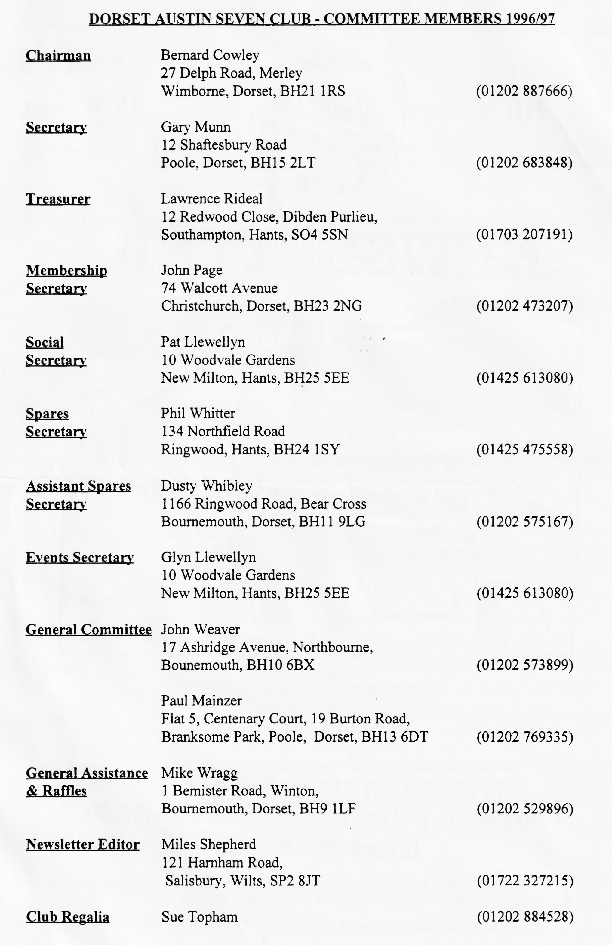

EDITORIAL
Hallo Everyone,
Welcome to several new members, Paul Azulay from Wimborne who has a 1937 Ruby, Ray Burford from Hum with the ex-Roger Nunn Special and Gary Fatt and Suzie Jeffery from Bournemouth who are hoping to purchase a car. We look forward to meeting you all at Clubnight or the rally and hope you enjoy your Sevening!
By the time you read this, the Swanage rally will be just a happy memory. There were 175 entries including 45 Austins with 44 tents and 31 caravans booked in! Many thanks to Pat, Glyn and all those who helped before, during and after the event.
I'm on holiday next month so please send all copy to John Weaver for the newsletter. See you all on Merv's Run
BFN, Miles
I've just spent a very satisfying morning in the Motor Home. The Ulster was rolled out into the sunshine and dusted off prior to taking it down to the MOT man. All was well except the left headlight which would not light up. A few minutes cleaning the contacts and we were set. The engine fired as soon as I cleaned the plugs and checked the points and we set off to the garage. Half an hour later, clutching the said certificate and I was in the local Post Office wit the rest of the paperwork. I was surprised to find that my `Logbook' needed to be changed to reflect the new status of 25-year Exempt. This seems to me to be the way elderly cars will be separately identified and could be the thin edge of the wedge regarding Continuous Licensing.
SECRETARIAL
Well Folks!
Austin Seven Club, you do us proud. As usual the Dorsets walked away with a good percentage of the trophies.
Due to the holidays, I was not at Club Night, but I understand that attendance was down a bit. The Lighthearted Concours went well, I'm told and congratulations to Harold Seal who was judged to have the most admired car.
Whilst writing this, our own rally looms. I understand that we have record numbers of entries, I hope it will prove successful as it takes a lot of hard work to organise, I hope you all make the most of it.
See you at Club Night - Gary
Here I am back from Spain already, where does the time go? We all had an excellent time on the Club Holiday, the accommodation was first class and the meals very good value. With excellent weather and good company, what more could we want! Between us, I reckon we most have covered some 4000 miles in our Sevens. The only trouble encountered were a weak coil and a cracked spring `U' bolt. That must say something for Austin dependability.
No sooner than we were back from Spain than back in the car for Spye Park, as usual a top-class weekend, I thought the Barn Dance would never stop....or the bar close! Many thanks once again to our friends in the Bristol

THE DORSET ADVENTURE AT THE BA7C SPYE PARK RALLY
Friday dawned bright and clear, or the plan was to leave for Spye Park around 11.30 but in went the sun and down came the rain so our start was delayed until around 1 p.m. Although it was still drizzling, Jane, myself, Scott and Jo set off to meet Russell in his MG B with friend Mike as passenger. This must be some sort of practice vehicle for his Austin debut, but he managed to keep up with us in the rain. Scott was handicapped having fly screens and no hood. Bt the time we had reached the 'George' at Longbridge Deverill, the rain had stopped and we dined on sausages and chips with BSB, afterwards being entertained by our team walking across a telegraph pole laid over a stream.
We arrived at Spye Park around 4 p.m. in bright sunshine, to be greeted by Phil, Hillary and Harry (he's the one with the wet nose) Whitter with Chummy and trailer with all mod cons, tents were erected and tea was brewed. That evening a pub supper was taken at the George in Laycock. fed and watered, we ascended the long hill out of the village back to our sleeping bags.
As usual, sleep was hard to find on an airbed - there's always a bump or a hedgehog in the wrong place or your head is where your feet should be. Then nature wakes you around 3.00 a.m. so you fumble to find the zips to get out, five in our case, that makes ten by the time you've got back; by then you've woken everyone else up who then need to go through the same motions. But morning's not far away and someone has the kettle on for the first brew, I usually try to miss this event, finding it better to feign unconsciousness. This, with luck, brings a cup from the second brew plus biscuits.
Jeff, Marilyn, Willie, Ann, Ben, Marion, Bernard and Jacky arrived mid Saturday morning, having just arrived back from the DA7C trip to Spain. Lunch was taken at the Rising Sun, just out of Spye Park, followed by a trip to Lackham Agricultural Centre Country Show where we were allowed free entry. We joined various modern classics along with an extremely rare Riley Nine Woody Estate with trailer filled with various vintage cycles and a motorcycle. First stop for the lad was a lorry filled with autojumble which we thoroughly scoured - to little avail. We were followed shortly after by Chairman Bernard who enquired as to the price of the new A7 head gasket. 'One pound be alright?' was the reply, Bernard did not haggle on this occasion. A trip round various breed of chicken and duck was followed by pots of tea and cake with discussions and comparisons of ornamental cabbages, plants, cheese, cakes and Marion's bargain envelopes and cards - and an Austin Seven head gasket.
back at the camp site, George, Joy, Richard, Margaret and family had arrived. The other Dorsets put clean socks over dirty feet whilst hands and faces were washed under the cold tap. Some unnamed members of the DA7C are known to have taken a shower and one pair in particular took to a Jacuzzi! This is the wrong attitude and has been noted by the Committee who also noticed that some members had failed to turn up, having gone to some 'do' or other at Goodwood.
But the gallant few returned to Laycock for dinner where a table had been set aside for us. We were joined by Colin, Sylvia, Marc and Mandy. After we had feasted, we returned to Spye for the Barn Dance and Smiles beer. The last of us were filtering back to our beds near 3.00 a.m. followed by zips and a pee from 3.30 a.m. onwards.
Sunday - 7.00 a.m. was the first brew (so I'm told) followed by 'try to find the autojumble'. Some being better than others at this event, who having gone to bed before 1.00 a.m. had a better sense of direction. after high tea, bacon and eggs, cornflakes and more tea with more trips to the Autojumble, everybody seemed to have bought a bargain and cars were lined up at heir pegs for judging, followed by hot dogs and burgers, ice creams and tea, trips to the loo, driving tests and finally the results of the judging:-
Bernard 2nd, Phil 1st, Gary 3rd, Jeff 1st, Richard 3rd, Ben 3rd
Vince 1st, Dusty 1st (but not all in the same class!)
Many thanks to Andrex, Brooke Bond and Bristol Austin Seven Club. Dusty

An invitation from the Wessex Ducks
Phone 01202 876730 13 Oakhurst Close
West Moors Ferndown BH22 ODF
Dear Mrs Llewellyn,
THE WESSEX DUCKS - Local Branch of 2CVGB
I am writing to thank you, in advance, for allowing us to participate in your Swanage event again this year. In return, we would like to invite your club to our annual Treasure Hunt on Sunday 1st September 1996 at the Elm Tree, Ringwood, where I believe you hold your own meetings.
We normally meet at 12 noon onwards for a drink and a bite, and those who want to enter the Treasure Hunt can start when they please, as the event is not timed and ends back at the Elm Tree (except for those who get lost!).
The route will be over 25 to 30 miles during which entrants are asked to answer cryptic clues and collect certain items. As far as possible, we try to avoid steep hills - we only have 602cc, or in some cases, 425 cc, so your Austin's should have an advantage on us there.
I do hope that at least some of your club would like to come, and although numbers in advance would be useful, it's not essential as we will be obtaining the necessary waiver and hopefully print enough sets of clues.
Look forward to hearing from you, Yours sincerely,
Chris Tucker,
Chairman, Wessex Ducks
Other Events In Our Area
27 - 28 July First Wessex Down's Syndrome Show, Sandy Ball's Holiday Centre
Showground, near Fordingbridge. Wide range of cars, ancient and modern, UK and US styles, models, craft stalls, lawn mower racing, Saturday night
jazz, Swing and 60's Night. Entries to 01202 577434
28 July West Country Concours at Haynes Motor Museum. There may just be
time to enter if you phone 01963 440804.
26 August New Milton Centenary. Contact Paul Boxall on 01425 619790. Glyn and
Pat may have more details.
15 September Falling Leaves Classic Tour. Starts at Thruxton and follows a route via
Salisbury, Bournemouth Sea Front and the Bovington Tank Museum before finishing at the Haynes Museum. Call 01963 440804 during office hours

AUSTRALIAN RACER VISITS DORSET
It was a pleasant surprise to see Ian Brock at our may Meeting. Ian is from Adelaide and had brought his single seater racer and spares in the back of a LWB Nissan van. It was very interesting to see the details of this car, which was originally built before the War. Good luck on your 'raid' Ian!
BOOK REVIEW
Coleman's Drive by John Coleman. Republished by New European Publications, 14-16 Carroun Road, London SW8 IJY. Soft cover, 260 pages, 30 b/w photos, 4 maps. £10 from the publishers, post free.
This book is a paperback reprint with a new introduction of John Coleman's motoring emulation of Tschiffely's Ride in 1925, accomplished with two horses, from Buenos Aires to New York. It took Tschiffely two years.
Coleman wished he had the bigger brake drums of a 1926 Austin 7 - unfortunately his was 1925. At Copiapo after repairing the magneto for the umpteenth time Coleman bad developed stomach trouble and the nearest hospital was about 120 miles away to the north on the coast, just off the route, at Barquito where Coleman was cured after doses of injections and pills. His next ailment was an outbreak of boils, one of which appeared under a tooth, giving him agony until the tooth was extracted by an American doctor in Lima. In Peru, Coleman was awakened during the night by an earthquake.
In Ecuador a young man leapt in front of the Austin, he was giving warning of a large, uncovered manhole in the middle of the road, since these were often stolen. At Cuenca, about 25 miles away, Coleman was warned of a tribe of head-hunters who particularly liked shrinking heads with beards on them, as they were more of a novelty. Coleman's beard changed to a bonus in the remoter parts of Nicaragua, where he was sometimes given the sign of the revolutionary forces, the beard being a symbol of association with Fidel Castro. Coleman paid for a bed for the night or slept in or by the car, preferably wider cover. He only used his tent once, and that was in Philadelphia, where motels were expensive. He had introductions to Austin agents on his route, some of which had very English names, but could not speak a word of English.
The book has excellent maps as well as photos to back up a well written description of a brave adventure.
P.M.A.Hull Reproduced from the Bulletin of the VSCC No 211, Summer 1996

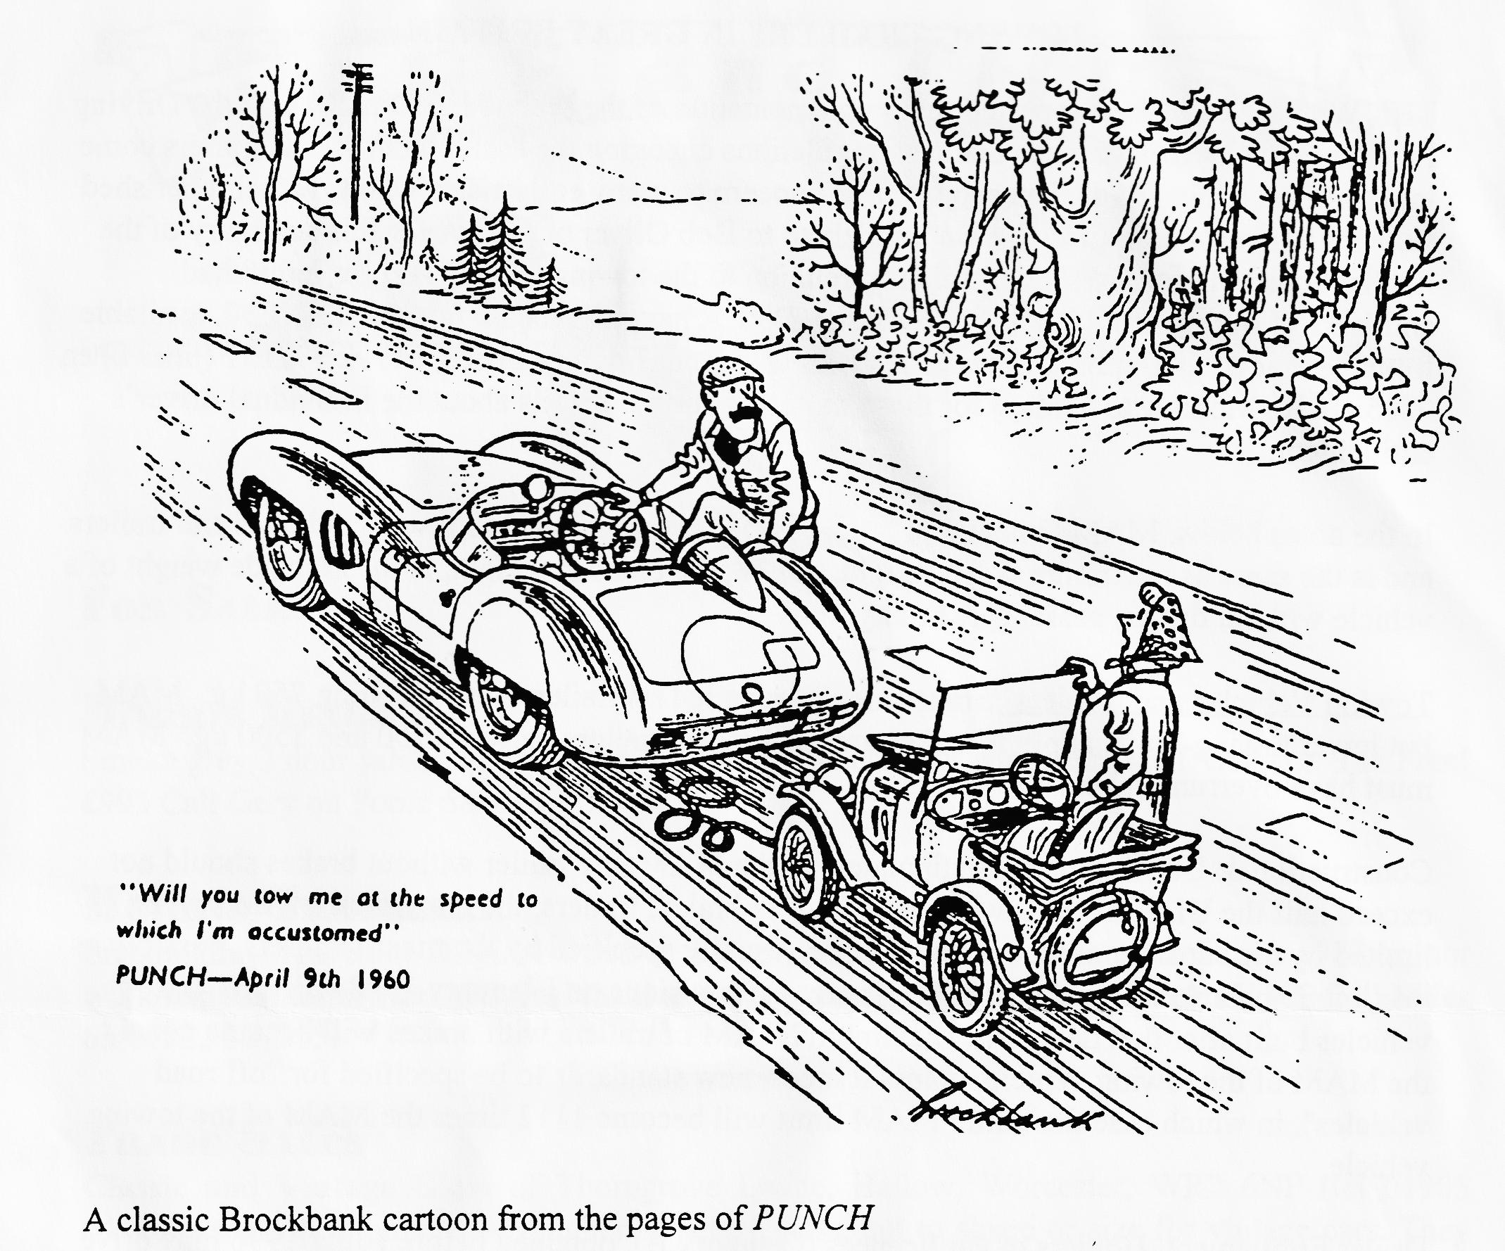
AROUND THE NEWSLETTERS
I note that the article we ran last month on Two Girls in a Chummy has appeared in the 750 Bulletin and the Magazine of the Pre War Austin Seven Club. They both ran the pictures, we didn't because the photocopies were not good enough for reproduction.
There are many long serving editors of A7 Club Newsletters, Peter Hickling of the Pre War Club is one of the longest, I think. Over the twenty odd years he has been editor of his journal, he has had a good input from various Sports Register Newsletter Editors. One of the longest serving of those is Chris Gould who has held down the job for about ten years and is looking for a replacement. If you are interested, please contact Chris on 01903 233255. great expertise is not required - I used to do the job about 15 years ago!
Meshing Point, newsletter of the Scottish Club, always contains some snappy articles, I liked the one about the man who mowed 'AUSTIN into his lawn! They also have a section rounding up the news from other clubs, a good idea which I am happy to copy!

TOWING TRAILERS IN GREAT BRITAIN
THE Winter News Sheet reported that implementation of the second EC Directive on the Driving Licence (911439/EEC) means that new regulations changing the entitlement to tow trailers come into force on I July 1996. The subject is of concern to many enthusiasts who tow their cherished vehicles to events on trailers. We are indebted to Bob Oliver of DVLA for this summary of the implications both for the size of trailer in relation to the towing vehicle and for individual entitlement. As reported in the Winter issue, DVLA has published a fact sheet, INF30, available from Vehicle Registration Offices or DVLAs Customer Enquiry office, 01792 772151 (lines open 0815 -1630, Monday to Friday) for those requiring further details about the individual driver's entitlement.
In the notes below, MAM (Maximum Authorised Mass) is applied to towing vehicles and trailers and is the same as maximum laden weight. ULW, the unladen weight, is the curbside weight of a vehicle without driver, passengers or any load.
Towing Vehicles and Trailers Brakes are not required on trailers not exceeding 750 kg. MAM, but lower towing limits apply if brakes are not fitted. Trailers between 750 and 3500 kg. MAM must have overrun brakes.
Construction & Use Regulations stipulate that the MAM of a trailer without brakes should not exceed half the ULW of the towing vehicle. For braked trailers, the maximum MAM will be limited by the capacity of the towing vehicle (usually specified by the manufacturers, possibly as maximum towable mass). New Type Approval provisions on I January 1998 will alter this for vehicles built after that date. The maximum N4AM of trailers with brakes will become equal to the MAM of the towing vehicle, unless it meets new standards to be specified for "off road vehicles", in which case the trailer MAM limit will become 1112 times the MAM of the towing vehicle.
Driver Entitlement: Holders of car licenses (Category B), obtained before I July 1996 may drive vehicles (including cars and lorries) not exceeding 7500 kg. MAM, and buses and coaches which are not used for hire or reward. They may tow trailers with cars and lorries not exceeding 7500 kg. MAM provided the total MAM of the towing vehicle and trailer does not exceed 8250 kg. There is no limit on MAM for combinations of bus or coach and trailer.
Drivers who pass their car test after this date will be limited to driving vehicles up to 3500 kg. MAM and with up to eight passenger seats. Unless they pass a test to obtain additional entitlement, they will be able to tow trailers only as follows:-
Trailers not exceeding 750 kg. MAM, without brakes, provided the MAM of the trailer does not exceed half the ULW of the towing vehicle; Trailers not exceeding 750 kg. MAM with brakes; and Trailers over 750 kg. MAM only providing the trailer MAM does not exceed the ULW of the towing vehicle and the combined MAM of the towing vehicle and trailer does not exceed 3500 kg.
It is important to note that the limits are defined by MAM and not actual mass, so the actual load within a towing vehicle and on its trailer has no bearing on the entitlement. For example, after I July 1996, the largest trailer a new driver of a Land Rover Discovery (MAM of 2700 kg.) can tow has MAM of 800 kg. - given that the smallest car trailer listed in a recent advertisement claimed a 750 kg. capacity, and was clearly over 50 kg. mass itself, new drivers will not be able to tow car trailers behind Land Rovers, even empty, without obtaining additional entitlement.

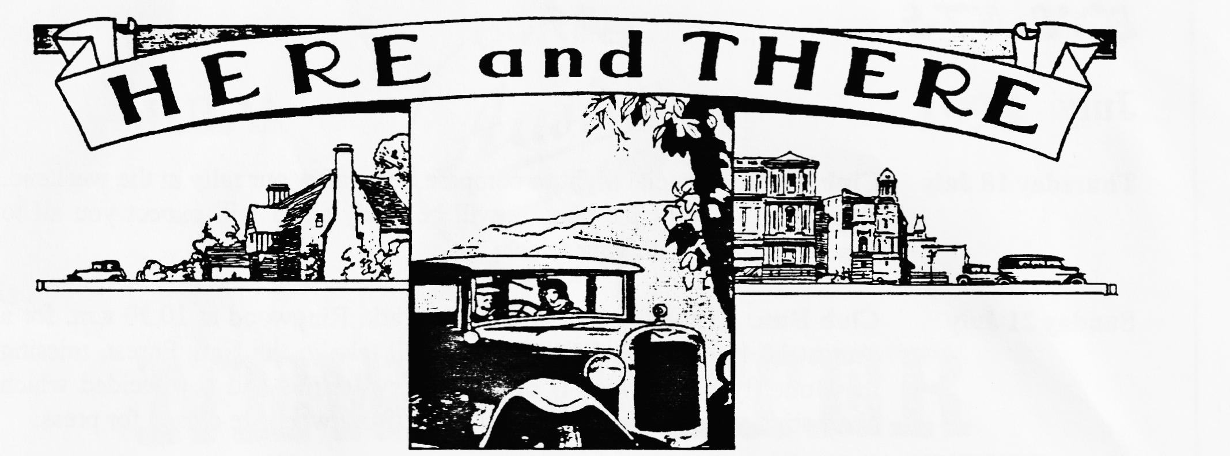
FOR SALE
MORRIS MINOR
Smoke grey 2 door saloon in very good condition. Recent new wings etc. MoT October. Tax Free! £995 Call Gary on Poole 683848
MORRIS TRAVELLER
Smoke grey Traveller. Original wood in sound condition, full concours rebuild in 1981, minor work required to interior. Original in all respects except for replacement carpet. £1100 Call Miles on 01722 327215.
TRADE SALES
Classic and Vintage Glass of Thorngrove Lodge, Hallow, Worcester, WR2 6NP (tel 01905 641700) sell flat laminated or toughened safety glass, cut to shape or size for vintage cars. They are able to polish edges, cut wiper notches and so on. They will also fit to your frame or channel if required. They also make lamp and instrument glasses to pattern, plain or bevelled.
Tee Publishing of the Fosse, Fosse Way, Radford Semele, Leamington Spa, Warks, CV31 1XN publish a Steam Heritage Museums and rally Guide at £3.50 including postage. They can be reached by phone on 01926 614101 or fax 01926 614293.
OVIERSIKAS EVENTS
I have details of events at the Rosengart Museum in Germany during September and the Dutch 7 Provinces Tour over the August Bank Holiday if anyone is interested. I gather there will be a substantial British contingent at the Dutch event, I am only sorry that business forces me to miss it, their hospitality is well known! Please get in touch if you want to be involved.

EVENTS
July
Thursday 18 July Club Night. A social night to compare notes after our rally at the weekend. Hopefully, some of the photo's will be ready and I will expect you all to regale the editor with your tales!
Sunday 21 July Club Run. Gather at the Furlong Car Park, Ringwood at 10.30 a.m. for a start at 10.45 a.m. SHARP! The run will take in the New Forest, missing the Butterfly Farm which is closed. Terry Jeffries had not decided which alternative attraction would receive our custom when we closed for press.
Thursday 25 July Committee Meeting. We gather at the Tyrell's Ford at about 8.30 p.m. to deliberate on weighty matters like how to improve the annual rally.
August
Thursday 1 Aug Eightish till Late-ish. Meet at the Three Tuns, Bransgore for a quiet noggin and natter in the company of like-minded enthusiasts.
Thursday 15 Aug Club Night. After the excitements of July, we thought we'd have a Noggin and Natter with a chance to look over any photos from Harman's Cross. See you there?
Sunday 18 Aug Club Run. Mery Frampton has offered to organise this month's run so meet at Queen Elizabeth Leisure Centre, Wimborne at 10.00 for a 10.15 start. Alternatively, catch the convoy at Sturminster Newton Mill at 11.00. The route will about 40 miles so be prepared.
Other Events
27/28 July VSCC Prescott Hill Climb. Camping available from Friday afternoon onwards. Jazz Band on the Saturday.
28 July Damerham Country Fair. This event is only held every other year but is always excellent value. Contact Phil Whitter for details.
Sat 10 August Ellingham Show, Sommerley Park, near Ringwood. As part of our 20th year celebrations, we have been invited to put on a show of cars at this prestigious event. Please let Phil Whitter know if you want to attend. Tel 01425 475558
Sunday 11 August RNLI Rally and Country Fair, Luccombe , Near Milton Abbas. This is a really good day out, see Dusty for further details.
I have details of many old car events all over the country, so i fyou are looking for an event to enter, or
simply to attend, please see me at Club Night - Miles

