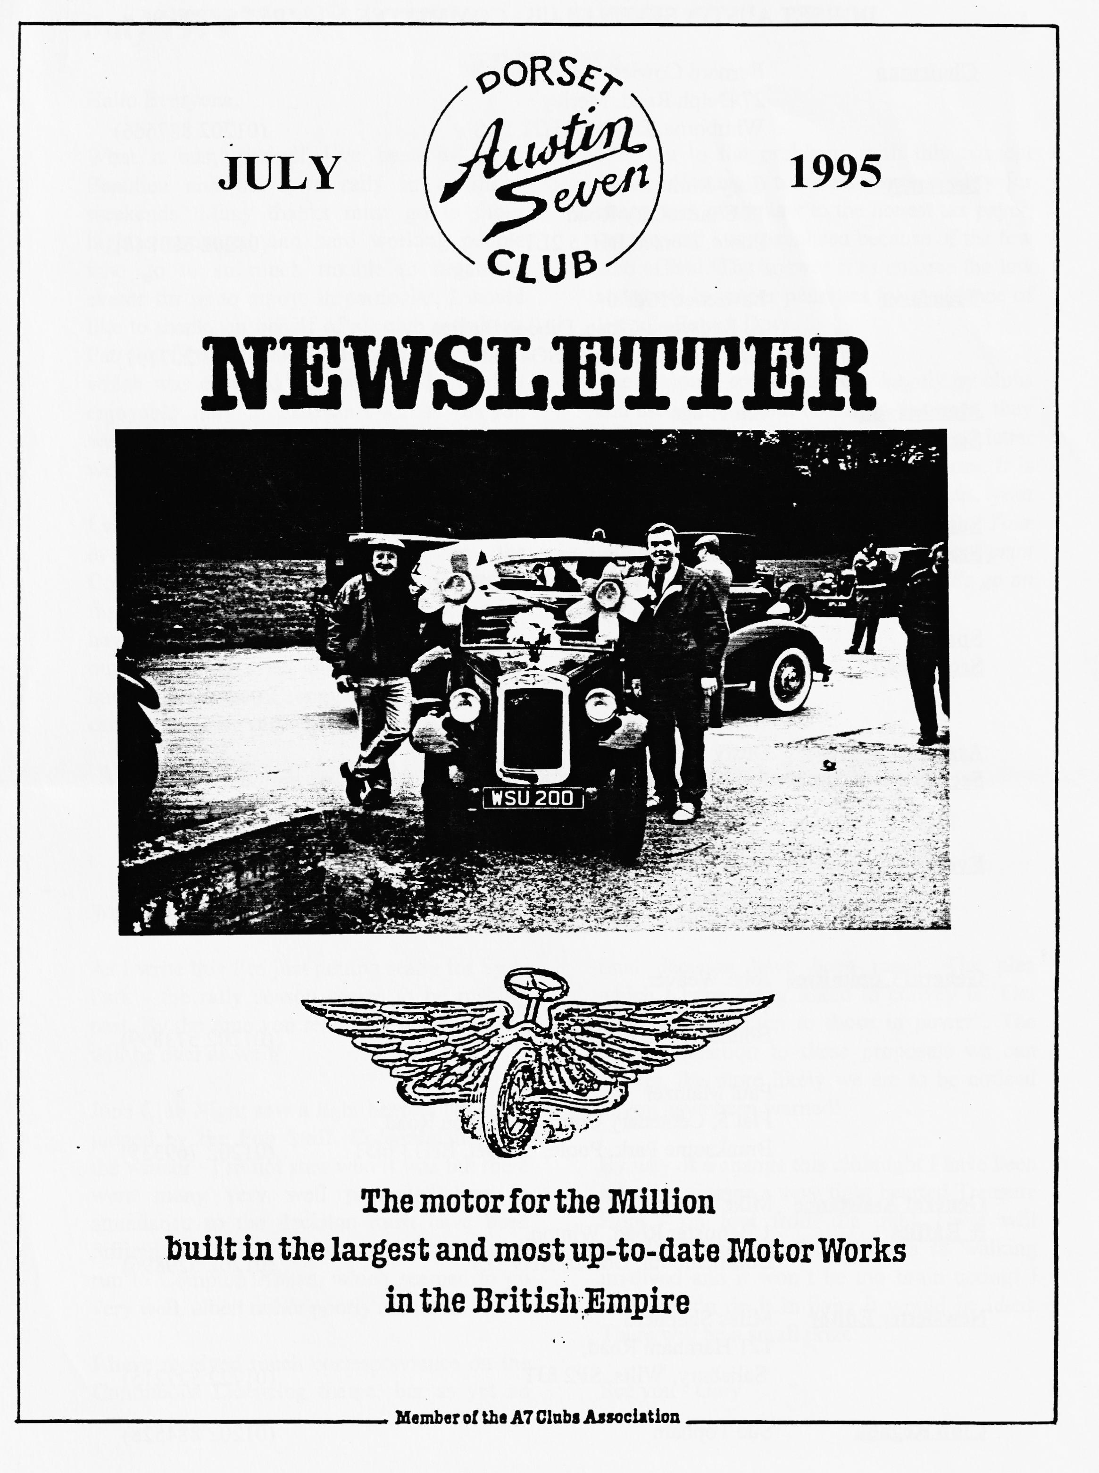

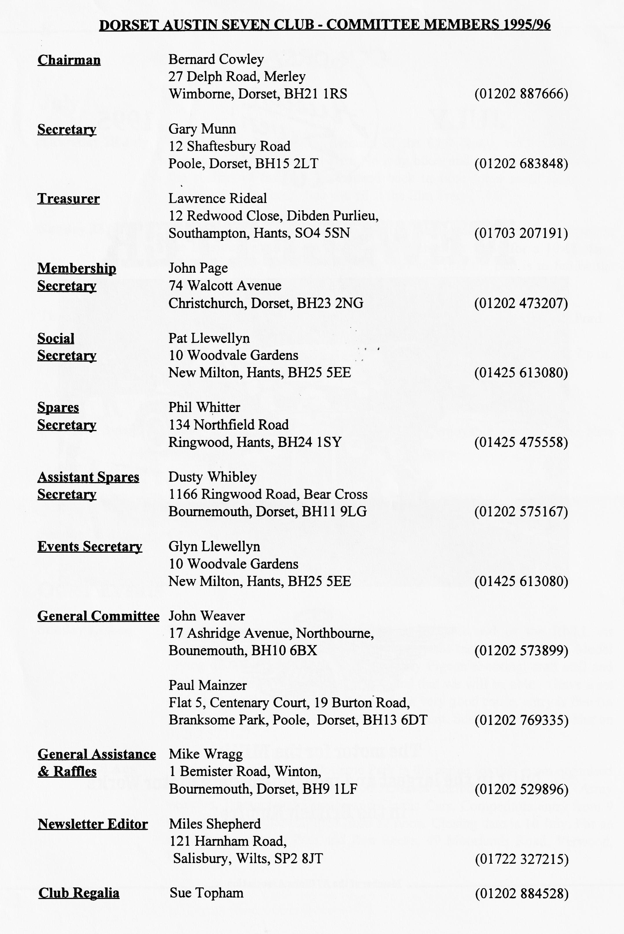

What a busy period! I've been to Spye, Beaulieu and our own rally in as many weekends. Many thanks must go to those highly motivated and hard working people who go to so much trouble to organised events for us to enjoy. In particular, I would like to thank, on behalf of all club members, Pat and Glyn for their months of hard work which was crowned last weekend by a most enjoyable rally at Harman's Cross. If you weren't there, you missed a cracking weekend.
I would like to add my weight (getting greater every day!) to Gary's points on the Continuous Licensing debate. You may recall that this is not the first time the Government have tried to tax possessions. Last time, the outcry was so great that we succeeded in having the proposal scrapped. A co-ordinated campaign was very successful in drawing
attention to the problems with this concept which effectively transfers responsibility for observance of the law to the honest tax payer, i.e. you and I are penalised because of the few who offend. The answer is to enforce the law and provide proper penalties for avoidance of Vehicle Excise Duty.
The response so far has been largely by clubs and associations, but useful as these are, they do not carry the weight that a reasoned letter from a constituent to the local MP does. It is not too late for you to play your part, your MP's address is in the phone book. Your letter is important - don't delay, get into print before the end of this month when MPs go on holiday for 3 months!
See you all at Club Night! BFN, Miles

Well Folks!
As I write this I'm just getting ready for Spye Park - the rally season seems to be rushing past. By the time you read this, our own rally will be over as well!
June Club Night saw a light-hearted concours judged by the Pub Staff. Congratulations to the winner - I'm not sure who it was but there were many very well-presented cars in attendance so the decision must have been difficult. Paul Henwood organised June's club run to Compton Abbas, which seemed to go very well, albeit rather poorly attended.
I have received much correspondence on the Continuous Licensing theme, but as yet no
final decision has been made. The plea which I keep being asked to convey is "Get your letters written to those in power". The more opposition to these proposals we can muster, the more likely we are to be noticed ....you have been warned!
By way of a change, this club night I have been asked to arrange a very light hearted Treasure Hunt - on foot from the pub! There will literally be only a few minutes of walking involved and it won't be too brain taxing! I think if you do it in pairs it would be ideal. There will be a small prize.
See you - Gary

CLUB NEWS
Welcome to new member Chris Large of Hermitage. No details of the car but Chris is looking for a trailer to move the Seven around! Hope to see you at a Club night soon!
HAPPY BIRTHDAY DUSTY - Twenty One (again) on 6 July. Don't forget that Dusty can carry out a very useful repair to crankcases with broken front bearing lips. Contact him on 01202 575167.
CONGRATULATIONS To all the winners at Spye Park, Beaulieu and our own Swanage Railway! I had to leave Spye before the prizes were awarded so if anyone has any results, please let me know. The club turnout was again excellent, and I'm told the Saturday night was worth the trip on its own - missed it again, maybe next year! Dusty won Class X at Beaulieu for the best replica Ulster with his immaculate Red Ulster. I did not see any other First Class Awards among the strong Club contingent which included the Cowleys, Ballards and Mackenzies with cars and autojumble stall. Other cars were shown included the Whibleys, Stalkers, Cresseys, Mooneys, the family Bridge, Llewellyns, Gary Munn, Andrew Walls, John Stone; Chris Sheret, Jeff Savage, Bob Stanley and yours truly! I met the man who rebuilt my car in the 50's (Reg Nice) and another owner (Martin Eyre)
A SUMMER GAGGLE
The mid-summer run in June should have been a celebration and well supported. Perhaps it was the rugby match between England and New Zealand that kept you all away. Only five cars turned up at the start, kindly organised by Paul Henwood. Paul and Gary in the Box led the way followed by Bob Stanley, Stan Warburton and Jane Symonds all on their own and at the rear were Sue and Mervyn.
It was a lovely route on a gorgeous summer’s day with no stops for breakdowns or incontinence. Through leafy lanes and along quiet roads to Holt, Horton and almost to Cranborne. Then left towards Handley amidst blue and yellow fields of oilseed crops. Across the downs we rolled to Ashmore, Fontwell Magna and then guess where - Sturminster Newton. Sue and I had completed 54 miles to get back to our starting point! The pleasant drive continued through Hazelbury Bryan and finally to the pub at Buckland Newton - The Gaggle of Geese. A pleasant Free House serving excellent beer and food. Here we were joined by late arrivals Paul and Emma, Joy and George, Dusty and Jane with Mark and Scott.
The afternoon visit was to the Cerne Giant, just to check on his enormity [I hope not to repaint him! Ed]! And then we found Cerne Abbas alive with people. Everyone's garden seemed to be open to the public and there were various attractions in the streets including plant stalls and a craft fair.
Thank you Paul for organising a lovely run, pity about the Rugby, we think you'd have enjoyed the run more than watching England lose!
Mervyn
CONTINUOUS LICENSING
This has been such an emotive topic that I thought you would like to know what other clubs and organisations have been doing in response to this threat. The Federation of British Historic Vehicles Clubs, of which we are a member, has written a very detailed response to the Minister. This runs to 11 pages of cogent argument, facts and figures which I will not reproduce here. If you wish to see the details, see me at Club Night. The VSCC (which I belong to) have also written a strongly worded letter to the Minister and are urging members to write as well. The Austin 7 Clubs Association have written and also urge individuals to respond to their MP, this really is the most effective way of making the point. It worked well last time, let's try to make it work this time, too. Other A7 Clubs have risen to the challenge, and most have written to MPs and/or the Minister. Pre War managed to get a representative along to the DVLA meeting at the end of April. The meeting was apparently told that only the method of applying the proposals was open for discussion. This might have been to limit the discussion, which might well have gotten out of hand but it certainly caused considerable alarm. This was compounded when, in response to the usual question of why the Nanny State was interfering in private ownership matters, came the response "the Minister had decreed that an off road licence will be required for all vehicles, irrespective of condition." Apparently the Minister can do this in the same way that you are required to have a licence for a gun. And I thought rule by decree was confined to the Soviet Union!
The real reason behind the attempt to tax possession of cars is that the Police need a better record system to track criminals. I have no objection to that but for them to penalise me for the transgressions of others really makes me angry. The police claim that they do not have the resources to inspect vehicles for excise duty evasion. How then can they enforce the proposed new laws, particularly the off road tax? DVLA claim they are being ripped off by the so-called "Month Skippers" but the Select Committee only acknowledges that £200 million is lost in total. This is less than 5% of the total duty liability so the money is not the issue. A more important issue is that if a vehicle is on the road without a current Vehicle Excise Duty licence, it's insurance is invalidated. A better system would include basic Third Party insurance in the vehicle Excise Licence, a proposal put forward by Dave MacCurrie, Secretary of the Pre-War Club and one that I heartily endorse.
So what are we to do? Apparently, the decisions have been taken; the honest motorist is to be penalised once more and I can see no effective action being taken to prevent the very evasion DVLA and the Minister for Transport claim to be stopping. In my view, we will have to resort to solving the problem ourselves. Report of all vehicles kept or used on the road without a valid licence to the Police at every opportunity; force the authorities to take action, for it is they who are going to cost you hundreds of pounds extra to enjoy your hobby. In the worst case they could injure or kill a member of your family and you will have a difficult, time consuming and expensive task to bring them to justice. You will not be able to rely on the police to do the job, as they should.
The Minister and your MP have a duty to respond to your concerns when they expressed to them. This means that if you write to them, they are obliged to reply. They will never know that you have strong feelings on this topic unless you tell them. You might make the following points:
- The present proposals will penalise the honest vehicle owner.
- The proposed system cannot be enforced any better than the old one.
- The proposed system will be expensive to administer.
- The only way that evasion can be prevented is to convince the evader that the chance of being caught is high and that the penalty will hurt.
- The long record of broken promises concerning tax on possession means that it is unlikely that he will command your support in future elections!
There is a new Minister of Transport so make sure he knows your views too. send your letter to him at the House of Commons, Westminster, London SW1A OAA. If you do not get a reply within 10 days, write again asking for a reply. If you do not get a response with a further week, threaten to go to the Parliamentary Ombudsman claiming maladministration.

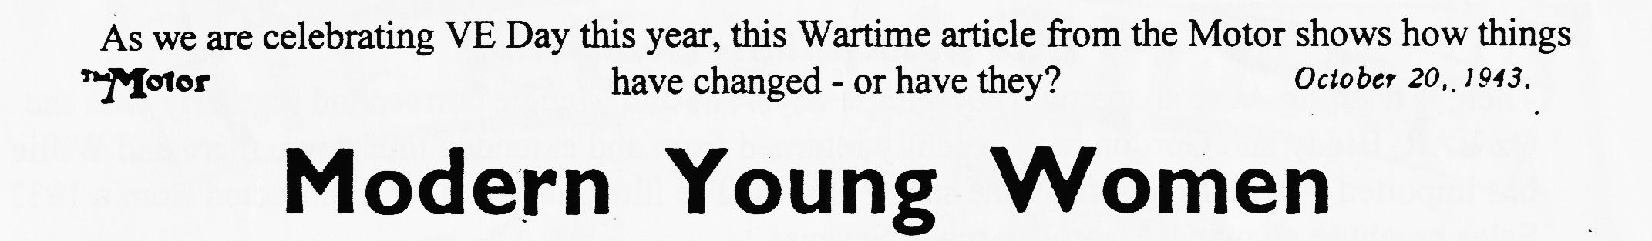

MAN has become accustomed to the new order. The scarlet gash of a mouth, the tenuous outlines of a feminine face and a cloud of curled hair behind a windscreen, dusty or otherwise, have become commonplace. '
No longer will the little woman be allowed to run the car down to the shops on a Saturday, -permission for this favour being given her in grudging condemnatory tones, to be followed by a scowling review of the gateposts and the garage doors. Should these show signs of brutal conflict with the wing of the car or, worse still, should the cellulose paint-work show the slightest sign of a scratch, then heaven help her.
"What Husbands Can't Do
How the feminine counterpart of man could be expected to become a good driver without spending the requisite hours at the wheel was just one of those mysteries. Like the facts of life which you're supposed to know by instinct. And has any husband ever been able to teach his wife to drive? Is there any man who could stand calmly by while she stalled the engine for the hundredth time, or was just a fraction of a second behind his thoughts when she changed down? •
No, it required the insulation of the complete stranger, the non-committal mechanic who is being paid to instill the rudiments of mechanics into the featherbrain of a woman. This man was not in a position to express audibly his private views on the skill of his pupil.
The war, which has swept private cars off the read as if some giant hand had wiped the slate clean, has given the girls their opportunity. The call went forth. Women's work was needed. Shoulder to shoulder to the men must they stand. So into the driving seats they went, to waggle gears, to stall engines, to make curious fishlike signs with inadequate hands. To struggle manfully (or should it be womanfully?) with spare Wheels and cumbersome jacks. To study dipsticks instead of lipsticks; to speak glibfully of retardation ratios and to assess impartially the camber of the roads.
There is a masculine theory extant that either a woman is a very good driver or she is just the reverse. Wherever men gather, one may hear of a particular paragon of motoring virtue of the opposite sex, but she is the one exception who proves the rule that women are dud drivers. The rest, the undistinguished females resolutely doing their best under trying circumstances, Knowing the prevalence of the maxim, dare not put their powers to the test.
Slacks and Dungarees
The women have donned slacks or dungarees, fired with determination to learn how the darn things 'go. Aided and abetted, encouraged and guided by the M.T. Sections of the A.T.S., the W.A.A.F. and the civilian motoring concerns, who broad-mindedly or tentatively, according to the managing director's views on women, have opened the door a crack for the other sex to come in.
At last, I hope, we shall begin to see a common acceptance of the fact that women are not angels or devils, enchantresses or adventurers, but merely a specie of the genus man, and that there is nothing the average man can do that a woman, given equal opportunity, cannot. I also .suspect that women are beginning to discover men's jobs aren't so difficult after all. Can you imagine a man running a home and rearing children? No. It is much too difficult and dull. So the fragile, protected female is flung out into the cold, hard, . masculine world, where, maybe, she finds things not so tough as she has been led to believe.
Glamour and all this sex nonsense 'fall into their right perspective. Men and women fall in love—what could stop them?—but the atmosphere, the approach, the motives are saner. The tender little woman for whom men cherished a loving contempt has given place to the slim girl driving a three-ton lorry with a deftness, a verve and vigour which call forth sincere admiration: The girl can meet you mentally on an equal footing. She knows by experience the wearisomeness of breakdowns, the shattering fatigue of driving long hours. She has not been incarcerated in a house all day long coping with problems which are the opposite of yours. And she knows what you need by way of relaxation when the day's work is over. Could any training be more inducive. to the building of that dream home after the war?
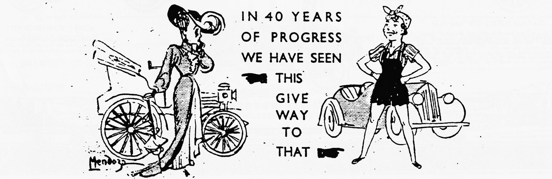
When Women were Chattels Now regarding the purely mechanical side. I have a theory, as yet unbacked by statistics, to the effect that children are born with a potential flair for mechanics, regardless of sex. Why should a girl be supposed to have a domesticated mind and a boy the opposite? Relit of the prehistoric days when women were the chattels of men. Remnants of the tradition that left women guarding the castle whilst the men went away for a few years of warfare. .1 wonder how many such warriors came back to find their castles much more efficiently run in ...their absence?
Anything a woman wants to do she can achieve. But the men have for too long demanded something soft and clinging, frivolous and insipid.

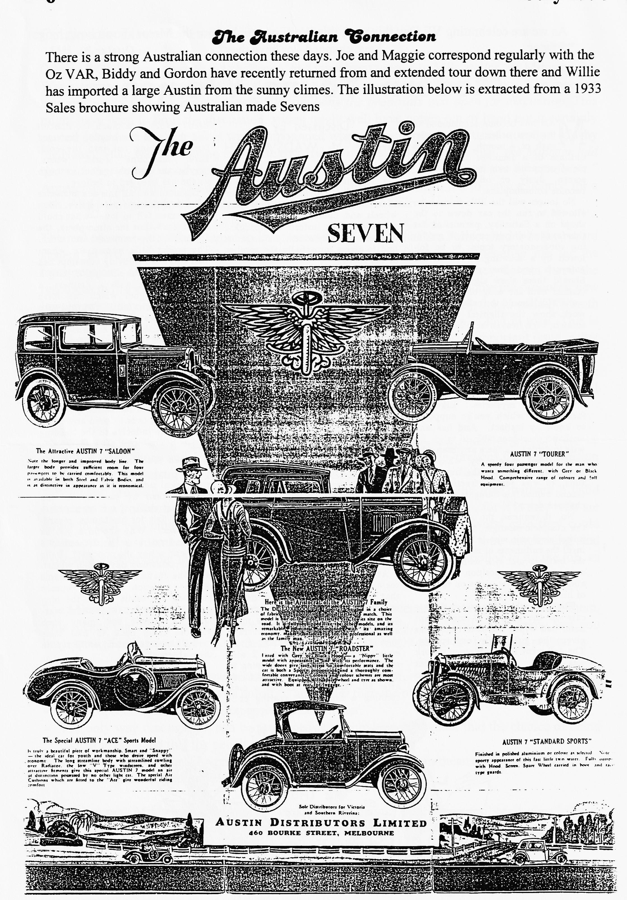

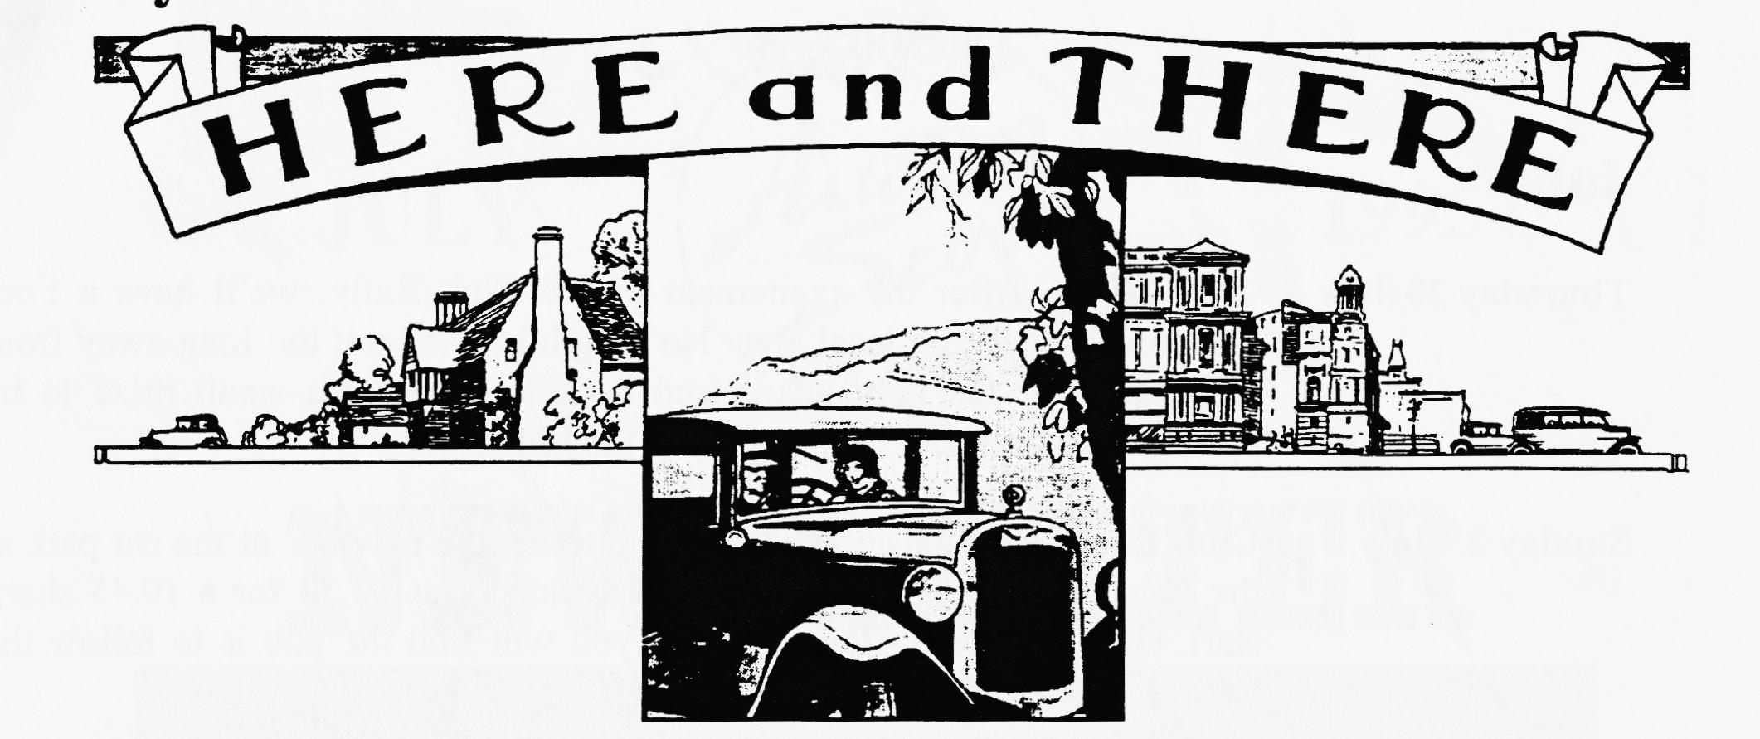
For Sale
1937 Austin 7 Chassis Excellent condition, with V5 £150, contact Phil Whitter on 01425 475558.
and
1937 Austin 7 Opal good all round condition. Taxed and tested, used regularly, seen on last month's Club Run. £5000 ONO. Contact Jane Symonds on 01747 811979
Wanted
Chassis required for building an Ulster Special, probably a Ruby but others considered as well as any other items necessary, providing Mum can stand another mess in the garage! Contact Matthew on 01202 880496
Also
Trailer to move my Austin Seven around on! Chris Large, Awry House, High St, Hermitage, Newbury, Berks, RG16 9RE.
Annual B-B-Q
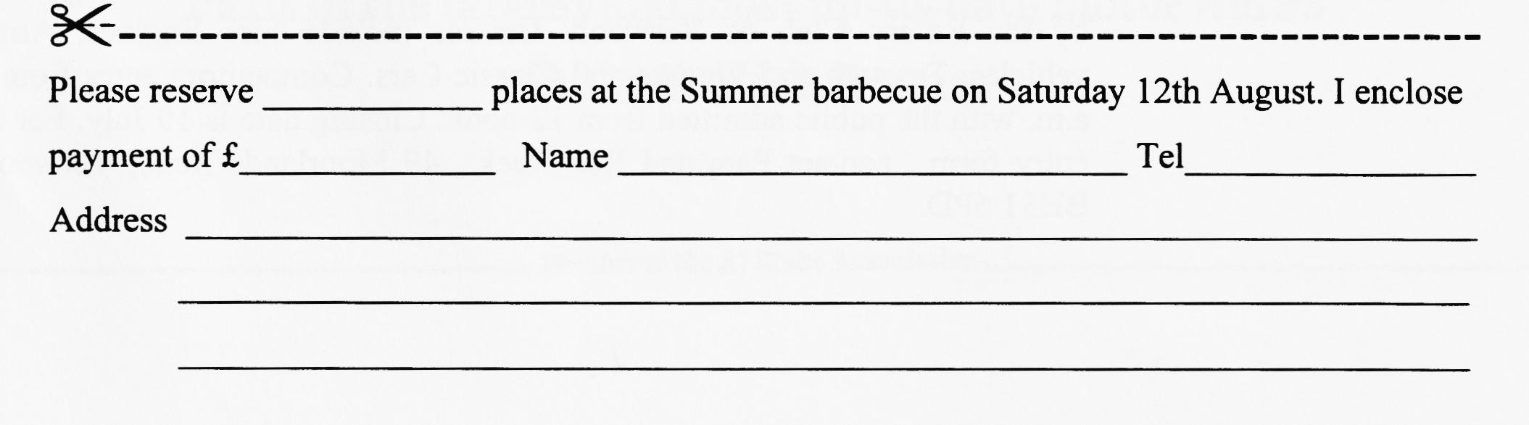
Our Summer barbecue will be held at 1st Milton Scout Centre, Caird Ave, off Lymington Road, New Milton on Sat 12th Aug at 7.45 p.m. Don't be put off by the venue, the Scout Centre is in very well maintained grounds and is ideal for a barbecue. .A barbecue will be provided but bring your own food, wine, beer and glasses. Chairs will also be provided. After dark we will be able to use the Hall for musical entertainment, whether to listen or dance to. A charge of £1:50 per head will be made to cover the cost of the charcoal and venue. If you would like to attend, please return the slip below to plat Llewellyn before 7th August, cheques payable to Dorset Austin 7 Club. See map on page 2 for directions.
EVENTS
July
Thursday 20 July Club Night. After the excitement of the Club Rally, we'll have a Foot Treasure Hunt in the local area. No long hikes and not too long away from the charms of the pub, guaranteed back in time for a small prize to be presented in the Barn! See you all at the Elm Tree.
Sunday 23 July Club Run. Terry's Run! Meet at Wimborne, the new RV at the car park at the Leisure Centre by Queen Elizabeth School at 10.30 for a 10.45 sharp start. Do not be late - the only way you will find the pub is to follow the leader!.
Thursday 27 July Committee Meeting. The Committee meet at 8.30 ish at the Tyrell's Ford. Saturday 29 July Evening Run to the Banks ArmS of Constitution Hill. Prompt start at 7 p.m.
August
Thursday 3 Aug Eight (ish) till Late. Venue for this very enjoyable gathering the New Queen, Avon Causeway.
Thursday 17 Aug Club Night. A quiet gathering for a Noggin 'n Natter, perhaps to discuss the successes of the Rally season!
Sunday 20 Aug Club Run. Full details next month.
Other Events
Sunday 13 Aug Country Fayre and Vintage Vehicle Rally in aid of the RNLI. At Luccombe Farm near Milton Abbas. Attractions include Dog Show, Model Flying display, show organ, juggling, Clay Pigeon shooting, craft stall and many more displays and rides. It is hoped that we will be able to have a set aside area for the DA7C Austin. It's for a very good cause, entry is free (in your Austin) and it is just that little bit different. See Dusty or phone him on 01202 575167
Monday 28 Aug Verwood Rustic Fayre. Potterne Park is the venue for this event organised by the Rotary Club of Verwood. Classes include Fire Engines, Army vehicles, Tractors and Vintage and Classic Cars. Competitors entry from 9 a.m. with the public admitted from 12 noon. Closing date is 10 July. For an entry form , contact Pam and Ron Reeks, 49 Moorlands Road, Verwood, BH31 6PD.

