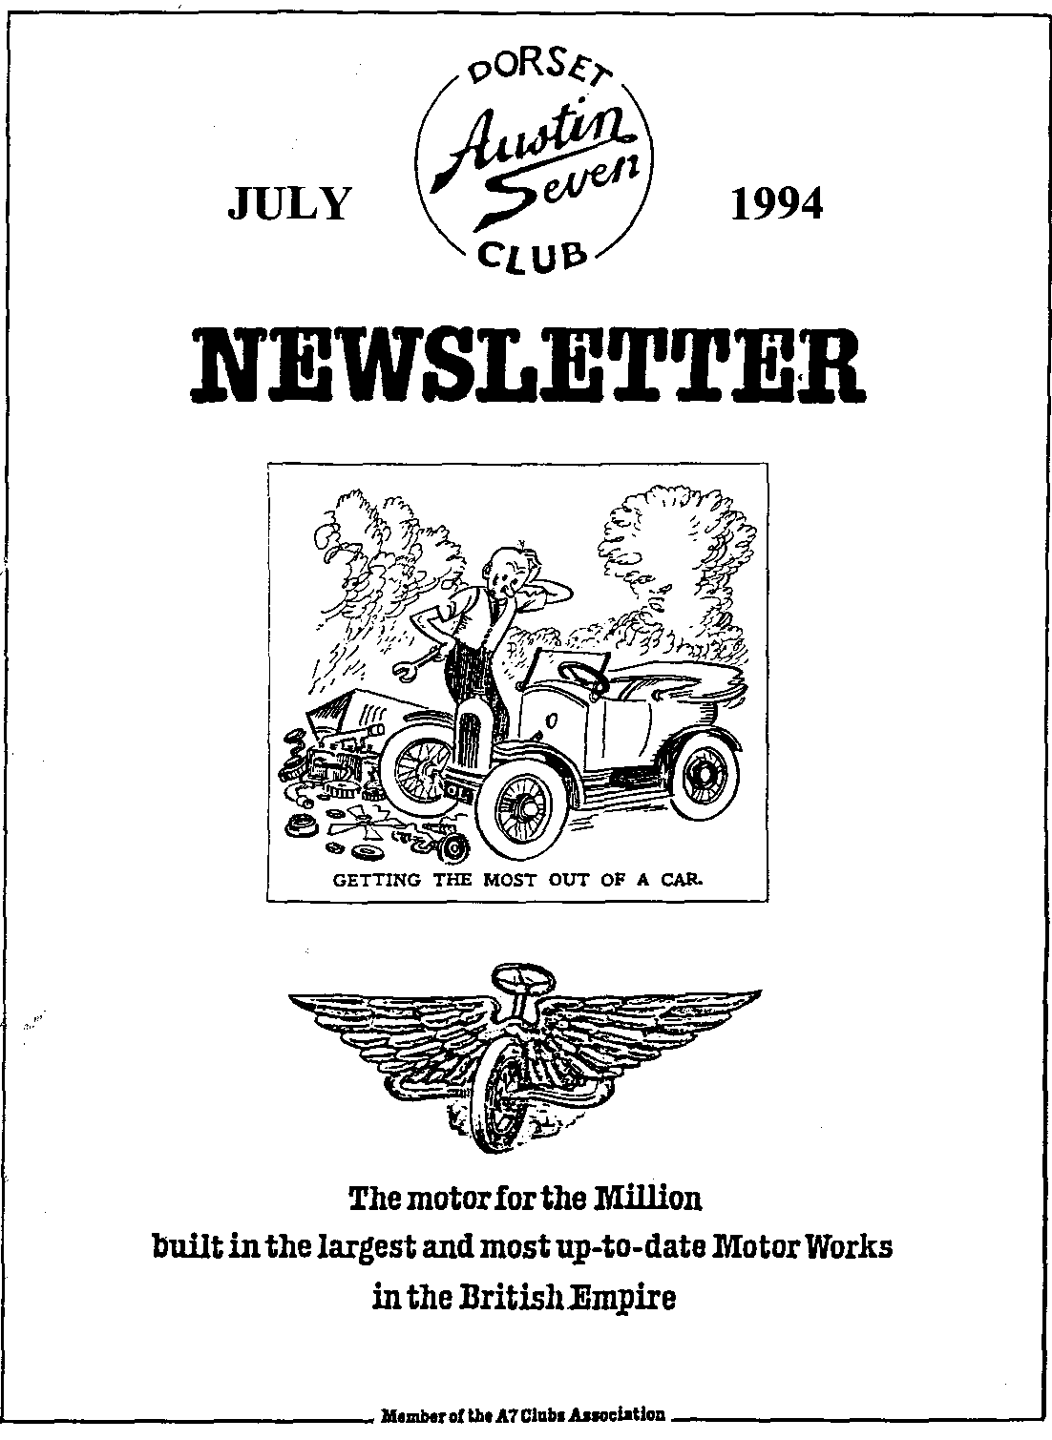

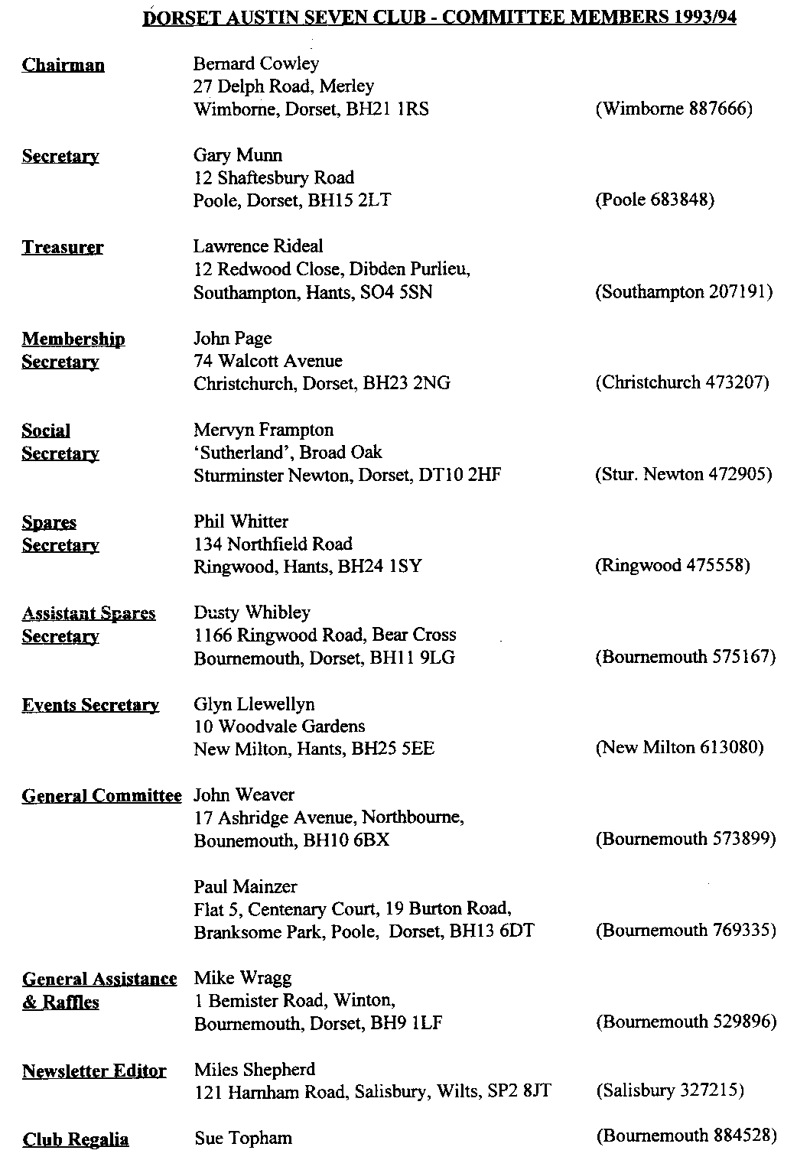

July 1994
EDITORIAL

Hallo Everyone,
As I write this editorial, I feel a pang of conscience. The poor old Chummy is languishing in the motor home. My pathetic excuse this month is that the builders have blocked the entrance to the garage with a massive skip which is full of roofing tiles. What is more, I still haven't finished sorting out the oil on the brake linings...so that is why you have not seen the Editorial motor on the road for a while!
This lack of mobility is galling as I had hoped to get to Spye Park, Beaulieu and then trundle up to Malvern for the VSCC's 60th Birthday Week, returning in time for Swanage Railway Rally. The plans did not quite work out although I did have time to visit Spye and see many old friends.
We have a number of very interesting articles this month and I must thank these correspondents on all our behalf. Biddy and Gordon are off on their travels once again but Biddy has provided several more of famous pen pictures, and a useful insight into how rally insurance is handled in Australia.
Sue Topham took the time on her Spanish holiday to record the events for us. Joe and Maggie Stalker paused in the work they are doing on their cars to send in several items of interest, notably the article from the Essex Club you read last month. Marion and Ben Trimby provided the report on Paul's Vineyard trip and Dave Whetton kindly snatched some time from his busy schedule to not only organize our participation in Motorcade, he also provided the report. Many thanks to all these correspondents, without whom there would be little to record!
I'll be working in Manchester for the next three weeks, so I will miss the Club Rally, Club Night and the next Committee night. However, all should be back to normal in August, weather and holidays permitting!

See you then? Miles

SECRETARIAL

Well Folks!
As you know, several of us were missing in Spain for half of June. Ten cars in all travelled from Plymouth to Santander in the north of the country. Luckily the crossings both ways were very good to us, we even got a look at the ships engines. I think an Austin 7 power plant would only just start one of these huge diesels.
We had an excellent time, covering about 7000 miles between the cars in total. We hardly had any trouble; if I recall, one dodgy ignition switch and one puncture - surely a tribute to our much loved '7's. Anyway, I understand an article may well appear soon.
We were, of course, back in time for the June Club night - an informal concourse, judged by a 'regular' of the Elm Tree. The 'Nunn' Coleman's Mustard van won the award - Well Done!
Paul Mainzer organized the run to a delightful vineyard near Frome. Well worth a visit - once again a report should appear soon.
By the time you read this, the Club Rally at Harman's Cross will be over. As I write this, entries are somewhat down on last year. Let's hope things pick up nearer the time!
As you all know, Sue Topham runs the sale of club oriented clothing. She has expanded stocks to include sun hats and jogging gear, so if you haven't had a look lately, please do so. She is offering some excellent buys which all appear to be of very good quality
Hope to see you all at the many summer events, and of course at Club Night,
Gary

AUSTIN SEVEN BEGINNINGS - 45 - A STORY OF AUSTIN FOLK.
KEVIN and MARION WISSETT

Kevin and Marion, great buddies of George and Joy Moony, have a story which is quite amazing in that they have for many a long year wanted to own a Seven, even joined the Dorset Club in anticipation and as yet have not achieved their ambition. They remain cheerful and full of happy optimism. As the saying goes 'it's better to travel than to arrive'.
Kevin, always keen on old cars, started off in 1959 with a £30, 1937 Austin Goodwood 16. Kept it for around 4 years doing the repaint, refurbishing bits only, since it was in fact very mechanically sound. Kevin had a super Father in Law: was very, very nice and understanding when Kevin reversed into a wall when learning to drive - in the 1937 Sunbeam Talbot which he had loaned him! (How many of us can make that claim?).
Amongst the list of 'used to own', are Ford Populars, Hillman Minxes, Standard 8, Vauxhalls - Cresta and Victor, Fords and 1946 Lanchester 10. The going price for the latter was 2 spray guns and an air filter. Around 1978, or '83? Joy and George drove Kevin and-Marion up to Sheffield to view a 1929 Austin Heavy 12-4 .... £500 for a rolling chassis and 7 boxes of bits. On George's advice he bought it'. Sadly found the requirement of new timber needed a bit daunting; George then lived too far away to lend a hand, etc. etc. £1,000 offer tempted a reluctant sale BUT selling will always be regarded by Kevin and Marion as their biggest, their very biggest mistake by far.
1985 and still looking for the elusive Seven. George calls to say, 'found just the car for you, ETT 635, a 1937 Morris 8, four door saloon.' Friend Phil Whitter had made it road worthy for a local school teacher enabling her to sell it. Miss Savage, the teacher, had had it from new in 1947 and had in fact toured Ireland then laid it up until 1985. Mind you, George and Joy were living in the South, Kevin and Marion in Lancashire. No probs. the car was promptly bought and taken up to Lancashire. Kevin decided to make a classy car of it and promptly set to work on the body. 1987, K's work took him to Norway for a year. Of course the car went too: something for spare time activity. They trailed it to the Ferry, just about drove it on and off the other side, reversing the procedure when bringing it back to UK in 1990. At this time they moved south to Bournemouth, with the Morris in tow! Still working on its restoration, soundly and steadily.
However!!!:-
1994, Sunday, June 26th is THE BIG DAY for Maroon and Black ETT 635 is entered in the famous Michael Sedgewick Run from Beaulieu. A classic biggy for the first public appearance. We all wish them well.
The final, heartfelt words of both Kevin and Marion were, 'WE REALLY DO HOPE THAT NOW AT LONG LAST WE WILL BE ABLE TO OWN AN AUSTIN. Wishes, laced with a good bit of determination, do come true.
Meanwhile, see you on the Sedgewick Run. B.B.May, 1994.

BREAMORE MOTORCADE JUNE 5TH 1994
A much more subdued affair this year with 11½ motors on display. However, the sun shone on the righteous all day and for once we only encroached on one other club's stand - albeit the R-R toffee noses. For those who missed the event of the year (soon to be overtaken by the Swanage Experience I suspect), we were given the pivotal site, the focus of the show next to the loo-exit, bouncy castle and whiskey draw. This accounts for the CROWDS of spectators, or "punters" admiring out MAGNIFICENT DISPLAY and the Club's Security Guards having to keep watch over the exhibition. "The Crown Jewels?" I hear you ask. "Moon Dust?" "Madonna's Bra?" - No, no, no. AN AUSTIN SEVEN CHASSIS kindly loaned by Tony Day with transport by Dusty; the cut-away engine with support from Jeff and Frank; and the ever favourite "Price when New" windscreen stickers from Jeff Bridge. How we failed to win the Stand-of-the-Year Competition I'll never know. To top it all off there was even a Committee Table with sun umbrella au milieu. Lunch was quieter than in previous years with the children (under 21) missing but Gaye aided the odd siesta with some old favourites, a turn that is always welcome.
Traditionally there now follows a definitive list of Members Attending:
Phil and Hillary Whitter '27 Chummy OT 6068; Norman and Jane Whibley `30-based Special VU 4916; Jeff and Marilyn Bridge '31 SWB Box WP 2201; Maggie (Do I really have to pay?) Stalker '31 Open-2-Seater CG671; John and Gaye Weaver '32 LWB Box FK 5382; Willy McKenzie '34 LWB Box BPD 827; Scott Whibley '34 Ulster type Special GSK 253; Biddy and Gordon Brown '37 Pearl Cabriolet SH 5475; Bob (No problem this year) Stanley and Colin Chalk '36 Rally-prepared Special USV 421; Gordon and Lena Pope '38 Mk11 late Ruby (concealed hinge) FAU 742; plus two unlikely Austin 7 Heavy Twelves Arthur Cox's '30 Burnham PL3551 and late arrival Joe Stalker's '29 Clifton Tourer SN 4755.
Also in attendance were Enticem 'n Trapem (Purveyors of Quality Goods to the Gentry) with helper plus many friends and fellow club members with ring-side seats.
David Whetton

THE SOMERSET VINEYARD RUN
19TH JUNE
Seven Austins met in Wimborne at 9.30 am, an early start. Not too disappointing at the turn out, when there had been so much on lately with our wonderful Spanish holiday behind us.
Well, off we went along beautiful countryside, Stan, proudly displaying his 'Union Jack'. I did think it was something to do with D-Day but anyway it was lovely to our flag, blowing in the wind (Ben, I would love one!).
Arriving a little early for the pub opening, we took ourselves round the small castle. Then at midday 'The George' at Nunnery Frome was open. But to our dismay was fully booked. The sadness on our faces, however, made them think again and they opened the restaurant and did us proud.
After lunch it was off to the vineyard, a guided tour by the owner, very interesting how 'vines' survive in this climate. Their herb garden was very pretty. A taste of wine which made us feel we had to put our hands in our pockets, a cup of tea and Gary indulged in a cream tea, no beer! How's that for the books. Many thanks, Paul and Emma for a lovely day, nice ending to our holiday.
Ben and Marion (It's all go! Off camping now, at Spye)

.SEVENS IN SPAIN 94
Had a good journey down with a lunch stop but can't remember the name of the pub! Travelling down in 2 convoys of 5 cars each, a comfortable night followed at the Drake Hotel on the Hoe. The D Day celebrations were in full swing so we watched the military band before retiring.
We boarded the "Val Loire" to enjoy our mini cruise. A few of us retired to our cabins after taking our seasickness tablets but the night passed calmly and we arrived in Santander the following morning in hot sunshine. Santander was crowded with people coming and going - a bit confusing for driving on the right!
Our party broke up for shopping and sight-seeing but we met up again later for the drive to Laredo and the Hotel Miramar, our first destination. It was in a superb position, high above the town and overlooking the bay. Paul Mainzer was first in the pool, which was Mucho Frieo! as they say (freezing), followed by Jackie, Ben, Mike, John and me. It was lovely to relax in the pool and sunbathe after being in the hot car all day. The hotel rooms were well appointed, with TV and views over the bay, so after from settling in we had our meal in a bar restaurant in Laredo.
The town was very much a mixture of modern flats and houses but also had a quaint old quarter with traditional buildings and bars. It wasn't easy to find restaurants big enough to seat all of us, but we managed it in the end and had a great variety of dishes, some very traditional. The menu of the day proved to be squid which caused general mayhem as most of us had ordered it thinking we were getting scrambled eggs! However, washed down with plenty of vino, what could be better [the cartoons Sue has drawn will not reproduce but were very funny]! A few of us felt a bit queasy the next day but we all survived. Translations of the menu gradually got better after this episode, thanks to Cynthia's efforts.
Excursions each day followed, passing through magnificent scenery in the mountain villages where life is still very rural, traditional clothes and methods of farming still used. There were flowers and birds in cages on the balconies, and always smiling people waving through their windows or from the fields as we passed by.
The only wet day we had was when we visited Castro Vrdalles, a little town a few miles from Laredo with a ruined castle on the harbour. Here we were surrounded, when sheltering from the rain, by children from a coach party, all anxious to try out their English on us. The favourite topics of conversation were whether we had met Princess Diana and what were our names? They managed all our names except for Glyn, who now known as Glynno throughout Spain!.
The Brigadier Wilbourne (Brian and Sue) arrived promptly at 10 am and lead a convoy of us to visit the campsite at Noja where they were staying before moving onto Isla and a lovely beach they'd found . Here we had a lovely B.B.Q and swim. The energetic few played rounders. Things hotted up when Men vs Women teams got going. Marion was so anxious to get a rounder that she fell flat on her face in the sand, and Joy made an excellent first base. Pat was just getting us moulded into a good team when our driftwood bat broke in half. At this point, play was adjourned for more vino! Brian's filming should cause some hilarity as he has some shots of us on video. He also videoed the cars travelling through the mountain roads on our way to visit the caves at Culavera. This last should be excellent although we did hold up the traffic a bit!
We moved onto Lieganes for our last 3 nights, where we enjoyed on road parking in a mountain village. The hotel was traditional Spanish style with polished stone floors. Our bedroom overlooked the gardens and covered pool. We had 2 excellent evening dinners in the hotel. The menu included salmon and cow Chop!!
Apart from our outing to the caves at Culavera, we also visited the lake at Embalse del Ebro, on the Burgos road. The long steep hills on route caused a bit of over-heating and one or two of us boiled over. There was also a memorable trip through the mountains and capons where Gary was advised by locals to take an off-road route through the village of Coterillo and up over the mountain pass using a steep, unmade track. Glyn and Pat got out and used their hand throttle to make the last bit while Ben pushed Marion out to make the last steep section. But we all made the summit, feeling very exhilarated and proud of our Austins for making the gradient. The views at the top were truly magnificent.
Our thanks to Glyn and Pat for booking and arranging the holiday, it was one that we all really enjoyed.
Sue and Mike Topham
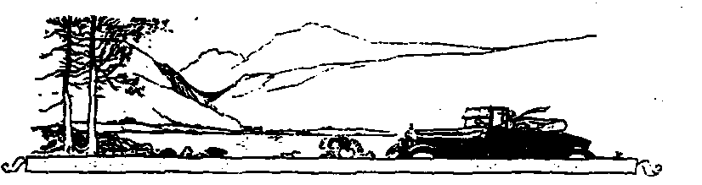
Coast to Coast 1994
T
he rally we have enjoyed most this year was in driving rain, mist and eventually some wind and sun. It was organised by a keen group, the North East Club for Pre War Austins and it ran from Scarborough to Morecombe. We were not quite brave enough to drive our 1936 Hertford 12/4 all the way from Dorset, so we took her on a trailer to a B&B near Pickering. The owners agreed to look after the modem and the trailer while we took part in the rally.
The organisers had sent us route instructions about two weeks before, with warnings about steep hills and the inadvisability of attempting some of the hills with rear brakes only. The route was about 160 miles, starting in Scarborough, through the North Yorkshire moors, across the Pennines and then south into Lancashire and to the seaside at Morecombe. It was extremely well planned, away from fast roads and traffic, and through some of the most beautiful and exciting countryside in Britain.
Sunday May 22nd and we were on the seafront at Scarborough, with some doubts. The weather was wet, gloomy and cold. The North Sea was greyish brown. Folk in a Morris 8 were filling their tiny 3 gallon tank from cans and said they had had a bad journey through fog from Durham. Before we had time to wonder why we were there, things started to liven up. A batch of Austin 7s arrived with cheerful people, and the cafe opened to serve breakfast and hot drinks. A starting line was erected and a few of had to move in order to be on the right side of it. Suddenly there was a lot of activity. Cars were arriving, friends were meeting and the atmosphere was busy. We started just after 9 am.
The first part of the route took us south towards Filey. It was drizzling and we soon went up a hill into fog and heavier drizzle. We followed an Austin 10 and some 7s. Their rear lights were dim as we tried to keep them in view. 12 miles further and we were in flat open country with the mist clearing. Coming to the first 1 in 4 hill, we were amused to see an A7 do a U turn and reverse skillfully up it. A stopped Ruby was topping up his radiator already and a smart Chummy overtook us. The countryside was beautiful, viewed from the top of the hills, with strong yellow rape fields and dark green crops. At the first village, we caught up with the Chummy and the reversing Box caught up with us, now facing the right way. After the third village there was a nice straight bit, we had rain but no mist and could see 7's ahead and behind. We were all passed by 3 TR's with their hoods down. The wiper motor began to feel a bit hot. We had an engine falter and stopped to peer under the bonnet. There seemed to be some metal filings in the distributor, so we blew them out and put things back together. No more trouble. We drove along the beautiful Castle Howard road and thought about revisiting Brideshead. It was the coffee stop next at Byland Abbey. This was to give us strength for the steep hills to follow.
We had driven about 50 miles by now and there was a warning for White Horse Bank, a 1 in 4 gradient. We went up carefully in 1st gear through leafy trees and followed a smart cream Austin 10 2 seater and dickie. We met the owners of an XK 150 Jaguar later who mildly complained about always having an Austin 7 in this rear view minor, trying to overtake. Sounded like the limousine and the bubble car. Having reached the top, the next instruction was a warning about descending Sneck Yat Bank, steep, narrow and long! It was. We were with a bunch of cars now, confident in our leaders and not bothering too much with our route books. This was not a good policy as a bright Austin 7 turned left at a T junction and the following 8 or 9 cars turned right into a private residence, Brawith Hall! Luckily we were at the back of the group and could reverse onto the road, leaving the others with their embarrassment and followed the Austin 7. We had a wonderful drive through open moorland. It was Ministry of Defense land with not a house to be seen for miles.
Lunch stop was next in Reeth village. It had almost stopped raining by now. It was nice to catch up with the other entrants and stretch our legs before the afternoon section through Swaledale and over Buttertubs Pass. There wasn't a warning this time about the steep gradient. Perhaps the organisers thought we must be used to them by now. From Hawes to Ingleton was wonderful. We went higher and higher into the mountain and had a great feeling of achievement when we reached the top. There was nothing to prevent us dropping off the left side of the mountain, just some plastic cords along the edge. We had a relaxed run down to see the Ribblehead Viaduct near Ingleton. There were danger warnings about lambs, but we got past them safely!
We were soon crossing over the M6 and heading for Morecombe. The Irish Sea looked just as grey as the North Sea, but at last we had sunshine and at the finish line we made new friends and promised to meet again next year.
There were 86 entries, 13 failed to turn up at the start. A few left the run early and some joined in half way. 62 arrived in Morecombe. The remarks column and signing off sheet were full of words like 'terrific', `fantastic', 'great fun', and 'ace'. Next year the club plans to limit entries to pre-1960 cars and hope to raise the numbers to 100. We hope to be here too.
As for value for money, the entry fee of only £5 per vehicle was well worth it. We even had a newsletter in June telling us how the money was spent and an apology for making a profit of 11p per entry! And this after reimbursing the unfortunate Jethro (pseudonym) who had his wallet stolen in Morecombe.
Joe and Maggie Stalker

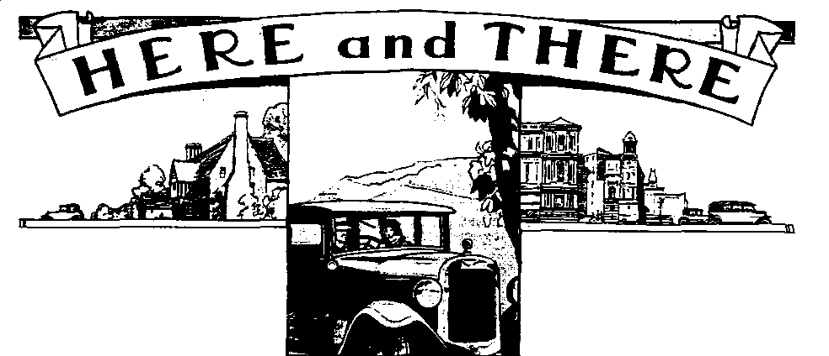

FOR EXCHANGE OR SWAP
While quietly minding my own business at Breamore, this chap came up to me and said "I've just had an operation and want to swap my 1945 WILLYS JEEP in excellent, restored order for a Chrome-Rad Austin Seven Box. I told him, of course, that he must be mad, but I promised him I would relay this not-to-be-repeated-offer onto my fellow Club Members. You never know! Don't ring me, contact O Harding on 0722 716706. - From David Whetton.
There has been a lot of movement on the book front. First, many people will have seen the reprint of Williams' essential book Austin Seven Specials on Seven Workshop's stand at Spye Park. You can appreciate its importance when you realise that it was first printed in 1958 and went through six re-prints. The new version is a photo litho which means the pictures are poor quality but this is compensated by the addition of an addendum which puts right most of the misprints and errors of previous versions. A snip at £12:99 from Foulis.
Ex Association Editor John Bateman's book The Enthusiast's Guide to Vintage Specials is at last available, from Haynes at £24:99. John covers more than 80 individual specials and competition cars of the inter war period. I'm looking to add this to the personal library!

Despite rumours to the contrary, Wyatt's long out of print Austin 7 - The Motor for the Millions is again available, this time from Roadmaster Publishing, PO Box 176, Chatham, Kent, ME5 9AQ. It will be recalled that this was the definitive history of the Seven, it has been up-dated by the author and should make even better reading than before. Sadly, I have yet to see a copy and have no idea of price.

CLUB EVENTS
July
Saturday 16 July Barbecue. Wilverley barbecue site, 7.45pm. If you want to go, please ring Mervyn urgently. on 0258 72905. See page 7 for location map.
Thursday 21 July Club Night. Light hearted Suitcase Sale! Bring along your suitcase full of junk to sell. Unique opportunity! For the less frantic bargain hunters, the Bar will be open and you can be sure of a very good turnout for a natter about The Rally.
Sunday 24 July Club Run. Beach run to West Dorset, bring along a picnic. Meet at Wimborne, Safeways Car Park at 9.45 am for 10 am start.
Thursday 28 July Committee Meeting. The meeting starts around 8.30 at the Tyrells Ford.
August
Thursday 4 Aug 8 ish till Late. An informal gathering at the Three Tuns, Bransgore.
Thursday 18 Aug Club Night. Meet at the Elm Tree, Hightown for the monthly gathering. Details next month.
Sunday 21 Aug Club Run. With the Club Rally looming, details have yet to be worked out, see next month's edition for details

OTHER EVENTS
Saturday 30 July Butterboy Bonanza, Oakford Fitzpaine Recreation Field. Beer or light refreshment tickets for those attending. See Mervyn for further details or the June Newsletter.
Saturday 30 July Damerham Country Fair. This super country show is held every other year and those who attended in 1992 will remember what a nice day out it was. Please let Phil know on 0425 475558 if you want to attend.

