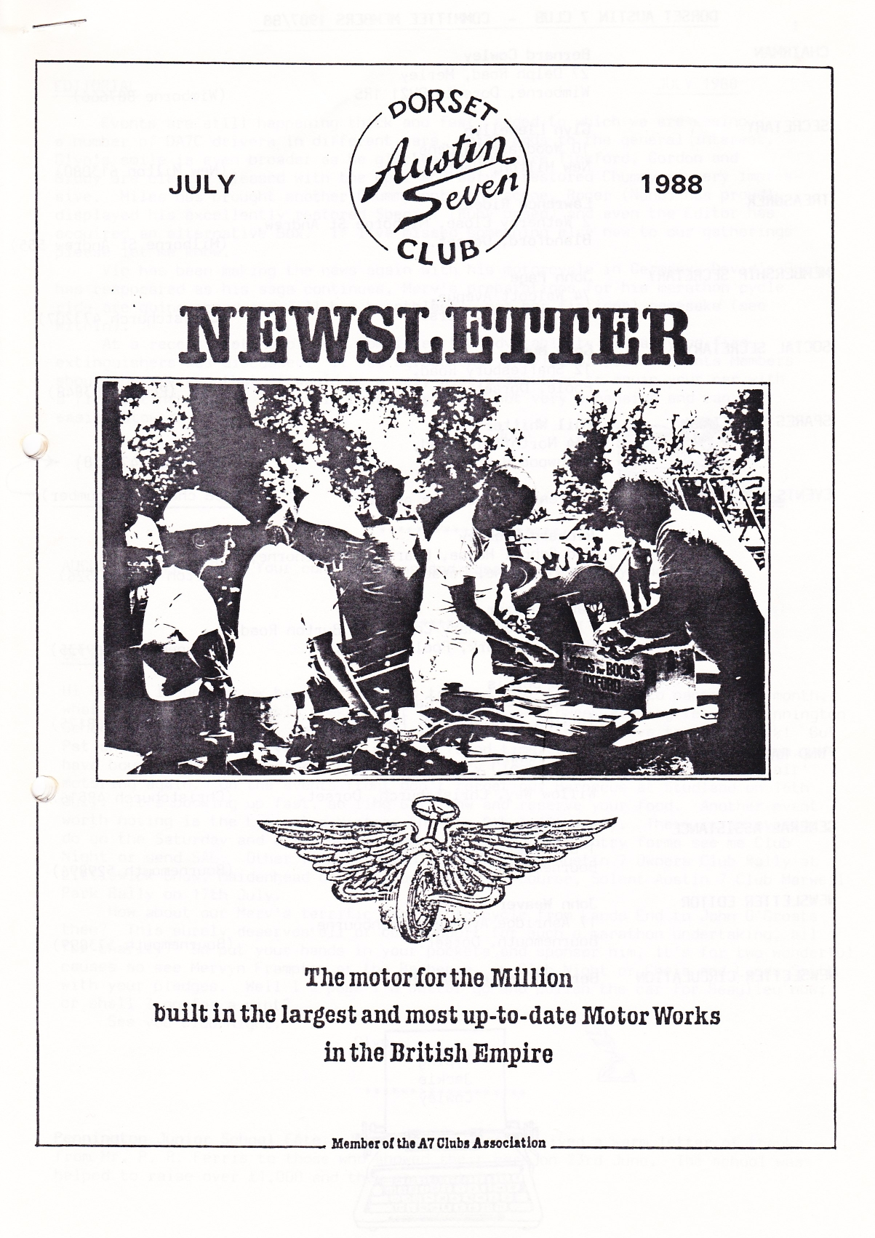

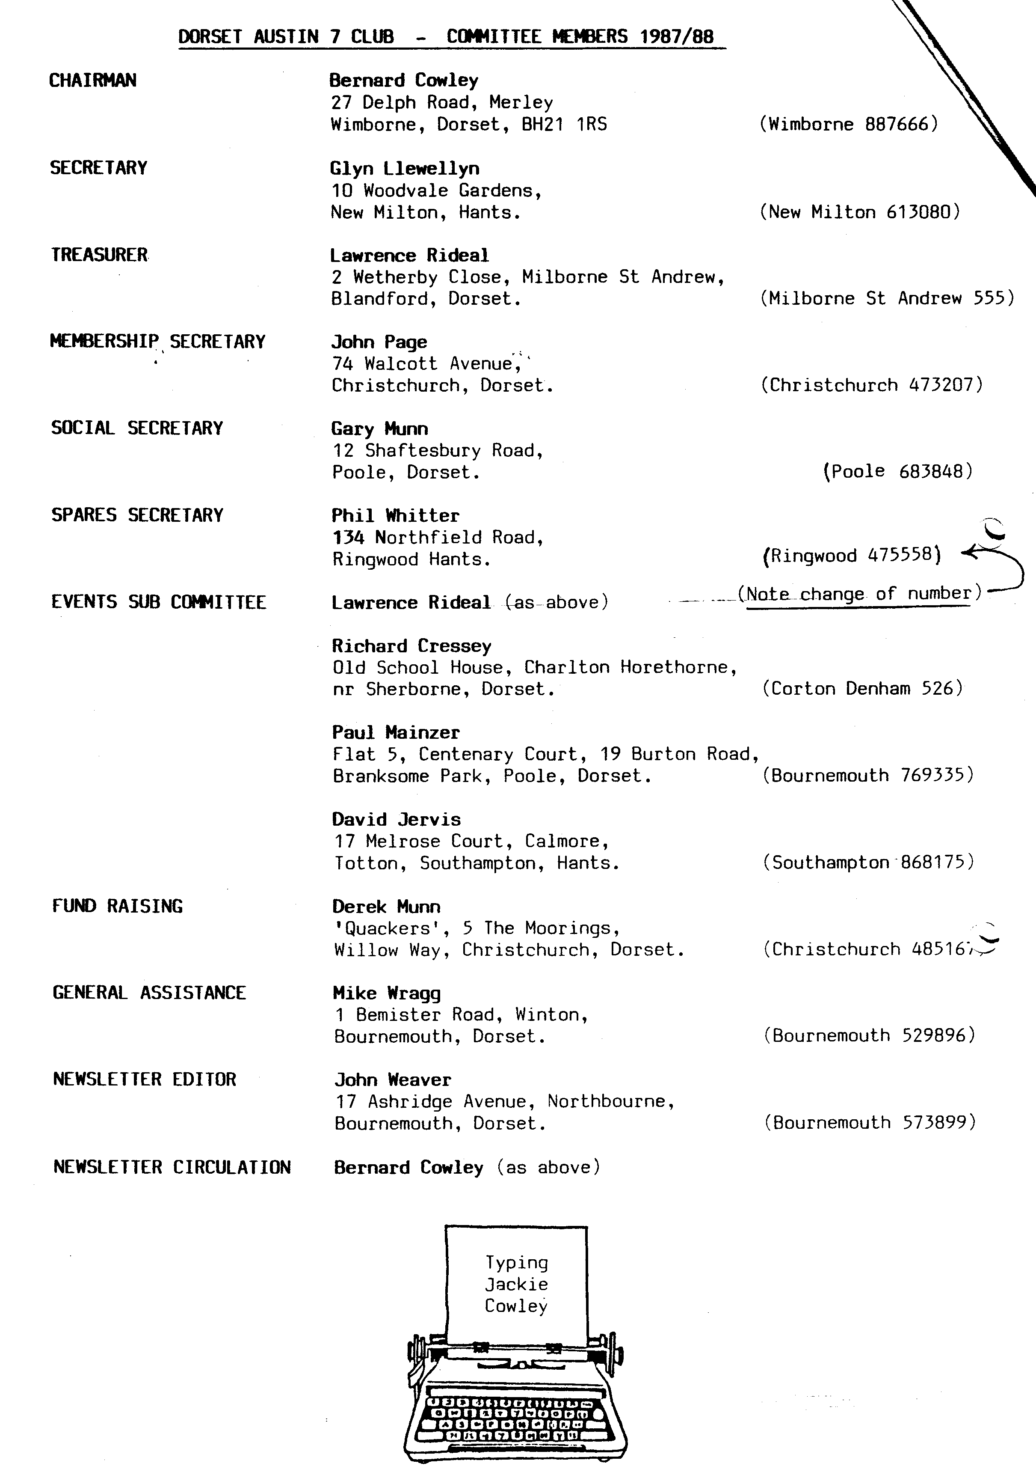

EDITORIAL JULY 1988

Events are still happening thick and fast, added to which we are seeing

a number of DA7C drivers in different cars, which adds to the general interest. Glyn's smile is even broader as he glories in the rare Tickford, Gordon and

Biddy are clearly pleased with the Opal and Gary's restored Chummy is very impres­sive. Miles has brought another Chummy onto the scene, Roger (Nunn) has proudly displayed his excellently restored Special (Ruby based) and even the Editor has acquired an alternative Box. If I've missed something else new to our gatherings please let me know.

Vic has been making the news again with his motorcycle in Germany, David's Opal has reappeared as his saga continues, Merv's preparations for his marathon cycle ride are 'going ahead and Jill has breathlessly met her fictional namesake (see within).

At a recent meeting of your Committee the advisability of carrying fire extinguishers was discussed. It was agreed that in view of recent events Members should be advised that it would be a very wise precaution to equip your car with a fire extinguisher. The small powder-type are not very expensive and can be easily stowed.

John

SECRETARIAL

Hi Gang. I don't know how I've managed to find time to put pen to paper this month, what with a very enjoyable week-end at Spye Park, a midweek evening fete at Pennington School, a treasure hunt, Beaulieu Rally, Marwell and I still have to go to work! But Pat and I enjoy it all very much, we even found time to buy another Austin Seven. We have bought the Tickford from Club Member Mary Clenaghan so are back to 'open air' motoring again. On the events front don't forget our Barbecue at Studland on 16th

July. It's booking up fast, so ring Gary now and reserve your food. Another event worth noting is the Lymington Vintage Show on 9th & 10th July. There is an evening do on the Saturday and a run on the Sunday. If you need entry forms see me Club Night or send SAE. Other forms available are for the Austin 7 Owners Club Rally at Littlewick Show, Maidenhead on 29th August and of course, Solent Austin 7 Club Marwell Park Rally on 17th July.

How about our Merv's terrific project to cycle from Lands End to John O'Groats then? This surely deserves all of our support for such a marathon undertaking, all

for charity. So put your hands in your pockets and sponsor him, it's for two wonderful causes so see Mervyn Frampton at the Barbecue, on Club Night or Chris and Lynda Smith with your pledges. Well I s'pose I'd better go and polish the car for Beaulieu now;

or shall I go for a pint?.

See you Club Night.

Glyn

**Pennington Junior School Fête.** The Secretary has received a warm letter of thanks from Mr. P. R. Ferris to those who showed their cars on 23rd June. The school was helped to raise over £1,000 and they are grateful.



SPYE PARK RALLY - 19th June 1988

They've always said to me, "You **must** go to Spye". This year Gay and I decided that we would. Jackie, Bernard, Daniel, Glyn and Gary were camping for the week-end and various others planned to arrive on the day, but we compromised - going for the week-end, but in B & B on Saturday night. We are glad we did because the B & B at Lacock was excellent and we would have missed a great Barn Dance in the marquee on Saturday evening and a visit to John and Janet Stone's home for tea prior to that. John collected us Saturday afternoon and led us to his home, on a pretty little run. Apart from enjoying an excellent tea in the garden a good natter ensued and we were able to admire their current restoration. Our warm thanks to them.

The weekend weather was glorious with an amazing number and range of Sevens

on display. The Bristol AX seem to have the Event well organised and are fortunate to have such a perfect setting. For those who don't know, Spye Park is an private estate of considerable interest in itself. The fact that the Event is well away from the general public seems to concentrate all the enthusiasm and make the Rally all the more pleasant.

Bernie came away with another 'pot' and Paul's box came second in its class.

Apart from the week-enders twenty Club Members and children (including one grandchild) arrived on Sunday. It was also nice to see Roger and Rosemary Ballard who were Merely Motoring again. L•

It was also interesting to meet Christine and Andrew Lowe and Keith Marriner from the Midland A7C. They were the chaps who planned and cast our Club car badges.

If you have never attended 'Spye'-think about it next year. They are right, it's a 'must'.

We thoroughly enjoyed the week-end.

Ed.

A7 v MORGAN TENNIS **or** IT'S A WASH OUT

I would like to be able to say it was a warm and clear evening on the 30th but the truth is that it was pouring with rain before we reached Ringwood. However eleven hardy optimists did arrive, only to be soaked to the skin.

I don't know how many people got a game but as we arrived Phil and Monica were doing their best, in the rain, to uphold the honour of the Dorsets. After that the heavens opened and all we could do was shelter under umbrellas and console ourselves with hot dogs, beefburgers and beer. The only thing that can be said in favour of the rain is that I think it saved us from a "thrashing" - that Morgan lot had a very professional look about them!!

Our thanks to Bob of the Morgan club who arranged the event and whose excellent tennis court we were to have used! Despite the rain we all had a good laugh and enjoyed the evening.

Jackie

CHARLTON HORETHORNE FEAST DAY - 25th June 1988

I have been an Archer fan for longer than I care to remember so when Richard and Margaret mentioned that Jill Archer (Patricia Greene) was going to open the Charlton Horethorne Fête I was already hunting out and dusting off the autograph book. However, Bernard, bless his cottons, came up with something even better - an early novel called 'The Archers Intervene' - so I decided to take that instead.

Time doesn't fly when you are waiting for something exciting but eventually Saturday did come and off we toodled in Emma to meet John and Gay (minus Gabrielle J. who wasn't feeling too well) and Gordon and Lena who were with Victoria.

Gay had planned the route and lunchtime stop and entrusted me with the chore of map reading. I am proud to say that I got our small convoy to Milborne Port without a hitch.

From the lovely Queen's Head, after an enjoyable lunch, we motored on to Charlton Horethorne to put the 7's on display.

The village was buzzing with activity and Victorian Ladies and Gentlemen were busy behind their colourful stalls. I really must ask Margaret, 'How many balloons can you get in an Austin 7?' I wonder whether Brian won 'What time did the watch stop?' and did John, when confronted by a Gorilla, guess his weight correctly?

Then my moment arrived - Jill Archer was opening the Fête. Like a star struck teenager I lunged forward and asked her to autograph my book (the others groaned). She did better than that (and you can eat your heart out Lawrence) she gave me a cuddle and we (Brian, Lena and Gordon) had our photograph taken with her. (Oh joy, Oh bliss!) To be quite honest I don't know why I was picked to do this write up because after such excitement - apart from saying Hello and Goodbye to Fran, Merv, Biddy and Gordon - I was on cloud 9. Brian informs me that it was a really enjoyable outing and that I really excelled myself in looking stupid.

As for me, well I'm still clutching to my bosom a much loved book which now bears the inscription - To namesake Jill, Good luck from Jill Archer (Patricia Green)

sigh.

Special note to the Cresseys. Do you think you could invite Walter Gabriel next year?????

Jill

What Jill did not mention was the fact that during all this time she was in a wheelchair cheerfully guided by the highly dependable Brian - both in thirties gear. Sad to say she has a broken ankle. It's clear from her account that she didn't let the pain and inconvenience spoil her day; or anyone else's. We hope it won't be too long before she is back firmly on her feet, although Brian will miss doing the shopping, cooking, washing, bed-making, cat feeding, etc.. (What a hero!)

Fran had prepared a marvellous tea at Broad Oak and must have been a bit disappointed that there were not more to appreciate it. Thanks Merv and Fran for your kindness.

Ed.

**OUR THANKS to David Whetton for the large and impressive DA7C badge he made *for our stand at 'Motorcade '88'. It was just right.***

CAN YOU HELP ? Jeff **Bridge wonders if anyone can show him an original A7 grease gun, complete with rear axle injector, so that he knows what to look for.**





BODGER'S CORNER - THE OPAL SAGA IX : LEFT OVER BITS & PIECES (Part 1)

IT WORKS! It really does. But it is going to take quite a few runs before the driver stops shaking - it's so NERVE-RACKING wondering what's going to break next. However, a few smashing runs like last Thursday's to somewhere-near-Fordingbridge will help to bring back the ring of confidence.

The purpose of screwing out yet another episode in what Bob described as "only a bl**dy weekend's job!" is to pick up a few bits and pieces I've found left over in the bowels of the wordprocessor. The other interesting collection of bolts, studs and wiggly bits that were left behind on the bench and floor are in a large tin just in case they are needed.

Radiator: when I took the radiator off, one of the bottom bolts was left behind

in a pile of rust. Lord Austin wasn't all that clever 'cos he put two large holes in the radiator behind the bottom bolts so that the bolts slowly rust away from within and when they come a bit loose all the water comes out. My two little First Years (see Bodger on child slave labour Dec. '87) came up with a New Bit turned down from a 2" billet of stainless steel during one lunch-hour. They turned one end down to an 8 mm. thread and cut it off leaving a plate, 3 mm thick and 2" diameter, attached and all from one solid piece. This I managed to solder on to the bottom of the radiator all by myself. However, stainless steel billets come a bit pricey - four gobstoppers each! I have spent some considerable time on my knees researching how

Club Members cushion these bottom bolts. The official method had two springs, most y, have very little but the one I've used - two old engine mounting rubbers - helps use up some of the bits and pieces on the bench. (Re-cycling)

Manifold studs: Having discovered that water rusts, Lord Austin then turned his attention to the inlet/exhaust manifold studs. "What fun they'll all-have _in—fifty years", he thought, "if the studs screw straight into the water tubes around the engine." However, new studs are not the answer since water will still spurt out from each one on that glorious day of start-up. He Who Knows All puts Red Gunge on the ends of his studs before screwing them in, but he would wouldn't he.

Front Bearings: How not to smash The Lip when using The Very Large Hammer to drive in the front bearings - put grease inside the lip. Then hammer away until you get an eye-full.

To he grippingly continued in part 2 next month. David Whetton







SALE 7

1. Austin Seven Special with Artesi (RTC) body. £2,000

1933 .

2. Austin Ten Cabriolet. A Chrome radiator. For total restoration. £1,000

Contact Terry Jefferies *4,,'*New Milton 616372 (Evenings)

3. Austin Seven Saloon 32/33 Longbase. The famous Chocbox (Gabrielle J.) New MOT. £2, 500 o.n.o.

Contact John Weaver B'm'th 573899'

4. 1934 Nippy - Sound condition but could do with some tidying. Engine rebuilt by Stuart Rolt, not yet run in. New battery. Twin SUs £3500 with existing engine or £4000 with kit for original sports engine.

5. Sports Engine - Crankshaft, crankcase, Renault rods, original sump, manifolds and 30VE1 carb. No cylinder block or head.

Miles Shepherd 0722 27215 WANTED

Two good Ruby bumpers. One late Ruby screen. Contact Bernard Cowley % Wimborne 887666

EVENTS

1­

JULY Thursday 21st July - Club Night. Evening Run to Milton Abbas. Meet at Wimborne Square at 8.00 pm.

Sunday 24th July - DA7C Vintage Picnic Tea Run - with Strawberries and Cream! Meet at the Furlong Car Park, Ringwood, at 11.30 am. After a pub lunch there will be an afternoon run ending with a forest picnic. BRING YOUR OWN PICNIC - but Strawberries and Cream will be provided.

Thursday 28th July - Committee Meeting at the Tyrrells Ford at 8.30 pm.

AUGUST Thursday 4th August -'8 to Late' (for those who want to meet for a natter) at the Avon Causeway Hotel, Hurn.

Thursday 18th August - Club night. A short Evening Run to the Red Shoot, Linwood. Meet at the Elm Tree, Hightown, at 8.00 pm.

Sunday 21st August- Club Run to Singleton and the Weald and Downland Museum. No pub lunch. Bring your own picnic and lubrication. Meet Ringwood Cattle Market (the Furlong) at 9.45 for 10.00 am **or** The Fighting Cocks, Totton at approximately 10.30 am.

