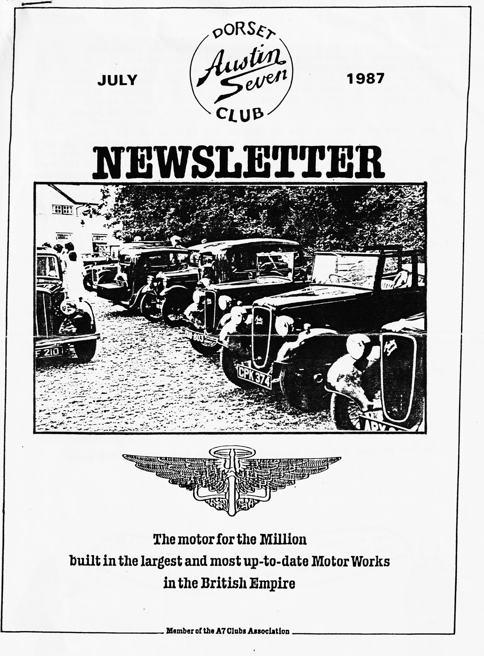

EDITORIAL JULY 1987
Ever since that memorable Club Run, when your Editor drove part of the way with his handbrake on, he has been particularly conscious of his brakes. The drivers of at least two cars behind mistook the scent of burning brake shoes for trouble in their own electrics as we sped along. They happily realised that they were in the clear when a spectacular trail of smoke issued forth from my nearside rear hub whereupon, risking all, Rob overtook and waved me down.
All this was much to the disgust of some veteran 'Dorsets' and a useful experience for me. After a few weeks depending on the rivets I turned, as some of us do, to Munwellyns. Although not trying to put them out of business, I have included this month the first of two articles concerned with the maintenance and repair of the A7 braking system. If your system is original, this info. might prove useful. Believe it or not, it appeared in 'The Austin Magazine' more than fifty years ago, when autojumbles were unknown and long before the stork had even been informed about Gary or Glyn.
Once again those who attended the Club Barbecue at Studland enjoyed a very pleasant and amusing evening. The food was in abundance, the charcoal and the chef glowing brightly and the weather reasonable. Once again, it was the preparation that counted. Many thanks to those who laid it all on. The 'dip in the briny' seems to have become a tradition. Glyn and Mike could not resist going in. The former was attired in swimming shorts and engineer's cap whilst the latter was clad only in bravado, as last year. Photographs taken in the dusk do not reproduce too well, but the evidence is within. Have you the lucky Newsletter? Using the edge of a coin …
Thanks very much to those who have let me have something for the Newsletter this month. As a result, we have more variety and a formidable competition. More is needed for next month and the month after so keep it coming in
John Weaver.
+++++
AUGUST NEWSLETTER
Please let me have that article/photograph that you mean to let me have — by 5th August.
+++++
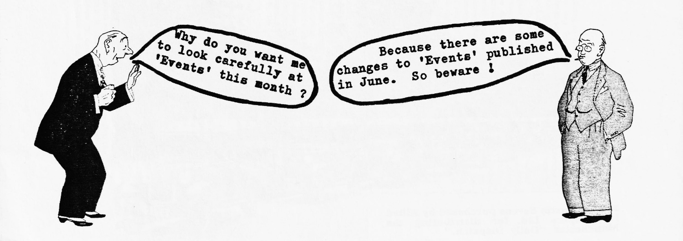

SECRETARIAL Hi Gang
As I reported in the Secretarial last month, thanks to Keith Marriner and Andrew Lowe (Marrilowe Enterprises?) it looks certain that we shall have our club badge cast in aluminium after all. Keith has made the 'Austin Seven' script part of the mould and Andrew is casting the badges using melted down A7 crankcases. So, if you have any broken or damaged aluminium A7 parts that you don't want, please let me have them and I will see that Andrew gets them. I may possibly have a sample of the badge by next Club Night.
Last Club Night proved to be a rather damp evening, more like November than June, but I understand that a few brave members managed to follow Bernie over to Damerham in the wilds of woolly Wiltshire (or is it still just in Hampshire?) where I understand a pleasant evening was had by all. Sorry Pat and I couldn't make it.
Spye Park was our next event and unfortunately John Stone informed us that he could not, after all, organise the usual Saturday run as he had to work. So most of the 'Dorsets' decided to travel up on the Saturday morning and camp for just the one night. Bernard and Jackie organised a run to a pub for lunch on Saturday and we all attended the Barn Dance in the evening. The Rally itself started the following morning and as usual it started to rain just in time for the prizegiving. It was, however, as usual, a very pleasant weekend, where we were made most welcome by the Bristol Club.
Plans for our '50s and 60s Evening' are nearly complete and the date set. Gary has had considerable difficulties in tying up the room, the entertainer and finding a date that did not clash with too much else, so please do support what promises to be a .terrific evening. See more details in this Newsletter.
The following Wednesday evening saw many 'Dorsets' at the evening Rally of the H.C.V.C. at Little Gore Farm. This is really just the H.C.V.C.s June Club Night, but over the years it has expanded to a quite sizeable evening 'do' with a jazz band and even some steam exhibits.
By the time that you get this Newsletter, Beaulieu Rally will have come and gone and many of you will have an extra 'pot' on the mantleshelf, and some will be talking of the bargains obtained at the Autojumble.
Well, that's all from me this month; see you Club Night.
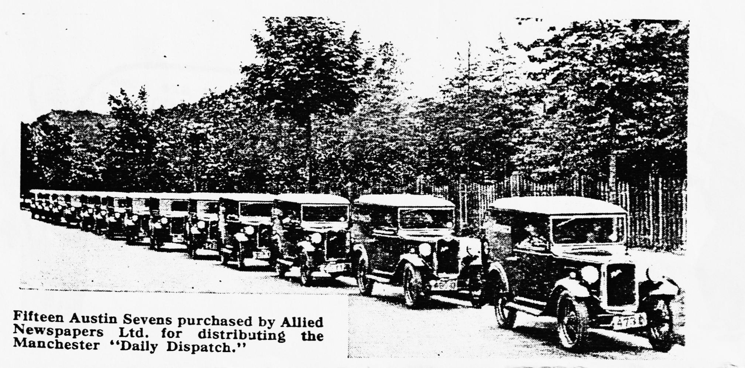
Glyn
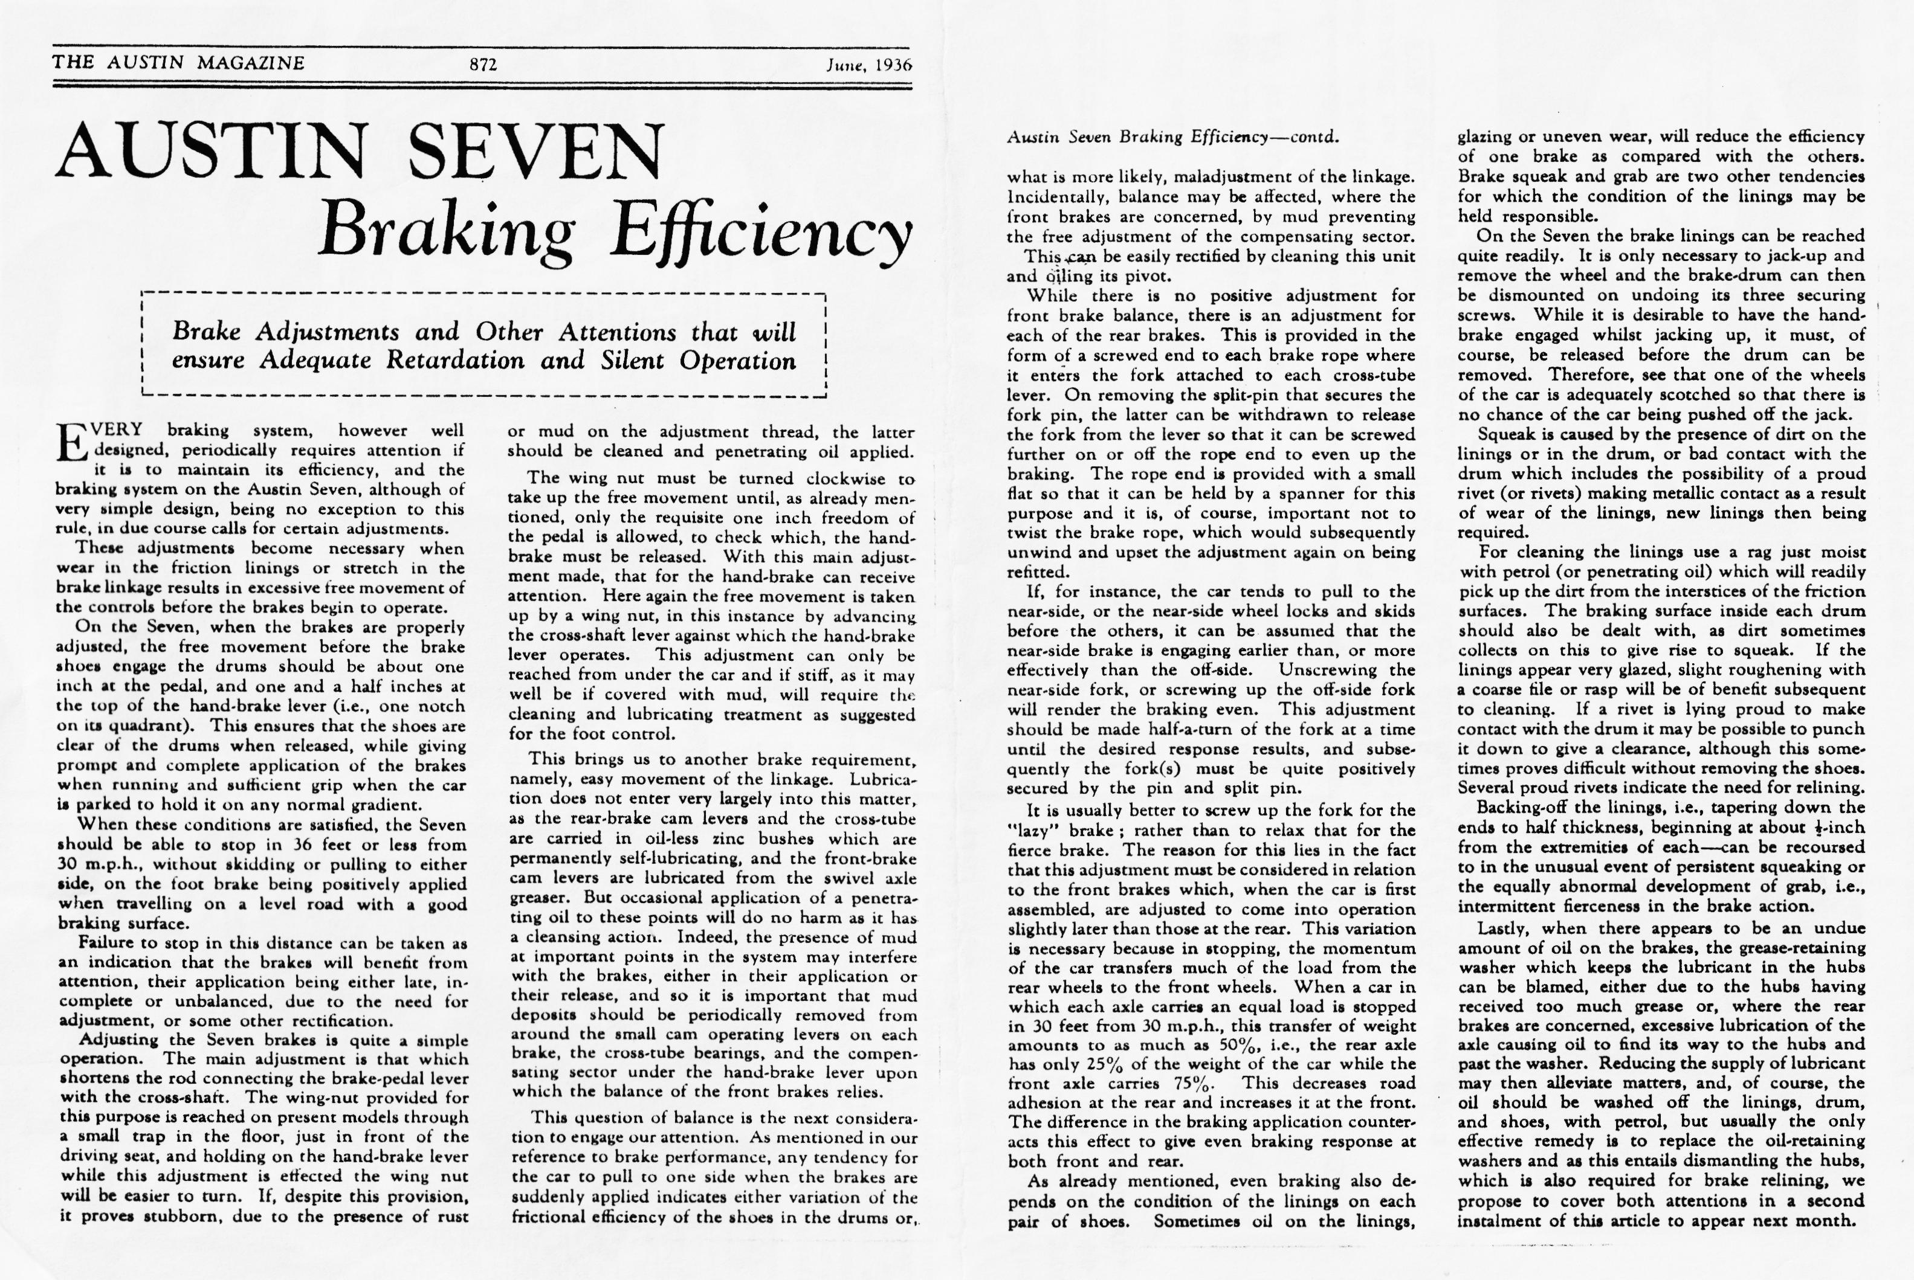

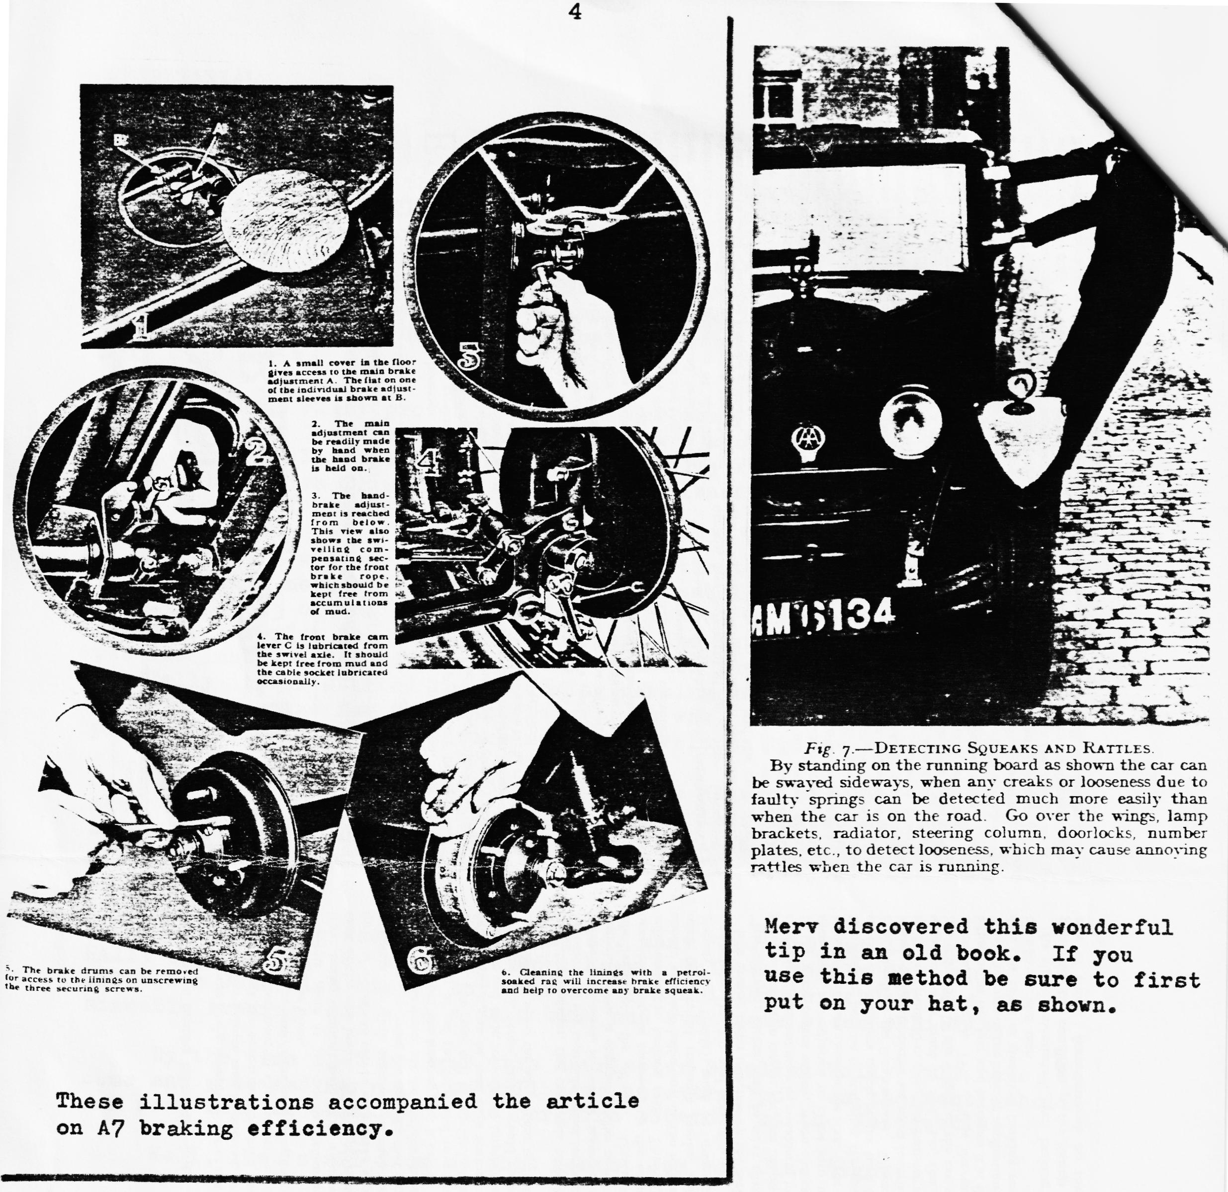
FOR SALE
AUSTIN SEVEN SPECIAL. 1935 Ruby chassis fitted with new open, aluminium, 4-seater body, with hood and tonneau cover. Taxed and with MoT Certificate. Interesting registration - AAA339. £2,750. Ring Mike Wragg on B'm'th 529896 or 531464.
FOR SALE
1936 A7 Rolling Chassis complete (less body) Eng. G/Box Axles, wheels, tyres, steering Box, red. and grill. Chassis cleaned and painted. D.V.L.C. registered ESU 718. £350 ono. Enquiries to Highcliffe 3984

CHARLTON HORETHORNE FEAST DAY
Those of us who accepted Richard and Margaret Cressey's invitation to take our cars for display in the village found it a delightful experience. The village centre is virtually unspoilt and has that 'timeless charm'. There were the church, the manor farm, the pub, the school, and the green all as we imagine to be typical of an English village - and well cared for too.
It was a pleasure to wander round and be associated in a very small way with such enthusiasm and local pride. Here is one admiring 'towny' who was very sorry not to be able to stay for the Barn Dance in the evening, or long enough to discover exactly how many balloons it had been possible to stuff into Richard and Margaret's Box. However, we stayed long enough to have an interesting and enjoyable day.
Thanks to Merv and Fran for the hospitality at Broad Oak on our return journey - also much appreciated.
+++++++++++++++++
A SEVEN MILE FOREST WALK was undertaken by Brian and Jill with Chris and Linda Smith and their Leukemia Research Support Group. Children Rachel and Rebecca were with them.
GLAD TO MEET....Peter Adams at Damerham and hear about his Pearl Cabriolet. Restoration is just about complete.
A NASTY VICIOUS STREAK....is coming out in two certain club members. They are learning to play croquet
WE WERE NOT UNREPRESENTED on the Bristol to Weymouth Run. Merv and Fran were there in their Ruby. Any other 'Dorsets'?
A GOOD LINE UP....of 'Dorsets' at Braemore. As well as the usual 'runners' we were glad to be joined by Jeff Bridge in his Box and Dave Tanner with his pretty Opal, together with their wives and a young lady Bridge.
FOR THE FOURTH TIME....Bernard won the Rose Bowl at Spye Park for the Chummy.
AND A SURPRISE....for John and Gay at Braemore where we won a cup for our turn out in period costume.
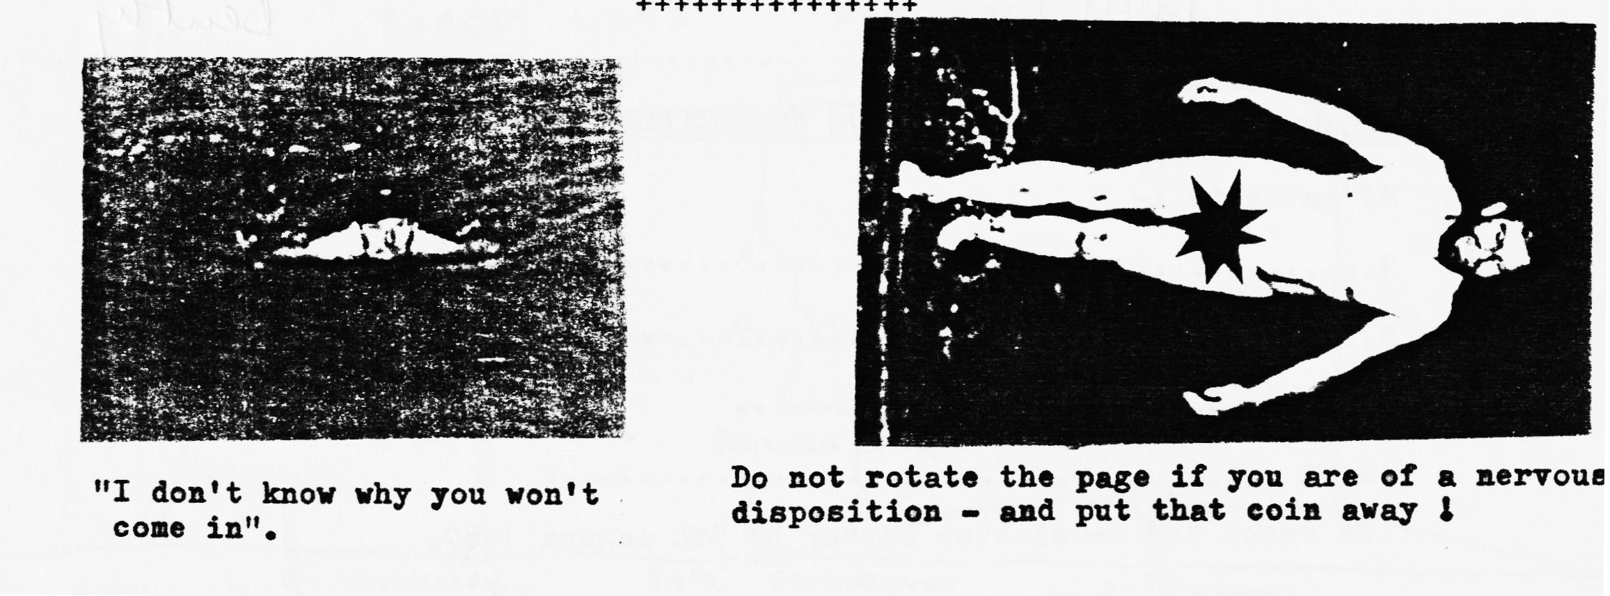
HAVEN'T SEEN....Vic Steele recently, but according to the 'Evening Echo' he was off to compete in the Isle of Wight with his Opal. Small beer this for a man who also competes as far away as Eastern Europe - but glad to know that he hasn't ended up in a salt mine.
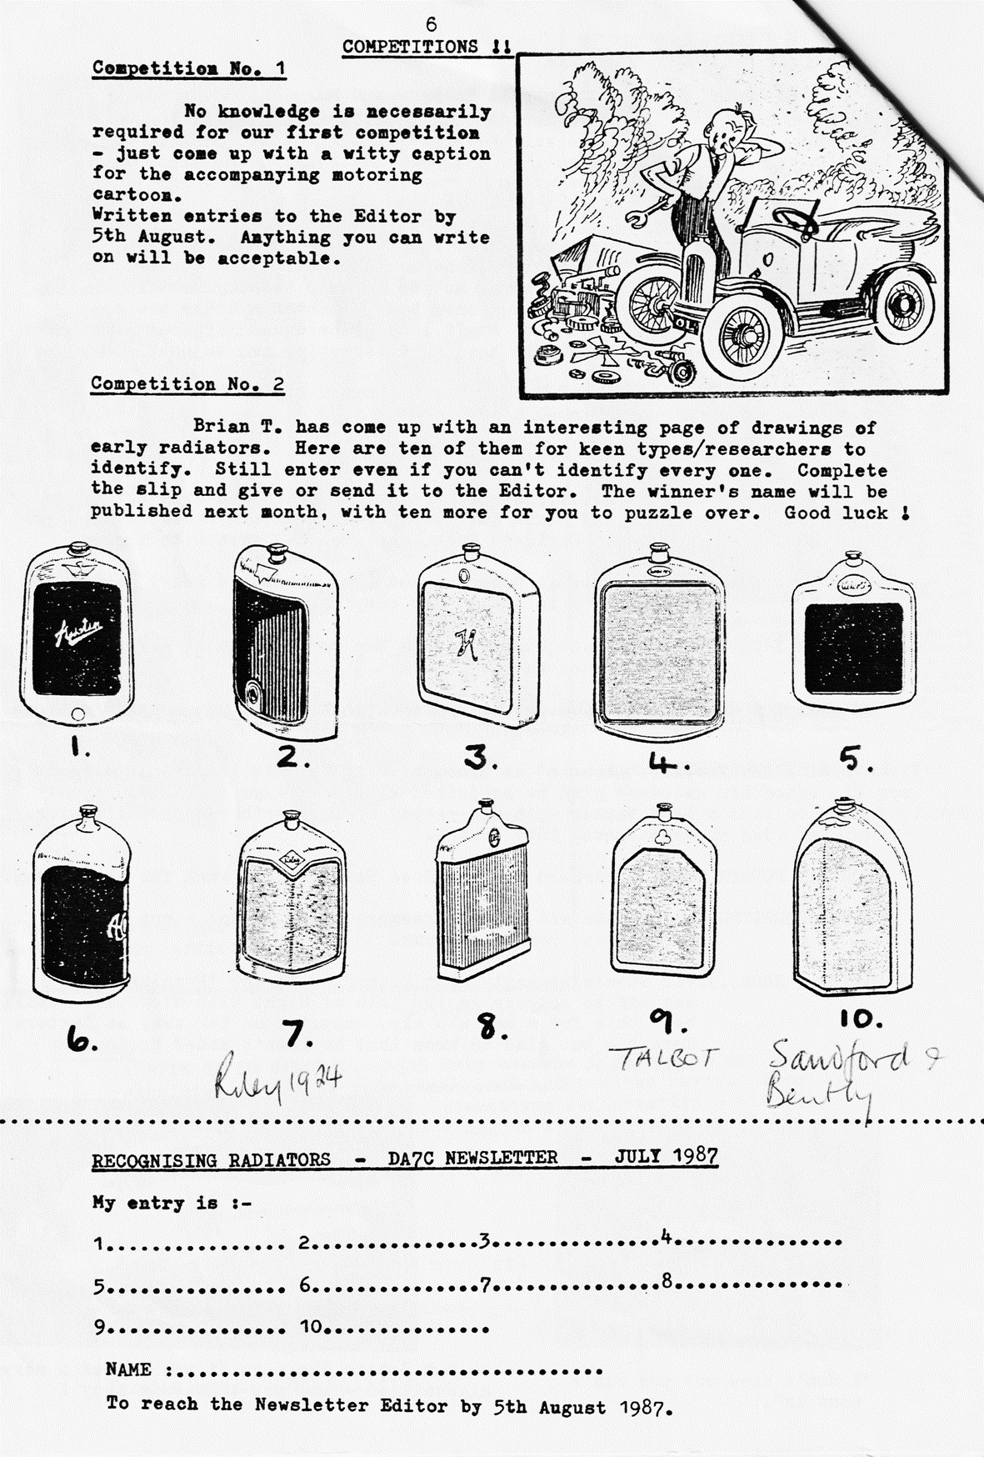
COMPETITIONS
EVENTS
JULY
Saturday 11th July. Evening Run to the Drovers Inn north of Wimborne. Meet at Wimborne Square to leave at 7.30 pm.
Thursday 16th July. Club Night. Meet at the Elm Tree at 8.00 pm for a run to The Filly Inn, Brockenhurst area.
Thursday 23rd July. Committee meeting at the Tyrrells Ford at 8.30pm.
AUGUST
Saturday 1st August. 2.20 pm Members are invited to bring their cars to the Salvation Army Fete at the home of Mr. & Mrs. Nicholson. Club cars will be displayed with the magnificent Nicholson Collection. Please do your utmost to support this event. Phil's map will get you there.
Saturday 15th August. '50s AND 60s EVENING' Details within. (Evening run transferred to 29th)
Thursday 20th August. Club Night. Meet at the Elm Tree et 8.00 pm for a run to the Royal Oak, N. Gorley.
Friday 21st - Sunday 23rd August. Purbeck Rally and Autojumble.
Thursday 27th August. Committee meeting at the Tyrrells Ford at 8.30pm.
Saturday 29th August. Evening Run to Corfe Castle. Meet at Wimborne Square at 7.30 pm.
SEPTEMBER
Thursday 2nd September. Visit to Hall & Woodhouse Brewery (see June Newsletter)
Sunday 20th September. Visit to the Barnes family at Shaftesbury (details next month)
OCTOBER
Saturday 24th October. Charity Party/Disco in aid of Leukemia Appeal. 8 pm – 1 am Avon Country Club.

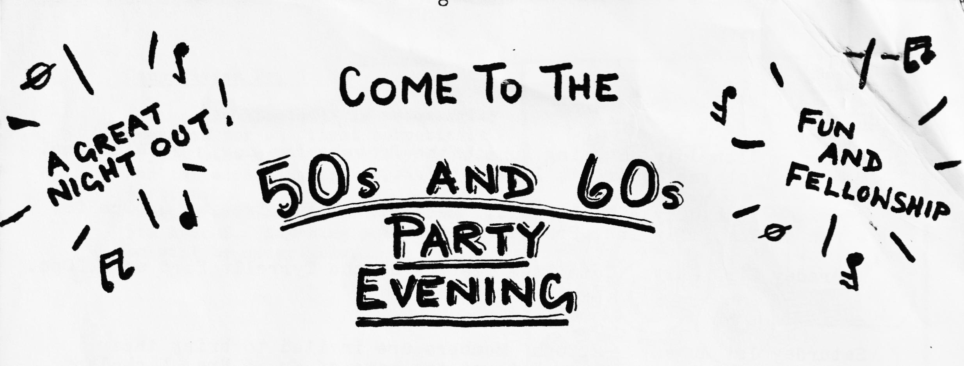
Following on from last month's preliminary notice, we have managed, after some difficulty, to arrange our 'do' for Saturday evening 15th August at 8pm in the River Room, Avon Country Club 262 Christchurch Road, Ringwood - where we held the Barn Dance. Mr. Chris Redwood will be playing and singing to get us jiving to all those old Rock & Roll numbers. Anybody who hasn't heard his talented performance should definitely do so'.
There will be a free Ploughman’s Supper laid on and, of course, extended bar time has been arranged. Fancy dress is optional but, judging by the turn out for the Barn Dance, we hope many of you will enter into the spirit. What were you wearing in the era? We'll look forward to seeing on the night. You might even win a prize!!
Friends are most welcome, the more the merrier, but unfortunately those not old enough to drink cannot be allowed in. We really would like to see maximum support end promise that you won't regret it! Please return form by 1st August at the latest to: Gary Munn, 12 Shaftesbury Road, Poole, Dorset BH15 2LT.
Remember folks this is your one end only chance to book your place.
NAME:
ADDRESS:
PHONE:
Please reserve me places for our 50's & 60's Evening on Saturday 15th August, 8 pm at £3.50 each.. I enclose cheque for ……………………………………. (payable to Dorset A? Club)

