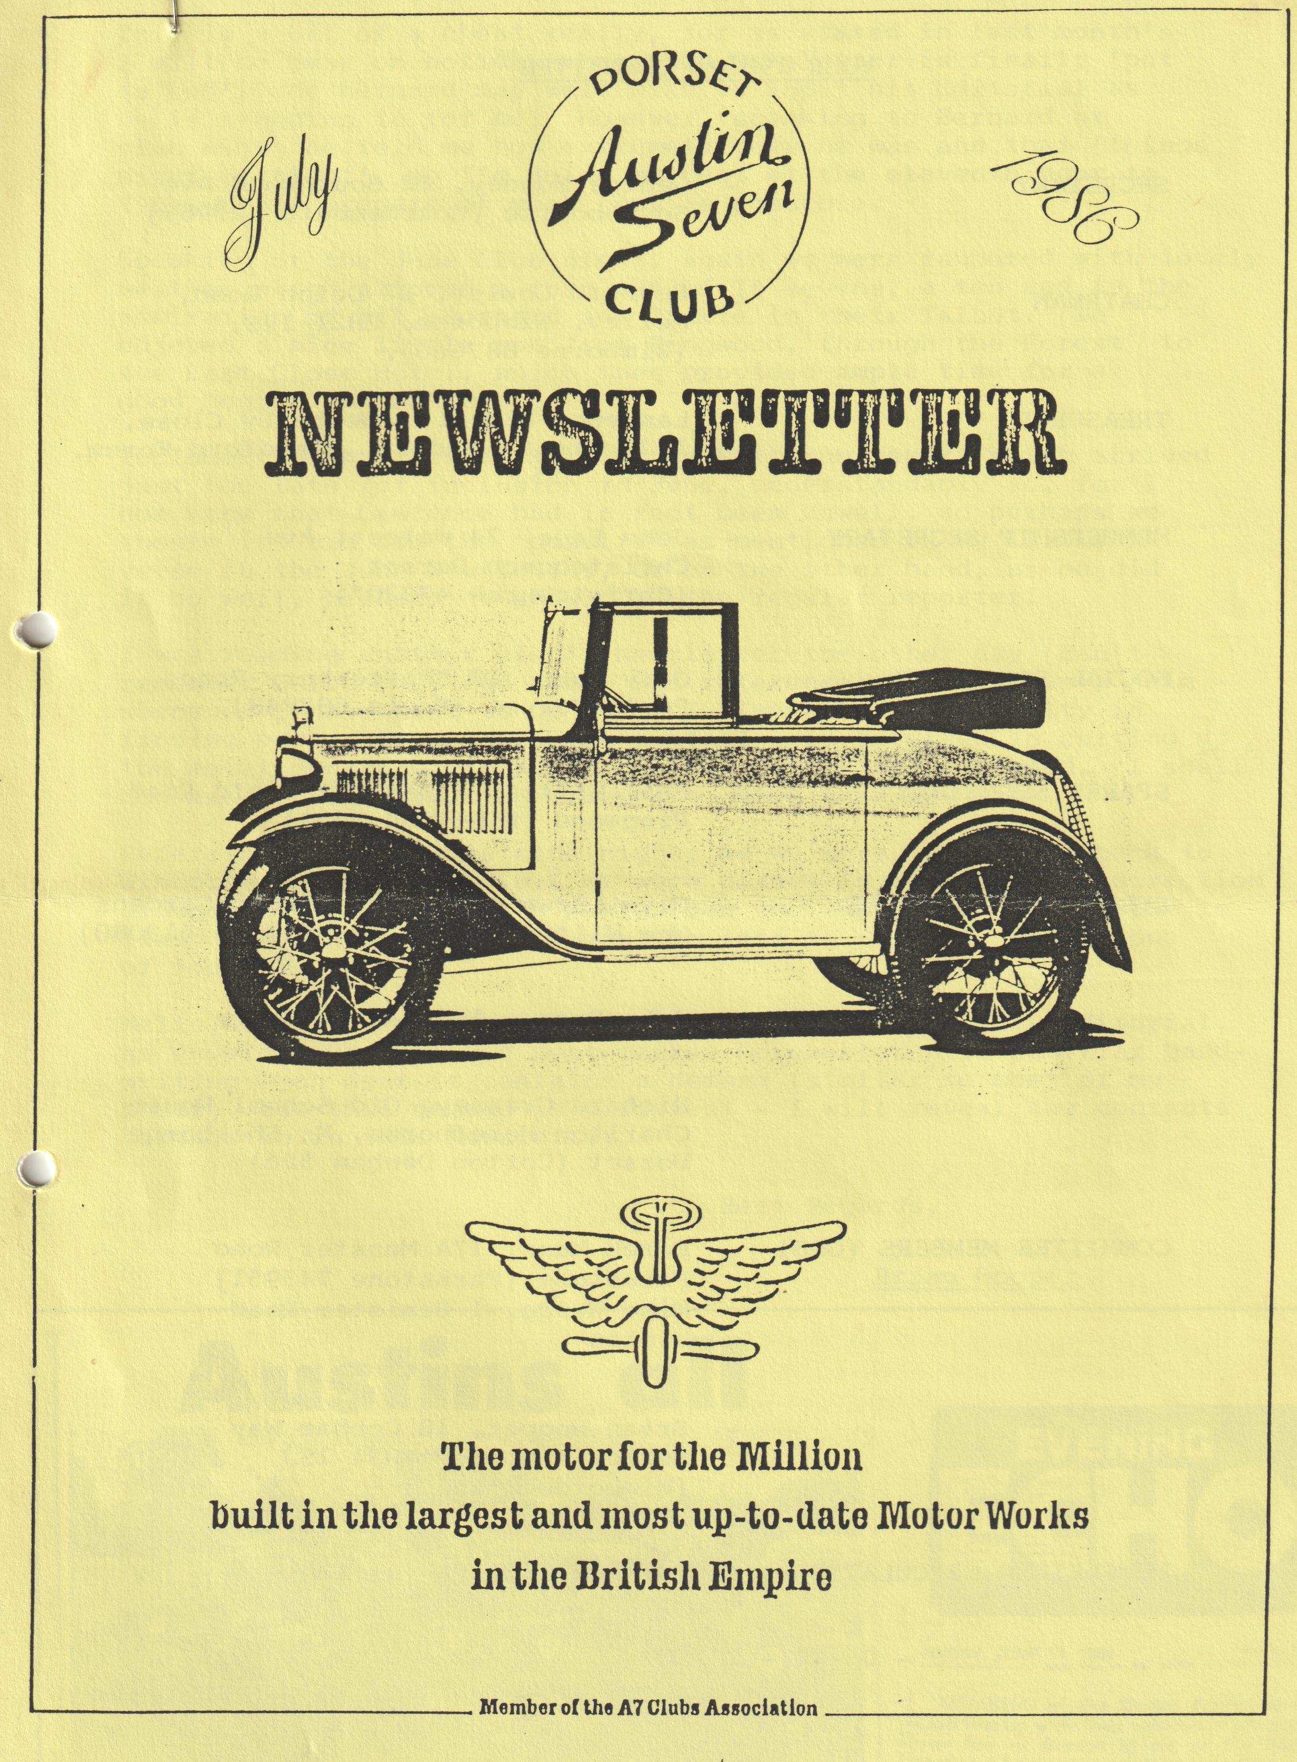

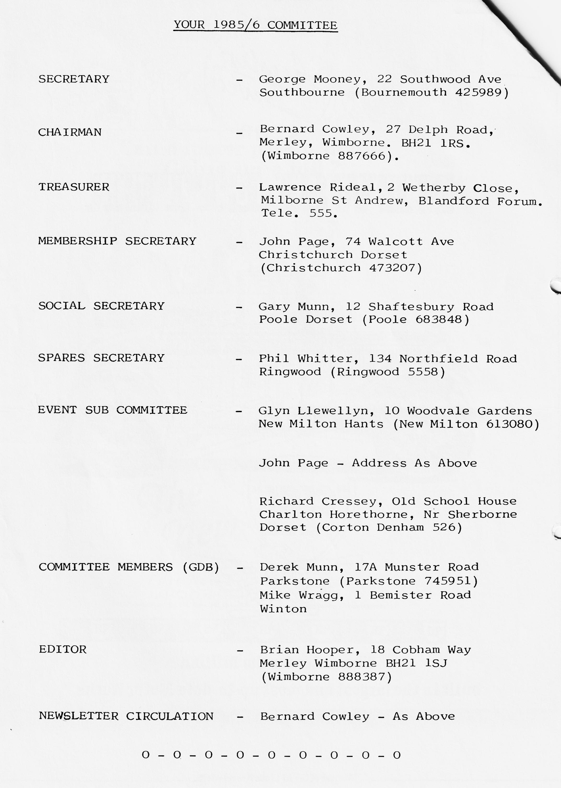

EDITORIAL JULY 1986
This is a bit of a cheat really, for as stated in last month's will be away on holiday when this Newsletter is finally 'put to bed', and Bernard may well wish to input his Editorial as he is standing in for me. However, speaking to Bernard at club night he told me how extremely busy he was and that 'things might be tight', so I'm doing my best at the eleventh hour to type up and prepare as much copy as possible.
Speaking of the June Club night, again we were favoured with lovely weather which allowed a turnout of 16 sevens, a ten and to the admiration of all, Bernard and Jackie in their Talbot. We enjoyed a nice little run from Ringwood, through the Forest to the East Close Hotel, which then provided ample time for a good Noggin and Natter.
Included in this Newsletter is the Bath run report which arrived just too late for inclusion in June, understandably so, for I now know that Lawrence had in fact been unwell, so perhaps we should let him off the 'penalty' as mentioned in my little verse in the June Newsletter, or on the other hand, as he did it so well, perhaps he should be the regular reporter!
I was reading another club's Newsletter the other day (can't remember which one) and there was reference to making up a shim. Whenever I have need to do this, I always have difficulty in finding very thin metal. The quote I read referred to cutting up the metal container in which certain cigars are packaged. I shall now ask my cigar smoking friends to save them for me.
Referring back to June club night, as we were travelling back to Wimborne about 11.00 p.m., we were passed in the opposite direction along the Magna Road by a Box saloon who recognized us in time to flash headlights, albeit I was too late to respond, was it one of 'ours'?
Hello, Hello, what is this, just as I've finished this Editorial, an envelope has arrived post-marked Dorchester with familiar handwriting - oh dear it contains a demand (similar to most of my post!) but this demand is different - I will reveal the contents further on in this Newsletter.
Best Regards,
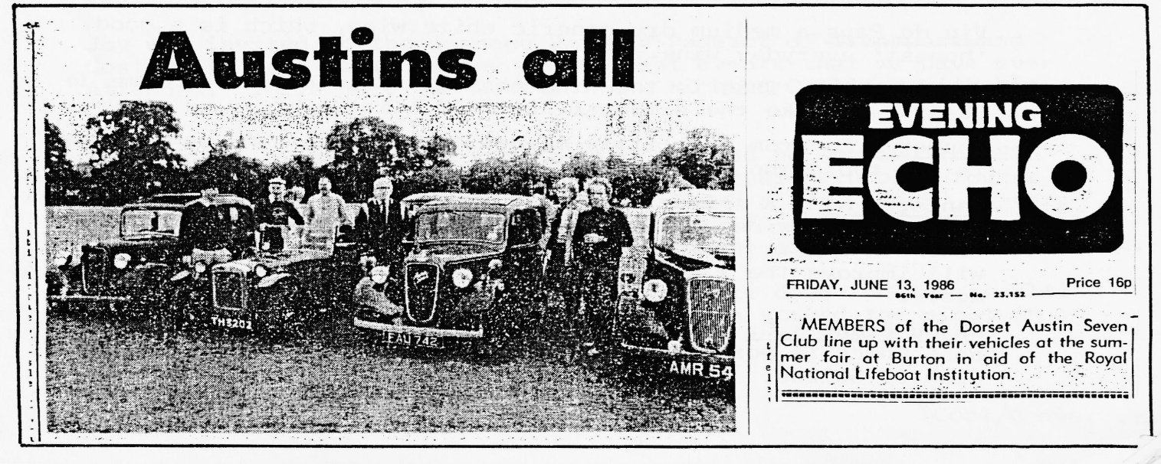
Brian Hooper
WINE
As more and more wine is being consumed in this country, it might be of interest to those members who enjoy a tipple to know little about some of the alternatives that are available to Supermarket Screw Top Bottle and cardboard cask varieties:-
BEAUJOLAIS
Just south of Macon, the Beaujolais is a beautiful rolling area of 'La Belle France', full of colour and soft light. All the Beaujolais wines are best drunk young. Sometimes a 'morgon' or a 'moulin a vent' will improve with just a few years in the bottle, but generally 'the younger the better' is a good attitude to Beaujolais wines. We tend to drink them at room temperature, but in France they often present them slightly chilled.
Beaujolais Villages A.C. comes from 40 tiny villages in the north of the Beaujolais region, and only they have the right to use this 'appellation'.
Beaujolais A.C., not a great wine, but it is good and honest, with a lovely colour and a full body.
Brouilly A.C., a lovely wine with fine bright colour, a full fruity flavour and wonderful bouquet. Perfect with almost everything and if chilled, one of the few wines that really do enhance the flavour of an 'eastern' meal.
Morgon A.C., a favourite Beaujolais both in the taste and after taste - a distinct hint of cherry. This gives the wine a warmer, softer and more 'sensual' feel to other Beaujolais.
ALSACE
Nestled amongst the slopes of the Vosges mountains, the vineyards of Alsace look across the Rhine to the forests of Germany.
Sylvaner A.C. a soft light bodies wine, delicate and fresh. An ideal accompaniment to picnics, salads, and most 'simple' meals.
Muscat D'Alsace A.C. This is not like a Muscadet from the Loire, and is either enjoyed very much indeed, or found to be practically undrinkable!
WHITE WINES FROM THE LOIRE
The Loire valley has something approaching 80 different appellation contrôlée wines, very few of which are drank in the U.K., the Rosés are relatively common, but the most popular are whites.
Vin de Pays a medium dry generic white wine, which is a good 'honest' everyday wine.
Muscadet A.C. This is the wine that the French add to Creme de Cassis, to make the national aperitif 'Kir'.
Saumur A.C. from the little market town of the same name, this is for those who enjoy a really dry white wine.
Sancerre A.C. a splendid example and perhaps the most famous of the Loire wines. 1983 was an exceptional vintage and this wine has a real freshness and elegance. Served chilled, this will improve the flavour of almost anything except 'heavy' meat meals.
Anjou Blanc A.C. a difficult wine to find (as opposed to Anjou Rose which is more common). It is medium dry and ideal with Fish or Salads.
SECRETARIAL JULY 1986
Hello again,
As I. write this'. secretarial, I . am.: enjoying :the sunshine .at Attingham Park Rally, on a beautiful .Rally Sunday
The English Rally scene.is something very special and I believe quite unique in Europe. No wonder people come a. long way to join in.
As I write, the. Braemore Motorcade is underway. I hope those of. You who were there also had a good day. There. is another event.at Malvern at the 3 Counties Showground on 4th - 5th October.
Now to update you on what has been happening to us at past events and to give a brief report:-
Joy wrote a report on the Daffodil run, but somebody appears to have lost it. Briefly, it was a lovely day for the first rally of the year. The run was similar route to previous years, nevertheless, it was very enjoyable with splendid show of Daffodils en route.
The Cafe at Stockbridge had changed hands that weekend and it was chaos and the service hopeless! I .believe this was the 20th run, and I can tell you that the Mayor of Bournemouth has assured The Bean Club of continued support for next year.
We handed the long-haul award back this year, having been the first A7 ever to win, and, guess what, it was won this year by a young man in an Austin Seven Special
At the Pavilion car park, a lady driving a Top Hat A7 was complaining about her steering not being very good. With help from some stalwart males the trouble was quickly diagnosed as an oval eye in the front axle - I have never seen one so bad.
The Woodford Rally and Country Fair took place on 4th - 5th April. A charming small rally near Salisbury. Roger Ballard turned up also with his Box and his newly acquired 10 Chrome rad Cabriolet - lovely car but terrible paint problem.
The organiser for the cars was really charming, but it was not very well organised at the Rally Parade, and I think he was disappointed when we left the ring earlier than he wanted. The Panther Motorcycle owners club were out on a run and found the rally by accident, quite a nice addition to the Rally.
Joy was invited to the Swanage Railway Pageant of Transport and Costume in May. This is one of the best events that we have ever attended. There were two Austin 7s - Richard Collings with his Chummy and our Box. There was a prize for the best period dressed person and the £25 prize was won by one of Richard's friends dressed in plus fours, a smart pullover, cheque shirt, flat cap and a Black Dog. A very natural and casual outfit and the least artificial, and other people who must have spent hours making clothes were surely very disappointed. The traffic across the ferry to Swanage broke down and the resulting traffic flow through Wareham was heavy so we stayed the night in Swanage which made it a pleasant weekend.
During the weekend, I got lumbered helping a lady with a Fiesta that wouldn't start, and got a £10 tip and a socket set! But that is a long story.
Sorry to miss out on some of your newsletters but: my new job takes me away each week and time is a problem for my own activities.
On the motoring front, I saw for the first time a small car made in East Germany called a TRABAUT. It has body panels made out of paper and Polyurethane! Different isn't it. There are thousands of these small cars in the Budapest area. I guess they are the people’s car in Hungary.
I was under the impression that the three-cylinder, two stroke Wartberg had gone out of production - I was wrong, they must have just ceased exporting them, for they are all over Hungary.
Well folks, see you on the rally scene somewhere, all the best. That's it from me for this time.
Your wandering reporter,
George
Editor's Footnote •
Nice to hear from George. Sorry I’ve had. to edit out but some of the forward events you mentioned precede this Newsletter.
* Re this guy's dress I think I've read your writing correctly and if it was a Black Dog, where was he wearing it - on his shoulder!
- 0 - 0 - 0 - 0 - 0 - 0 -
PRE-WAR AUSTIN SEVEN CLUB LIMITED
We have entry forms and details of their "Sausages, Champagne, Sevens and Steam" event at the Midland Railway Centre, Swanwick Junction, Nr Ripley, Derbyshire on Sunday 31st August. Entries close on July 26th and if you require details/entry form contact Bernard Cowley (Wimborne 887666).
MIDLAND AUSTIN 7 CLUB - STANFORD HALL RALLY - 7TH SEPTEMBER Details and entry forms for this event can also be obtained from Bernard, closing date 20th August.
POSSIBLE TRIP
Re the article this Newsletter, the subject was discussed at the Committee Meeting and an evening meeting will be arranged early in October. As previously stated, let Paul know if you are interested, so that we have an idea of numbers who would like to attend the meeting.

THE BATH RUN
Having last been to Bath with the Club in 1981, and been left behind with Hilary Whitter (something I'll always remember) when our convoy separated, it was with some trepidation that I again set out to join this year's Bath Run, some five years on
We assembled in Wimborne Square and chatted in the sunshine awaiting the arrival of our leader - suddenly John Page appeared having started the morning off well with a puncture and done a Le Mans type wheel change somewhere in the vicinity of Magna Road (rumour has it that he's looking for a cheap puncture repair kit). Anyway, the Le Mans type wheel change led to a Le Mans type start from Wimborne which we left at 10.00 a.m., promptly on schedule - hard luck late risers and slow starters! - and trundled off in the direction of Badbury Rings.
On a journey as far as Bath, it was obviously fairly impractical for us to take too many of our usual highways, byways, bridleways, mountain tracks, dry stone walls and river beds which have featured on previous club runs, so we kept, for most of the way, to A Roads where we were able to make fairly smooth unimpeded progress, apart from one or two stops in lay-bys to check our numbers. - Unfortunately, from the ladies point of view there weren't any 'Ladies' at these stops - perhaps something to be borne in mind for future runs (no pun intended), or should the club invest in a Car-a-Loo? for members use only of course!
Hence some of us were relieved to arrive at the George, Bathampton for lunch - I hadn't visited this pub before and must confess that I was impressed with my lunch, pint and the situation twixt canal road and railway. Most visited the canal, but I found myself drawn in the other direction towards the railway line, and site of the old station which was, and still is, at a fairly busy junction on the Old Great Western lines between Bath, Swindon and Trowbridge - In 1938 you could get a through train to Bournemouth - it took 3 hrs. 42 minutes , so even then an Austin Seven would have been quicker!
Gary joined us shortly before we set off to explore Bath, having travelled many miles from some all-night party at Yeovil or Stoney Cross or somewhere, and was quite miffed that he only had time to sink four pints prior to leaving.
In Bath we parked close to the Royal- Crescent, broke into small groups and made our separate ways round the city. Our party was fortunate to enjoy the services of the Club's Bath guides, Brian & Jill, who once lived there and pointed out a number of things we would otherwise have missed. For instance, the torch snuffers which looked like inverted ice-cream cones outside some of the grand houses!
Bernard and I, and the ladies who followed joyously, were then side-tracked by the Camden Works Museum where we spent a very happy hour. This is an absolutely splendid place and comprises almost the entire stock and fittings of J. Bowler's, a local business which traded in Bath from 1872. to 1969. They specialized as Engineers, Plumber and general brass founder, gas fitter, locksmith and bell hanger, ironmonger, and aerated water (i.e. pop) manufacturer.
What makes the museum so interesting is that they simply never threw anything away - amongst the hundreds of item display were calendars dating from the 1890s in their or wrapping, sufficient equipment to install a complete old fashioned bell wire and pulley set, gas illuminated signs (quite dangerous) and crate upon crate of old type ginger beer bottles - I could go on, but I think instead you'd better go and see for yourselves!
Suitably charged with nostalgia, we emerged from the museum, encountered a traffic jam in Royal Crescent and under Richard Cressey's guidance made our way along some real A7 type back lanes to Avoncliff - another idyllic setting where the Kennett & Avon Canal and small road cross over the river Avon and railway line (Bath - Trowbridge) by way of an aqueduct, the main spar of which must be 200 years old!
Overlooking all was a most attractive pub with terraces going down to the river. Unfortunately, we arrived prior to opening time, but nevertheless enjoyed a scrumptious home-made cream tea outside in the sun.
Several hours later, we arrived home, travel weary and tired, but with that feeling that we'd enjoyed a jolly good day out! Thank you organisers.
N.B. The convoy nearly got split in Bath (history repeating itself
At the risk of being boring, please everyone KEEP AN EYE ON THE CAR BEHIND YOU AND MARK CORNERS WHEN ROAD CHANGES OCCUR.
Lawrence
- 0 - 0 - 0 - 0 - 0 -
Have had a couple of events passed to me by Glyn, as follows:-
BRANSGORE CARNIVAL Meet at Thorny Hill 11.30 a.m. 2nd August.
BASHLEY FETE The Bashley Fete and Flower Show is on July 26th at 12.00 noon.
If you require more information on either of the above, I suggest you contact Glyn Llewellyn (New Milton 613080).
POSSIBLE TRIP
In the May Newsletter, a brief report was made of Paul Mainzer's offer of running a trip to either France or the Channel Islands. He is still keen to pursue this, and has received a letter from Hilary Fitch of the Bristol Club, which Paul has asked to be published, for it may encourage members to support a trip:-
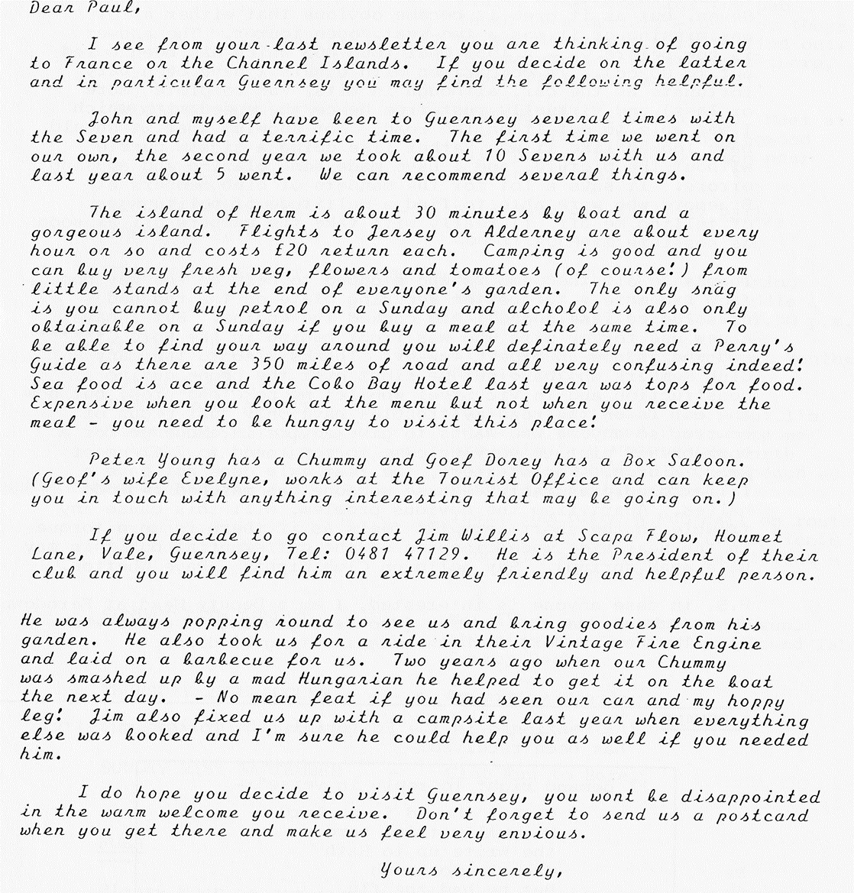
At the June Club Night, Paul suggested that perhaps we could arrange an evening meeting for interested parties to discuss the trip, and a venue and date will be advised either later in this Newsletter or the August edition, meanwhile please let Paul know if you might be interested, his telephone number being (0202) 769335.

DAVE AND HIS MOTOR
I would like to introduce myself, as a new member, through the pages of our magazine and, as you will all be more interested in the car than me, I'll start with that.
It came in bits, in boxes, and was advertised as an Austin Seven, but as it grew it became obvious that either a lot was missing or it was a two-seat, open tourer. The answer is now before us - a 1938 Opal (Duo 803 which has been bored out to 803cc). In comparison with others I have been very fortunate as the car, although in bits, was complete (more or less) and virtually rust-free hence the speed with which I was able to get it on the road. Not knowing what it should have looked like it was rather like doing a jigsaw puzzle without the picture, and I have made some glaring and amusing errors. It says a lot for the manners of club members at Braemore who were able to find a multitude of polite ways of telling me off. (I really will take the bumpers off as soon as possible Glyn).
Thanks to all the members who stopped to help on the way home from Braemore - the bottom securing plate on the rad had un-soldered itself and I had cooked the engine. But I have a new use for my wife who was right behind in the Ford C****** and who is now an expert tow-er. Thanks also to the many club members who have put me right over the phone during construction and to Vic Steel who let me poke and prod, but now the car is on the road my troubles have only just begun of course, so anyone who wants to give advice in exchange for a home-brewed pint is very welcome to pop round to 7 Glenmoor Road, Winton. For starters, the rear axle does not have a filler plug, presumably because someone has matched two odd halves. Apart from the obvious problem, will this cause any trouble in the short-term (It feels as if there is more torque in the near-side wheel in spite of the differential, but this may be a weak spring). Say hello on Club Nights - Dave Whetton.
P.S, In case anyone is interested, I am a Deputy Head at Ferndown Upper School, married to Sue (who is beginning to guess what I've let her in for) with two unsuspecting kiddies.
I DEMAND
As mentioned in the Editorial, the following letter has been received:-
"I demand right to reply in verse":-
Whilst the Ed is no Bard
He really tries hard -
the write up to Bath
Clearly no laugh
But he had the flu
and I had flu too
so whilst I'll relate
It was a bit late
It was certainly not forgot.

Touché
Lawrence
Editor's Comment:
And after all the nice things I said in the Editorial - still I concede - but when will we get the verse!

EVENTS
SUNDAY 13TH JULY Strawberry & Cream Run. Meet in Ringwood Cattle Market Car Park at 10.45 a: m. for an 11.00 start. The venue for the pub . lunch is a Mystery - but• for. those of you who can't wait to find-out or who want to go straight there, phone .Phil (Ringwood 5558).
THURSDAY 17TH JULY Club Night - Evening Run. Meet at the Elm Tree, Hightown Ringwood 8.00 p.m. Run to Downton near Fordingbridge.
SUNDAY 20TH JULY Spye Park - Bristol A7 Rally.
THURSDAY 24TH JULY Committee Meeting.
FRIDAY 1ST AUGUST Another of the 'Extra' evening runs, meet at the Cat & Fiddle at Hinton.(on the A35) at 7.30 p.m.
THURSDAY 21ST AUGUST Club Night - details in Next Month’s Newsletter.
MONDAY 25TH AUGUST This is the 'Beach Run', but I'm reliably. informed that where we are going - WINDSPIT (Nr Worth Matravers) doesn't have a beach as such - just flat rocks! There should be a Pub call on route, but you may care to bring a Picnic lunch just in case we can't find a pub to accommodate us! Meet Wimborne Square 10..30 a.m. for 10.45 a.m.)
SUNDAY 24TH AUGUST For those not on the beach run, there is the Christchurch Round Table Donkey Derby.
THURSDAY 28TH AUGUST Committee Meeting.
THURSDAY 18TH SEPTEMBER - Club Night
SUNDAY 21ST SEPTEMBER Club Run to Bere.
PUBS
Please keep an eye open for Pubs that serve meals and have sufficient room to accommodate 'our lot', preferably off the Grockle routes for our occasional Sunday lunch stops and evening runs.

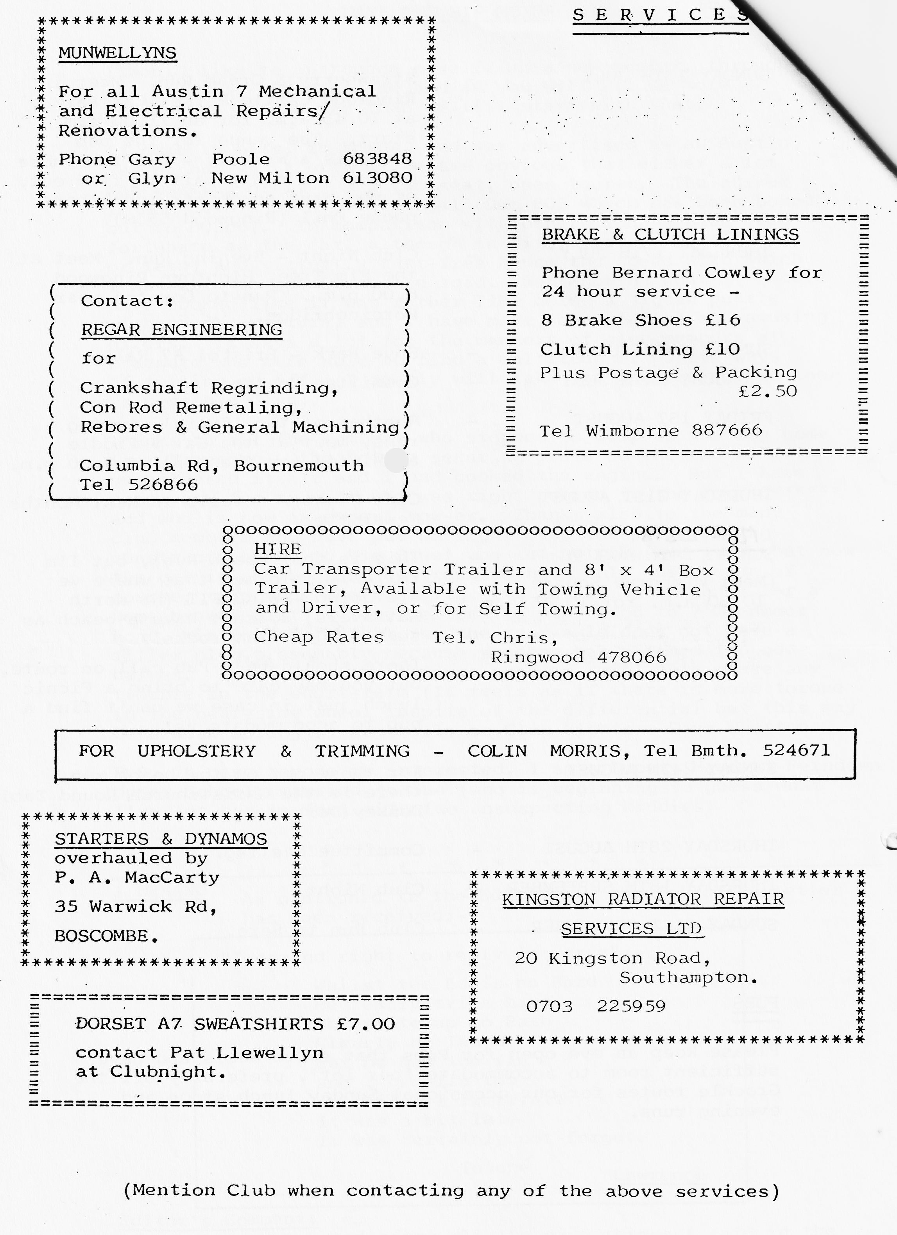

WOOKEY-HOLE RUN.
When you think it was the second fairly long run in the same general direction within about a month (We had a massive turnout for the Bath run in the middle of May) the turnout for this run was not at all bad.
Pat, Glynn & Trevor, whom it was very good to see, came in the ruby Ruby (something to do with locked-out sisters, hence no Special), Gary, Gordon & Lena, John, Cynthia & the boys, Mary & David in their very nice tourer plus yours truly mit Frau, made up the party.
Again, a delightful run Northwestwards to Bruton, where Richard and Margaret were waiting for us together with Cyril Taylor, Richard's Dad. From there, we made our way through Wells and over the top (some of us with difficulty. Why people in Red Boxes have to stop dead just to get into 1st. gear, which then promptly jumps out again, hence another stop, I shall never know. Neither John, who happened to be just behind, I fear!) Be that as it may, we finally arrived, safe and sound at the Queen Victoria Inn at Priddy, where we did refresh ourselves. Although not a Whitbread house, the beer was more than acceptable likewise the food. But, Oh, my Goodness, mightily slow in coming.
After lunch the party broke up. Some of us going into the Hole, others for a walk. Since I was last there the whole complex has been taken over by the Madame Tussaud Organization, who have obviously spent a great deal of money and are now wasting no time in getting a handsome return on their investment. Although, to be fair the entrance fee includes a visit to the old paper mill and sundry exhibitions, which were worthwhile. The parking facilities are excellent as was the commentary in the caves.
We started for home about 4.45 and because the traffic was by now heavy, the party unfortunately got broken up at a fearsome junction. We decided, together with Gary, to go home taking the Blandford route, whilst the others turned back to look for Gordon & Lena. I trust all was well in the end. Another successful run with very grateful thanks to all, who made it so.
PAUL.
ti

