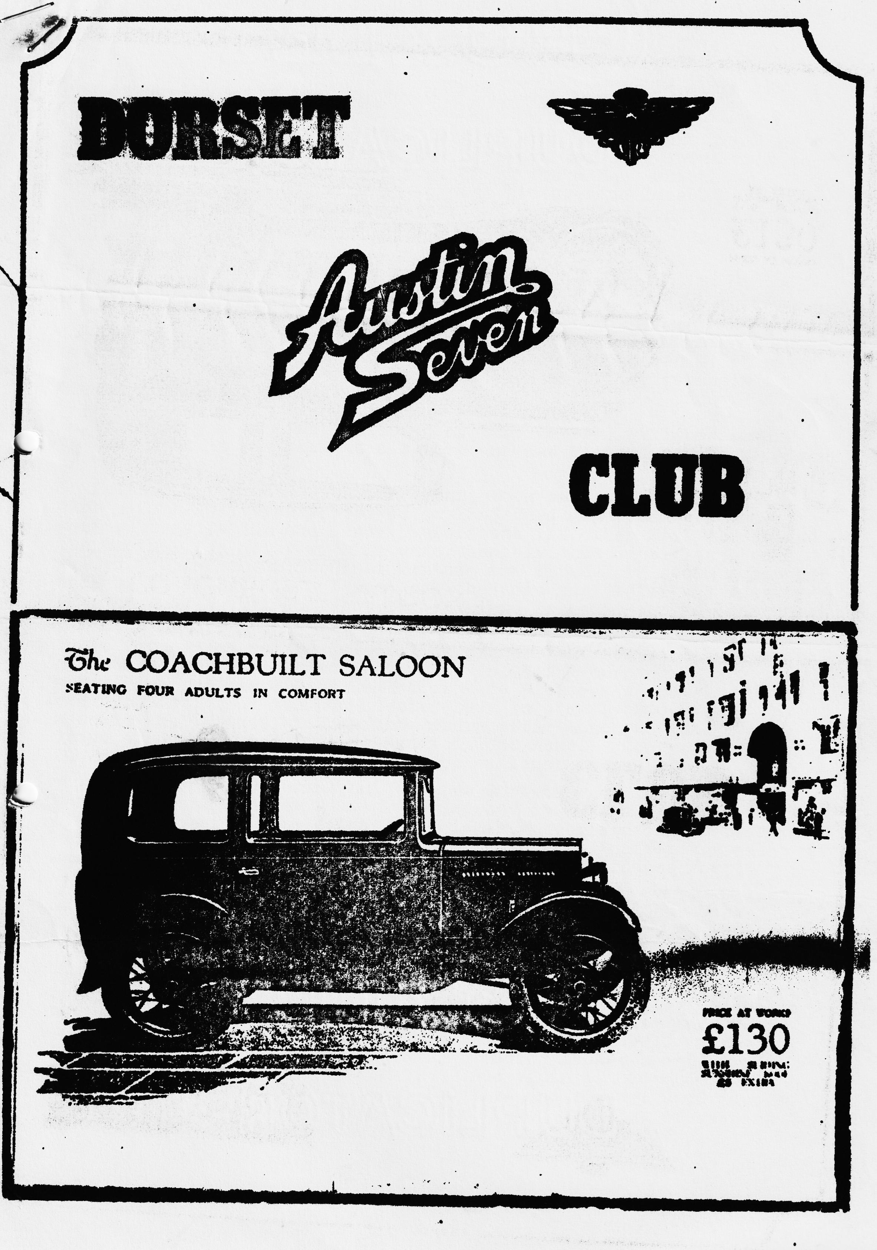

DORSET AUSTIN 7 CLUB NEWSLETTER JULY 1985
CLUB NIGHT THURSDAY 18th JULY
We are having a run out to 'The Langton Arms' at Tarrant Monkton, nr. Blandford. We will leave the Safeways car park (next door to the Dormers) in Wimborne at 8 p.m. SHARP for a run, which our treasurer Lawrence tells me is through picturesque lanes. If you are late ;you will have to make your own way to the Langton Arms.
EDITORIAL Hi Gang,
Have you all lost your pens? or even pencils I haven’t had an article or letter for two months! Come on you horrible lot make an effort, I think the most prolific letter writer is Rosie Cressey and she's only 4!
Those of you who have followed my Ruby lately, will be pleased to hear that it has now had a rebore and new pistons, so hopefully no more smoke.
Pat and I together with Gary Munn, took part in the Bristol A7 Club's 20th Anniversary weekend on 22nd/23rd June and were made most welcome by Ian and Jenny Dunford and the other Bristol members, the weather was not very kind' unfortunately but we all enjoyed a guided tour of the S.S. Great Britain the first Iron steam passenger ship built by Brunel. I last saw the ship just after she was brought back to Bristol from the Falkland Islands and was most impressed at the progress of the restoration.
We did not go to the Celebration dinner but went to the dance afterwards which was good fun. The following morning we all went for a run via Blaise Hamlet, a very picturesque hamlet which made you feel that you had stepped back in time by 300 years, and then to the Compass at Tomarton, where after lunch we took our leave of our Bristol friends and made for home. Congratulations BA7C on 20 years may you prosper for at least another 20.
On Wednesday 26th June quite a few Dorsets went to the Little Gore Farm rally in New Milton (I must say it made a change not to have to drive miles to a 'do') This is a terrific little rally held in a farm yard and has a super atmosphere. After the rally John Page dragged us down to the Centurion public house for drinkies.
Then of course there was the Solent A7 clubs Paultons Park rally, there seemed to be as many Dorset members there as there were Solent members. The day was warm and sunny, without a cloud in the sky, well that is apart from a thick black smog rising from a corner of the field where certain giggly persons were burning chickens and things on a Bar-b-que and consuming alcoholic beverages in large quantities, I did hear it said that this was the Whitter encampment. Certainly, I did make out Phil in the haze dashing about spatula in hand, prodding sausages and turning chicken legs, not a pretty sight. Once again, we did quite well in the Concourse taking at least four 1st and several 2nd places, once again an enjoyable day out. Now if you are sick of reading my waffle you know what you can do, don't you? GET WRITING.
Glyn.
EVENTS CALENDAR
THURSDAY 18th July Club night run to the Langton Arms (see top of Page 1)
SATURDAY 20th JULY EVENING RUN to Studland bring your swimming gear if it’s fine. Refreshments after at the Banks Arms. Meet at Viewpoint at the top of Constitution Hill, upper Parkstone at 7 p.m.
SATURDAY 27th JULY Bashley flower and country show, we have once again been asked if we could show some cars at this pleasant little country show. Please make an effort to support this as it is advertised that the Do: set Austin 7 club will be there. The show starts at 2 p.m.
SATURDAY 27th JULY DORSET ANNUAL EVENING BAR B QUE. Hurry. hurry, this is your last chance to book up. We have decided on a change of venue again this year, and our bar b que is to be held at the Forestry Commission site near Hatchets Pond, on the Lymington to Beaulieu Road about 2/3rds towards Beaulieu on the left. Food will be supplied cooked to the highest of standards and musical entertainment will be laid on as well, Please fill in reservation form at the end of this newsletter. P.S. Bring your own booze.
SUNDAY 4th AUGUST BEACH RUN Leave Wimborne Square at 10.30 a.m. for a run to Durdle Dor for a picnic lunch (you bring your own) and a swim. There will be no pub stop, so bring your own refreshment.
SATURDAY 10th SUNDAY 11th AUGUST SPYE PARK RALLY
For those of you who will be camping at Spye Parke I have it confirmed that we shall be able to camp on the Friday evening. On Saturday John and Janet Stone are organising a run with a pub lunch stop, we shall end up at the Stones establishment for a cup of tea. The Bristol A7 club's annual Rally is on the Sunday.
THURSDAY 15th AUGUST Club night - a run out details next month.
SUNDAY 18th AUGUST Club run details next month.
SUNDAY 18th AUGUST Midland Austin Seven Club's Longbridge Rally (camping Saturday night if required)
SUNDAY 25th AUGUST 750 Motor Club's Hawkhurst Rally, Kent
MONDAY 26th AUGUST A7 Owners club, Littlewick Show
SUNDAY 1st SEPTEMBER Midland A7 club's Stanford Hall Rally (camping Saturday night if required)
SATURDAY 7th SUNDAY 8th SEPTEMBER BEAULIEU AUTO JUMBLE
SUNDAY 15th SEPTEMBER Christchurch Model Railway club an exhibition of Model Railways, Vintage Cars, Motorcycles, Stationary Engines etc. 10.30 a.m. 4.30 p.m. Mill Road, Christchurch.

AN ARTICLE TAKEN: FROM ONE OF THE MOTORING MAGAZINES IN 1982
The Austin 7, ancestor of the Mini Metro, shares its 60th anniversary with GH. Sue Baker examines the contrasts between driving a 7 then and now.
Cocooned in the draughtproof comfort of our modern cars, motorists today take so many things for granted. We expect the engine to fire easily at the turn of a key in the ignition. We simply switch on the heater on chilly mornings, glance at a petrol gauge to see when the fuel is running low, and drive on a motorway at 70 miles an hour without a second thought about the miracle of modern mobility. How different it all was when the Mini Metro's famous ancestor, the Austin 7, was a new car. In those distant days of motoring, starting meant swinging on a handle, Winter warmth was often crudely provided by a hot-water bottle on the lap. Knowing the contents of the petrol tank meant dipping a stick into it and driving flat-out at 50 miles an hour was a thrilling adventure. Motorways had yet to be invented, and map-reading was a vital skill for picking route avoiding steep hills which could cripple an early popular car. This year marks the 60th anniversary of the Austin 7, launched on the market in the summer of 1922 at £225. Today we are anesthetized to frequent car price rises. Back in the birth car of the Austin 7, the opposite happened. By five months after its launch, the price of the Austin 7 went down to £165. Those were seemingly halcyon days of what sounded by today's standards like extraordinarily cheap motoring.
A gallon of petrol cost two shillings, or 10p. A pint of Castrol oil was 1s 2d or 6p., membership of the AA was then two guineas, or £2.10. But the average weekly wage of a skilled worker was only £5, although the proportion of it that he kept after the taxman's share was more generous then today. Income tax in 1922 was only 22p in the £. In fact, when you consider what would buy back in the 1920s compared with today, the price cf the original Austin 7 works out roughly on a par with a modern Metro now.
Nostalgia apart, we are in many ways far better off in our current aerodynamic boxes than the 1920s motorists were in their brick shaped Austins. Then, rustic suspensions and cross-ply tyres gave a spine jarring ride on rough road surfaces of which there were many in the 1920s, long before today's smooth motorways were invented. Sophisticated modern car suspensions cushion the judders and jolts. Radial tyres now give a better grip and handling characteristics than the 1920s motorist dreamed of, and it is possible to turn a corner at speed without running the risk of the car overturning into a ditch, Early vacuum windscreen wipers ground to a halt going up hill. Today we take efficient wipers, bright piercing head lights and draught-proof cars for granted.
Oil and petrol may have sounded far cheaper in the early days of motoring, but were they? Not really - especially when you consider how much more often an early car needed servicing: oil changes every 1000 miles were commonplace. Now cars like the Metro need servicing only once a year. Today's cars are faster, more efficient, much quieter and far more reliable. What they lack, compared with their ancestors, is character and the flavour and distinct personality that sheer unreliability gave to cars like the 1922 Austin. The Austin 7 was Herbert Austin's most famous model. He designed it himself and took a fatherly interest in the development of the car through a range of models. It was destined to become a motoring legend, one of the greatest and best-loved British cars of all time. In its original version it was shaped like a brick on bicycle wheels, earning it the popular nickname of the "matchbox on buttons".
Later variants including the Austin Ruby were only marginally more aerodynamic. In its day, a comparatively cheap car, the Austin 7 is now highly sought-after by collectors prepared to pay thousands of pounds for a model in mint condition. Enthusiasts still keep hundreds of Austin 7s in road going condition today. The 750 Motor Club, formed more than 40 years ago to promote the preservation and use of the Austin 7, has 800 owner members, mostly in Britain but including some in Australia, America, Norway and Japan. In 1980, 48 of the club's members drove their Austin 7s on a group rally to Monte Carlo. Last year 17 cars went to Germany. This year, to mark the 60th anniversary, the club is arranging a run from John o' Groats to Land's End.
Thus the magic of the Austin 7 is being kept alive today by enthusiast owners, many of them born long after the car went out of production. Its eventual successor, confusingly also called the Austin 7 when first launched, was the Mini. But the original model endures today not only in lovingly restored and preserved examples of the car, but in the warm memories so many motorists have of it from their own early days on the road.
FOR SALE
RUBY PETROL TANK BELIEVED SOUND £10
WANTED URGENTLY! HAS ANYBODY GOT A 15-20ft LADDER THEY WANT TO SELL. THE CREEPER’S TAKING OVER MY HOME. GARY MUNN POOLE 683848 around 6 p.m.
SERVICES
MUNWELLYN'S FOR ALL AUSTIN 7 MECHANICAL AND ELECTRICAL REPAIRS AND RESTORATIONS, PHONE GARY ON POOLE 683848 OR GLYN ON NEW MILTON 613080
BRAKE AND CLUTCH LININGS . PHONE BERNARD COWLEY. WIMBORNE 887666 FOR 24 HOUR SERVICE. 8 SHOES £16 CLUTCH LININGS £10
REGARS ENGINEERING, COLUMBIA ROAD. BOURNEMOUTH FOR CRANKSHAFT REGRINDING AND-CON ROD REMETALING. BLOCKS REBORED AND GENERAL MACHINING.
SHOT BLAST AND STOVE ENAMELLING: SPRAY FINISHERS, NUFFIELD INDUSTRIAL ESTATE, POOLE £35 for 5 A7 WHEELS (CASH) MENTION THE CLUB
UPHOLSTERY AND. TRIMMING COLIN MORRIS, BOURNEMOUTH 524671
RADIATORS REPAIRED OR YOUR RADIATOR RE-CORED HANTS AND DORSET RADIATORS 77, STANLEY ROAD, BOURNEMOUTH 301277
RESPRAYS: GEORGE MOONEY. BOURNEMOUTH 425989
STARTERS & DYNAMOS OVERHAULED P.A. MACCARTY 35, WARWICK ROAD, BOSCOMBE MENTION-BERNARD COWLEY OR CLUB.
