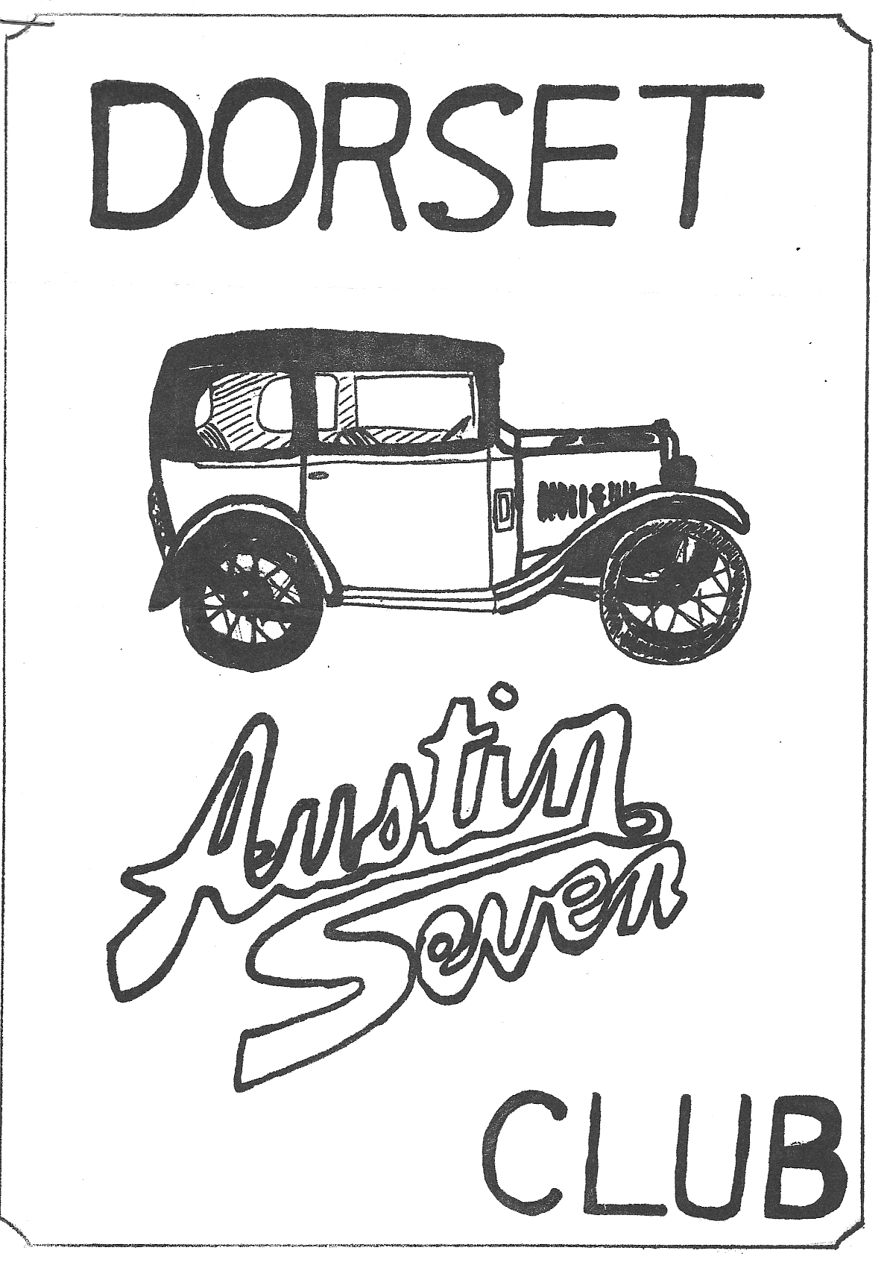DORSET AUSTIN 7 CLUB NEWSLETTER JULY 1981

Next Club Night Thursday 16th July
Meet at the "Clay Pipe" Sandford for a Noggin and Natter with our more western members (guns to be handed in at the door please).
Directions to the "Clay Pipe" as follows. Turn right off the A351 Wareham Road at Holton Heath Garage, S.P. Organford, the 'Clay Pipe' is on the left.

Next Committee Meeting
Thursday 23rd July at 8.30 p.m. Tyrells Ford, Avon.

EDITORIAL
Hi Gang,
Your newsletter may not have a cover this month, due to the mess and confusion caused by building an extension, I have lost the stencil. I expect the typist has tidied it away somewhere!
We have had a very busy month on the rally scene, with a run to the Berkley Castle Rally, and the evening rally at Little Gore Farm. This was followed by the Solent A7 Club's barbeque and, of course, the 'Beaulieu' A7 Rally. Articles on these events in this newsletter.
Last weekend found us in the wilds of Wiltshire for the Dorset/ Solent A7 club's camping weekend, organised by Phil and Hilary Whitter. An article has been promised for next month.
Finally, did you see the article in the June edition of Practical Motorist on restoring a Big Seven? It was written by 'Dorset' member Kim Henson, who works for that magazine.
See you at the 'Clay Pipe'.
Glyn

CONGRATULATIONS
To junior member Rosie Cressey, who cut her first tooth during the Crofton camping weekend.

NEW MEMBERS
A warm welcome to Keith Mitchell, 14, Three Acre Drive, Barton-on-Sea, Hants who is restoring a Pearl Cabriolet. Keith also restores vintage bicycles and has a fine collection including a penny farthing.

TWO NEW EVENTS . .
There is a car rally at Longleat on the 26th July called 'Wheels at ' Longleat Entry forms from Bernard Cowley or phone him on Wimborne 887666
The second event concerns the Royal Wedding celebrations in Wimborne. We have been invited by Wimborne Town Council to join the parade and festivities starting at 5.30 p.m. on the 29th July.
The starting point will be Leigh Park. Please try to attend this event which promises to be fun for all the family.

Events Reminder
Thursday 16th July - Club night noggin and natter at the 'Clay Pipe' Sandford.
Sunday 26th July - Run to 'Wheels at Longleat' leave Wimborne Square 10.30 a.m. Entry forms from Bernard Cowley, Wimborne 887666 or see him club night.
Wednesday 29th July - The Wedding Day. A parade through Wimborne starting at Leigh Park at 5.30 p.m. to Wimborne Square.
Saturday & Sunday 1st & 2nd August - Scottish A7 clubs Doune Rally a couple of us have decided to take a week’s holiday to include a visit to this rally. We will be leaving on Thursday evening 30th July and returning Sunday 9th August. We also hope to go to the Isle of Skye. Anyone interested in accompanying us telephone me on New Milton 613080 or Gary Munn on Ringwood 78795
August 1st & 2nd - Alderholt Steam Rally.
Sunday August 9th - Dorset A7 Club run to H.M.S. Victory. Meet at Ringwood Cattle Market Car Park for 10.30 a.m. start

THE AUSTIN SEVEN CLUB'S ASSOCIATION INSURANCE SCHEME
The following letter concerning the scheme was received by our secretary Bernard Cowley: -
The Austin Seven Clubs Association
21.5.81.
Dear Club Secretary,
Due to an unprecedented and totally unacceptable rise in premiums announced arbitrarily by Everest Insurance Services, the A.7.C.A. has. re-negotiated the insurance scheme with Richardson, Hick and Partners and, as from May 21st, the A.7.C.A. will be recommending that club members wishing to take advantage of the insurance scheme, should in future deal with :- Direct Insurance Services Ltd., 325/331 High Road, Ilford, Essex 1G1 1UJ Tel. 01-514-3222 (ask for Mr. Bird).
Further details of what has happened at Everest will appear in 1981C, and will of course be discussed at the A.7.C.A. meeting on July 12th.
In the meantime, would you please advise your members of the above information as soon as possible, via your newsletter or by any other means open to you.
People who have renewed with Everest since April 1st will find that premiums have soared, but whether they will now be able to get any, or all, of their money back is not at the moment clear. Of course, anyone having paid the higher sum, and having been accepted by Everest will most certainly be totally covered as per the scheme for the following 12 months and may like to just leave it at that until they can join the Direct Insurance's scheme when next they have to renew.
The Direct Insurance Services scheme will be the same as that previously held with Everest as far as cover goes but there will now be a sliding scale of premiums as follows.
Annual Premium
A.7.s value up to £3,500 £20.00
£3,500 to £5,000 £25.00
£5,000 to £6,000 £30.00
over £6,000 £30.00 + £1.00 per cent increase
(i.e. £6,060 -£31; £6,120 -£32.00 etc. etc.)
Please accept my apologies for the formal and duplicated form of this letter, but time is of the essence.
Should you wish to have any of this clarified I can be contacted on Bristol 37573 between 10 a.m. and 3 p.m. on weekdays, and Winterbourne 778021 at most other times.
Yours sincerely,
Ian Dunford

Bristol A.7.C. Berkley Castle Rally
7 p.m. on Friday evening saw five Austin 7s belonging to myself, Debbie, John Page, Glyn Llewellyn and Lawrence Rideal, ready for the three-hour trek to Berkley. After a short chat, we set off in convoy, stopping only briefly and occasionally to answer calls of nature etc. The trip was trouble free and enjoyable, and we reached the site just after 10 p.m. to set up camp in double quick time and race down the road for a couple of much needed pints before closing time. Suitably refreshed we settled down for a good night’s rest, but for some reason none of us got to sleep much before 3 a.m.
Up at 8 a.m. Glyn and I carried out a decoke and changed a burnt-out valve on his car before some people were even up.
By the time everyone was ready it was approaching midday, so we decided to drive straight to a local hostelry for lunch and a drink. Getting lost on the way, we asked one of the locals for directions, which he gave and solemnly advised us not to turn right when we had finished at the pub because there was a 1 in 4 hill which even Mini's couldn’t get up! Well after a couple of drinks and a good meal we had all decided that a challenge like that could not be passed by by an ever optimistic A7 driver. Well it was steep and to make matters worse there was a hairpin bend half way up! John Page's Box ground to a halt in front, so we all leapt out as he turned round and with a helpful push, reversed the rest of the way up much to the astonishment of the passersby! Glyn's Ruby and my chummy of course got to the top in forward gear and unaided, but Lawrence's Box had to climb in a manner similar to John’s. A suggestion that we drove all the way down and tried once again met with instant disapproval so we drove on. After a short drive around and an overhaul of Lawrence's car, we returned to camp, armed with fish and chips & cider for tea.
By now numerous other Dorsets had arrived, including Bernard Cowley & Co. Roger & Rosemary Ballard & dog, Phil Whitter &
family & relations, dining table, kitchen sink and all. Brent and Wendy Gillard and family, John & Janet Stone and family and Richard, Margaret and Rosie Cressey.
At 8.30 p.m. we wandered down to the Barn dance, where the Jazz band was playing. After a few pints, the Caleigh band came on, so the Dorsets leapt to the floor and all but took the place over. For some strange reason the caller had remembered us from Caldicot Castle rally and, to cut a long story short, by the end of the evening the Dorsets had managed to completely destroy anybody’s hopes of doing any of the dances correctly.
At 1 a.m. we staggered back to the tents exhausted after a fantastic time. After a night cap of coffee cheese and biscuits, and having our fortunes told by Gipsy Rose Hilary Whitter, we fell into bed tired out.
Needless to say, on Sunday morning no-one got up very early, but finally all the cars were leathered/polished etc. and parked in their respective spaces. During the day we wandered around the 100 odd cars and autojumble and most of us had a go in the driving tests, which the ladies seemed to do better than us men, most annoying!
At 3 p.m., John Page, Debbie and I decided to have a go in the inter club driving tests for the Dorsets, which consisted of jacking the car up with a plank and changing wheels against the clock. The test went smoothly and so we wandered back to take down the tents, whilst the other teams were competing. At 4.30 p.m. we rushed down to see the prize giving and to our delight the Dorset club won the interclub driving tests. Debbie won 1st Prize for the best car entered and driven regularly by a lady. Prizes were also won by Richard Cressey, Glyn Llewellyn, Bernard Cowley, Brent Dillard and myself. All in all the Dorset Club seemed to walk away with the majority of the prizes.
Weighed down with all our silverware, we wended our way home for a trouble-free journey, apart from losing two of the cars in our convoy. We searched but could not find them but they found their own way home, much to our relief!
A tremendous weekend was had by all and once again we are indebted to the Bristol Club for organising a great rally and, believe it or not, lovely weather - unheard of at Berkley Castle

June in the D.A.7.C.
What a month! 9 events!
Ah well, we didn’t make them all but here are a few notes of the ones we managed to get to.
Saturday 13th June - Run to the Wagon & Horses, Lymington. Glyn rang up to see if we would manage a 6.15 start, no chance, I know it isn’t a working day but I work just as hard at home. It was too early to start, seems it was for Glyn too! We missed the run from the Cat and Fiddle so we trundled along direct to the Coach and Horses.
It was a lovely evening and when we got there, there was no sign of any Sevens! Not a trace for the public to see! They had put them all in the back car park. Shame, a good turn out too. The Coach and Horses is a nice little pub and we had a good window table with 14 or 16 people in the group. Eventually we were joined even by Lawrence, with a friend.
There was a sing along entertainer playing an organ and Glyn and I sang our hearts out but we couldn’t get the rest of them going. As with most entertainers with amplifiers it was too loud so we eventually all left and had last orders at the Quay, Lymington. A friendly fun evening but not a chip shop open! We eventually went on our way as we left the others in the New Forest.
Sunday 14th June - Museum in Action Day, Beaulieu. It was my daughters Sarah’s birthday so I thought we wouldn’t be going but the children voted to go, so we packed the lot, 4 chairs on the carrier, birthday cake etc. (no champagne, just Nescafe) and we had a lovely picnic and a super day out. If you haven’t been on one of these action days, try it next year. Take your Austin and get in at half price, there is a cavalcade, the workshops and cellars are open and lots to see and do, a really good day out.
Wednesday 24th June - Little Gore Farm H.C.V.C. Rally. This is a very pleasant evening event courtesy of the Davis family who have hosted this for a number of years. A good mixture of machinery to be seen from stationary engines through bikes, lawnmowers, farm implements and cars to a 30 ton Foden Lorry. We had 4 cars from the D.A.7.C. and one superb Sunbeam ladies bike bravely ridden in by new member Keith Mitchell. Our Ruby was subject of some criticism for arriving in 15" off-set "go faster" wheels but that is another story. After a little while we popped to the local for a welcome beer and then made our way home.
The month finished up for us at Beaulieu again at the National A7 Rally 28.6.81, always a super event but spoilt this year by a rather cold day. No doubt somebody will be writing about this rally so I won’t.
That is it Folks! the All Action Club, Dorset A7 Club must be one of the most active in the country, I hope you enjoy the events too.
See you in July.
George & Joy Mooney

BEAULIEU 1981
On Saturday evening at 7 p.m. I joined Glyn Llewellyn, Willie McKenzie and Paul to set up camp in Keith Roache's meadow in preparation for the Solent A.7.C. bar-b-que. Soon we were joined by John Page and family who were caravanning in the site next door, we then wandered on into the bar-b-que field as we had heard the bar was open! There we met Phil & Hilary Whitter, and an entertaining and boozy evening was had by all. Hours later we staggered back to the tents sometime around 2 a.m. so I was told.
Next morning the Dorsets were in a sorry state, especially Glyn (it's a lie, I don't remember that, Ed) who couldn't even manage his usual fry up for breakfast, an Alka Seltzer salesman would have done a bomb on site
We set off for Beaulieu about 10.30 a.m. and after a couple of dashes for the nearest hedgerow, Glyn decided he had better go home to bed! Arriving about 11 a.m. I met several other Dorsets most of whom were scouring the Autojumble for bargains. Phil Whitter seemed to spend most of the day buying bits for our new club spares scheme, which certainly looks like being a very useful asset to all members judging by the effort Phil was taking over choosing valuable spares (next club night should see them all on sale. After an attempt at the driving tests and general look round the 300 odd Austins, it was time for the judging. I must say the Dorsets seemed to do well once again. Of those I saw, my sister Debbie Won 1st Prize with the Chummy, Phil Whitter won 1st Prize with his Ruby and Dave Simonds got highly commended with his Box, but I didn’t manage to see anyone else to discover if they were also prize winners, so please forgive me for not mentioning you'. About 5 o'clock we all wended our way home laden down with goodies and prizes.
Gary Munn

FOR SALE
Move of house requires that no reasonable offer be refused for 1936 Ruby (complete except for body), which would form the ideal basis for an RTC type special. - Phil Edwards, 7, Copse Road, Burley, Ringwood. Tel. Burley 2441 & Southampton 23855 Ext.443

WANTED
Cut out for '26 Chummy (Type which has 2 brass covers) Gary Munn, Ringwood 78795.

THANKS
Many thanks to Dave Kenny of Poulner, Ringwood for a further supply of labels for the newsletter envelopes.
CLUB SPARES SCHEME
OUR SPARES SECRETARY, PHIL WHITTER, HAS ON BEHALF OF THE CLUB PURCHASED A BATCH OF THE MOST POPULAR A7 PARTS. OTHERS WILL BE ADDED AS THE SCHEME GETS OFF THE GROUND. SPARES MAY BE PURCHASED ON CLUB NIGHTS OR BY ARRANGEMENT WITH PHIL. A LIST OF THE PRESENT STOCK FOLLOWS.
½ shaft Keys | All felt oil seals
King Pin Sets (Early & Late) | All Gaskets
Lock Washers | Spark Plugs
Manifold Nuts and Studs | Fly wheel Keys & Nuts
Oil Pump springs | Fan belts Early & Late
Exhaust flange nuts & bolts
Distributor points (Ruby Type)
Prop Shaft Universal Joints
Radiator Hoses
Shock absorber rubbers & Washers
Rear spring pins and bushes
Front spring shackle bushes
All studs and stepped studs
Track Rod Kits
Valves
Valve guides
Valve springs
17-inch Rim tapes
Distributor Caps (Late)
Brake Cables
Brake Cams
Brake Cam bushes
Brake drum screws
Clutch mousetrap springs
Clutch Comp. springs
Core Plugs Large and Small
Engine Mounting rubbers

