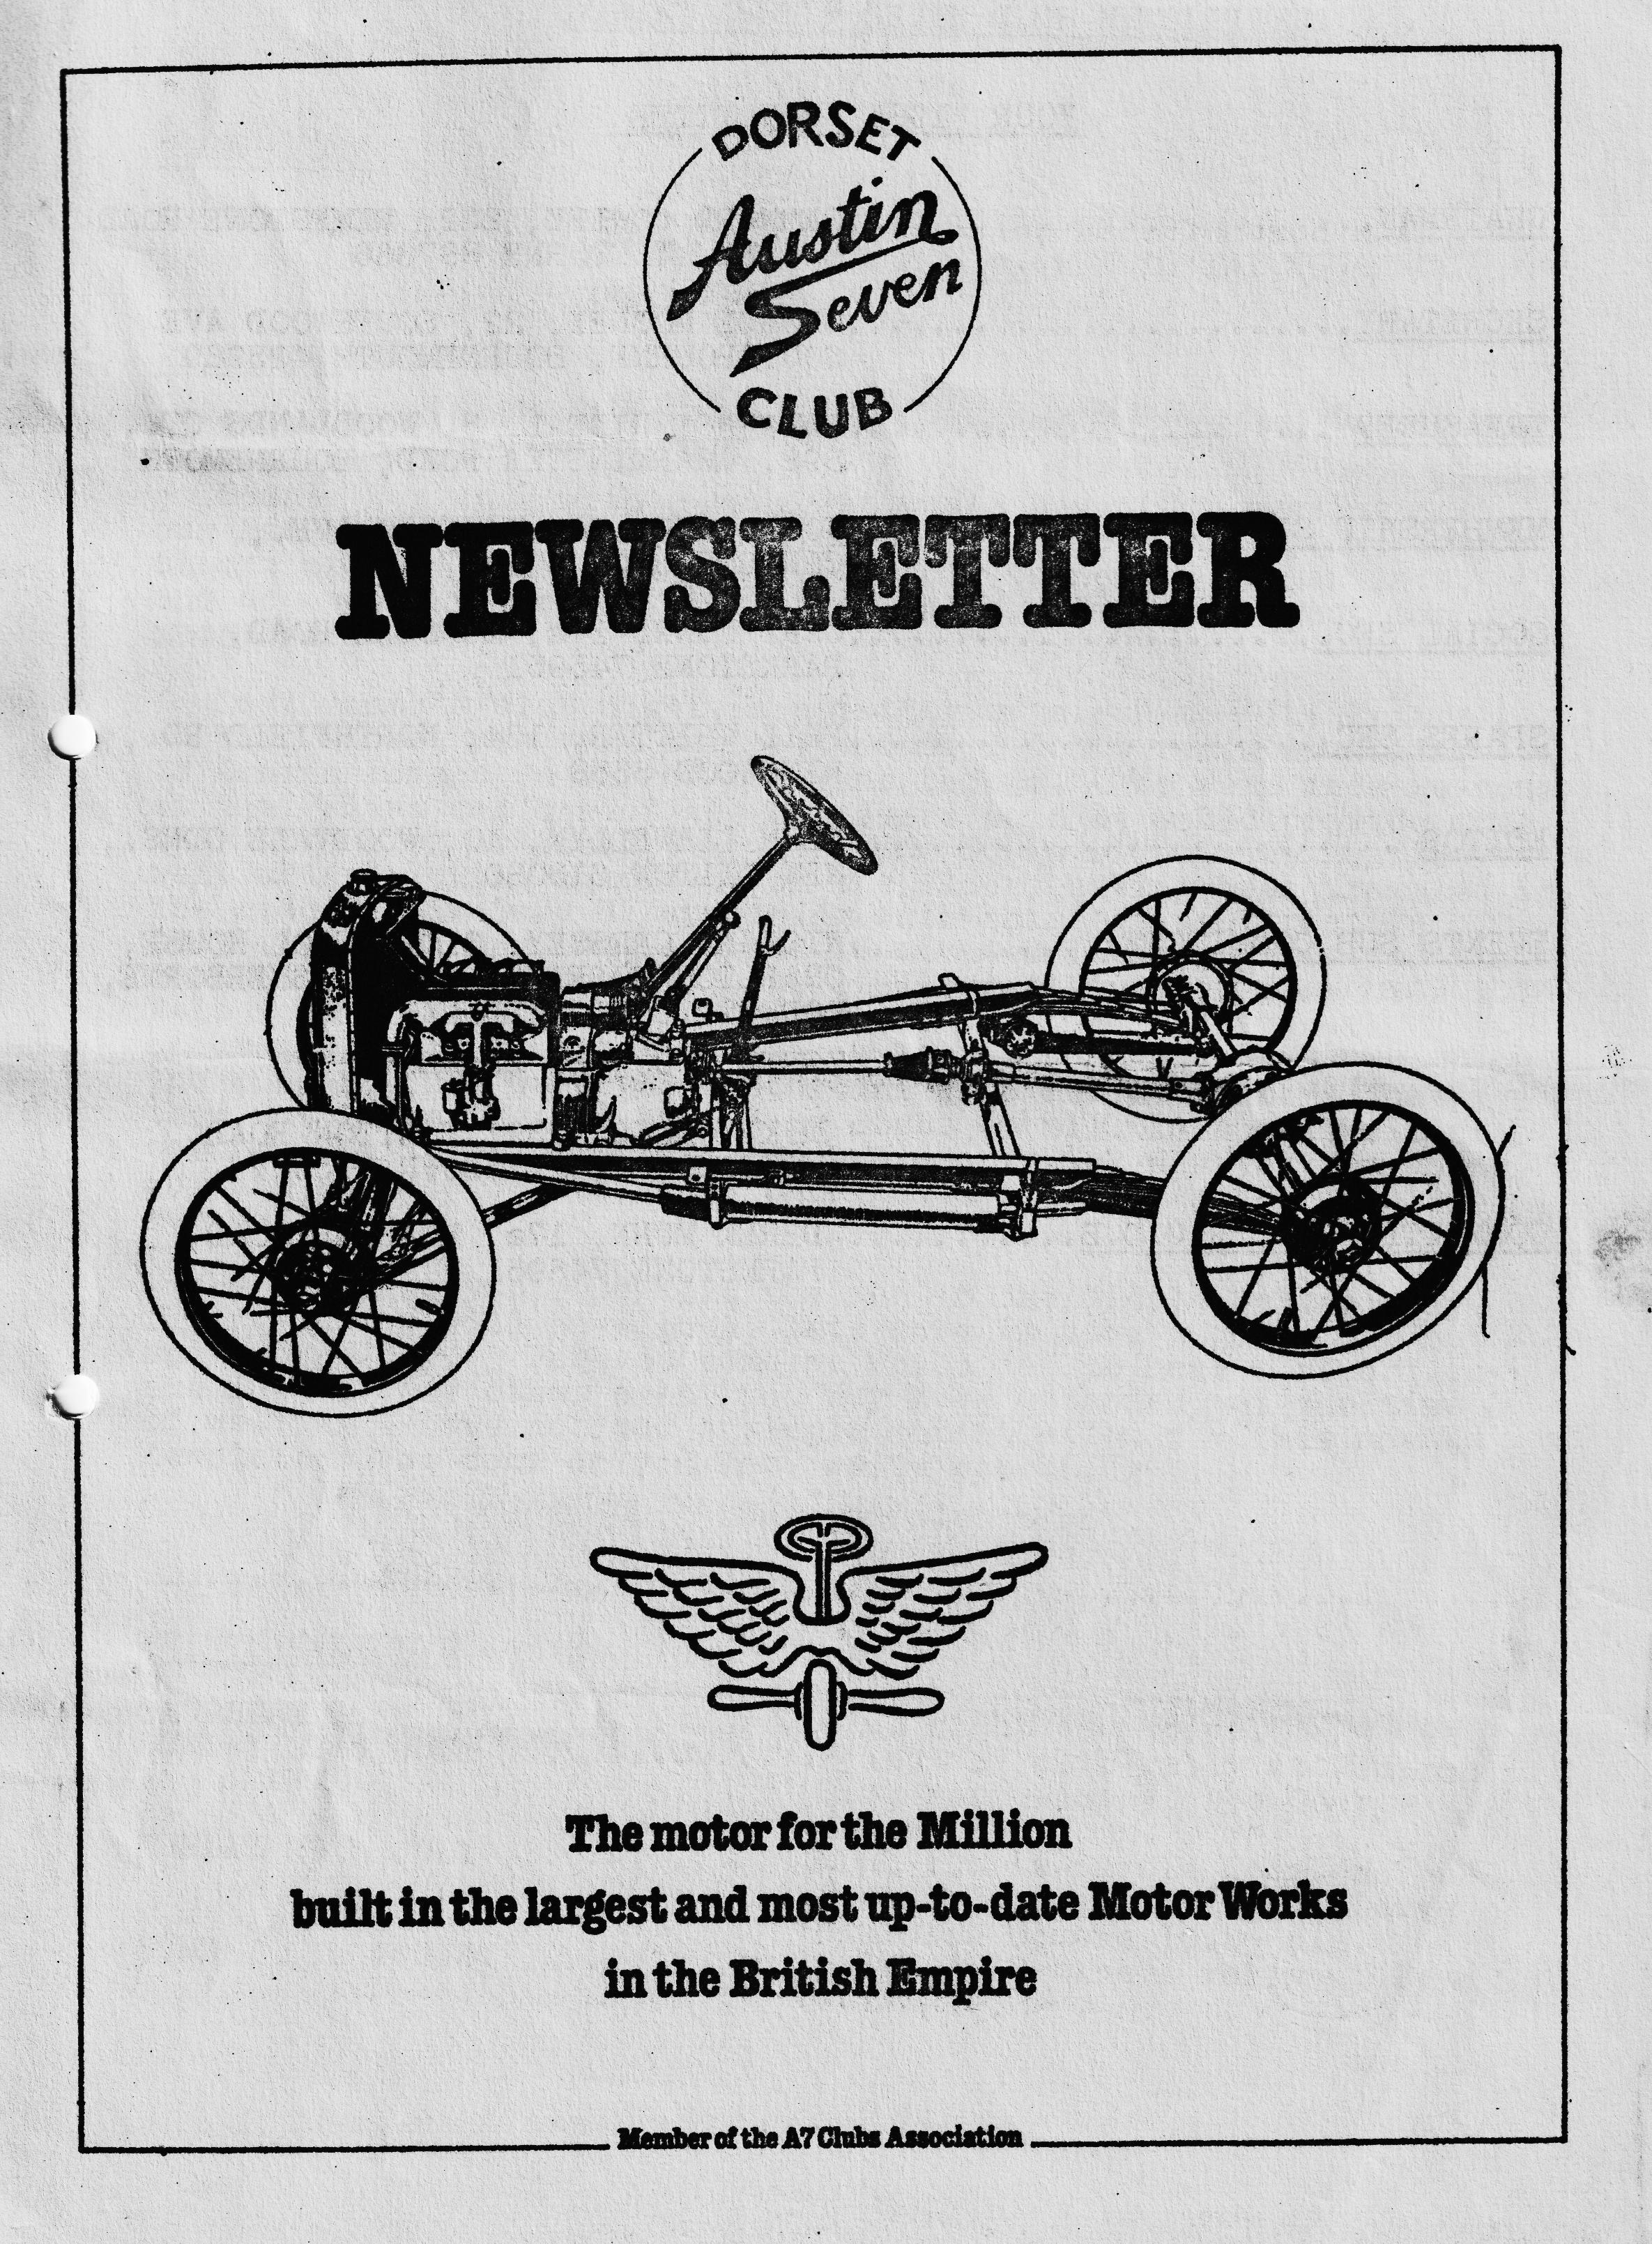

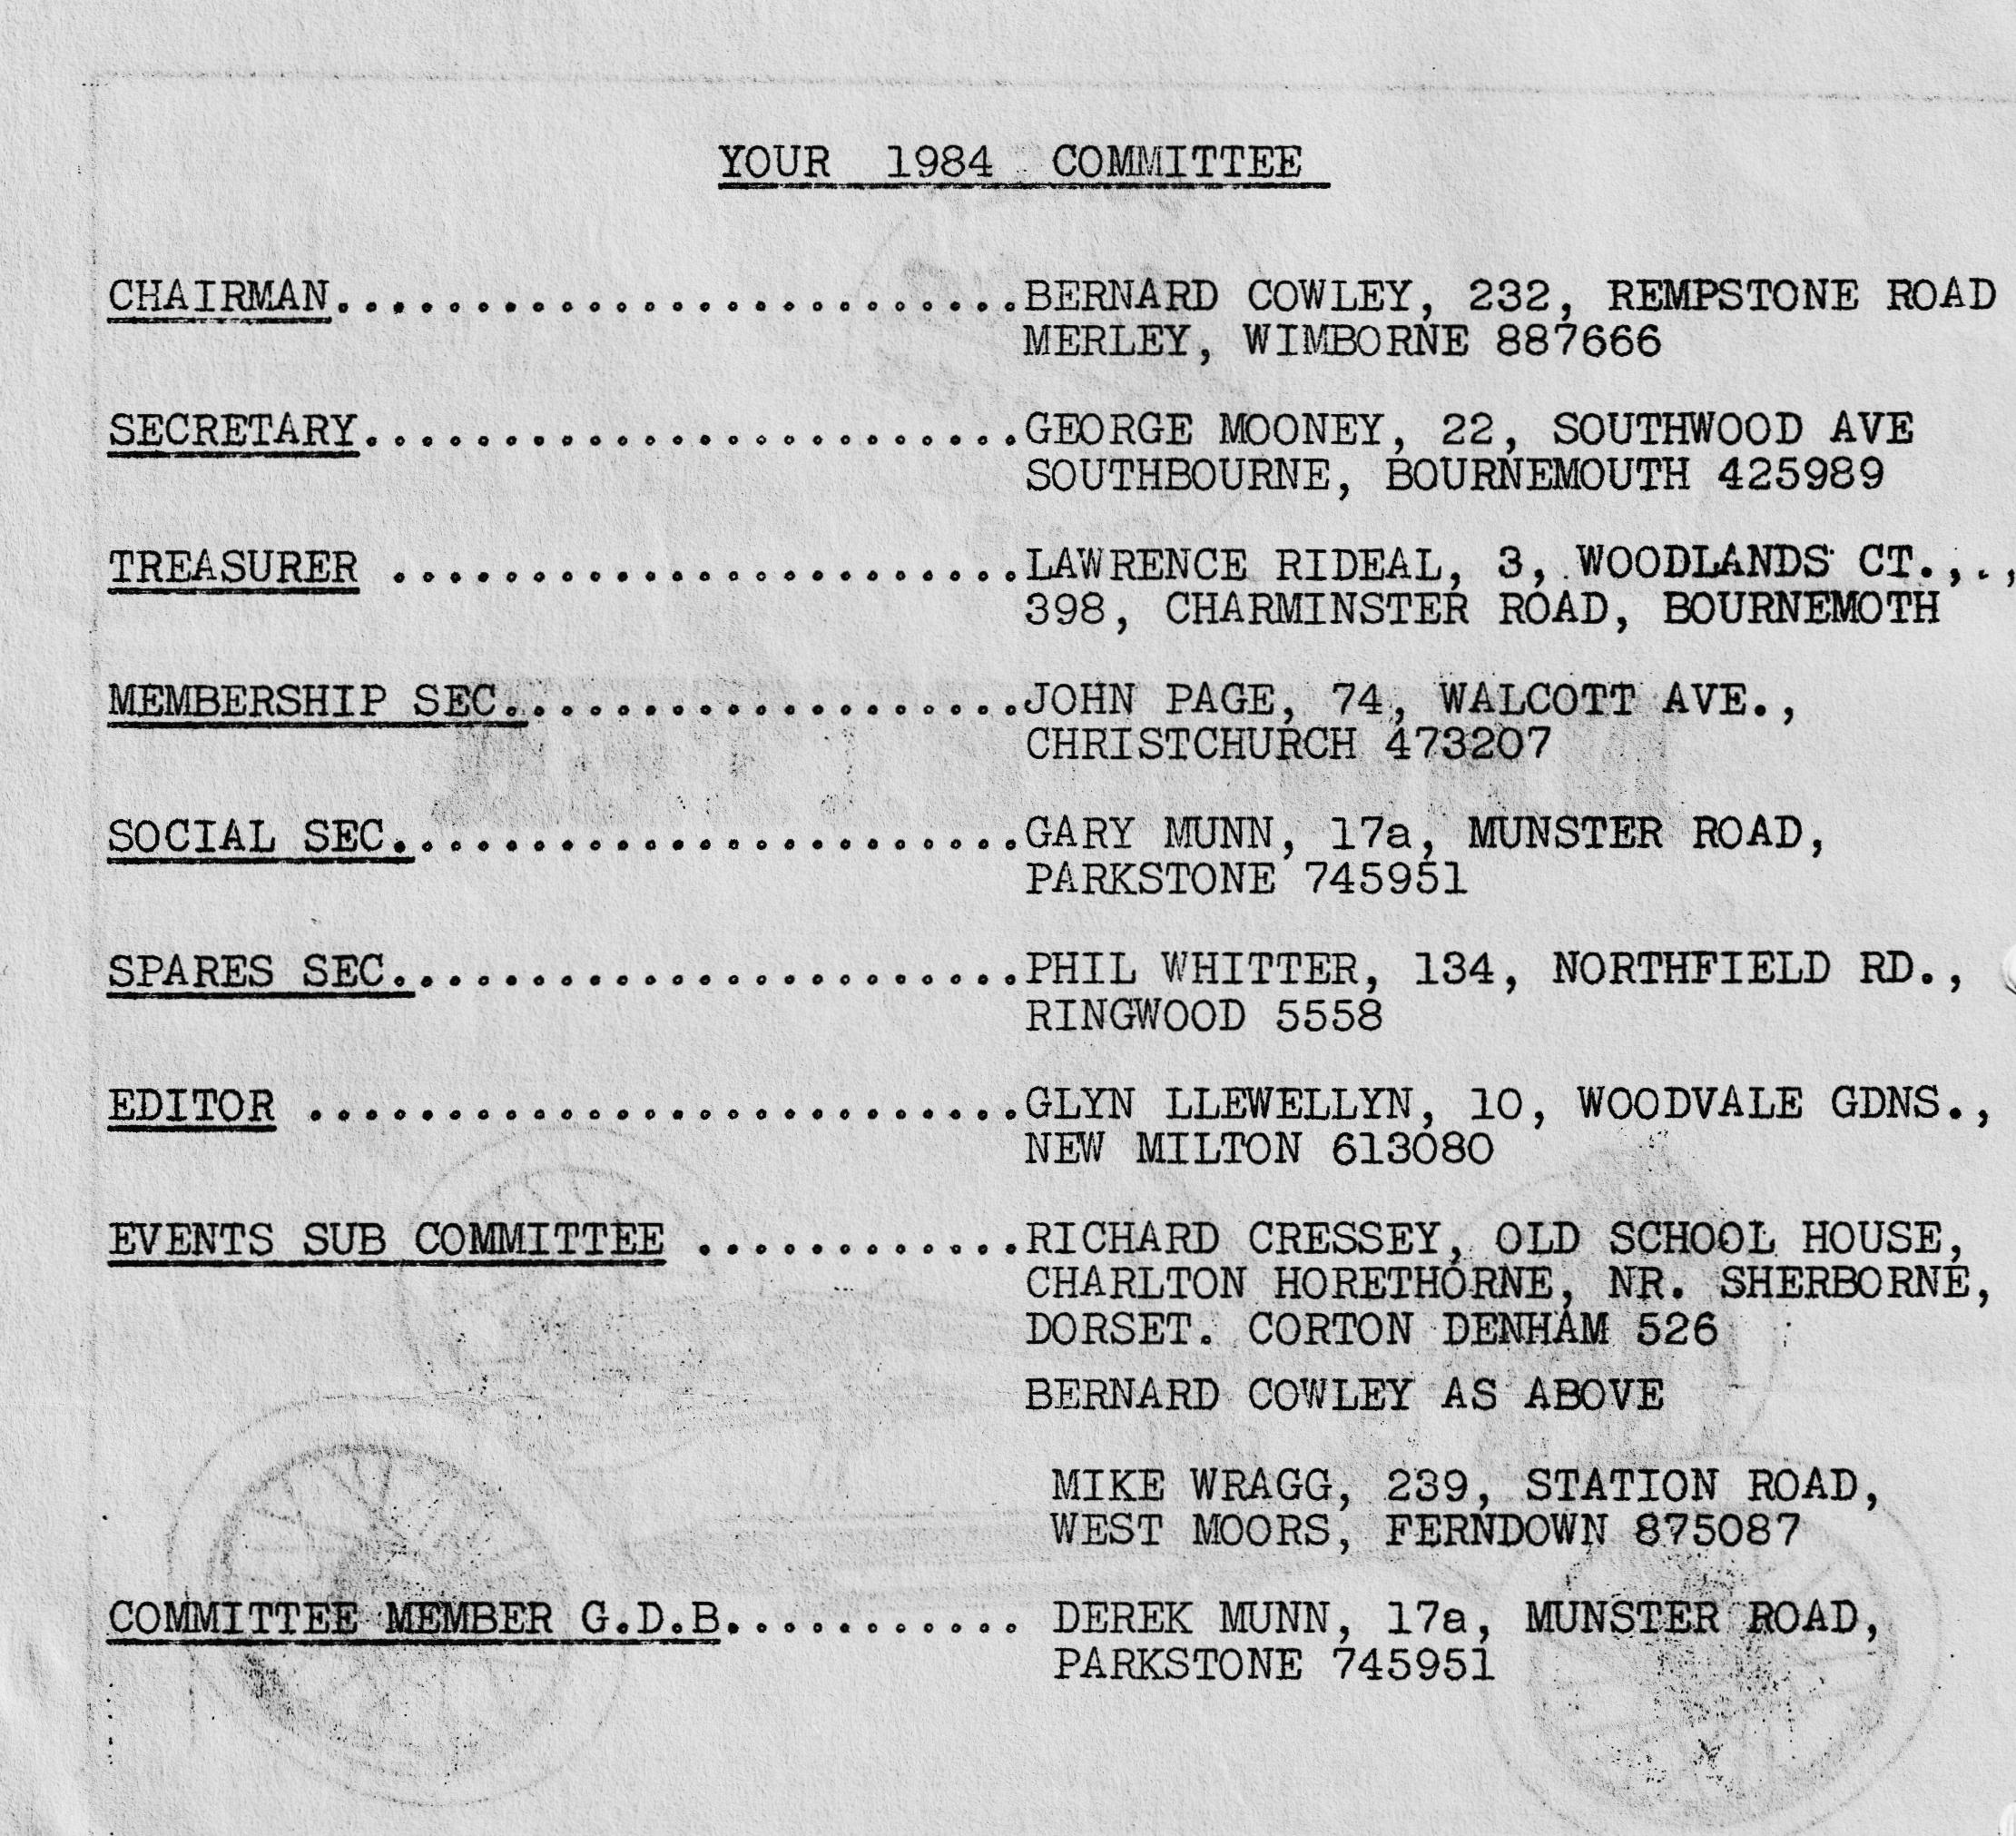

DORSET AUSTIN SEVEN CLUB NEWSLETTER JULY 1984

CLUB NIGHT
THURSDAY 19th JULY MEET AT THE NAGS HEAD, CHRISTCHURCH ROAD, RINGWOOD FOR A 8 p.m. RUN TO THE WOOLPACK INN, SOPLEY.
EDITORIAL
Hi Gang,
Summer has come with a bang, it was a beautiful evening for our Bar-b-que last Saturday which was a great success, the only slight problem being that a lot of folk turned up rather late, and as we had to be packed up by 10-45 p.m. there was not too much time.
Last month’s club night, consisting of a run to The Friars at West Moors, was very well attended, I don’t remember seeing 15 Austin sevens on any of our runs before. We were made welcome at the Friars and one of the customers said he would provide free beer if one of us would take his wife for a ride in an Austin. Well, after picking myself up of the floor having been trampled in the rush, I saw Gary disappearing with this not unattractive lady in his Chummy. He returned 10 minutes later however and the customer, true to his word, supplied our table with free beer!! Well, Bernie, you weren’t there, were you! One unfortunate occurrence that evening was that we lost Gordon and Biddy Brown on the run, so this is a good opportunity to remind members that they must keep the car behind in sight at all times and wait at corners until the car following has seen which way you are going. Fortunately, Gordon and Biddy managed to find us again and all was well.
By the time you read this the run to the Middle Wallop Army flying museum will have gone, let’s hope we have a good turn out and a fine day. Perhaps someone would let me have a report on the run or any other event you may have attended. At the time of writing I have not had a single contribution for this month’s newsletter, so come on you lot, write something!!
See you club night,
Glyn.

EVENTS CALENDAR
THURSDAY 19th JULY Club night see above.
SUNDAY 22nd JULY Solent A7 club rally at Poulton Park near Romsey, see George Mooney for form.
SUNDAY 29th JULY Club run to Durdle Door, no pub stop so bring a picnic. Leave Wimborne Square 10.30 a.m.
SUNDAY 5th AUGUST Bristol A7 club rally at Spye Park.

6th -13th AUGUST ...... .......... Dorset/Midland A7 Club holiday in Barmouth, North Wales. Ring Glyn on New Milton 613080 or Gary on Parkstone 745951.
9th 10th 11th AUGUST Swanage Railway Centenary Historic vehicle rally.
11th/12th August ..... ........... Yeovil Festival of Transport.
25th 26th 27th AUGUST ..... Netley Marsh Preservation club Pageant of Transport.
The organiser of the Bashley Flower Show near New Milton has asked me to see if I can arrange for a few Austin 7s to join in the event on 28th July. Please telephone me on New Milton 613080 if you can come. Glyn
DORSET BAR-B-QUE
Pat and I gave up trying to load everything onto the Ruby for the club bar-b-que at Studland and transferred everything into our Transit van. We set off in hot sunshine at 1 p.m., and after stopping in Parkstone to pick up the organiser, Gary Munn, we left for Studland via Wareham, as we did not want to get caught up in all the traffic at the Sandbanks Ferry. On the way we set up sign posts for those coming later. We were soon on the beach and swimming in the warm sea (yes it really was warm, even Gary went in) and there were several topless young ladies to be seen (gosh, Bern you are missing out this month!! Ed)
Jackie, Bernie, Claire and Daniel arrived with the food at 7 p.m. and we set about lighting the fire and getting everything set up for the evenings nosh, chicken, beef burgers and sausages were the fare for the night accompanied by disco music from Trev’s Tranny. There was soon a good crowd of Dorsets and Jackie and Pat were kept busy burning, sorry, cooking lots of bangers and chicken.
At about 10 o’clock some of us decided that it was time for an evening dip and, led by Mike Wragg and his friend Judy, we nervously made our way into the sea, surprisingly it was still very warm.
As the last ferry left for Sandbanks at 11.10 p.m., we packed everything back into the van and all made our ways home.
Thanks to Jackie and Pat for their hard work and to Gary for the organising.
Glyn

Club member Paul Mainzer has recently acquired a 1933 Box Saloon.
Have you heard the one about the Irish Wood Worm, found dead in a brick ?

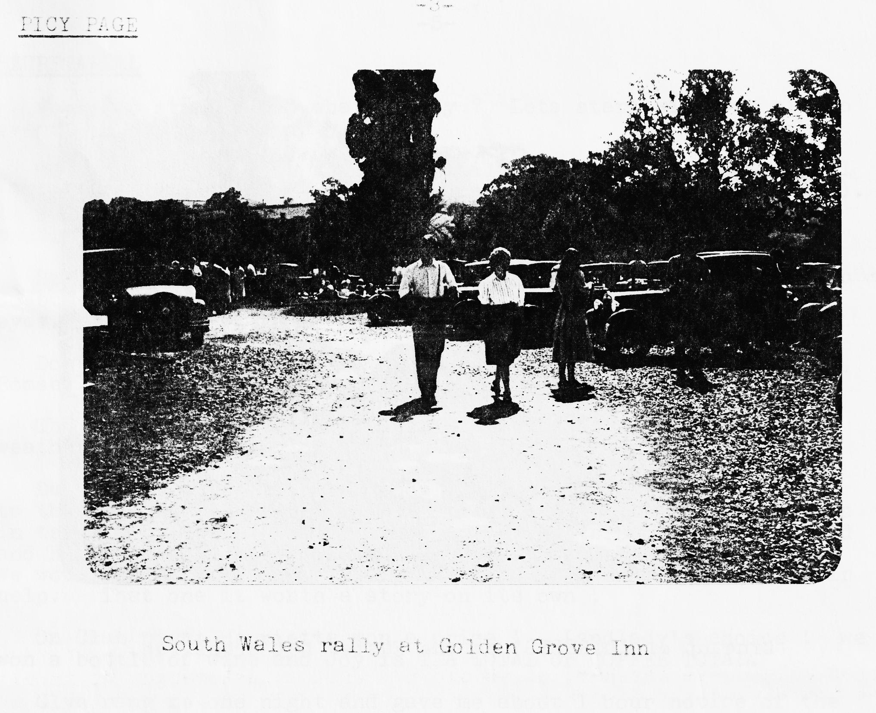
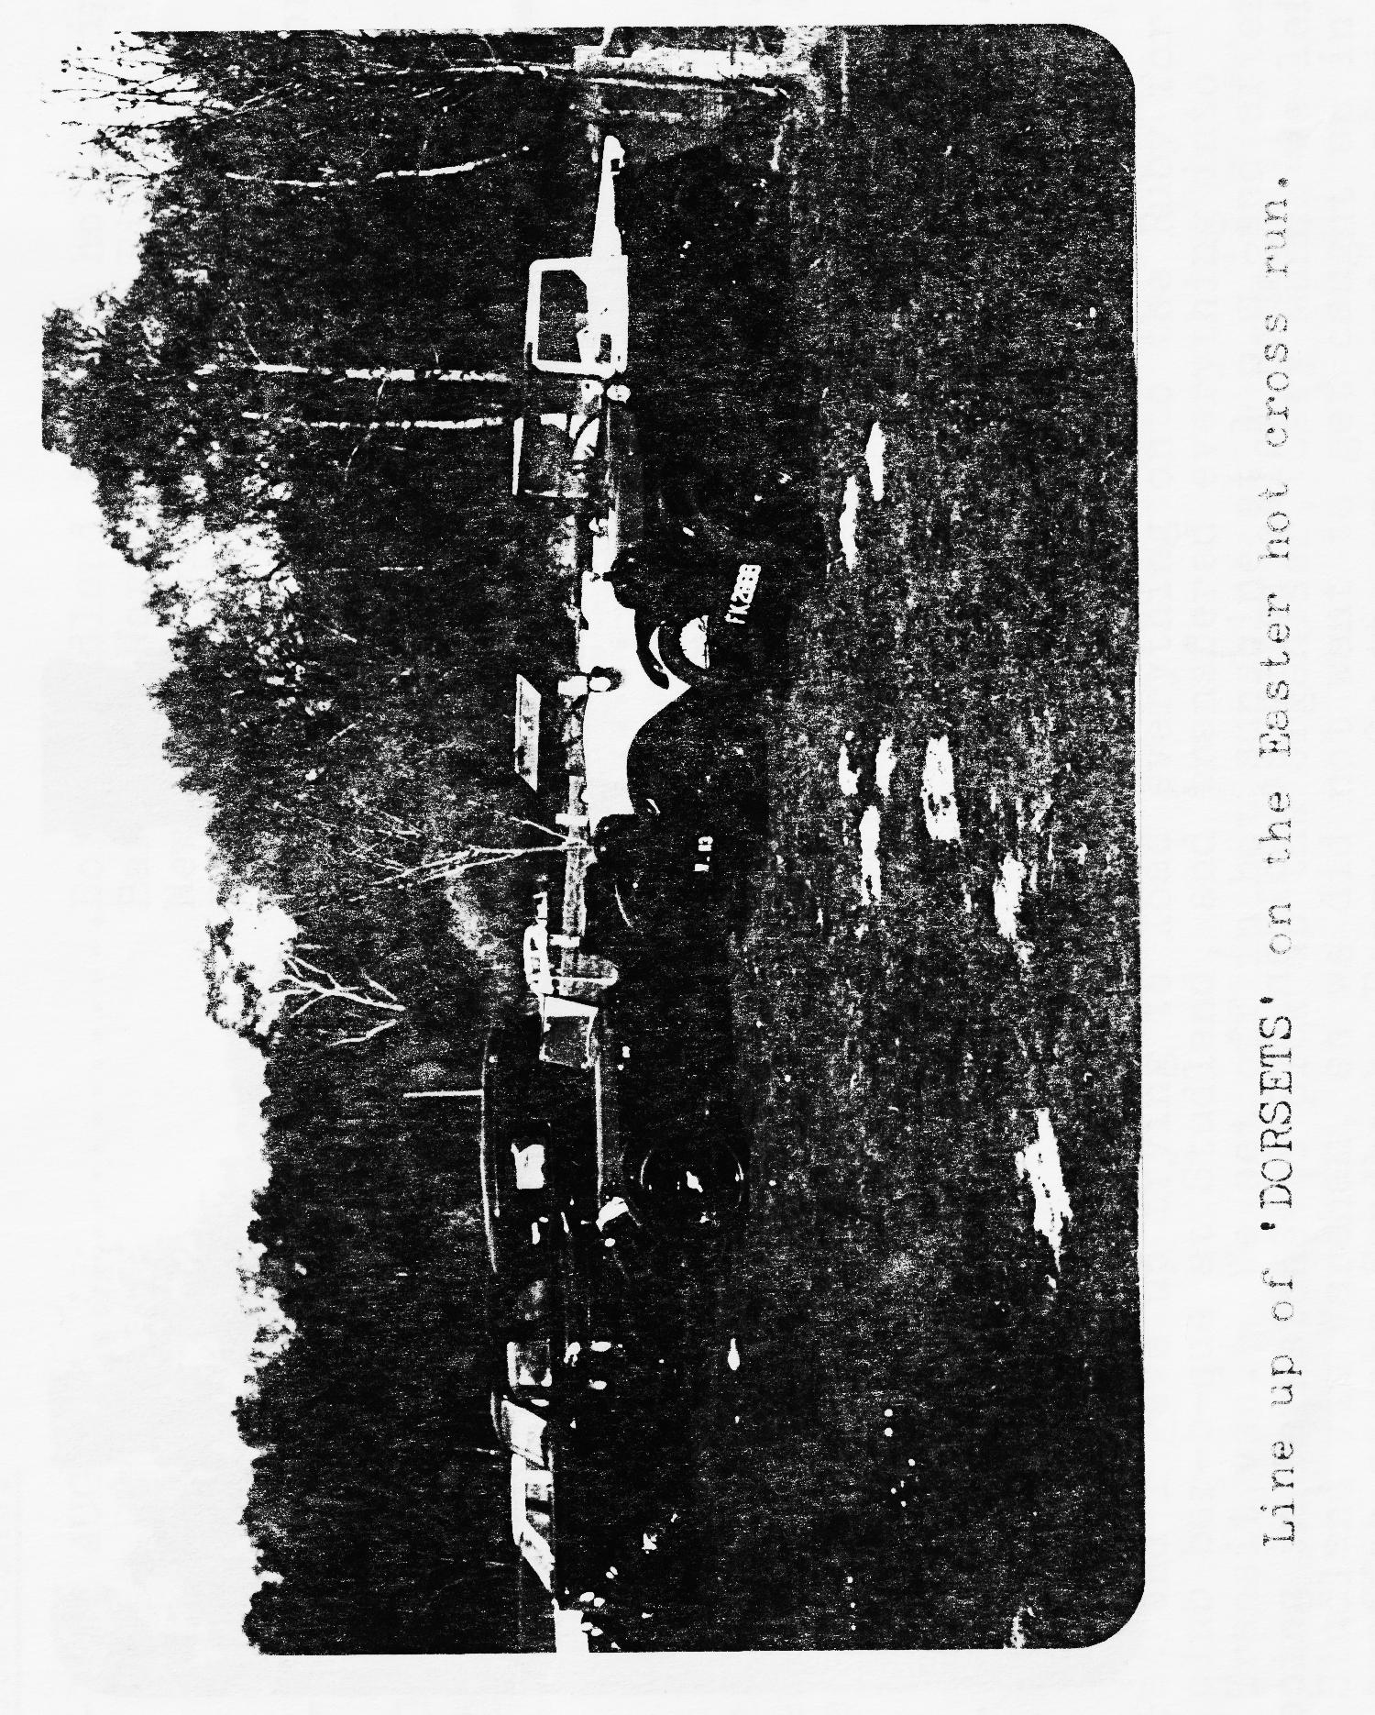

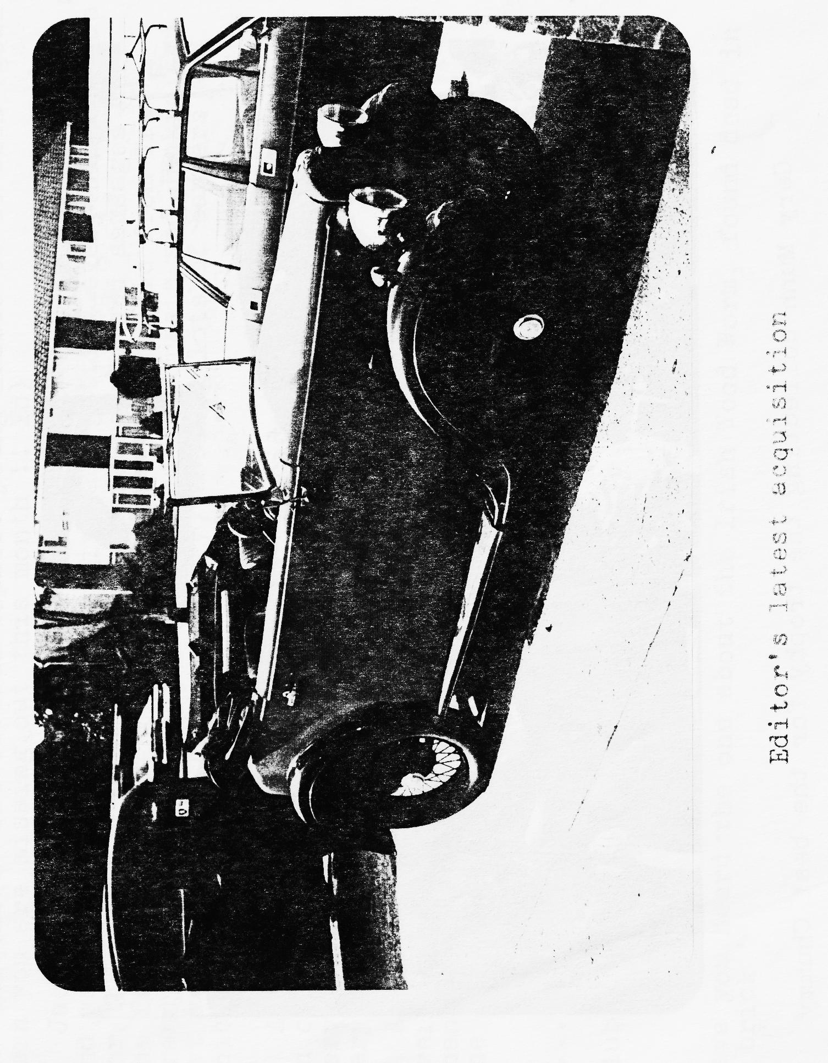

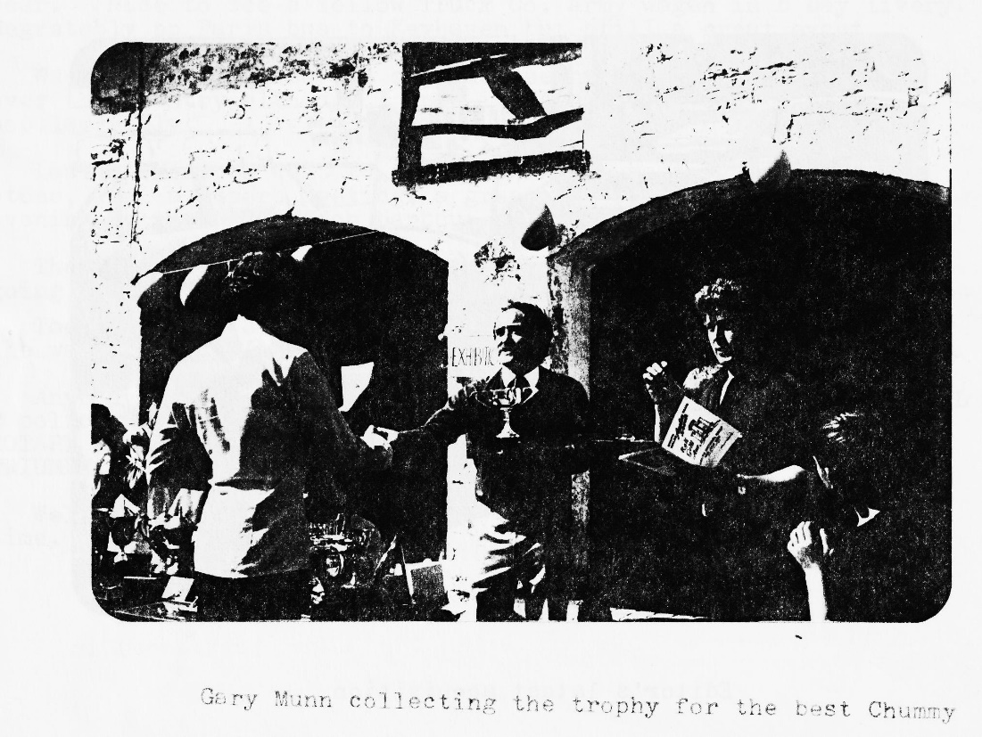
SECRETARIAL
Where to start? and what to say? Let’s start with one or two events.
Midland A7 Club have sent me details of the 21st Stanford Hall Rally to be held at Lutterworth near Rugby on 2nd September (Sun). It looks like a good event. I have entry forms for anybody wanting one.
Spye Park is coming up which promises to be a superb event, no doubt the DORSET MORRIS men will be in action. A sight for sore eyes.
Don’t forget the SOLENT rally 22nd July at Paulton’s Park, Ower, Romsey. They are looking for support from the DA7C.
The summer rally season is in full swing and the blazing June weather has made A7 motoring and rallies so much pleasure. During the last month Joy and I had a busy time. We went up to the Attingham Park rally in Henrietta and on the way back we were in trouble with fuel starvation. John Platts stopped and helped, and he stayed with us for 2 hours until the problem was traced. We would like to say a very big thank you to John & Ron for their help. That one it worth a story on its own.
On Club night Henrietta won a prize! Landlady’s choice: we won a bottle of wine and Joy is TEA TOTAL or COFFEE TOTAL
Glyn rang me one night and gave me about 1 hour notice of the Little Gore Farm Rally! Even 1 hour was better than missing it like I usually do. Super little event and well attended this year. Nice to see a Yellow Truck Co. Army wagon in D Day livery. Regrettably no Paris bus to Keyhaven but still a great event.
We went to Beaulieu and enjoyed seeing many friends from all over the country although I know it is not everybody’s most popular rally.
Last weekend we went to the Aston Marin meeting at Silverstone. What a superb meeting, a great day out followed in the evening by the DA7C beach barbecue. The weather was perfect for the Barbecue, but HON SEC wasn’t going in swimming twice in one night.
The only problem with this summer is that work is getting in the way rather.
Anybody interested in motorbikes? I saw 2 new NORTON INTERPOL 2 police bikes the other day fitted with the long development ROTARY WANKEL engine, they look superb. May they prosper and TRIUMPH who are now back in production.
Well that’s it from me for now. Must go, it’s nearly closing time. George

SERVICES
MUNWELLYNS. FOR ALL AUSTIN 7 MECHANICAL AND ELECTRICAL REPAIRS PHONE GLYN ON NEW MILTON 613080 or GARY ON PARKSTONE 745951
AUSTIN 7 CLUTCH AND BRAKE RELINING service by return of post BERNARD COWLEY, WIMBORNE 887666
MIG, SPOT & GAS WELDING. SKILLED TECHNICIAN WILL WORK AT YOUR HOME OR IN OWN WORKSHOP, CAR TRAILER ALSO FOR HIRE. PHONE CHRIS SMITH, RINGWOOD 78066
RADIATORS REPAIRED OR RE-CORED, HANTS AND DORSET RADIATORS, 77, STANLEY RD., BOURNEMOUTH 301277
AUSTIN 7 RE-SPRAYS GEORGE MOONEY, BOURNEMOUTH 425989
6 VOLT BATTERIES BERNARD COWLEY, WIMBORNE 887666
UPHOLSTERY & TRIMMING COLIN MORRIS, BOURNEMOUTH 524671

TECHNICAL TIP
When removing Austin 7 cylinder heads, the low compression type with 18 mm spark plugs, to save hammering a screwdriver or chisel between the joint, try using the hook end of a Ruby boot key into the plug holes 1 and 4 alternately. Even better, get 2 Ruby boot keys and make it even easier. This dodge does not work with the high-compression 14 mm heads.
Pinched from Bristol A7 club newsletter with thanks.

