NEWSLETTER
January 1999

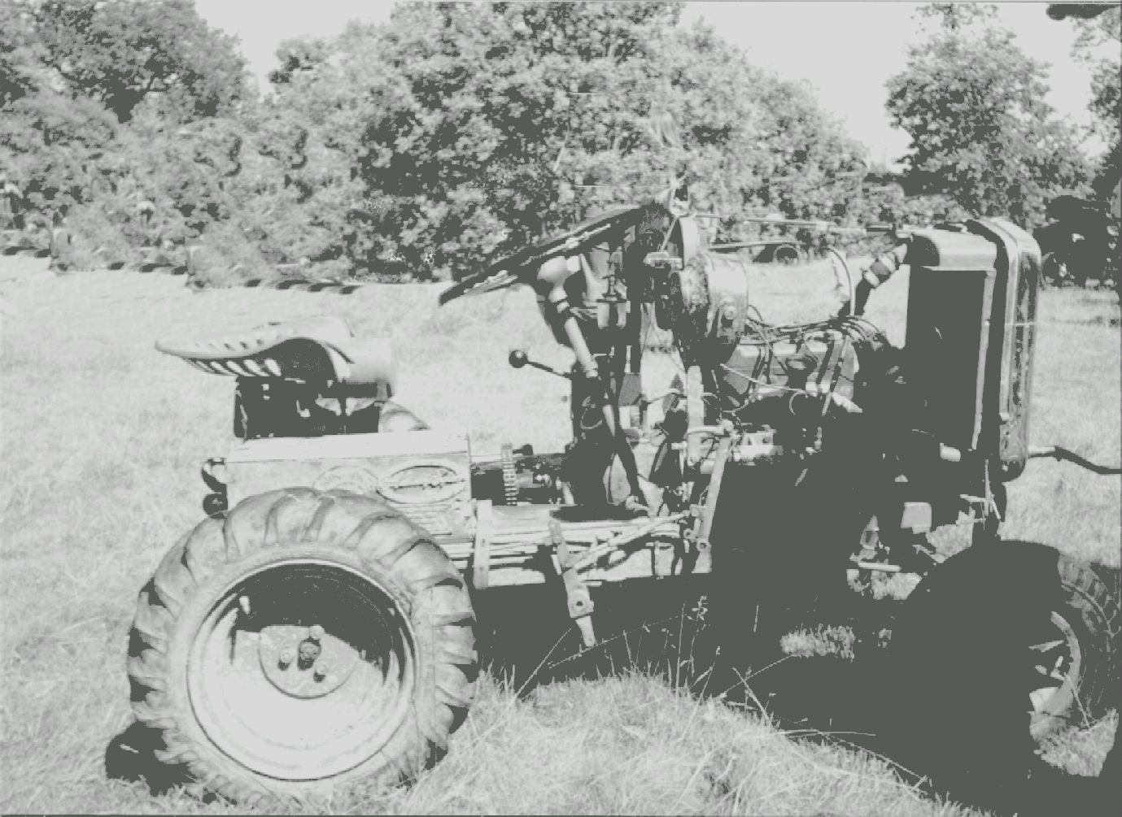

The motor for the Million
Built in the largest and most up-to-date Motor Works in the British Empire

Member of the A7 Clubs Association

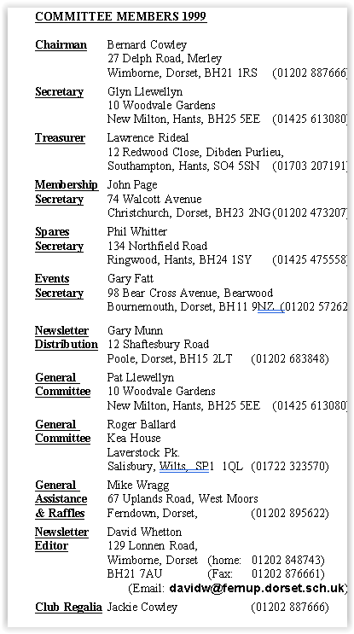
CONTENTS

Club Contacts 1
Editorial 2
Secretarial 2
Club Run 3
From the Internet 3
Letters Page 7
Tip of the Month 7
Committee Business 9
The Way We Were 9
Here & There 10
Family News 10
Future Events 11

FEATURES
Motoring in Mauritius 4
IHVO Press Release 4
New Year’s Sonnet 5
Technical Torque 6
Xmas Hangover 8

CLUB NIGHTS
are held on the third Thursday of every month at The Tyrrell’s Ford Hotel, Avon (on the Ringwood/Christchurch Road)
B3347

This month's cover photograph features the AUSTIN SEVEN TRACTOR first seen this year at Spye Park and then briefly at our own Swanage Rally. Ted Whiteway of Devon utilised the engine plus bits from a 1935 A7 in 1965 to make a gang-mower for his farm and it is currently owned by C Michelmore of Chudleigh. Thanks to Glyn for ‘photo.

EDITORIAL

Thanks to Pat & Glyn for another stunning Club Christmas Meal – together with the Triumph crowd we took over the whole hotel! This month’s Newsletter once again is stuffed with articles from Members – another CRACKER!

We now have TWO INTERNATIONALLY ROVING REPORTERS – Phil Whitter and younger Matthew Cheeseman (who is heading for Chile – I hope Dad has kept up to date with the political goings-on; there is a New Year’s message from the House of Fatt; and, joy oh joy – a letter from the farthest reaches of the DA7C empire. Starting this month is a new feature as requested by several new members – Tip-of-the-Month as compiled by the Assistant Editor and I am sure he will be bending the ears of the older Members for their favourite juicy bits.

There are two important CLUB EVENTS being organised in the next two months – a new MURDER & MYSTERY EVENING in February and our old favourite, the SKITTLES EVENING in March. Don’t forget – they are only being organised for YOU - support these events by returning the booking forms IMMEDIATELY (one this month, one next), or Lord Austin’s ghost of Christmas Past might play havoc with your widgets and trunnions - nasty!!

One last thought – what to do with all those unwanted Xmas prezzies & boxes of biscuits? Donate them to the Club RAFFLE PRIZES - see John Page at Jan Club Night.

David

Deadline for the next issue is 29/01/99 . Please send material to me by post, fax or E-mail or pass it over to the Editorial Team at Clubnight.

HSECRETARIAL
i Gang

I hope you all had a merry Christmas, and may I wish you all a very happy and prosperous new year. The Club Christmas dinner went down well, (literally!) and we raised £92 for the Macmillan Cancer unit at Christchurch Hospital by donating our Christmas Card money to them instead of swapping cards.

I have been out and about in the Tickford between Christmas and New Year, planning the route for the New Years Day run, which will have come and gone by the time you read this. I just hope the rain keeps off as it has been so wet, it would be great to see some sun.

I had a visit from a chap named Feiko Jac De Vries from Holland the other day. He owns and runs a chummy and has just found a body of an Austin 7 short wheelbase which he says was a Tickford. He measured the hood frame and made drawings of the gears etc. on my car and says he plans to put the body on a chassis he already owns, and hopes to have it finished sometime next year. Good luck to him, it’s some undertaking.

Pat and I are off to Cypress for a couple of weeks (hopefully sunny) in January, so we shall not see you on club night. But we'll be there in February.

Glyn
REMEMBER TO RETURN THE FORM ABOUT THE MURDER MYSTERY EVENING BEFORE 31/01/99 -
February Club Night will be TOO LATE

GARY’S PRE-XMAS SPIN 20/12/98

Eight cars gathered at QE School on a very bright and sunny winter’s day including our intrepid travellers from Exeter – Richard and Marlies Bishop. Pete Treliving was the only one brave enough, however, to have his hood down!

We left about 11 am and headed through Cranbourne to White Mill, Sturminster and on towards Moreton. After cutting back past the Red Post, we went up the very attractive Winterbourne Valley which looked a picture in the bright, clear sunshine. From there we headed back through Langton Long retracing our steps to Wimborne where the landlord of the White Hart had reserved the car park for us!

After a very pleasant meal and the customary chat, we all made our way home.

Many thanks to Gary for arranging a beautiful run, a good pub and above all – fantastic winter weather.

Bernard
From the internet

Hi – MERRY CHRISTMAS & HAPPY NEW YEAR to you all. I’m currently in QUITO (Ecuador) and have spent 14 days in PERU. I’m heading south again as I am only 3000 miles from my intended destination in SANTIAGO CHILE. I’m taking care of myself, weather is great, having a whale of a time and the girls are very beautiful!

Matthew Cheeseman: matthewcheeseman@hotmail.com

I have 2 A7 Specials in bits and I only want one! One hillclimbed in the early 60s, the other a pile of bits. The fast one has Fiat Topolino front end – no body but we have pictures. The other has a mud-plugger body. Very cheap – Chris Holbrook 01633-244906

For those interested in the Meridian TV transmission of GOODWOOD REVIVAL on 20/9/98, it is now available at £12.99 +£2 p&p from Duke Marketing, 13 St Georges St, Douglas, Isle of Man, Tel 01624-6400000. Hugh Barnes hb10001@admin.cam.ac.uk



Lost Motorist:”Leatherhead?”
Village Ne’re Do Well: “Fishface!”

Motoring in Mauritius

by Phil Whitter

MAURITIUS may be an island in the Indian Ocean, but the first thing you notice is that they drive on the left and all the road signs and markings are in English. This is in no small way due to the 100 years of British rule prior to independence in 1968.

You soon learn that the most important part of any car is an efficient horn! It is used to warn people of your approach since there are few pavements and that you are going to overtake. Overtaking is a frightening experience – everyone does it in the most unlikely places – with a line of vehicles in front, whilst vehicles are approaching and especially on bends. The procedure appears to be to establish that a space exists in the on-coming traffic, pull out, sound your horn and then go for it!! If anyone is approaching they slow down and you go faster. It seems to work but there is an added complication in that most country roads are elevated to prevent monsoon flooding with a shear drop either side of at least 1 metre. The most difficult vehicles to overtake are mopeds with vast loads of vegetation and old Bedford trucks overloaded with sugar cane.

Although hard to believe, MOT-type tests are carried out annually on new cars after the first year and on older vehicles every six months. However, it was difficult to see where this happens as, apart from the major towns, all other garages appear to be in someone’s front garden with the cars up on scaffolding poles.

There is a tremendous variety of cars with everything from luxury Mercedes and 4x4s to Austin Cambridges and Minis. Once out of the capital, Port Louis, every front garden seems to have either an Austin Cambridge or a Hillman Minx abandoned in it. We did not see any scrap yards and obviously everything that can be adapted for another use gets re-cycled.

If you want to be really different you would need to get yourself a big motorbike - it’s either mopeds or police Hondas and nothing else.

To end on a positive note – road rage definitely doesn’t exist on this tropical isle.

Phil Whitter

and thanks to Phil, our World-wide roving reporter, who arranged a family wedding to coincide with this report. - Kate Adey would be proud of you and so are we - Ed.

MORE EUROPEAN MADNESS
from an IHVO press release 3/10/98
The rights of historic vehicle enthusiasts to store non-roadworthy vehicles for future restoration or to dismantle them for parts will be seriously prejudiced by the PROPOSED COUNCIL DIRECTIVE COM/(97)358;97/0194SYN : END OF LIFE VEHICLES. Only establishments with permits will be allowed to dismantle vehicles for spare parts and second-hand parts for re-sale will have to be checked for safety and environmental protection and before cars can be de-registered, a certificate of destruction will be required from a licensed dismantler.
The IHVO recommend that “member states shall exclude from the scope of this Directive certain vehicles that are considered to be of historic interest”. In addition there should be exemption for all vehicles first manufactured before 31st December 1960 and all vehicles not registered on the date the Directive comes into force.
thanks to member Kevin Bisset for spotting this bombshell - Ed.

A New Year’s Sonnet Entitled

“We’ve Had a Lovely Year”

Oh goodness me, where has it gone
Time goes so fast, we hear.
But we couldn’t have blinked and missed it
‘Cos we’ve had a lovely year.

We’ve been on runs and jolly jaunts.
We’ve been both far and near.
So good to spend this time with friends
- We’ve had a lovely year.

Our little cars don’t cause us fuss
To get them into gear.
With engines revved we’re soon away
- We’ve had a lovely year.
With someone at the end of line
To follow up the rear,
We drive down pretty country roads
- We’ve had a lovely year.

Our Swanage Rally – oh so wet!
It seemed so very queer
‘Cos other ones - the sun shone bright,
But - we’ve had a lovely year.

And now we come to start again.
So to our friends most dear –
We wish you all a future bright
And
- HAVE A LOVELY YEAR!

Gary & Suzie Fatt

Things That Go BANG in The Garage
There must be many reasons for unexpected bangs in the garage of a Sevener but surely none as unusual as that experienced by GLYN Llewellyn recently. He was just pushing his Seven into the garage (the engine wasn’t even switched on) when suddenly there was a loud bang. He looked around the car but could not find any obstruction or resultant dent that could have caused the sound. On further investigation he discovered a rubber glove which he had been wearing earlier whilst working on the car had been left on the floor. The glove had been caught by the rear tyre which had trapped the air inside and then progressively squeezed the glove until - it burst!!! TREBS
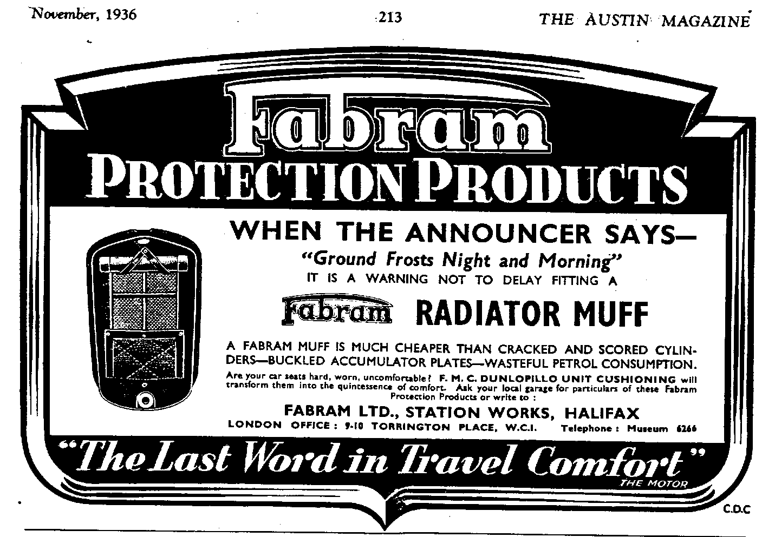


concluding the Series on Lubrication of the Austin 7

Fan Bearing.
A nipple is fitted to this unit to which CASTROLEASE Medium should be applied every 250 miles with the grease gun.

Also Requiring Attention.
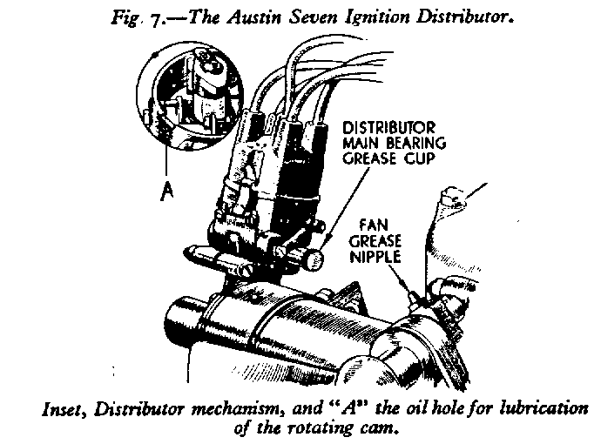
Every 1,000 miles make a point of going round your Austin Seven and applying a few drops of Wakefield OILIT to the carburettor and ignition control rod joints, door hinges, bonnet fasteners, etc. It is a good plan, too, after nuts or screws have been removed. for any purpose, to apply a drop of oil before replacing these.

Electrical Equipment:
Dynamo.
The dynamo bearings are packed with grease before leaving the works and require very little attention. Every 1,000 miles, however, add three drops of Wakefield OILIT through the lubricator near the mounting flange. It is well to note that far more trouble is caused by excessive oiling than by too little.

Distributor.
Every 500 miles give the grease cup two turns. This will lubricate the Distributor main bearing. This grease cup should be filled with Wakefield CASTROLEASE Medium. At the same mileage interval apply two drops of Wakefield OILIT to the cam lubrication wick through the hole provided. Take care not to over lubricate these parts.

Windshield Wiper.
Every 1,000 miles apply a drop of Wakefield OILIT to screen wiper mechanism. Except on the Trico model, a small screw can he removed from the top of the casing to permit the oil to be injected.

Starting Motor.
This Unit requires very little attention as the bearings are packed with grease before leaving the works. Occasionally remove the clip-secured commutator cover and inspect the commutator. This should be kept free from oil, brush dust, etc., by the application of a soft cloth to its surface whilst the spindle is slowly turned.

LETTER BOX

Dear David, Many thanks for the return of the photos - very observant of you
to spot the camping use of the door chain!

I had fun and games with A7 electrics recently. I knew that the dynamo bearings needed replacing and decided to sort them out. Everything went well and the dynamo was back in record time. But when I started up I found that it was not charging. What had I done wrong? Well, after removing the dynamo three times, dismantling and rebuilding it, I was stumped! So it was off to Lucas Services and the experts with their little meters. I hadn't really done anything stupid only overlooked that the brushes were just on their limit of wear. They definitely looked OK and seemed to be bearing on the commutator with the correct amount of pressure. But the dismantling had upset them enough not to work.

So the moral of the story is to listen to "her indoors” and agree that if it is working don’t muck it about or choose to break down in the relative comfort of ones own garage. Does anyone own, use and therefore understands a meter? If so any chance of a crash course?

The weekend after all that fun, Marlies and I went down to St Ives with the Crash Box Club. The car behaved impeccably for the 240 miles round trip and we had a great time with wonderful cliff walks, good food and good company.

Finally, many thanks for everyone’s' hospitality when we have managed the trip from Exeter and joined in the various club runs this year. Have a happy Christmas and we look forward to meeting up in '99.
Richard and Marlies Bishop

Tip of the Month
For those of you with older Sevens, the ones with the fuel tank at the front, if you need to replace the CORK which holds the fuel tap in the tank but have difficulty getting hold of one, then why not make one yourself? All you need is a wine cork (shouldn’t be too difficult at this time of the year), file it down to the required diameter, drill a hole through the centre and - voila!! On a technical note, it is advisable to wait several hours after finishing the bottle before attempting this job!

Thanks to John Page
Whose Museum is it Anyway?
In last month’s Newsletter we featured pictures of 4 Austin 7s in the Hurn Motor Museum with varying degrees of mystery surrounding them. Asking the Veteran Austineer himself – John Harris – he responded “They’re all mine!!!!”
The 1928 TT Replica whose colour really was orange for easier identification by the timekeepers, was “blown” but the air pump on the side was to pressurise the petrol tank because the carburettors are slightly above the level of the petrol. The odd windscreen is a Chummy one chopped down as the regs demanded a hood at that time as well as the ubiquitous leather strap.
The mystery chassis is 1923 – they had no starter at all, no shock absorbers and yes, it is the correct deeply dished steering wheel.
Even the Top Hat in the background of the photo belongs to John. The little curator!

Christmas Hangover

Cars for Sale In Roman Numerals of course: MCMXXII = 1922

MCMXXXI = 1931 MCMXXV = 1925 MCMXXIX = 1929

Incidentally, I notice that the year 2000 will be Mm which took me to thinking what was the shortest year expressed in Roman numerals (easy - I, V, X, L, D and M are obvious candidates) and what was the longest since the birth of Christ? - work that one out for yourselves!

Club Kite Flying: it certainly was a gusty day and at one stage there was real danger of the strings getting tangled exactly as in the Xmas competition!!

Bernard = Chummy; Phil = Chummy; Richard = Ruby; Gary = Ruby;

David = Special; Lawrence = Morris Minor; Peter = Ruby.

Australian Austin Sevens:

No.123 = 1924 Gordon England Brookland Super Special owned by R Wright, Brisbane.

No.73 = 1937 Arrow Roadster owned by G Singleton, Maleny

No.19 = 1927 Doctor’s Coupe owned by P Goldsworthy, Southside

No.84 = 1937 Utility owned by D Moore, Yeronga

No.78 = 1929 Sports owned by K Collins, Birkdale

No.91 = 1929 Meteor owned by B King, Sunnybank

and the cards to get this Christmas were from VINCE LEEK:



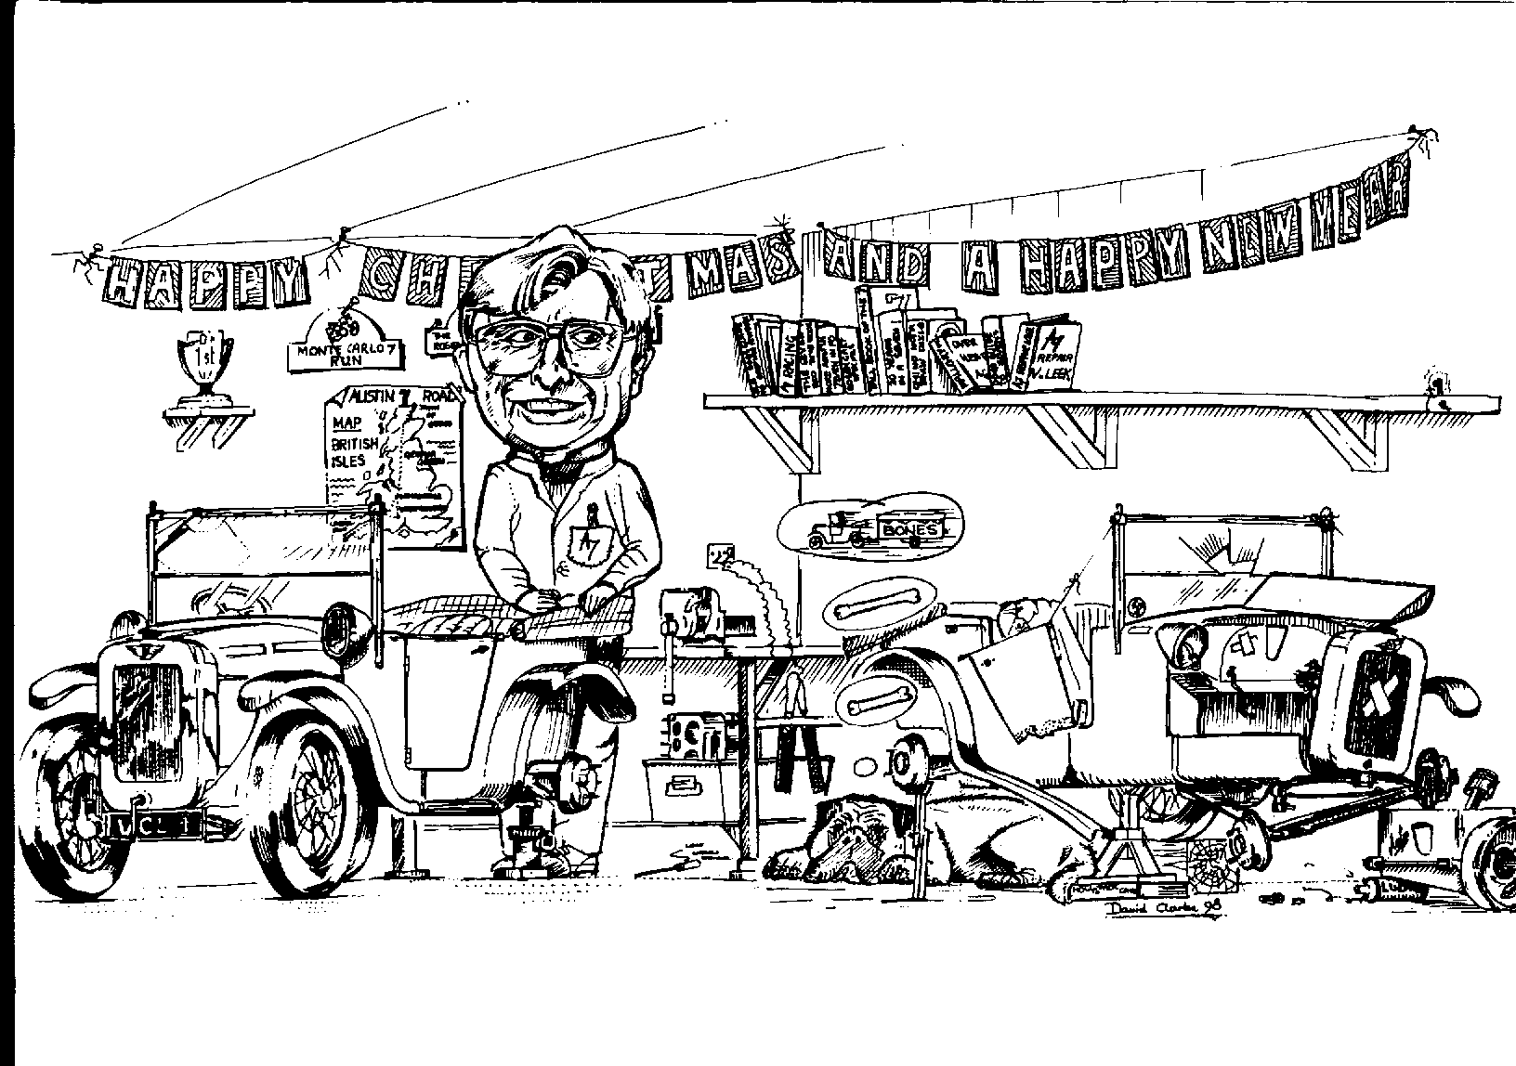
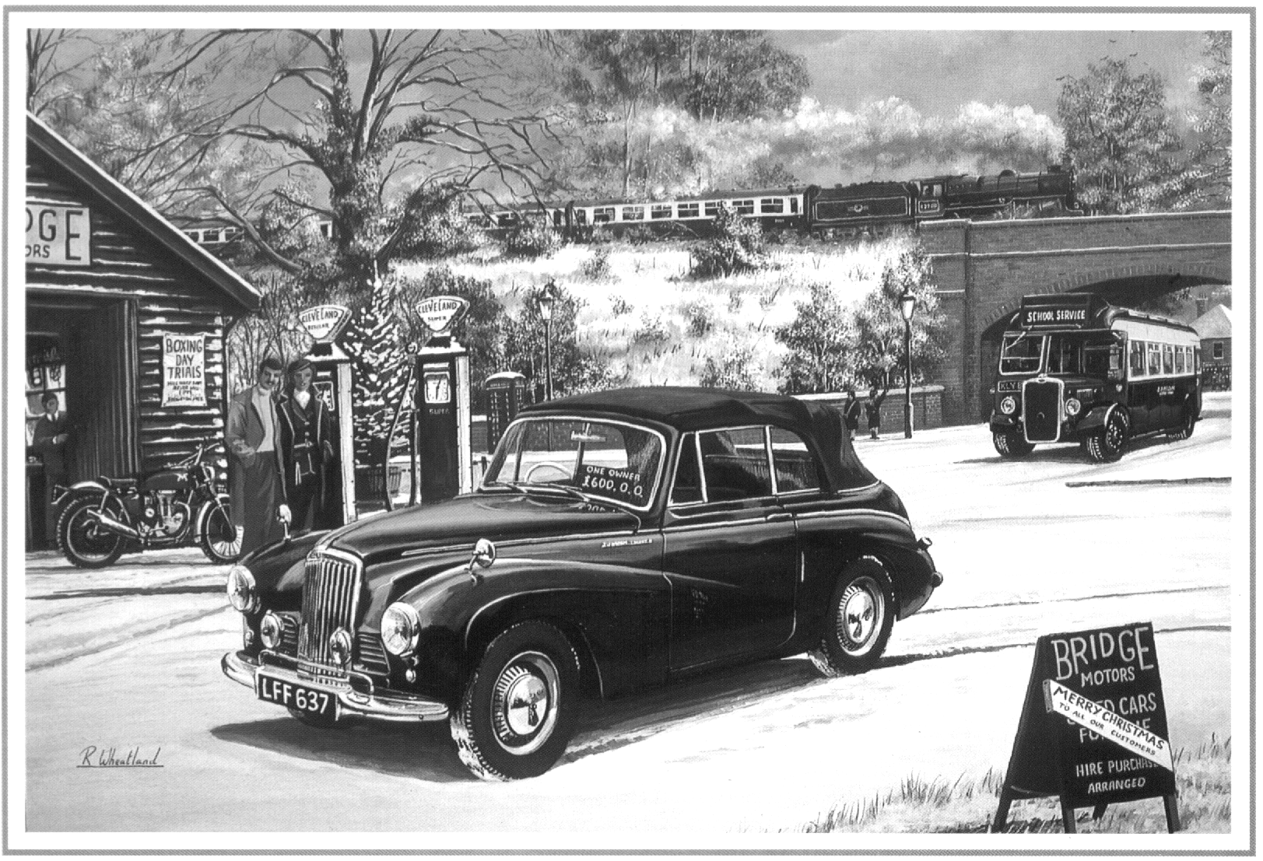
and Arthur Cox

(with his usual Motor & Allied

Traders Benevolent Fund card)

COMMITTEE BUSINESS
Young Gary Fatt is trying out NEW IDEAS!(Hooray!! – Ed.) and two suggestions will be tried out this year – an 8-til-late in The West and a summer BBQ+Dance at The Tyrrell’s Ford. An EASTER RUN TO FRANCE is being organised by Gary Munn (see back page) – but please ring IMMEDIATELY if you’re interested as the planning can’t go ahead without sufficient response NOW. Gary M. is now our official, St. John’s Ambulance – trained First Aider and the Club is purchasing a pukker kit – well done that man! The Club will be giving FREE to all members a copy of the “Red Cross Book” – not first aid this time, but CAR-AID: it lists all bona fide A7-type services across the country.

THE WAY WE WERE - a blast from the past
From the Club magazine for JANUARY 1978

“Following last committee meeting, it appears that 350x19 Dunlop tyres do not give such good service as the Avon sidecar type. Dunlop wear in the centre and leave the outside intact.
It is interesting to hear that someone has had upholstery work done by the nuns at Stapehill Convent. Could this end up as Nun & Co versus Munn & Co.?
At this month’s meeting at the Nags Head, Mike Riley is to give a talk on Daimlers.
SPOTLIGHT ON..... GLYN LLEWELLYN –
Glyn purchased his 1934 Ruby Saloon in 1975 from Jim Bury about 80% complete and in a very poor state. He spent the next 18 months restoring it to its present, excellent condition and Glyn says that he would like to refit the sunshine roof as a finishing touch. Back in the summer he purchased a 2.5 litre Riley which he uses as family transport when there are plenty of petrol stations around.
LOCAL RESTORATION SERVICES –
Bead Blasting Armour Motor Products, Winton
Dynamo Re-wind Simms & Co, Christchurch
Glass Autoglass, Boscombe
MOT Colehill Service Station
Plating Electrostatic Finishers, Boscombe
Resilvering Coronet Silversmiths, Parkstone
Upholstery Draper, Boscombe
Shotblasting Sprayblast, Hamworthy
Wheel Building Reg Mills, Lytchett Minster
White Metal Bearings John Kirkby, Croydon


FOR SALE

1938 BIG SEVEN 4-doors, sunshine roof. Details from Reg Stones Tel:01425 274355 (Eves. only please)

WANTED

ULSTER-TYPE EXHAUST MANIFOLD/System and TWIN-SU CARB MANIFOLD for that winning combination so eagerly sought after by David Whetton: 01202-848743
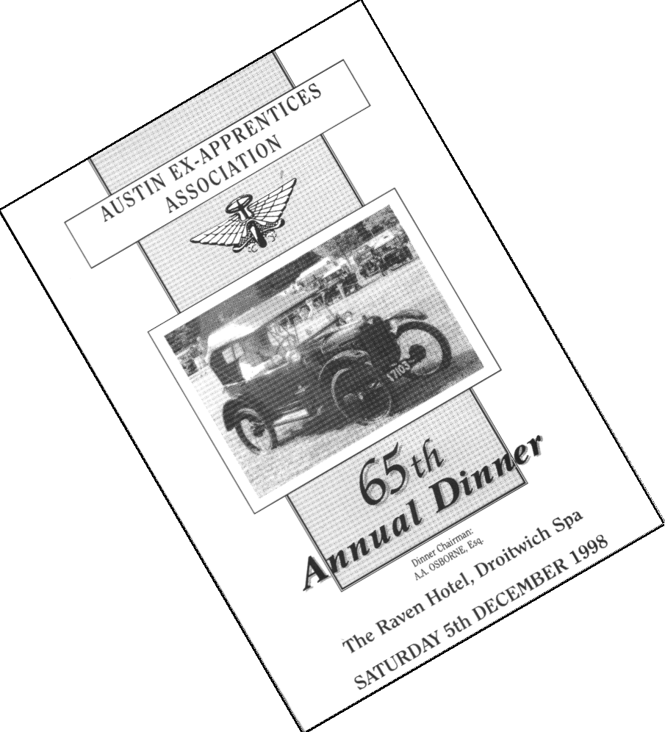
CLUB FAMILY NEWS

We all hope that MIKE TOPHAM has recovered from his son’s birthday party - You should know better at your age to join in drinking games Mike!!

Word on the street is that DUSTY is replacing his old Volvo Estate with a newer one, although from what we hear, he’s doing it piece by piece. Well, why sell a perfectly good old car with some nice new parts on it?!! We can’t wait to see the new car out of the garage, but as for buying the old one .......

Some say being the wife of a Sevener can be a lonely experience with all those hours spent in the garage. Well, not for everyone.... HILARY WHITTER, SUE TOPHAM & PAT LLEWELLYN are off to the Albert Hall in March to see Cliff Richard in his 40 years concert. Meanwhile, not to be outdone in the independence stakes, JANE WHIBLEY is going to see BB King at their second visit to the BIC in May having to miss their first due to the expected arrival of the first grandchild in March. We wish Mandy & Marc all the best. Betting is the first Xmas present won’t be a train set but an A7 (in bits of course as an educational kit!!)

And who found themselves featured on the front of the menu at a celebration dinner he was attending for the Austin Apprentices Association? – our own JOHN HARRIS getting a cup at Beaulieu this year. Don’t you just find it so tiresome being famous??
oO CLUB DIARY Oo

January

Thursday 21 Jan. Clubnight : Feely Bag Night with John Page

Sunday 24 Jan. Club Run : with Lawrence Rideal. Meet Cat & Fiddle, Lyndhurst Rd., Hinton Admiral, Christchurch 10.45 am for 11 am off. Short New Forest run followed by short New Forest walk. Bring suitable footwear.

Thursday 28 Jan. Committee Meeting.

February

Thursday 4 Feb. Eight-till-Late Coventry Arms, Mill St. (A37) Corfe Mullen

Thursday 18 Feb. Club Night: Illustrated talk on Plants & Gardens with Pat Haskell

Sunday 21 Feb. Club Run. Bernard’s North Dorset Wander
Thursday 25 Feb. Committee Meeting.

Saturday 27 Feb. Murder & Mystery Evening with Dinner – see flyer this month
Return to David Whetton or ring 01202-848743 by 31/01/99 to book.

oO FUTURE EVENTS Oo

Saturday 27 March Skittles Evening with Buffet – booking form next month.
Thursday 18 March Club Night: Noggin ‘n Natter
Thursday 15 April Club Night: Lawrence Quiz
STOP PRESS STOP PRESS STOP PRESS
PROPOSED TRIP TO FRANCE – EASTER ’99
Details are yet to be finalised, but it looks like : THURSDAY (4 pm-ish) 1st APRIL (from POOLE ) until MONDAY (10 pm-ish) 5th. APRIL in BRITTANY/NORMANDY. £250 (approx.) for 2 people, B&B accommodation for 4 nights plus ferry.
If interested you MUST RING GARY MUNN 01202-683848 immediately on reading this. If there isn’t sufficient response NOW he will not go ahead with making any bookings etc.


Happy Motoring

