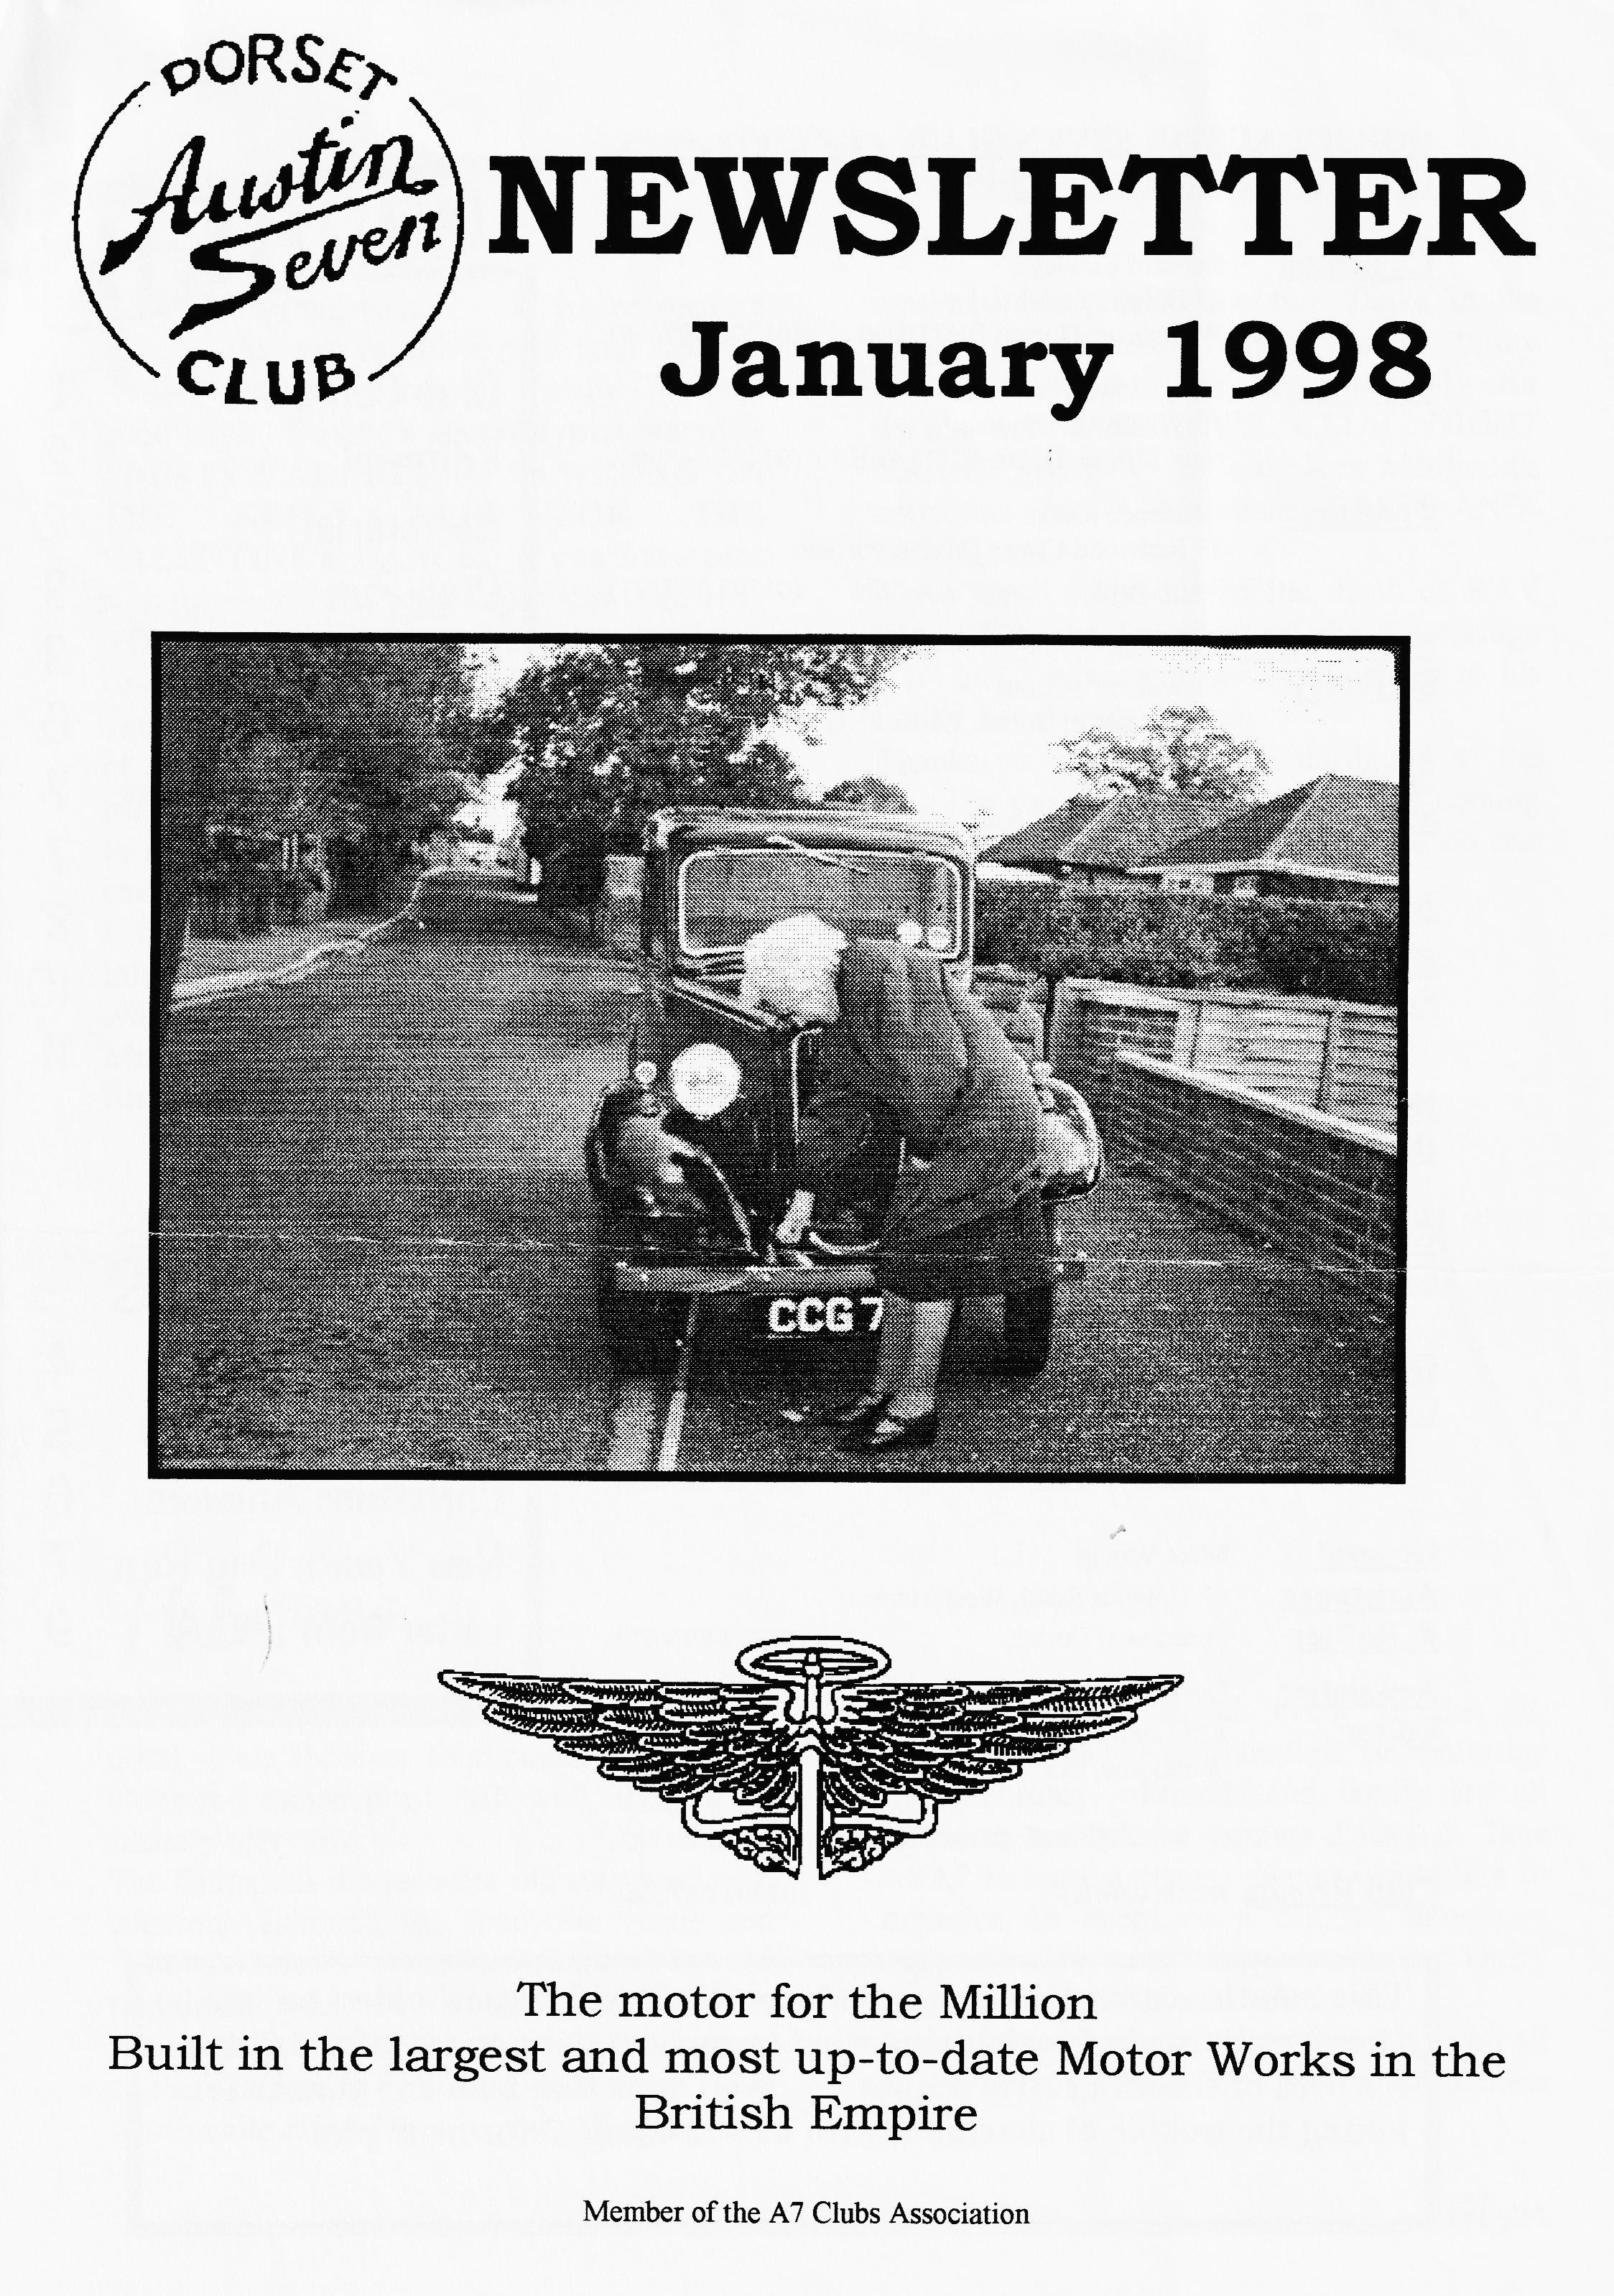

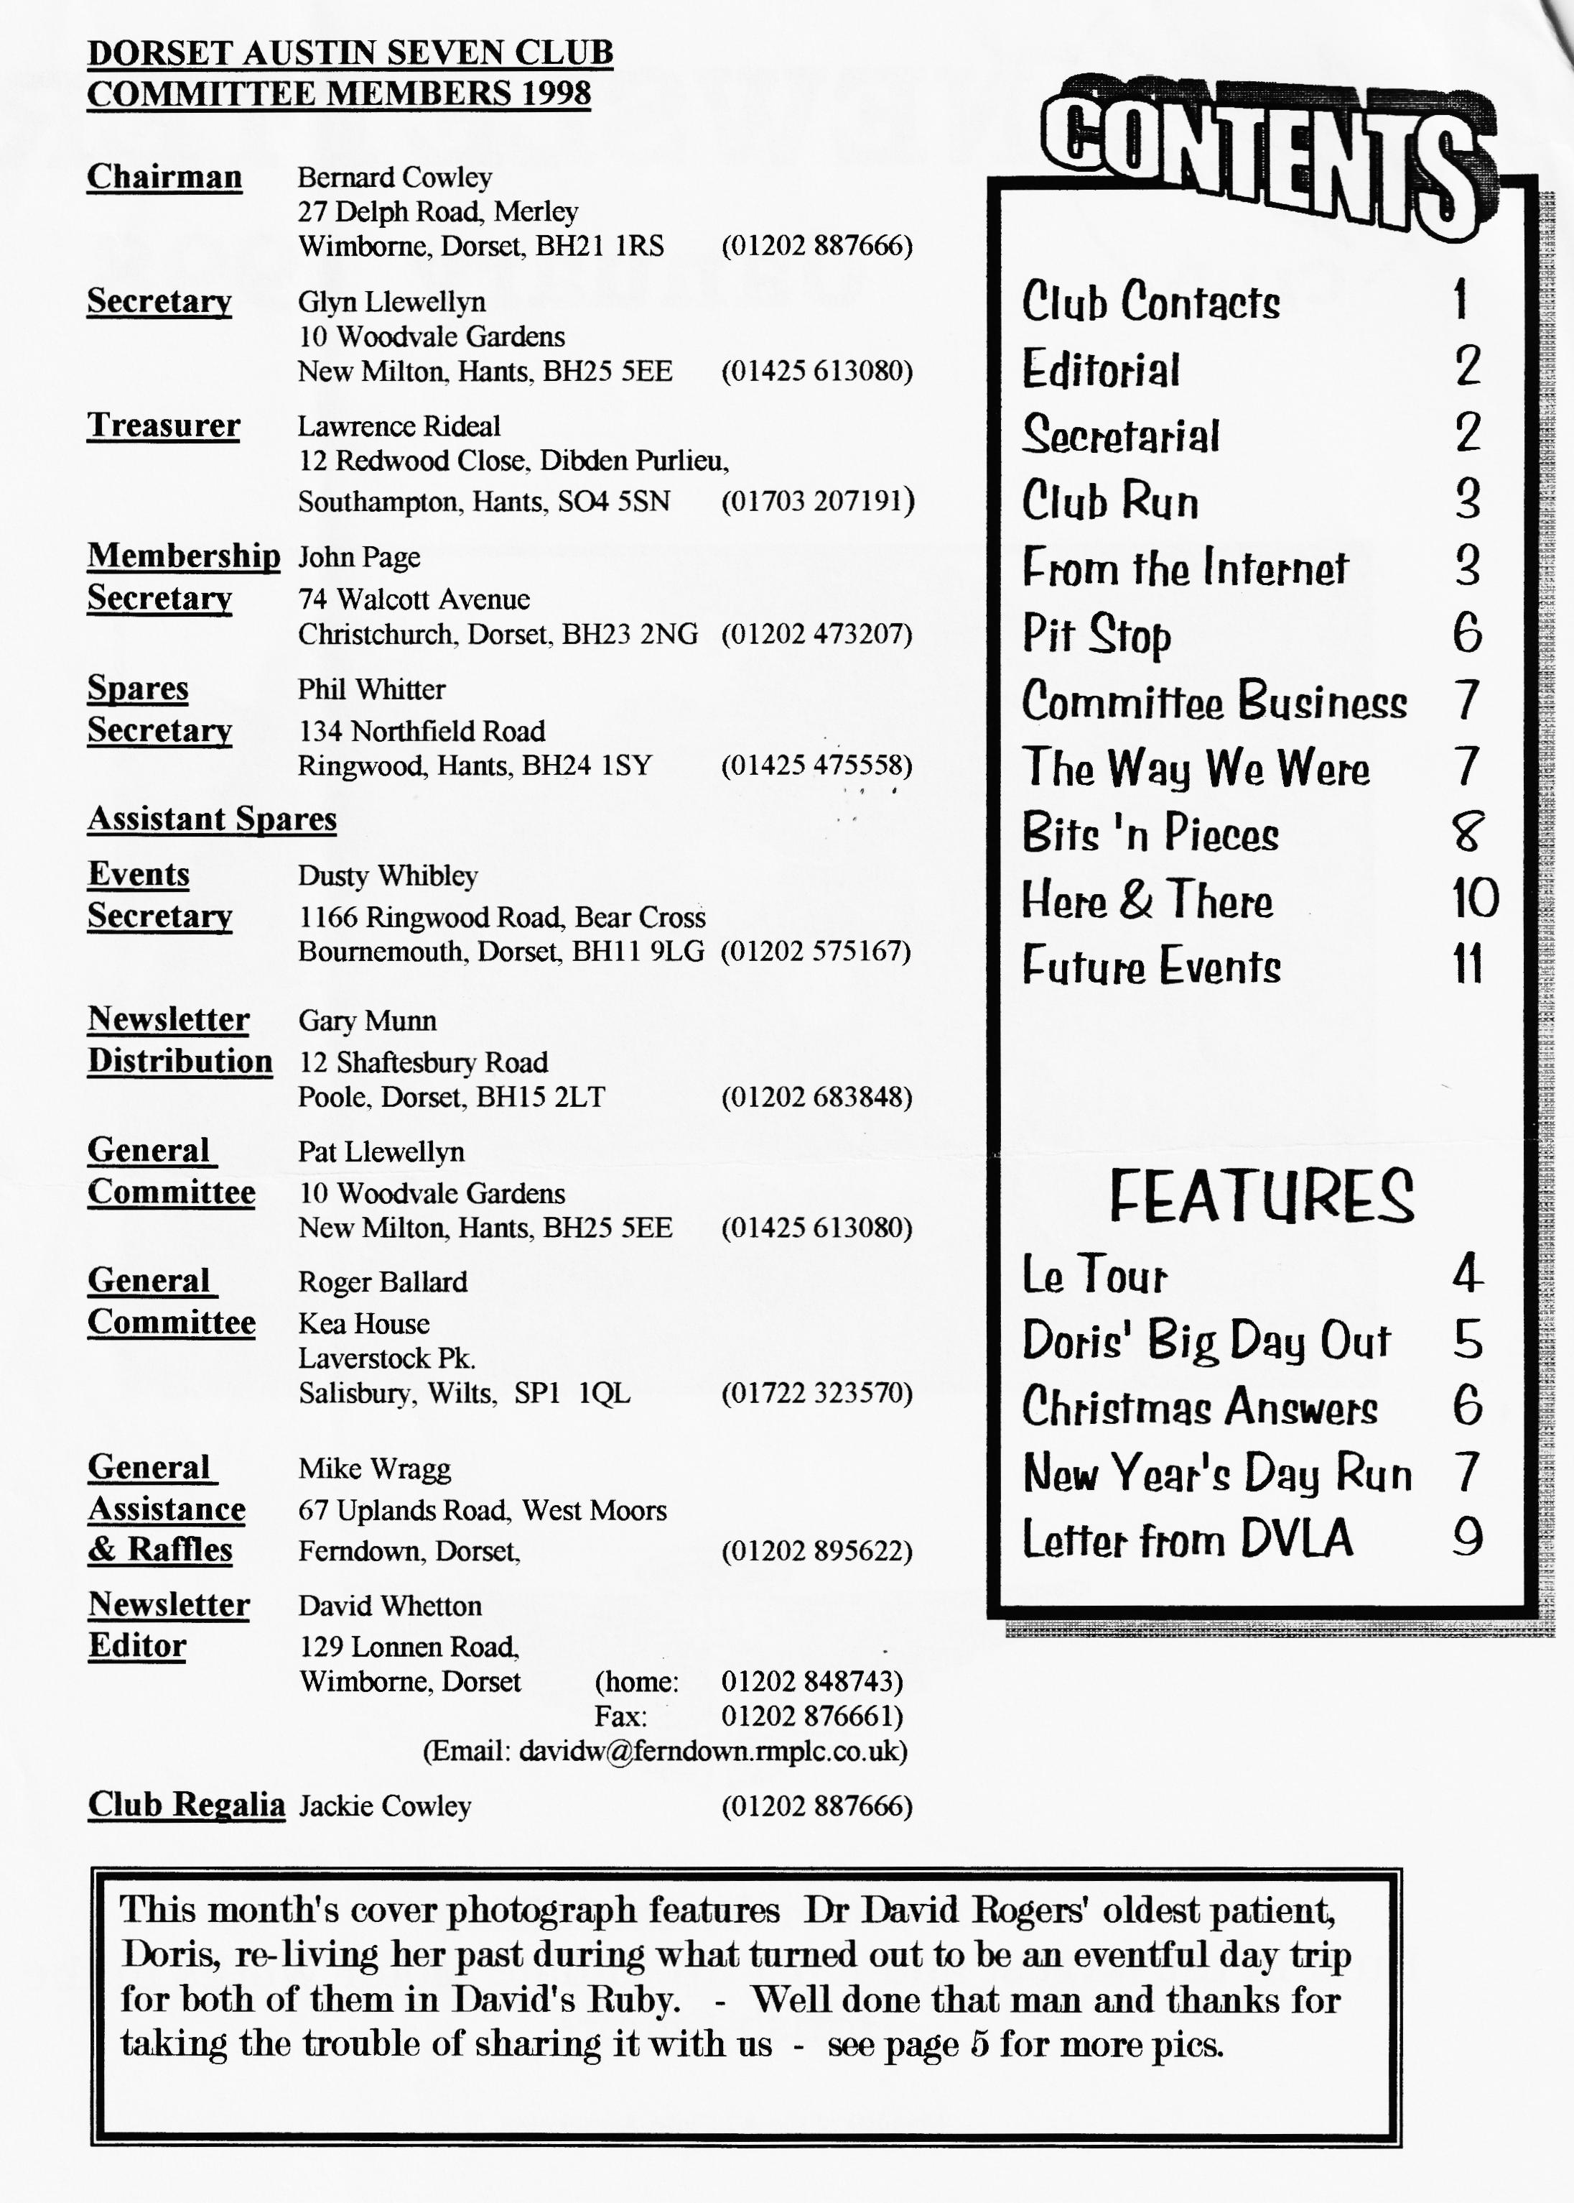

EDITORIAL

Congratulations - if you're reading this you've either paid your subs or you've "borrowed" a copy from the good guys. Firstly a severe typist warning - DUSTY'S ADDRESS WAS WRONG ON THE REPLY SLIP FOR THE VALENTINE'S DANCE. If you have sent a cheque with the pink reply slip then ring NOW on 01202-575167 to check it has been re-directed. If not, then pay by cash on the January Club Night or use the tear-off slip at the end of this edition. You also need to phone Dusty & Jane to indicate an interest to avoid a cancellation and to discuss your contribution to the American Supper.
I have received a note from the Stalkers informing us of this year's Coast to Coast Run which will be a new West to East route from Morecambe to Ravenscar-ish and the Pennine Run from Matlock to Kelso - you've read the
reports, now join in the fun. Dates in the What's On section. Whilst I'm on future events, study the last page carefully for details of JANUARY'S CLUB NIGHT GRAND SALE - not only Ken Medlicott's collection but a Members' BRING-AND-BUY SALE.
News has reached me of the death of RAY WALKER, the President of the Cambridge A7C and I have sent our condolences to his family and friends.
Thanks to everyone who contributed to the mag last year and keep those articles coming - make it a New Year's resolution to do one article or write one letter in '98.
David
PLEASE NOTE NEW E-MAIL ADDRESS:
davidw@ferndown.rmplc.co.uk

Deadline for the next issue is 23/01/98 . Please send material to me by post, fax or E-mail (NEW ADDRESS) or pass it over at Clubnight.
SECRETARIAL

HI, FOLKS,
I trust you all had a merry Christmas. As usual, I am three or four pounds heavier blooming mince pies! Ah well, I'm on the January diet now.
The Christmas dinner went off very well with everyone enjoying the food, the venue and "The Buddies". The collection we hold traditionally in lieu of sending each other Xmas cards raised £80 which will be donated to the MacMillan Unit at Christchurch - a worthwhile effort I'm sure you will agree.
Our next main social event is the St. Valentine's dance at Pamphill on Saturday 14th. February. Friends and family are all welcome and please contact Dusty & Jane ASAP to book a place. If you would like to organise an event or a run, or have any suggestions for something new, contact Dusty as new ideas are always welcome.
May I take this opportunity of wishing you all a very happy, prosperous and peaceful new year.
Glyn.

GARY'S SHORT WINTER WANDER – 21st. December 1997
Six Austins left Ringwood including a '29 Box, a Mulliner, a '34 and '36 Ruby and a '37 Cabriolet. The day was dull but dry and our merry little band wended its way through Giddy Lake, past the Barley Mow Pub at Colehill, past the Cross Keys Pub at Mannington, past the Twin Oaks Pub at Horton, past the Albion Inn at Verwood, past the Three Lions Pub in Stockton, past the Royal Oak Pub at North Gorley and, just as we were beginning to despair of Gary keeping up the best traditions of the Club, we turned into the White Hart in Ringwood at exactly 12.10 only 10 minutes lost through a slight detour around Horton where sleeping policemen tried to dismantle the odd Austin 7. As the White Hart is a Pope's Pub, I tried to ingratiate myself with the landlord by revealing my 18 years with the brewery. However, he was quite unimpressed and only commented on how things must have changed. Thanks to Gary for a lovely run through some very interesting countryside with horse riders galore, Horton Tower in the mist, the old railway bridge at Verwood, ducks on the river Avon, the old timber barn at Stockton and even a ford full of water in which to wash off all the accumulated mud - well done.
Stan Warburton (with a little help from Sheila.) And thanks to another two new contributors - everyone's getting in on the act now - YIPPEE!! Ed.
Patrick Young, who lives in the Southern Highlands just outside Sydney, posted this on the British-Cars-PreWar mailing list recently, and gave permission for inclusion in the A7CA magazine. He writes:
"Last November I was at a club night at the Singapore Polo Club of the Malaysia and Singapore Vintage Car Register, which is a splendid oasis of calm in the frenetic city state and really good fun. All sorts of different folk representing all sorts of vintage (and "classic") cars.
I met a chap called Ted who is about 70 something and probably a good ten years older. He lives in Johore just across the Malaysian border and drives to the club nights in his Austin 7 convertible. He parks it on the edge of town, as the central Singapore traffic is a bit feral.
He has owned the car for a significantly long period of time, buying it from the original owner in Malaya. This owner, in order to hide the car from the invading Japanese during World War 2, encased the car in an enclosed extension to his house with petrol tanks around it. When the Japanese arrived with documentation noting his car, they sought to requisition it and the owner said something to the effect of "it's already gone and I didn't even get a receipt, just a slap in the face." The Japanese accepted the story and when the war ended, the man was able to break down the wall to his house extension, put fuel in the car and drive it out onto the Malayan roads!
Oh, and they took Ted's flying licence off him last year because he couldn't see. However, post cataract operation and with "a couple of fine plastic lenses in place" Ted is re-applying for his pilot's permit!"
Best regards, David Cochrane david_cochrane@ingineur.co.uk

24th. August BEZIERES to LE PUY This was a day of troubles - John & Vince broke a half shaft in the morning and someone else, not yet identified broke another in the afternoon. Yesterday, Frank McDonald ran a big end, David & Janet Edroff were down to the last thread on a wheel, the AEW is having fuel starvation problems and Ken & Eileen Cooke ended the day with a misfire. The support team are stretched to the limit and the whole organisation is being tested for the first time. On the positive side, the run today was spectacular - the weather was brilliant, the countryside beautiful and the views breathtaking.
Crossing the PYRENEES, we climbed 3 major ranges with the second being the highest at 1250m.(4,100 ft.). The road zigged and
zagged upwards and down through tight hairpin bends with no road edges, bright sunshine and occasional leafy shade . The climbs through the passes on the D25 and D48 were brilliant but there was no place to stop for a meal and we had to go on as far as FLORAC before we could even get petrol. The lady owner dashed out of the office and gave Joy a teddy mascot for "le petite voiture". We eventually arrived at the campsite around 7 pm after 220 miles and the Tacot Club members arrived an hour later going straight to bed after a bad night at the previous campsite that we had abandoned.

25th. August LE PUY to VICHY
Shortly after a very early start we saw a magnificent medieval castle along the D13 perched high on a rocky outcrop. The first signpost of the day read "BEAULIEU 4 km" had we gone wrong somewhere? But shortly we entered VORAY and started to climb up into the sunshine to beautiful views of conifer
and deciduous forests. During a brief photo stop a huge wagon fully loaded with tree trunks just managed to squeeze past.
The road became faster and wider and soon we arrived at CHAMEUX for coffee. The road continued to climb to the inappropriately named town of CRAPPONE where the crosswinds were trying to push us off the road but soon we started to descend to VIVEROLS and St. JUST only to begin climbing once again up to GRANDRIT. Up and down we went all day - AMBERT, OLLIEOGIRMES and PASLIERES but, a little worrying, only seeing a solitary Heavy 12. However, after a delicious lunch of braised veal (has this man no morals? - Ed.) we arrived at the grassy campsite in VICHY at 1.45 pm. and were joined by the rest of the tour by 5 pm. in good time for a civic reception at a Victorian-style Parc des Sports complete with hydro. In the evening there was a "Son et Lumiere" but a massive electrical thunderstorm sent everyone scurrying for their beds. 127 miles today but a rest tomorrow.
George & Joy Mooney
To be continued
Thanks again to G&J for sharing Le Tour de Votre Vie - Ed

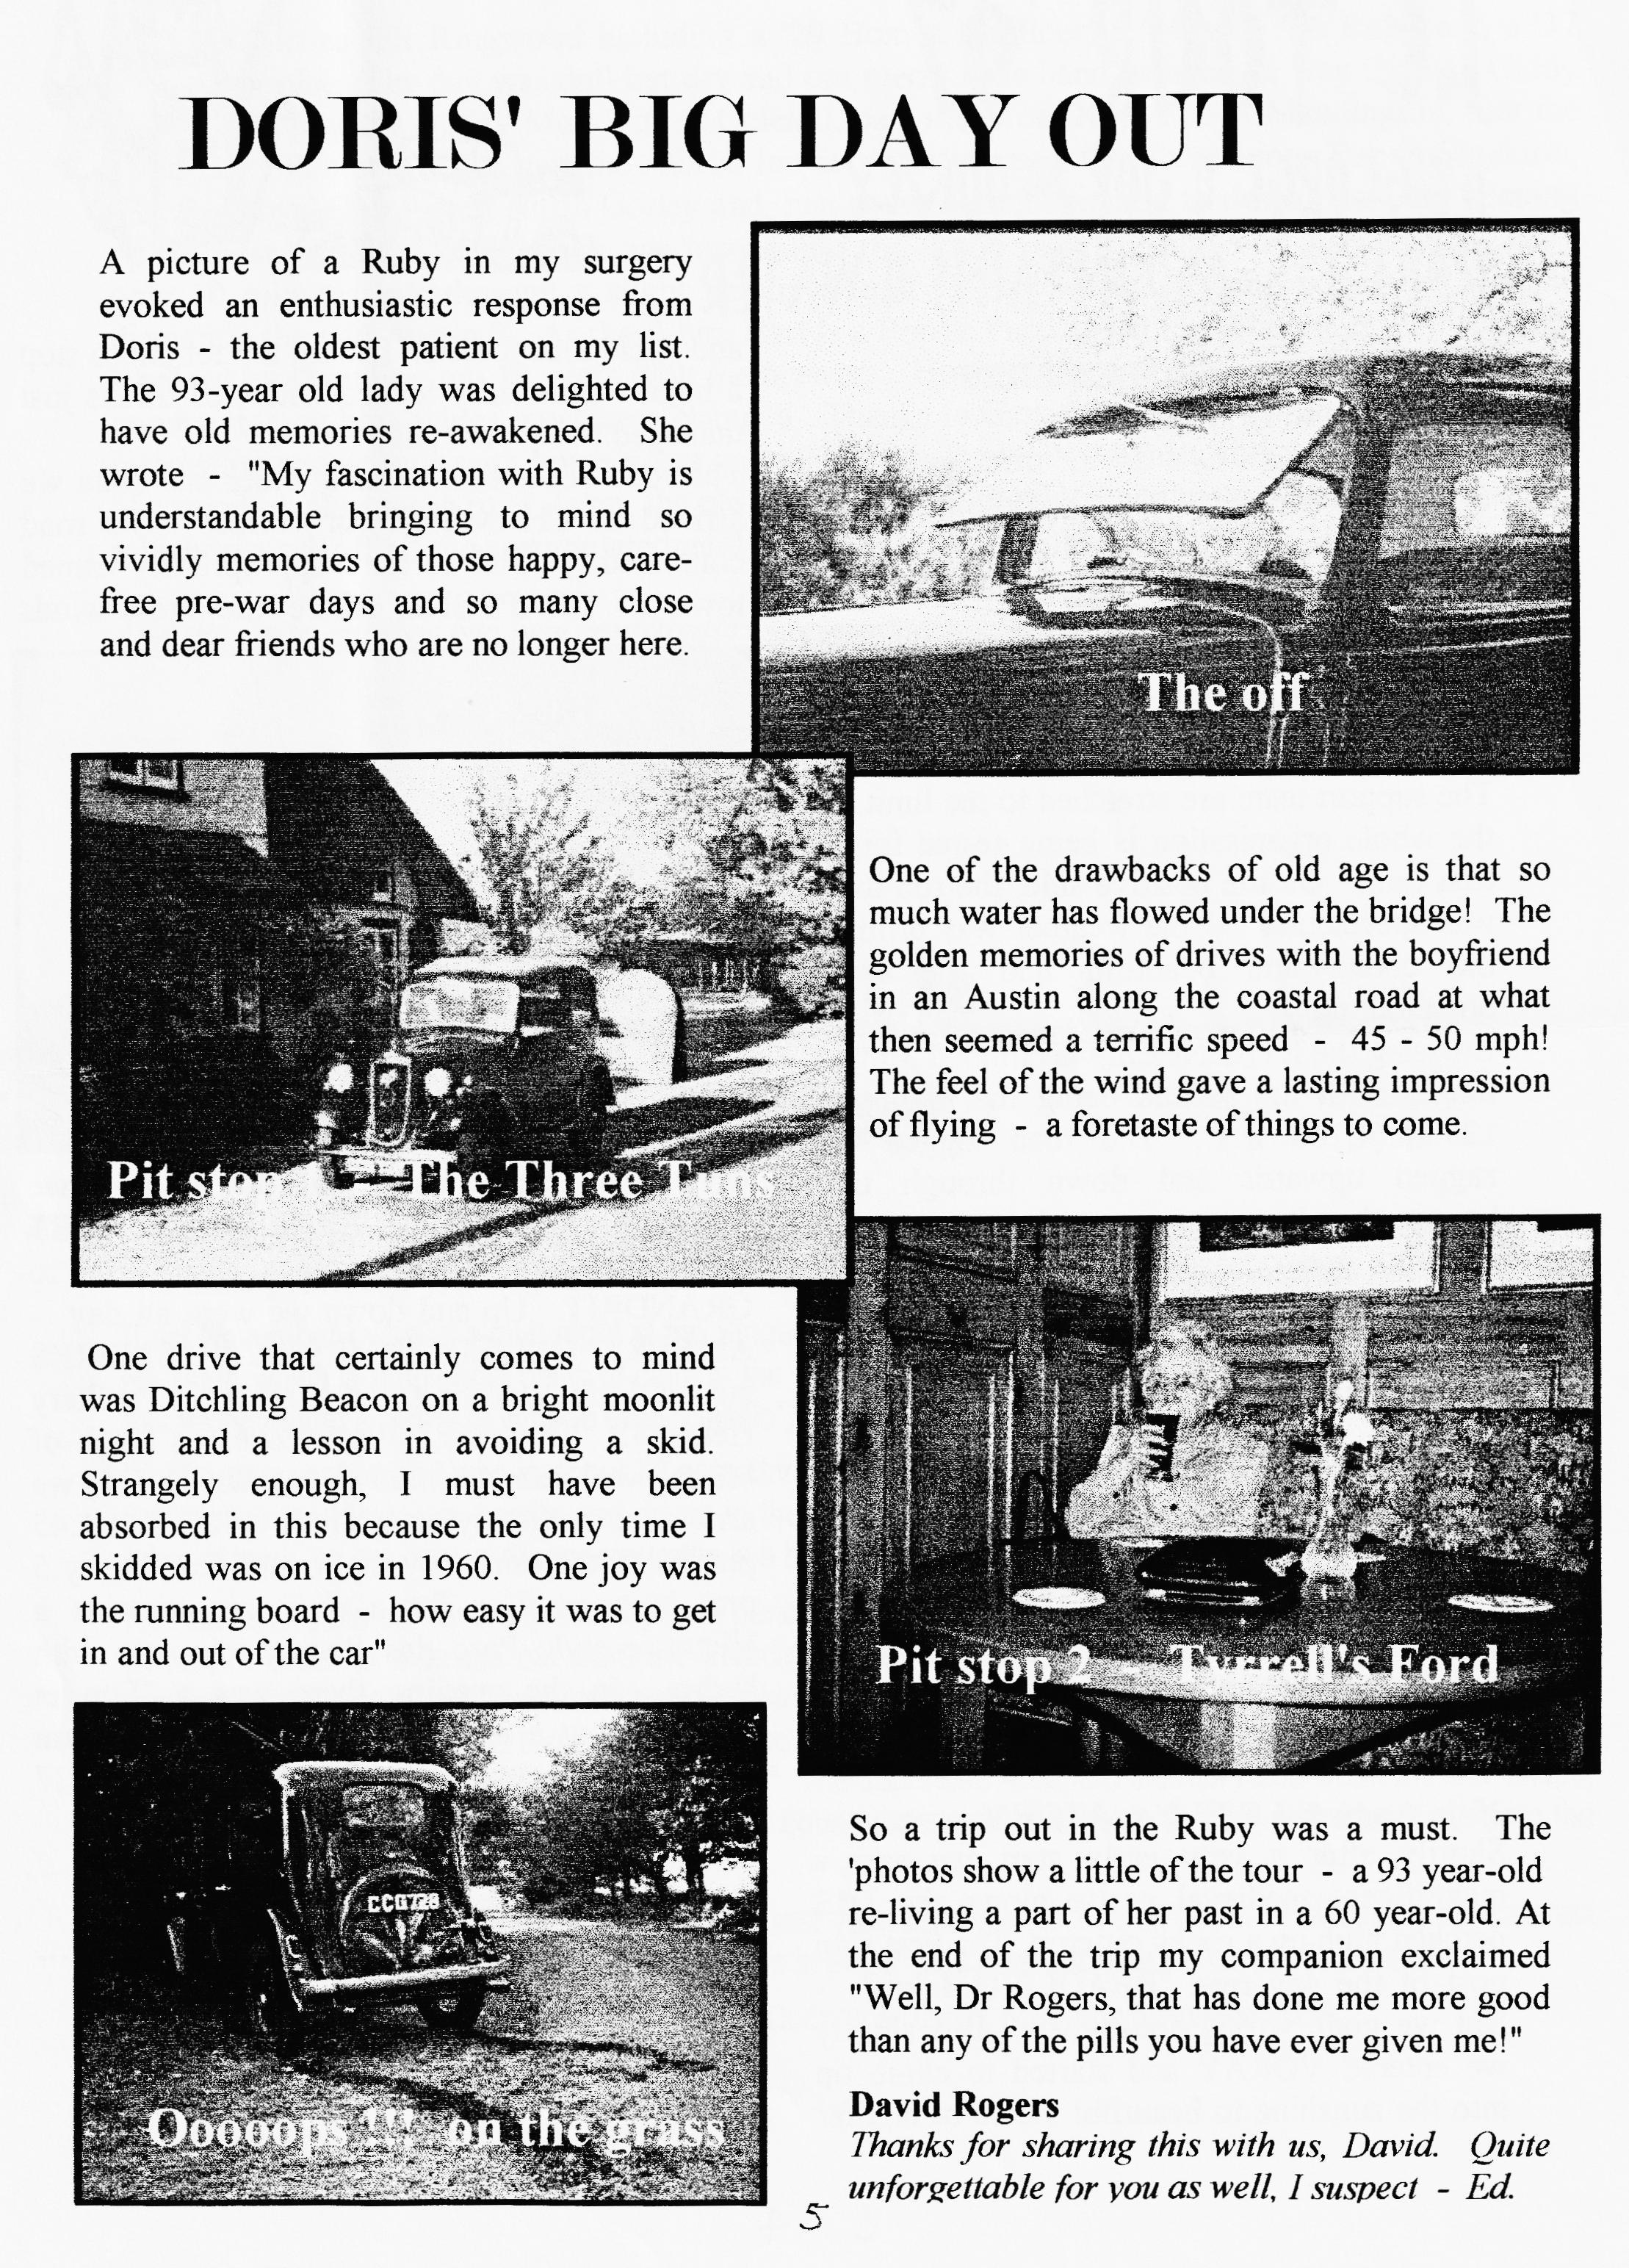

2nd. & 3rd. IN CLASS
FOR DORSET RACERS
 | 750 TROPHY CHAMPIONSHIP TABLE FOR 1997 - The final position
 | Points | Class | Driver | Mallory  23/3/97 | Snettenn  06/134 | Cadwell  04/5 | Lydden  17/5/97 2 rounds | S'stone (Stowe)  03/08 | Pembrey  20/09 | S'stone 1S/10
 | 28 | B | Ronnie Haynes | 5 | 1 | 4 | 8 | 10
 | 14 | B | Vince Leek |  |  |  |  | 6 | 8
 | 4 | B | Keith Hamer | 1 |  |  | 1 | 2
 | 37 | A | Graham Goode |  | 4 |  | 10 | 8 | 10 | 5
 | 14 | A | Graham Chambers |  |  |  | 6 | 7 |  | 1
 | 11 | A | David Whetton |  |  |  | 4  _ | 5 | 2
 | 3 | A | John  Skeavington |  |  |  |  |  |  | 3

Will the boys be out for the first race next year? - MARCH 22". MALLORY PARK. Watch this space for the latest news and hottest views in 1998.
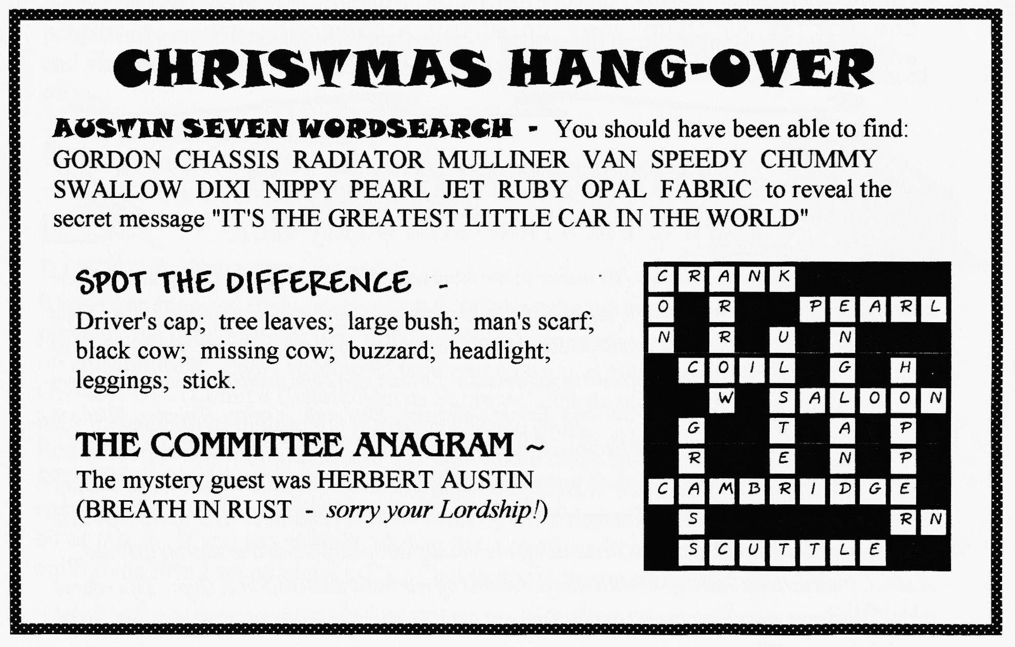

COMMITTEE BUSINESS
This month seemed a more serious affair as we discussed such weighty matters as the £80 donation to the MacMillan Unit, the DVLA Newsletter (see below), the saga of the more-than-probable move from the Elm Tree (watch this space as news breaks), the piston position (see below) and the Xmas Dinner for 1998 (same place, same time (12/12/98) - book now to avoid disappointment!) and an unexpected bomb-shell that 1998 will see Pat & Glyn's last organisation of our Swanage Rally. In order to achieve a seamless take-over, any volunteer could work alongside P&G this year to learn the ropes. More details next month.
THE WAY WE WERE - a blast from the past
From the Club magazine for JANUARY 1977
"The Club badges are well on the way to being produced. When they arrive they will be 20p each. Last month's turn-out for the Tabletop Concourse was very good with articles ranging from a modified gear box lid (for a boat) to an original oil filler accessory for a Chummy. First prize went to Gary Munn for a very good renovation of a wiper motor and 2nd. prize to Glyn for the door trim from his Ruby which he had made completely by himself.
EVENTS - 22nd. January is a Social Evening in the Skittles Alley of the "Fighter Pilot" Canford Heath. We hope you will bring along your wives and/or girlfriends (at the same time?!! - Ed) to the outstanding social event of the Dorset A7 Club year to enjoy a friendly game, a chat and a chicken-in-the-basket - all for 80p per head."
TO GO OR NOT TO GO
Glyn & Pat's New Year's Day Run
That was the question - whether 'tis nobler in the mind to stay aged awhile. yet the great heavens called, nay, but did open forthwith and spilled a vast ocean upon the ground and our heads. Only those of unsound mind surely would be abroad this very day. And yet 'twas so, for the hour of 10.30 am brought forth a goodly crowd of jolly Austin Sevens and their multitudinous passengers - George and Joy Mooney, Paul and Emma Mainzer, Ben and .Marion Trimby, „Richard Cressey, Gerry and Barbara Jeffries, Roy Birtwistle and family, Jill and Brian Tolster, Arthur Cox and family a ten-ing, John and Cynthia Page, John Cheeseman, Glyn and Pat and, of course, us - Gordon and Biddy. Sue and Mike Topham braved the elements in their open-top Alvis and new member Paul Perry came to see us off even though his own Pearly one was off the road.
A sheet, instructions bearing, to each was presented by our noble leaders Pat & Glyn. life roared into those brave wee chariots and to the challenge did they speed towards the highway: left, right, straight across, T junctions, unnamed roads, fords, on and onwards learning as we went: Boar
Continued on page 8
7

War start, miles to Salisbury, Silverstone in Forest Road, church on the shore in 1080 and much, much more.
But, maybe, the best of this was that all these twisty, twirly lanes did lead us to a great hostelry of joyous name - "The Globe". And in that haven (e'er yet in yon High Cliffe) our leaders of such hard labours did mark our scrolls until they declared "W1NNER!!" to Terry and Margaret Jeffries and unto the happy couple didst give a bottle of "special" brew. And we rest felt pleased that we none had disgraced ourselves in finding the right globe. Then away we each departed all pleased that we had faced the vital question of "To go or not to go" and had chosen "GO!!"
So, good friends let that your motto be.
1f in doubt in things Austin Sevening
"GO!!"and, we'll guarantee,
you'll-be in Seventh Heavening.

_Friends, to one and all; a very happy New Year and a big thanks to Pat and Glyn for a merry, and very eventful and above all, a fun-loving run.
Biddy Brown.
(See Biddy's advert on page 11 for mitigating circumstances - Ed)
BITS 'N PIECES - an occasional focus on SPARES
PISTON NEWS
Sometime ago I suggested that, on balance, you may be better off paying extra and getting Australian JP pistons from Tony Leslie. However, recently a number of people have experienced problems with this product in terms of inconsistent sizing and you may wish to consider, instead, supplies from the SEVEN WORKSHOP based on: -
✓ No previous piston problems
- Rings are made in New Zealand and no reported problems
✓ I will stock them in the Club Spares.
- Supplies will be guaranteed for a long while.
RUNNING-IN NEW RINGS
It has been reported that the use of MULTIGRADE OIL prevents the bedding-in of new rings resulting in excessive oil consumption. Some specialists recommend using a good quality "STRAIGHT" 30 GRADE OIL (Comma Classic/Morris Supreme/ Penrite etc.) for the first 1000 miles before changing to multigrade if that's what you prefer.
Remember, it is important only to use multigrade oil in an engine which has been STRIPPED DOWN AND ALL OILWAYS SCOURED OF SLUDGE, including the camshaft. If you have spent time and money on an engine overhaul do not use cheap oil or mix it. If you use straight 30 then use a good quality as above or if you prefer multigrade then I recommend GTX - but that's up to you of course.
Phil

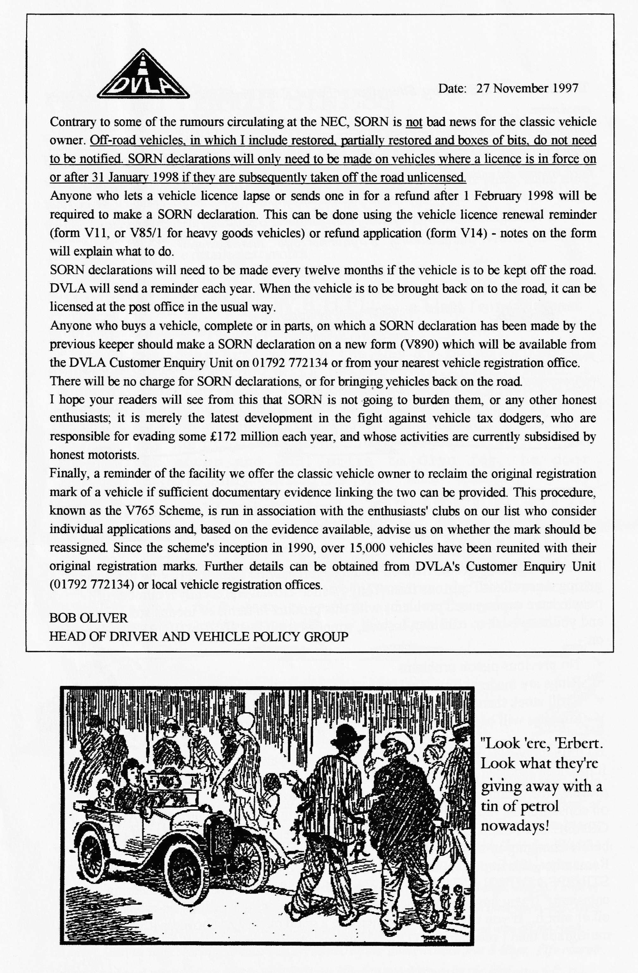

NEW MEMBER
Welcome to SUSAN BENNETT of Durweston with her 1936 A7 Ruby which she has owned for the last 20 years! It is black (what else!) with fawn interior and red seats. The genuine mileage is 50,000 miles although it is currently off the road awaiting a new coat of paint. Susan is only the third owner. Say hello at club night.
FOR SALE
Chassis', mag/coil engines, 3/4/speed gearboxes, axles, road springs, wheels, brake parts (incl. Girling), body parts, headlights, sidelights, instruments suitable for specials, original handbooks and1927/39 parts lists, seven-related books, hundreds of items at sensible prices.
For sale: my own 1934 chrome rad van immaculate condition after recent "wings off' professional respray. Fun to drive with advertising/film work potential, V5, MOT, £5,600. (Non-running road/race 7 "special" requiring restoration or Morgan 3-wheeler or flat-rad 4-wheeler requiring restoration + Morgan spares or pre-74 single seat racing car, any formula/condition considered in part exchange) Ken Medlicott (01963) 440604 (T)
WANTED
One 18" Austin Seven road wheel - Bernard 01202 - 887666
One A7 Ruby PETROL TANK in good condition - John Harris but please ring Vince 01985 - 847658 (day) 01985 - 216632 (eve)
CLUB FAMILY NEWS
A Christmas Card from John Weaver reports he is on the mend and hopes to be with us soon. What a trooper!
Leesa, beloved daughter of Jeff & Marilyn Bridge, has graduated from Southampton Institute with a BA in Social Sciences. What a winner!!
ROLL UP! - ROLL UP!
Lymington Players present - -THE LINDEN TREE" By J B Priestley
Produced by Bibby Brown and starring (!) Gordon Brown
Feb 3th - 7th. Ring Box Office 01590-671337. Bookable by Credit card
Community Centre, Lymington

oo CLUB DIARY oo
January
Thursday 15th Jan Club Night - Grand Spares (ex Ken Medlicott and Members' Bring-and-Buy Sale. Bring your own clean, good AUSTIN 7 spares properly labelled and realistically priced. This is not an auction and there will be no Club percentage. FOR MEMBERS ONLY FOR THEIR PERSONAL USE.
Sunday 18th Jan Club Run - by John Page. RINGWOOD 10.30 am for 10.45 start.
Thursday 22nd Jan. Committee Meeting. Tyrrell's Ford
February
Thursday 5th Feb. Eight-till-Late The Manor, Christchurch Road, Parley Cross
Saturday 14th Feb St Valentines Dance Pamphill, 8pm. Ring 01202-575167
Thursday 19th Feb. Club Night. ANTIQUE WEAPONS - a talk by Basil Faraway
Sunday 22nd Feb. Club Run. - by Bernard. Details next month
Thursday 26th Feb. Committee Meeting. Tyrrell's Ford
oo FUTURE EVENTS oo
Thursday 19th March Club Night - watch this space for details of new venue.
Sunday 22nd March Dusty's annual MUD RUN.
Saturday 28th March Skittles, Monmouth Ash
Sunday 24th. May Coast to Coast '98 - details later
Saturday/Sunday 5/6th. September Pennine Run - details later
