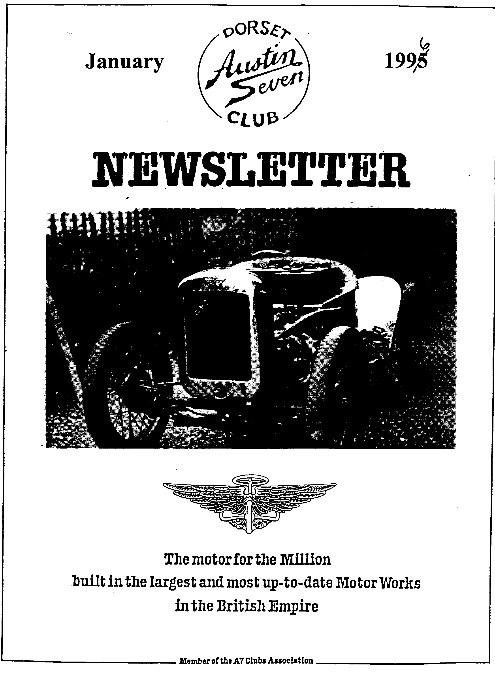

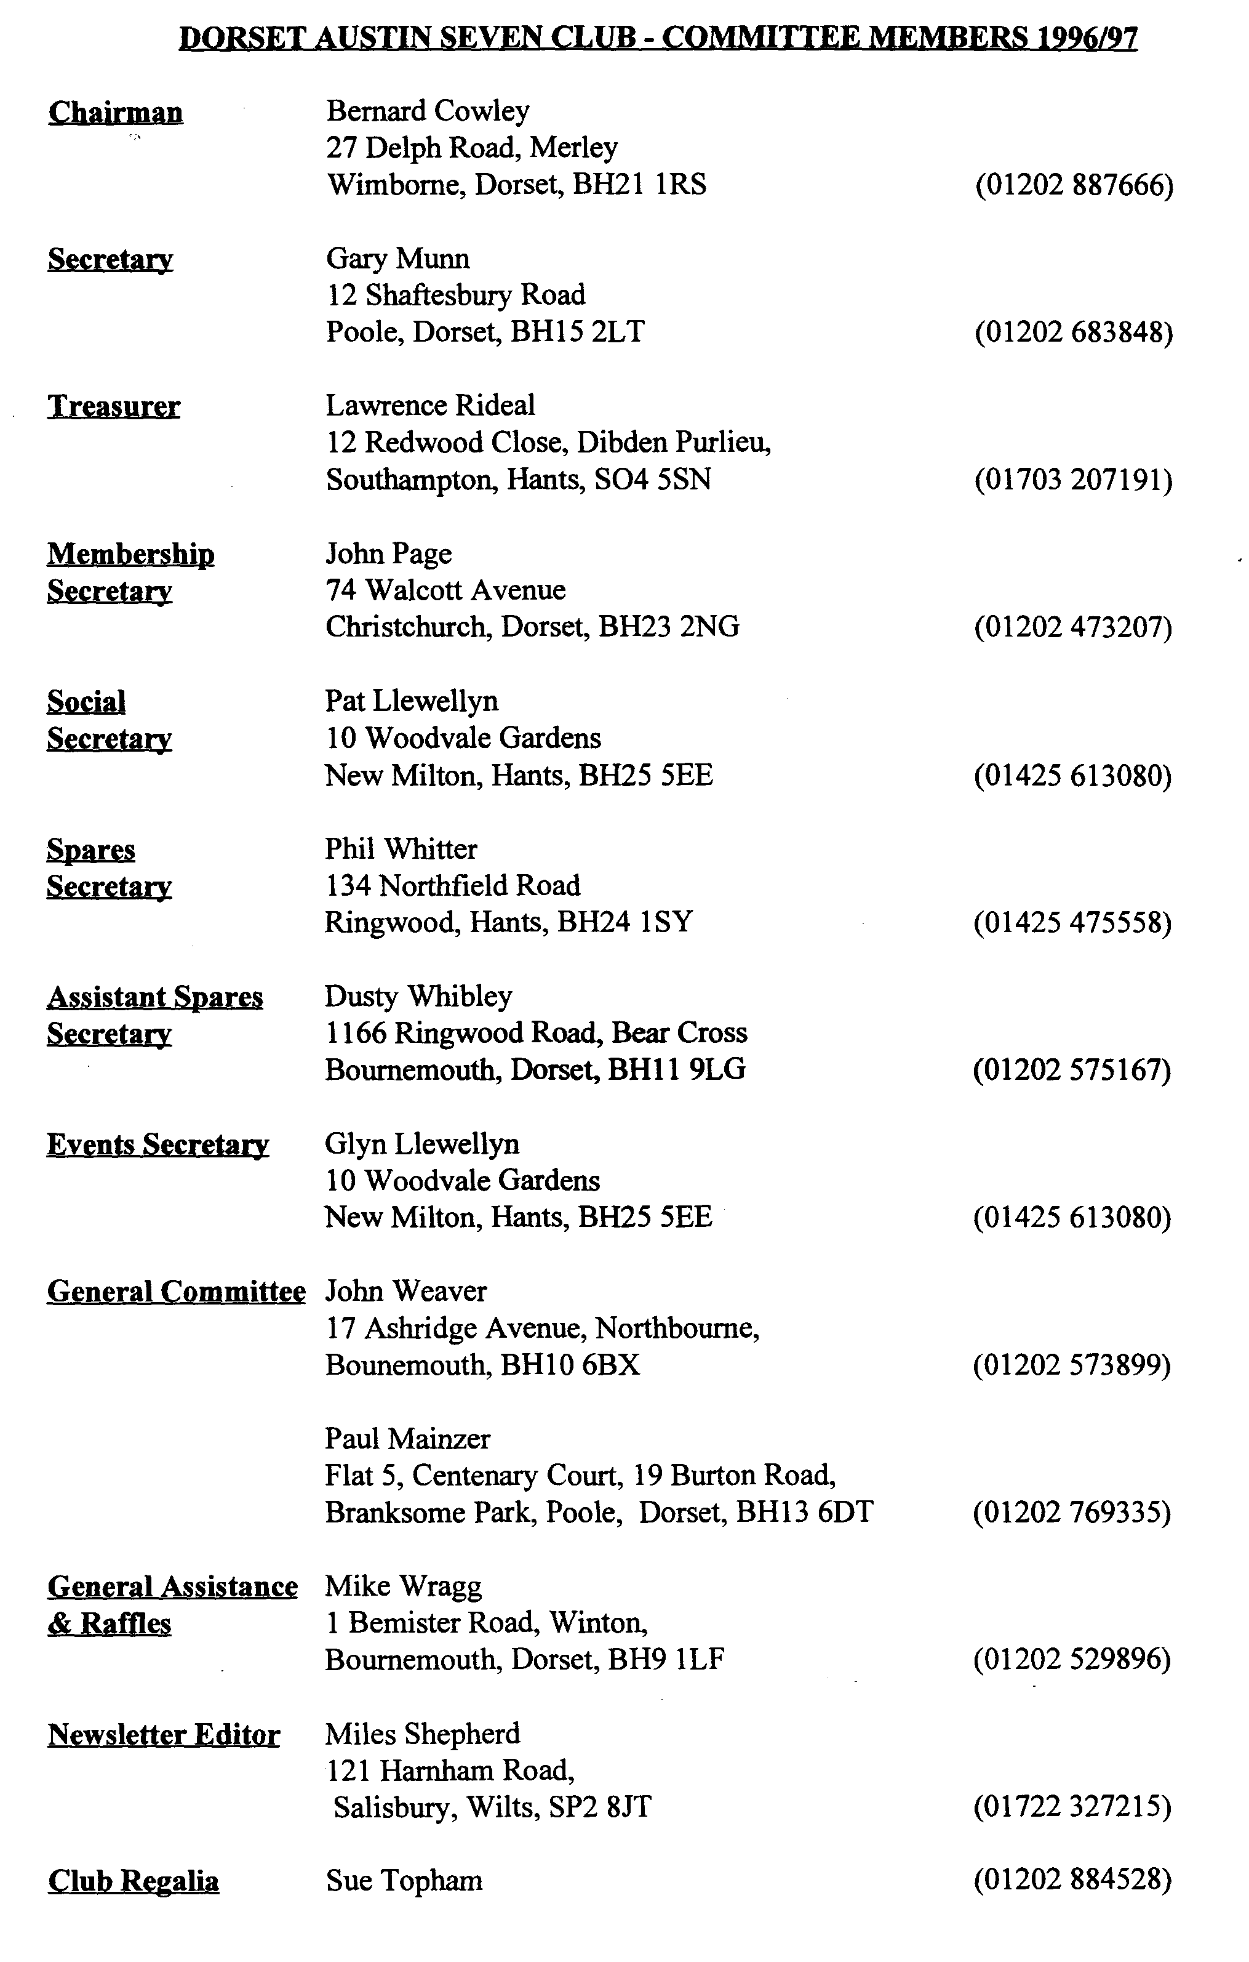

January 1995
EDITORIAL

Hallo Everyone,
As you read this month's offering, you will see that I have relied on articles from many other Austin newsletters. This is partly because I am low on original material but also because some of the material is very useful for members restoring cars. If you have a particular need, please let me know so that I can see if we can provide information to a wider audience. I don't feel too guilty since in most cases the magazines from which I copied material have copied some of our articles or cartoons!
John Page tells me that Paul Henwood wins the draw for the early membership and will enjoy a free subscription next year.
As this is the start of a New Year, I feel it is appropriate to thank some of the many people who have made contributions to the Club. First to those who have written articles or supplied material for this Newsletter, many thanks for making my life easier! Everyone is also grateful to the generosity of all those who have provided prizes for the raffle. Particular thanks to Glyn and Pat Llewellyn for organising so many memorable events in 1995 and last but by no means least, thanks to all our members for taking part in a very friendly Club and making it such fun to belong to.
BFN, Miles

Deadline for the next issue is 29 January -but I'd prefer to have copy at Club Night!! The cover shows Alec Issigonis' Ulster built in the Mid 30's for a Shelsley Hill Climb
SECRETARIAL

Well Folks!
As I sit here at work, Christmas is over and the New Year is still ahead of me. It seems that after all the build-up, the festive season is over in a flash!
The annual Christmas Dinner was again a great success, everyone seemed in good spirits. It's a shame the service was so slow but I believe that we did get an apology from the staff. Apparently they were two chefs short. Anyway, a change of venue may be sought for next year. Treasurer Lawrence tells me that we raised £100 for the Wessex Children's Hospice - excellent news!
I organised the December run; the weather was diabolical. I couldn't even see the car behind half the time; nevertheless, we had a reasonable turnout and were, as usual, made most welcome at the Cartwheel at Whitsbury.
December club night was traditionally fairly modestly attended, with the annual noggin 'n natter and just a few spares sold, enabling members to escape to their garages over the festive period!
A reminder from Pat - don't forget our skittles night in February at the Monmouth Ash, Verwood (see page 7 for details), it's always a light hearted evening, you really don't have to be very good ....no one is worse than me!
I've recently finished a 1933 Opal which is now on the road. Garage space forces me to sell either it, or my 1938 Pearl. Both are nice cars, can I tempt anyone to either as I can't make up my mind which has to go!
See you - Gary

Roof Repair and Renovation (Part 2)
After undoing the roof lining, a portion of each side roof panel is unfastened. Then the front rail is unscrewed at the ends from the cant rail and the ends of all lengthwise members released. A new rail is made with the old one used as a pattern. By adopting a lap joint as shown in Fig. 4, (see last month for this fig) the new rail is easily inserted from above. To strengthen the joint between the front rail and cant rail, small plates may be screwed on the inside corners. The side panels and roof cover are re-fixed, also the drip moulding, after which the screen is inserted and the roof lining replaced.
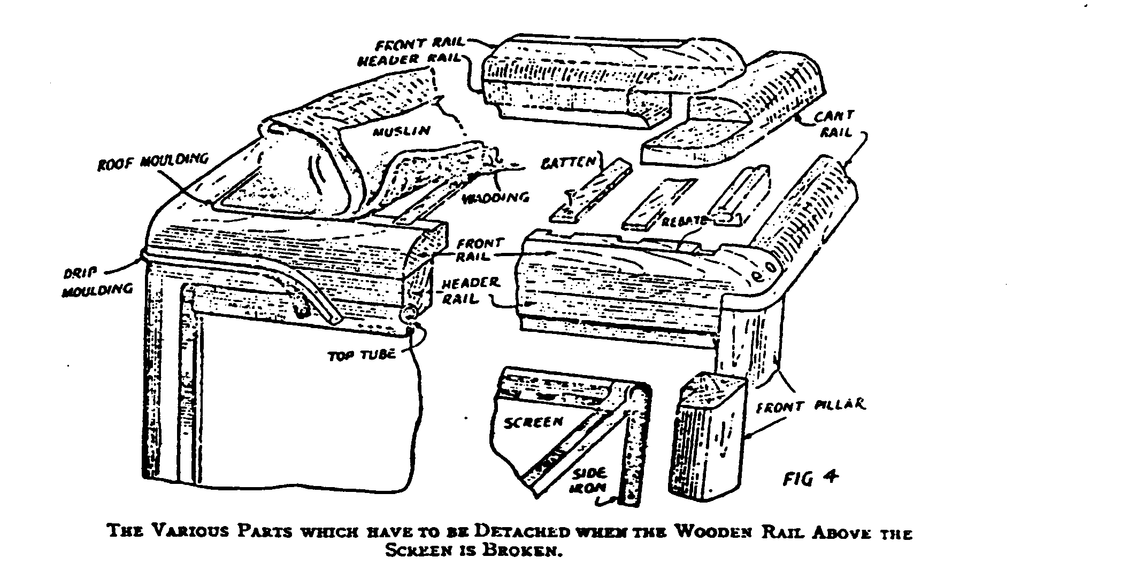
Spicing a Broken Cant Rail
The top illustration in Fig. 5 (see over) shows a broken cant rail and it is proposed to splice it instead of inserting a new rail throughout. After removing the drip moulding, also the roof lining around the damaged area, the cant rail is sawn through each side of the fracture. A new cant rail section is prepared which, as shown in Fig. 5, is first notched for the ends of the side panel ribs.
If the portion of cant rail to be replaced includes a joint with a body or standing pillar, then the new rail is lapped or mortised for this pillar. The exposed ends of the existing cant rail are next cut for a splice and the new piece is shaped accordingly. The splice at each end is cut so that it may be fitted from underneath. At the bottom of Fig. 5 the new portion of rail has been screwed into position.
Re-covering the Roof
If the roof leaks badly, the only remedy is a new cover. After removing the metal moulding all round the edges, the tacks are released which fasten the material to the wooden framework. When the wadding is taken off, the roof should be examined for any defective places. Test each joint of the battens with the hoop sticks to ascertain that all is secure.

The leather cloth is cut to size with an allowance of 1¹/2 in. all round, so that it is both 3 in. longer and wider than the roof opening. A good method of stretching the cover into position is to tack it first in the centre of the front and back edges, then at a corner, followed by tacks in the diagonally opposite corner. After this the other corners are secured. The next stage is to complete the tacking of the front, then the back-and finally the sides. Here the tacking proceeds from the centre to the ends. When the edges of the cover have been trimmed it is then ready for its moulding.
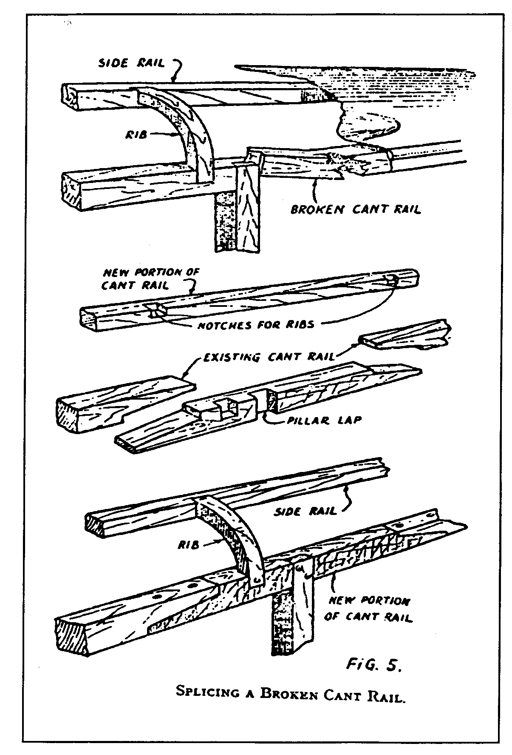
Roof Mouldings
It is advisable to use new metal mouldings rather than attempt to replace the old one. The moulding which conceals the edges of the roof cover usually has a flange. This is folded over the part where the nails or screws are placed so that the heads of the fastenings are hidden. This flange is secured in place neatly by hammering it
clown with a piece of wood which is
shaped on the underside to fit the moulding when closed.
The drip moulding, or roof guttering, is made in a similar manner. It has an upper lip or flange for folding and a channel at the bottom which forms the water gutter. This can be seen clearly in the illustration.
Reviving a Roof Cover
To revive a roof cover which is shabby but waterproof, it is first scrubbed with soap and water, well rinsed and wiped dry with a cloth. Any unevenness of surface is corrected with fine sandpaper applied gently, because care must be taken not to create any thin places. After dusting the roof, a coat of dressing or paint is brushed on. This paint may be purchased specially prepared for the work. The first coat is allowed to soak in thoroughly, at least overnight, then it is ready for a second coat, which, when dry, may receive a coat of wax polish.
- o 0 o -
Many thanks to Joe and Maggie Stalker who let me borrow their copy of the Vintage Austin Magazine, published by the VAR of Australia from which this article is copied. That said, I seem to remember a very similar piece by Phil Baildon several years ago. Anyway, hope you find this useful

Gary’s Pre-Christmas Run
A short, leisurely run was what I expected for the last run of 1995, and it was just as well considering the poor weather for the start of the run. Four maroon and two brown Austins set off from the Leisure Centre in Wimborne, with the families of Jeffries, Wilbourne, Mainzer and Munn in maroon while the Pages and Cawleys were in brown. Grandad Bernard was accompanied by Zak and Ethan.
The run went through the lanes towards Salisbury, with lunch at the Cartwheel in Whitsbury, a very nice country pub which serves good food. Towards the end of lunchtime, Phil and Hillary arrived with Dusty and Scott. The landlady was much taken with Dusty or his car, or both, and was last seen well wrapped up in warm clothes and a funny hat, going for a spin round the country lanes for a taste of vintage motoring. Her comments on the journey are not known.
So that was it for 95, thanks to Gary for organising the day, roll on 1996.
John Page
A Bit Of A Wind Up
w
ith a dull click my window disappeared down into the door recess of my Seven. On all previous occasions there had always been about an inch showing above the aperture in the door-frame.
When I then attempted to wind-up the window to close it the whole lot speedily descended whilst at the same time the window handle pirouetted gracefully clockwise. What had gone wrong? One of the Essex Austin Seven Club's Sunday runs was due to take place three days later and I was sure that the experts would know what to do. It was, however, the usual story and I should have known better. 'Oh! Mine's just the same. I use a wedge to keep it up, but the window on the passenger's side is OK' and the other variant 'They all go like that in time'.
This meant a few hours spent assessing the situation and attempting to find an effective solution. Eventually my technical know-how produced a short length of bungee-type luggage strap - one end of which I fixed round the window handle and the other end I fixed round the rear window winder. The snag here, however, was that I had to disconnect it each time I got in and out of the car! The Mark II variant much admired by other non-technical club members was shorter and instead of fixing it to the rear window I screwed in a small hook just above the door lock. Now I could open the door without bungee jumping. The day dawned, however, when I became dissatisfied with this lash-up and decided to take the lot apart to identify the cause. In my drawing I have attempted to show the main components of the winding apparatus.
To gain access to the inner workings of the window-winding gear the door skin has to be removed. This is achieved by removing the handle (F) by unscrewing the retaining screw (H). Next, release in any order - the door chain, the handle which is pulled to close the door, the lock mechanism and the pins which hold the oilcloth covered plywood to the door frame. With a downwards and outwards pull this will come away from the door and leave exposed the winding mechanism. In unrestored cars this is the time to notice deterioration around the bottom edge of the door. The ply-wood may have woodworm or just senile dementia and it is most likely that the door skin itself will be in a poor state where it is folded under to receive the framework for the door.
The mechanism is located on a plate which is held in place by four screws. In earlier models these are set into captive bolts but in my '37 Pearl the plate is screwed directly into the woodwork of the door frame. Before unscrewing these four fixings it is a good idea to mark the relative positions of the cogs and arms of the mechanism. This will assist with reassembly! Once released the winding gear can then be lowered making it possible to slide the two runners out of the channel under the window glass leaving the window itself still in place.
Next comes the tricky bit. The drum (E) is attached to the main plate by five lugs which must very carefully be prized open. Take your time with this operation so as not to break them off - we are not dealing with a pliable metal.
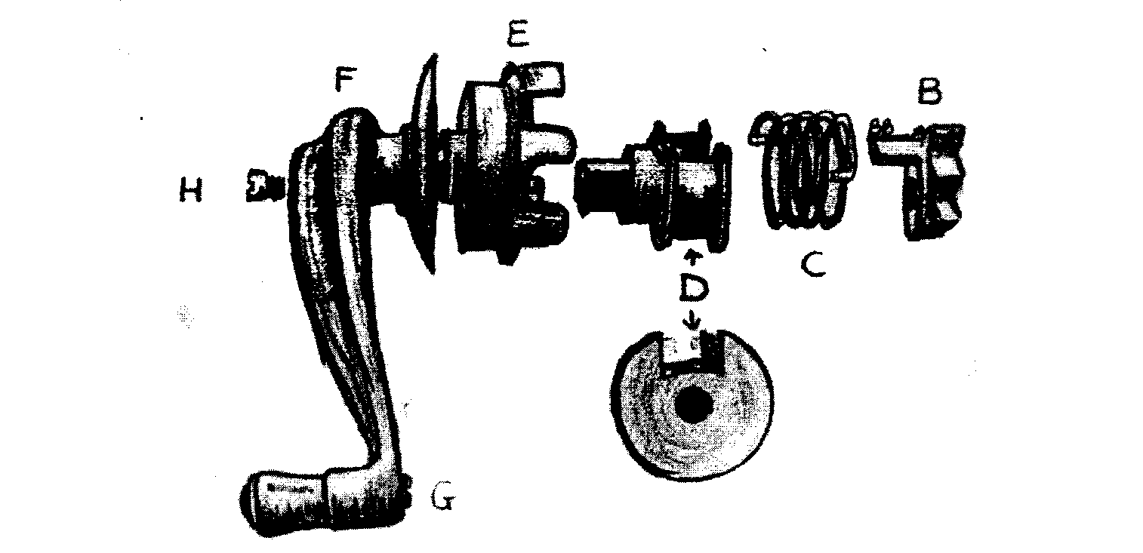
Once straightened out a few gentle taps on each of them in turn will disclose the essential inner workings of the mechanism. At this stage there should be four separate, loose items - the drum (E), the spool (D) with its spring (C) and a small cog-wheel (B) which has five cogs and a lug attached. This cog revolves around a spindle (A) which is attached to the backplate by a rivet. It may be necessary to give the square arm on (E) a gentle tap to release the spool and spring.
It is the spring (C) which is usually broken. At each end the spring should be bent inwards at right angles as shown in the diagram (J). It is one or both of these ends which will be found to have broken. The lug on (B) presses on these parts of the spring when the weight of the window is received by it through the cogs and this has the effect of opening out the coiled spring. This in turn jambs the spring, like a brake shoe, against the inside of the drum (E). However, when the handle (F) is employed, the spring tends to get wound up, thus reducing its diameter allowing the spool to revolve inside the drum to enable the operator to raise or lower the window.
All we have to do now is to find a suitable replacement spring... Has anyone out there got any ideas, if so spring into action at once. In my opinion there must be at least 500 required. I'd like
two please! Bart Walsh, EA7C
This article first appeared in CHASSIS, Magazine of the Essex A7C, thanks for the information

The New Year's Day Run
Through the eyes of Austin Seven Box Saloon ARM J06
New Year's Eve in the Austins' Garage:-
AKM to others: "I think it's my turn this year to take Terry and Barbara on the New Years
Day Run 'cos he was out here giving me the once over. When I get back tomorrow, I'll give you all the gen."
New Year's Day Evening, back in the Garage: -
The other Austins to AKM: What happened then? Tell us everything!"
AKM: "It was great! There were 16 Austins, in all the colours and sizes, 1 Morris
Tourer carrying the Tophams and 4 moderns carrying the youngsters. The weather wasn't too good but we all set off following Paul and Emma's Box (same colour as me). We went through Pamphill to the valley along by the river towards Shapwick where a little red van came to a halt. I think the Gremlins had been at work and pulled off one of his plug leads. No problem, Glyn soon put them back to rights in no time. On our way again, crossing over at Spetisbury and on to the A31. This was good fun for us Austins, we held up loads of caravans and cars, our little lights sparkling through the gloom. A few of us took a detour towards the `World's End' and then rejoined the convoy to Bere Regis. The weather was really miserable, fogy and damp and we couldn't see much. I think our owners were getting thirsty as the tempo lifted as it got closer to 12 o'clock. It's a good job Terry and Barbara didn't put on too much weight over Christmas or I would have puffed even more.
We roared along in grand style until we arrived at the watering hole - "The Sailors Return" at East Chaldron. A few hours later, they all came out. It must have been a brilliant pub because they were all jolly and suitably refreshed. Terry pumped my tyres up and off we went again in small groups to wend our way home. I really enjoyed myself; I wonder whose turn it is next time.
Night, night, sleep tight - hope the Rust Bugs don't bite!"
Many thanks to Paul and Emma for an enjoyable day
From AKM - via Barbara and Terry
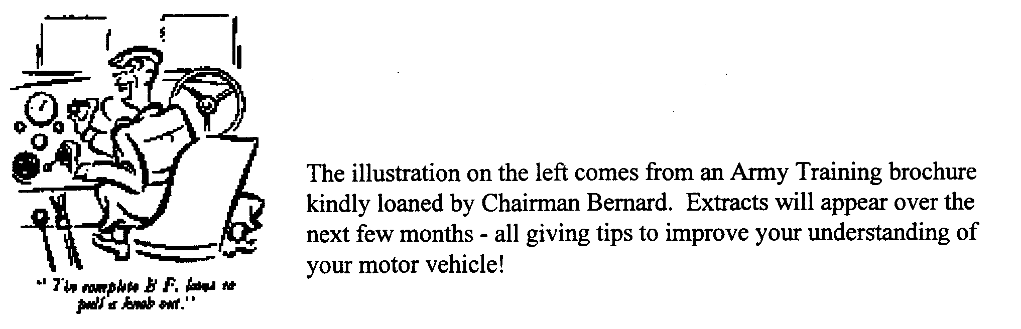

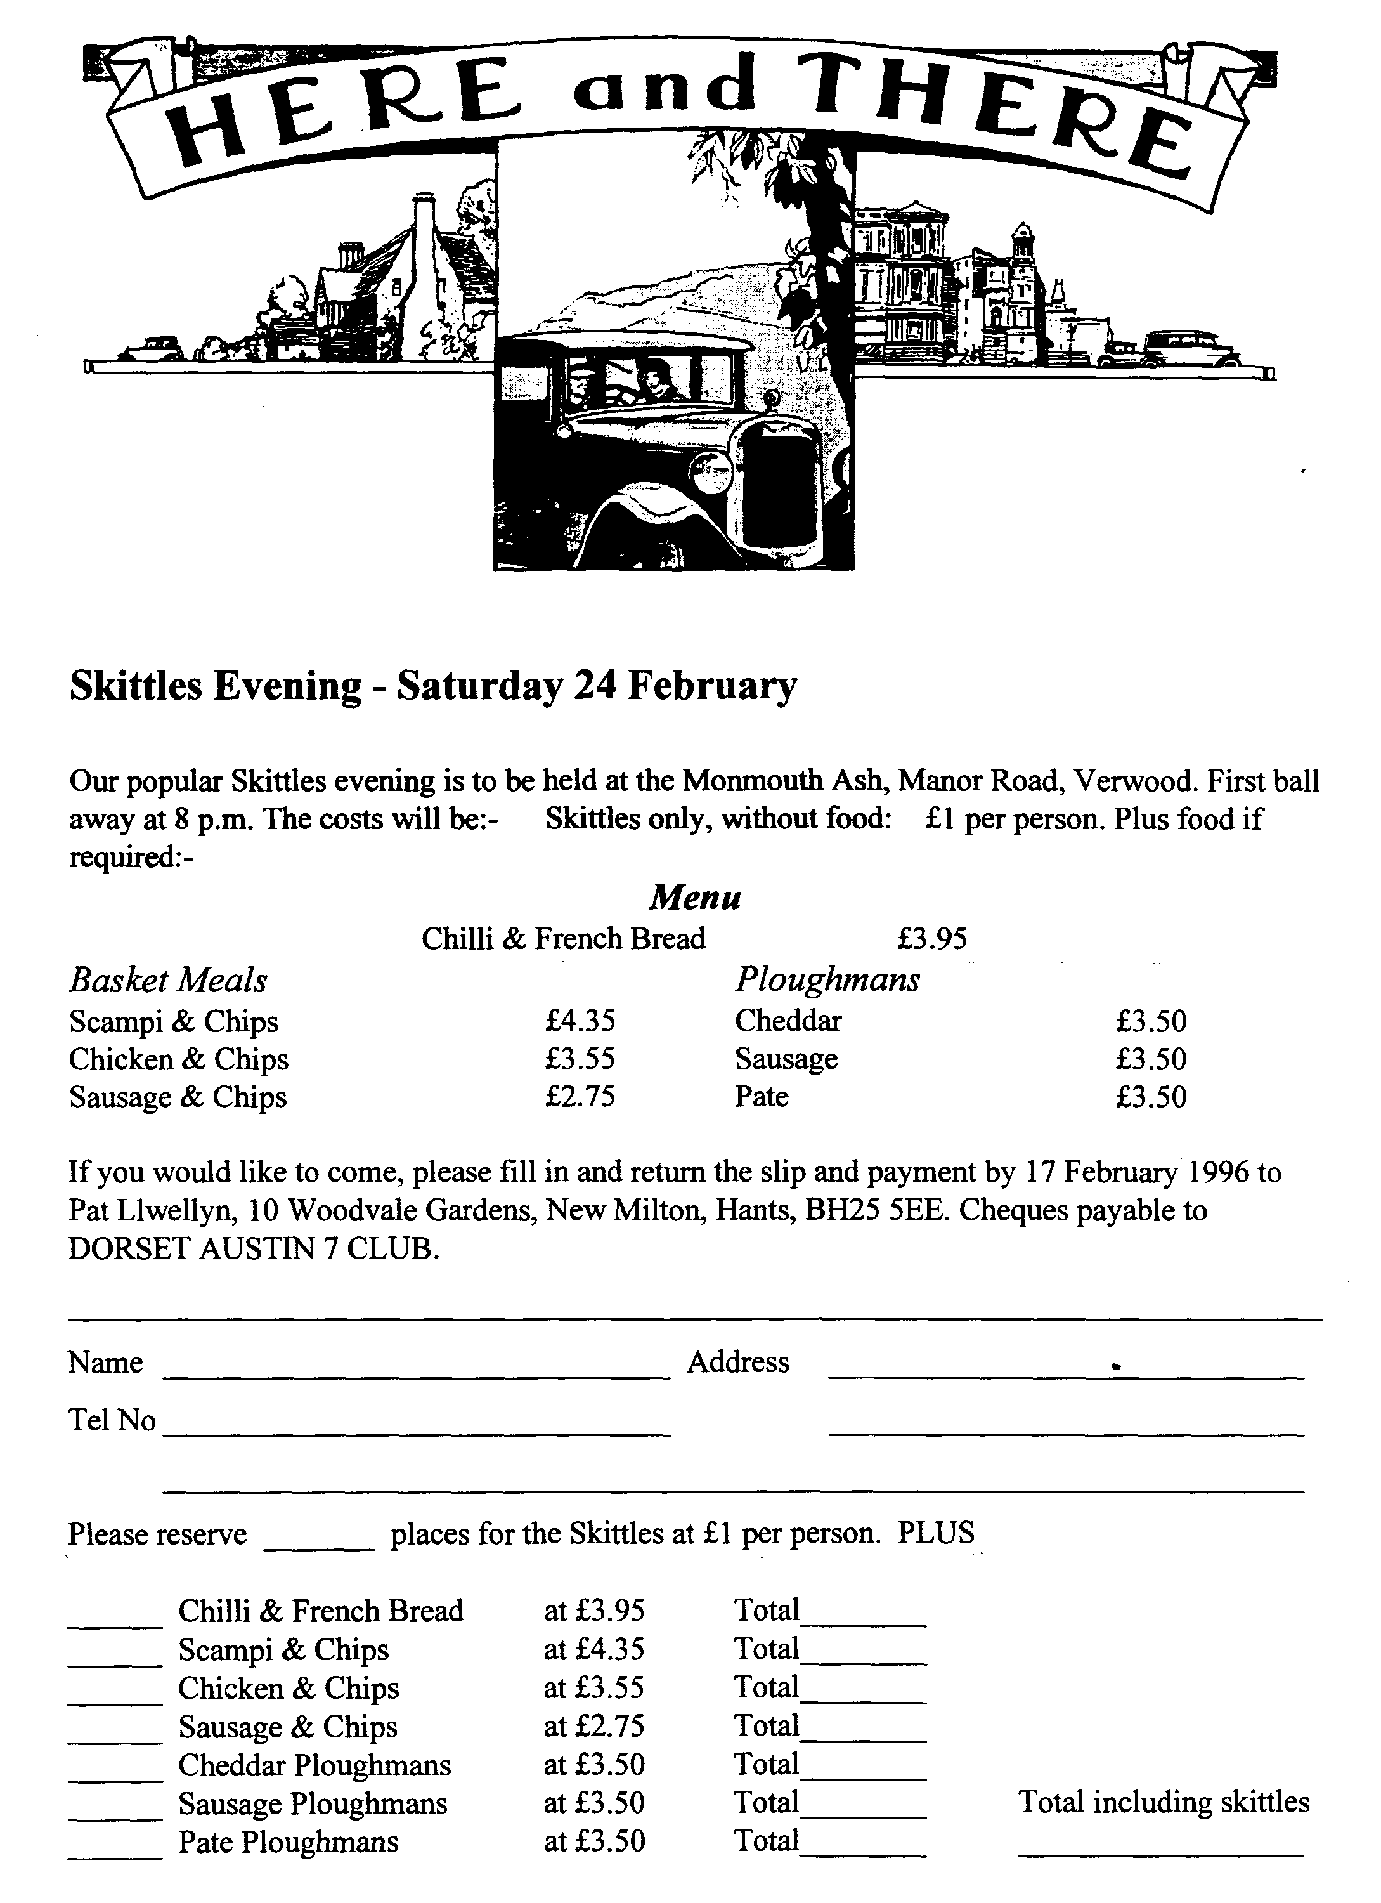

EVENTS
January
Thursday 18 Jan Club Night. The New Year starts at the Elm Tree with an illustrated talk on Poole. We have booked a well-known and entertaining speaker to give us an insight on the old town. No spares but all the crowd will be there.
Sunday 21 Jan Club Run. Lawrence is leading our first regular run of the year. Meet at the
Cat and Fiddle on the A35 at Hinton Admiral at 10.30 for a 10.45 start.
Thursday 25 Jan Committee Meeting. You Committee gather to discuss complex and weighty matters and so will gather at the Tyrell's Ford at about 8.30 p.m.
February
Thursday 1 Feb Eightish till Late. Meet at the Three Tuns in Bransgore where I gather they
do a very nice drop of 49-er!
Thursday 15 Feb Club Night. This is Merv's Quiz! These are always really good fun and cover a wide range of interests, not just motoring or Austins. Merv did tell me the topics but I have lost his note! The main point is that you need to form teams of up to 6 members. Mery will take care of the rest
Sunday 18 Feb Club Run. Either Dusty is organising his well-known Mud Run or Phil will
be plotting a more traditional road event. The final details will be made know at Club Night. Either way, meet at the leisure Centre in Wimborne at 10.30 for a 10.45 start - prompt!
Saturday 24 Feb Skittles Night. Meet at the at the Monmouth Ash in Verwood. Food orders to Pat, please, by 17 Feb 96. Prices have been held at last year's level so a good turnout is anticipated! Please see page 7 for full details.
Other Events
Saturday 27 Jan VSCC New Year Driving Tests. These are being held at the Brooklands
Museum site in Weybridge. The first car away is 10.45. Tickets are available on the day only at £5 per adult and £3 for children under 16. Family tickets for 2 adults and up to 3 children cost £14.
Full details of VSCC events are available from the Editor but extracts showing 'local' events will appear in the newsletter, usually a month before they take place. Let me know if there are any you need to know about earlier.

