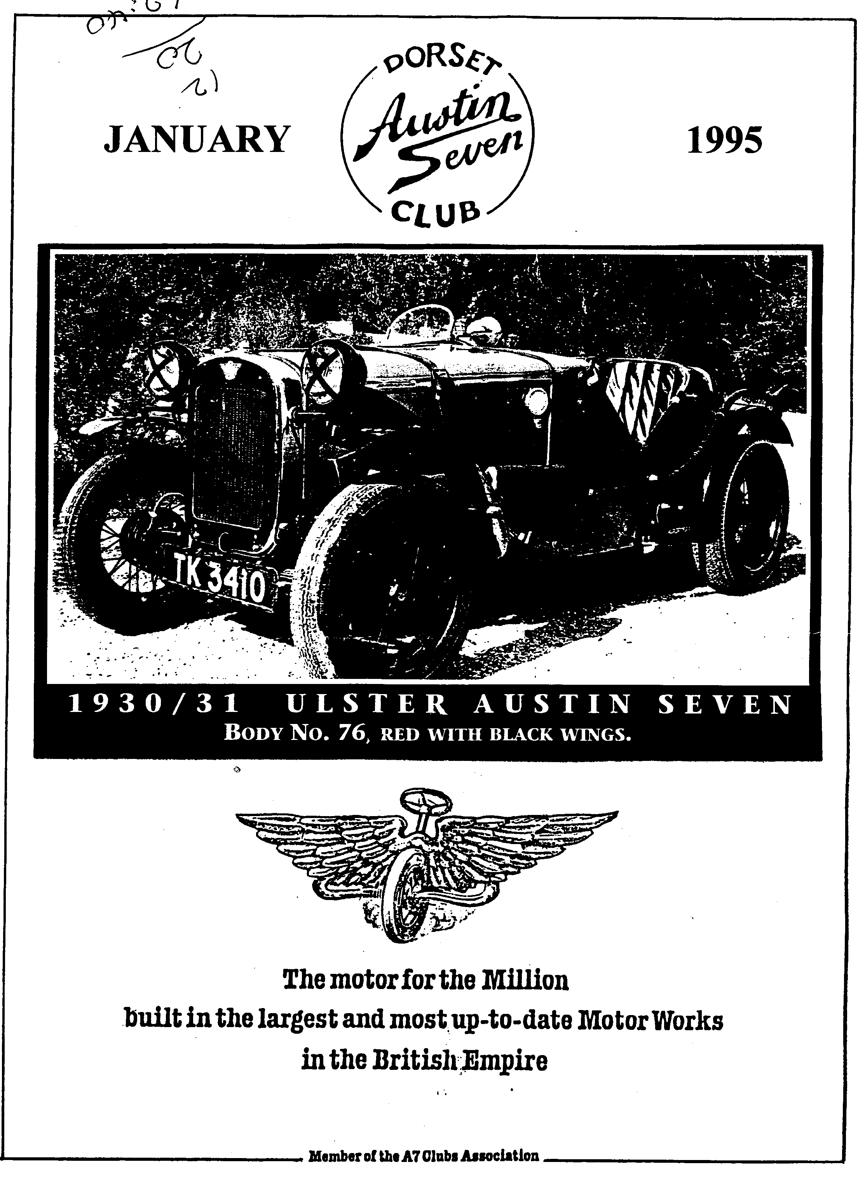

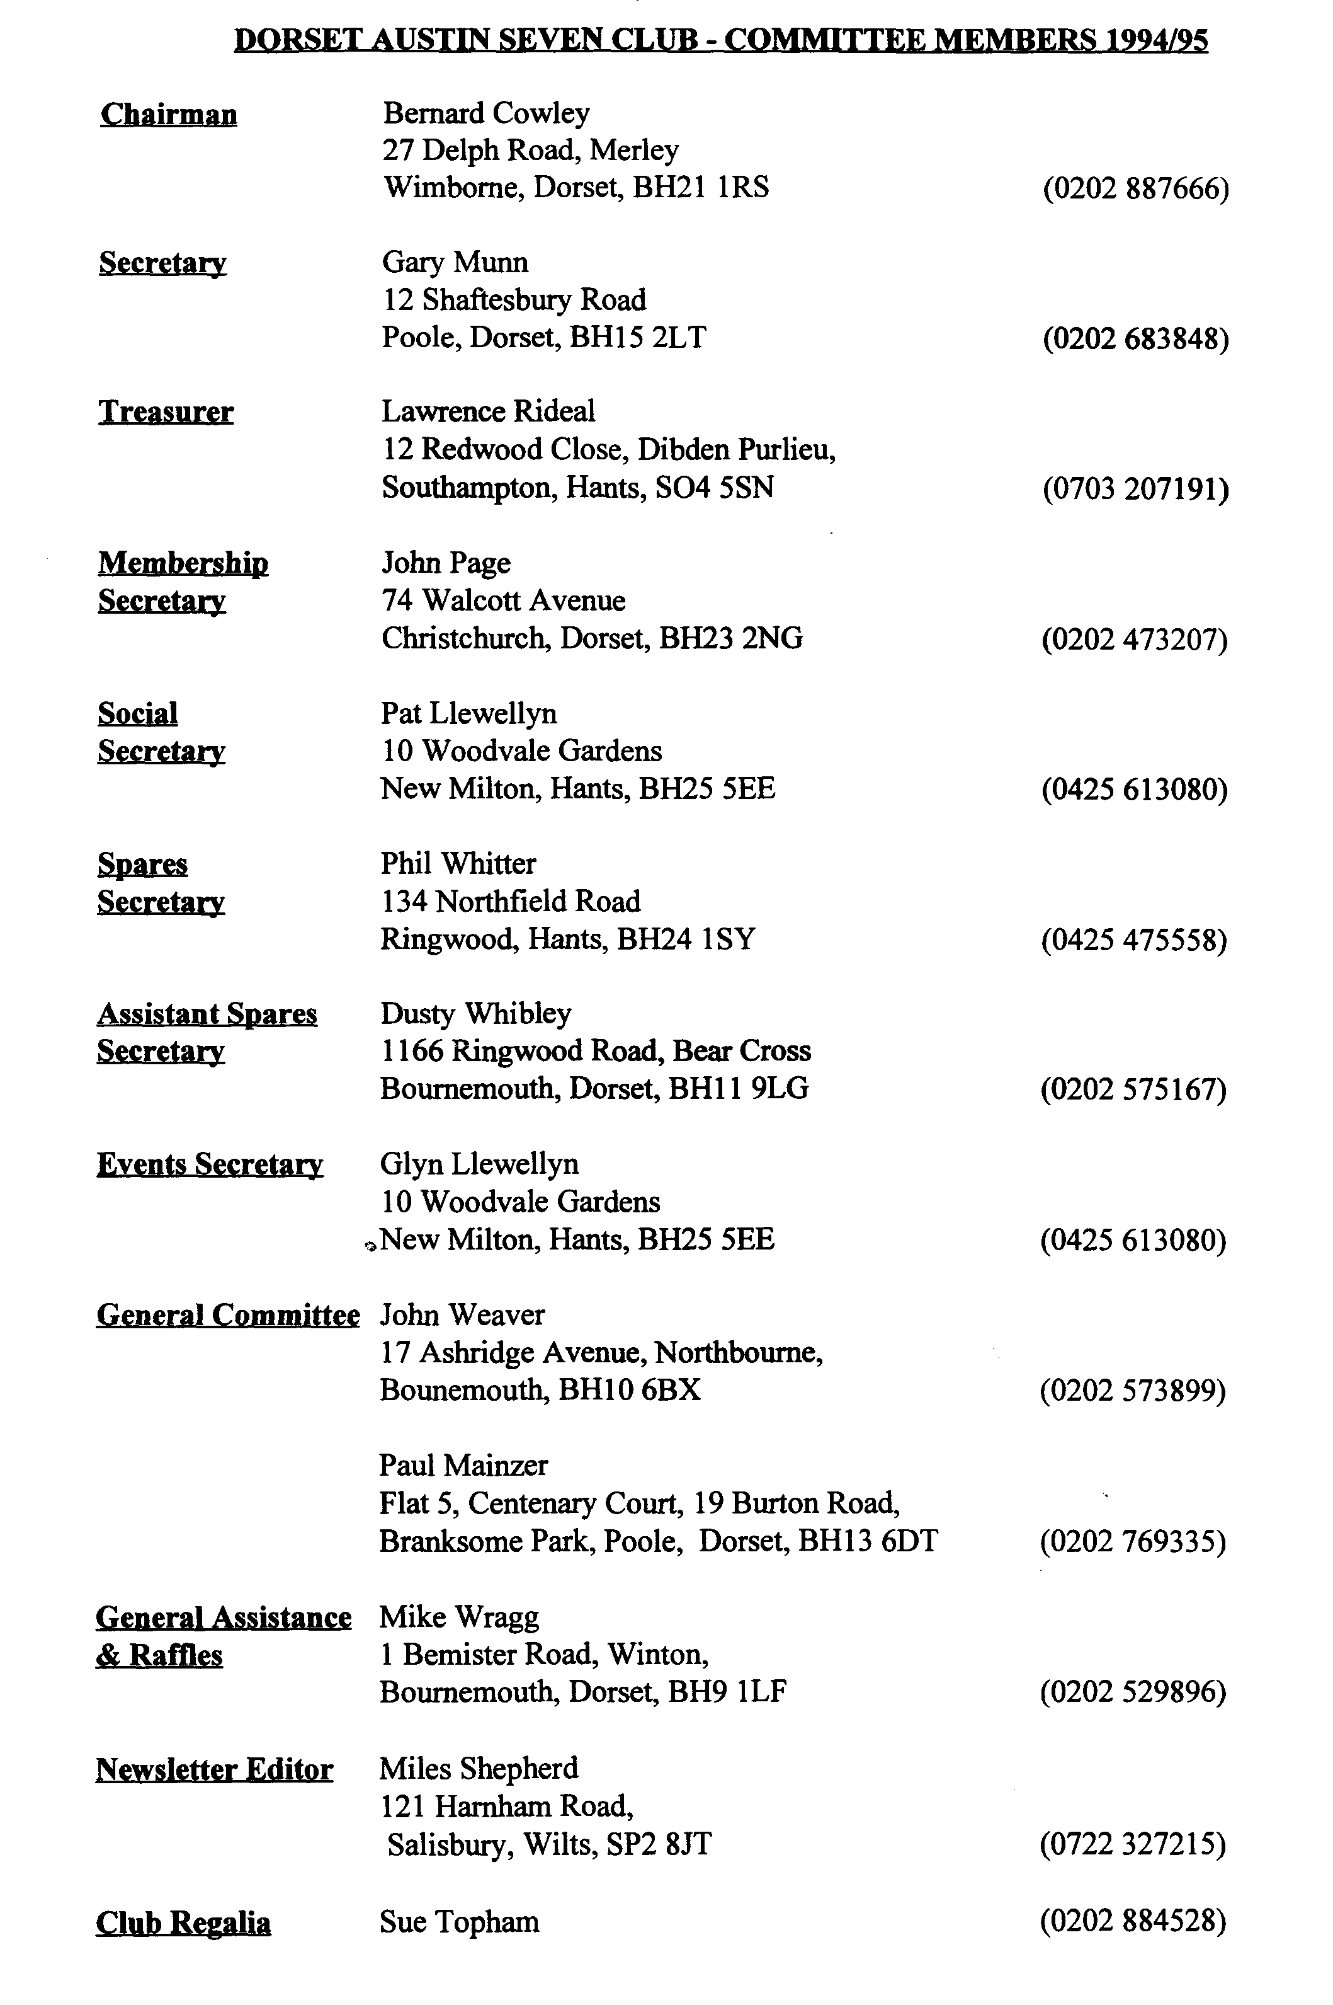

EDITORIAL

Hallo Everyone,
Welcome to 1995! A new year full of Austin activities planned by your Committee and I'm sure destined to be even better supported than last year. I gather the News Year's Day run was once more a tremendous success with a massive turnout. Well done to Glyn for organising it once more. I was sorry to have missed the Christmas Dinner which I gather was quite exceptional. I had hoped to be on Bernard's run which was also much enjoyed by all accounts, many thanks to Bernard for organising it - and for writing it up too!
While on about everyone's efforts over the last few months, Mike asked me to say thank you to the many members who have generously donated raffle prizes throughout the year, and especially for the Christmas draw. Many thanks to you all, please keep up the good work for '95!
Gary mentions, below that I could do with some contributions. What Editor couldn't! But seriously, I am short of pictures and Run reports. Photos are always returned, in good condition and I am known to buy the reporters the odd pint!
I hope you like the car shown on the front page. This is my 'new project' for 1995 and the reason for the departure of the Editorial Chummy. This venerable chariot is still for sale but will appear in the Motoring Press this month, so this is your last chance to buy a genuine vintage Chummy, with VSCC Blue Form!
That's it for January, see you at Club Night,
Miles

SECRETARIAL

Well Folks!
Welcome to 1995! I hope you all had a good Xmas, here's to a good 1995.
I think you will all agree, our Xmas Dinner was excellent - made even better with the addition of the live Band I fear there were a few hangovers on the run the next day Austin 7's are noisy creatures! Anyway, we all blew the cobwebs away on a pleasant run over the Purbecks, courtesy of Bernard.
I hope you have all enjoyed the various runs, club nites and social do's over the past year. I certainly have. I am sure Glyn would be grateful for a few run ideas and even organiser for the coming months, it really does ease the Committee burden somewhat and I'm sure Miles would be grateful for any Newsletter contributions (Yes, please! Ed.) so
go on - put pen to paper during one of these winter evenings!
The Rally Committee recently had a meeting with Dave Green from the Swanage Railway regarding July's rally. Once again they are very keen to join in, hopefully making it a more family oriented affair with Vintage fairground, rides etc, and they hope by then to have the line opened its full length from Swanage to Corfe - should be good.
I still have a vintage 1930 Box Saloon for sale, fully restored, taxed and MOT'd. Any offers around £4500?
See you all soon, Best Wishes, Gary

DECEMBER PURBECK RUN
What more could you ask for on a Run? Three steep hills, one fast straight, a deep ford, good weather, friendly company and a comfortable pub!
We set off from Wimborne slightly delayed due to keeping on the right side of the car park attendant. Gary gave him a ride in his Box. Most of the run, as usual, was on minor roads, going through Sturminster Marshall, Bloxworth Hyde and then cutting across to Creech where the first of the hills was. From there through to Church Knowle and on to Corfe.
Due to our late getaway, we arrived at the Pub at 12.30 but we still found parking spaces and room in the top bar. Although the pub was crowded, lunch was served very quickly.
From Corfe, we went across the Purbecks to Lulworth Castle for a look at the restoration which has taken about 10 years. After a climb of the tower and looking at a chapel and church in the grounds, we made our way home. Many thanks to Bernard for organising the run.
_{Autofest News}
Many of you will know that a strong contingent of Dorsets are taking part in this event. You may not know much more than that it is being held in the Czech Republic. The organizers have produced a very readable Newsletter from which I have extracted some bits about our members. Now read on
WELCOME to the first Newsletter from the But what of 1995?
organisers of the Bohemia Autofest in
Liberec in the mountains of North Bohemia It looks like we will have our biggest event
which are of course in the Czech Republic. ever with entrants promised from at least 20
different countries
The Bohemia Autofest was born in the first
year of independence from the previous Of the provisional British entries, we must
Communist regime which had held a tight give pride of place to the adventurous Dorset
control over our country for forty years. Austin Seven Club whose members look
certain to take Liberec by storm with well
The first meeting was in 1991 and this was a over half a dozen "Sevens" dating from 1927
very local affair with less than 30 entrants. to 1938 already provisionally entered, and
The Long Distance Award went to an entrant more registration forms arriving daily!
from Prague, just 60 miles to the south west
of Liberec. But this is not their first expedition into
mainland Europe, they came in 1992
In 1994, entrants including cars, motorcycles, covering over 1500 miles, this year it will be
autobuses, lorries, fire engines and military at least 50% more. Remember these little
cars came from 12 countries. The Long Austin Chummies (hope we spelt it right! -
Distance Award went to Chris Morley from You did! Ed) are only travelling at 30 - 35
California in the USA with a VW camper miles per hour. Well done all of you, the
van, what a difference four years made. welcome mats will be out for the Dorset
Austin Sevens, make no mistake about that.
More Autofest News next month, many thanks to Glyn who lent me his copy

Notes on the Austin Seven Clubs Association Meeting
Sunday 8th January 1995
Phil Whitter and Bernard Cowley attended the Annual General Meeting of the Austin Seven Clubs Association (A7CA) on our behalf. The following notes were prepared by Phil, to give you an insight into the work of the Association and to keep members in the wider picture.
Secretary
It was reported that the A7CA was investigating a Public Liability insurance from Cornhill which would cover all member clubs of the Association for an umbrella premium of about £500. Member clubs could be charged pro rata. MG and Mercedes clubs were also investigating similar policies. It was left to Howard Annett (A7OC & Chairman A7CA) to set this up if it met the needs of member clubs. Howard had already requested a copy of existing policies from each member club.
Treasurer
Geoff Walker (VAR & Treasurer) reported that there was a healthy balance of some £3500 and the Lickey Grange Appeal stood at about £2300. There was considerable discussion as to whether this should be transferred to the main account. Bernard Cowley suggested it be used for the 75th Anniversary celebrations, which received a favourable response. Midlands A7C members were actioned to report back on the current situation at Lickey Grange.
Editor
John Hinchliffe has taken over as editor from Les Gammon. John lives near Dover and owns a TT bodied Ulster which has genuine history although he describes it as a "Special". Can we all work hard please to supply him with copy.
Advertising
Hazel Gore was thanked for her hard work in producing so much revenue which offsets the cost of the magazine.
Archivist
Jonathan Cooper had to resign for personal reasons and Phil Baildon (Pre War A7C) agreed to return as archivist.
Membership
There were 13 full member clubs paying £20 each per year. Registers and some very small clubs pay £5. Only full member Clubs (one representative) were allowed to vote on major issues.
Breakdown Register
Gordon Phillips (750 MC) needed updates. If you can help, please respond direct to Gordon, address in the Association Magazine.
Films
There was some discussion on Joe Spalter's (A7OC) Film 'account balance of £1000+ returning to the central fund. Heritage Trust at Gaydon have produced a list of films now on video which were available at a special price of £11.25 each provided at least 5 or more were ordered.
continued on page 4.

Association Notes continued
Spares
Geoff Roe (PWA7C) showed a range of new rubber mouldings and fittings (see Phil's Spares Note below). Phil showed the fuel gauges produced by Willie McKenzie. Howard Annett reported that Taiwanese tyres were now available, 350 - 19 at £25 each, 400 - 17 £35 each. Solent Secretary showed an excellent heavy duty reproduction of the Moseley "Float on Air" cushion which sold at £40 - £50 each but in view of the work and materials involved, this was not considered excessive relative to the comfort afforded.
Election of Officials
All the existing officials were re-elected with the exception of the Editor and Archivist as previously reported.
A. O. B
The Ray Moprley Trophy for Sporting Achievement was awarded to Peter Gledhill who has actively campaigned a Chummy, which he has owned for 42 years, in numerous trials and long distance trips.
Freddie Henry (President of the Ex Austin Apprentices Association and Vice President of 750 MC) was being invited to become the President of the A7CA and a brief biography would appear in the Magazine in due course.
Phil Whitter.
CLUB SPARES SCHEME
(Phil's Spares Notes)
New spares are at an all-time high. It is disappointing that from time to time our main supplier goes out of stock of key "bread and butter" spares which I am sure not only involves them in high failure to supply costs but is also frustrating for customers who have to keep chasing the particular item. At present, parallel valve guides and large cotters are unavailable.
At the A7CA meeting I purchased some of Geoff Roe's rubber mouldings, so we now have the following rubber items in stock:
- Bonnet stop rubbers
- Bonnet catch sleeves
- 2 Seater Tourer/Opal hood rest pads
- Blind bumper iron ferrule for 2 Seater Tourers
- Oil resisting engine mounting rubbers
- Body gasket for trafficator mounting.
Regards,
Phil Whiner
Many thanks to Phil and Bernard for giving up their Sunday to represent the Club.

RubberDucks
The following is an extract from the October 1984 issue of CAR a South African motoring journal. The complete article was published (by me!) in the Association Magazine back in 1985.

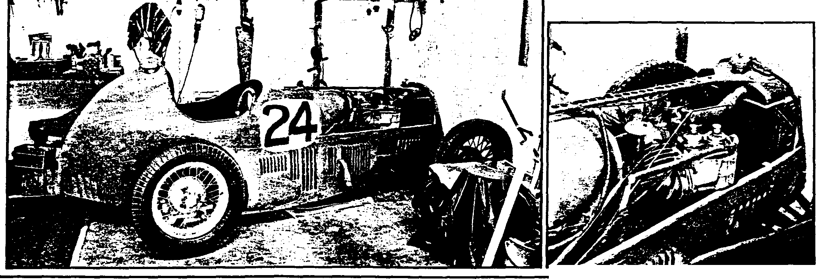
DURING the past 47 years, many of the people and machines that took part in the 1937 Pollsmoor Grand Prix have passed into obscurity. One notable exception is that of Dougie van Riet, a popular racing star of the day who was first South African home — and who lives in retirement in Somerset West, Cape.
A LONE SURVIVOR...
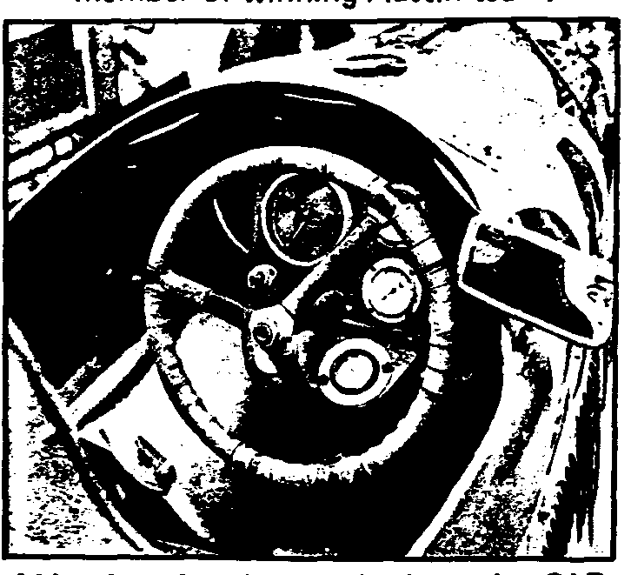
One of the hand-written captions in an album or historic racing photographs oonatea to CAR describes Dougie van Riet's Austin racer as follows: "1930-1 supercharged single-seater Austin. 749 cc. Wt — 1 050 lbs. Max. revs 5 500." The cockpit (above) is hard to enter and allows only just enough room to manoeuvre
Now in his seventies, Dougie has not raced for over 30 years, but he still owns two of the cars that he drove to giant-killing victories — the supercharged 1933 Austin Seven Brooklands racer that he drove in the 1937 Grand Prix, and a 1931 Austin Seven Ulster — also supercharged.
The Ulster is kept at his home and the Brooklands is stored elsewhere in the Western Cape, in a pleasant garage with a view of the sea. When it completed its last race in 1952, it was drained of fluids and put on blocks and has been laid up ever since.
When CAR inspected the car to photograph this surviving link with the Pollsmoor GP, it seemed at first glance to be ready to race again. Closer inspection revealed some inevitable decay in rubber components, but the mystique of a veteran racer clung to the car, along with a hint of burnt rubber and the faintest whiff of racing oil.
When the sail cloth cover was pulled aside, we found its alloy body in basically good shape, still carrying
its last racing number (24) and with the chrome Austin badge topping the wire-screened radiator. This is the only survivor of three cars built to compete at the old Brooklands track by the late Herbert Austin and Dougie van Riet has been its only owner — yet another rarity, with racing cars of that era.
Main achievements
Beside it was a black notice board that must have been used at some previous classic car exhibition, detailing the car's main achievements. They read as follows:
- 1937 Grosvenor GP: 1st South African car to finish.
- 1937 Rand GP: 1st place overall (against opposition which included Earl Howe in a 1,5-litre ERA, Raymond Mays in a 3-litre ERA and "Mario" in a Maserati 3300).
- 1938 Kimberley 100: 3rd place and member of winning Austin team.
- 1938 Camps Bay Hill Climb: 2nd fastest in Unlimited Class.
- 1939 Curtain Raiser to East London GP: 1st overall.
- 1948 Van Riebeeck Trophy: winner of fastest heat, and fastest lap.
With the louvred bonnet removed, the Murray Jamieson blower looks almost as big as the 747 cm³ side-valve motor, which drove through a close-ratio box to give a top speed of over 185 km/h. The car has four sets of wire spoked wheels which were selected to adapt the overall gearing to suit the track, and diff (with ratios of 4,4 or 4,9:1) is offset to a position close to the left hand rear hub, to allow a low seating position.
The narrow single-seater cockpit is hard to enter and awkward to leave but once you're in, presents you with a functional panel carrying 0-8 000 r/min rev-counter (red-lined from 5 000) and four gauges — for oil pressure and temperature, boost and "air". The last indicated pressure in the fuel tank, which was manually pressurised by the driver, operating a simple piston-type pump which lies horizontally to the left of the steering wheel.
Alongside it is the cranked gearshift, with its small black knob and an alloy shield has been flared to give the driver's arm the necessary freedom of movement.
The pendant throttle is stiff, the cable brakes feel firm and ready to go and the clutch, which has cast iron facings and works like a short-throw switch, has only a trace of movement in the pedal — to a casual probe, it feels solid. Beyond the pedals, you can see the power-train — and the road surface.
The tiny four-cylinder, side-valve engine is
"blown" by a Murray Jamieson supercharger
which is almost as big as the engine itself.

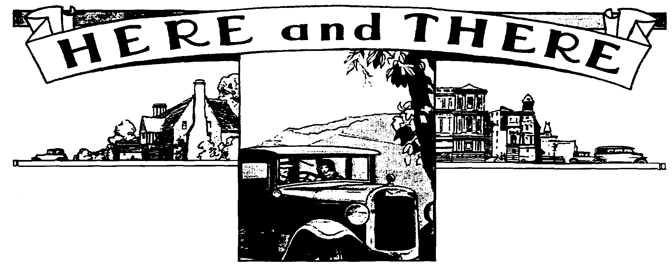
For Sale
Mid 1932 LWB Chassis. No 154197, all complete with both axles, brakes, wheels, handbrake, steering, solid crankcase, springs, etc., all good and sound. Please note that this is not a kit of parts - £350
October 1932 Ruby. As found in a barn, complete rolling chassis including complete engine and gearbox, front wings, windscreen, etc., etc., - no V5 at present but Swansea are happy to retain RN5330 for when the car is ready - £350
Late Ruby Chassis. In as found condition, too good to scrap or you could strip it for parts - £20
"Trailerised" Front Axle. All complete with brakes, hubs and springs, 36" between back plates £25, also A7 sized trailer angle iron frame, can be supplied with ball hitch.
All the above from Ian Rendle, Tel 0672 539416 (Marlborough)
1972 VW Beetle. Silver, original condition, new brakes, clutch and silencer. MOT for 10 months £1295,
1986 Mini Piccadilly Special Edition. - Good low mileage £1395 Both these two from Bernard Cowley, Tel 0202 887666
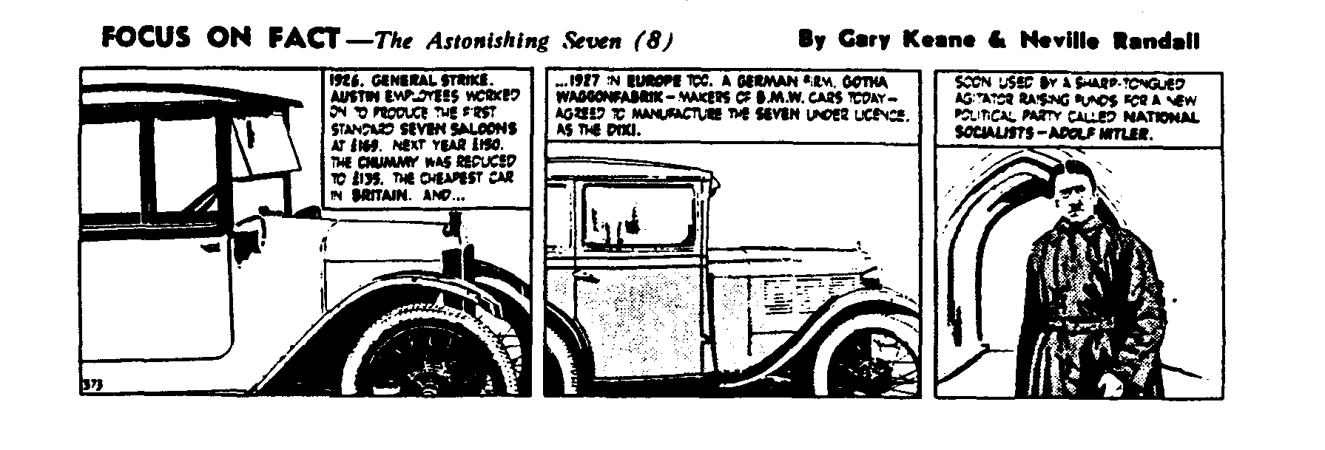

Technical Tip
I am sure you have all had trouble keeping water manifolds water tight. They always seem to leak when tampered with and the more you tighten, the more the rubber gasket spreads!
I use silicone sealer on both sides of the gasket BUT if you are not in a hurry, paste up one side only and apply the gasket to the manifold, leave it under light pressure over night and then paste up the other side and bolt up. The silicone has by now set on one side, so the joint will not spread when fitting, hopefully giving a good seal.
Gary
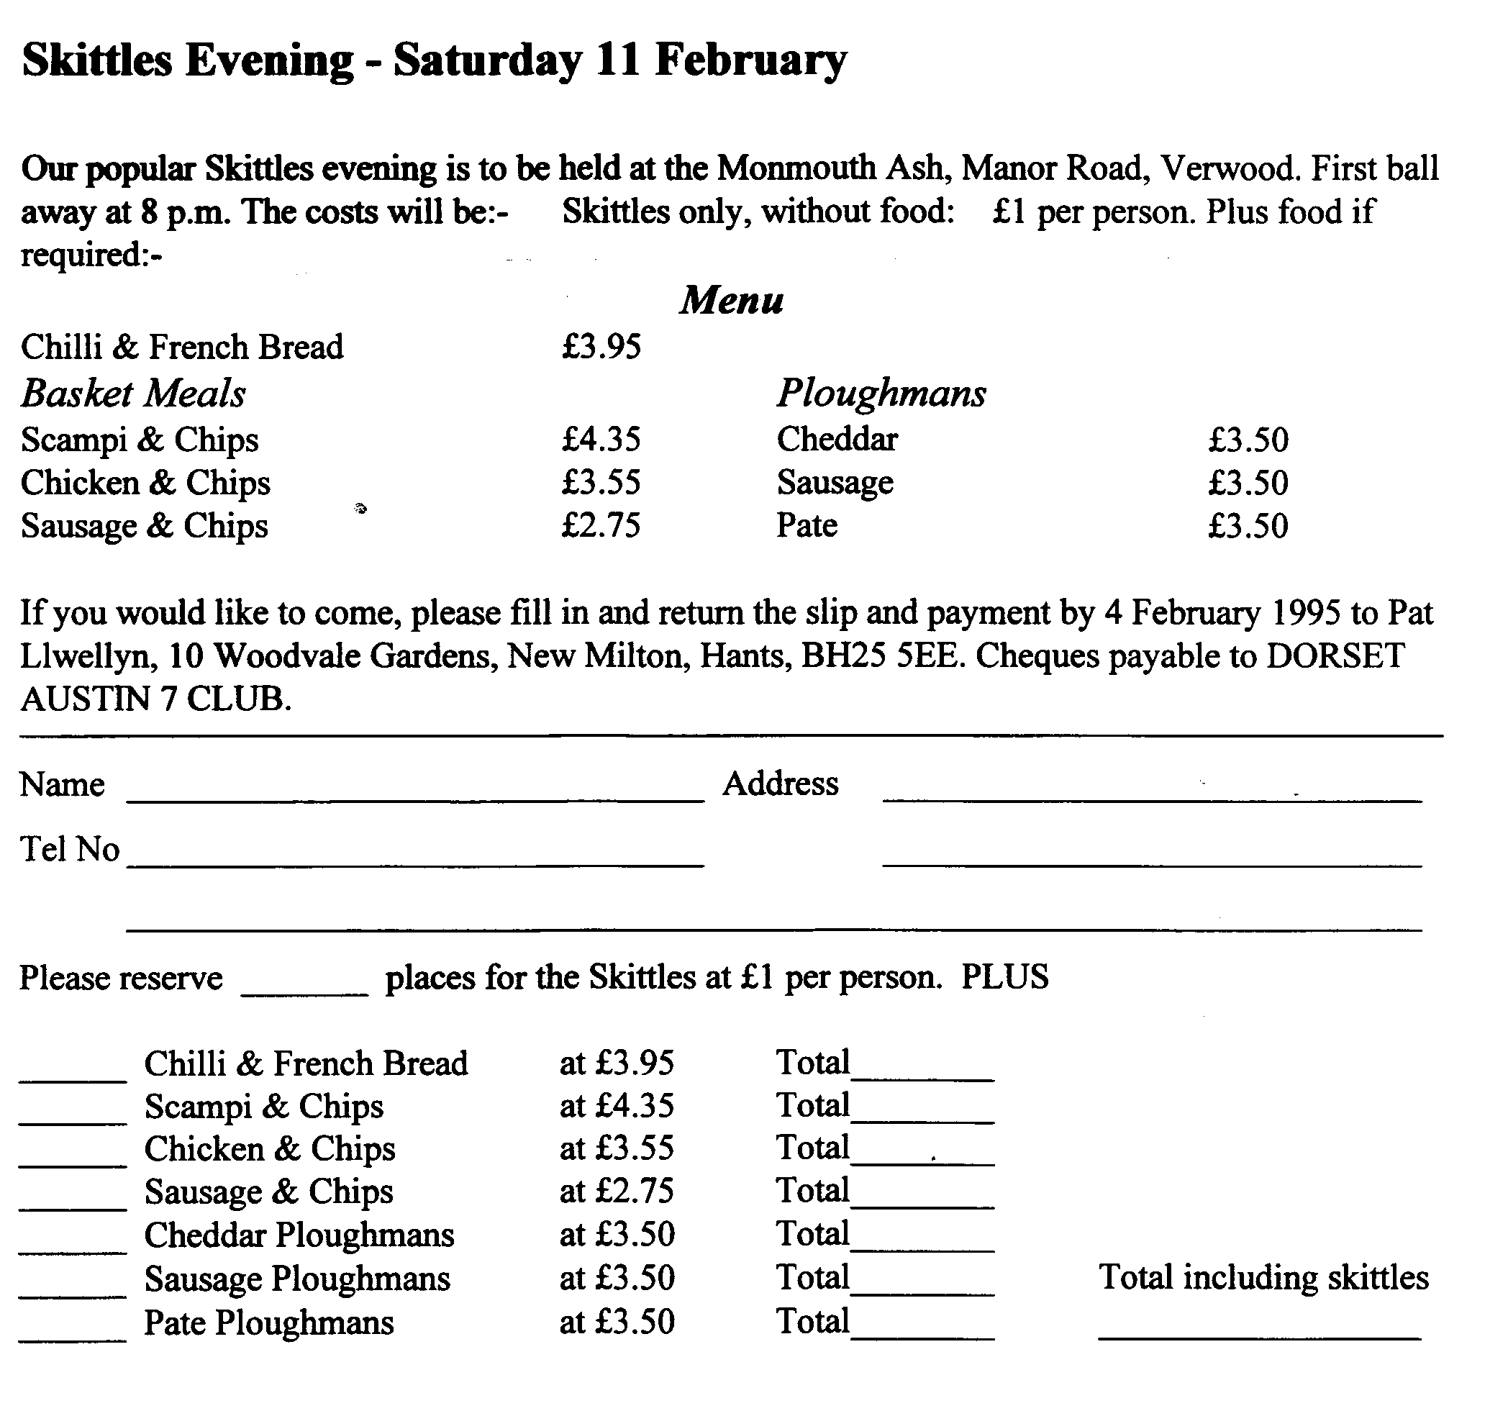
PS When fitting the side manifold - if using bolts, make sure they are only just long enough. Don't do what I did many years ago, screwing too long a bolt in, because they dig into the cylinder bores and punch a neat hole, thereafter necessitating a very expensive re-sleeving job!

EVENTS
January 1995
Thursday 19 Jan Club Night. Gather at the Elm Tree for an Open Forum. If you have a rebuild or restoration question, this is your chance to have it answered. A panel of respected and knowledgeable experts will be on hand to help, by explaining how Club Members have overcome similar problems. All the other attractions will also be present but Spares to order only. Another fine way to start the year.
Sunday 22 Jan Club Run. John Weaver is organising this outing, so meet him at 10.30 for
a 10.45 start in the outer car park by Safeway's in Wimborne. Further details next month
February
Thursday 2 Feb 8 till Late. Gather at the Fish, Ringwood. This is the one just off the A31.
Saturday 11 Feb Skittles Night. Our popular Skittles Evening to be held at the Monmouth
Ash, Manor Road Verwood. First ball away 8pm. Entry form on page 7.
Thursday 16 Feb Club Night. There will be a talk about the Swanage Railway in addition to the Spares Table, Club Regalia and all the usual attractions. This should be a chance to learn a little more about the Railway with whom we share our Summer Rally.
Sunday 19 Feb Dusty's Mud Run. Always an exciting run, gather at the Lay By in Magna
Road, near Canford School on the Bear Cross to Wimborne Road at 10.15 for a 10.30 start. Note this is a new RV to overcome the problems recently encountered at the Safeway’s Car Park. There is also a toilet here!
Dates for Your Diary
Saturday 28 Jan VSCC Driving Tests. Early start essential for this meeting held at the
Brooklands Museum. Entry to the grounds, museum and Tests (as a
spectator) is £4:50, with reductions for students, OAP etc. Details from the Editor.
Saturday 18 March Exmoor Fringe Trial. Based at North Molton with good access from the main Tiverton to Barnstaple road (A361 Link Road), 25 miles from J27 on the M5. Your Editor will be marshalling. Please ring if you want to make up a party to visit this very enjoyable event.
Full details of VSCC events are available from the Editor but extracts showing 'local ' events will appear in the newsletter, usually a month before they take place. Let me know if there are any you need to know about earlier.

