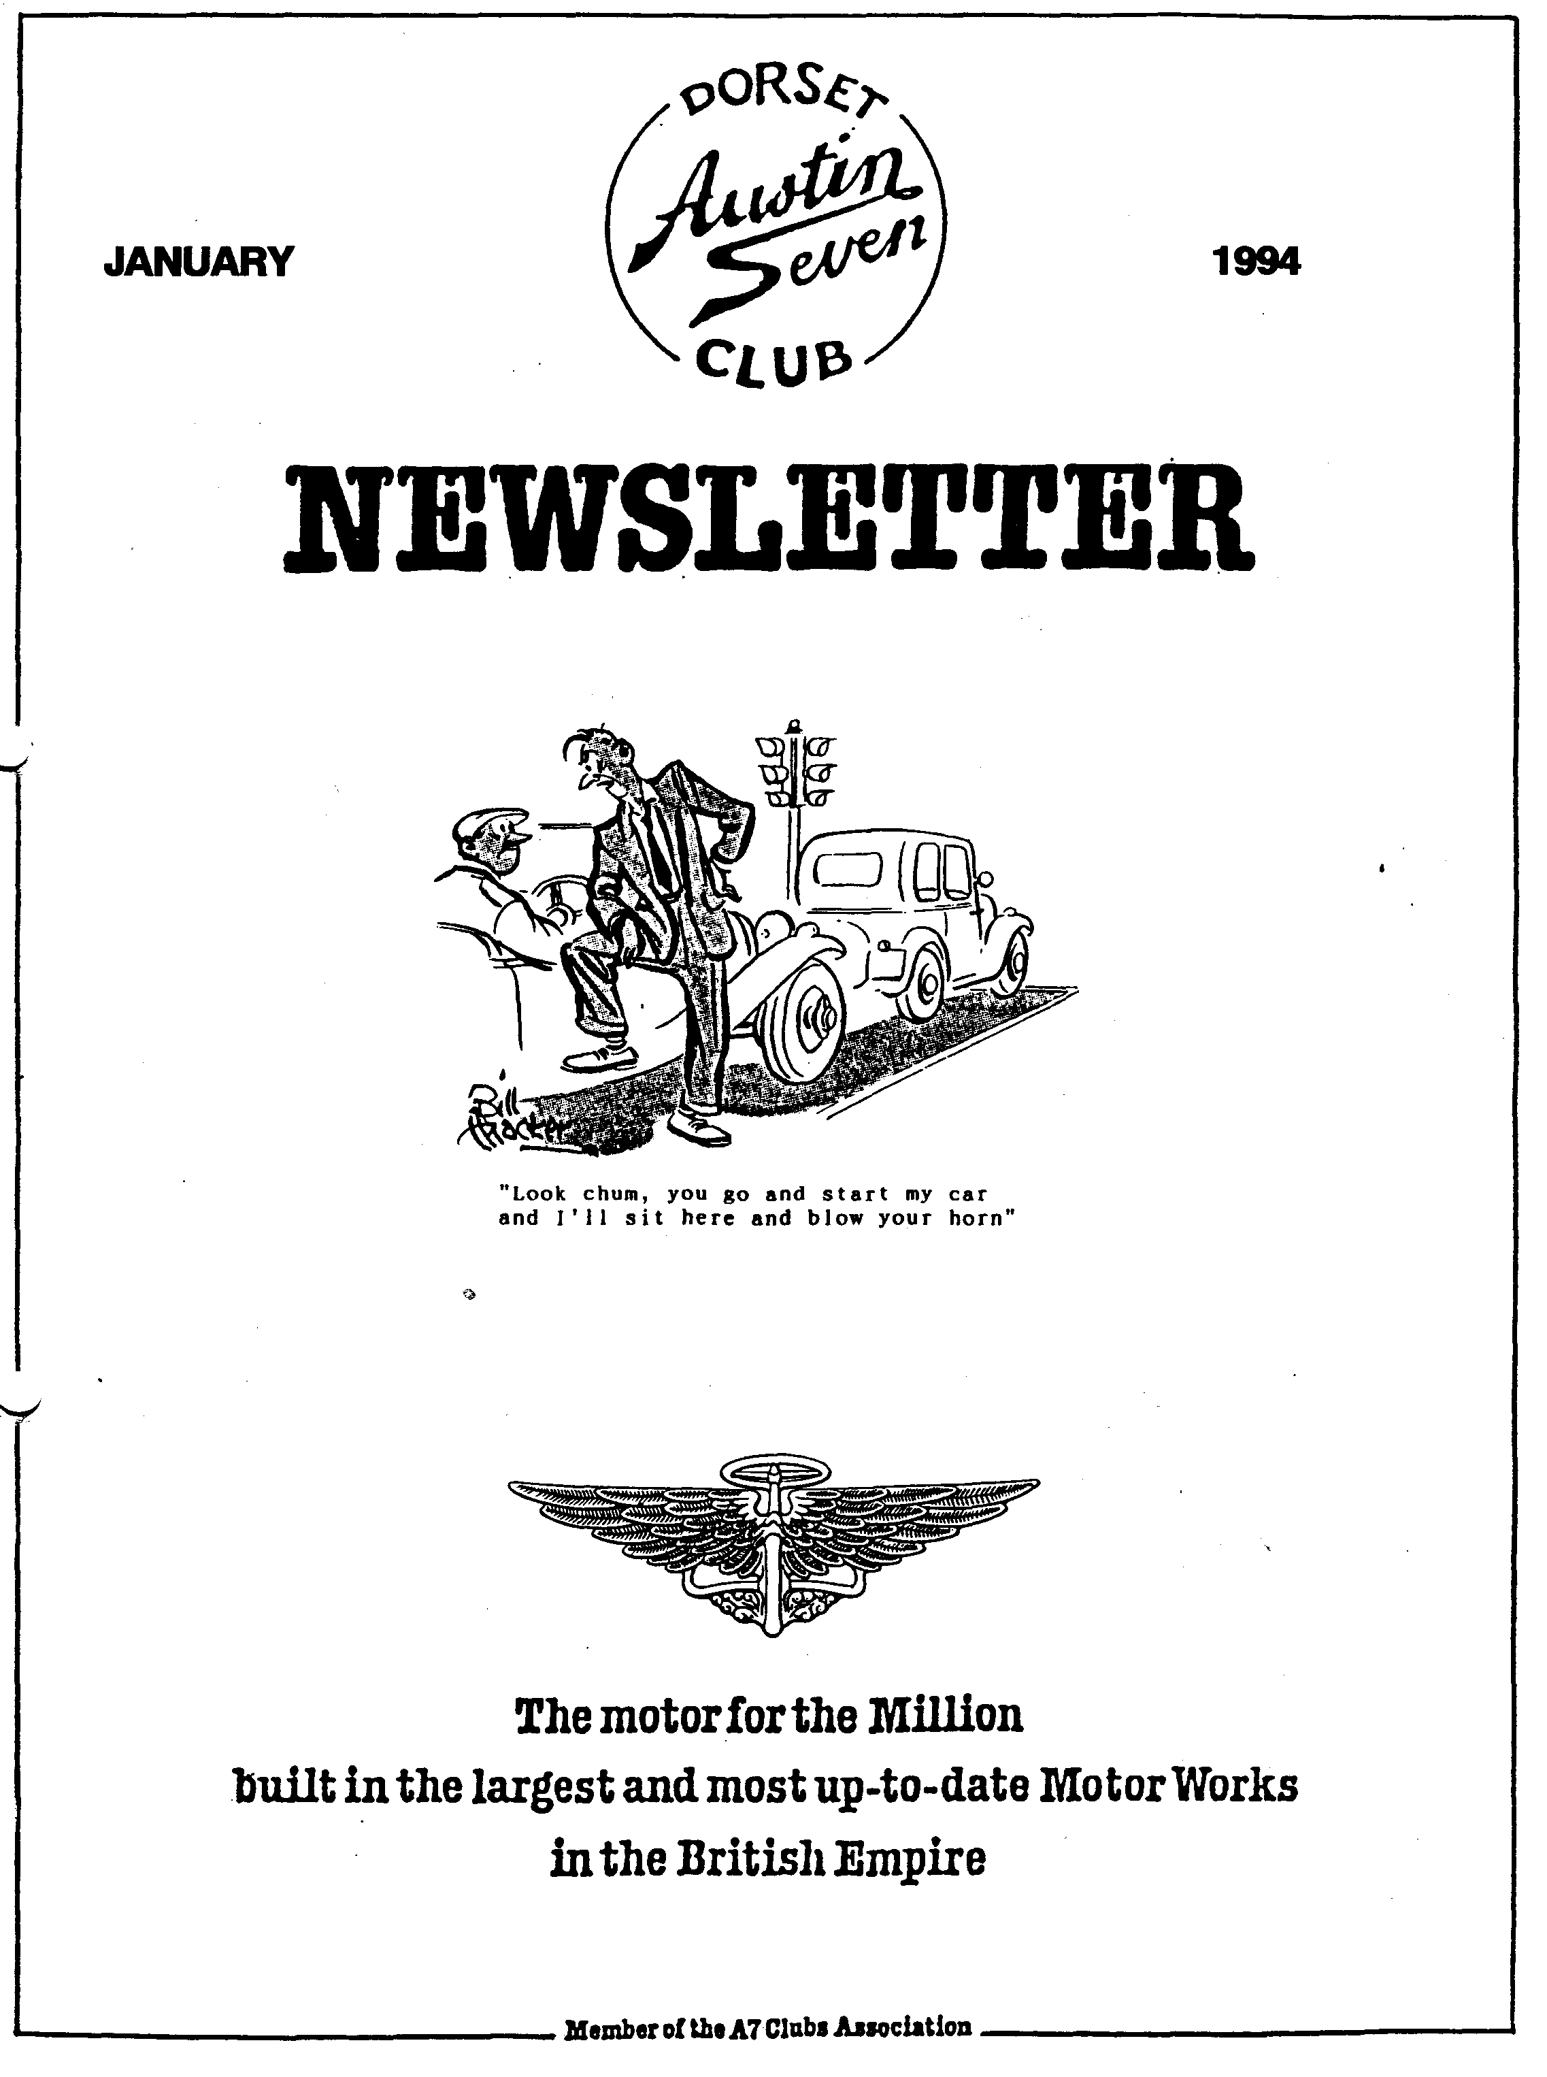

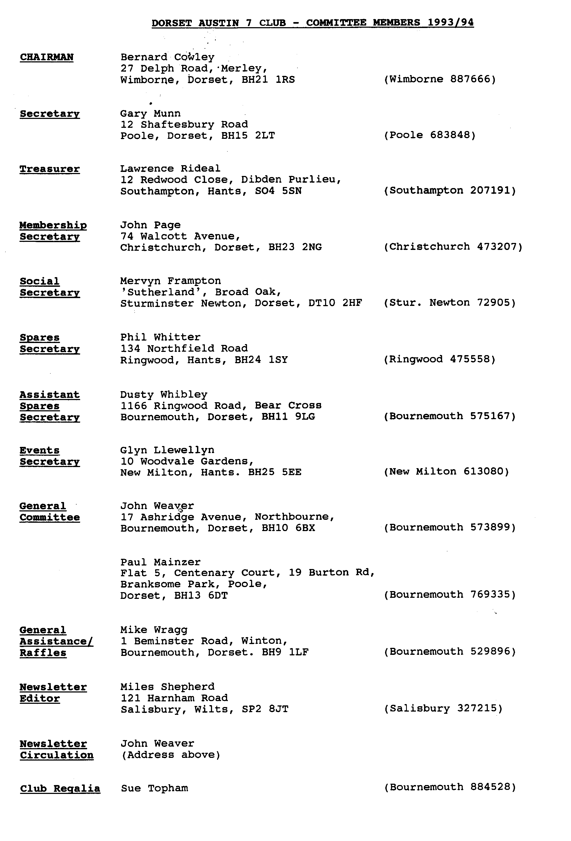

EDITORIAL
Hallo Everyone,
To all those whom I did not see at the start of More awkwardly, a clue to the ingenious
the New Year's Day Run, Welcome to 1994! I crossword Tony Day sent in, was omitted. Tony
hope everyone has a really wonderful year. apologises for omitting the clue to 18 Down.
However, it did make it even more cryptic, and
Glyn and Pat did us proud yet again with an as one member has already shown, it is still
excellent run to a pub which had the facilities possible to solve it. To compensate, the closing
to look after everyone properly. Sadly, I was not date will be extended to the Jan Club Night, 20
able to take part in the run as I am part way Jan, and the winner will be drawn during that
through rebuilding my back axle - using the evening. The clue, by the way, should have read
notes from a previous newsletter! Neither did I "It is said sick money is uneducated (3 - 4)". So
get to the hostelry. However, I did enjoy seeing complete that corner and bring your entry along
the crowd of over 25 Austin 7's plus 3 or 4 on Club Night.
larger models, their crews and supporters. They
made a stirring sight at the Ringwood car I've had a couple of other letters which are
park. Hopefully the simple rules for convoy published on page 6. Many thanks to all the
driving were able to be put into practice. Glyn correspondents.
made certain to leave directions for any late
comers -did anyone need them? I shall not be able to get to the next Club Night
as I'll be working in France from 15 - 30 Jan. If
As it's New Year, and resolution time, here is you have any material for the newsletter, please
the 'Oh Dear' Department! First of all I ran out post it to me or give it to any committee
of space last month and Terry Ts Christmas member. This means I'll miss the quiz AND the
Diet was left out. Perhaps it will keep till next skittles evening! I hope the rest of you enjoy all
year. these events. See you next moth, Miles
SECRETARIAL
Well Folks!
Christmas and New Year over, I hope you all I have recently received a letter from John
had a good time, everything back to normal Butler who lives in Woking and who has
again now! recently purchased a Special on a 1929 chassis,
fitted with a Super Accessories fibreglass body,
Talking of Christmas, I hope that anyone who their Cadet model, painted green. It used to
attended the Christmas dinner will agree, we all belong the our member Malcolm Green who
had a great evening, the food was good, as was purchased it in 1986 from a chap in Surrey
the company and the pints flowed well. Thanks, Road, Bournemouth, apparently having stood at
Mervyn. the side of the house there for some time. Mr.
Butler is very keen to trace this owner, and
The Club night was a fairly quiet affair, as it indeed, to trace the history of the car. If any
usually is near the festive season, and my one has any information about it, or even could
December Run was a little down on numbers pinpoint the address in Surrey Road, where it
but a good day out was had by all - I hope! stood, could they please contact me in the first
instance. By the way, Malcolm advertised it for
The January Club Night sees Mervyn's Quiz, sale in our May 92 newsletter.
always an excellent, entertaining evening out:
See you all there. Cheers, Gary

AUSTIN SEVEN BEGINNINGS - 40 - A Story of Austin Folk JO MOSS
This is, to put it mildly, a story with a difference. For here we have a member of some 8 or 9 years' standing and who has never actually owned an Austin Seven! As a young girl she got very enamoured, as a back seat driver, with the Box Saloon in which she was driven around the Westbury area by a family member. And if there's anyone out there with too many Vintage Swallow Saloons, then that is the very car she yearns to own!
How? where? why? what? when? well?....I can imagine the questions surging as you read. You see at first she really, dearly, at sixteen or thereabouts, wanted a MOTOR BIKE! Guess what Mum said..NO, NO, NO!!! Being by nature a lateral thinker, Jo had already got desire number two right in place: 'an interesting old car'... something similar to the one her Dad's stories had enthused her with, before sadly he died. So, with no negative sounds coming at this suggestion, Jo saved like mad and blew the lot on a £350 Morris Eight. With kind help from a friend the brakes were sorted, driving test successfully taken, and Jo was mobile. The persuasiveness of Club Membership Secretary John Page, whom she met at a Country Fair, and that of family friend Glyn, encouraged Jo to join the Dorsets. You can imagine the scene: 'Oh!, come and join us Jo. Yes, 'course you can join, even with a Morris!'
Soon, around 1985, Jo's mobility took off in the guise of 'Skateboard' (Bill Quayle's cryptic nickname what would we do without his jolly little quips?): a 1978 Morgan 4/4. Another car which she'd always wanted'. Having got it, she didn't want to let go of the Morris (signs of a budding Collector creeping in there) but had to: lack of garage space.
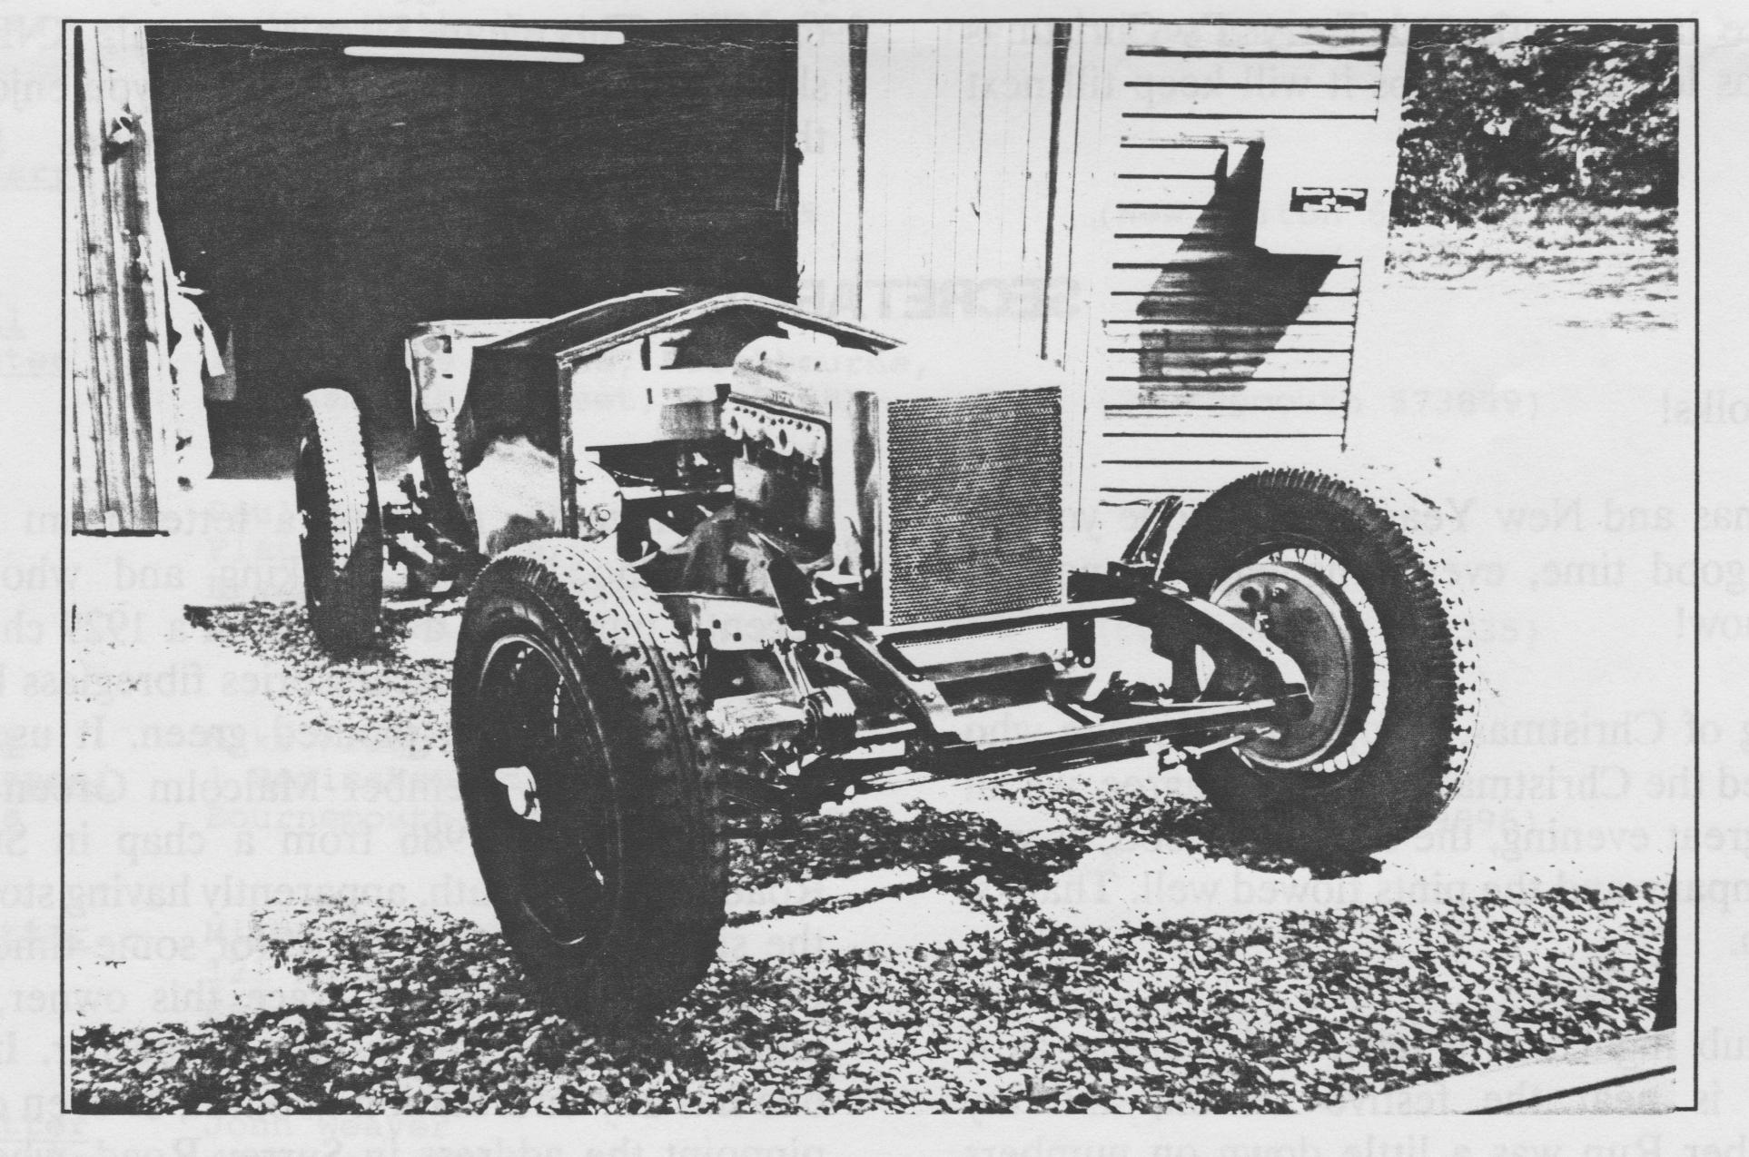
Very shortly after, she was visiting an aunt at Hengistbury Head. Aunt said, 'You like old cars don't you Jo, come and look at this in my garage'. A 1933 Essex Terraplane 4.2 litre Straight Eight. Hadn't been run for 16 years. Like the proverbial Toad and his love of 'the car's the thing' Jo tracks down the erstwhile owner, buys it and promptly sets about decoking the engine with its 16 valves! By now, she had tasted 'gold', sheer unadulterated 'gold' in the form of driving an Invicta. At last then, apart from

the Austin Swallow, Jo had formed her ultimate 'dream'. She advertises again and again. Meanwhile she buys an Invicta engine which just happened along her path. She is also by this time earning her living by restoration of vintage cars. In her spare time she is discovering that she has an unusual ability to achieve excellent results in Sprints and Hill Climbs in various Vintage Cars. Three years elapse, during which the advertising campaign never ceases and eventually is rewarded with a phone call of the 'I've one to sell', variety. So in 1990, Jo buys a 1930 4.5 litre Invicta Special,' a veritable Heinz Variety'. It was 'running', had a home made body 67 years old, completely wrong engine and lots more interesting bits and pieces besides. Full of verve, in every single spare minute Jo set about stripping it down, abandoning rogue bits, begging, borrowing, scrounging, having given for Christmas, Birthdays etc authentic bits to replace. I say authentic but as it's a Special, she is for example putting in some really posh, pukka seats. Where did she get them? They were advertised in the Dorset Austin Newsletter and are in fact Austin Seven seats. Proud Mum is giving the cost of upholstering them to Jo as a present this Christmas.
With sheer gutsy determination, painful hands, aching muscles, midnight oil burning and of course not to say despairing, tearful, body-wracking tears Jo is slowly getting together 'the car of her life'. (It's fact further ahead than this photo shows). Finally, after many other false, though optimistic, finished-date forecasting, Jo is sure that 1994 will see RRM 500 alive and running on the road! And of course -competing in the round of competitions as she is allowed to do in a Special. For example the other Invicta she drives has been invited by Coys Auctioneers to take part in the prestigious International two day event at Historic Silverstone for three years now in which she has been part of a team event which won second place. Sadly, Jo with her Special would not qualify the rigorous 'Original Car with Good Providence' specification. The other Invicta car and driver has in fact invited to take part in a similar event at Nurburg, Germany, with many cash incentives thrown in; such is Jo's and her Driving Partner's international acclaim. I should add that out of the driven, of the 40 cars invited to Silverstone there were only 4 women.
Getting Jo to admit or reveal details of her competition successes is somewhat difficult. She did, however, admit to not knowing where to house any more afterwards; that she was driving the 1s¹ Vintage car, in the Patrick Marsh meeting, to finish at Mallory Park. That she got a Class Record in a 41/2 litre Bentley, quarter of a mile sprint; won the Shelsley Walsh Hill Climb run by the Vintage Sports Club; competed in a /9.5 Silver Ghost Rolls Royce!. Once at Coy's she spun round twice on a very wet corner, though still finished 11th out of 40. Needless to say this is a very skilled , as well as dangerous, pastime.
Often Jo's ability, on the mechanical front is not taken seriously; suggestions that she make the coffee are politely ignored by rolling up her sleeves and offering to help on the nuts and bolts bit! Welding is on the list of skills to be learned and lathe work she leaves to the specialists with their multi - figure computerized machinery. Turning over a heavy engine proves difficult. Other 'heavy' jobs can be overcome with the leverage afforded by extra long handled spanners etc. or in the case of lifting with special gear. Finally, for the moment that is, Jo had her photo and a half page write up last May in the Vintage Car Drivers' Section of the 'Best of British Women' book.
One can't help but be completely enthused by Jo's happy approach to her total dedication, determination, mind bogging project and last but not least, her ability to be completely feminine to boot. I have also heard that Jo is in line to win the VSCC Ladies Trophy, that she is on the VSCC Committee and organizes their local meetings.
Jo, I'm sure I speak for every one, go well, reach your self-imposed goal of owning your road worthy Invicta rebuilt by your own self, and last but not least here's to you owning your very own Austin Swallow! Finally how about coming to Club Night and telling us your story: you've achieved so much that I'm sure that I have not got all the fine detail correct.
Happy 1994 to one and all. BB Dec 93.

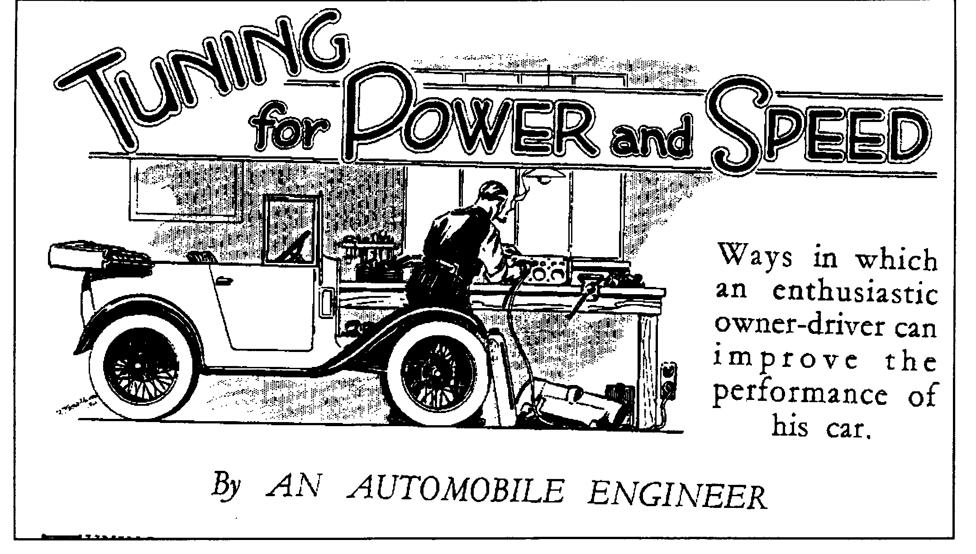
PART ONE
TUNING a car is essentially different from tuning These things having received attention, the engine
a pianoforte; only one object is in view in the latter can be tackled; we will presume that it is already in
case, whereas many different requirements may good mechanical order. In tuning an engine, as in all
prompt a man to tune his car! Acceleration, other kinds of work, it is essential to understand
maximum speed, flexibility, economy - there are what is being sought. " Power " is the rate at which
innumerable attributes and, as a rule, when one of work is being done and the power developed by a
them is improved, others suffer. Car makers have motor car engine depends upon two things:
therefore to keep a balance between these and other
features so that their products may be pleasing to as (i) The amount of petrol burnt in the
many individual owners as possible. cylinders per minute and
These owners are, in the main, satisfied to "leave (2) the percentage of the energy released, by
well alone," but some there are who, fired with burning the fuel, which is usefully conveyed
enthusiasm by successes attained by the make of to the flywheel.
their choice in racing events, long to dabble in the
mysteries of tuning. Usually, their aim is to attain The two methods available for increasing the power
higher speeds by methods not involving an undue output are therefore to enable the engine to consume
expenditure of skill or cash. The following notes more fuel per minute and to raise what is called the
have been written for their guidance and are " efficiency " of the engine. The first of these
applicable to most types of car. methods can again be divided into (a) increasing the
revolution speed; and (b) increasing the quantity of
Increased speed can be obtained either by increased mixture induced on each suction stroke.
power or by decreased resistance. Any reduction
which can be made in the friction and windage to be These matters will be made clear by studying the
overcome is equivalent to a like increase in power typical horse-power curve in a graph produced
output. The use of a light oil in the gearbox and rear which includes a "power requirement" curve given by
axle, higher tyre pressures, a partly streamlined Mr H R Ricardo as typical of a car weighing some
body, smaller wings and a folding screen, are all 30 cwt. The general form of these curves is,
helpful. however, applicable to any car. Power is in each
case plotted against road speed in top gear; the space between the curves represents surplus power

Tuning for Power and Speed (cont'd)
available for acceleration or hill-climbing and where the curves cut one another (point A) the surplus vanishes because the output balances the requirements. The car has then reached its maximum speed, in this case, 55 m.p.h.
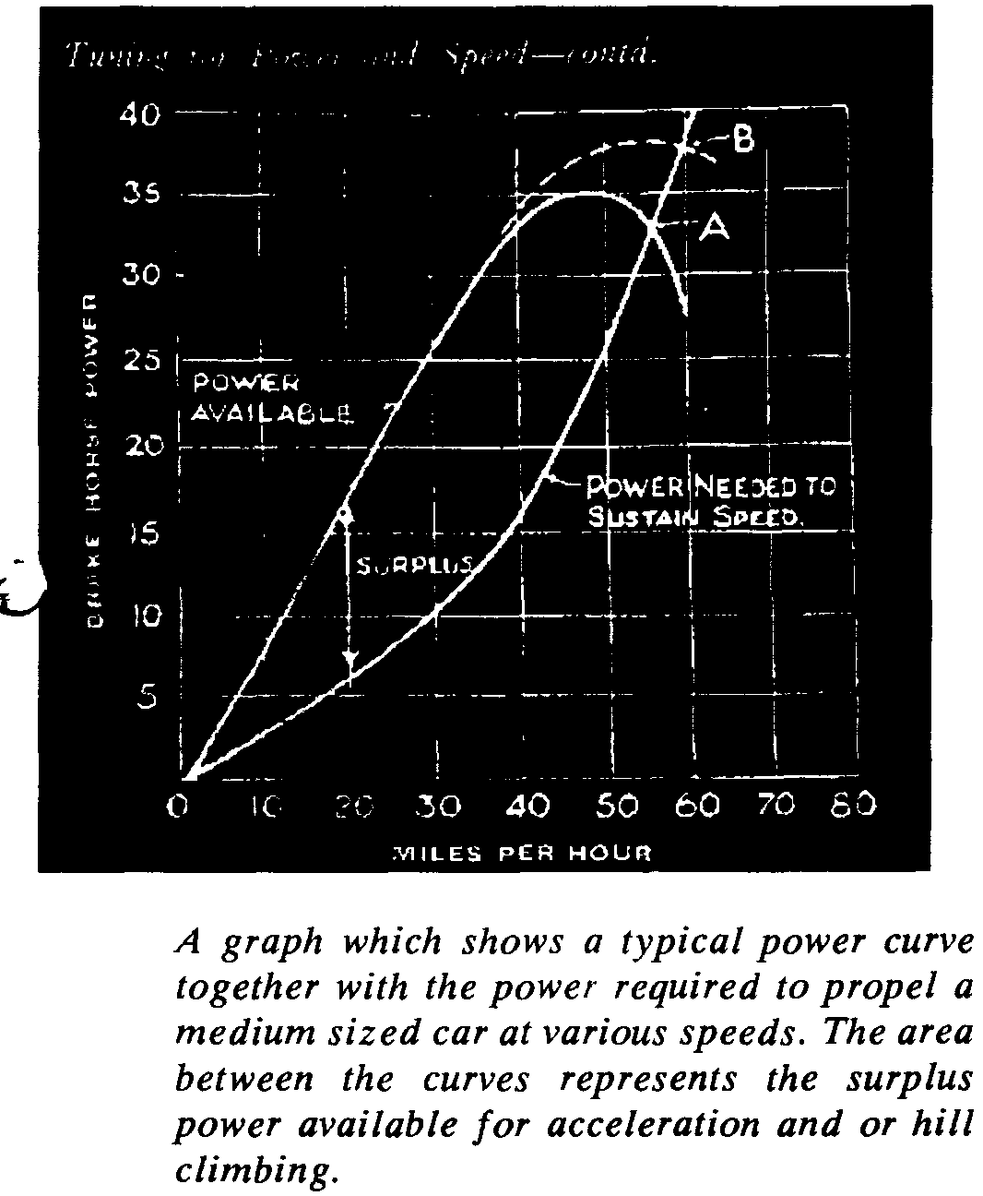
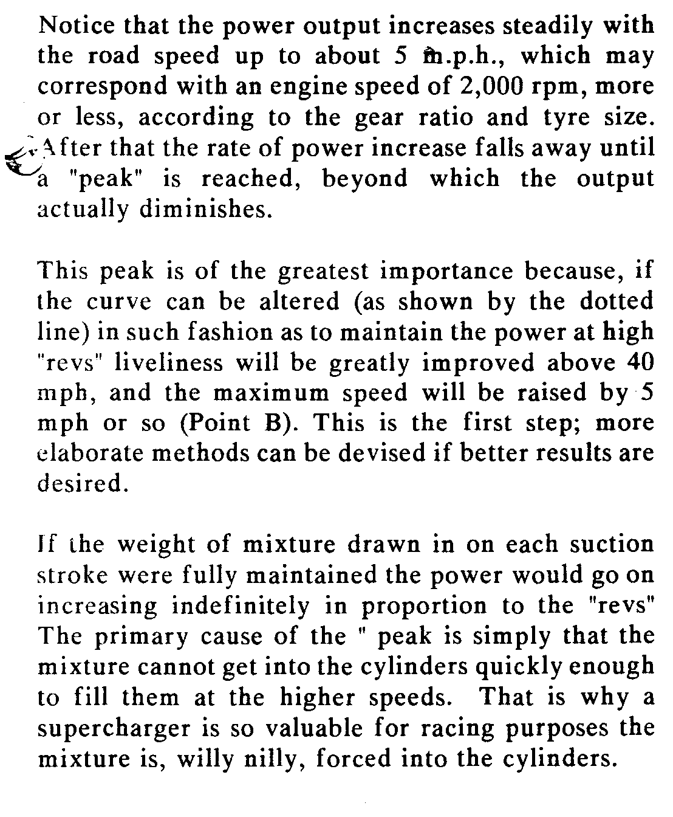
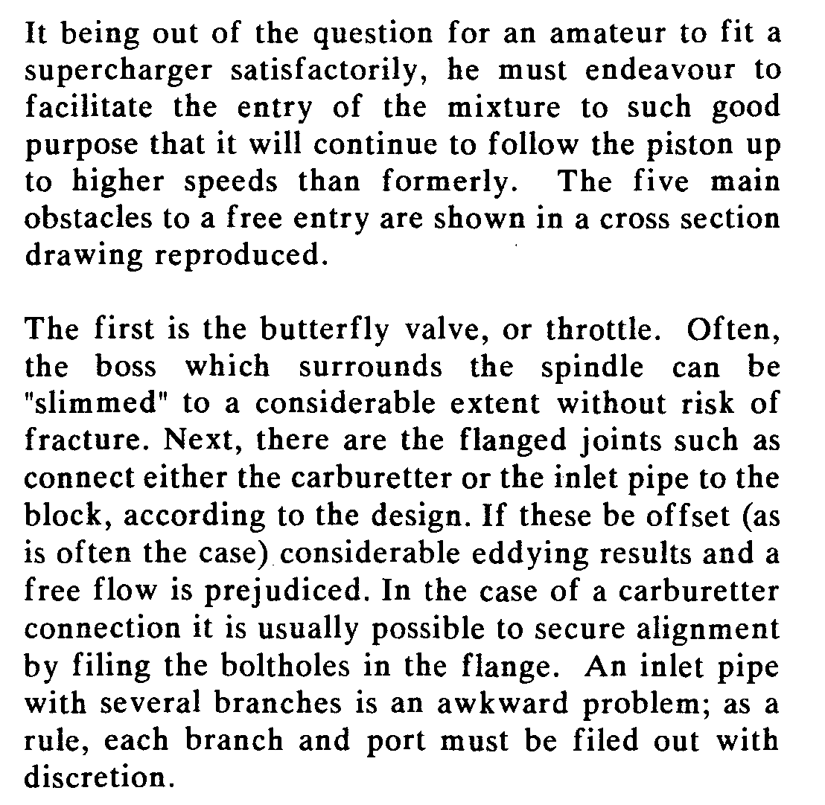
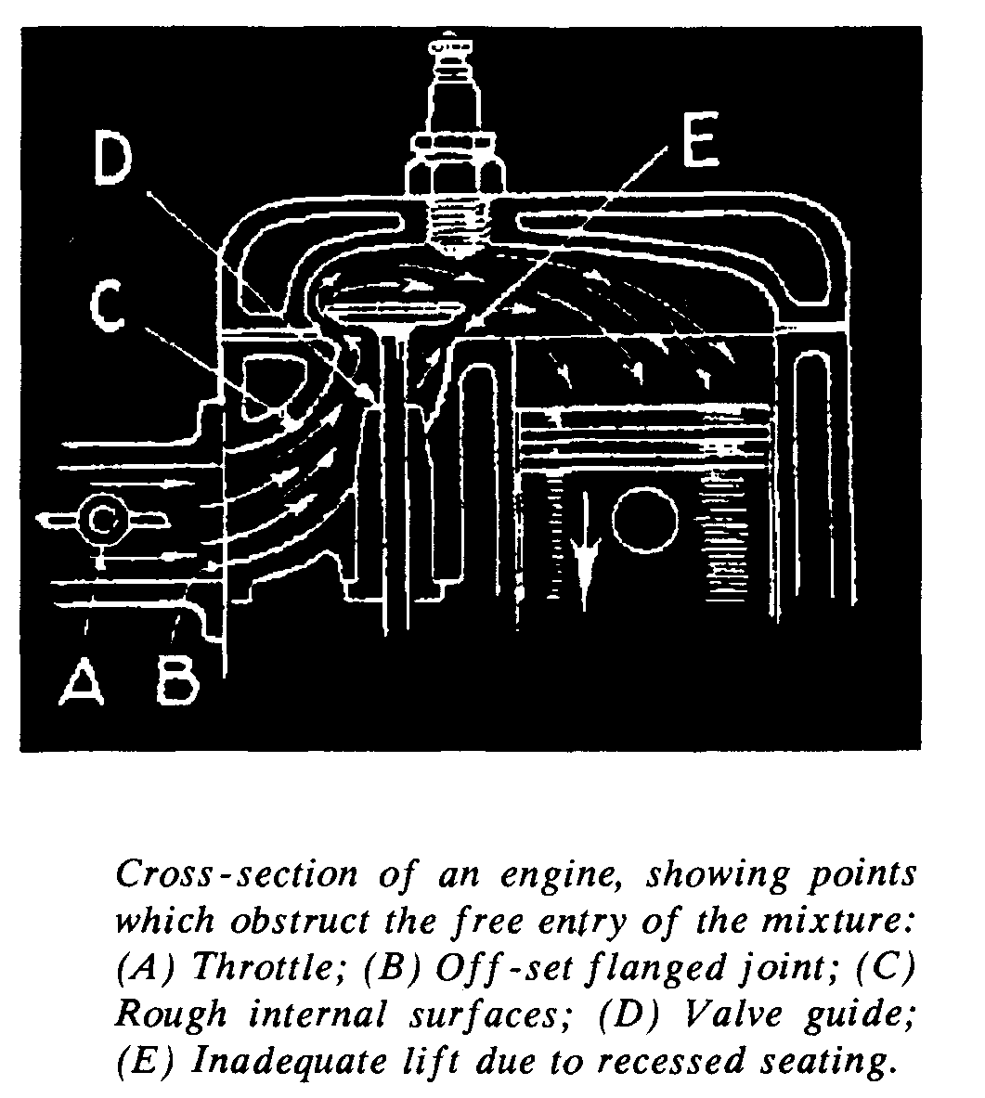
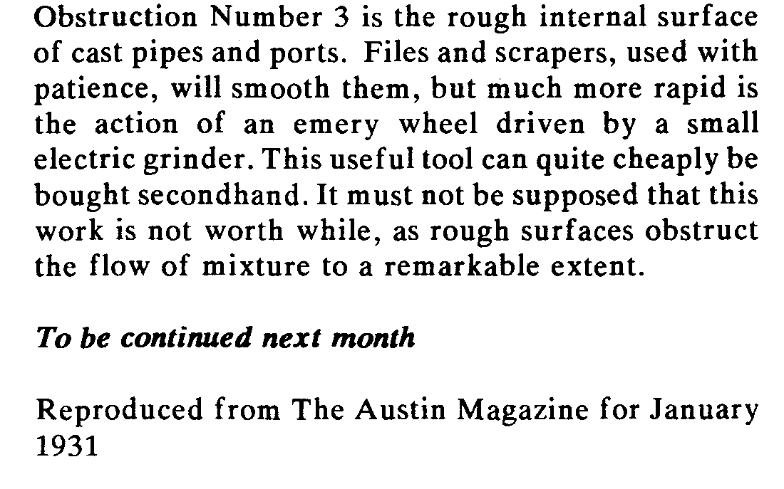

LETTERS
From: Joe and Maggie Stalker.
New Year's Day 1994 and we promised ourselves an outing with everyone in our "new" 1932 2 Seater. Yes, it would have been a bit crowded, but you know what we mean! We had just traded in the Box and hoped not to be last in line or holding everyone up on the hills any more on Club runs.
We did as were advised by Arthur Cox when taking on a used car and started by changing the oil in the engine, back axle and, disaster, the 3 speed gearbox. A small piece of curved metal nearly 2" long dropped out. A more observant oil changer might have noticed whether it came from the gearbox side or the clutch but Maggie is still an apprentice.
We couldn't risk any disasters so decided the 7 would have to wait to make her debut while we asked the experts. No one seemed sure about it but all advised that the 'box would have to be checked. This was the last thing we wanted to do but on Jan 2nd, 3rd and 4th our Christmas present had intensive surgery. Willy McKenzie arrived to give encouragement and advice. He produced a chart with all the bits and pieces that should be in the gearbox.
What a struggle for the first time engine removers. We thought we had read all we should read but tended to ignore things we did not want to do, like removing clutch pedal. Success came at last when we were both exhausted and the engine and gearbox were still firmly attached to the car. Joe said "lets detach the gearbox and see what happens". Well, of course it all did and within minutes the engine and gearbox were sitting on the work bench. We are glad we have gone to such lengths as the gearbox looks fine but there is a small piece missing from the clutch. There seem to have been 3 bits of shaped metal packing to take up wear. One was missing, or at least in an envelope for diagnosis. Phil has told us what to do instead of packing. The starter ring was a mess so all the effort has not been in vain and we can do all sorts of things to the engine while it is out of the car. Thanks to everyone for their help. Maybe we can make Lawrence's run if things go well.
Happy New Year and best wishes - Joe and Maggie.
- o 0 o -
From John Savage:
I have not been an active member during 1993 - for a number of reasons - but I have been enjoying the newsletter while slowly getting my car ready for its first MOT. This task and your request a few issues ago, for ideas and material makes me wonder if there is any chance of you listing Test Centres in the area which are known for their experience with Austin Sevens. At first sight, this may seem like free advertising but a similar thing was done a few years ago with a list of suppliers and specialists in our area. As I am a relative newcomer to Dorset, I would find that very helpful
Yours sincerely John Savage
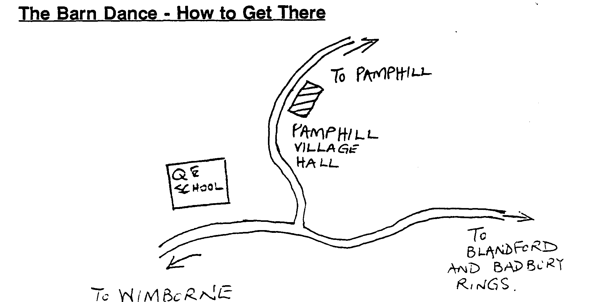

CLUB NOTICE BOARD
For Sale
1935 Austin 7 Opal In need of much restoration. Non Runner but spare engine, wheels and some parts. £1500. Also Ingersoll Rand compressor, 2HP single phase, 200 litre £250 plus many professional
restorer's tools. Ring Barry (ex Club member) on 0202 314 063.
1932 Special Part built Special based on 31 - 32 chassis and engine. Body on, new tyres etc. Most bits
there to finish. Space needed hence £900. Contact Mike Whit on 0590 677671.
1933 Box Saloon Dismantled, in fairly sound condition ALSO 1937 Ruby Dismantled, in fairly rough
condition. Phil Whitter has seen both these Dorset based cars and is prepared to describe them in more detail. The vendor is seeking £1500 ono for the pair. For more information, please call Phil (number inside front cover).
This will be the last newsletter to be sent to those who have not yet renewed their subscription!
VSCC EVENTS in 1994
This is an incomplete list of events over the next few months, the more distant events are not shown. Please see me if you want further information: More events will be listed next month.
February
5 - Herefordshire Trial based on Ledbury. Marshals wanted, volunteers to the VSCC Office (0635 44411)
26 - Pomeroy Trophy, for touring cars based on Silverstone. This is a traditional event, more a high speed trial
coupled with a driving test, scores based on performance against a formula taking into account size, comfort and additional seating.
March
5 - Derbyshire Trial, based on Chatsworth. Again marshals wanted, details above.
9 - Exmoor Fringe Trial, based on North Moulton. I will be marshalling, any other volunteers should ring
John Green on 0984 23468.
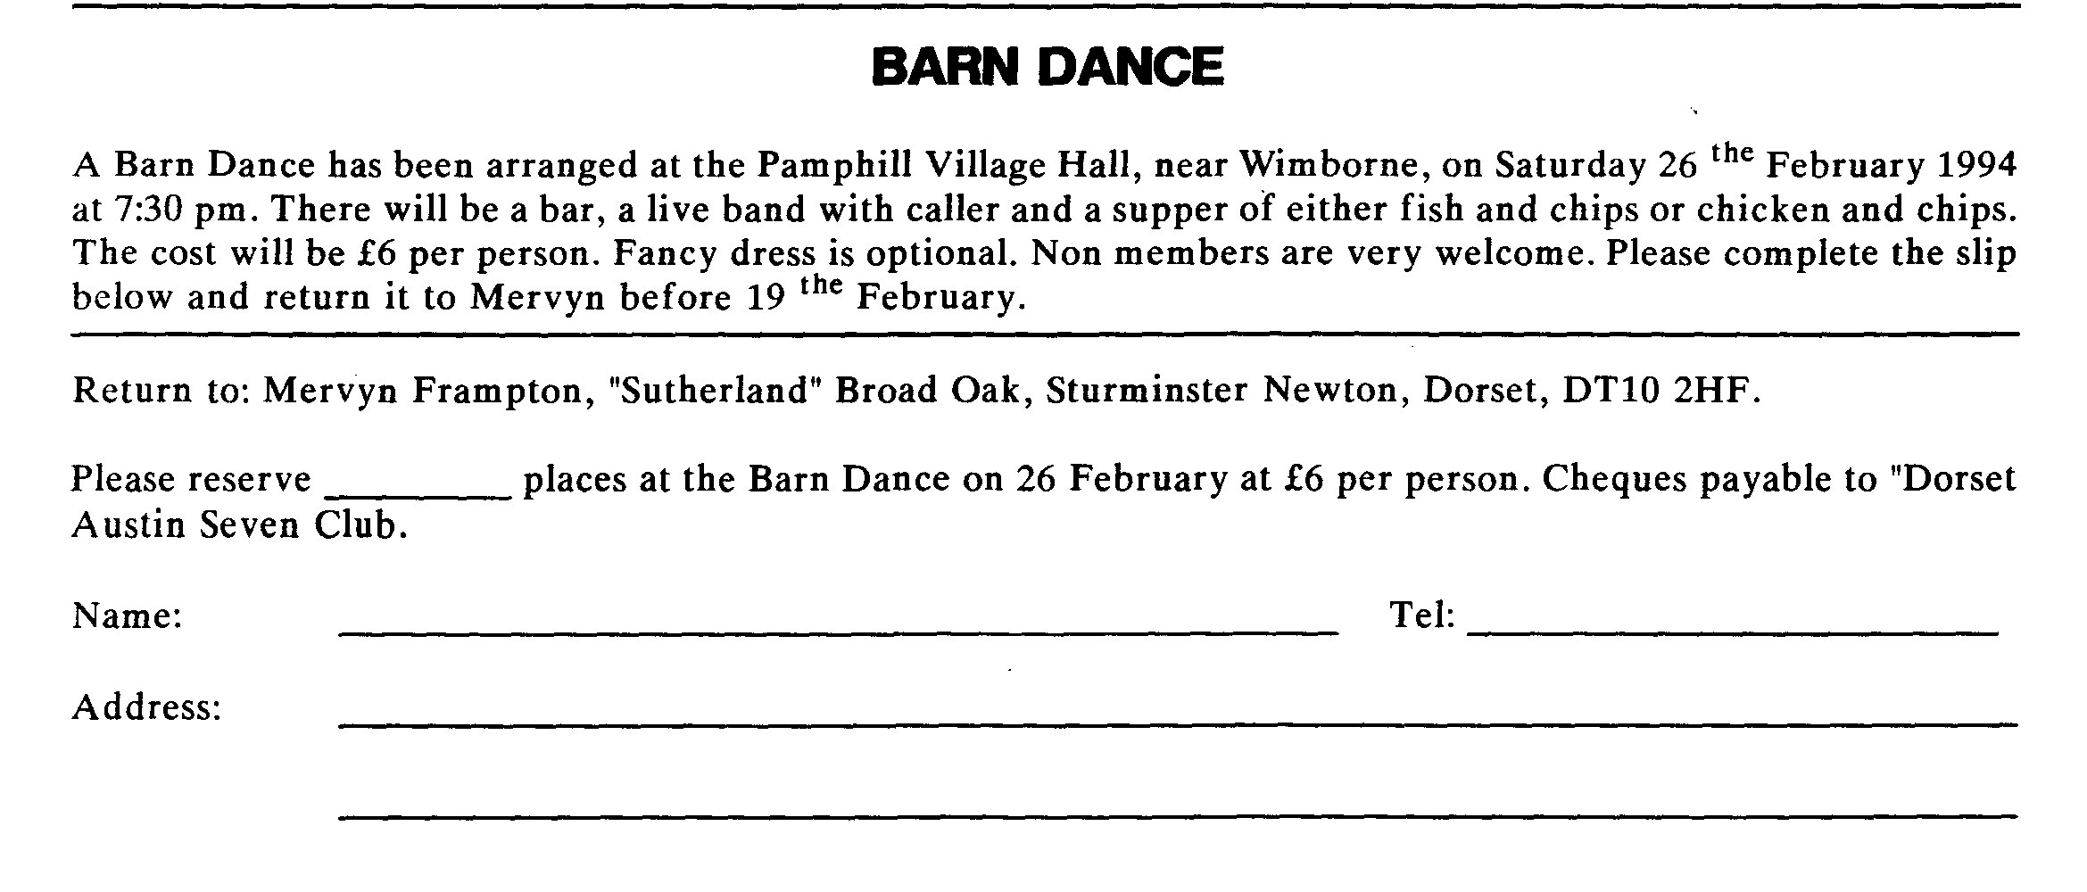

CLUB EVENTS
JANUARY
Thursday 20 Jan Club Night. Apart from the spares, Mery is organizing another of his famous Quiz Nights, Here are the subjects you will have to bone up on: Entertainment, Music, General Knowledge, Current Affairs, Nature, Sport and of course the Austin Seven. Teams can consist of 4, 5 or 6 people so don't be shy, come along and join in. Please arrive by 8 pm so we can have a prompt start at 8:15 for the Quiz.
Sunday 23 Jan Club Run. Lawrence has planned a special Winter Wander, so meet him at 10:30
at Ringwood for a 10:45 start.
Thursday 27 Jan Committee Meeting. Once more at the Tyrrell's Ford, 8 pm as usual.
Saturday 29 Jan Skittles Evening. Details as last month, please see map on page 6.
FEBRUARY
Thursday 3 Feb 8 ish til Late. Meet at the Woolpack, Sopley for the usual noggin and natter.
Thursday 17 Feb Club Night. Your Committee hope to have a guest speaker, plus Phil and the Spares.
Sunday 20 Feb Club Run. Organized by Dusty, what finer way to blow away the cobwebs from
Jane's bowling fiesta than a brisk run through the countryside with Dusty? Meet at the Wimborne Car Park at 10:15 for a 10:30 start. Don't forget to fill up with fuel before the start!.
Thursday 24 Feb Committee Meeting. Once more at the Tyre11's Ford, 8 pm as usual.
Saturday 26 Feb Barn Dance. Another of Mervyn's highly popular events, details are on page 7.
OTHER EVENTS
Saturday 29 Jan VSCC Winter Driving Tests. This very popular event is held each year at
Brooklands, near Weybridge in Surrey. Start is usually very early which will allow time to get back in time for the Skittles that evening at Sturminster Newton! See me for further details.
Saturday 19 Feb Charity Bowling Match. Arranged by Jane Whibley, this event is in support of a
thalidomide victim. It begins at 8:00 pm at the Bournemouth Bowl. Teams of 4 bowlers are invited at £5 a head payable on the night. See Jane at Clubnight or phone 0202 575167.
Finally a big thank you to the many members who have kindly donated raffle prizes in 1993. Please keep up the good work in 1994!

