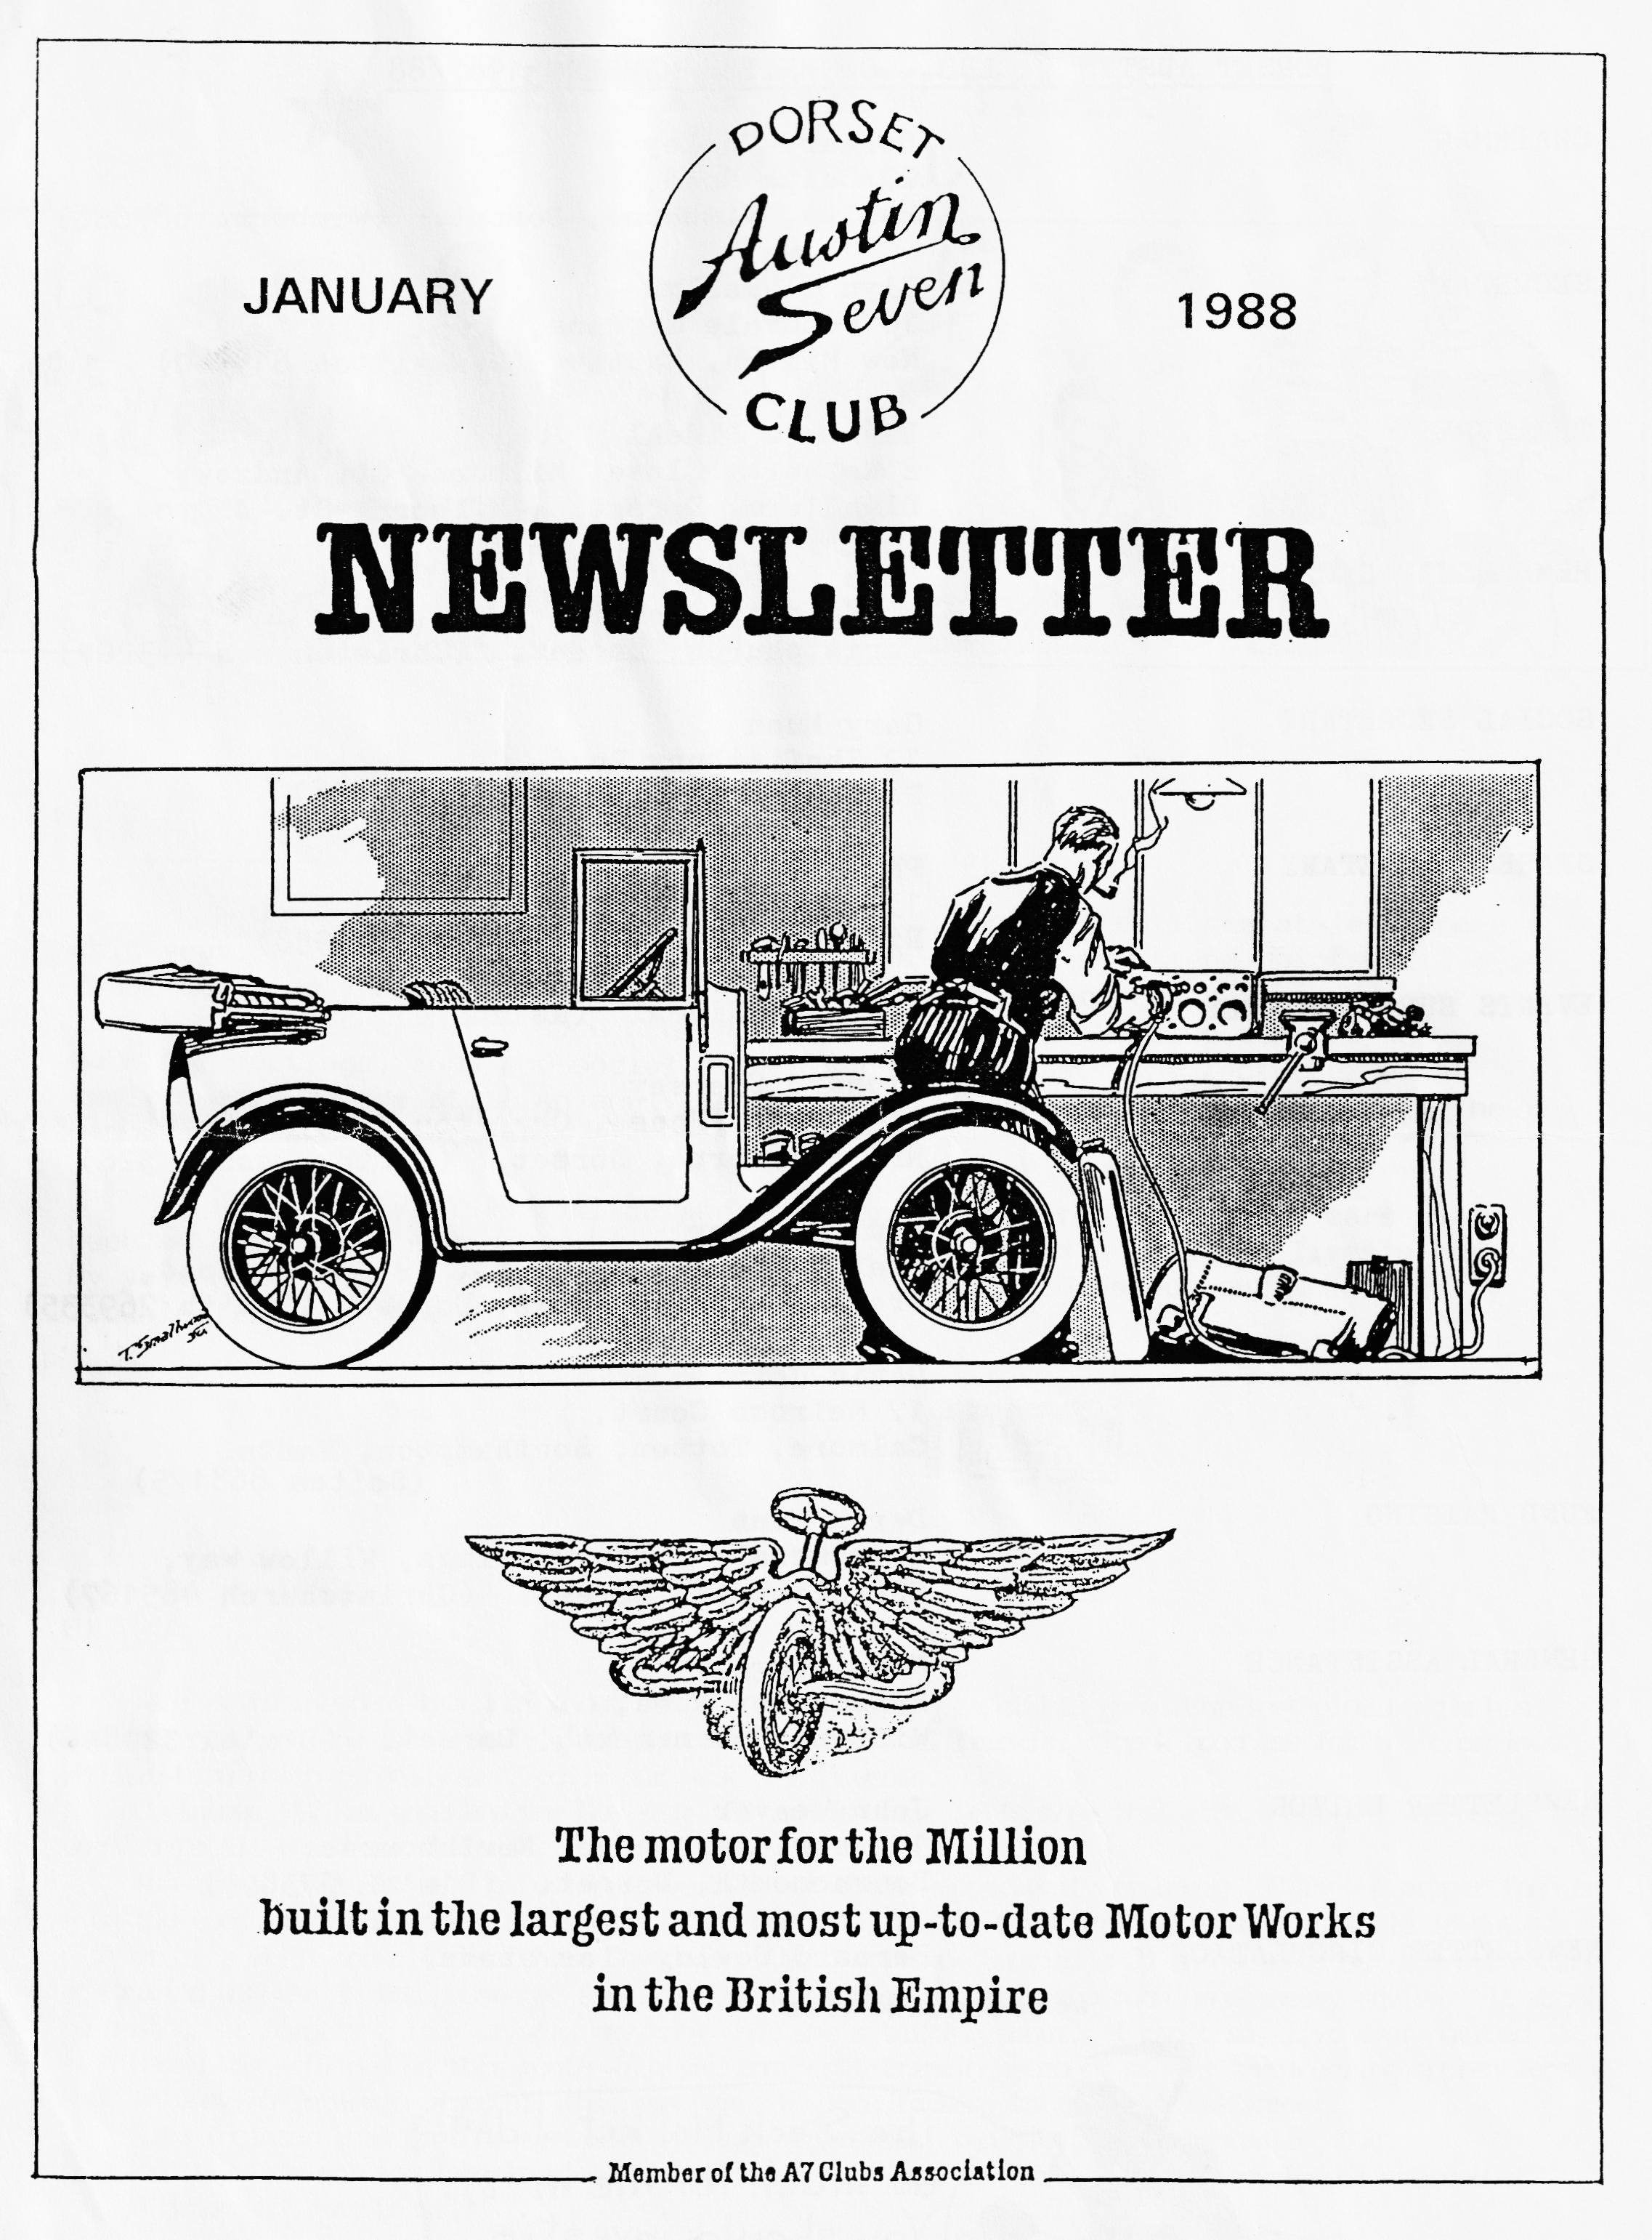

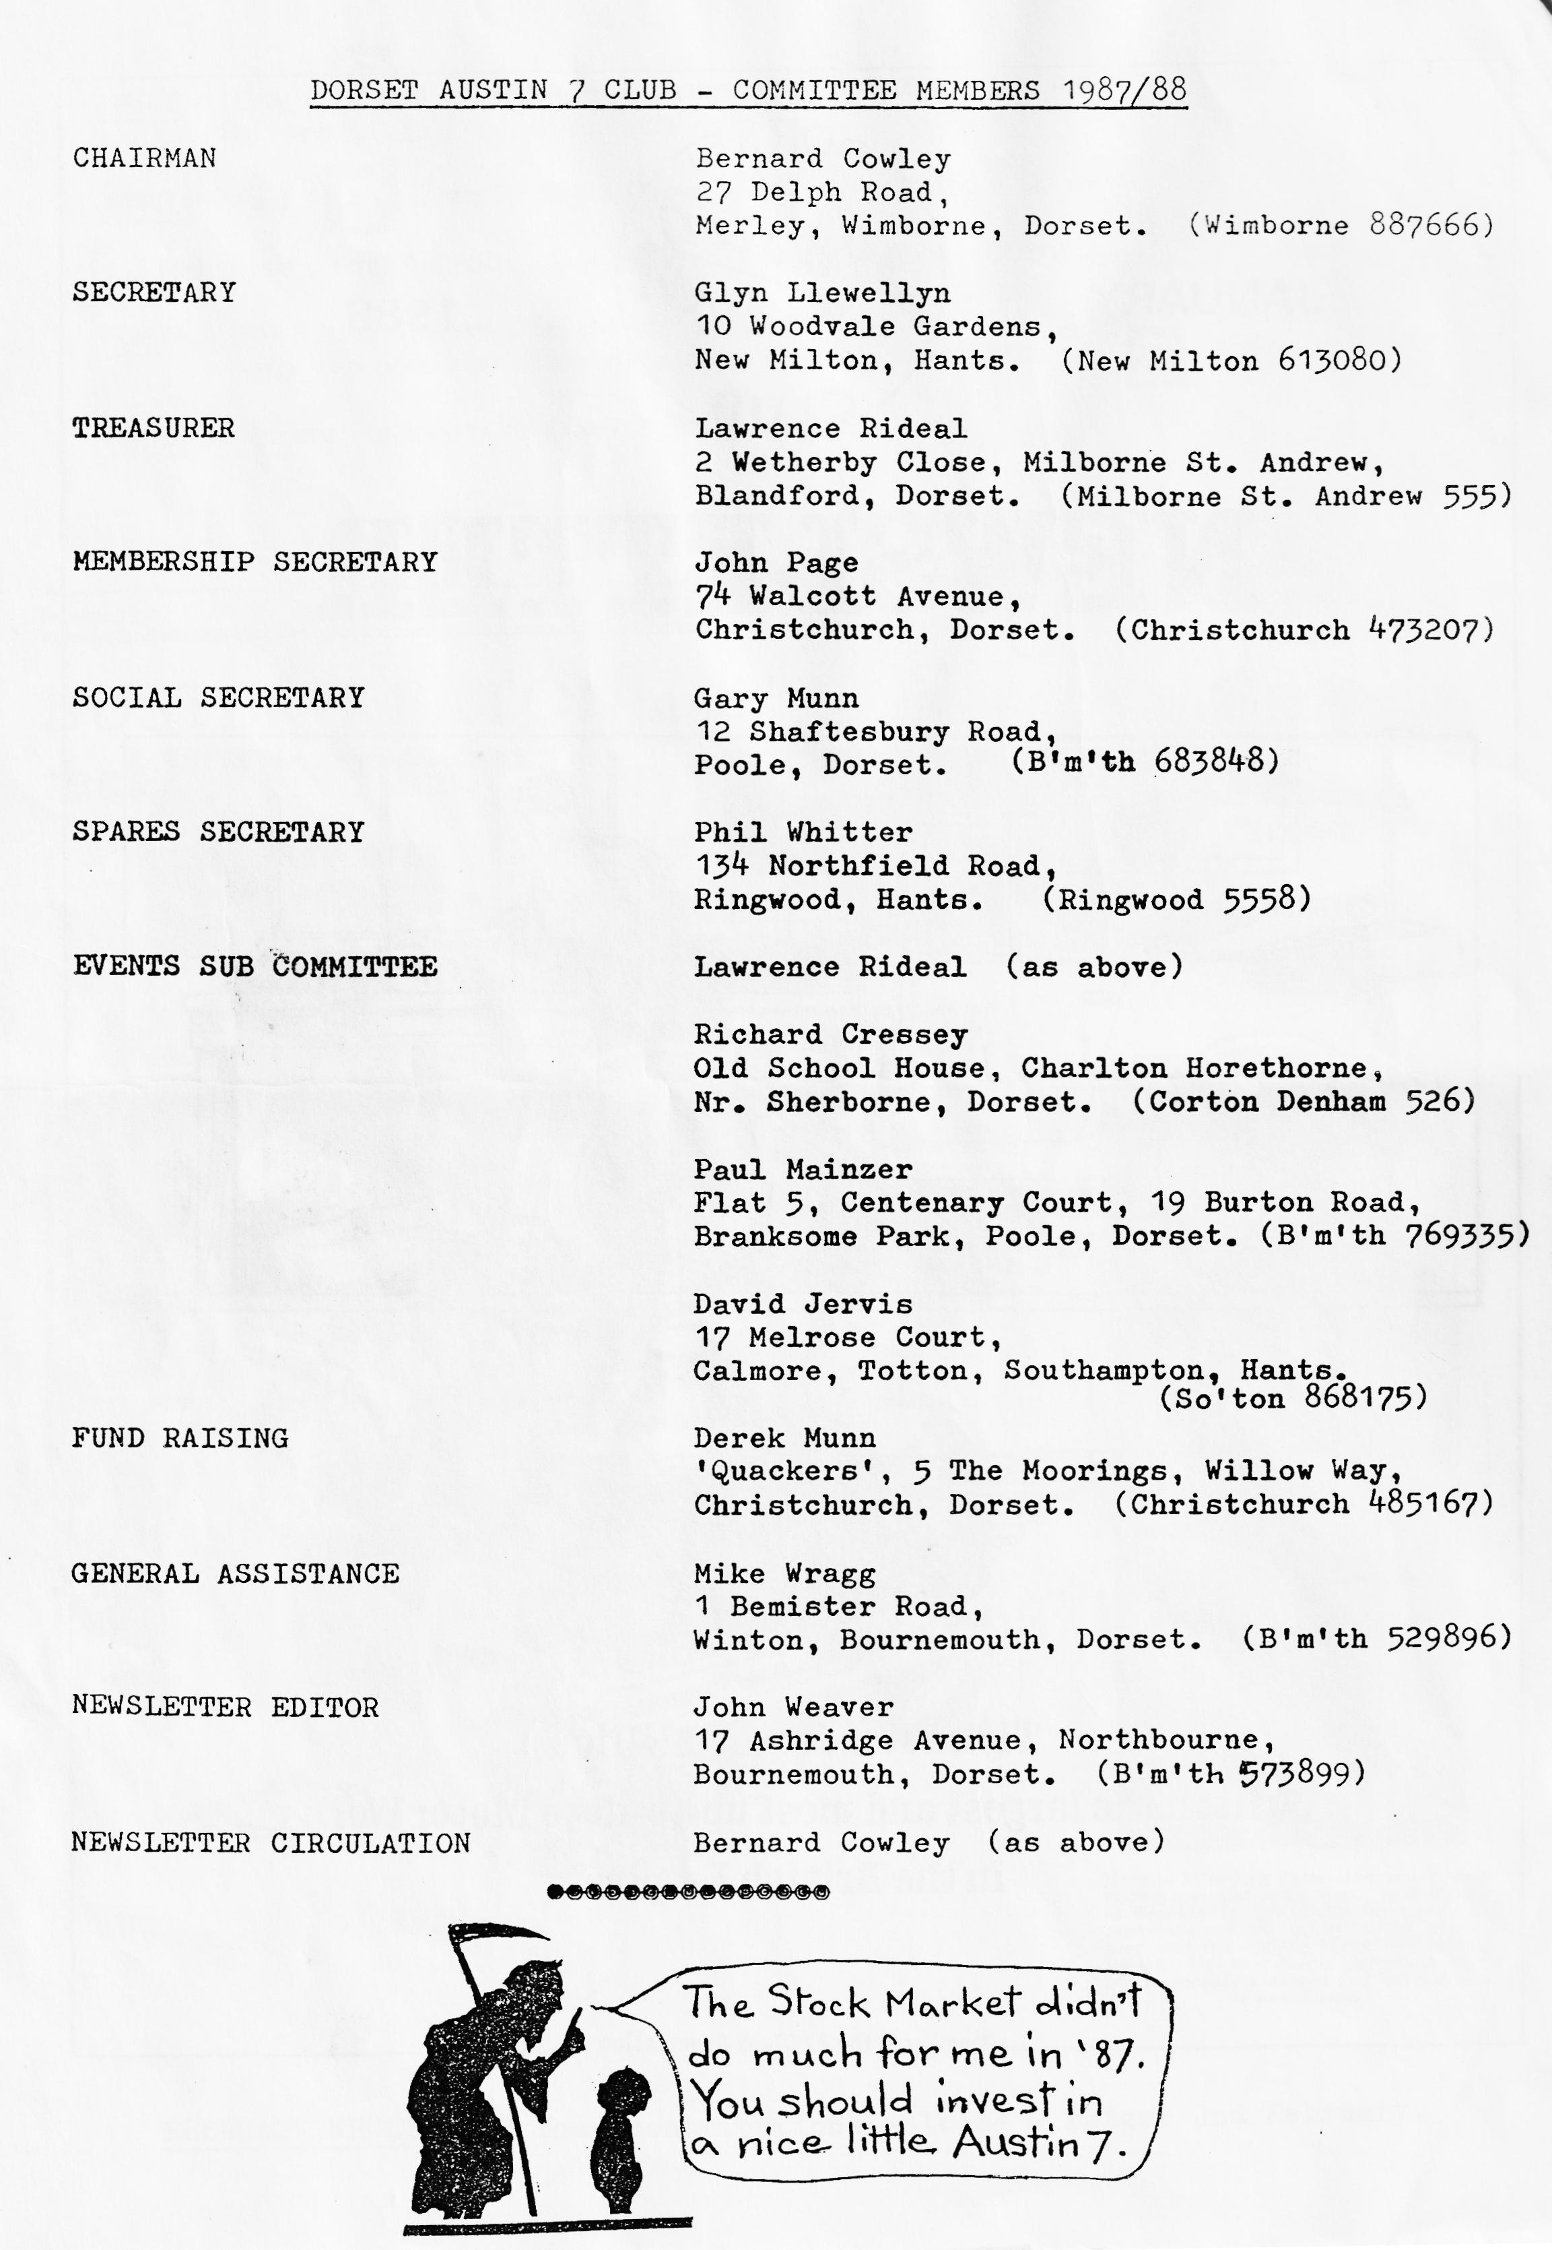

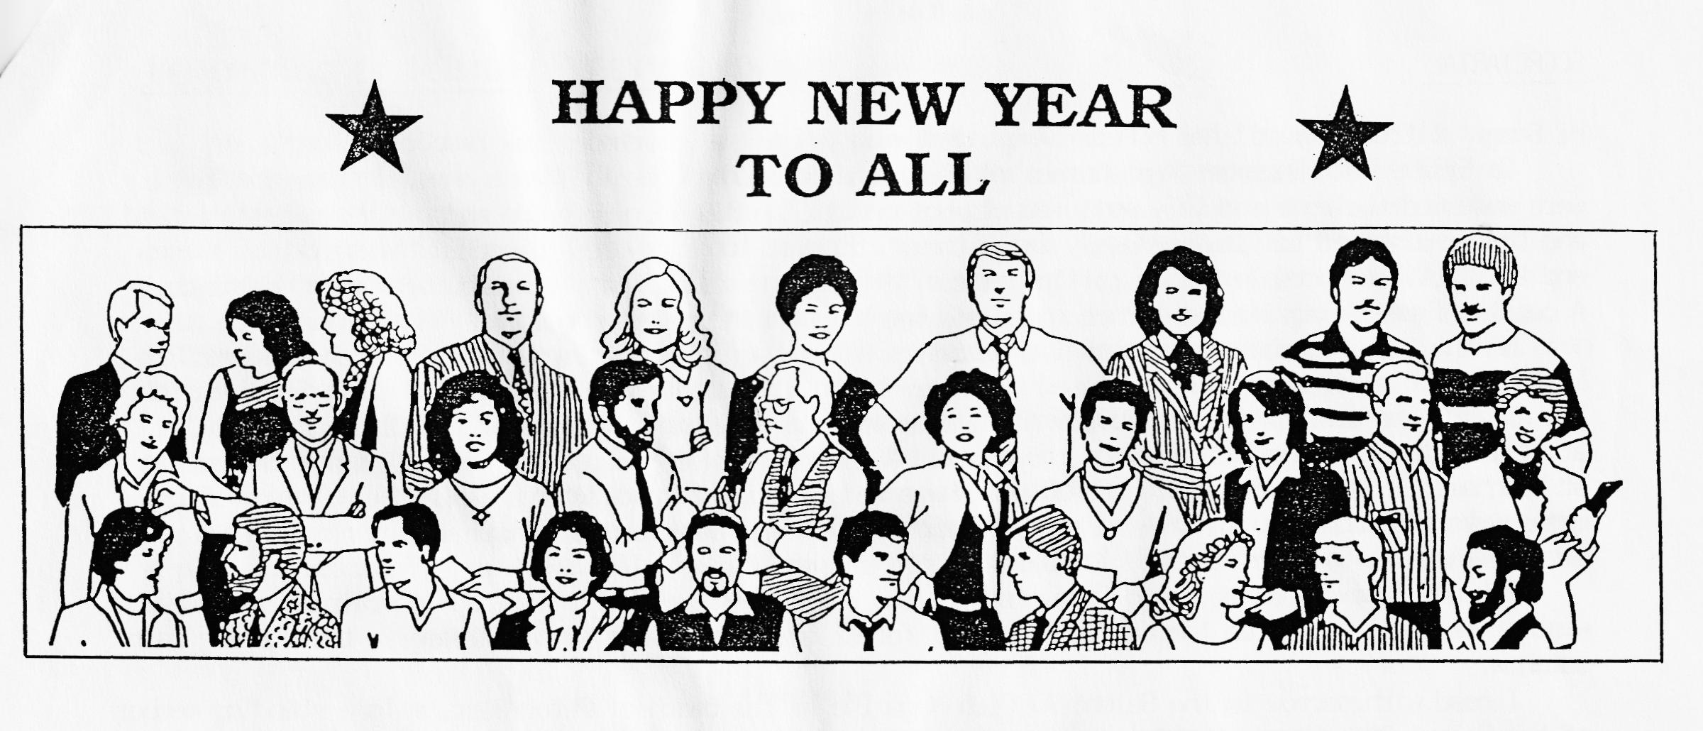
FROM OUR CHAIRMAN
Our Editor thought it appropriate that I pen a few lines at least once this year. Well, speeches and writing articles are not my strong point but I must thank everyone involved in the Club for their support throughout the year; not just the Committee who do such a grand job but also all the club members who make our meetings, runs and social events such a success. The fact that after twelve years we are still an active and, I hope, friendly, club still gaining new members, speaks for itself.
Hopefully, 1988 will be another enjoyable year of using our cars as much as possible, in good company, under cloudless skies - well, we live in hope!! My very best wishes to you all for a Happy, Healthy, Prosperous and Mechanically Trouble-free New Year.
Bernard.
EDITORIAL
As I write the dust has just about settled, the wrapping paper has gone, the last pine needle has been detected and the last 'empty' well shaken for that final trickle. Thank goodness for the capacious wheelie-bins which recently arrived in our neck of the woods. Christmas '87 has gone and the New Year '88 is with us. Let's hope that it's a healthy and happy one for us all - and our 'babies'. The traditional New Year's Day Run gave Club Members an opportunity to begin '88 in the proper fashion - on the road in an Austin 7. Gay and I joined the party at the Smugglers. Although my ankle is out of plaster it's still not clutch worthy. Gay doesn't mind driving 'Gabrielle J! on her own but draws the line at driving with me in the passenger seat. According to her she gets too much unnecessary advice. It might be that other competent lady drivers may know what she's talking about. I can't say I've ever noticed it. David has provided us this month with yet another intriguing account of his 'engineering apprenticeship'. that an amazing interest in detail this man has. We look forward to the next instalment. Also included this month an article on Austin Commercial Vehicles, as presented in 1931. Finally, it's not too late to check the efficiency of your antifreeze. (I wonder why I wrote that?) A Happy New Year to all! John.
SECRETARIAL
Hi Gang. I trust you all had a Merry Xmas and wish you all a very happy New Year.
On Friday 18th December most Dorset members were to be found at The Manor Arms, Burton, where we were made most welcome and very well fed at our annual Club Dinner. Everyone enjoyed the excellent food and the wine seemed to flow endlessly (also the Whitbread!!). Our hosts joined in the spirit of things and the Chef won a couple of the raffle prizes. I hadn't realised that it was quite such a formal do. A couple of people arrived in dinner suits and one with a bird on his shoulder!!
On the 28th December, after gorging ourselves silly over Xmas, Pat and I decided to go on the 'Bit in the Middle after Xmas' Run organised by Henry Morgan. We arrived at the Little Chef at St. Ives, on the A31 at the stated time of 10.30am and met up with several other members of the Club. Eventually, at 11.15 actually, we got started on the run via Alderholt, Fordingbridge and Godshill to The Foresters at Frogham. This is a delightful SMALL pub where we all tried to pack in for lunch but not many of us managed to eat, however, so after a pint Pat and I wended our way home. It made a nice charge from sitting indoors, however, and we blew a few of the cobwebs away.
Pat and I have just returned from planning the New Year's Day Run in the pouring rain. I hope the weather is a bit kinder on the day as beautiful forest scenery doesn't seem the same in the pouring rain somehow.
I read with sorrow in the Solent A7 Club Magazine of the death of Peter Burr, a long standing member of the Solent Club, who many of you may have known. Pete helped to run the famous (or infamous) Solent Cross Country run amongst others. Our condolences to his wife Ann and two children Kate and Tom.
A Skittles Match is being organised between ourselves and the Morgan Car Club with the venue the Old Barn Farm Inn (where we had our Club Skittles Evening) and is on 12th March at 7.30 pm. This is a light-hearted match not to be taken too seriously, but should be good fun, so put the date in your diary.
I read in the Bristol Club Mag. that the Spye Park Rally is definitely on next year. It is to be on 18-19th June, another date to note. Well that's all from me.
See you Club Night!
Glyn.

Headlamps—Seven.

Q
I have recently purchased my first Austin car, a second-hand 1932 Seven Saloon, and I wish to replace the headlamp bulbs. There is no instruction book with the car and I have experienced difficulty in removing the headlamp rims in order to get at the bulbs. Can you give me any information concerning these headlamps and advise me as to the correct bulbs to obtain for replacement purposes ?
A
The headlamps fitted to your Austin Seven car have Special double - filament Lucas - Graves bulbs ; the main filament provides the normal driving beam, and the secondary filament, which is slightly in front of the main and is surrounded underneath by a shield, provides the deflected anti-dazzle beam on operating the switch on the steering column.
On these lamps the securing screw cannot be swung clear of the slotted plate at the base of the lamp, as is usual when releasing the lamp front, and any attempt at forcing this screw clear will only result in the reflector being dented from the inside.
For removing these lamp fronts, it is necessary, after slackening the screw, carefully to prise off the front with a suitable tool and then, by swinging the top of the lamp front forward and downward, lift the slotted plate clear of the screw. -
Alternatively, the screw can be removed entirely, but if this is done, it must be ensured that the anchoring plate is not pushed away inside the lamp body, as this will necessitate dismounting the reflector before it can be reached.
The correct Lucas-Graves bulbs can be obtained from any Austin dealer or Lucas Service Depot.
.STIFF WINDOW— Seven.
Q
I would be obliged for your advice as to the best way of dealing with one of the door windows on my Seven. The window in the door on the driver's side continually sticks and it is difficult to lower it by means of the handle inside the car. This stiffness has developed during the winter months and now the only way I can release it and lower it is by banging on the inside of the window several times.
A
The difficulty in operating the window of your Seven may be i due to the moulding rail inside the door being slightly bent to put pressure on the glass. By resetting it the trouble with the window should be overcome.
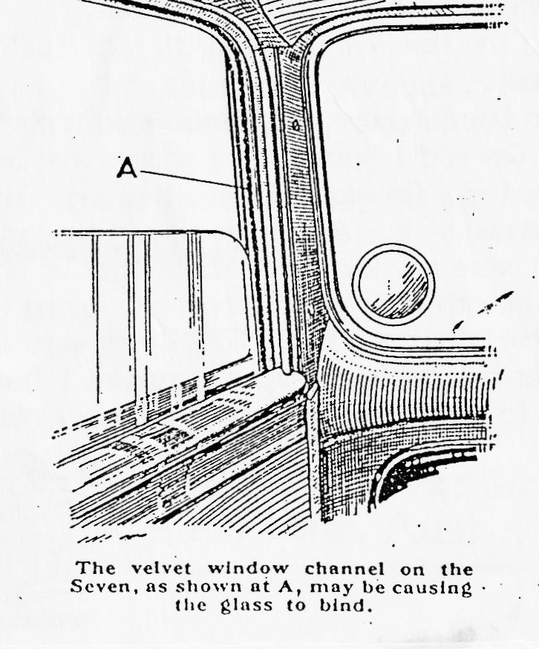
You might also examine the channels on either side of the window in which the glass rises. These may be binding, to make the action of the window stiff. If they are opened slightly and a trace of thick grease applied in the bed of each channel the stiffness should be eased.
If attention to these two points fails to correct the trouble, the winding mechanism may be at fault due to rust resulting from the intrusion of moisture. Access to this mechanism necessitates removing the winding handle, which can be detached by levering the small spring catch behind the handle away from the spindle with which it engages. A loop of wire is sometimes useful for doing this. The waist-line moulding, inside the door, and the door catch are both held by screws which are quite easily removed, and the panel itself, which is held by screws or panel pins, can be prised away from the door. The winding mechanism can then be examined and thoroughly greased to render its action quite free.

THE MORNING AFTER THE NIGHT BEFORE RUN - NEW YEAR'S DAY 1988
Well the 1st of the year dawned with pouring rain and high winds; is this a taste of the year ahead? I hope not! We all gathered at around eleven o'clock, clutching Paracetamol and propping our eyes open with match sticks in the Cat & Fiddle car park at Hinton. Glyn and Pat led the way as we threaded our journey through numerous country lanes, across the Forest to Burley, and on gently toward Milford on Sea. David Jervis unfortunately had to break convoy and head straight for the Pub, with some excuse about binding brakes, that's a good one Dave, how many pints did you manage to sink before we arrived? Gordon Pope veered off at one point muttering about excessive pressure, did he mean his or his oil's? ,Keep those jets rodded through Gordon!
We arrived at about twelve thirty at the Smugglers at Milford, where our hosts had reserved a whole section of the Pub for us. After a good meal and slight top up of the alcohol stream, we were all invited back to Glyn and Pat's for tea, as the weather was too bad for a walk.
I'm sure you will all echo my thanks to them both for their efforts and hospitality, it was such a pity the weather let us down. Glyn, you'll have to have a word with Him up there before the next Whitbread run!
Gary.

WE DIDN'T EXPECT a visit from Santa at the Club Christmas Dinner. Merv managed to fool some of the people all of the time. Thanks, Merv!
NICE TO MEET two of Mick and Sue's youngsters (Russell and Gaynor) on the New Year’s Day Run.
ALSO TO SEE their Cabriolet successfully braving the elements.
FROM YORKSHIRE we were joined by Gordon and Lena's daughter Jennifer, son-in-law Gordon and granddaughter Fiona. Good to meet them.
SAY IT VERY QUIETLY but Glyn and Pat have a 2CV for sale.
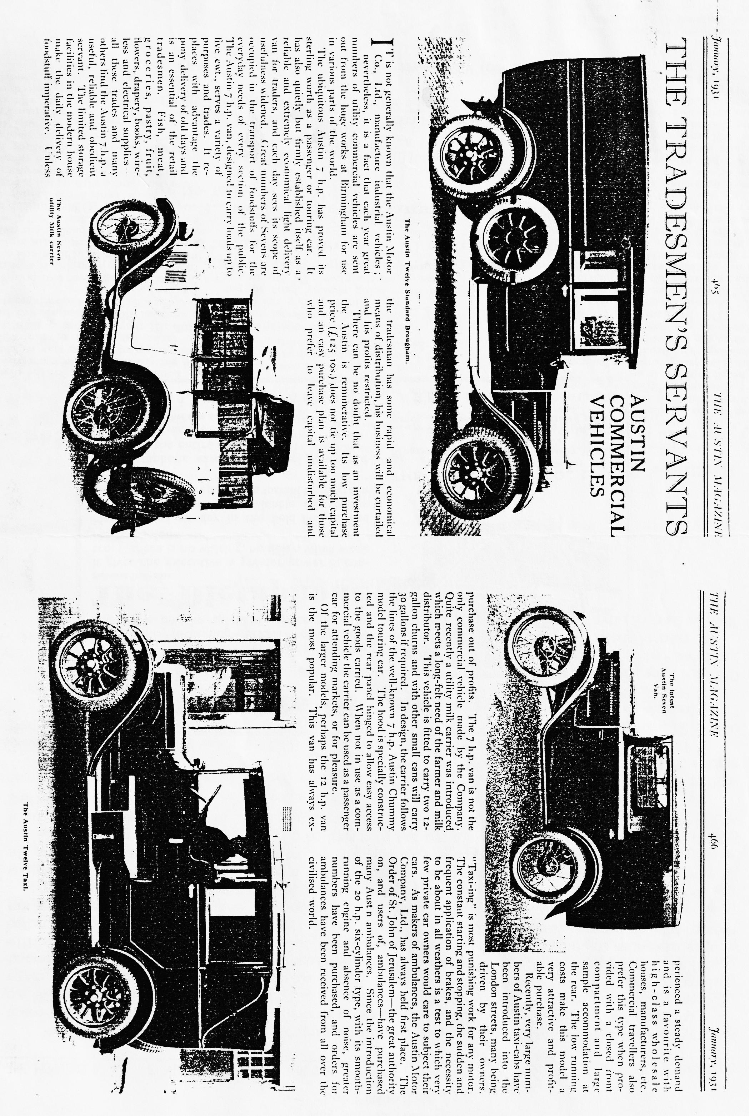

BODGERS' CORNER "THE XMAS PRESENT"
A trip down to Regar Engineering proved disappointing but interesting. The Opal's block hasn't even been looked at - but that's not a bad thing since I've still got a good excuse for sitting on the settee "planning", rather than going out to the garage. What was interesting, though, was a guided tour of the place and being introduced to the mysteries of Engineering Practice. I had always wondered how a crankshaft was ground and white-metal bearings cast. For those as innocent as myself, the grinding wheel is loose and attached to the crankshaft with a sort of hook which keeps the nodding grinding wheel rubbing against the journal as it goes round. There is no science or skill whatsoever in casting the white metal bearings - the metal is melted down on a gas stove and poured everywhere in the hope goes inside the bearing! Later, when cool, most of it is bored out again! The trick, of course, is to minimise the waste and collect up the swarf for re-cycling.
However, on to Xmas and what to do with Santa's prezzie of a timing light. This works fine on modern cars since the bottom fan pulley is directly attached to the end of the crankshaft and therefore goes round at the same time as the engine - not so on the A7 of course since the fan pulley is driven via cogs and things and goes round at a different speed to the engine. In fact, there is nothing that goes round at the same speed as the engine except the flywheel. With the flywheel cover off all that can be seen from the engine side is the starting ring teeth, so it seems reasonable to use those as timing marks. A quick count resulted in 80 teeth, so each tooth represents 4.5 degrees. However, on mine, TDC lies in between two teeth so the first tooth is at just over 2 degs., the second at nearly 7 degs. and the third at 11 degs. etc.. and a lick of paint highlights them for the timing light. Later cars are supposed to be TDC and that's easy enough, but the earlier ones are advanced by between 1.25 - 2 ins. The diameter of my flywheel is 10 inches, so this will represent between 14 and 23 degrees advance, or halfway between teeth 3 and 4 to halfway between teeth 5 and 6. I can already hear the screens of all you "ear men" and the abhorrence for things exact, but I remember when I first set up my engine, of not knowing how far advanced or retarded it all was since I had nothing to go on. At least I will now be able to see the relationship between movement of the distributor and its effect on the timing. I will also be able to check that the automatic advance mechanism is working.
Whilst I'm into figures the bearing sizes for the late three-bearing crank are: front 1.125 ins; journals 1.3125 ins; centre main 1.75 ins; and the rear main 1.25 ins; and the Austin Seven Workshop only has shells in standard +10, +20, +30 and +50 thou. sizes.
Sue is hoping that the top-end is back soon, since she's getting tired of hoovering around me all the time. More next month I'm afaid.
David.
PS. I'm writing this after the Henry Morgan rally. It makes one appreciate all the more the good planning of our and dearly beloved Committee. Thanks chaps. DW.
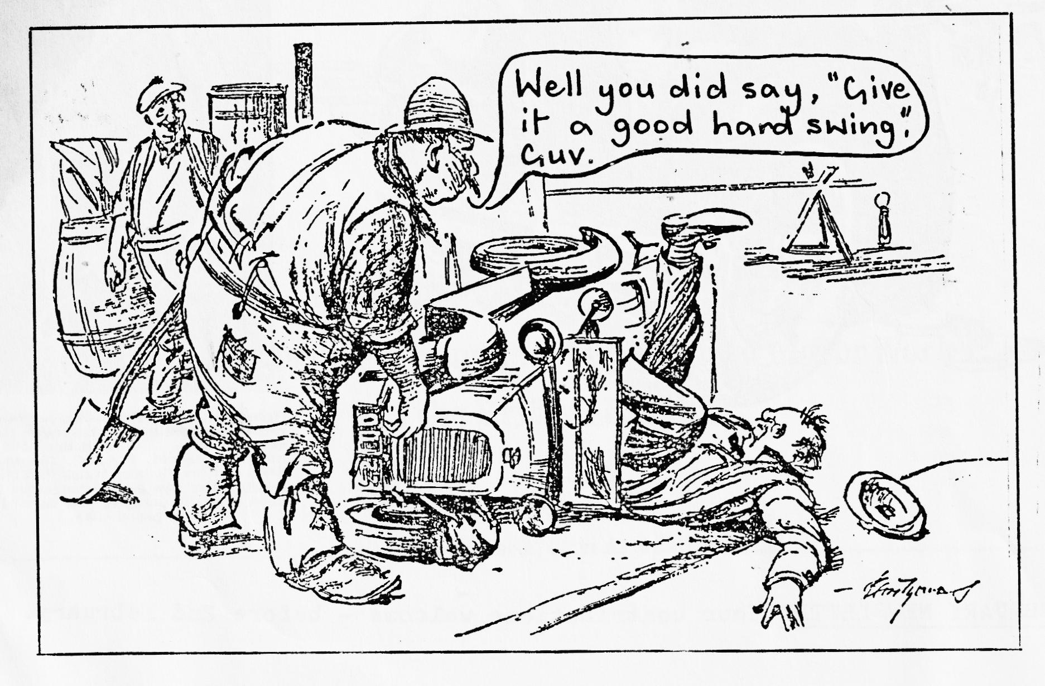
WANTED by Gary ( B'mth 693848) - A Chummy hood frame or pattern, a cut-out, 1 rear spring U Bolt and Mag. Distributor cap.
WANTED by Paul ( B’mth 769335) A Chummy hood frame or pattern, as above. .- I wish I had a hood for sale. This would make an interesting auction! (Ed.)]
FOR SALE 1931 R.N. long wheelbase chassis complete with front and rear axle- 17" wheels and tyres (can easily be converted to short chassis) Bernard Cowley ( Wimborne 887665)
WANTED by Bernard (telephone as above) 29/34 Steering Box.

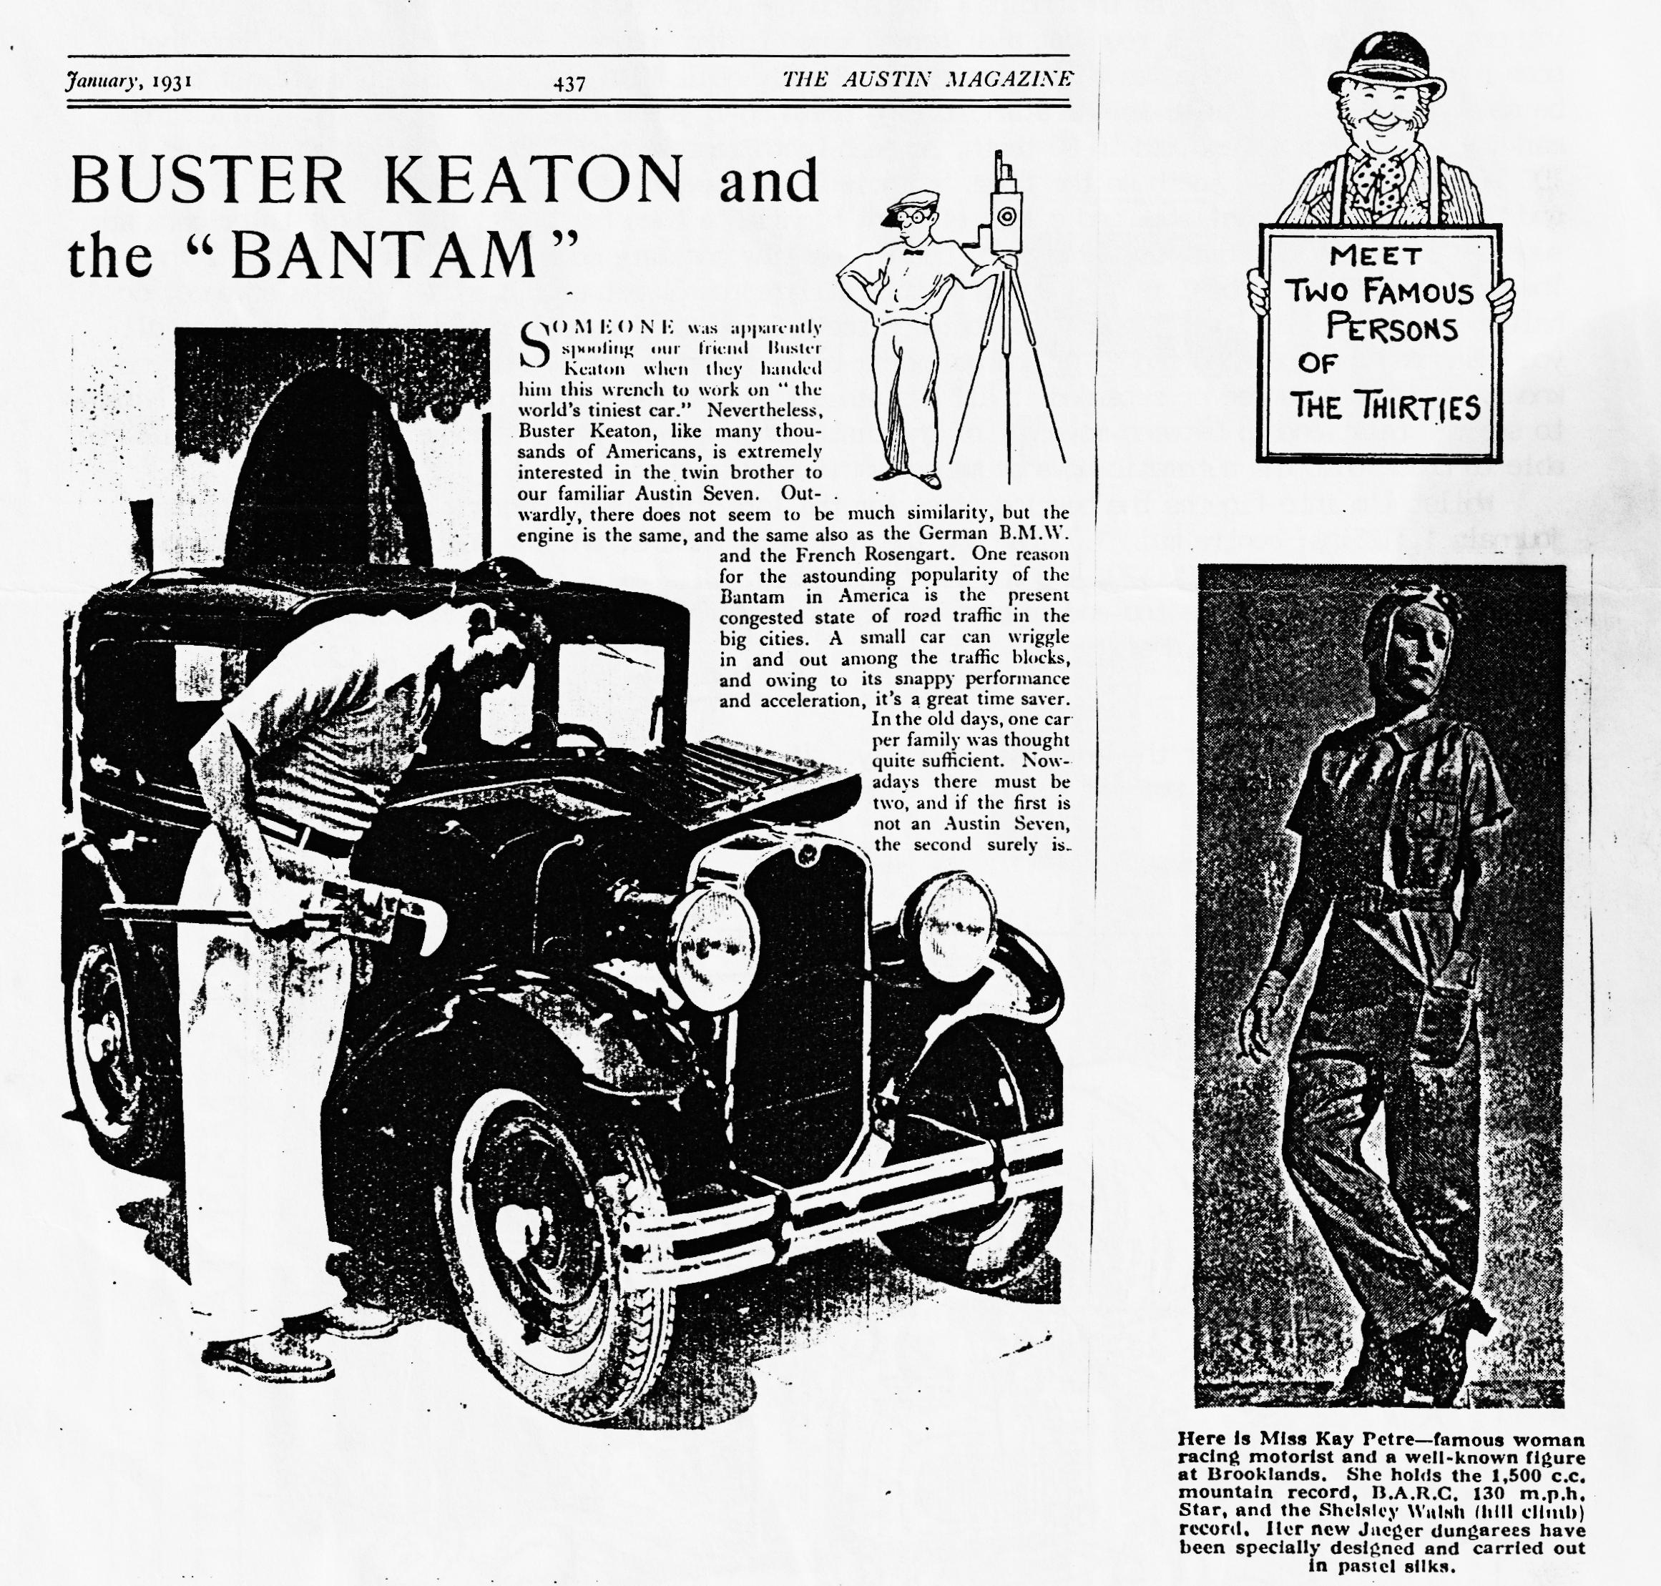
EVENTS JANUARY
Thursday 21st January - Club Night at the Elm Tree at 8.00 pm. NOT a Film show as expected because of a technical problem, but even better - a HANDY HINTS FOR SEVENERS EVENING, with practical demonstrations. Not to he missed fans! Come and see Phil trap his fingers.
Sunday 24th January. The 'Dorset Cream Tea Run'. Following a short run and pub lunch on to John and Gay's for a Trivial Quiz and tea. Meet Wimborne Square 10.45 for 11.00 am.
Thursday 28th January. Committee Meeting - 8.30 pm at the Tyrrells Ford.
FEBRUARY
Thursday 18th February Club Night at the Elm Tree at 8.00 pm
Sunday 21st February Club Run 'A West Dorset Wander'. Meet at Wimborne Square at 10.30 for 10.45 am.
