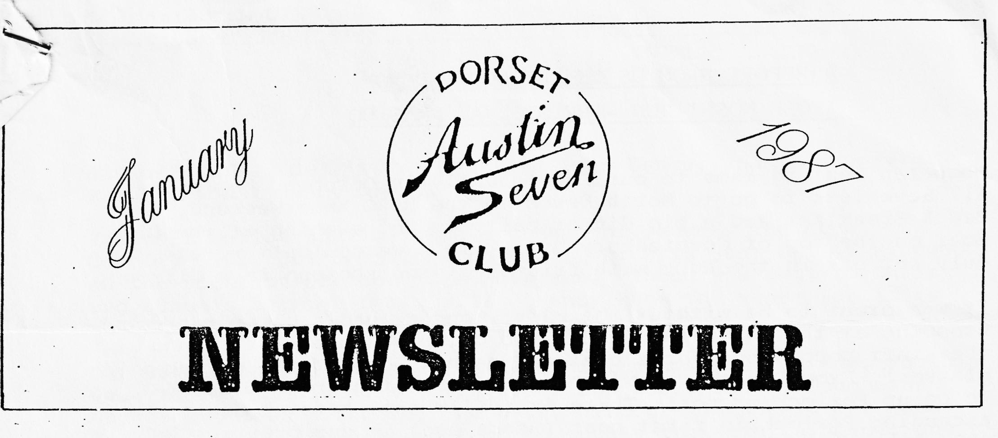
EDITORIAL
Happy New Year to everyone, and, although advised last month, apologies for this Newsletter being a 'budget edition'.
I hope you all had an enjoyable Christmas which I'm sure for many of you started with the excellent Club Xmas Dinner at the Manor Arms, Burton. This was a superb evening, and the meal provided excellent value for money and the cabaret supplied by John Weaver flashing about as a rent-a-tree and Paul Mainzer's very original Christmas story titled 'Get Lost at Christmas', being a subtle hint to Emma of his need for both a diary and road atlas for Christmas, gave everyone a lot of laughs!
The culmination of too much eating and drinking proved just too much for me to make it to the New Year’s Day run and when everyone :was meeting at Viewpoint, I was still in bed mentally debating whether it would be wise to get up before afternoon.
I see that the Barn Dance allows for Fancy Dress this year, and at the time of writing this I think I should go as the ghost of Christmas past!
Regards,
BRIAN HOOPER
Deadline for February Newsletter copy - Wednesday 4th February.
- 0 - 0 - 0 - 0 - 0 -
SPARES
Phil Whitter advises that as he is giving the talk at the January Club Night, that he will not be bringing along the spares. However, anyone desperate for bits can pre-order these for collection on Club Night by telephoning him (Ringwood 5558).

10 Magdalene Lane Shaftesbury.
A REPORT FROM US ON THE NORTH DEVON 'POSH NOSH' RUN - BRISTOL A7 XMAS DO
When Ian Dunford came to our Ruby's Rally in October, he invited all Sevenists to go to North Devon to the BA7C Xmas Weekend, Bed & Breakfast and a big dinner party in the evening at the Blue Boar on the top of Countesbury Hill. This we couldn't refuse, so duly set off in the Ruby with friends riding shotgun in a Citroen.
It was great to be without the kids!, and we had a clear run down stopping at the Thorn Falcon for two quids’ worth of 2-star and the staff popped out for a chat and gave us one of those free glasses! From Dunster to Minehead and then the great debate - to go up Porlock or not! There is a film somewhere of us ascending Porlock in first gear (years ago) in our previous Ruby when both of us had the same appalling fixed stare of horror! Anyway, this time we chickened out and went up the toll road the views are well worth 30p! We heard screams from behind and, yes, Mike the pilot of the Citroen was up to his normal tricks swerving side to side on the cliff road - his wife hates heights!
We finally made it to the Blue Boar - packed full of Austin Sevenists, but with ours the only Austin 7 there!, even the Dunfords came in a Diane!
The pub is superb, long and low and they smoke their own ham in the chimneys. Bed and Breakfast was £14/night including colour TV and private bath. It was all very cosy, specially as there were gale force winds and sleet outside. We had lunch and a trip around Lynmouth and Lynton and then back to change for dinner.
Everyone arrived all washed and pressed and settled in for a long evening! We all sat down together, 32 of us - 31 were drunk!
The menu was extremely good with four courses at £10 per head.
We can't actually remember a lot of that night, I know that after dinner there were singers and musicians one of whom could play, sing, dance, smoke, drink and chat up a woman all at the same time!, I also have memories of Ian Dunford legless and Morris Dancing with a dainty hanky in each hand.
Trying to get back into the Bed & Breakfast place was quite exciting in the small hours - the landlady bred Lurcher dogs. Sunday dawned and we all made polite conversation while feeling around for the Black Coffee. We went back to the pub at opening time where everyone was very quiet and scowling at noisy glasses of Perrier Water!
We set off after lunch and said goodbye to everyone - a goodly bunch who had made us foreigners from Dorset very welcome.
We had a wonderful time and will be back again, God willing, how about some others from Dorset?
Kevin & Pauline Barnes

ANNUAL BARN DANCE
SATURDAY 21st FEBRUARY. AVON COUNTRY CLUB 7.30 p.m. till Late
At last folks, details of our next Barn Dance, and this year with optional fancy dress!
You will notice that we have a change of venue - the Avon Country Club, 262 Christchurch Road, which is just out of Ringwood on the right before the Nags Head Pub. Those who went to Chris and Lynda's charity party will already know the venue for it is the same place.
Our Barn Dance is in the River Room which has its own bar, so this year there is no need to bring your own booze and a Ploughman’s supper has been arranged. We have, of course, engaged our good friends - The Old Pull and Push to supply the entertainment; any of you who haven't seen or heard them before - just ask someone who has.
This really is an event not to be missed and as we've said on previous occasions - you don't have to know how to barn dance its just one hilarious night! Please come and don't forget to enter the spirit in fancy dress - you might even win a prize.
We can accommodate about 80 people so bring along your friends although regretfully due to licensing regulations, adults only please.
Please book now to avoid disappointment by returning the booking form below, and by the 12th February latest:-
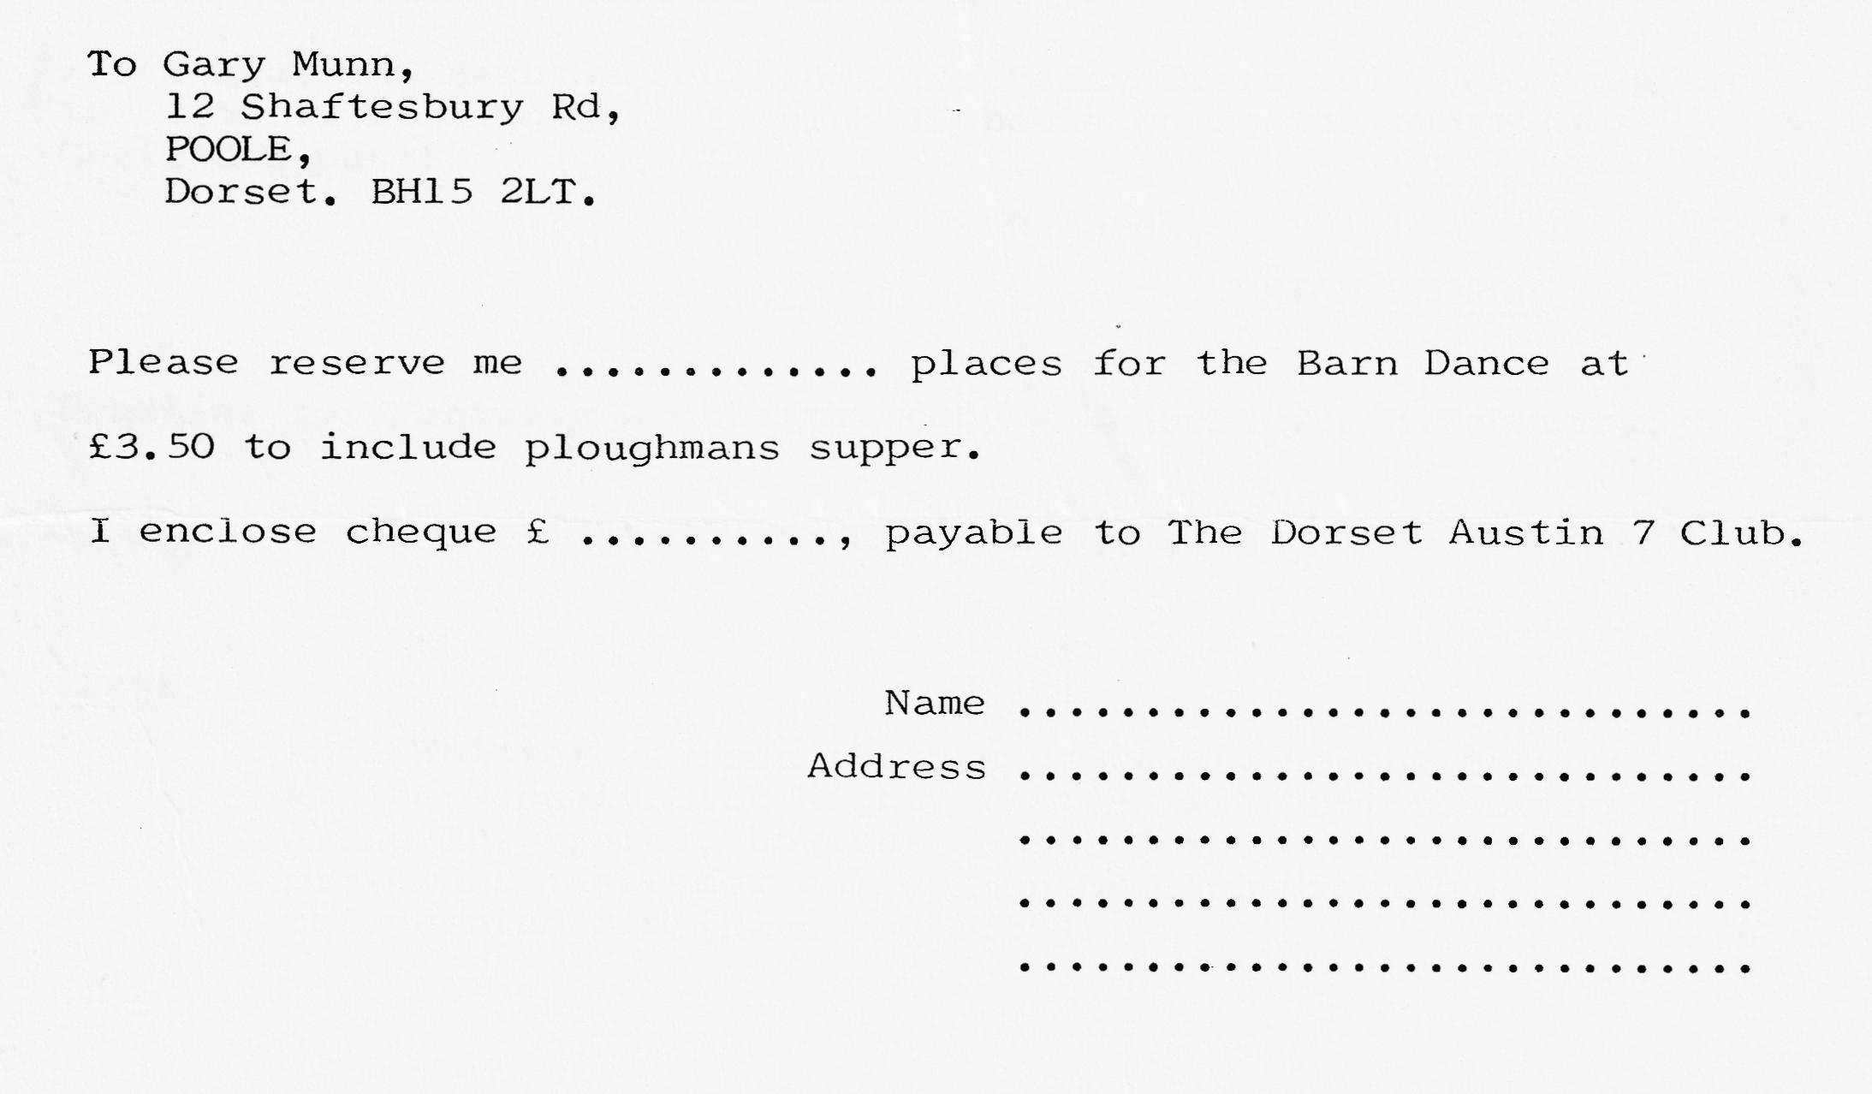

EVENTS
THURSDAY JANUARY 15TH Club Night 8.00 p.m. at The Elm Tree, Hightown. Ringwood. "Bright Sparks for your Austin" talk to be given by Phil Whitter.
SUNDAY JANUARY 18TH Club Run - meet Wimborne Square at 10.45 for an 11.00 a.m. start. (At the time of going to print details of the run were not available, but will be announced at January Club Night).
THURSDAY JANUARY 22ND Committee Meeting 8.30 p.m. Tyrrells Ford.
THURSDAY FEBRUARY 19TH Club Night - Details next month.
SATURDAY FEBRUARY 21ST Barn Dance - Details & Booking Form in this Newsletter.

