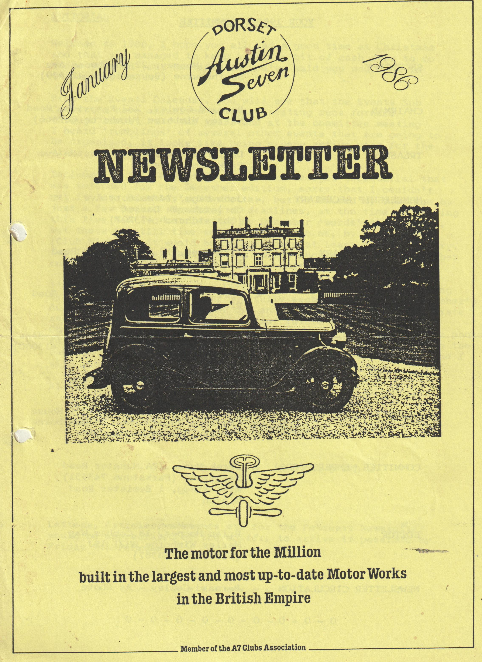

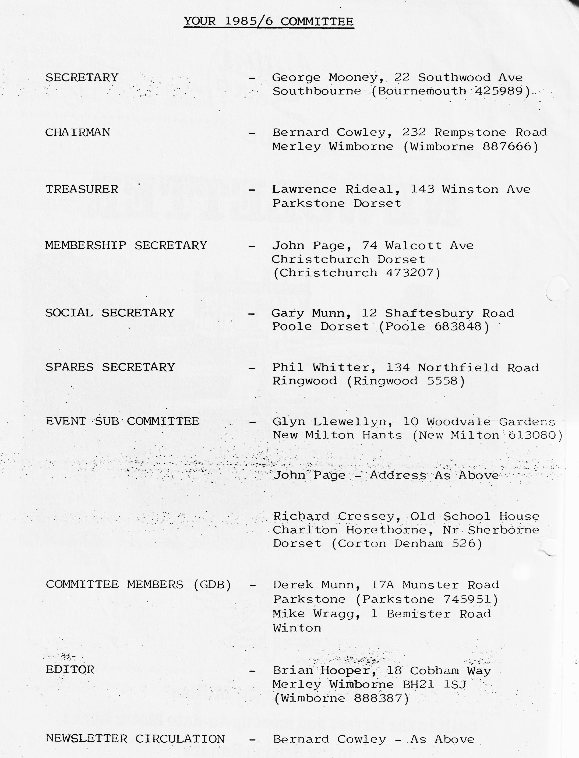

DORSET AUSTIN 7 CLUB NEWSLETTER - JANUARY 1986
Welcome to 1986, I hope you all had a good time at Christmas and that you managed to keep a little bit of cash over to do those jobs on your Austin that you've said you would do in the winter months.
From the Events Calendar, you will see that the Events Sub Committee have organised some interesting runs forward through almost half the year, and at the committee meeting I heard 'rumblings' of several other events that are going to be organised, it looks like being a very active year for the club.
Included in this month’s Newsletter is George’s secretarial that was intended for the December edition. Sorry that I couldn't get it into December's Newsletter, but it missed my deadline by just a few hours. Speaking of deadlines, at the time of writing this I have had two entries for my December 'words' competition, but there is still time to get entries to me, by January 16th (Club Night). It would be nice to have at least one more entry, for I can then say that I've had a 50% increase over the October competition which also had just two entries:
I'm trying to make the Newsletter a little bit more interesting by varying the front cover, hopefully each month, to show a member's Austin. This month it is my own and I would very much appreciate submission of any suitable photo for future months editions. Obviously, the reproduction is dependent on the quality of the photo, so if you have anything suitable, let me borrow it, writing on the back of the photo (lightly in pencil) your name and address and I will return it after making the necessary copy.
All the best, and happy 'Sevening' in '86.
BRIAN HOOPER
Letters, Articles, comments etc. for the February Newsletter would be appreciated by the editor, to arrive if possible by Friday 7th February.
SECRETARIAL - JANUARY 1986
Happy New Year, nice to be back again.
Sorry my last secretarial missed the issue, just a little lapse in communication and pressure of Christmas so forgive the double bumper issue this time and please accept my very belated season’s greetings.
What about the rain? Isn't it awful, but at least the A7 isn't leaking through the roof. However it keeps coming up through the floor on the watersplashes in the club runs. I was chicken and went very slow through a ford. However, care to the winds, I went splashing through last week on the excellent New Year’s Day Run.
Isn't the Editor doing a fantastic job: Keep it up Brian. Not much from me this time - Hooray:- who said that?
We received a card from the South Wales Club, remiss of me not to send them a card, so apologies to South Wales and please accept Dorset's best wishes for 1986, maybe they can win back some of their awards from the DORSETS. I note that Bristol Club don't do a Newsletter for December, seems not a bad idea in such a busy month.
Anybody see the article about Mike Hodgson's Chummy in "Automobile", most interesting, try to get hold of the December issue, very worthwhile reading.
Well, that is just about it for now - sat in the car on a wet evening on the way to the Editor - oh what we do for you all out there.
Hope we didn't bore you. All the best, see you on Club Night.
GEORGE
TECHNICAL TIP
In a recent copy of the Bristol A7 Club, Ian Dunford suggests that anyone needing a Ruby flexible petrol filler hose will find that Ford part No 1416973 is identical. I'm sure that Ian and the Bristol club, will not mind us passing this tip on to our members.
DECEMBER SECRETARIAL
Hello again!
Brian our Editor will be surprised to see this secretarial, he gave me a deadline which I couldn't meet, like me his time has been busy lately, but we found a way. Sorry for any heartache caused to you Brian.
Please add to your events calendar for 1986 the following: ANDOVER VINTAGE CLUB RALLY AND SHOW - SATURDAY 7TH and SUNDAY 8TH JUNE 1986. All interested please send S.A.E. to Mr. Malcolm Treasure, 112 Colenzo Drive, Andover, Hants.
I have had a letter from a lady who wishes to dispose of her husband's cars following his death. There is the following car offered to us. AUSTIN 7 1931, all up and running, described as an immaculate Blue Saloon. Offers below £2300 not considered. Any interested parties to phone Mrs Swift on 0272 852704 evenings to discuss further or arrange to view. Chassis No. 135647, Engine No. M109696. The car is stood in Nailsea, Bristol.
At the last committee meeting it was agreed to celebrate at the Barn Dance our 10th Anniversary as a club. Hence the 10th Anniversary Barn Dance. Come along and bring your friends.
Our last newsletter brought some smiles, the Bloxey and Baltic is of course the BLACK SEA and Baltic and as for the Fellini register, I have visions of Mafia style owners of A7s in dark suits with chalk stripe and Trilbys! But joking aside we were congratulated on the first issue from our talented new Editor by Robin Newman from the A7CA. Nice one Brian.
The January meeting is to be a film night which I am arranging but you will be pleased to know we plan a maximum of 2 films and a maximum of 50 minutes running time, watch this space for further details.
A visit to the RNLI or a speaker from them is being worked upon for a spring meeting.
The committee were virtually TEE TOTAL during the meeting, most odd, they must be getting in trim for Christmas. Next committee meeting - 2nd January 1986.
Henrietta Bassett made it to the front page of the Western Gazette last week as you can see from the enclosed. Fame at last!
I also include with this report a copy of the events calendar just published by the A7CA.
That's it for this time. Yours in restoration
George
CLUB RUN TO MELBURY ABBAS
The day dawned bright and off we went to ensure we weren't last to arrive and get caught for writing the article on the run, you can guess what happened, everybody else did the same and whilst we weren't actually late, the others were early.
A fine gathering of 9 cars were assembled in the square at Wimborne, not bad for a winter's day. Off we went down dry bright beautiful roads on a mystery tour, but we had to keep stopping as we kept losing the convoy. The first four of us were doing fine but where were the rest?
Eventually we got to the very cold and breezy rendezvous where we met up with Richard, Margaret and the children. It transpired that our recent new members Mr. & Mrs Weaver were the cause of the delays, John had been driving along with his handbrake on, I ask you. You can imagine the scene behind him, the rest of them kept sniffing and sniffing thinking they were on fire, it was only when the smoke started to appear from CHOCBOX that the mystery was solved! Bernard, I think you will have another customer for brake linings shortly.
One more car joined en route, and we finished up at Shaftesbury where we went for a walk down Gold Hill to get up an appetite for lunch at the OLD SHIP INN.
The portions of food were absolutely enormous, most of us couldn't finish it all, but for quality and value, I haven't seen a match for this pub.
After lunch we had to line up for the publican with the cars for a photograph then onward to Melbury Abbas Mill. There was a mill on this site detailed in the DOOMSDAY BOOK. The mill is being restored and will become quite a tourist attraction in due course.
We were made very welcome everywhere and it was a very successful day. After the Mill visit, we-all went our separate ways.
Our thanks to Richard and Margaret Cressey for arranging such a pleasant day out.
But beware, the last- to arrive on the starting gate gets the honour of writing the newsletter.
As this is the last issue before Christmas, I would like to take this opportunity to wish you all a happy, holy and peaceful Christmas.
All the best. George

MEMBERSHIP RENEWAL
There are still a few members who have not renewed their membership for 1986.
Please send your renewal application now otherwise membership will be considered lapsed, and this will be the last Newsletter sent. A Renewal/Application for membership form is included at the end of this Newsletter.
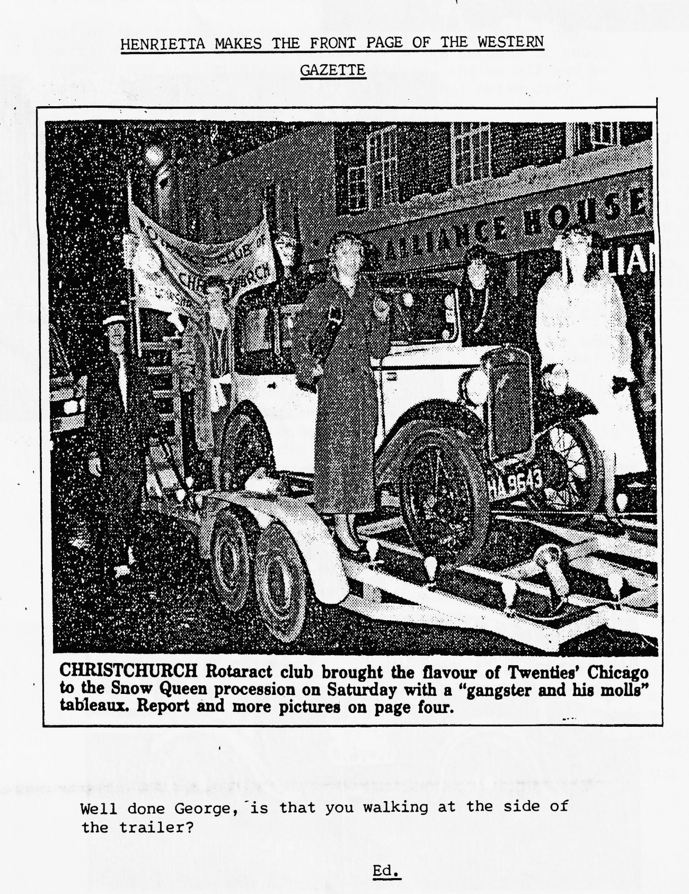

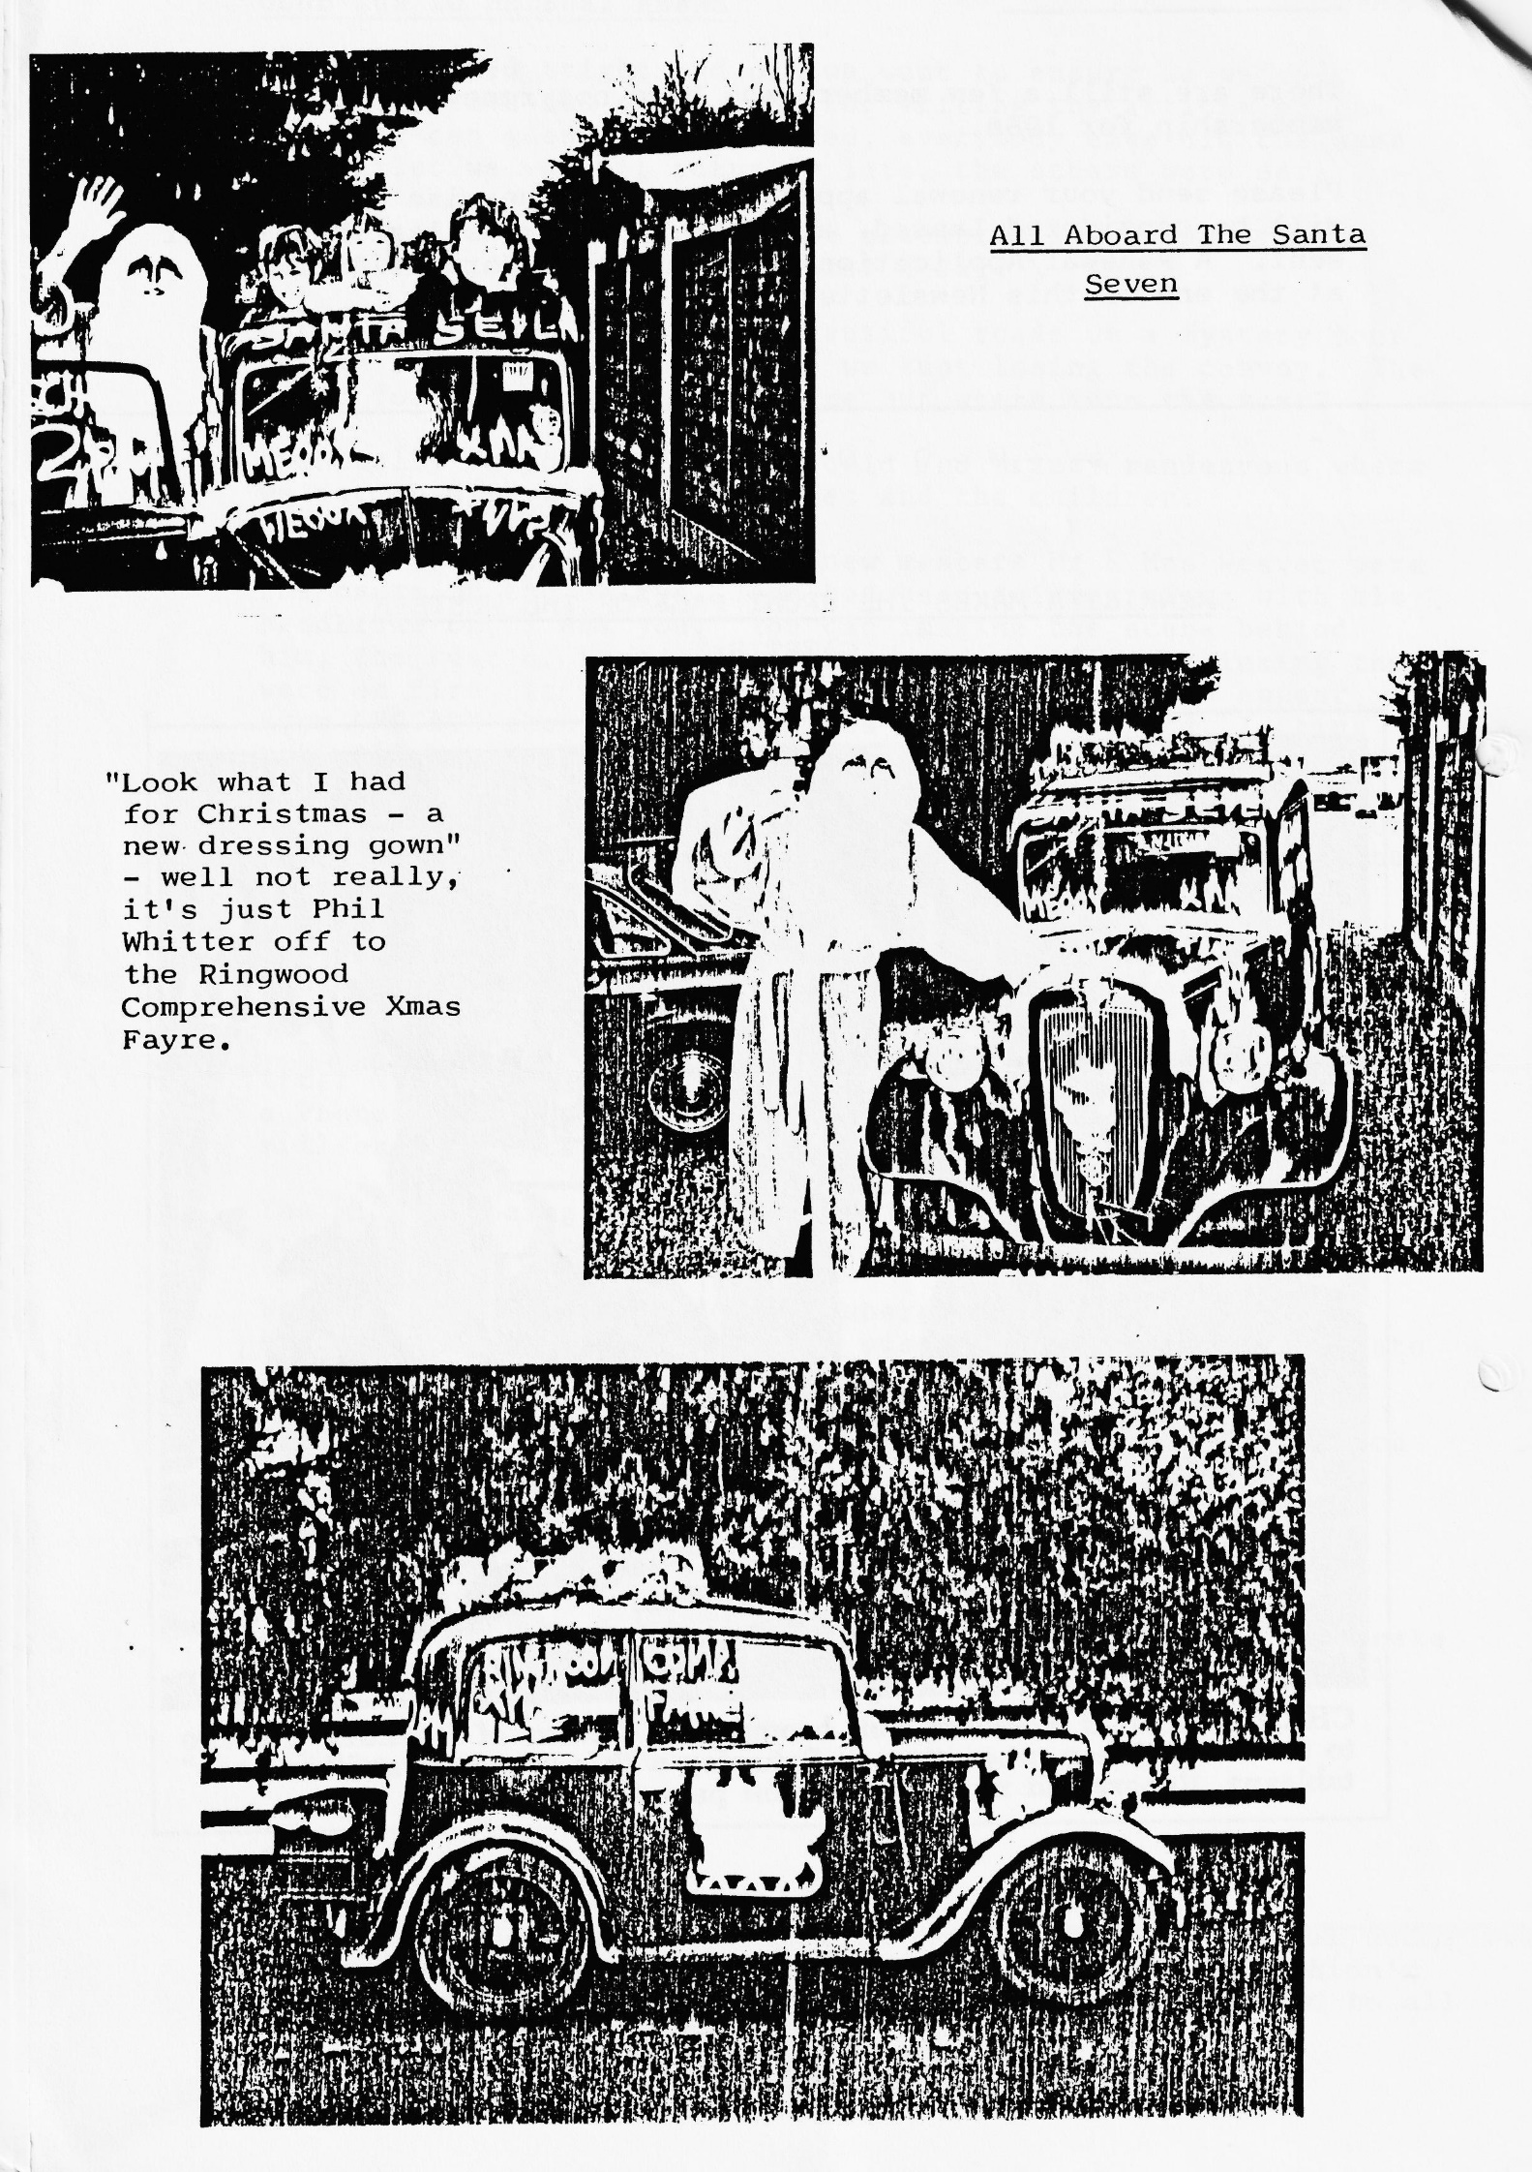

A CRANK WHOSE PISTON BROKE
(A Story of Christmas)
Having cleaned off all the 'spray on' snow from the previous day when the Austin had been used for transporting Father Christmas around Ringwood to the Comprehensive Xmas Bazaar, we loaded the car with football gear and set off with my son Keith (Centre Forward) and his friend the goal-keeper to Bashley Park where Gorley under 11's were playing Bashley.
The moderns all raced off to prove their superiority to the Austin, and I raced off to prove my ability to keep up. Keith's friend is impressed with his first ride in an Austin 7, kick off is at 11.00 a.m. and I reckon we should be o.k. for time (I tell Keith's friend that if I put both indicators out at the top of a hill it helps us to fly!).
Out of the Forest, by the pub and on to the straight near Murray Lacey's house then disaster - a few seconds of rough running and an almighty bang! Clutch in, engine off and we coast for quarter of a mile. "What was that noise dad?" "Crankshaft broken" was the sorrowful reply.
It's five.to eleven and kick off is at 11.00 a.m., so we start running up the road frantically asking a passer-by. the way to Bashley Park. "About :a mile up the road" comes the reply.
We keep running and arrive just in time albeit out of breath and the goal-keeper no longer impressed with Austin 7s.
Fortunately, they win 4 - 2 and before the end of the match I ring Glyn who gets my message relayed to him and finds the car, but can't find me. However, soon all is well, and I get a very welcome tow back to Ringwood - thanks once again Glyn.
So, for the first time in 24 years I have a broken crank and have been unable to get home, however It wasn't the Austin that let me down, I let it down. I have driven it hard for nearly 30,000 miles with no front bearing lip. It disappeared on the way up to John O'Groats back in 1982, but that didn't stop Willie Mackenzie and I doing the fastest run to Lands End in an unmodified car, neither did it stop us cruising at 50 m.p.h. to and from work and touching 60 plus!
Also there have been holidays with a fully laden car and roof rack towing a large trailer. Truly a car for all reasons and for all seasons, a tribute to Austin quality.
Phil Whitter
AUCTION NITE Thursday 20th. February-Club Night,
Auction Night, the time to bring along all of those bits and pieces that you've kept because they are handy if you never use them. Our auctioneer says to bring along anything so long as it's clean (motoring bits or what have you). Label with your name and any reserve price, 10% of proceeds to Club Funds.

RUN REPORT NEW YEARS DAY RUN
Both Austin and owner seemed reluctant to enter 1986; the Box was running on 3 cylinders and the owner running on Paracetamol.
Arriving late, we were greeted by about 7 Austins including Phil Whitter's very late model Ruby and our Editor in a Modern —obviously the Austin '3 bearing knock' was too much for his fragile head:
Glyn & Pat took us on a very pleasant route through the lanes and along the coast to the hostelry - The Rose & Crown at Brockenhurst, which the landlady had just finished restoring after a riotous previous evening. The food was home-made and extremely good value and Glyn had at long last taken us to a decent "Huntsman" pub, although the beer was going down a bit gently after New Years Eve.
We were planning a forest walk to 'Puttles' bridge organised by Pat, but the weather turned so awful we made do with going through a couple of fords (the liquid variety) and on home.
Thanks Glyn & Pat for a good day out, it always surprises me how many people stagger to our traditional 1st of the year run.
Gary.
P.S. Investigation of the 'Box' found a slipped valve collet - and this after only 4 months since a valve grind a little strange:
Editors Footnote
You were right Gary, even the noise of the windscreen wipers of the modern became difficult to bear and we made it straight home and crashed out. I did hear, however, that several members did go on walks, albeit in different places, everyone leaving Brockenhurst by differing routes. Our four-legged friends - Holly & Sally took the Whitter/ Whibley party for a lovely walk through a river and I believe that young Master Whibley had a mud bath! (good job that Mum wasn't there).

10TH ANNIVERSARY CELEBRATION BARN DANCE Saturday 15th February
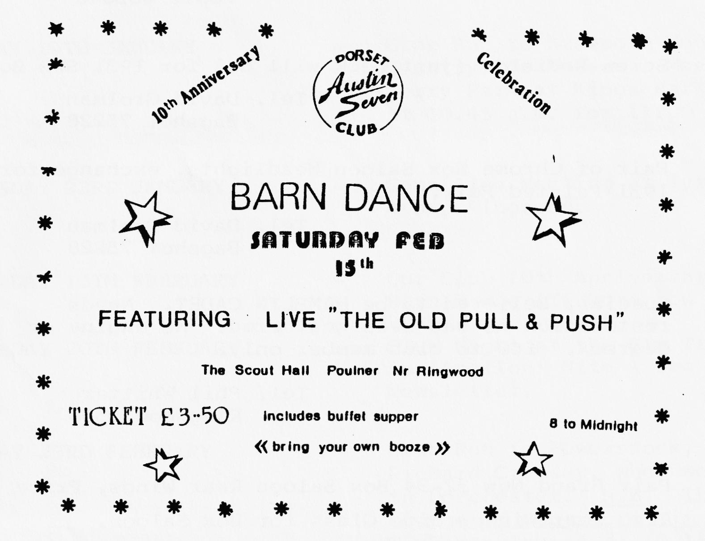
As promised last month there is an application form in this newsletter for tickets which are now on sale for our Barn Dance:-

Please let's have a good turn out of members for this occasion, friends of course are welcome and tickets will be sent on a first come first served bases. Please send in your postal bookings now or purchase on Club Night from Gary Munn.
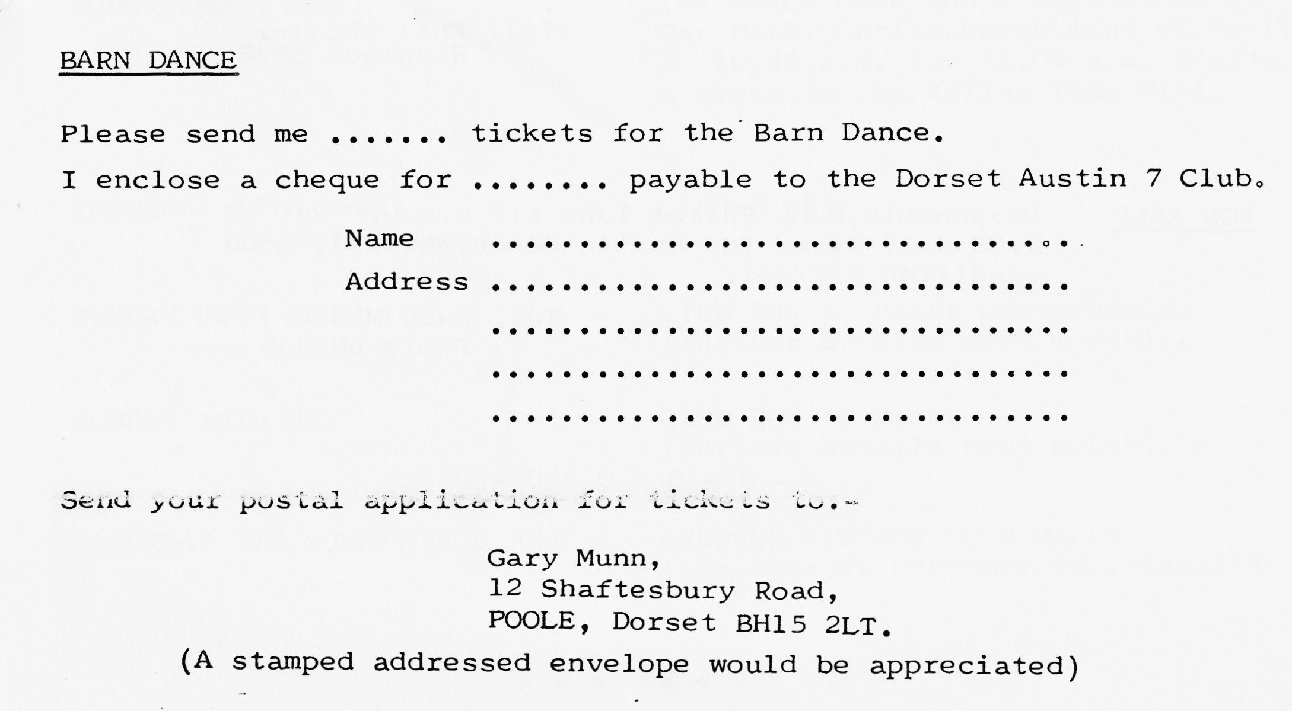

FOR SALE & WANTED
WANTED Set of 15" wheels with or without tyres for a Special, also a reasonable set of + 80 pistons. Tel. Gary Munn Poole 683848
WANTED Screw Radiator (just neck will do) for 1931 SWB Box. Tel. David Grolman Bagshot 75228
EXCHANGE Pair of Chrome Box Saloon Headlights, exchange for 1931 Painted Pair. Tel. David Grolman Bagshot 75228
FOR SALE Special, believed to be HAMBLIN CADET. Needs restoration as has been weathered. No engine or gearbox. £60 to club member only. Tel. Phil Whitter Ringwood 5558
FOR SALE Pair Brand New 32-34 Box Saloon Rear Wings, Price £50. Also Rear Window Side Glass for Box Saloon. Tel. David Grolman Bagshot 75228
FOR SALE 1935/36 SINGER (Model not known, but looks like an Austin 10 Lichfield), Complete. Standing in open. Scrap Price to clear from site. No speculators, or time wasters. Tel. Phil Whitter Ringwood 5558
FOR SALE Reasonable Ruby Petrol Tank £12 o.n.o. Set of 4.75 x 17 Tyres (on Austin Devon Wheels), good condition £12/set. Tel. Gary Munn Poole 683848
EVENTS CALENDAR
THURSDAY 16TH JANUARY - Club Night at the Elm Tree, Hightown, Ringwood. 8.00 p.m. 'FILM NITE'.
SUNDAY 19TH JANUARY - Club Run to Braemore House, Countryside Museum. Meet in the Lorry Park at Kings Park, Bournemouth at 10.45 a.m. for 11.00 a.m. start.
THURSDAY 23RD JANUARY - Committee Meeting at Tyrrells Ford, Avon, Ringwood.
SATURDAY 15TH FEBRUARY - Our Club 10th Anniversary Celebration Barn Dance (Tickets now on sale).
THURSDAY 20TH FEBRUARY - Club Night at the Elm Tree. This is 'Auction' Nite - see note in this Newsletter.
SUNDAY 23RD FEBRUARY - Club Run to Powerstock, organised by Richard Cressey, whom we are meeting in Dorchester. N.B. There is a change of departure time - we meet in Wimborne Square at 10.15 for a 10.30 start (Not 10.45 for 11.00 a.m. as previously advised.
THURSDAY 27TH FEBRUARY - Committee Meeting.
THURSDAY 20TH MARCH - Club Night
SUNDAY 30TH MARCH - THE MARCH HARE RUN - Meet at Co-Op Car Park, Christchurch (End of By-Pass) at 10.45 a.m. for 11.00 a.m. start, for a visit to the Ealing Tide Mill.
THURSDAY 17TH APRIL - Club Night
SUNDAY 20TH APRIL - Club Run to Hawks Conservancy, (further details next month).
SUNDAY 18TH MAY - Club Run to Bath, (further details next month).
SATURDAY 7TH/SUNDAY 8TH JUNE - ANDOVER VINTAGE CLUB RALLY. (see Georges December Secretarial).
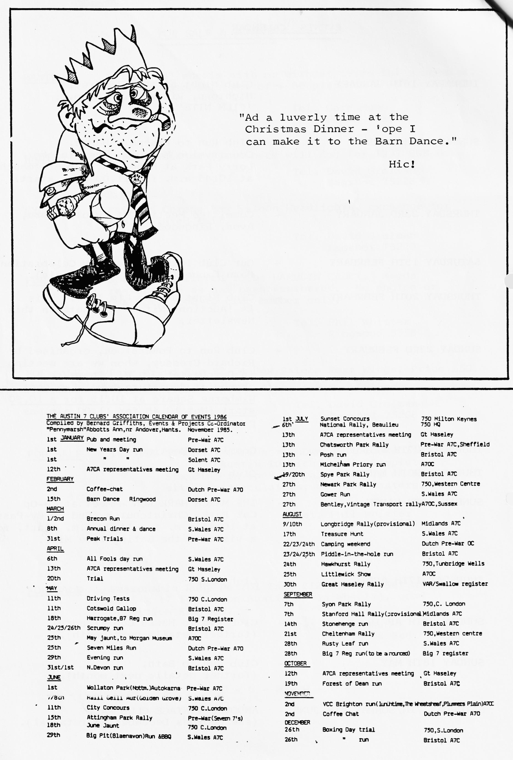

DORSET AUSTIN SEVEN CLUB
Renewal/Application for Membership
The Dorset Austin Seven Club is, as its name implies, a club for Austin Seven owners and people with an interest in Austin Sevens. There are many members who can help with technical problems and we also have a spares and an insurance scheme.
We meet at the Elm Tree Inn, Hightown, Ringwood on the third Thursday of every month at 8.00 pm and meetings consist of film shows, guest speakers, technical matters and social evenings.
All during; the year we arrange Club runs and we also attend various rallies and sometimes camp over weekends. We try to cater not only for the enthusiast but also for his family.
A newsletter is sent to each member every month and a superb Austin Seven Clubs Association magazine quarterly.
Membership subscription is £7 per year and if family membership is required £7.50. Cheque/P.O. should be made payable to DORSET AUSTIN SEVEN CLUB and sent to the Membership Secretary:- John Page, 74 Walcott. Avenue, Christchurch, Dorset.
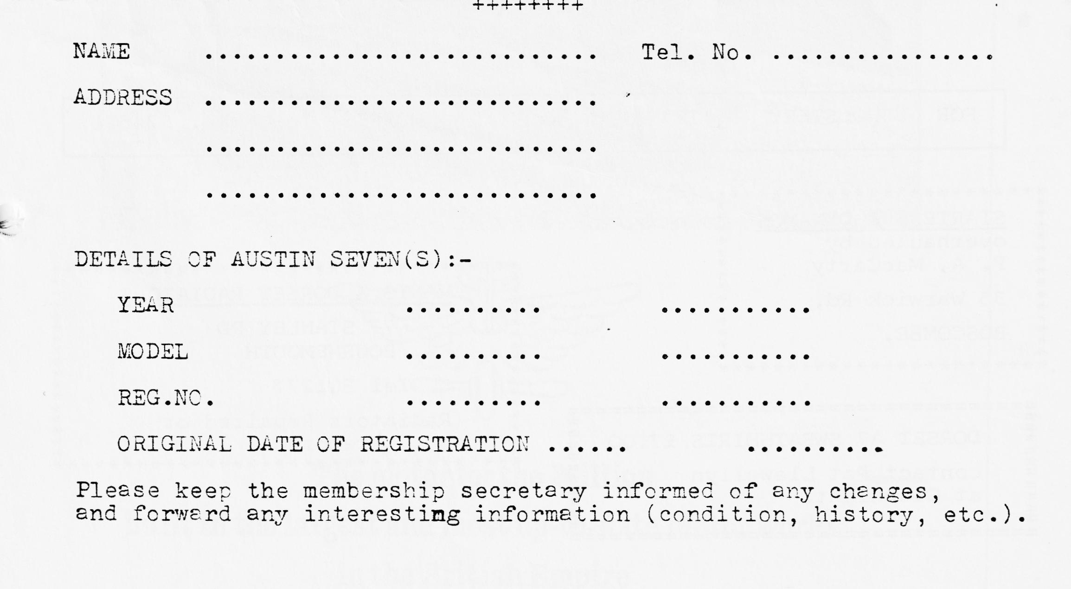
NB The Club year commences on 1st November when subscriptions become due. Any person joining after 1st August will be credited with membership through to October 21st of the following year. The December newsletter will be the last one sent for those who have not by that time renewed their membership.

