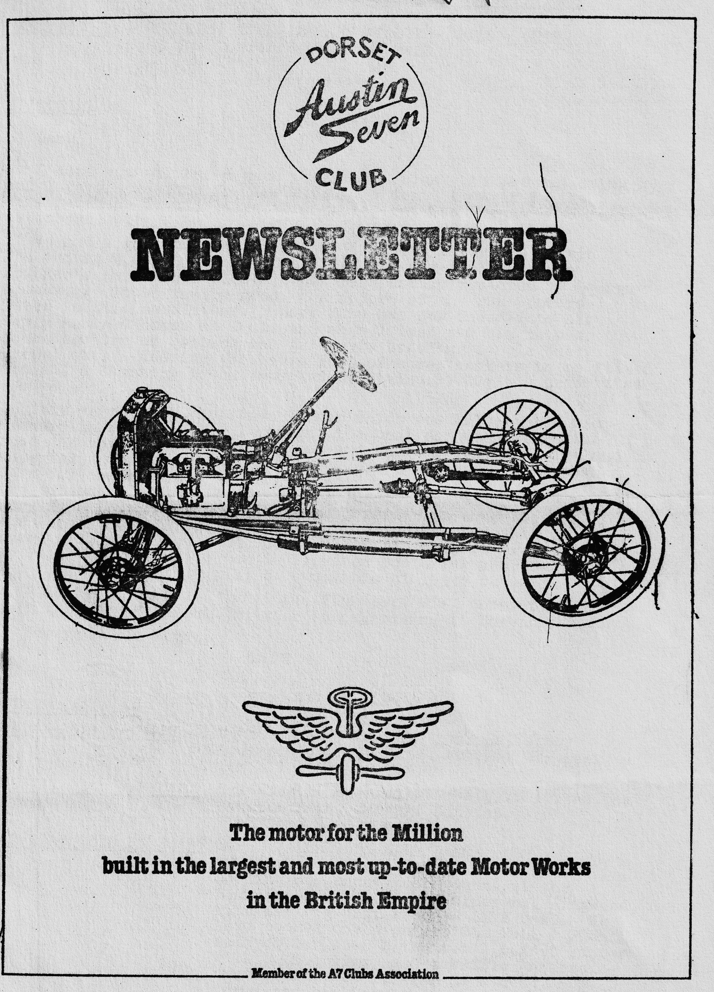

DORSET AUSTIN 7 CLUB NEWSLETTER January 1985
CLUB NIGHT - THURSDAY 17th JANUARY - QUIZ - QUIZ - QUIZ_ at The Dormers, Wimborne 8.30 p.m.
EDITORIAL
Hi Gang,
I hope you all had a nice Christmas, plenty.to eat .and -drink and lots of' presents for the kids. I don't know if I like this weather, it all looks very pretty but it’s not so get about in.
We had a good turn out: for the. New Years Day run. 9 Austin 7's and an M.G.B. It was the first run for Paul and Emma Mainzer's Box Saloon since it has been bodily restored by George Mooney, it looks really good A report of the run appears later in this newsletter. Gary Munn has now moved: into his newly acquired house at Poole and when I last saw him he was concentrating on getting the garage (a smashing double one) sorted out leaving the house full of boxes & cookers to be fitted and all and sundry to be unpacked. He obviously has his priorities sorted out
This year’s club Christmas Dinner, which was held at the Old Granary in Wareham, was, I thought, the best for many years - the food was very good and piping hot and the service was swift and cheerful. Everyone I have spoken to since agrees. Many thanks to Gary for organising a smashing evening. By the way, whilst on the subject of Club social evenings, don't forget to book with Gary Munn (his new address.; appears later in this newsletter) for the annual barn dance,. always a popular event, and this year there will be a live band, ,SO book NOW the numbers are limited to 70. By the way, supper is provided but bring your own drinks and glasses. Coffee will be available at 10p a cup.
Finally, I don't know what the Picky page will consist of myself this time, as Phil. Whitter is organising it for this month.
See you Club Night,
Glyn
EVENTS CALENDAR
SUNDAY 20th JANUARY.... Club run to Woodhenge near Salisbury Meet at Ringwood Cattle Market Car park for a 10.30 a.m. start.
TUESDAY 12th FEBRUARY Skittles match against the W.V.P.C. at the Langton Arms, Tarrant Monkton, Nr. Blandford 8.30 p.m
SATURDAY 16th FEBRUARY SUPER VALENTINES BARN DANCE. By popular request we are once again holding our annual Barn Dance at the Poulner Scout H.Q, at Poulner. nr. Ringwood, with one big difference - A LIVE BAND. We have booked -the popular "OLD PULL & PUSH" with caller John Witcher. A buffet supper will be supplied, and terrific entertainment guaranteed all for £3 a head, BUT hurry and book now numbers have been strictly limited to 70 people. Please let Gary Munn know now. Form at the back of this newsletter. CASH WITH BOOKING
THURSDAY 21st FEBRUARY - Club Night a Noggin & Natter
SUNDAY 24th FEBRUARY - Club run details next month
CHANGE OF ADDRESS
Gary Munn our Social Secretary has changed address, he is now to be found outside of drinking hours at 12, Shaftsbury Road, Poole, Dorset. Telephone Poole 684838
SECRETARIAL
Hello, seen in another A7 Club newsletter was the following advert: Exchange, one sledge and temperamental reindeer for late tourer with antifreeze. Contact F. Christmas, North Pole, before 24th December. URGENT Seems everybody has their problems.
I know of a sound crank and block for a 1928 Heavy 12, £75 or very near offer. Interested?
Wasn’t Christmas great? I always love Christmas, people seem so happy. The Christmas dinner held in Wareham was really good, the food was excellent and the service was second to none. Thankyou Gary, we enjoyed it, as did our guests.
After the Christmas festivities it was nice to get together with friends for the club New Years Day Run organized by Glyn. 9 Sevens I believe and an MG and a lovely bright day for a run through parts of the New Forest I (and others) never knew existed. The pub we stopped at for lunch was really splendid with good beer and food and cozy rooms but ever so dark inside after the bright sunlight. I was sorry to miss the second part of the run to Sammy Miller's motorcycle museum. Some other time perhaps. .,.
I know we all curse the dreaded MOT test but it does make you get down to keeping the car in sound condition doesn't it 1 I am in the middle of trying to get the Ruby up to scratch, quite a job in this cold, weather.
It seems probable that we will have 3 more cars on the go this year with Brian Hooper’s Ruby, Ted Coates 31 Tourer.(Chummy) both about ready and a new special from Terry Jefferies. For my part I have quite a bit of work I want to do on the house so it is not likely that PINOCCHIO will appear this summer despite earlier hopes.
We have been considering a possible alternative venue to the Dormers-but have so far not found a suitable place but we are booked through to May at The Dormers with summer meetings to be runs to various different hostelries.
Dear Ed,
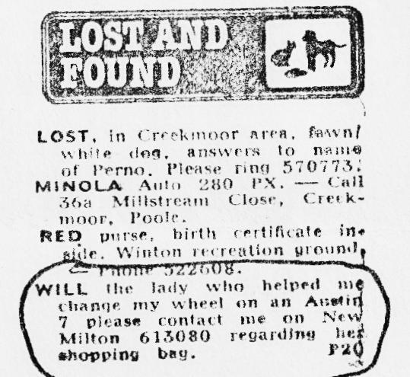
In my continuing research in information. op' Austin Sevens, I came across this newspaper clipping – undoubtably a damsel in distress, or could it. just :.have: ,been -- -- , Obviously, mystery surrounds the shopping bag - a technical secret on how to replace a wheel? or perhaps accepted in frustrated exchange for an Austin 7 three-wheeler? I look forward to next month’s newsletter when perhaps all will be revealed (or should I say re-wheeled?)..Regards BRIAN HOOPER •
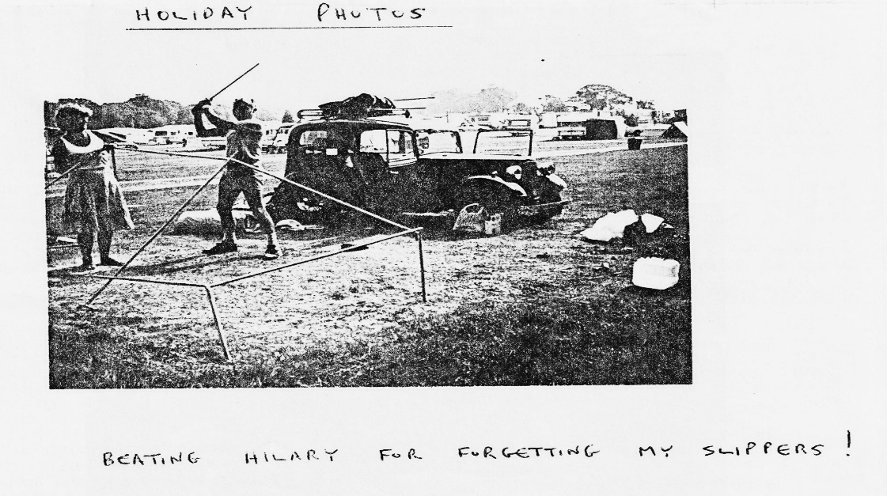
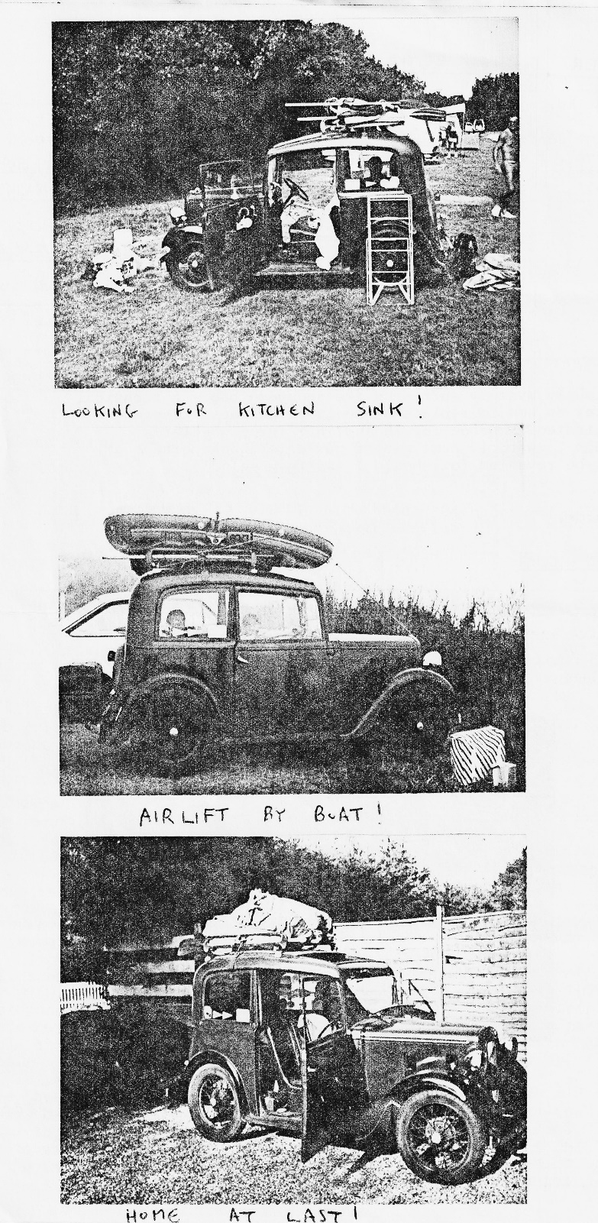
Secretarial cont.
Not much else from-me this month. Peter Foam of the PWA7C suggests 'If you run your axle on SAE 140 oil (Tractor oil) you will know it has a consistency like congealed toffee and it is impossible to poke it through the 1/2" plug hole. Inspiration came to Peter, so he put the oil in a washing up liquid bottle and immersed in hot water for 20 mins. NO problem at all! Try it, oh, and by the way, when did you last check your axle oil level, I can’t remember doing mine at all last year!
Happy Sevening, •
Sevens - The best of their kind,
George
SWANAGE SANTA SPECIAL
Wanting to enter into the spirit of Christmas, then what better "spirit" than a glass of sherry and a mince pie or a present from Santa while riding in a steam train from Swanage to Herston. Such was the last-minute offer at the November meeting (too late for the mag) that found ourselves joining five other cars on a bright Sunday morning in Wimborne Square for a trip to Swanage Railway Co. via the Scott Arms.
After a very picturesque run to our lunchtime venue (don't have a muff on your radiator for going up Kinston Hill' '. ) we joined the pre-Christmas rush for our beer and food. The children decided to practice their dubious potting skills on the newly covered pool table-- fortunately the landlord was too busy to notice and so were we!
Two hours later we emerged into the fresh. air for a swift downhill run into Swanage station where we were met by George and Joy and Lawrence with his son Guy. Taking our places on the train we waited for the steam to buildup. It was-at- this time that Hilary appeared to gather a number of empty sherry glasses left-by previous drinkers hence giving Glyn the impression that she had drunk a lot - totally false! Eventually we were off and we slowly chugged down the line towards Herston. Our carriage seemed to have an oval wheel for not only were we going from side to side but up and down as: well Then, just as we gathered speed we slowed. down and stopped in true BR fashion; This added to the interest as there was much speculation as to whether they were "stringing out" the short track or running out of steam. (we subsequently learnt it was the latter) After a short stop we were off again: and were .presented with our sherry and mince pie. By this time we had pulled into Herston station and the children had an opportunity' for a photo with Santa and friend (I think it was a bear!) With everybody back in place we departed in reverse for Swanage and Santa presented all the children with a gift. We soon arrived back at Swanage and after a brief visit to the souvenir shop we said our farewells and departed for home. However, by coincidence everybody decided it would be a. good idea to go back on the ferry but unfortunately so did every other Sunday motorist so we all joined the long queue for a long wait in darkness before finally getting back. I’m sure we all enjoyed the day and: it is all credit to the splendid effort put in by the Swanage Railway Co. in restoration and track laying and. I am sure we all wish them well' in their quest to Furzebrook: P.S. If I missed anybody out I apologize as I forgot to write this until the New Year—PPS Oh, and thanks to Bernard & Gary for. organising it all.
Phil Whitter
•

THOUGHT FOR ’85 (Heard in the pub)
"ARE YOU CONCERNED AT YOUR SLOW RESTORATION? PERHAPS IT DETERIORATES AT THE SAME RATE AS YOU RESTORE IT!!
1984 LIGHTING REGULATIONS
As a result of an article in DA7C newsletter earlier in the year I had intended to reply promptly about one or two omissions, when along came the 1984 regulations which bring our lighting regulations in line with the E.E.C. The ‘84 regulations actually make the lighting of old cars less stringent than before. For example, when I got rid of the "caravan" rear lights which the original members of DA7C will remember, and fitted two original looking lights each side of the number plate, I now discover that they were too close together, but not any more. The revised regulations do not stipulate a minimum separation on old cars.
The following -table is mainly designed for Austin Sevens but would actually be applicable to all cars getting the cheaper Road Tax rate and some newer cars. What it does mean is that for some prewar cars that originally had two 'D' lamps each side of the number plate ends were obliged by later legislation to fit two more rear lights on the wings, can now legally remove the lamps on the wings.
- - . Roger Ballard
Type of lamp | Exceptions | Wattage | Height above ground (millimetres) |  | Distance from side of car | Distance apart
Front lamp (side) | No exceptions | NR | MAX | MIN | 510 max | NR
 |  |  | 2300 | NR
Dipped beam headlight | NR before 1st Jan 1931 | 30 min | NR | NR | NR | NR
Main beam headlight | NR before 1st Jan 1931 | 30 min | NR | NR | No closer than dipped beam | NR
Direction indicator | NR before 1st Jan 1936. | 15 to 36 if fitted | NR | 350 | NR | NR
Rear lamp | No exceptions | NR | 2100 | NR | 800 max | NR
Rear fog lamp | NR before 1st Apr 1980. | NR | NR | NR | NR | 100 min and not more than 100 mm from stop lamp
Stop lamp | NR before 1st Jan 1936.  Only 1 required up to Jan ‘71 | NR | NR | NR | NR | 400 min if 2 fitted
Rear registration plate | Plate must be illuminated of fitted | NR | NR | NR | NR | Must illuminate number plate if fitted
Rear reflector | No exceptions | Not applicable | 1525 | NR | 610 max | NR
This information was gleaned from the 103 pages of "The Road Lighting Regulations 1984" and I think that they are correct but; I will not be held responsible for any inaccuracies.
NR.= No Requirement.
Roger
The 1st of the Year
The first day of 1985 downed crisp and bright, in fact far too bright to cope with the hangover of the night before! Armed with paracetamol and Alksa Seltzer I set forth to meet the gang at the Cat & Fiddle. Funny how Austin 7's seem even noisier after a few – well, quite a few drinks, the night before.
In a convoy of 9 Austins and an MGB we ventured into: the forest through many a lane unknown even to Franz Klemmer - sorry John Page, and he's been around long enough. (that’s true'. Ed.) We arrived at our destination - a pub (surprise surprise) The Billy at Brockenhurst, which didn't look much from outside, but was very warm and friendly inside. After several 'hairs of the dog and some hot sustenance, most of us intrepid Austineers ventured onwards to the Sammy Miller Motorcycle Museum at New Milton
We found an impressive collection of some 70 old bikes of all ages, but were none the less unable to find the Model Paul Mainzer rode in the Boar War! Much close scrutiny went over restoration standards which we decided were high. About 4 o'clock we all wended our ways home to catch up on lost sleep from the night before. Thanks to Glyn & Pat for a good day out.
Services
Munwellyn's for all Austin 7 mechanical and electrical repairs \and restorations. Phone Gary on Poole 684838 or Glyn on New Milton 613080. •
Brake end Clutch Linings Phone Bernard Cowley Wimborne 887666 for 24 hour service, 8 Shoes £15.25 Clutch £8.50
Regard Engineering Columbia Road, Bournemouth for Crankshaft regrinding end CM rod remetaling. Blocks rebored and general machining.
Shot Blast and Stove Enamelling Spray Finishers, Nuffield Industrial Estate, Poole. £35 for A7
wheels (cash) I can recommend them. Mention the club.
Upholstery and Trimming Colin Morris, Bournemouth 524671
Radiators Repairs or your radiator re-cored. Hants and Dorset Radiator; 77, Stanley Road, Bournemouth 301277
Resprays George Mooney Bournemouth 425989
TECHNICAL-TIP
How to fit an Austin Seven Half shaft
Lap the hub on the shaft ,using valve grinding paste until the hub can be moved round the shaft steadily showing that high spots have been removed. Clean off paste and fit the hub on the shaft without the key and tighten up hard. Note the position of the nut, i.e. count the threads on the half shaft showing and mark top flat or corner of the nut. Remove hub, fit the key and tighten up the nut - it should go on the same distance as without the key. If the nut will not go on so far, the hub is riding on the key and that is the cause of failures.
To remedy, file the key until the nut will go fully home. This will need several trials - file only a bit from the key each time where it been marked.
When finally assembling, if you find that the cotter-pin will not go in, do not slacken off a fraction, but remove the nut and file a bit off, so that when fully tightened, the cotter will slide in. A useful tip is to mark the end of the shaft in line with the cotter hole.
Sometimes when the hub and shaft are very worn and further metal has been removed by grinding, you find that the whole axle is locked due to the fact that the halfshaft gear has been pulled up hard on to the diff. cage. Do not worry, however, as a tapered sleeve shim can easily be made from bending round a piece of thin copper or even aluminium from a cigar tube or pastille box and cutting to size with ordinary scissors. After fitting this shim, the nut should be tightened after 5, 25, 50 and 100 miles or until it will tighten no further showing that the shim is fully bedded in. Even without the shim, the nut should be checked after a few miles.
One can, of course, drive, an Austin 7 with a broken halfshaft, provided the broken end is pushed in to lock the differential and a wheel nut used as a distance piece to stop it working back.
Acknowledgement to Mike Burgers
Well that’s it for this month gang, I desperately need more material for next month, so articles, poems, crosswords etc. to me by 14th February please.
Glyn .

