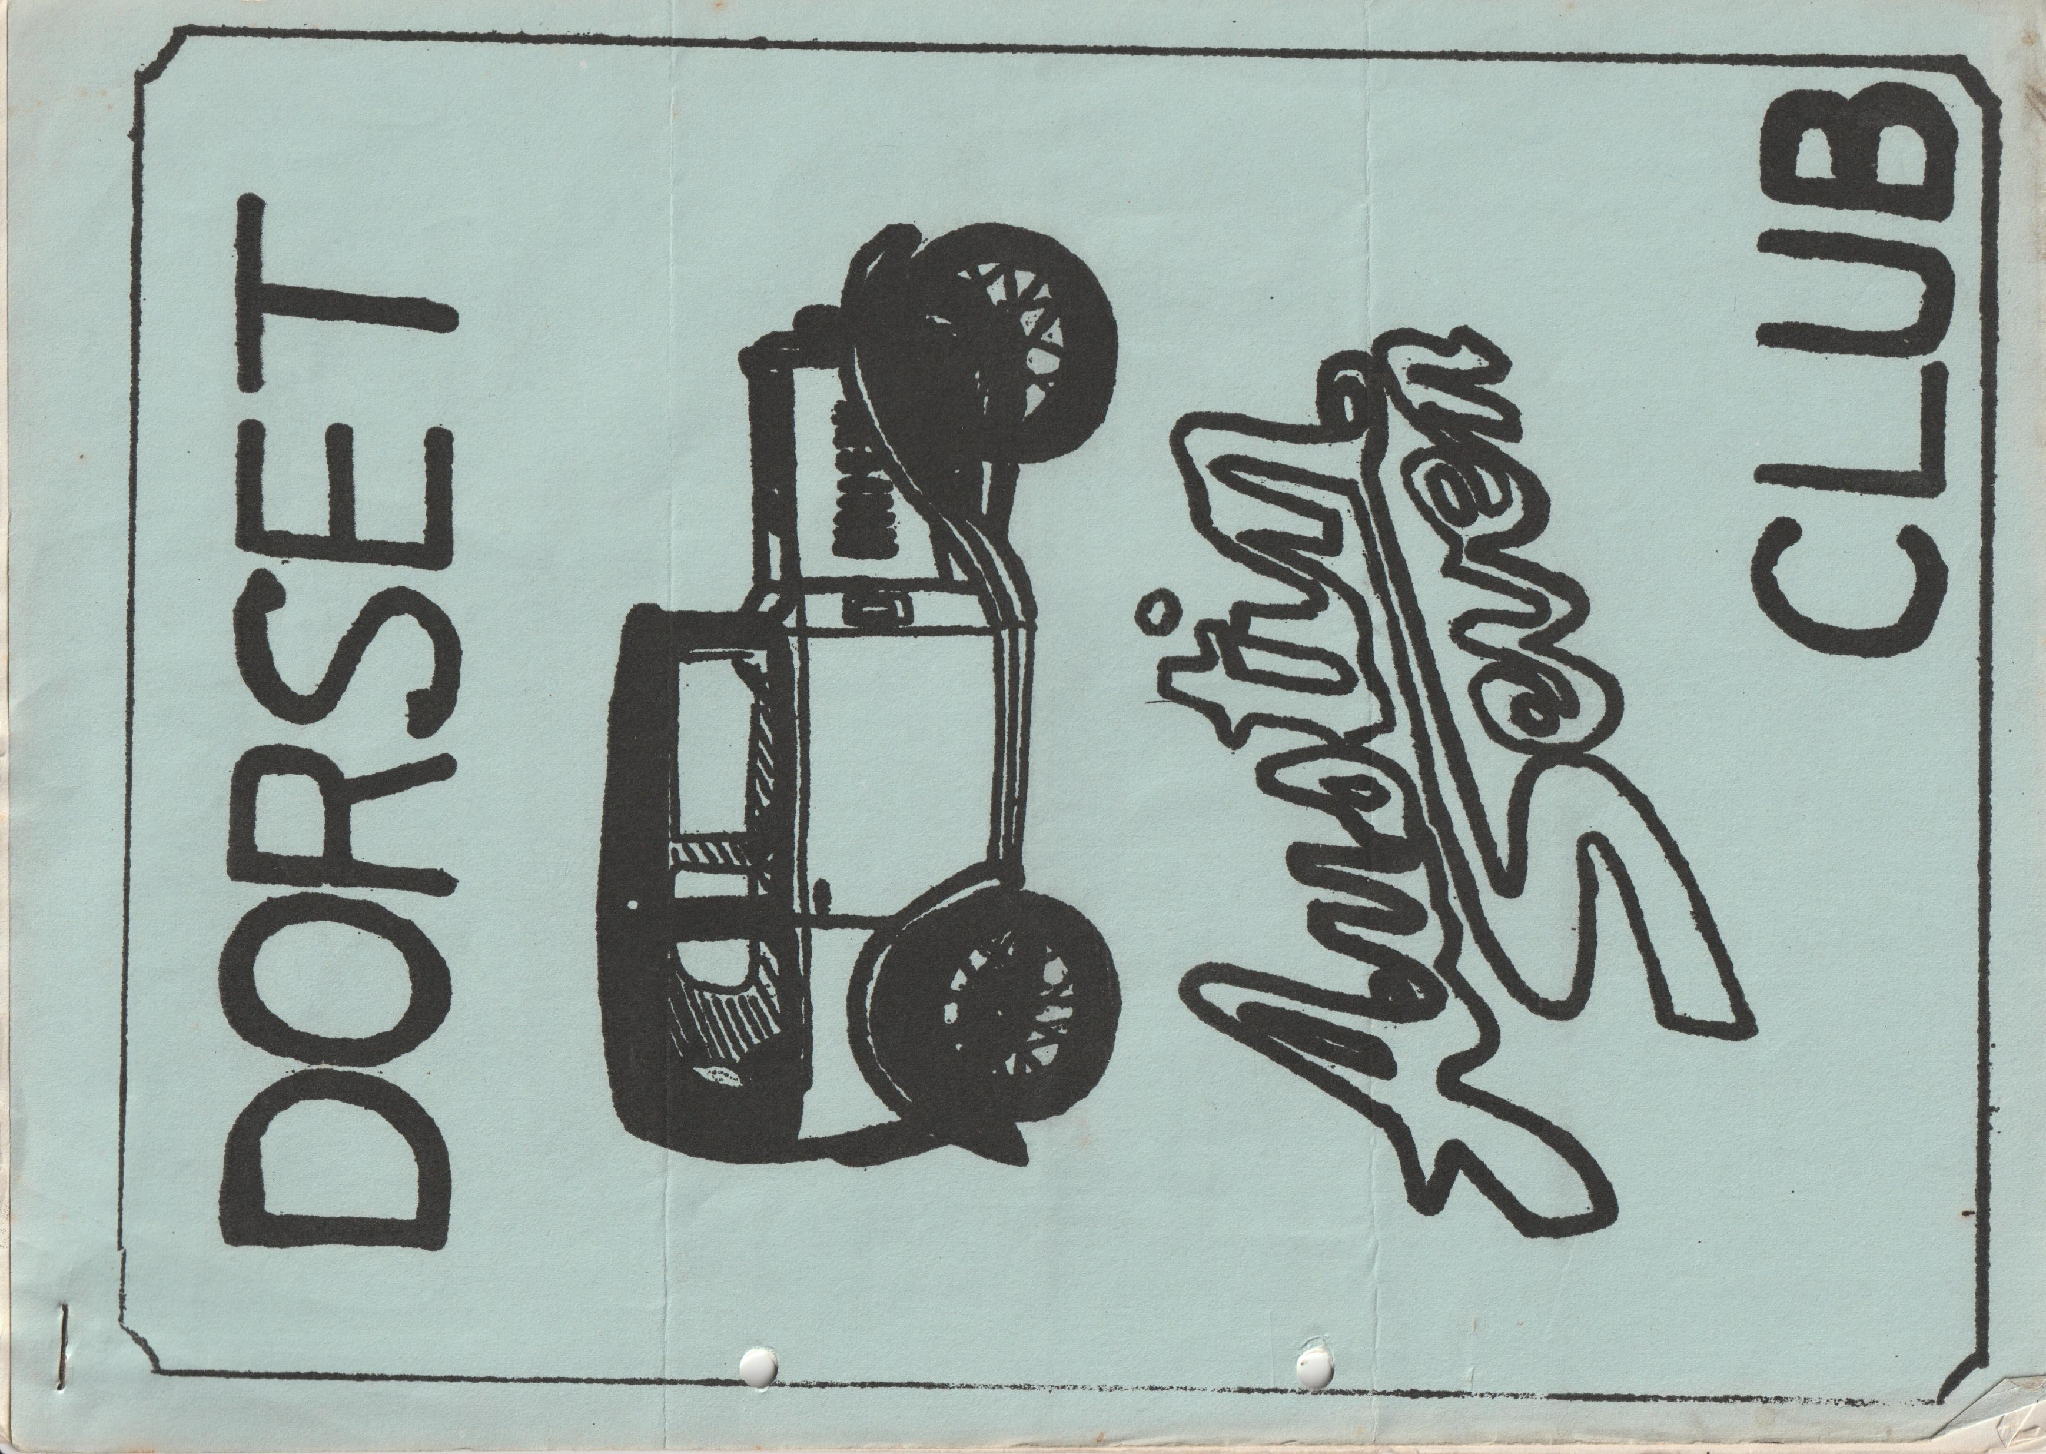

DORSET AUSTIN 7 CLUB NEWSLETTER JANUARY 1984
NEXT MEETING
CLUB NIGHT JANUARY 19th An illustrated talk by Norman Aish on Public Transport lasting about an hour at the Dormers at 8.30 p.m.
SUBS SUBS SUBS SUBS SUBS SUBS SUBS SUBS SUBS
**** **** **** **** **** **** **** **** ****
SUBS ARE NOW OVERDUE, AND THIS IS THE LAST NEWSLETTER YOU WILL GET IF YOU HAVEN’T PAID. CHEQUES SHOULD BE MADE PAYABLE TO DORSET A7 CLUB AND SENT TO THE MEMBERSHIP SECRETARY MR. J. PAGE 74, WALCOTT AVE., CHRISTCHURCH, DORSET.
EDITORIAL
Hi Gang,
Happy New Year to all of you from myself and the rest of the Committee. I hope it will be as good as last year on the Austin scene, though I have heard some disappointing rumours that the Caldicot Castle Rally, run by South Wales A7 Club, may not be held this year, which would be very sad as it is a super rally in a lovely setting, which we in the 'Dorsets' always look forward to. Beaulieu could be another casualty. I understand that the 750 club have been shocked by the price required by Beaulieu for the field. Let’s hope they can sort something out, or perhaps find another venue. When I have definite news of these events I will let you know.
Everyone seems to have gone special building mad in the 'Dorsets' just lately. Jeff Kingsland was the first to appear with his Ulster-style special at The Dormers last summer and I managed to get my Cambridge style car on the road right at the end of last year. Chris Smith is building an RTC which I understand is well underway, and George Mooney has just acquired "Pinocchio” - a wooden-bodied racing special in need of restoration and Jumbo Clenaghan has yet another set of kit parts with a new aluminium body, which incidentally may be for sale. So, we will have to have a Dorset Hill Climb Team, any offers to organise something along those lines? perhaps even a Club event. Let me know if you have any ideas and perhaps we will have a talk about it at the committee meeting.
Glyn
EVENTS CALENDAR
THURSDAY 26th JANUARY COMMITTEE MEETING AT TYRRELLS FORD AVON.
SUNDAY FEBRUARY 5th Club run to King Arthur's Country. Leave Wimborne Square at 10 a.m. or Sturminster Mill at 11 a.m. There will as usual be a Pub lunch.
SATURDAY FEBRUARY 11th DORSET ANNUAL VALENTINES BARN DANCE. POULNER CENTRE NEAR RINGWOOD. DANCING TO BERNIE OUR USUAL COCKNEY CALLER. 7.30 p.m. until late. Bring your own beer and glasses. A PLOUGHMAN’S STYLE SUPPER WILL BE PROVIDED. SEE THIS NEWSLETTER FOR DETAILS AND BOOKING FORM.
SUNDAY MARCH 4th CLUB RUN DETAILS NEXT MONTH
MARCH 15th CLUB NIGHT THE DORMERS
MARCH 24th SKITTLES EVENING AT THE 'MONMOUTH ASH' VERWOOD. More details next month.
SUNDAY APRIL 8th Club run details next month
THURSDAY APRIL 19th Club night 'The Dormers'

SECRETARIAL
Sorry I missed last month’s issue, I don't know how I missed it, time flew as usual. As you must all now be aware, the date for registering a claim on your cherished number or unrestored car/motorcycle without a SWANSEA registration document has now passed. From now on it seems as though 'A' registered 7's could be the order of the day! heaven forbid.
My family enjoyed a pleasant Christmas and I was pleased to receive a book called "The Motor Cars We Owned" by S.L. Spicer. The first chapter was on Austin Cars, how sensible! and I noted with pleasure that the 20 HP AUSTIN was compared favourably with the ROLLS ROYCE.
Nothing of a secretarial nature to report except perhaps to offer thanks on behalf of the committee for the fine support given to the club by so many regular attendances at meetings throughout the year and for the extra ordinary good humour of all who came to the Christmas dinner which was a very great success. During the year we have had considerable help from the ladies as always and much encouragement from other locality clubs.
Dorset Club go and seem to take many awards as far away as Caldicot and are always pleased to join Bristol Club at Berkley Castle. I noted in a BA7C newsletter recently that there is unlikely to be a 1984 Beaulieu Rally due to Lord Whatsit wanting £1700 for the site for 1 day! Seems unreasonable to me, so farewell to Beaulieu.
Now's the time to get working on those cars for the long summer season so get stuck in. I'm sure we all look forward with high expectations to a fabulous 1984, may I on behalf of the committee wish you all a very prosperous and happy new year.
George
NEW YEARS DAY RUN
With all the New Year festivities I thought this year the annual 1st of the year run on the 1st of course would be poorly supported, but no! on arriving at Ringwood, a line of 9 Austins, an upright Ford Pop., a Morris Minor and 3 moderns - what a good turnout. There was Glyn, Pat and Trevor, John, Cynthia and the boys, George and Joy and mum, Phil and Hilary, Gordon and Biddy in Rubies, Jim and Mary in their Tickford, Gary Munn & Dusty in Box's and nice to see Kim in his Big 7 and a friend of his in an upright Ford Popular. Richard and Margaret Cressey with Rosie and Emily came all the way from Sherborne. Paul and Emma, Mike and Pam and Jackie and myself in Moderns. Don't worry, I'll soon have the super-fast Chummy back on the road.
We all left Ringwood and followed all the back lanes to Burley and then on to Brockenhurst. Certainly, a very well thought-out run. We ended up at a pub - fancy that after all that drink the night before too! I noticed it was a Whitbread house specially for the person who shall be nameless (We only drink proper beer in this part of the Country. ED) We were made very welcome by the landlord who told us that he owned a '31 Box with a sunshine roof. Unfortunately, he didn’t have it there, but he showed a great deal of interest in our cars.
There was a separate room off the bar which we took over and had very pleasant snacks. As the pub was near the sea, after a five-minute drive most of the brave ones ventured out into the bitter wind along the embankments by the sea, to walk off the drinks I suspect! In all a very well-thought-out run. Thanks to Glyn and Pat for the organising it. I’m sure that everyone enjoyed themselves.
Bernard
SERVICES
FOR SAND BLASTING, STOVE ENAMEL AND LACQUER 4 WHEELS FOR ABOUT £30 cash. SPRAY FINISHES, 14, ABINGDON ROAD, NUFFIELD INDUSTRIAL ESTATE POOLE 685488

ARCHIVIST REPORT – The previous page was completely missing!
Liechtenstein Run cont.
Some of the higher mountain passes may still be closed and we may have to prepare alternative routes. The return journey will be made by a more Northerly route skirting Zurich and Basle. On returning to France it is intended to visit the Schlumpf Motor Museum at Mulhouse. It is hoped that a competitive event can be organised in France in association with a local car club. As on past runs, we are likely to be invited to civic receptions or be entertained by local car clubs. Overnight stops and longer stops will be made at suitable stages throughout the journey where both camp sites and hotels are available. Wherever possible minor roads and roads of scenic beauty will be chosen and large cities avoided.
Eligibility
All entrants must be members of a club recognised by the Austin 7 Clubs' Association. Vehicles must be pre-1939 Austin Sevens fitted with A7 radiators, engines and wheel centres.
Awards
Suitable awards will be presented, and all finishing entrants will receive a certificate and a plaque. This will be a 750 MC championship event.
Tender Vehicles
Tender vehicles with or without trailers as well as a modern route car will be required. The tender vehicles should be capable of carrying two extra adults in addition to their crews. The tender vehicles and passengers will receive free cross-channel ferry tickets and will, of course, join in the social events.
Cost
It is not possible to quote an exact figure at this early stage. Negotiations are in progress for sponsorship. With no sponsorship the entry fee will be approximately £135. This sum is for the passage of one car with two occupants for the return trip across the channel plus a contribution towards the 'breakdown service'.
The event will be limited to 50 cars and entries will be reserved on a 'first come first served ' basis. When the entry of 50 cars is complete a reserve list will be opened on the same principle.
Please return form to: - Event Sec., M.V. Hart, Dormer Cottage, Abinger Hammer, Dorking, Surrey.
Drivers Name ………………………………………………………. Club …………………………..
Passengers Name ……………………………………………………Car Reg. No ………………….
Type ………………………………. Year ……………………….
Can you provide a Tender vehicle? ………………………………..
If so what type? ………………… Trailer? ……………………….
Address ………………………………………………………………………………………………
…………………………………………………………………………………………………………
Telephone No. …………………………………………………….

ANNUAL VALENTINES BARN DANCE
TO BE HELD AT THE POULNER CENTRE NEAR RINGWOOD ON SATURDAY 11th FEBRUARY
This is your only chance to book for our yearly evening of hilarity and entertainment, in which we attempt, mostly unsuccessfully to square dance! Honestly it really is worth coming along, more for a laugh than any serious barn dancing!! All friends most welcome, the more the merrier There will be a Ploughman’s buffet supper, hot punch on arrival, a raffle and we have once again booked our excellent caller 'Bernie' and friends to supply the 'dancing' from 7.30 p.m. until late. All this for only £2.50 each. The Poulner Centre is easy to find, just take the Poulner/ Hightown slip road off the main dual carriageway just North of Ringwood, then left at the mini round-a-bout and the Scout Hall is in front of you at the end of the road. The Centre is new, it boasts a stage for the caller, is larger than our old venue at Wimborne, and hopefully has easier parking,
Please try to support your Club, it really is a good evening out - ask any club member! But remember this is your only chance to boo. Please fill in the entry form below and return it to me ASAP - by the end of January.
DA7C BARN DANCE RESERVATION FORM
PLEASE RESERVE ME …………………… PLACES AT £2.50 each.
I ENCLOSE A CHEQUE PAYABLE TO THE DORSET AUSTIN SEVEN CLUB
FOR £………………..
Name …………………………………………………………….
Address ……………………………………………………………………………………………..
……………………………………………………………………………………………………….
Tele No. ………………………………………………………….
BRING YOUR OWN BOOZE & GLASSES
Please return, form by end of Jan. to Gary Munn, 17a Munster Rd., Lower Parkstone, Poole, Dorset

