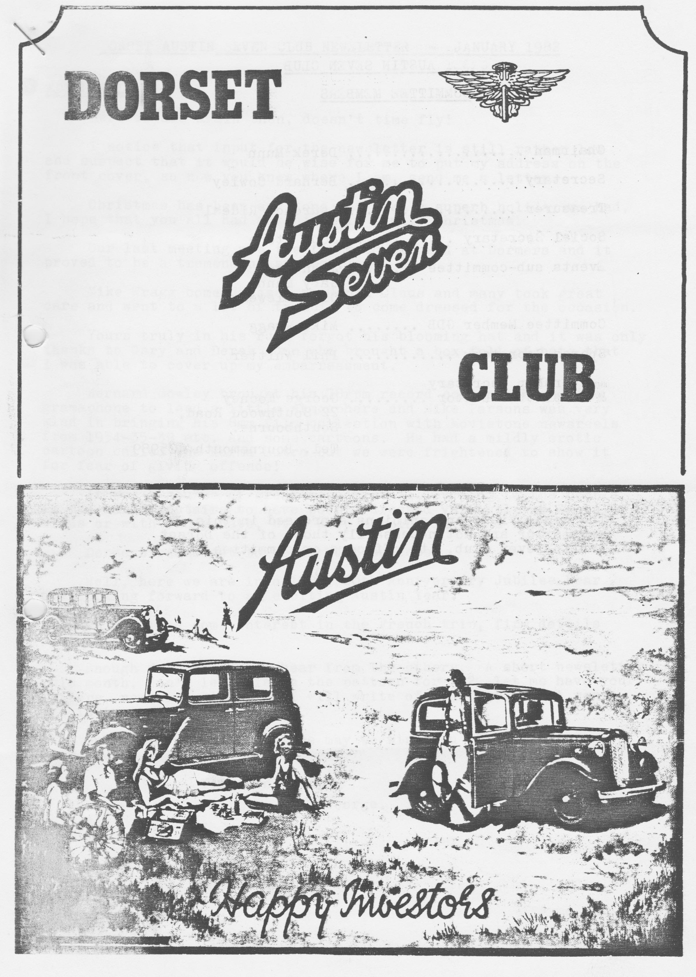

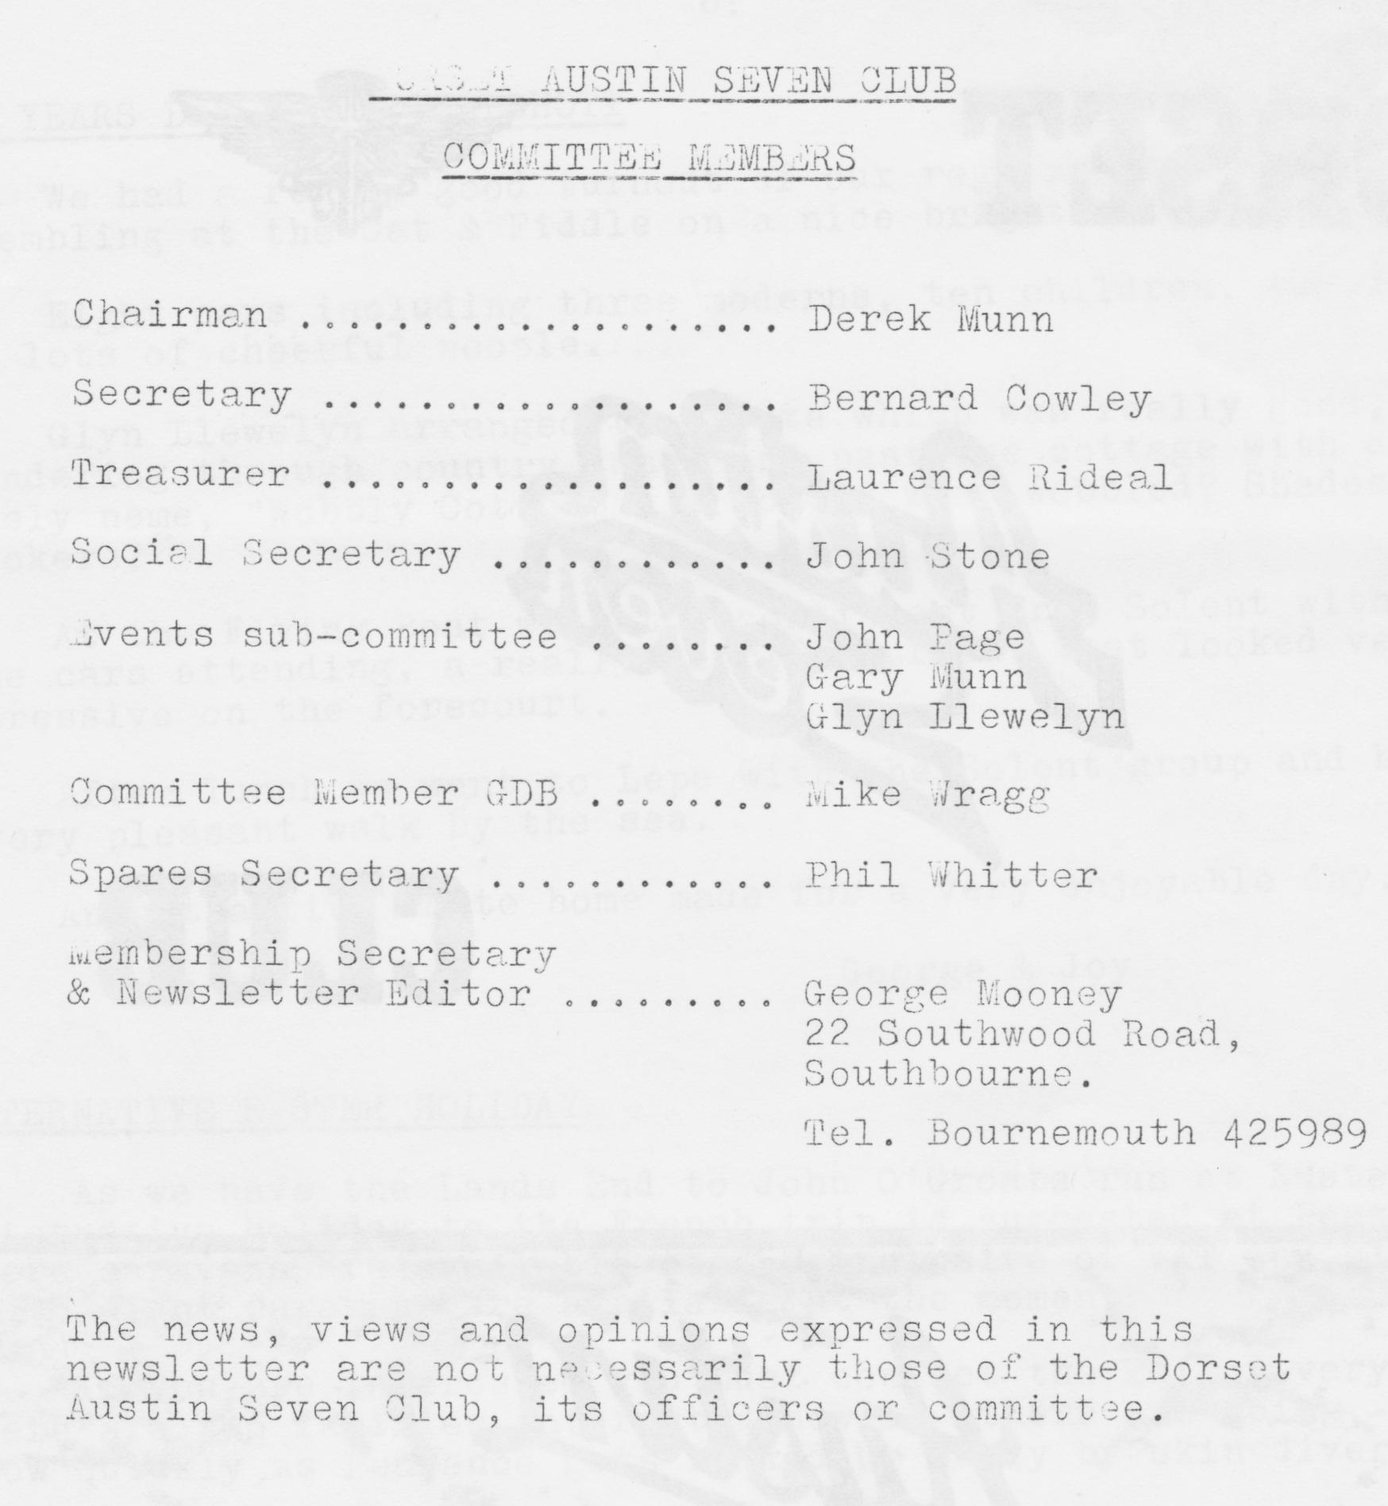

DORSET AUSTIN SEVEN CLUB NEWSLETTER JANUARY 1982

Here we are again then, doesn't time fly!
I notice that input for the newsletter is still rather low and suspect that it would be wise for me to put my address on the front cover, so now you know where I am, send me a letter.
Christmas has been and gone and what a superb holiday we had. I hope that you all had an enjoyable family Christmas.
Our last meeting was the first to be held at Dormers and it proved to be a tremendous success.
Mike Wragg come dressed as Santa Claus and many took great care and went to a lot of trouble to come dressed for the occasion.
Yours truly in his rush forgot his blooming hat and it was only thanks to Gary and Derek Munn who brought a box full of hats that I was able to cover up my embarrassment.
Bernard Cowley brought his 78rpm record collection and the gramophone to lend a little atmosphere and Mike Parsons was very kind in bringing his 8 mm film collection with Movietone newsreels from 1934-35-39 etc and some cartoons. He had a mildly erotic cartoon called the Karma Sutra but we were frightened to show it for fear of giving offence!
It was a source of great amusement all evening to the people in the bar downstairs to have people dressed variously as Santa Claus or with funny hats, etc. keep popping in for a beer.
Dormers seems set to be a great success.
Well, here we are into 1982, 60th Anniversary Jubilee Year and looking forward to an exciting Austin Year.
We have had some interest in the French trip, firm details next issue.
Enough from me now to hear from the others. A short newsletter this month, don't let this be the pattern for '82, let me have your letters, news and views and I will write of Henrietta next month, she is in the pink.
On behalf of the committee may we wish you all a Happy New Year.
Yours. in Trim,
George.

THREE MONTH CALENDAR
16th January. Saturday Skittles evening at the Langton Arms, Tarrant Monkton, nr. Blandford
21st January. Thursday Club Night at the Dormers, Wimborne. Brush up on your Austin facts and general knowledge for a bit of fun.
23rd January. Saturday Solent 10th Anniversary Party, Beaulieu.
24th January. Sunday Club run to Shaftesbury. Leave Wimborne Square 11 am sharp.
28th January. Thursday Committee meeting. at the Tyrells Ford, Avon, 8.30 pm.
13th February. Saturday Barn Dance at the Scout Hut, Wimborne. Highly recommended.
18th February. Thursday Club meeting. Dormers, Wimborne.
21st February. Sunday Club Run to Hamble. Depart 10.30 am from Ringwood cattle market car park
25th February. Thursday Committee. Meeting.
18th March. Thursday Club Meeting, Dormers, Wimborne. Event details in February newsletter.
21st March Sunday Club Run to Corfe Castle and Kingston. Start at Wimborne Square 10.30 am sharp. Luncheon at the Scott Arms, Kingston.
25th March. Thursday Committee meeting, Tyrells Ford, Avon, 8.00 pm.
Will other club secretaries please note - visitors to Dorset A7 Club runs are always welcome so come along if you can. Tell your members.

SALES/WANTS
OIL SAE30 £2 per gall. Contact: Chris Smith, Ringwood 78066. Chris can now undertake mechanical, body, other general repairs and MOT testing in his own new company Somborne Autocare, telephone number as above.

MEMBERSHIP MATTERS
No new members this month at time of going to press. Just a reminder we still have a number due to renew subs for 1982.

CHAIRMAN’S CHAT
Well, what a start to the year. The brakes on my, T.R. are frozen up, the battery on Jane's car leaves a lot to be desired and yet the only car in our garage that works first time every time is Gary's Box. I've been taking a lot of stick about this lately!
But still, one chap has got himself organised for the Channel crossing this Summer. Have you seen the stripped-down A.7 doing the trip for the P & 0 advert on the telly? I wonder whose car it is. Pity we didn't think of it first, it might have paid for a few trips for our proposed visit to France at Easter.
News so far for the trip to France is that John Page has sorted out the most reasonable route to Cherbourg from Weymouth, return fare for car and two adults is £71.80 by Sealink on a five-day Mini Break from Thursday 8th April and returning on Tuesday 13th, April. I am still trying to contact reasonable caravan sites to use as a base on the west side of the Cherbourg peninsular. Estimated cost to be about £10 - £12 a night per caravan.
What an enjoyable run the New Years Day trip was to Calshot. It was nice to see a lot of familiar faces amongst our Solent friends. The facial expression of the landlord at the Flying Boat pub was worth seeing. He must have wondered what had hit him when our whole crowd turned up. Thanks a lot Glyn for organising the trip, it was very enjoyable and very well attended.
Happy New fear and happy motoring.
Derek.

OLD GROANERS

How did you find your steak Sir? Easy, I moved a chip.
****
Teacher: Barbara, finish off this proverb. One good turn.....
Barbara: One good turn gives you all the blanket.
****
Teacher: Ivor, where is Felixstow?
Ivor: On the end of his foot.
*****
Man: This bun tastes of soap.
Waiter: Yes Sir, it's a Bath bun.
*****
Man: Your thumb is in my soup:
Waiter: It's OK Sir, it isn't hot.

When is it bad luck to have a black cat follow you? When you’re a mouse.
****
How did Mum know you hadn't washed your face? Oh, I forgot to wet the soap.
****
And what is your new baby brothers name? Dunno, he can't talk yet!
****
What is a buttress? A female goat!
****
What is out of bounds? A knackered kangaroo!
****
What is a myth? A female moth!
****
Our kitchen is so small we have to use condensed milk!
****
Abe: Answer the phone.
Solly: It's not ringing, my life.
Abe: Always you leave things to the last minute.
*****
Arab Sheik to first son: What do you want for Christmas.
Son: A Country Cottage! so he bought him the Taj Mahal.
2nd Son; What do you want? A Mistress!
So he bought him a harem.
3rd Son: And what do you want? A Cowboy Outfit!
So he bought him British Leyland!
*****
THIS AND THAT
Deliberate mistake! who spotted it? I forgot to tell you that the film you should look out for is "The Eye of the Needle.”

CLUB SPARES
Business is hotting up and Phil is doing his best to meet your needs from his stock. Current stocks of the following items at time of going to press.
All felt oil seals King Pin sets early & late
caskets Lock washers
All studs and stepped studs Manifold nuts and studs
Brake cables Oil pump springs
Brake cams Prop shaft universal joints
Brake cam bushes Radiator hoses
Brake drum screws. - Rim tapes 17"
Clutch linings Rear spring pins & bushes
Clutch, mousetrap springs Rad caps, (Ruby)
Clutch comp. springs Spring shackle bushes.
Core plugs large & small Spark plugs
Distributor caps (late) Shock absorber rubbers & washers
Engine mounting rubbers Shaft keys
Exhaust flange nuts & bolts Track rod kits.
Distributor points (Ruby type) Valves
Dynamo brushes Valve guides .
Fly wheel keys & nuts Valve springs
Fan belts early & late (original and nylon)
RUN TO THE HIGH CORNER INN

Having organised this run several weeks in advance, no one could have guessed the appalling weather conditions that occurred on Sunday. Mind you, according to several of the people there, it seemed that only Ringwood and the New Forest suffered from the snow! We all met at Ringwood car park at 11 o'clock apart from the Munn family who managed to be late! (as usual). Surprisingly nearly everyone had turned up in an Austin so we had a convoy of nine cars trundling along through little lanes which Gary had discovered but which also seemed to have the most snow on them. The trip there was certainly quite a test of anybody’s driving ability but it was fun to discover all the leaks in the floor boards and draughts which a lot of people never knew existed in cars!
We all arrived safely at the High Corner Inn and warmed ourselves in front of a log fire. Whilst we were there, Dave Tanner and daughters joined us, as did Jeff Kingsland and Kathy. We all had some food and a warming drink, (that was my excuse anyway!) When 'time' was called we wended our way to the car park and an impromptu snowball fight with Phil Whitter coming off the worst, attacked mainly by Gary and Hilary! Anyway, everyone got home safely. Happy New Year to everyone.
Debbie Munn

NEW YEARS DAY RUN TO CALSHOT
We had a really good turnout of our regulars for the run, assembling at the Cat & Fiddle on a nice bright morning. Eight cars including three moderns, ten children, two dogs and lots of cheerful people.
Glyn Llewelyn arranged the route which was really good, meandering through country lanes and past one cottage with a lovely name, "Wobbly Cottage”, I wonder what wobbled? Shades of Twickers?
At the Flying Boat, we met a contingent from Solent with nine cars attending, a really terrific turnout that looked very impressive on the forecourt. After lunch we went to Lepe with the Solent group and had a very pleasant walk by the sea.
An attractive route home made for a very enjoyable day.
George & Joy

ALTERNATIVE EASTER HOLIDAY.
As we have the Lands End to John O'Groats run at Easter an alternative holiday to the French trip is suggested at Penzance where caravans are available at £58 inclusive of VAT and electricity. Up to eight caravans are available at the moment.
If you are interested you must contact the Editor very quickly. There are two families interested now if others are going, let me know quickly as Penzance gets booked up early by skin divers!

SALES/WANTS (cont.)
For Sale - Restored 1934 Box Saloon, used up to earlier this year. Re-sleeved engine not even run in £1500. Please contact T. Carr-Jones (club member) for further details on Bournemouth 511071

BARN DANCE 13th February
Here is a reminder that the Barn Dance is on the 13th February at the Scout Hut, Redcotts Lane, Wimborne, starting at 7.30 pm. A professional caller and cold supper are included in the price of the tickets which are available from John Stone @ £2.25 each. Closing date 1st February 1982.
Absolute knock-out event last year, if you didn't come you missed a treat.

