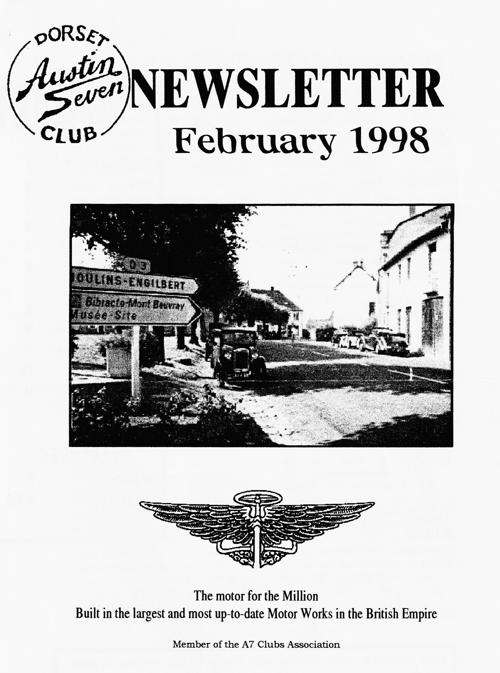

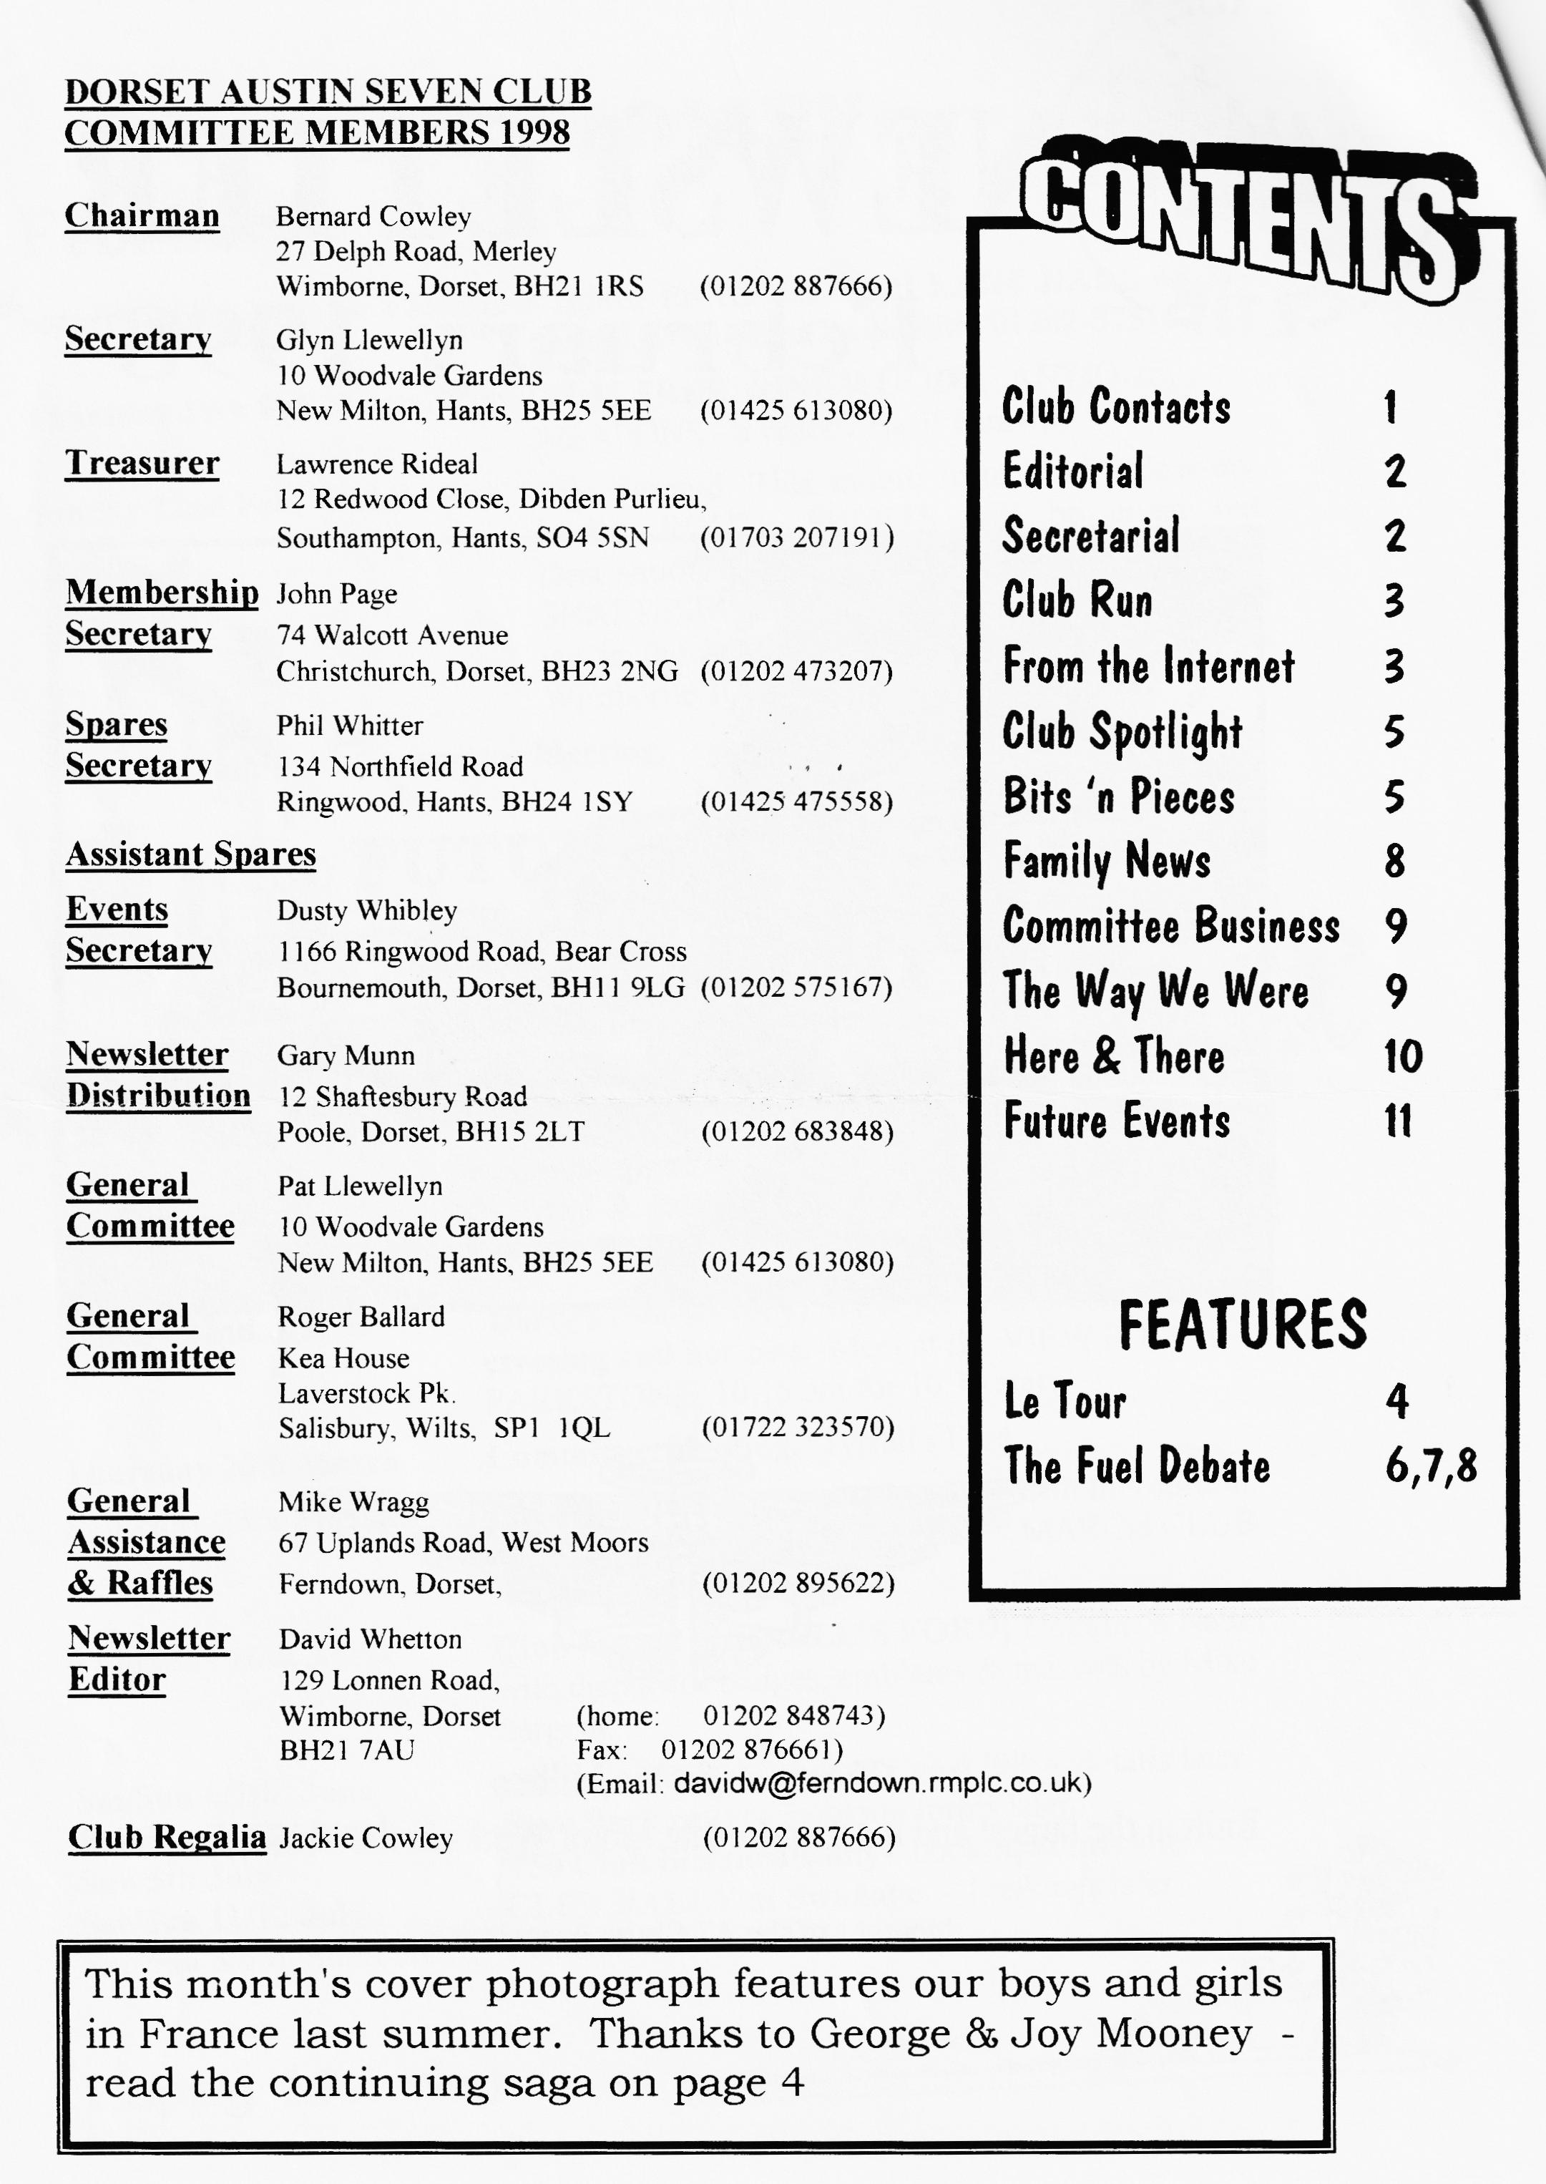

EDITORIAL
Another new member writes up the monthly Club Run again it's a good way to break the ice and to meet people, but I think this is a first even for us - it was Richard & Robert's first ever Run! Well done those men. I have been collecting material on the Great Fuel Debate for some time now, thanks to those members who have donated the odd article or two, and so I've grouped it altogether in this edition for us. However, I have a simple solution to the whole question - convert the cars to steam and burn all the paper that has been used up on the affair. However, there's not a lot we can do but wait and see. An elderly gentleman from USA E-mailed me to say he'd been running on unleaded for years and it didn't do him any harm - except a burnt valve because of the lower octane! Please see the two appeals for interest on page 10 and act NOW - people trying to organise events on our behalf sometimes need to assess the interest of the Members before committing themselves to time, expense and possible embarrassment. And, finally, a .message from the Membership Secretary - please ring if your Newsletter address label is wrong.
David
Deadline for the next issue is 27/2/98 . Please send material to me by post, fax or E-mail (see new address) or pass it over at Club Night.
SECRETARIAL

HI GANG,
There was a good turn-out for the Sale of Spares at the January Club Night. I hope you managed to find that missing part for which you had been looking. Phil tells me that business was brisk. (See report on page 5 Ed.) It has been decided by the Committee to move the venue from the Elm Tree to TYRRELL'S FORD HOTEL at Avon, where we hold the Xmas dinner. This is because of the change of use for the Barn at the Elm Tree. You will, no doubt, have seen the big Sky TV screen and the pool table and we could not rely on having "our" room each month. The first
meeting at the new venue will be on the 19th. March.
The January Run also saw a good turnout with a dozen cars. The Bishops’ even came from Exeter and Richard & Margaret Cressey made the trip from Charlton Hawthorn. We would all have benefited from coming in boats rather than cars as it turned out!
Pat & I are off to sunny (we hope) Spain on the 27th January in our campervan and we hope to meet up with the Tophams down there for a glass or ten of Sangria and the occasional bottle of Rioja. We should be back for Club night, so see you all then.
Glyn
PAGE'S PERAMBULATION -
18th January 1998

Being a new member I thought I must meet up with some fellow Austin 7 enthusiasts as nothing much happens down here in Devon. To make the 10.30 deadline meant that son Robert and I had to leave Exeter at 7am the latest! We managed that..... just... with Robert still recovering from the excesses of Saturday night. The weather on the way up was not good and there was localised flooding in several places, but at least the S.W gales were behind us.
We arrived in Ringwood at 10 am and decided to fill up with petrol and promptly got lost and nearly missed everyone. We enjoyed an excellent run with ten other Austins first crossing a very swollen ford just outside Ringwood and on through a wonderful part of the New Forest. Just before the lunch stop, one more ford and this one
defeated all but a few. But we made it to the Filly Inn at Setley and a chance to get to know as many members as possible and to enjoy some good pub grub.
We decided to make an early start home and left at 2 pm taking the main road up to Cadnam. Once back on the A31 the wind and rain really hit us and with sponges nipped in under the windscreen to catch some of the wet we were ready to head West! With only one brief stop to clean the dynamo commutator to give some charge and to take on water, we arrived back home at 6 pm, a total of 217 miles. Many thanks John for the run and thanks to everyone for a very hospitable welcome. ‘Twas handsome m'dears!
Richard and Robert Bishop.
217 miles!! And some of our members cringe at the thought of -10!! Welcome indeed to the battling Bishops. - Ed.

For Sale - Austin Seven 1934 'RP' Saloon in 'Dual Beaver' original paintwork two-tone light brown. Probably the most original Austin Seven I have ever seen in 28 years of owning Austin Sevens. £3,750 tel. 01322-615600 (Swanley, NW. Kent) - ask for Derek from Andy Cliffe [cliffea@oldpeter.agw.bt.co.uk]
As to Alfins - they're aluminum brake drums with a cast iron liner cast into them and I'm manufacturing them. From John Hardy [hardwire@webleicester.co.uk]
Dear David
We hope to be at the club night this week, but just in case we miss it, perhaps you could inform any interested parties that the Coast to Coast date has been changed to June 6th -7th. The May Bank holiday proved too difficult to arrange. It seems that Morecambe accommodation is fully booked because there is a Line Dancing Convention. We have no desire to be anywhere near that! The Pennine Run is still on for September 5th and 6th.
Happy New Year, we'll see you sometime,
From: Joe & Maggie Stalker [joe@jstalker.demon.co.uk]
Vintage Radiators near Towcester who make original pattern strip-film radiators for Austin Sevens are closing down soon. Tel: 01327-857728
From: David Cochrane [david_cochrane@ingineur.co.uk]

26th AUGUST-REST DAY
Torrential rain until lunchtime kept us camp-h
bound, but Jim and Gaye took us all into CUSSEN for lunch in the campervan after which Joy & I took an autobus into VICHY returning about 5 pm. The evening was spent trying to dry things out and bed by ten was the only viable option.
27 AUGUST VICHY -AUXERRE
We woke late 6.40 to the sound of others on the move. We managed to leave at 8.10 am - not too bad. The morning was clear with no sign of rain and as our objective was to get to AUXERRE with all haste so we could dry out, we set out at a good pace. When we stopped for coffee with Vince Leek and John Harris our cars attracted at least a further six at the same time. The cafe owner was, I am sure , most surprised and happy. The countryside was attractive all the way and the D944 is a very nice road with very little traffic. 189 miles later, we arrived at the attractive, municipal campsite and were soon established, drying all our wet things in the strong afternoon breeze. Very quickly all was dry and we had steak Hagie and chips at the cafe/shop. However, the rain started a little after 7pm and as I complete this at 7 am the following day it is still raining. What to do next? Hotel?
28 AUGUST AUXERRE-
COMPEIGN
As we woke the rain was still hammering down - 12 hours non-stop. Before we left the campsite I had to remove and dry the plugs because I forgot to cover the carb inlet, flattening the 'battery trying to start but Jean got me going with jump leads from the Morris Minor. At one stage Eddie and Judy in the Chummy in full all-weather gear (no hood) were at the side of the road and as I came up beside her and tapped her on the shoulder she jumped a mile. After leaving we had a persistent misfire, so we stopped after our coffee break to see what was the problem. The problem was caused by me as I had broken a plug insulator rushing in the rain. We stopped for lunch at a little brasserie in the village of MON MIRAEL, arriving at the campsite after others who had arrived earlier. At least it was dry on arrival and we have been able to dry off. 185 miles today.
In the evening at about 7.45 we all set off (11 of us) in the Kontiki camper with Jim and Gaye to COMPEIGN for our evening meal. It started off with most of the group going in via the window and it was all laughs from there on.
Tomorrow is another rest day and we will look at the city.
Will our intrepid heroes ever dry out? Will they rust away before reaching home? Watch this space - Ed.

BITS 'N PIECES - an occasional focus on SPARES
THE JANUARY SPARES SALE

Some Members who attended the January Club Night were disappointed not to see tables full of spares as they said they had expected to see all of Ken Medlicott's collection rather than the hand-picked selection amounting to £500. (I think I had some part to play in this, calling it the Sale of the Century - Ed.) In spite of this, there were still some bargains to be had as I had priced the items more-or-less at the price we paid for them.
It was disappointing that the bring-and-buy section of the event was almost nonexistent but perhaps we just do not want to sell-off any of our Austin 7 stuff!
We took £200 on the night and therefore still have about £250 worth of the spares in the Club. (The difference is due to some
expenditure and a difference in some prices.) One thing the sale confirmed is that whenever one buys a quantity of spares, a considerable amount will not be sold no matter how carefully they were selected. Taking this into consideration, my future policy will be only to buy spares which 1 know people want and for which there is an immediate demand. The amount of work involved in the visit, selection, pricing, listing and finances seems not to be justified.
Phil
Thanks Phil, on all the Members' behalf for all the hard work you put into the spares scheme. I, for one, got exactly the right parts I needed at the sale and it certainly was 'justified' from My point of view - Ed.

CLUB SPOTLIGHT -- THE RAFFLE

Every month we take part in THE RAFFLE under the control of our MASTER OF CEREMONIES - Mike Wragg. But what's it all about?
In the beginning, at the Nags Head, Ringwood there was a very small charge for the room and Members would drop a few coppers in an ashtray to cover the expense. However, on moving to the Dormers, over 12 years ago, the landlord made a substantial charge and the raffle was born. Derek Munn - Gary's father first ran it as a meat raffle and 10 years ago, when Mike took over, it still continued as such with meat brought in by
butcher-member Alan Seymour. However, Mike started to add the odd tin of bear or bottle of wine and, at one stage, a member connected with Max Factor did the ladies proud with cosmetics. More and more members started to donate prizes and one high moment was an extremely large Panda in a Christmas raffle which was won by - Mike himself.
These days, Pat Llewellyn buys exactly £20 worth of prizes each month and with the raffle taking about £45, we can cover the cost of the room and give a boost to Club funds at the same time thanks to Mike. Where would we be without him? Not quite so deaf! Ed.

THE FUEL DEBATE
1 - THE PROBLEM
FEDERATION of BRITISH HISTORIC VEHICLE CLUBS:
Following the Federation's conference held at Gaydon in March, and the consequent formation, an inaugural meeting of a Fuels Committee was held on 1 July 1997.

The following assumptions were made:-
- The sale of leaded petrol at garage forecourts in the UK would be banned with effect from 1 January 2000.
- Leaded fuel in limited quantities would continue to be blended for sale at approved motor racing circuits.
c The fuel being made available at the pumps in some European countries and known as Lead Replacement Gasoline fell far short of providing full engine protection and was unlikely, in any case, to be widely marketed in the UK for commercial reasons.
d. There was no scientific evidence to support the marketing claims of organisations offering products such as pellets which were to be merely placed in fuel tanks or fitted in small containers to the fuel line.
The Committee agreed the following conclusions:-
- the single most important risk to engines no longer able to use leaded fuel was exhaust valve seat recession.
- The best solution to using unleaded fuel in historic engines remained the engineering option; that is the fitting of hardened seats.
- Whilst agreeing the universal danger of valve seat recession, a valve recession additive which protected valve seats but caused damage elsewhere could enjoy only limited endorsement.
- There was still much misinformation at large about the use of leaded and unleaded fuel in
historic engines. There was no absolute maxim which said that using unleaded fuels in historic engines would inevitably result in valve damage - and there never had been -the point was that there was significant risk.
- The overall conclusion to be drawn from all these assumptions was that the solution to the known problems of using unleaded fuel in older engines lay in the so-called 'after market' provision of fuel additives.
Finally, the Committee made the following decisions:-
- It is vital to evolve a test protocol which involved testing by wholly independent and accredited test organisations.
- To liaise with the oil industry to ensure, if possible, that suitable products would be available on garage forecourts by 1 January 2000, and listed engines for which it would not be suitable.
- The Federation would work closely with motoring organisations, particularly the AA and RAC to acquire an accurate database showing the numbers of vehicles likely to be affected by the withdrawal of leaded petrol.
- Lastly the Committee would be examining further the implications of the continued need for light piston-engined aircraft to use leaded aviation fuel (AVGAS) and any relevance there might be to the future use of older road vehicles.

THE FUEL DEBATE
2 - WHAT'S THE FUSS
R D Greenaway writes in Australia, where they are faced with the same problem, that the BIG LEADED MONSTER has been based entirely on the need to protect valuable catalysers which, he claims, only have an effective life of 3,100 miles anyway. He also claims that there is no health risk associated with lead in petrol using very persuasive data from Germany, Australia, UK, America and New Guinea (!) and, on the contrary, claims that unleaded is much more dangerous using dimethylbenzene, mesitylene, toluene, xylenes and benzine to replace the lead all of which are known carcinogens. Work at London University has shown that unleaded petrol used without catalytic converters produces "vast amounts" of carcinogenic compounds and, he claims, the UK National Society for Clean Air has removed all support for unleaded petrol.
Reported in Microlight Flying Oct'97
THE FUEL DEBATE
3 - NO PROBLEM
DR CATHRYN HICKEY, TECHNICAL MANAGER AUTOMOTIVE FUELS SHELL UK LIMITED
SHELL LOW LEAD 4 STAR PETROL:
In the UK the quality of all petrols is controlled by BS4040 which defines the specification limits in a wide range of areas which must be met by any petrol in order for it to be sold as a leaded 4-star petrol.
The specification covers four key performance areas:
- Octane quality to prevent engine knock or 'pinking'
- Volatility to ensure the vehicle starts and accelerates, without problems.
- Stability and non-contamination to ensure the petrol is free from contamination and stable.
- Exhaust valve protection to ensure the petrol has sufficient lead to prevent exhaust valve seat recession. The current specification in BS 4040 to control the lead content are : 0.15g/1 max.- 0.05g/I min.
The BS 4040 specification was jointly agreed by the motor manufacturers, motoring organisations and oil industry through the British Standards Institute as being the quality of petrol, that extensive vehicle testing has shown to be required to ensure damage free operation in vehicles needing 4-star petrol. Shell Low Lead 4 star exceeds all specification requirements of BS 4040 as a 4-star petrol for all engines needing leaded petrol. In particular the lead content of Shell Low Lead 4 star is typically 0.07g/I which exceeds the minimum lead content specification in BS4040 of 0.05g/1.
Shell Low Lead 4 star meets all requirements of the motor manufacturers including Rover, for a 4 star petrol, and its use in their older vehicles is fully supported.
FROM BRIAN WILBOURN E-MAIL
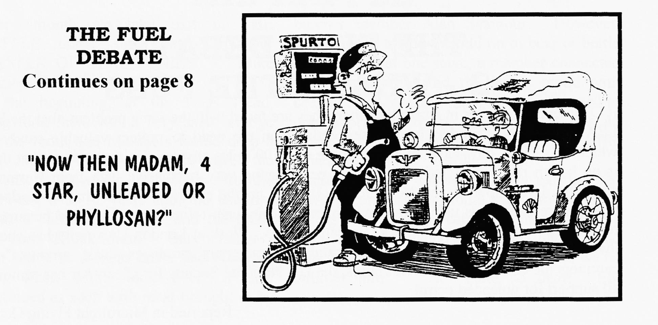
THE FUEL DEBATE
4 - THE CAMPAIGN
It was noted that, although a mechanism existed within the European Union whereby member countries could seek derogation for a limited number of years, this course of action was judged to be extremely unlikely in the case of the United Kingdom. Your Fuels Committee are of the opinion that a campaign should be mounted to lobby the British Government to consider or reconsider application to the EU to extend the date for discontinuation of supply of leaded fuel, if only to allow sufficient time for substantive research into an effective and meaningful additive to replace the previous lead content in petrol.
Support on this matter is to be generated through a press release and hopefully through co-operation with the specialist motoring press.
Federation of British Historic Vehicle Clubs
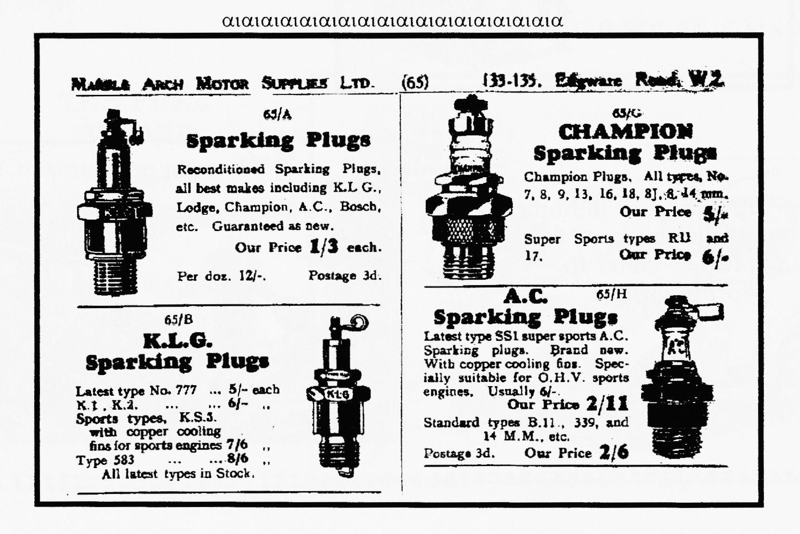
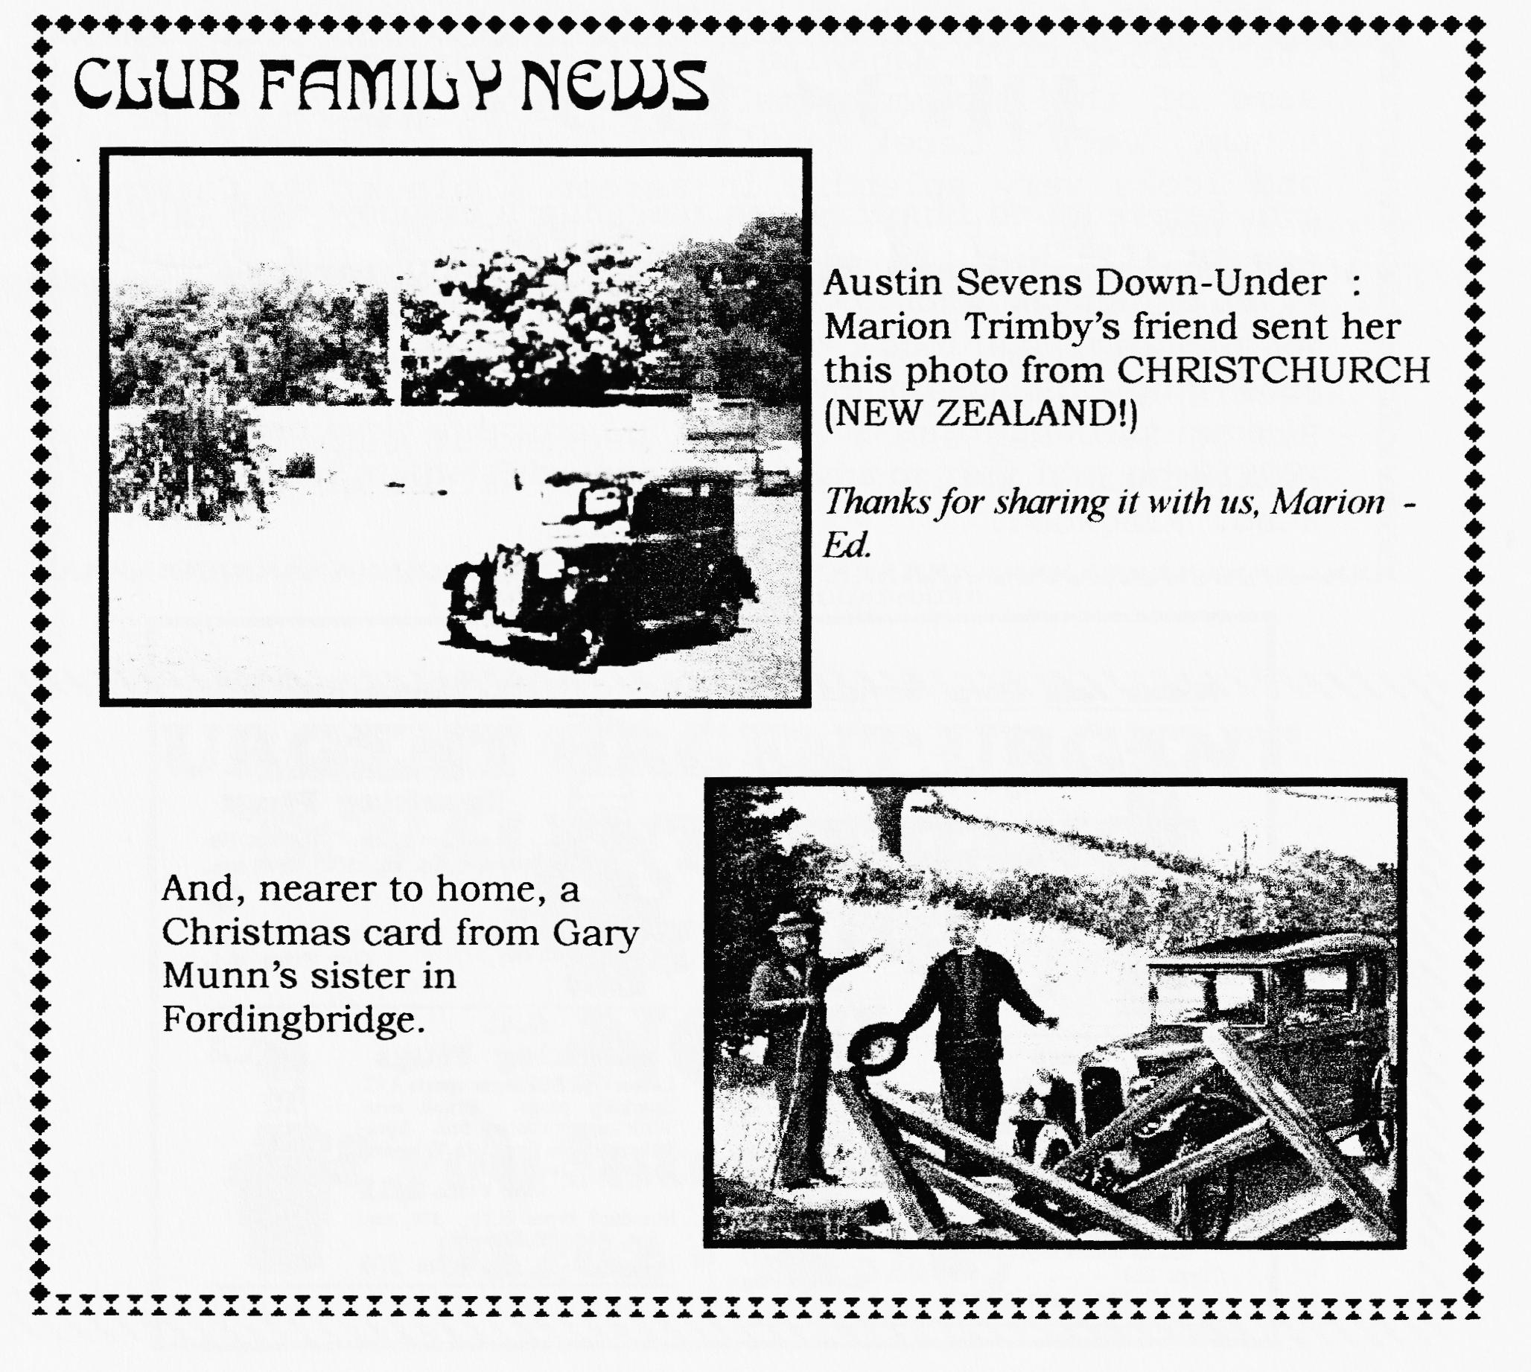
COMMITTEE BUSINESS
At last we were able to welcome Roger Ballard with a toast or two after his recent illness. THE DIE HAS BEEN CAST & THE DECISION TAKEN - it's official, the new venue from MARCH will be THE TYRRELL'S FORD HOTEL, RINGWOOD. Full details and map in next month's newsletter. This month we concentrated on events for the year under our new co-ordinator Dusty - lots of new ideas - well done that man. It is hoped we will be able to publish a programme for the year next month but we still need ideas of different/interesting places to go & things to do plus volunteers to organise a Club Run or two.
THE WAY WE WERE a blast from the past
From the Club magazine for FEBRUARY 1977
"SECRETARIAL: I have had a letter from Ian Dunford asking us if we want to join the Austin 7 Clubs Assoc. I believe it would be a good idea as we could then get the Association Magazine and have representation on some of their committees. The entry fee is £5 per annum.
Gary & Derek Munn's '30 Box is now on the road and looks very splendid in maroon & black. My Chummy has now lost its body and I am starting to renovate the chassis, Glyn's Ruby is nearly ready for the road and Mike Wragg is still trying to hunt one down!
Future events: 23rd.March Chris Gould's 10,000 mile record at Goodwood. The DA7C will organise a Sunday Run on 1st. May and a camping weekend in June.
Next meeting 17/2/77 - Noggin & Natter at The Nags Head, Ringwood. - Bernard."

NEW MEMBERS
This month we extend a very warm welcome to PAUL AZULAY of Colehill who owns a '37 Ruby and to MELVYN OAK of Tiptoe with his '29 Top Hat AZ 5180. Say hello to the Committee at Club Night.
ADVANCE NOTICE
John Page wonders if sufficient people would be interested in a Sunday run (possibly June 14th.) to PETERSF1ELD to join members of a MICROLIGHT FLYING CLUB for a fascinating day of cars & planes. As a bonus for us, they would take anyone up for £10 for half an hour. As this involves another club, John needs to have an early indication of interest before committing himself. So, see him at the February Club Night or ring him on 01202473207.
URGENT URGENT URGENT
St VALENTINE DANCE
Ring Dusty
Now
If you intend coming
'o1202-575167

oo CLUB DIARY oo
February
Saturday 14th Feb St Valentines Dance PAMPHILL VILLAGE HALL nr. QE School, Wimborne 8pm. Ring 01202-575167
Thursday 19th Feb. Club Night (ELM TREE, RINGWOOD).. ANTIQUE WEAPONS - a talk by Basil Faraway
Sunday 22nd Feb. Club Run. - by Bernard. This month instead of follow-my-leader, ROUTE SHEETS will be given out. Destination — The old hilltop town at SHAFTESBURY followed by optional afternoon tea in the Wimborne area. Meet at QE School, Wimborne I 0.15am for 10.30 start.
Thursday 26th Feb. Committee Meeting. Tyrrell's Ford
oo FUTURE EVENTS oo
Thursday 5th March Eight till Late: THE FISH INN, The Bridges, Ringwood (with Folk accompaniment!)
Sunday 22nd March Dusty's (not-so-very) MUD RUN to include the ferry crossing and hot pies. Meet at the VIEW POINT, PARKSTONE, 10.15 am for 10.30 start.
Thursday 26th March Committee Meeting. Tyrrell's Ford
Saturday 28th March Skittles, Monmouth Ash See flyer with this edition. Bookings needed at FEBRUARY or MARCH CLUB NIGHTS or by post.
Thursday 16th April Club Night (TYRRELL'S FORD) Noggin 'n Natter with display of badges, emblems & mascots by Mike Sargent.
Sat/Sun 6/7th. June (change of date)Coast to Coast '98 - details later
Fri/Sun 19/21 June Spye Park rally - booking forms later
Sun 5th July 750 Club Beaulieu Rally- booking forms later
Sat/Sun 11/12 July CLUB RALLY at Swanage - bookings later.
Sat/Sun 5/6th. September Pennine Run - details later

