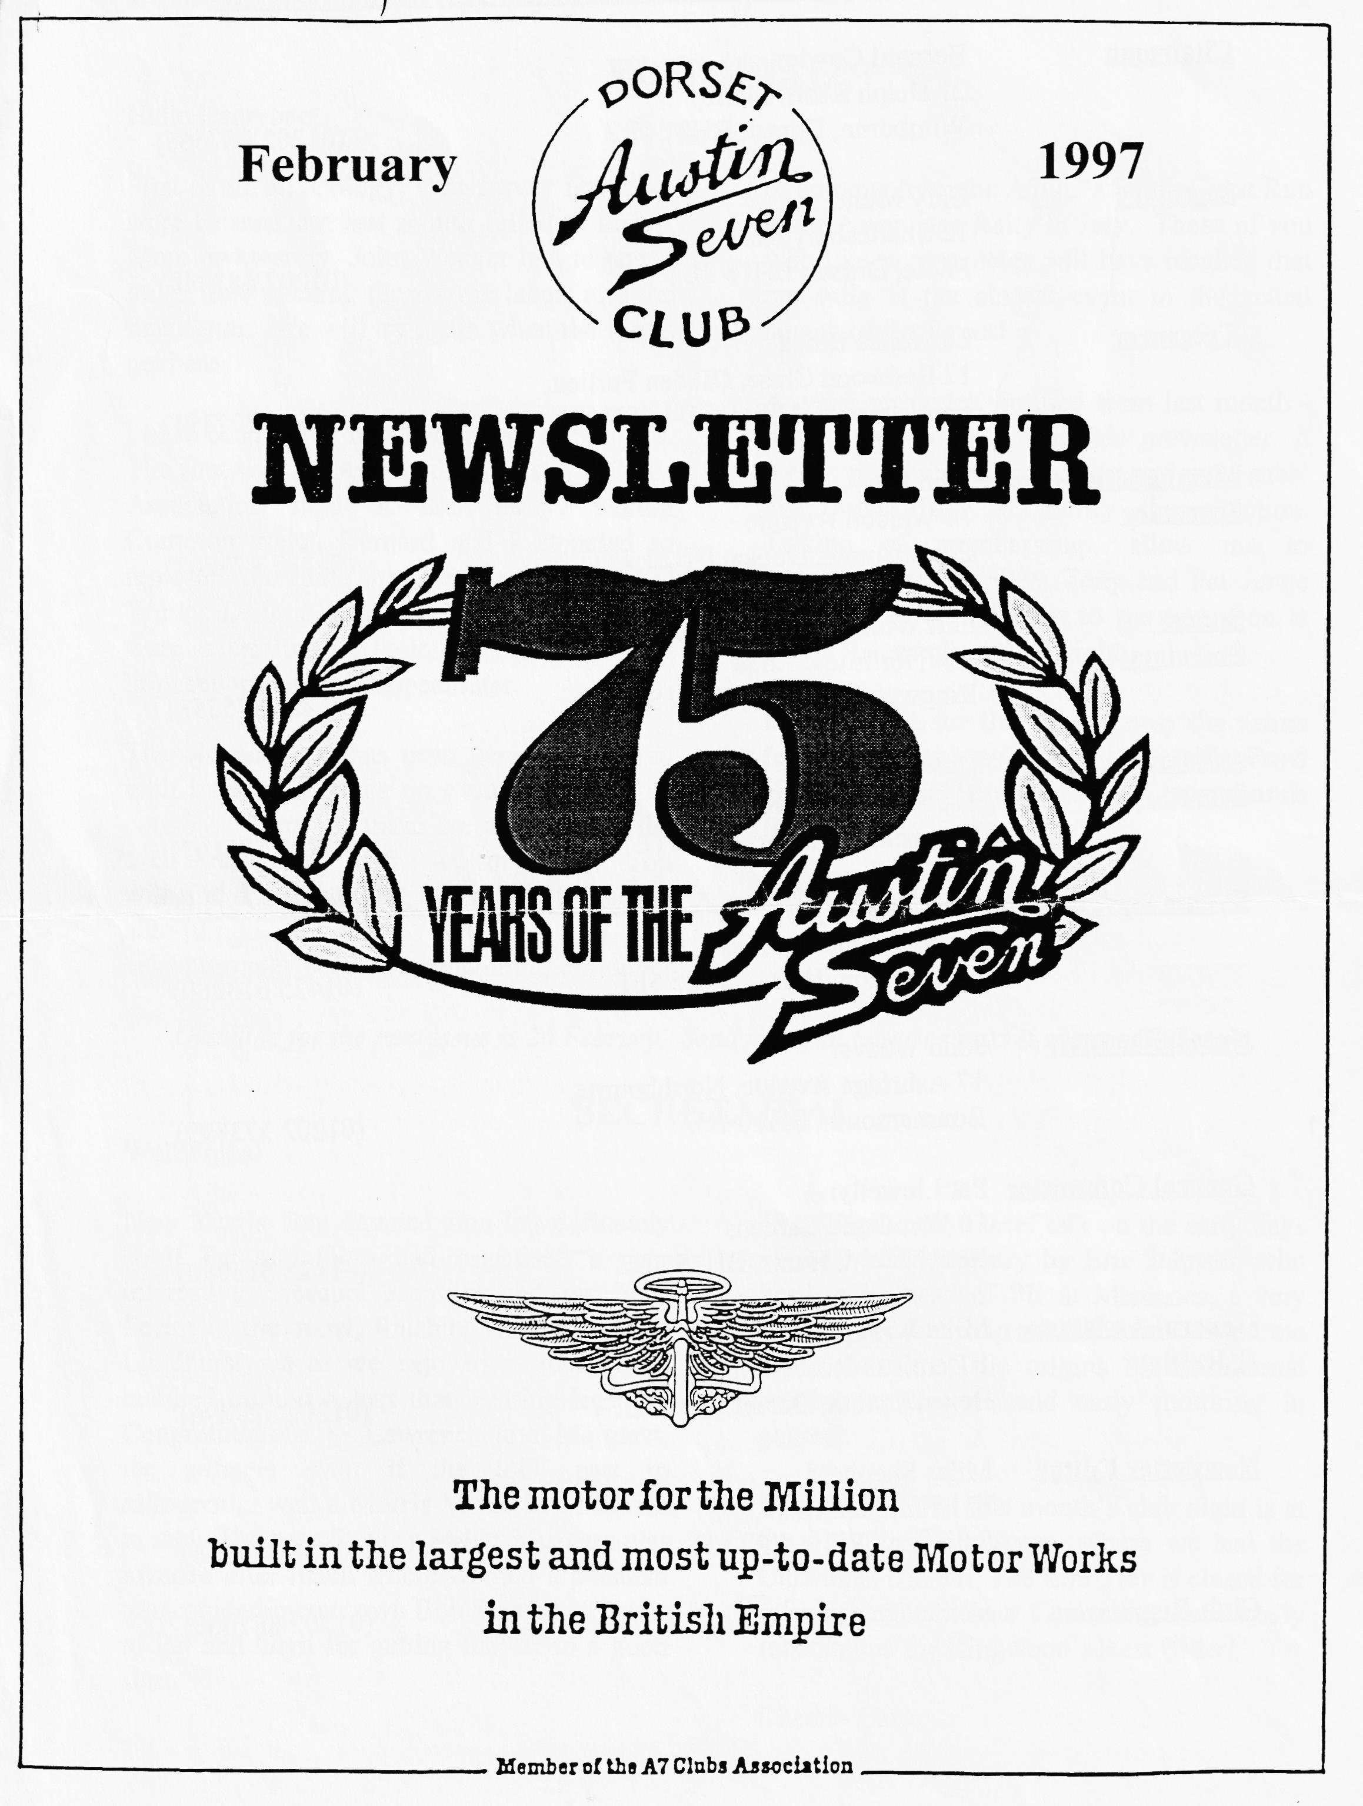

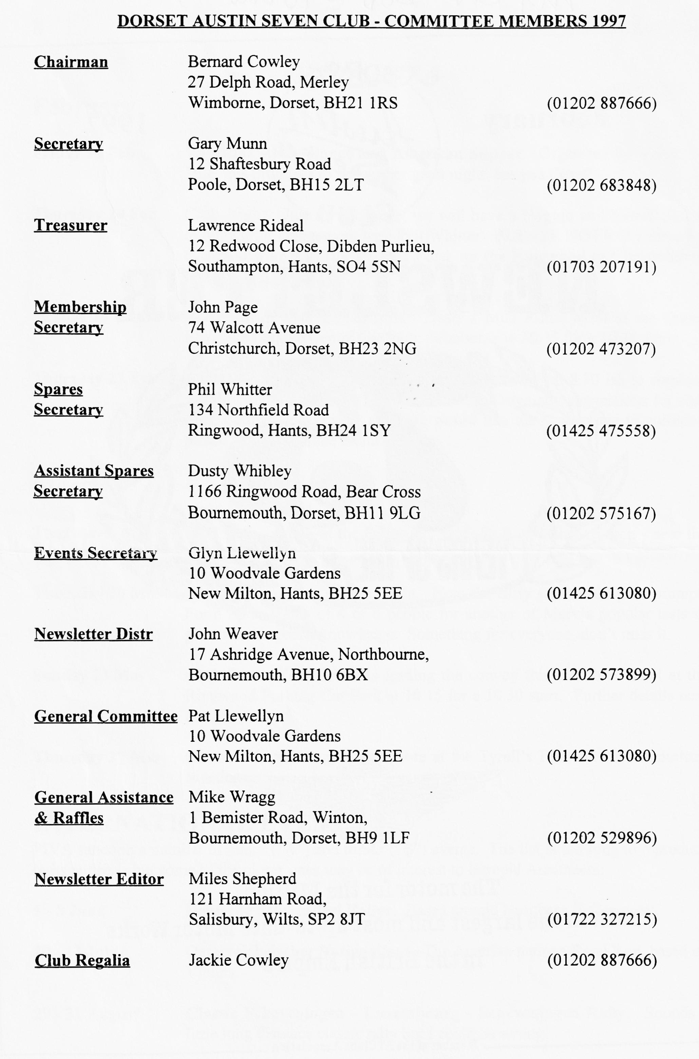

EDITORIAL

Hallo Everyone,
First of all, an apology. The survey forms we were to send out last month failed to arrive. More awkwardly, John Weaver had to spend much time sticking those little labels into the newsletter. We will try again when the forms get here.
I have been to my first two events of the year. The first was the AGM of the Austin 7 Clubs Association held at the Belfry, Milton Common which Bernard and I attended to represent the Club; the second was the VSCC Winter Driving Tests at Brooklands. Both were interesting in their different ways and brief reports on both appear later.
The old post bag has been generously filled with interesting notes on events all over the country. Many of these are to celebrate the 75 di Anniversary of the Austin Seven. You will find details of the Gaydon event, plus the auto jumble advert. As part of the celebrations, we will be welcoming a number
of entrants from the A70C's South Coast Run at our Swan age Rally in July. Those of you who like to note dates will have recalled that our rally is the closest event to the actual launch of the Seven!
A quick reminder, omitted from last month if you are not receiving this newsletter, it means you have forgotten to pay your subs! See John Page to rectify the situation. Talking of membership, allow me to welcome new members Tony and Pat Junge to our club. We all hope to see you soon at one of the events or club night.
Don't forget, for this month only the venue for Club Night will be the Tyrell's Ford Hotel, on the Ringwood to Christchurch Road..
BFN, Miles

SECRETARIAL

Well Folks!
New Year's Day dawned fine but definitely cold! Pat and Glyn had organised a very interesting Treasure Hunt around the New Forest in the snow, finishing at the Swan at Lyndhurst where we enjoyed a good meal, huddled around a less than roaring log fire. Congratulations to Lawrence and Margaret, the winners even if they took part in a Modern ... well a Morris Minor is a Modern to me! The new Sammy Miller Museum was invaded after lunch where we had a personal tour, guided by our own Bob Stanley. Thanks to Pat and Glyn for getting the7o4ff to a good start.
Club Night saw a brief talk on the early days of the Motor Industry by Eric Johnson who used to be head of PR at Mercedes, a very knowledgeable chap who certainly taught me many details of the origins of the internal combustion engine and early motoring in general.
Don't forget that this month's club night is at the Tyrell's Ford, Avon, where we had the Christmas Dinner. The Elm Tree is closed for refurbishments. Your committee can usually recommend the Ringwood's Best Bitter!
Cheers- Gary

ORIGINAL AUSTIN SEVENS
A BOOK REVIEW
While idly chatting to Phil Baildon, the Association Archivist at the AGM, I noticed that he had a book on Austin Sevens which I had not seen before. Apparently, this book was released in December last year, in time for Christmas.
The cover note says the book is "the restorer's guide to all passenger cars and sports models 1923 - 1939". There are also facts and figures on the Rosengart, the Dixie and the American Bantam so the coverage is really very good. Of course, if you wanted details of the commercials, you would have to go to an expert like Glyn.
Entitled Original Austin Sevens, what makes this book different is that almost all the photographs have been specially commissioned and thus. few have been seen before. The quality of these pictures is excellent. Pics were taken by the author, Rinsey Mills and Paul Dubois and show good colour on good paper with tremendous clarity which makes it very easy to see the details. Another unique feature of this book is that its chapters are not based on a chronological collection of models; rather, each is a collection of pictures and text on a part of the car. So you get a chapter on instruments, engines, wheels and so forth. This presentation is very useful because it allows you to identify the changes between the models and over time. Other chapters include paintwork, electrics, upholstery and electrics.
Do not expect to find a perfect reference for each model of A7. Although the photos are excellent, some are of heavily restored cars and they are not necessarily correct in every respect. For instance, the Ulster shown has louvres on the top sections of the bonnet. As far as I am aware, even the blown works cars did not have such bonnets. Similarly, the section on paintwork does not show definitive colour schemes but this is due to the limitations of printing technology.
Everyone I have spoken to says how useful they have found the book. It is a pity that it was not out in time for Christmas, despite the publication date of 13th December. It would have made a great present for the Austineer in your life. Several of the Association Reps were pointing out cars they knew personally, and I note that Roger Spearman's ORT features prominently.
Chairman Bernard and I were so impressed with this • book that we persuaded the rest of the Committee to allow us to bulk buy some copies. Details will be found on p7. Delivery should be before the February Club Night. As the order is limited, it will be first come- first served.
I've ordered my copy!
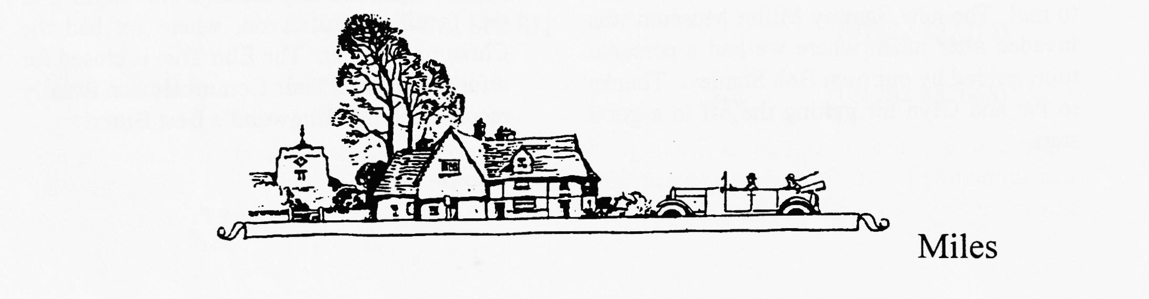

Notes From the Austin 7 Clubs Association AGM
Held at the Belfry, Milton Common on 12 January, Bernard and I attended on behalf of the Club. The following are from the notes I made during the meeting and are not the official Minutes of the Meeting. These will be circulated later.
Treasurer: The Association is still solvent and has a healthy surplus with income exceeding expenditure by about £4000 in the past year. There is around £20,000 at the bank, before the 97A magazine bills are paid.
Editor: The Editor has recommended that Peter Relph, Newsletter Editor of the Sports Register be awarded the Ken Warren Memorial Trophy for his recent articles (see 96D and 97A). My memory of winning this cup in its first year was that it left me as Association Editor less than later!
Archivist: The Australian posters were available (at £16 each) plus Garage Charts. Both very expensive and there is a local source of the Garage Charts, in Bournemouth. Phil Baildon also mentioned that Lickey Grange development had received final planning approval. This means that the Grange itself is at last safe from development. Demolition of the post-war buildings should have started by the time you read this. The Prototype had still not been confirmed formally for the 75th Rally, although it was understood that the Science Museum thought it might stay at Gaydon for some length of time. The Prototype is not running and there is no prospect of getting it going. The restoration idea may be shelved as the Museum is interested mainly in maintaining the original fabric of the car as a genuine prototype. This attitude would be very laudable if the car had not already suffered "restoration" in the Fifties, which caused several departures from the original. The good news is that the Science Museum puts the car in its top 100 attractions in terms of visitor attraction, value etc. despite it being an amalgam of the 3 original cars.
Other Officials made reports which indicated that the Association is going pretty well. At this point the officers all stood down but didn't get off quite that lightly and they were all re-elected. One interesting note was that long time Chairman, Howard Annett, announced that he would stand down at the end of 1997. This opens the debate on who should succeed him. My personal vote is Phil Baildon!
GAYDON '97: After lunch, Gaydon was discussed at length.
JOGLE Planning goes well and there are some 15 entrants so far. I think this may be the limit but you can always ask! Motor Rail from London to Inverness is still a possibility now that the special wagons have been located. Mike Hodgson is to write up the run. The proposed film has been dropped.
THE RALLY The commemorative print of several cars in front of Lickey Grange was on show, Bernard took a copy to display at Clubnight, so this is probably old hat to many of you! Costs are £25 unmounted, £35 framed or £55 for the limited signed edition. The draft programme was shown, and very good it looked too. Much depends on getting the advertising in to fund it but there will be the usual car and owner details. It will be interesting to compare with the

programmes from the previous celebrations. It had been hoped to produce a commemorative model, possibly from MatchBox but it was felt that it was too late for this. Investigations continue. Two resin cast pewter models were shown. These could be produced quite cheaply and were attractive items, so the idea is likely to go ahead.
DINNER Several guests have been invited and Bob Wyatt (Motor for the Millions author), Joe Edwards (Ex Apprentice), Connie Teather (Swallow employee) and Mickey Driscoll (son of Pat, famous Works driver) have indicated that they would attend. Val Biro is likely to give a short talk after dinner, but details were still to be finalised.
DISPLAY The display of unusual Austin items had met with a very poor response. If you can help, please get in touch with Jon Milne on 0181 643 2759 asap. Items will be insured and could be collected if necessary.
OTHER EVENTS All going well. I gather that getting B&B near-by is becoming difficult even now. We must all be getting soft!
AUTOJUMBLE Details of the autojumble were discussed. Please see the advert on page 5
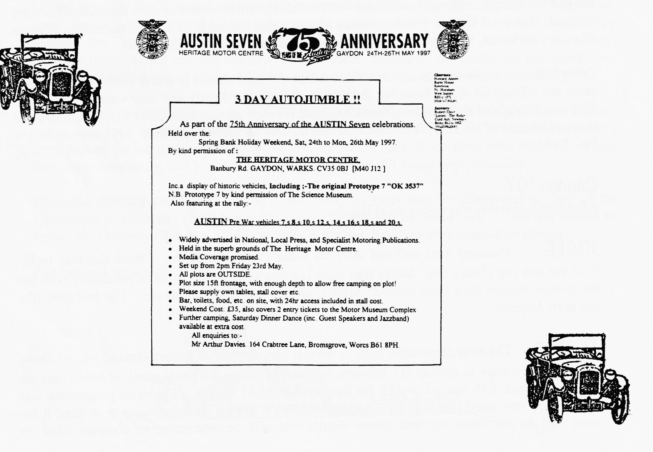
FINALLY If you get your entry completed entry form plus payment in to Alan and Lorna Martin BEFORE 28 Feb, you will save yourself £1! The form is on page 6!

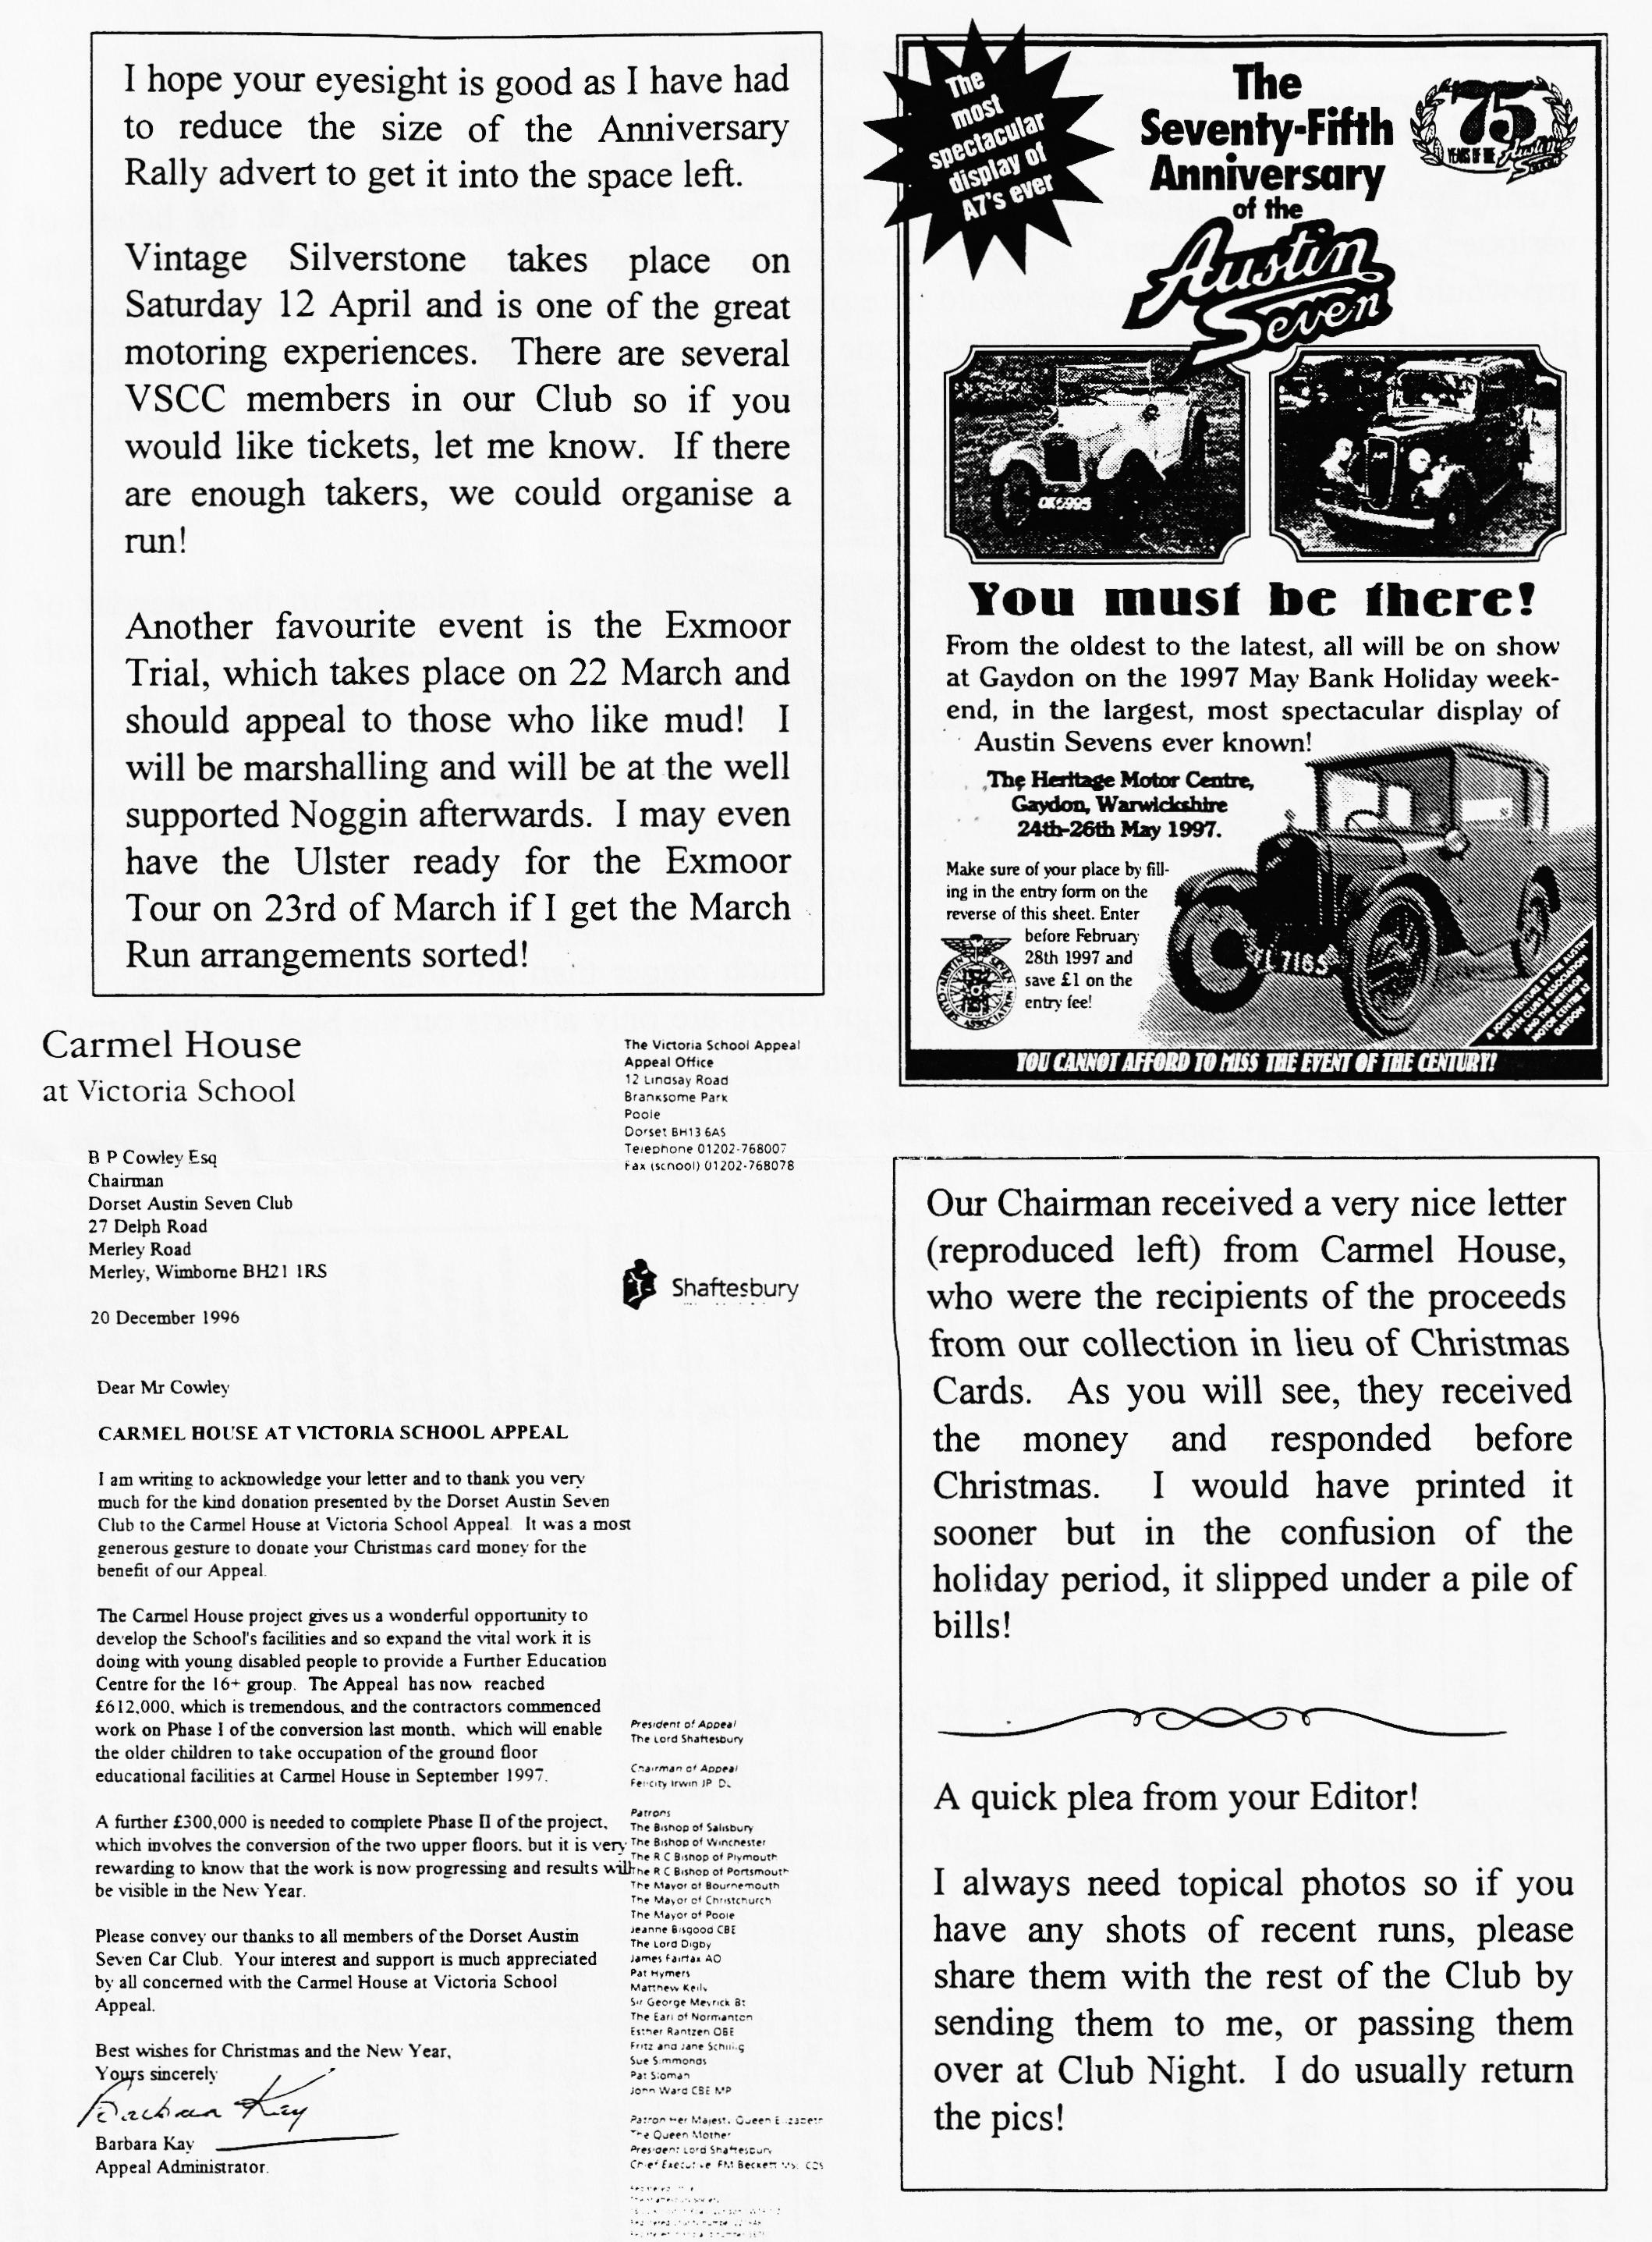

ADDITIONAL EVENTS
Early Notice
Austin Seven Trip to Holland. Following last year's trip to Northern Spain, at the behest of various Dorset Club members, we have agreed to organise a similar trip to Holland in 1997. The trip would last about 10 days and would take place in the first half of June. If you are interested, please send your name, address and telephone number to us by return. We will then circulate a suggested itinerary with costs, ferry details, places of interest etc. Jeff and Jenny Morgan, The Ranch, Well Path, Horsell, Woking, Surrey, GU21 4PJ (Tel 01483 724730).
Another Early Notice

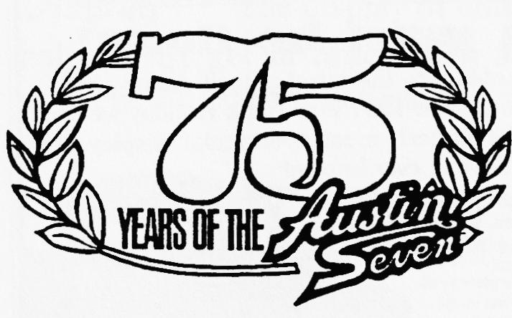
We all know that this is a major milestone in the calendar of Austin enthusiasts. The main rally to mark the anniversary will be held at the Heritage Motor Centre at Gaydon , over the late May Bank Holiday. A comprehensive set of celebrations is planned and if you got :to any of the earlier jamborees, you will know these rallies are particularly enjoyable and attract a very wide range of enthusiasts from all over the world. In addition to the celebrations for the Seven, 1997 is also a landmark for several other models and so the turn out should be much bigger than previous Jubilee Rallies. The entry form is reproduced below. Please cut out (there are only adverts on the back of the form!), complete it and send it to Lorna and Alan Martin with your entry fee.

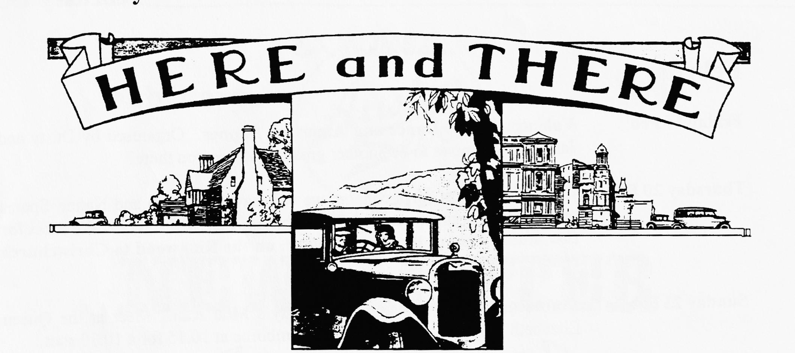

WANTED
Matthew Cheeseman is looking for a pair of short rear shock absorber arms for the Ruby he is restoring. If you can help, please ring Matthew on 01202 880496
AND
Running or non-running Austin Sevens, "Specials", abandoned projects, large/small amounts of spares. Cash waiting, Ken 01963 440604.
AND
Phil Whitter is looking for a pair of 1932/34 Box Saloon headlights (black or chrome). Good price paid or exchange for spares. If you can help. please call Phil on 01425 475558.
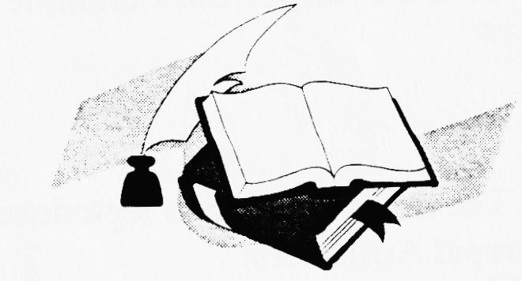
A New Service for Members

As you may have read elsewhere in this Newsletter, a new Austin Seven book called Original Austins is now available. It is currently being advertised at £19:95. Your Committee have made arrangements to bulk buy copies so that we can pass on the savings
to our members. If you would like to order a copy, please WRITE to me, enclosing a cheque for £14 payable to the Dorset Austin 7 Club and I will bring one to the next club night for you. This represents a saving of £6. Stocks are limited so its first come first served!

EVENTS
February
Friday 14 Feb Valentine's Day Dance and American Supper. Organised by Dusty and Jane, this promises to be another great night, see you there?
Thursday 20 Feb Club Night. Just for a change, we will have a Noggin and Natter. Spares only by prior arrangement with Phil Whitter. PLEASE NOTE We meet for this month only at the Tyrell's Ford, on the Ringwood to Christchurch road.
Sunday 23 Feb Club Run. Your annual treat - Dusty's Mud Run. Meet at the Queen Elizabeth Leisure Centre Car Park, Wimborne at 10.15 for a 10.30 start.
Thursday 27 Feb Committee Meeting. The Committee gather at about 8.30 ish to consider weighty matters at the Tyrell's Ford. If you have any suggestions for club runs, outings, or anything else you would like the Committee to consider, please let a committee member know.
March
Thursday 6 Mar 8 till Late. gather at the Fairmile , Fairmile Road, Christchurch - near the Christchurch Hospital.
Thursday 20 Mar Club Night. Merv's Quiz Night. Note the early start 8. 00 p.m. prompt! Form up in teams of 4 or 6 people for another of Merv's popular tests of general and special knowledge. Something for everyone, don't miss it.
Sunday 23 Mar Club Run. Your Editor is leading the convoy this month so meet at the Ringwood Furlong Car Park at 10.15 for a 10.30 start. Further details next month.
Thursday 27 Mar Committee Meeting. Once more at the Tyrell's Ford for the Committee Meeting.
INTERNATIONAL EVENTS
FIVA sanction a number of major ("A") and minor ("B") events. The list is too long to reproduce in its entirety but some of the closer ones may be of interest to intrepid Ausitneers:
5 - 8 June Deutsche Schnaufferl Rallye. Based around Nurnberg in Germany.
10 - 13 July Osterreicheischer Nationallauf. The Austrian nation Road Run, based on Vienna.
29 - 31 August Classic Scheveningen - Luxembourg - Scheveningen Rally. Sounds a little long distance classic rally but I could be wrong!
14 - 16 November Coupe des Sources. Belgian Retor show, Spa, Belgium.

