

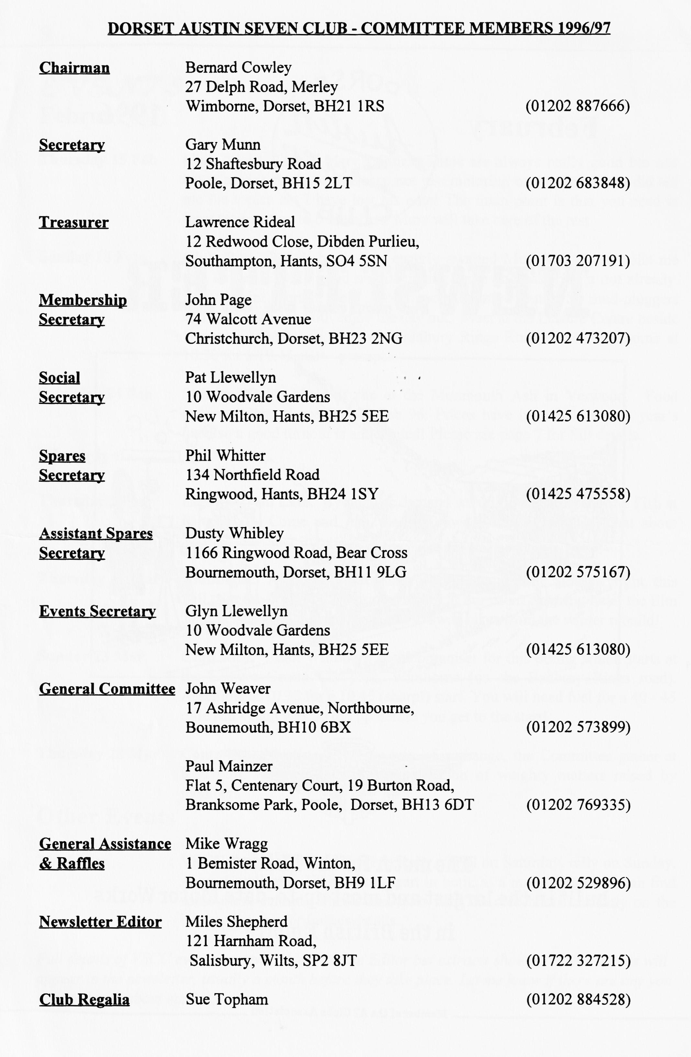

**EDITORIAL**

Hallo Everyone,

Memorial Trophy, the real answer to low cost motor sport. Ten rounds varying from hill climbs through trials to track racing. If you are interested, please contact me as soon as possible.

Mike Wragg tells me that Ian Reekes won the year's subscription so he will have no excuse for not getting my old Box Saloon on the road for next year. Did you see Jo Moss on Trade Secrets at the end of January? If not, she was passing on the old dodge of swapping wiper blades over when the driver’s side has given up. Keep the copy coming in, see you all at the Elm Tree.

BFN, Miles

Yes, this really is 1996! Despite my valiant attempt to deny the passing of the old year, it did slip away. 1996 started well with a good turnout for Paul Mainzer's New Year's Day Run. Perhaps it will get even better and I shall be able to get to the next Club Night and collect all those articles and pictures you have been hanging onto for the past 2 months.

My own activities so far this year have been limited to the VSCC Brooklands Driving Tests. Held at what is left of the old track, it proved to be a very good day out, despite the cold. Well recommended for a visit next year - I might even take part rather than marshal!

Continuing on a competition note, I have details of the Pre War A7C's Bert Hadley

**SECRETARIAL**

Well Folks!

Here we are in 1996, A Happy New Year to you all. Paul Mainzer organised the traditional New Year's Day Run, very well attended considering hangovers and grotty weather, the latter necessitating the drive to be cut somewhat short but I think everyone appreciated the warm up at the hostelry!

January's Club Night was particularly entertaining with our guest speaker, George Blake, an expert on all aspects of Poole, ancient and modern. This time he gave us a slide presentation on the history of the Quay and the commercial and passenger trade over the centuries. I feel it was one of the best attended evenings we have had.

Our second club run of the month courtesy of Lawrence and Margaret saw us travelling eastwards through the lanes to the Fleur de

Lys at Pillty, near Lymington; a lovely old pub. I hope you will see a report (So do I!! Ed.).

Don't forget the lighthearted skittles night Pat Llewellyn is organising. Full details were in last month's newsletter. There is still time to enter if you ring Pat (phone number opposite). The venue is the Monmouth Ash at Verwood on Saturday 24th February so hurry up and book!

I understand that the Elm Tree is being turned into a Berni Inn, let's hope that it does not upset our arrangements to use the Barn for our meetings. Apparently many car clubs meet there through the month, which should provide them with steady trade. Fingers crossed!

See you at Club Night - Gary

***SPARES REPORT***

**PISTONS AND RINGS**

For some years, the supply and quality of pistons and rings (mainly rings) from Taiwan has been variable. It is absolutely vital to the Seven owner that a rebore with new pistons should repay the time and effort involved. when English pistons were available, it was fairly easy to get at least 30,000 miles from a rebore and new pistons!

With this problem in mind, I have discussed Australian JP pistons with various people and with the English supplier, Tony Leslie of Holmesdale Sevens and firmly believe that they represent the best quality and value for money product currently available. I strongly recommend that you spend another £30 to get peace of mind and long life with the JP product. Some of you may be sceptical remembering there was a problem with a batch of brittle gudgeon pins. As a result of this, JP invested a large amount of money to provide the necessary quality control and paid compensation to those who claimed for damage.

My discussions with Tony Leslie of 31 January resulted in the following information:

ROAD PISTONS are 4 ring, solid skirt (suitable for normal and fast road use) available for Austin rods or fully floating gudgeon pin type. Sizes are +20, +30, +40, + 50, +60, +70 and +80. Prices:

AUSTIN Type £110 per set FULLLY FLOATING Type £112 per set

RACING PISTONS (different alloy) with 3 rings above the pin. Sizes +60 and + 80

AUSTIN Type £115 per set FULLLY FLOATING Type £117 per set

All are supplied with Next Day Registered delivery at £5:70 and come with bore clearance detail. Mastercard and Visa facilities. Contact Tony Leslie on 01323 833603.

N.B. Rings are 12 thou deeper than normal Austin rings and ***do not fit*** other pistons. They should be run in for 1,000 miles on quality straight SAE 30 oil as multigrade oil is so efficient that it prevents boring marks from being polished out. After 1,000 miles you can revert to 20/50 but only if the engine has been stripped and oilways scoured out when the rebore was done. Quality SAE 30 is Comma or Morris Supreme ( I would then use GTX).

As a final word, Dusty has used JP road pistons in an engine which will rev to 7,000 rpm - it has done 8,000 miles and oil consumption is negligible (V2 pint in 1,600 miles)

Regards, Phil

**THE REFUND OF VEHICLE EXCISE DUTY - 25 YEAR EXEMPTION**

Have you received yours yet? I got nearly £30 back from the Chancellor! I gather that there has been a small number of forms issued which show the wrong amount to be refunded. The error is one month. If this applies to you, the DVLA will have written to you if you have not yet caned the cheque but if you, like me, have rushed down to the bank on receipt of the dosh, you will have to claim it back from the DVLA, Driver and Vehicle Licensing Centre, Longview Road, Swansea, SA6 7Th, quoting their reference VPS/1/6/06 dated 8 Jan 96.

**LOOKING AFTER YOUR"TRAFFICATORS**

**Lubrication.**

Every 2-3 months, or if the arms become stiff at any time, raise each arm and by means of **a** brush. matchstick, or other suitable article and apply a drop of thin machine oil, I such as sewing machine or typewriter 11 as illustrated. Only the merest of drop of oil should be used-any excess may affect the working of the operating mechanism. The -"Trafficators" are kept in the closed position by means of a spring. The arms can be pulled out by hand. If any difficulty is experienced, switch the "Trafficator" on and then, supporting the arm In a horizontal position, move the switch to the off position.

**Replacing a "Trafficator" Bulb.**

If of any time, the arm fails to fight up when in operation, raise the arm in the manner previously described, and examine the bulb, replacing it if necessary, with one of -the same size and wattage as fitted originally. The correct replacement bulb to use is the 6 volt. Lucas No. 255 (3-watt festoon type).

The methods of replacement are given below. Do not attempt to remove the bulb holder while the "Trafficator" is switched on, as this may cause a short circuit.

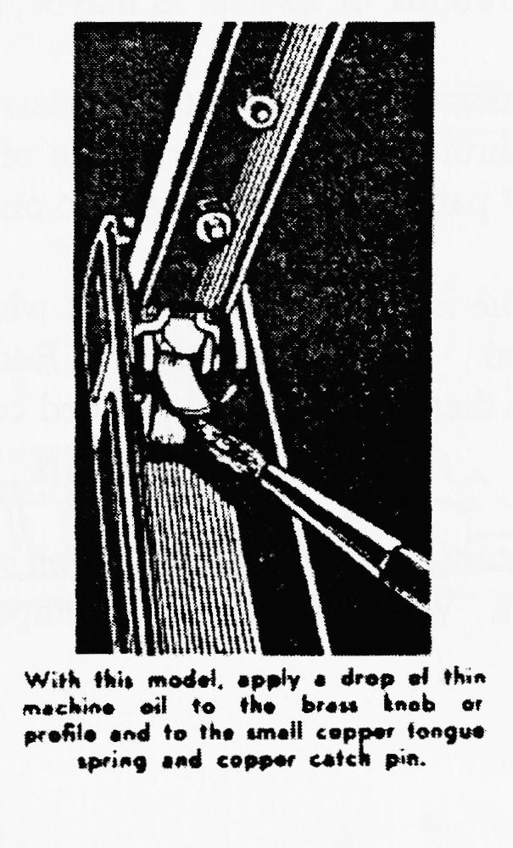



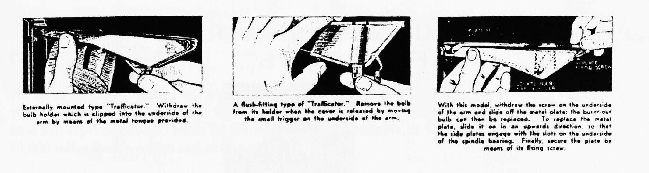

**MURDER BY CHOKING**

Of all the toys provided (unintentionally) by A well-meaning manufacturer for a B.F. to play with, the choke, or carburettor strangler, takes the prize. The complete B.F. loves to pull a knob out ­especially if he can choose a time when by all the rules it should be pushed in and left in.

The choke is provided to make it easy for you to start a cold engine. A label on the vehicle tells you to push it in again as soon as possible. The instruction book tells you *to push it in again as soon as possible.* The Bedford Driver's Handbook tells you the same thing. Common sense *should* tell you-but maybe it isn't as common as we thought.

Let us explain what the choke does and why it has to be used intelligently.

A petrol engine operates by burning a mixture of petrol and air. The mixture is composed of so many parts of air and so many parts of petrol, and the "ingredients" are measured by weight. Just a minute, we can hear you saying. Air doesn't weigh anything. Are you telling us, or are we telling you ? The office in which this book is being written is twenty feet square and twenty-four feet high. If it were possible to cram all the air from it into a sack, do you think you could carry it? Come up and try it sometime. It weighs just over 700 lbs. or, as near as maybe, a third of a ton I

But that is by the way. For full throttle performance„ the mixture should consist of about 13 parts of air (by weight)to one part of fuel. For part throttle performance, in an efficiently designed carburettor, the ratio can be thinned out to 16 or 17 parts of air (by weight) to one part of fuel.

These mixture ratios are satisfactory after an engine is warmed up. That is why we make use of various devices to shorten the warming up period. Take a look at your Bedford if you don't believe us. The inlet manifold " hot spot " and the thermostatically controlled cooling system will give you an idea of what we mean.

But-during the warming-up period, and for cold starting, these mixture ratios are much too lean. The colder the mixture, the richer it must be to burn. When the outside air temperature is at zero,

a one-to-one mixture ratio is required. In other words, if you wanted to burn up the air in the office we mentioned just now, and the temperature was at zero, you would need 700 lbs. of petrol.

Talk about being wet, that's wet with a vengeance. All the same, if you mean to start an engine at this temperature, you must have a one-to-one ratio. Only for an *instant,* of course, but you must have it - and we give it to you by the choke. We also make it impossible for you to carry on running with this very wet mixture by fitting a device which automatically changes the ratio and makes it much leaner as soon as the warm engine starts to run. If we didn't, the engine would peter out almost immediately, anyway.

The leaner mixture thus automatically provided while the choke is still pulled out is about 4 Or 5 to one. And that is still very wet. So we arrange that, when you push the choke half-way in, the ratio thins out a bit more--this rime to about 8 or 9 to one.

So far, so good, but even at 8 or 9 to one, cylinder bore wear is excessive, and we dare not leave the choke in the half—way position longer , than necessary: This, unfortunately - we've said it now and we won't go back on it - as, *unfortunately,* is where we have to rely on you. *You* have to push the choke in - right in - with your own fair hand. And if you mean to graduate from the " utter B.F." class, you'll learn to do it at the right time-which is as soon as the engine will run on the proper mixture.

Remember, with the choke half out, the mixture ratio is 8 to i for full throttle and 9 to i for part throttle. With the choke pushed in, it is i 3 to i for full throttle and 17 to i for part throttle. There's a lot of difference, as the absentminded professor said when he took hold of the wrong end of the poker. And the result of that difference, if you misuse the choke, is to increase engine wear by between *two and three hundred percent.*

The moral is, don't experiment with the choke control. If you can't stop playing with it, ask the sergeant to hand your vehicle over to someone else. Maybe he can find. you a job making little stones out of big ones. That's an occupation where destruction *is* a virtue.

**The 'OTHER' Spanish Holiday**

Pat and Glyn Llewellyn plus others will be taking their regular Austin Seven break in Norther Spain during early June. They will be going via the Plymouth/Santander Ferry. along with others, I intend to drive down to Spain (by Austin 7 naturally) to meet them there. Any member who would like to join this small adventurous party is welcome to do so. The proposed itinerary is as follows:

Sunday 9th  June

8.00 am Ferry from Poole to St Malo, arriving St Malo approx. 5.00 pm. Drive about 40/50 miles, stay over night.

Monday 10th June to Friday 14th June

Leisurely drive down through France at whatever pace suits us. Stay at hotels en route. Aim to arrive at Llanes (Spain) on Friday to meet up with the other Dorset members.

Saturday 151h June to Thursday 20t' June

Stay at or around Llanes to enable exploration of the surrounding countryside etc.

Thursday 201 June

Return to Plymouth via the 14.30 ferry from Santander.

Friday 218 June

Arrive at Plymouth - drive home.

For those who can't stand ferries . . . possibly drive back.

All the details of prices etc. can be found in the Brittany Holidays brochures 'Holiday Breaks in France' and 'Holiday Breaks in Spain', or phone me on 01985 847658 if you would like more information.

Vince Leek

P.S. Possible spare seat available.



**Skittles Evening - Saturday 24 February**

Our popular Skittles evening is to be held at the Monmouth Ash, Manor Road, Verwood. First ball

away at 8 p.m. The costs will be:- Skittles only, without food: £1 per person. Plus food if   
required. Pat needs food orders ***before 15 Feb*** so phone your orders through as soon as possible.

**For Sale**

**1938 Austin 7 Pearl Cabriolet.** Maroon, a very original and sound car. Very good condition with long MoT. £4995. Call 01202 683848

**1933 Austin 7 Box Type Opal.** subject to much recent restoration, new MoT. Very nice condition £4995. Call 01202 683848

**For Sail!** 14 ft Fletcher Speedboat (1983) Blue with 50 hp Mercury engine, overhauled in 1995. New prop and winch - complete with road trailer. As seen, £900 ONO. Call Lawrence on 01703 438923

Thank you very much for the donation of £100 to the Children's Hospice Appeal from the Dorset Austin 7 Club's Christmas Draw. Will you please thank all who contributed.

***EVENTS***

**February**

**Thursday 15 Feb Club Night.** This is Merv's Quiz! These are always really good fun and cover a wide range of interests, not just motoring or Austins. Mery did tell me the topics but I have lost his note! The main point is that you need to form teams of up to 6 members. Mery will take care of the rest

**Sunday 18 Feb Club Run.** *Definitely* Dusty's eagerly awaited Mud Run. Dusty tells me

that he has a really good non-damaging route and has tried it out already. For the faint hearted, there is a tarmac alternative route! So mud-pluggers and road hogs can both enjoy the day out. Meet at the Leisure Centre beside Queen Elizabeth School on the Badbury Rings Road out of Wimborne at 10.30 for a 10.45 start - prompt!

**Saturday 24 Feb Skittles Night. Meet at the** at the Monmouth Ash in Verwood. Food

orders to Pat, please, by 17 Feb 96. Prices have been held at last year's level so a good turnout is anticipated! Please see page 7 for full details.

**March**

**Thursday 7 Mar Eight(ish) till Late.** By popular demand we will be returning to the Fish at

Ringwood. Come and join the In Crowd gather for a quiet chat about Austins and other things.

**Thursday 21 Mar Clubnight.** After the excitements of the Quiz and the Skittles Night, this will take the form of a Noggin n' Natter at our usual watering hole, the Elm Tree in New Town. A good chance to swap takes from the winter rebuild!

**Sunday 23 Mar Club Run.** Brian Willbourn is the organiser for this outing which starts at

the Leisure Centre Car park, Wimborne (on the Badbury Rings road). Assemble at 10.30 for a 10.45 (sharp!) start. You will need fuel for a 40 - 45 mile run - each way so top up before you get to the start!

**Thursday 28 Mar Committee Meeting.** Just by way of a change, the Committee gather at 8.30 p.m. for their monthly consideration of weighty matters raised by members

**Other Events**

**23/24 Mar VSCC Exmoor Fringe Trial & Rally.** Trial on Saturday, rally on Sunday.

A great weekend. I'll be taking part in both, as a marshal unless I can find some more suitable wheels and tyres than the race boots currently on the Ulster. See me for further details..

*Full details of VSCC events are available from the Editor but extracts showing 'local' events will appear in the newsletter, usually a month before they take place. Let me know if there are any you need to know about earlier.*