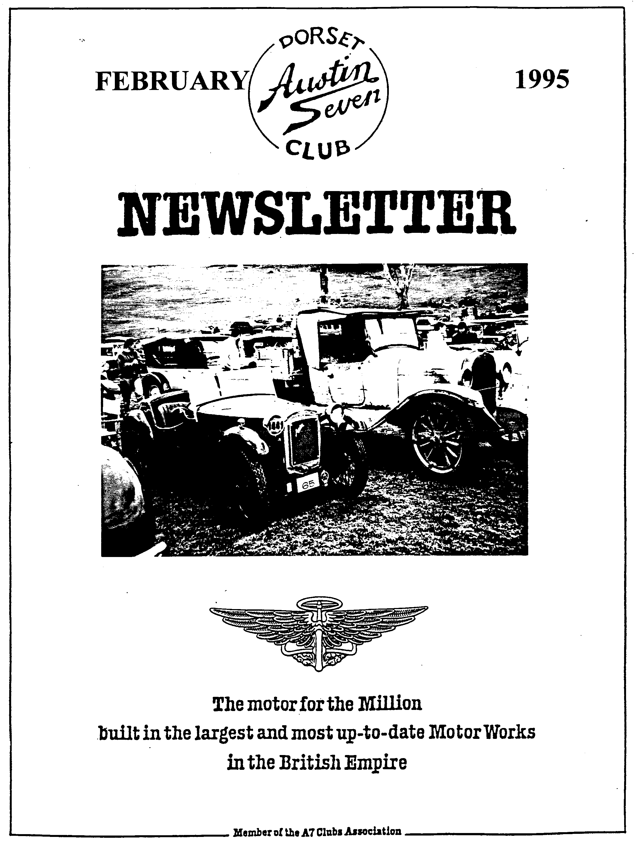

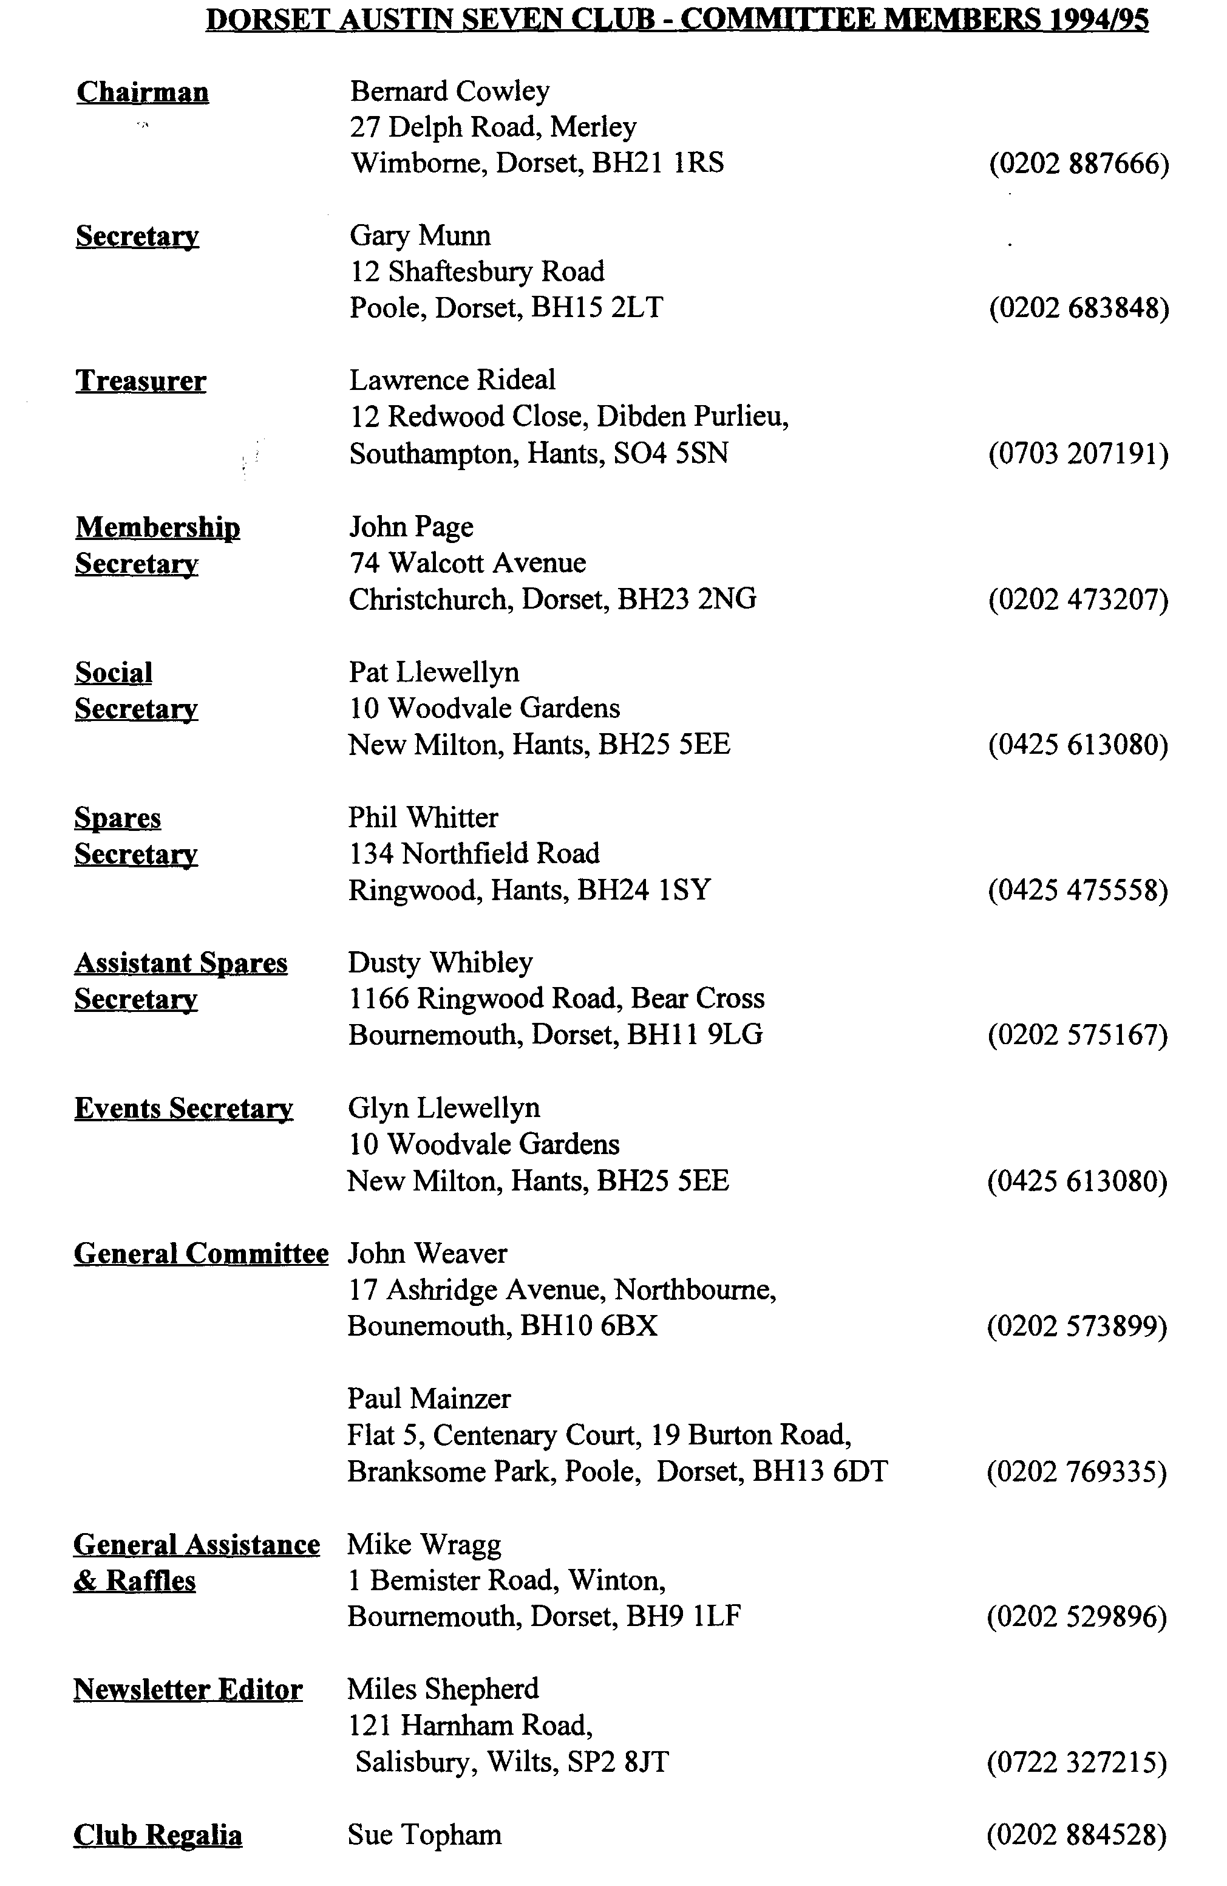

EDITORIAL
February 1995 1

Hallo Everyone,
1995 has got off to a good start, thanks to Club Members! I have received some excellent material for the Newsletter, as you can judge in this and future editions. So many thanks to all those who have contributed to our journal. Please keep up the good work, especially the Run Reporters.
I have to tell you about a splendid 'non-present' I received just after the last edition closed. It is a Workbench Barometer which uses a piece of string to test whether it is raining, not raining, windy, very windy, sunny or cloudy. It also has a safety feature built in to tell if the garage is on fire! The product of Northbourne Naff Novelties, no garage should be without one. Many thanks to the donor.
Well, the Editorial Chummy has passed on to pastures new. I am glad to say that the
Chummy was quickly MOT'd despite the 15 month lay-off so the new owner, a VSCC member has driven it away to Oxford where it will enjoy family life and driving tests at the hands a young and enthusiastic family. I have to say that the Motoring Press, in the form of the Automobile provided an excellent response. The advert attracted something like 20 callers, some from as far afield as the Irish Republic. My 'new project' for 1995 is now in residence and I shall start work on replacing some of the non-functional components such as the dynamo and speedometer. I hope to have it MOT'd and taxed for Easter.
That's it for another month, see you at Club Night,
Miles

SECRETARIAL

Well Folks!
I thought Club Night was particularly good last month, a technical discussion chaired by Phil Whitten. Many points of interest were raised and virtually all answered from the floor. It never ceases to amaze me that despite how seemingly simple our cars are, there were so many small, and indeed some large, modifications during the production period. I think Miles took notes of some of the questions and answers, which should provide interesting reading (Yes, I did, but Phil's notes on page 3 are much better!). On this subject, it would be nice to continue the technical tips article over the next few newsletters. Please give it some thought, however small the tip, it may prove very useful to many of us. Please put pen to paper.
I could not get to John Weaver's January Run, which I gather ended near Wilton. No doubt we shall all be enlightened by an article shortly (Yes, see page 2).
You will see that we have changed the Wimbome run start to a layby in Magna Road near Canford School. A few months ago, I was pulled aside at the start of a run by the Car Park Warden who advised that we were making his job very awkward. Although not technically parked, we ought to pay! At his suggestion I wrote to the Council asking for an official dispensation but to date have not even received the courtesy of a reply. Enough said!
The Committee apologise that we will not be in our usual room this month, due to a misunderstanding but the Landlord who is very sorry. Instead we shall be using the room upstairs, over the main bar. Don't forget, see you there
Gary

WEAVER'S WET WILTSHIRE WANDER
Nine Austins (two Tourers, three Box Saloon, three Ruby Saloons and one Ruby Cabriolet) assembled in a Wimborne car park on a wet drizzly morning. Making a prompt start, the convoy left Wimborne heading towards Cranborne at a steady cruising pace. At the well-known land mark of the Horton Inn, our route deviated off the main road to follow some lovely (and sometimes muddy and through many puddles) Dorset lanes, skirting Gussage All Saints at Amen Corner, through Wimborne St Giles and on to Sixpenny Handley.
After a steady climb, we crossed into Wiltshire and then down quite a rapid descent through the villages of Bower Chalke and Broad Chalke. From here, past Bishopstone to the turning for Wilton the road follows a valley which meant the cars could make good time. On the approach to Wilton our route turned left into a lane which took us past the villages of Bulbridge and Burcombe and eventually on to Barford St Martin and the lunch break at the Barford Inn. The rain at this time had become quite steady so the log fire in the pub was a most welcome sight.
After a short time, the Whibleys joined us, Dusty with Holly in his Box Saloon and Scott with an extremely wet bottom in his Special. Needless to say, Scott made full use of the log fire to dry out!
There was no improvement in the weather so the majority of us congregated around a table near the fire to chat about everything and anything for the next two hours. Around 3.00 pm the remaining members returned home, following the route taken in the morning - and as is always the case, the rain ceased about five miles from the end of our journey!
Thank you John and Gaye, for a most enjoyable run, and especially for sorting out such a fine hostelry as the Barford Inn.
Marion and Ben
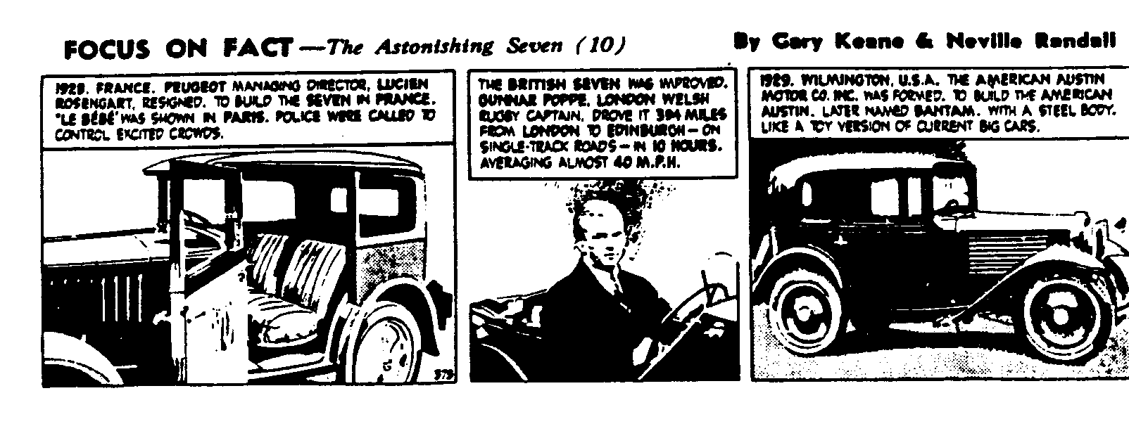

February 1995
CLUBNIGHT TECHNICAL FORUM
At the January Clubnight, our Technical Forum took the form of an open discussion on various aspects of the Austin Seven. Members were encouraged to contribute ideas both for questions and answers. Here is a summary of the more interesting points.
ENGINE
- Head nuts torqued to 20 - 25 Ft Lbs.
- Seal stud threads with Red Hematite etc. to prevent leaks
- Need to lift engine to get access to the pressure relief valve - any thoughts on making it adjustable?
- Camshaft end-float is best adjusted on the bench (if the engine is dismantled)
- Machining of later flywheel to take earlier ring gear (the early rare 1 ⁵/₁₆ flywheel can be used if you can find one)
- There are several sizes of rear oilseal scrolls and cam shaft bearings - make sure you have the right ones!
TRANSMISSION
- Use of Ruby thrust and levers on 3 speed box
- Use of ‘0' rings on Carden pin to space blocks out to reduce side play in Carden housing Excellent idea.
- Do not over fill rear axle – ¼ pint but check oil regularly. Crown wheels and pinions are very rare
- Use of a patent `Speedy sleeve' to eliminate a scored bearing surface for modern oil seals is being investigated (typical application on wheel hubs and crankshaft?)
BRAKES
- Always use footbrake when adjusting (jam with piece of wood against the seat)
- 750MC's Special Builders Guide advice seems useful - adjust front to come on before rear and rear offside slightly before the nearside. Try a cable adjuster to tune the cable (do all this with the car jacked up off the ground)
- Did you know that slots are cut into the flange of steel brake shoes to reduce squeal and prevent upset to animals from harmonics beyond the range of human hearing?
ELECTRICS
- Did you know that using a late coil (positive earth) in an early car (pre Dec 35) will result in erosion of the plug earth electrode due to reversed spark. Also the coil will not be so efficient in this direction. All coils are marked CB and SW not +ve and -ve as on modern coils. Remedy is to reverse the connections on a late coil if fitted to an early car. Note that all coils are dated on the base.
Lastly Here is a challenge for you! What is the correct setting for slotted brushes on early starters and CAV dynamos? All brush holders are adjustable, not just the third brush. AND the answer needs to be practical, not theoretical.
Thanks to all for your contributions, Regards, Phil Whitter

4 February 1995
More Technical Topics
General
All mating surfaces must be clean and fit together properly. Raised threads should be lightly countersunk and pips or lumps removed by filing or scraping.
Silicone Adhesives
Use the correct adhesive. Some, such as bath sealant, are not oil resistant and are corrosive.
Cylinder Block and Crankcase Joint
Remove all studs from the crankcase and all valve gear from the block. Coat the top of the crankcase with valve grinding paste and lap the block to the crankcase. For some obscure reason, all crankcases are high in the middle. Work on this until the crankcase is an even matt finish. ensure you wash off all grinding paste afterwards. Lightly countersink the fixing holes in the crankcase. Check that the cover over the oil pump drive is properly sealed and is below the top of the crankcase. Place a bead of silicone adhesive around the base of the cylinder block, do not fit gasket, bolt down tightly, preferably using new studs and nuts. Don't use too much adhesive as it will ooze out in all the wrong places. If as a result of omitting the gasket, the pistons protrude above the cylinder block, then the gasket must be fitted.
Leakage from the Rear Main Bearing/Flywheel
Oil escaping from here is usually due to a worn oil scroll, incorrect size oil scroll or the oil-thrower missing. There are several sizes of oil screw, the correct one is a snug fit to the flywheel boss. The preference is to fit a modern lip seal. Leakage can also be due to a distorted rear main bearing housing or cover allowing oil to escape from the joint. The oil drain hole in the housing does not always line up properly with the hole in the crankcase. Drill both out to 5/16" to ensure alignment. Seal joint with silicone adhesive, fitting both gaskets. ensure adhesive does not block the drain hole.
Front Camshaft Bearing Locating Screw
Leaks can occur due to poor fitting of this screw. If it is the original square type, you cannot tighten it without first removing the cylinder block. If you have to go to all this trouble, then it is probably best to replace it by tapping the bush 5/16" BSF and fitting a decent screw and fibre washer.
Oil Filler Tube
A leak sometimes difficult to cure is the thread of the oil filler tube. This area is vulnerable as the rotation of the crankshaft is continually throwing oil at it. Seal the thread with a low strength Loctite. Don't be misled - a poor fitting filler cap will allow oil to run down outside the tube, giving the impression that the thread is leaking.
Crankcase Pressure
Oil can be forced out of the crankcase by overfilling or crankcase pressure. The cure for the former is obvious. The only natural ventilation of the crankcase is via a few small holes in the valve chest cover. These must be clear. More ventilation can be provided by fitting a crankcase breather to either the oil filler tube or the valve chest cover but this should only be necessary on worn engines.

February 1995 5
More Technical Topics cont'd
Sump
Like all other joints, it is essential that all 14 fixing screws and threads are in good condition. Fit oval and spring washers. Stripped threads and stretched studs must be attended to. Seal with silicone adhesive and fit the gasket. Check that screws are tight after sealant has set.
Leaks from Head Studs
Oil or water leaking from head studs is nearly always due to a badly fitting head gasket. Raised threads should be suspected or the gasket binding on the sides of the head studs. Light countersinking of the holes in the cylinder head can help. Fix new studs in the block using a low strength Loctite. ensure that both the top of the block and the cylinder head are ground flat. When fitting the head gasket, coat both sides with a little grease. It should not be necessary to use any gasket sealant. Tighten down the head studs in the correct sequence to 24 ft lbs. If there is a persistent leak from the centre stud - the cylinder block is probably cracked in that area.
Conclusion
I expect that after going to all the trouble of fixing the above leaks, it will leak somewhere else!
Vince Leek
The Old Car Scene Down Under
What would they be like? Rolf Harris? Crocodile Dundee? Dame Edna? Sir Les Patterson? Pommies hear so many stories about their cousins Down Under that the imagination can run riot as one lands at Adelaide at 5.30 am on a chilly Spring morning in late September.
But here to meet us at that unearthly hour were our dear Canadian friend (Joan Lawrence, wife of Bob who gave a slide show presentation to DA7C a few years ago) and not two, but four Australians. Two, Bob and Judith Riches (present at Phil and Dusty's 50th Birthday Rave Up and 1994 Beaulieu) had come just to make sure that we had arrived safely. The other two, Bill and Jot Watson Bay to Birdwood committee members, had come to take us to our Motel. And this summed up Australians, particularly the Old Car fraternity: fabulous hospitality and a willingness to put themselves out on our behalf.
Our reason for the visit to Adelaide was to attend the biannual Bay to Birdwood Run featuring 1,803 vehicles spanning the years 1900 to 1960, driving about 40 miles from the Adelaide coast up into the hills to Birdwood, which boasts the National Motor Museum, as interesting in its way as Beaulieu.

6 February 1995

Happily, a dozen or so Austin 7 were on the run and we met several of their owners at an Open Day at the South Australia Club House and Car Park [I think this is the A7 Club of South Australia. Ed] which is owned by the Club. Over club-provided tea and cakes, we chatted and made new friends, found the Pearl and Opal were never exported to or even made in Australia. The Nippy, Ulster, Box and Ruby, however, are quite common. I was lucky enough to speed down the Adelaide Grand Prix course in Doug Veale's Ulster with the roar from the exhaust really making me feel I was in a racing car.
Have you ever felt like the Queen or some other VIP? Of course, we are all used to being waved at and pointed to by various people, as we give our Sevens their airing, but in the Bay to Birdwood run, where we were passengers in (dare I say it?) a 1948 Morris 8, we were cheered by thousands lining the 40-mile route, many with arm chairs and picnics, barbies etc. out on the roadside grass, and occasionally even on the centre grassy area. If you want your ego inflated, take part in the 1996 Bay to Birdwood.
On reaching Birdwood, our ego inflation continued as we found our free luncheon passes admitted us to the VIP tent where we dined in the presence of the Governor of South Australia and the Premier of the same state. The night before, too, we had been given 2 tickets by absolute strangers to attend the Official Dinner and Ball of the Bay to Birdwood Weekend. Would we, like Cinderella, be brought back to rude reality at midnight, or were there more wonderful surprises in store????
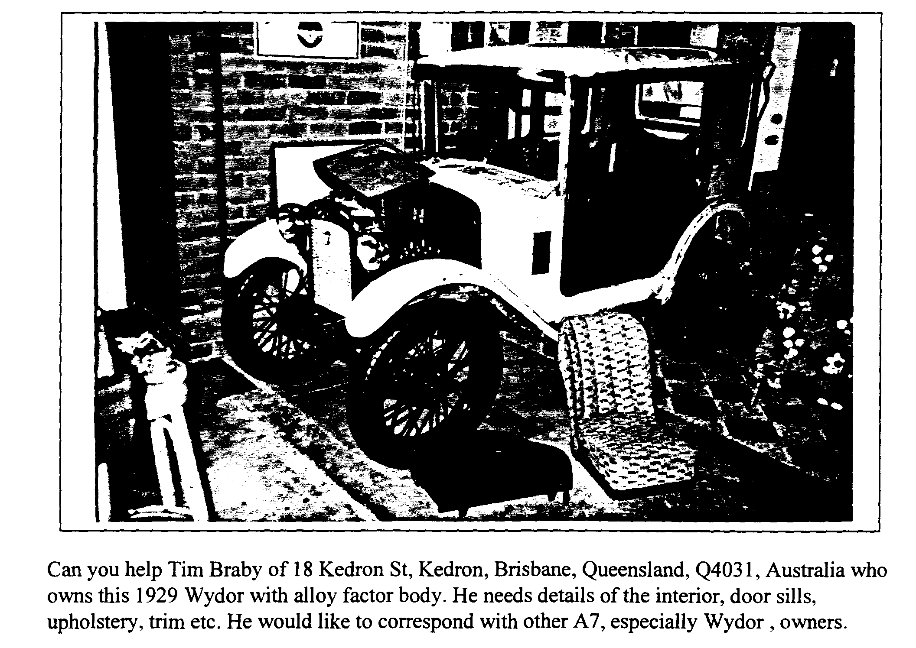
(to be continued) GORDON BROWN
PS The cover photo shows some of the cars at the end of the Run

February 1995 7
For Sale
Ken Medlicott sent in a long list of spares which included engines, complete and in pieces, mag and coil as well as gear boxes (various speeds), every variety of wheel from 14" to 19" and lots more besides. He is a great sports enthusiast and I shall be visiting him one day soon to find some bits for my Ulster. So if you need anything, get in touch with Ken on 01963 440604.
Kim Henson passed me an equally long list of Big Seven spares currently for sale from non-member Tony Freeman of Weymouth. He was hoping to build a Special but has been side tracked by other projects. The list is too long to reproduce in full but contains most of a car, no log book but many engine and chassis parts are available. Contact Tony on 01305 813407.

Reproduced below is the official thank you from the Children's Society for the money you raised
at the collection in lieu of Cards at the Christmas Dinner Well done everyone

8 February 1995
EVENTS
February
Saturday 11 Feb Skittles Night. Our popular Skittles Evening to be held at the Monmouth
Ash, Manor Road Verwood. First ball away 8pm. Entry form see last month's page 7.
Thursday 16 Feb Club Night. The talk about the Swanage Railway has been postponed due the change in room for tonight, we'll have a noggin and natter instead. Meet in the upstairs room over the main bar for this month only.
Sunday 19 Feb Dusty's Mud Run. Always an exciting run, gather at the Layby in Magna
Road, near Canford School on the Bear Cross to Wimborne Road at 10.15 for a 10.30 start. Note this is a new RV to overcome the problems recently encountered at the Safeways Car Park. There is also a toilet here!
March
Thursday 2 Mar Eight till Late. Lost Keys on the Badbury Rings Road, opposite Kings
Garage, Wimbome. See you there?
Thursday 16 Mar Clubnight. Hopefully, the Swanage Railway Talk postponed from February Clubnight - and back in the usual room at the Elm Tree. Phil expects to have the Spares but if you want anything particular, you might ring first.
Sunday 19 Mar Club Run. Gary is organising this month's outing so meet at the Cat and
Fiddle at 10.30 for a 10.45 start. Further details next month.
Thursday 23 Mar Committee Meeting. As always, at the Tyrell's Ford, 8.30 start.
Dates for Your Diary
Saturday 18 March Exmoor Fringe Trial. Based at North Molton with good access from the main Tiverton to Barnstaple road (A361 Link Road), 25 miles from J27 on the M5. Your Editor will be marshalling. Please ring if you want to make up a party to visit this very enjoyable event.
Saturday 1 Apr Fifties and Sixties Evening. With the Buddies (Christmas Dinner Duo) at
Pamphill Village Hall. Entry form next month.
Saturday 22 Apr Colerne Speed Trials. Anyone fancy a run up to Colerne, near Bath to watch this event, if so let me know and I will arrange tickets. Spectators must be VSCC members or escorted by one!
Full details of VSCC events are available from the Editor but extracts showing 'local ' events will appear in the newsletter, usually a month before they take place. Let me know if there are any you need to know about earlier.

