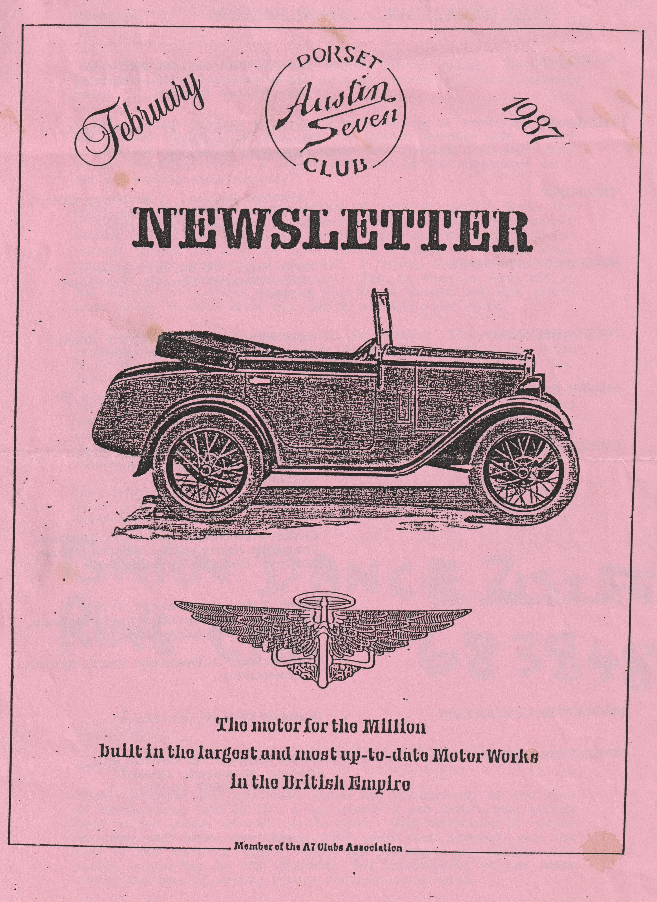

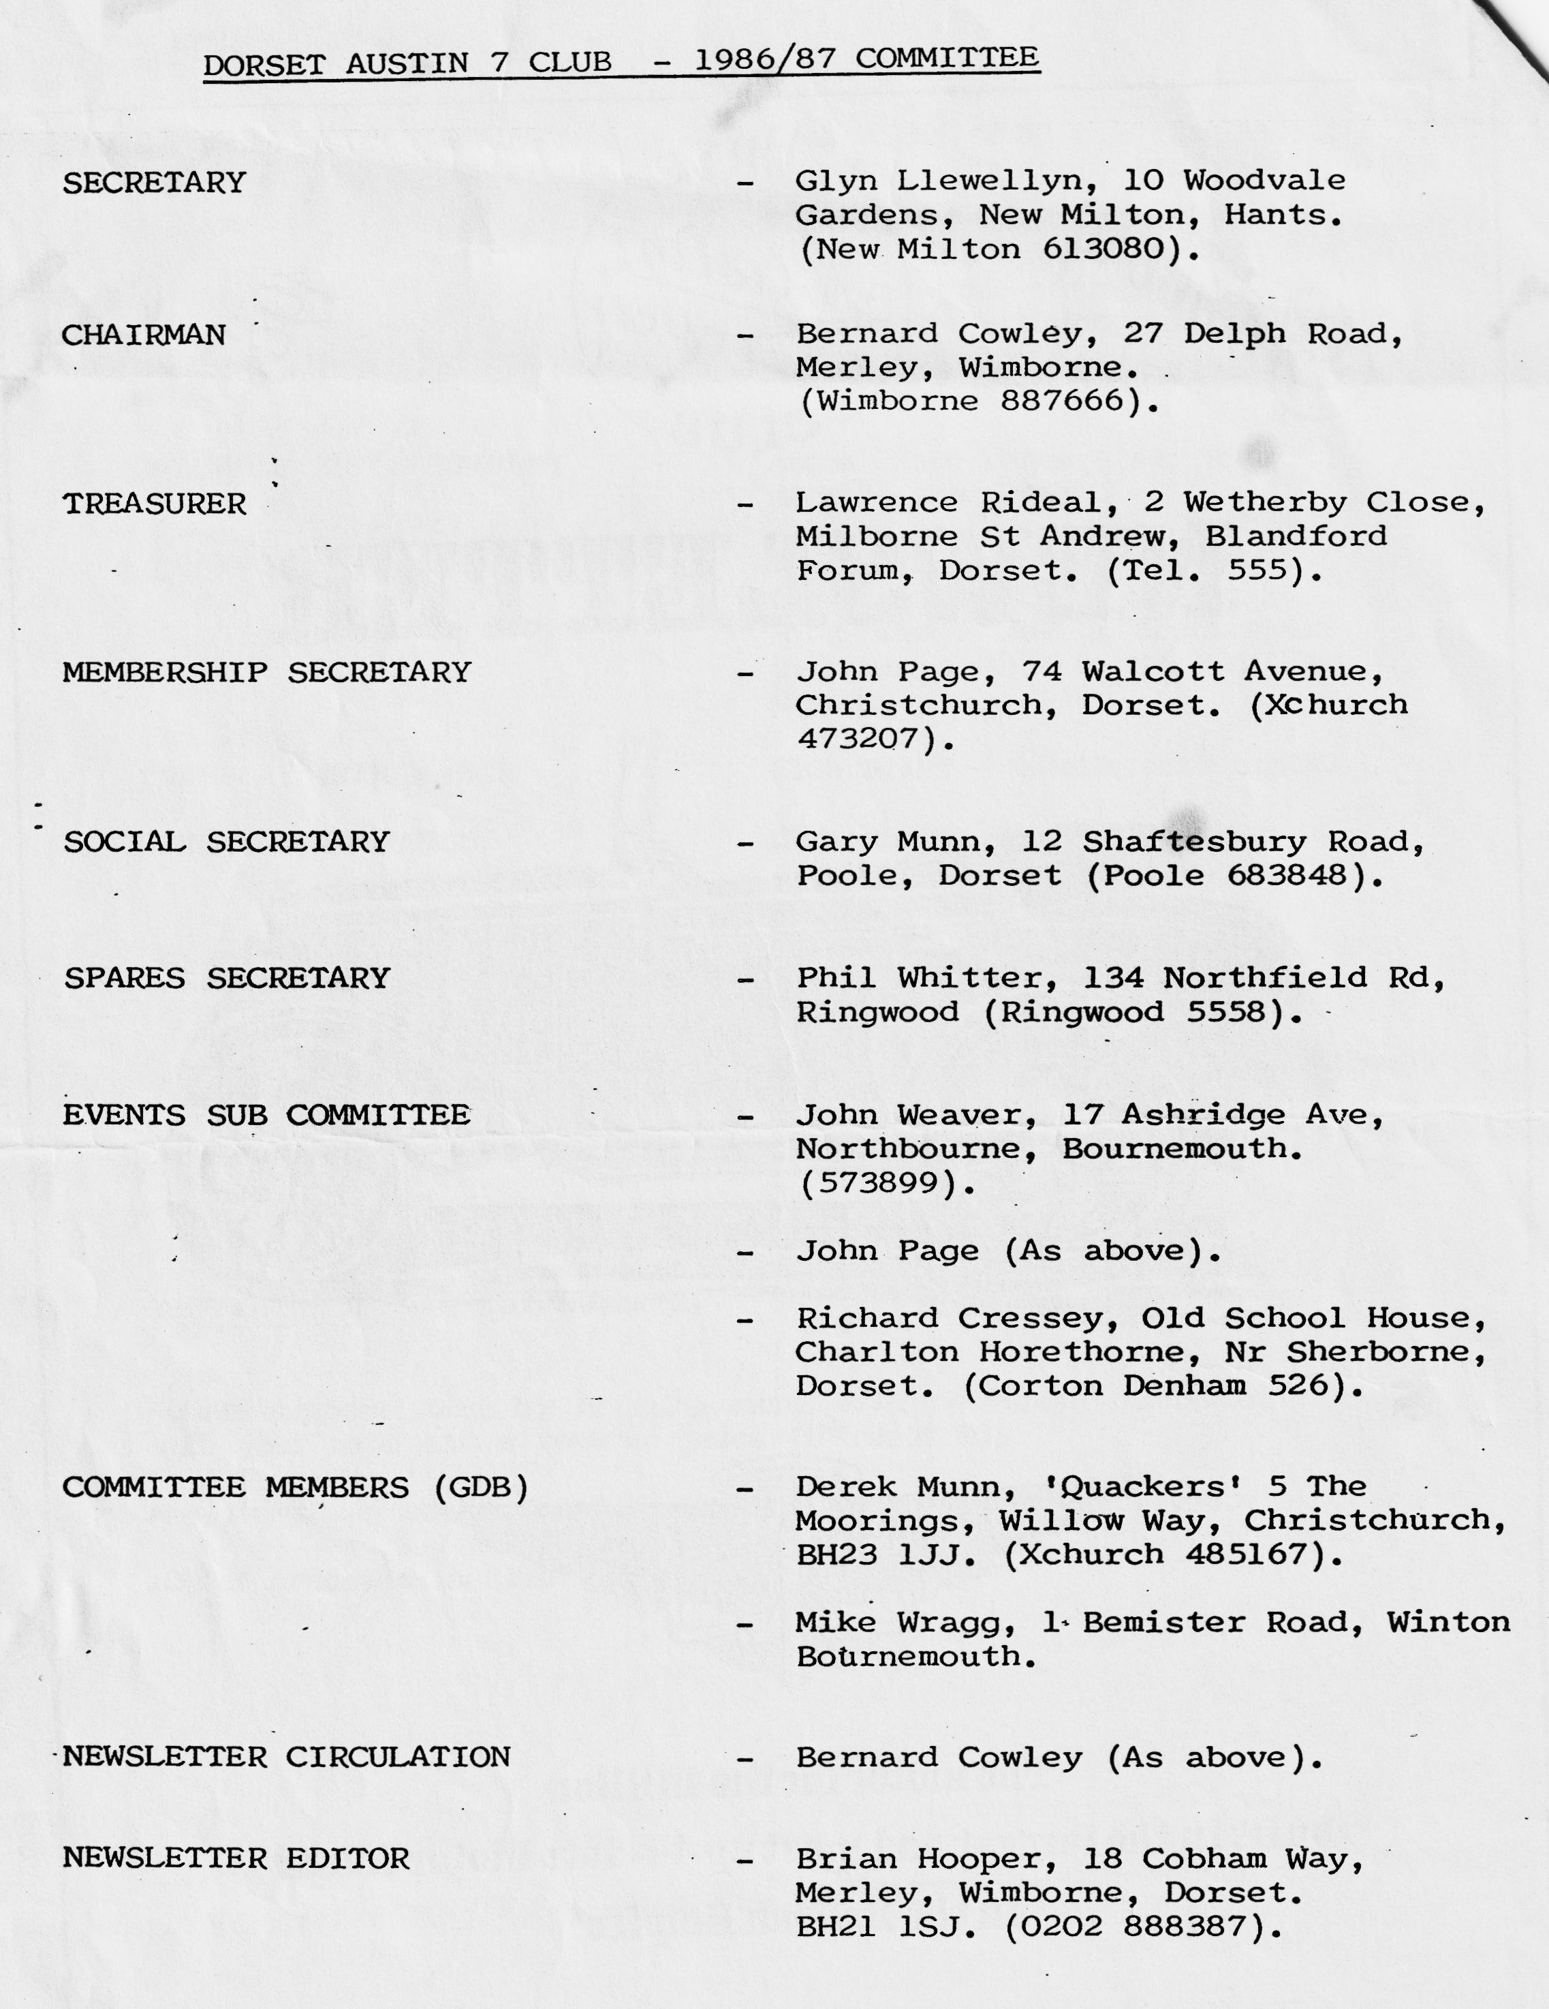

EDITORIAL FEBRUARY 1987
After the rush to get out the budget edition January Newsletter it's quite nice being able to put this one together at a more leisurely pace.
I had .a little problem with the Ruby a couple of weeks ago when the dynamo stopped charging, and the ignition warning light flicked on and off not only when the engine was running, but also when it was switched off - a slight movement of the stationary car set the warning light blinking!
After spending several hours trying to sort it out, I found the problem to be two-fold - the connector on top of the dynamo wasn't making contact and the spring on the make and break part of the voltage control cut out unit had broken, allowing it to flap about making contact whenever it pleased! I finally fixed it about 1.00 p.m. on the January Club Run day, just in time to dash off in the Modern for a quick bevy at the Fox & Hounds and then return home to try it out - all's well and in working order again.
I'm looking forward to a couple of the events - The Auction night if anything like last year should be a good cabaret - the Mike El Bernie Show! , and the annual Barn Dance is still one of the funniest events ever.
Sadly, we won't be able to go on the Easter weekend, which looks very well organised and should prove to be a splendid event, but for those of you going, don't forget to lay in some booze for the Sunday - the pubs are closed and those restaurants open only serve drinks with a meal.
For future Newsletters, I could do with some material, so if you've time to put pen to paper on any subject I would be pleased to receive it.
Regards,
Brian Hooper
(March Newsletter - deadline for copy - "Wednesday 4th March)
SECRETARIAL Hi Gang,
Thank goodness that the awful snow has disappeared at the time of writing this, and as it's a bit warmer I can think about getting back in the garage to work on the Opal. The restoration is coming on quite well now, the 'Black Bits' have been sprayed, and the rest of the body is almost ready for priming. During the cold spell, I gave up on the bodywork and concentrated on the seats and at the time of writing I have finished one of them.
I haven't heard of many restoration projects in the Club of late. I know Paul Mainzer is busy on a Chummy and a little bird tells me that Dave Tanner may have acquired two Chummies, other than that I have heard little. Why not drop a line to the editor with details of any acquisitions and restoration projects, and if you need any help or advice let us know - someone in the Club could help.
I had a letter recently from Miles Shepherd who has just retired as editor of the Association magazine, thanking everyone for their past support. His deputy, Geoff Canning, a Dorset member by the way, is taking over the job so may we wish him well, and thank Miles for his sterling efforts in the past.
Pat & I enjoyed the Dorset Cream Tea supplied by Gay and John Weaver after last month's club run - what a spread, can we book it as an annual event Gay? Anyway, many thanks for your hospitality (and oh, those beautiful scones!! - another couple of pounds to lose, Ah well).
Sadly, I read in the Mail a short time ago that the name 'Austin' is to be dropped - seems very sad to see it go after such a long and distinguished career.
See you all Club Night,
Glyn
- 0 - 0 - 0 - 0 - 0 - 0 -
EASTER CLUB RUN
.Last Year at a Club Meeting, Paul Mainzer said "Let's do something different next Easter", and after a lot of effort on his part (thanks Paul), it was decided to have a trip overseas. Having looked at quite a few countries in the Atlas, and after a lot of heart searching, the Hotel De La Roque on Guernsey was picked for the weekend.
Twelve of us will be going with the cars - which go free! And the cost is £128 per person with free insurance. There is still one 'Twin' available if anyone fancies the trip and a deposit of £10 each is required.
The details of the trip are:-
OUTWARD:- Depart Portsmouth on Thursday 16th April at 10.00 hours arriving Guernsey Thursday 16th April 19.45 hours.
RETURN:- Guernsey on Monday 20th April at 0900 hours arriving Portsmouth Monday 20th April 18.45 hours.
Derek Munn
WHAT THE DORSETS ARE ALL ABOUT!
No doubt a few members know that I have had a few problems with my Talbot (because I can' t afford anti-freeze) . Well, having mentioned the problem at Club Night, and a couple of days later I had two solutions given by members, one even calling to my house - many thanks Jeff Bridge and Bob Stanley, this is what club spirit is all about, I'm sure they won't mind me mentioning their names.
Bernard
THE DORSET CREAM TEA RUN
Six intrepid Austins assembled in Wimborne Square at 11 o'clock on Sunday 18th January with their occupants suitably cladded out for the subzero elements, one even thoughtfully brought along a shovel in case snowdrifts impeded our way to the pub!
Bernard led on a picturesque run along the snow-lined route passed Gaunts Common, to Verwood and back via Holt to our lunch-time destination - The Fox & Hounds at Hampreston. Here we were joined by two 'Moderns' , their drivers giving excuses about problems with their Austins, which naturally no-one believed!
Have any of you visited the Fox & Hounds since its massive facelift and extension? I certainly had not, and what a transformation - vastly extended and tastefully modernised offering excellent food and of course Whitbread beer for Glyn!
Suitably refreshed and warmed, we set off to John & Gay Weaver's house for an interesting video viewing of a recent T.V. programme featuring the History and Evolution of the A7 which included some period film and pictures, and of course of our old friend Stanley Edge.
The highlight of the day followed - a superb cream tea with homemade goodies prepared by our host Gay. We all wandered off about 5.00 p.m. with thoughts of possible diets! Many thanks Gay - this surely has to be an annual event!
GARY
0 0 0 0 0 0 0
DORSETS FAR AND WIDE
You might like to know that we are read world-wide, we have a member in Norway (Bob Green) and, luckily, we met up with him in 1982 when the jubilee rally of the 7 was held in Birmingham. Bob has a Chummy which he said he had recently had to dig out of the snow!
Recently, I have had correspondence with a chap from Florida USA (much better climate! ) and he found out about me talking to someone in his local shopping Mall (I' d like to know who). He has what he thought was a 1927 Top Hat, but this has turned out to be a 1930. We are hoping that he will join the club shortly.
BERNARD
GARY'S PUB RUN
Sunday 14th December dawned bright and sunny, but unfortunately, we were late for the run (the Newsletter said 10.45 for 11.00 start), the Cowleys arrived at 11.05, so off we went immediately. There were seven A7s and we went on a pretty run through Sway, and Brockenhurst, twice through one ford and once through another and after all being carved up by a modern, we went through the Ornamental Drive at Rhinefield.
It was certainly noticeable on hills that the three-speed cars pulled better than the four-speed, with the drivers of the latter not knowing whether to keep in third gear or drop down to second. After a pleasant drive with the autumn colours of the forest showing their best in the sunlight, we arrived at the lunch stop at the Red Shoot Inn, just on opening time due to Gary's perfect timing.
From the pub we went to the new country park at West Moors and had a brisk walk around the lake, on to the engine sheds where a fleet of modern steam engines were plying for hire. The track width is variable from one foot to one foot six inches, so it's very nail-biting to wonder whether you will do the whole circuit or come off at the first bend! You may have guessed we had a derailment on that same bend. Luckily, we were just watching, but it was quite fun seeing the railway bods get the train back on the rails.
Anyway, quite an entertaining end of the day, with many thanks to Gary for the organisation.
Bernard
GRAHAM HILL
I learnt that Colin Chapman's wife, Hazel, had a pretty good business mind when I bought an old 1929 Austin Chummy from them. I paid Hazel £25 for the car, even though I knew it was not a runner, and I had to tow it away because there was something wrong with the propshaft. But it was already a car with quite a history and wore on its windscreen a little sticker to indicate that it had been over the Grossglockner, a mountain pass in Austria, one of the highest in Europe. Actually, Colin and Hazel had to get out and walk beside it for the last couple of miles - it got a bit breathless at that height. It was to serve me well for nearly three years, but the car did have certain drawbacks. It had virtually no brakes to speak of and I used to help it stop by running the nearside wheels along the kerb. But the lack of brakes meant that I developed a fantastic sense of anticipation for I had to drive about two miles ahead all the time. Many's the time I had to turn right when the fellow in front suddenly indicated that he was turning right. couldn't get stopped in time and couldn't swing into the lane of traffic on the left, so I just had to go round beside him. The starter didn't work either, so I had to run alongside the car with the door open and the ignition on, pushing it till it got up a bit of speed, then lean in, flick the lever in and out of gear and when the engine started I'd jump in and off we'd go. I drove the Chummy for about three years, putting in oil, water and petrol in about the same quantities. It devoured oil at an astonishing rate, and water used to go straight in and out.
One day I thought I should give it a bit of a service, so I took the drain plug out of the gearbox -and nothing came out, no oil at all. So I put some oil in and, of course, it just came straight out again. The back axle was the same - I undid the plug and not a drop came out. I couldn't quite see where to fill it so I just squirted a bit up through the drain hole and screwed the plug back in. But it didn't really need transmission oil at all; a most extraordinary car.
In fact, it was fairly reliable and it served me pretty well all the time I owned it. I still had it when we started Speedwell Conversions in 1958 and had left it outside the workshop one night and walking back to it later I suddenly thought, Lord, there's some villain sitting in my Chummy. So I rushed up and found all the fabric roof was torn and had caved in, and there was fur everywhere. Some poor cat had jumped from a great height off a nearby building and landed on the roof. Of course, it had gone straight through and from a distance the fabric hanging down had made a shape like the back of somebody's head. So that meant a new roof. Shortly after I sold it for £25, the same amount I had paid for it nearly three years earlier. About three months later the police came along and asked was I the owner of a car with this particular registration number - the poor thing had been abandoned in Chelsea. The new owner had thoughtlessly abandoned my beautiful little old car - I wish I owned it now , it would be a pleasure to have it renovated
EVENTS
THURSDAY 19TH FEBRUARY Club Night, 8.00 p.m. at the Elm Tree, Hightown, Ringwood. This is our annual 'Auction Night' - the opportunity to clear out your accumulation of unwanted articles, and to buy a bargain.
SATURDAY 21ST FEBRUARY Annual Barn Dance - see last month's Newsletter.
SUNDAY 1ST MARCH Club Run, meet in Ringwood Car Park at 10.30 a.m. for 10.45 start. Run to Southampton including a visit to the Spitfire Museum.
THURSDAY 19TH MARCH Club Night - details next month.
SUNDAY 22ND MARCH Club Run to Sherfield English - full details next month.
THURSDAY 16TH APRIL - MONDAY 20TH APRIL - Easter Club Run. (See this Newsletter).
AUCTION NIGHT (19th February)
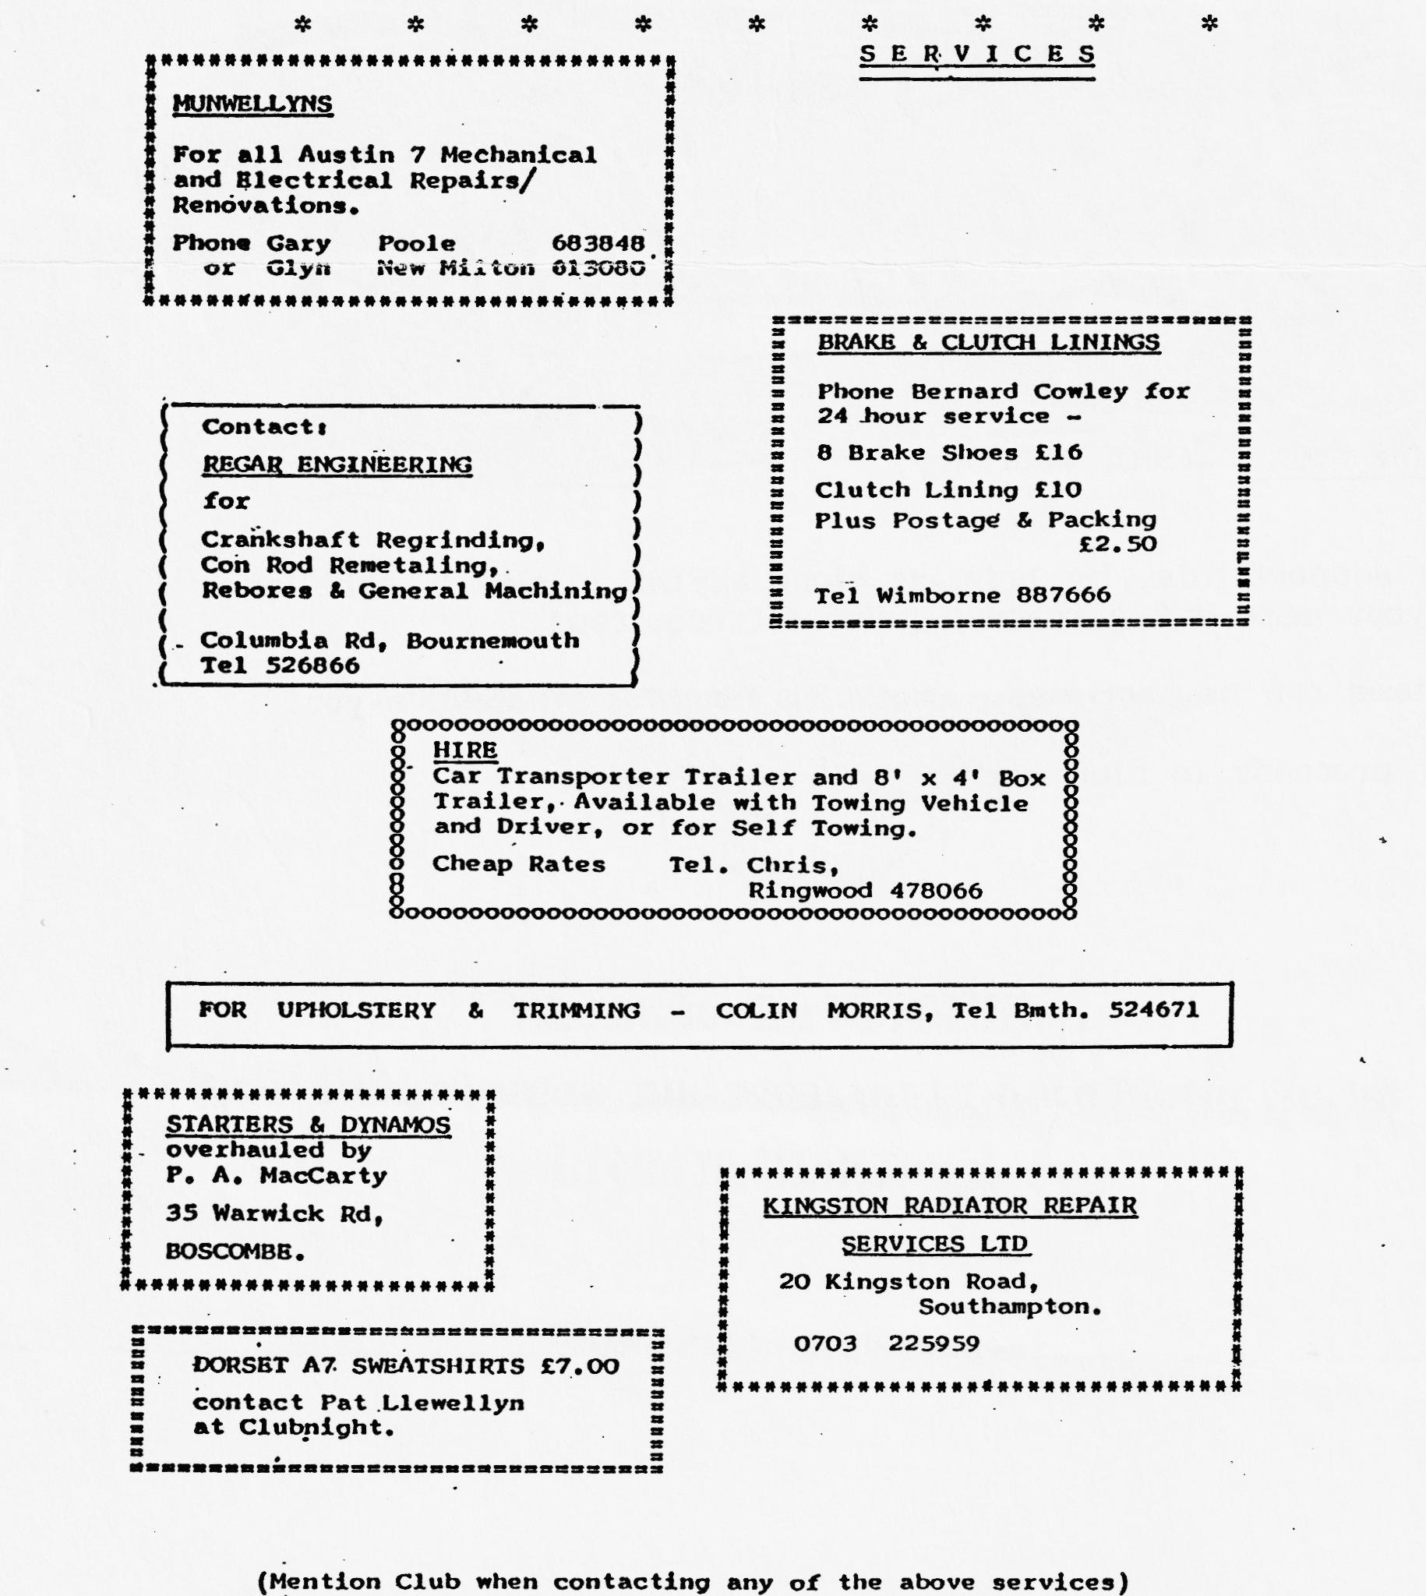
Please support this, by bringing along anything 'clean' , labelled with your name and a reserve price (if required). Any items can be- auctioned - motoring bits, or what-have-you. 10% of proceeds to Club Funds.

