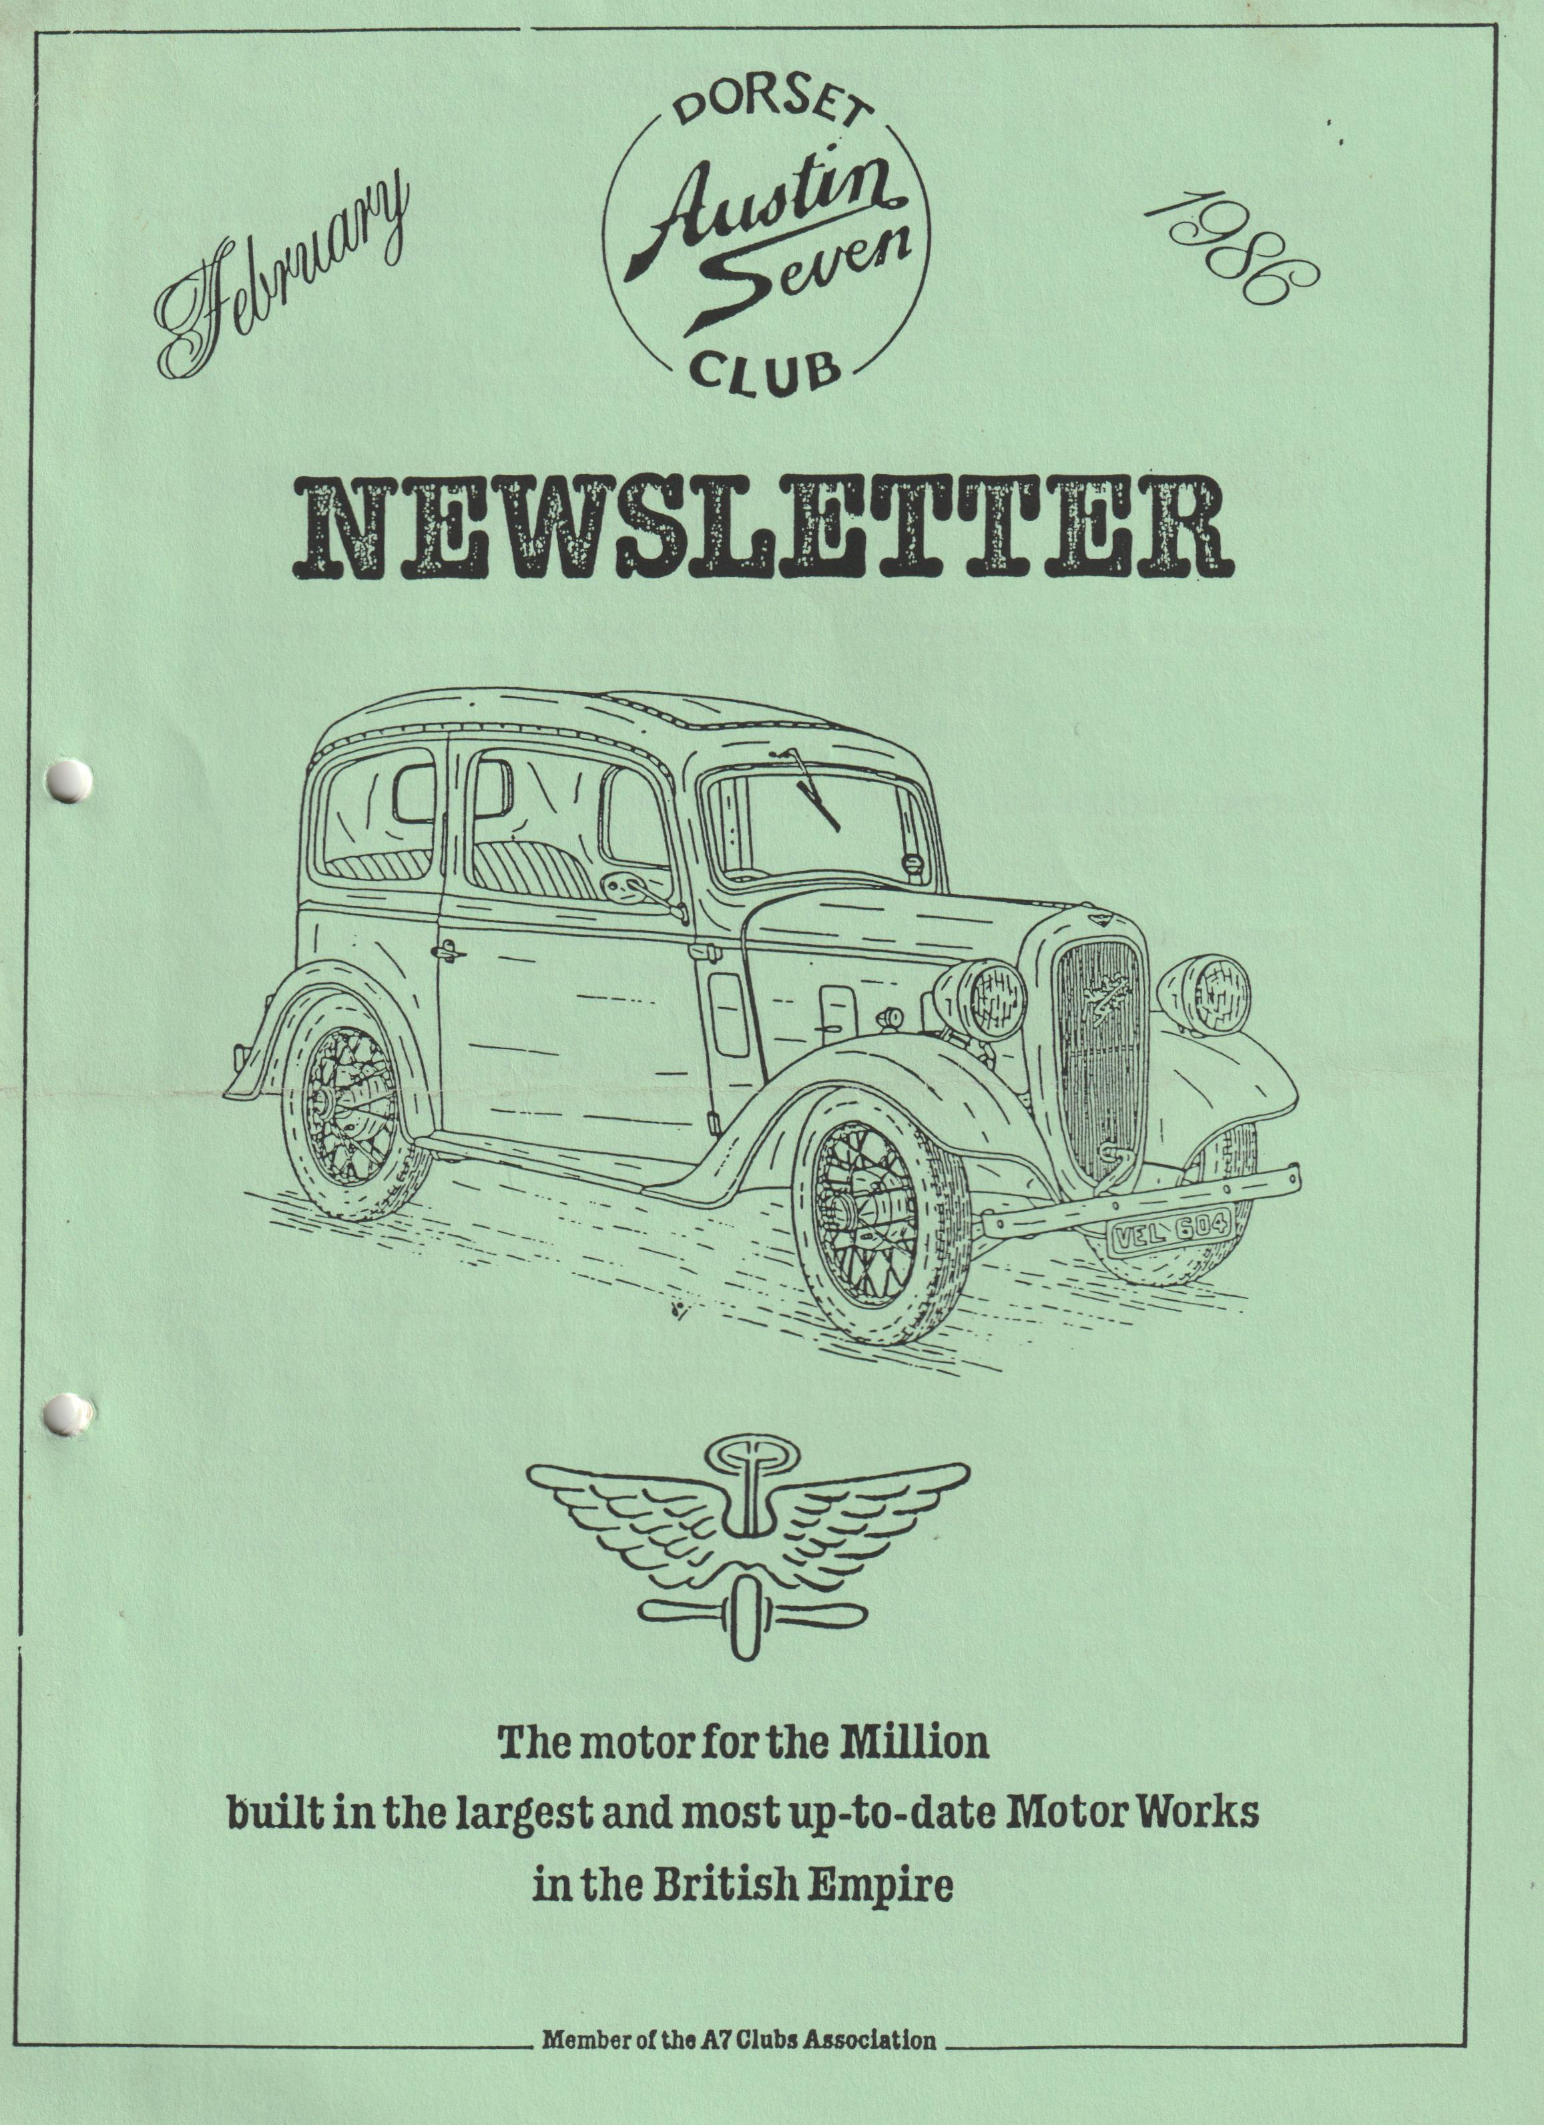

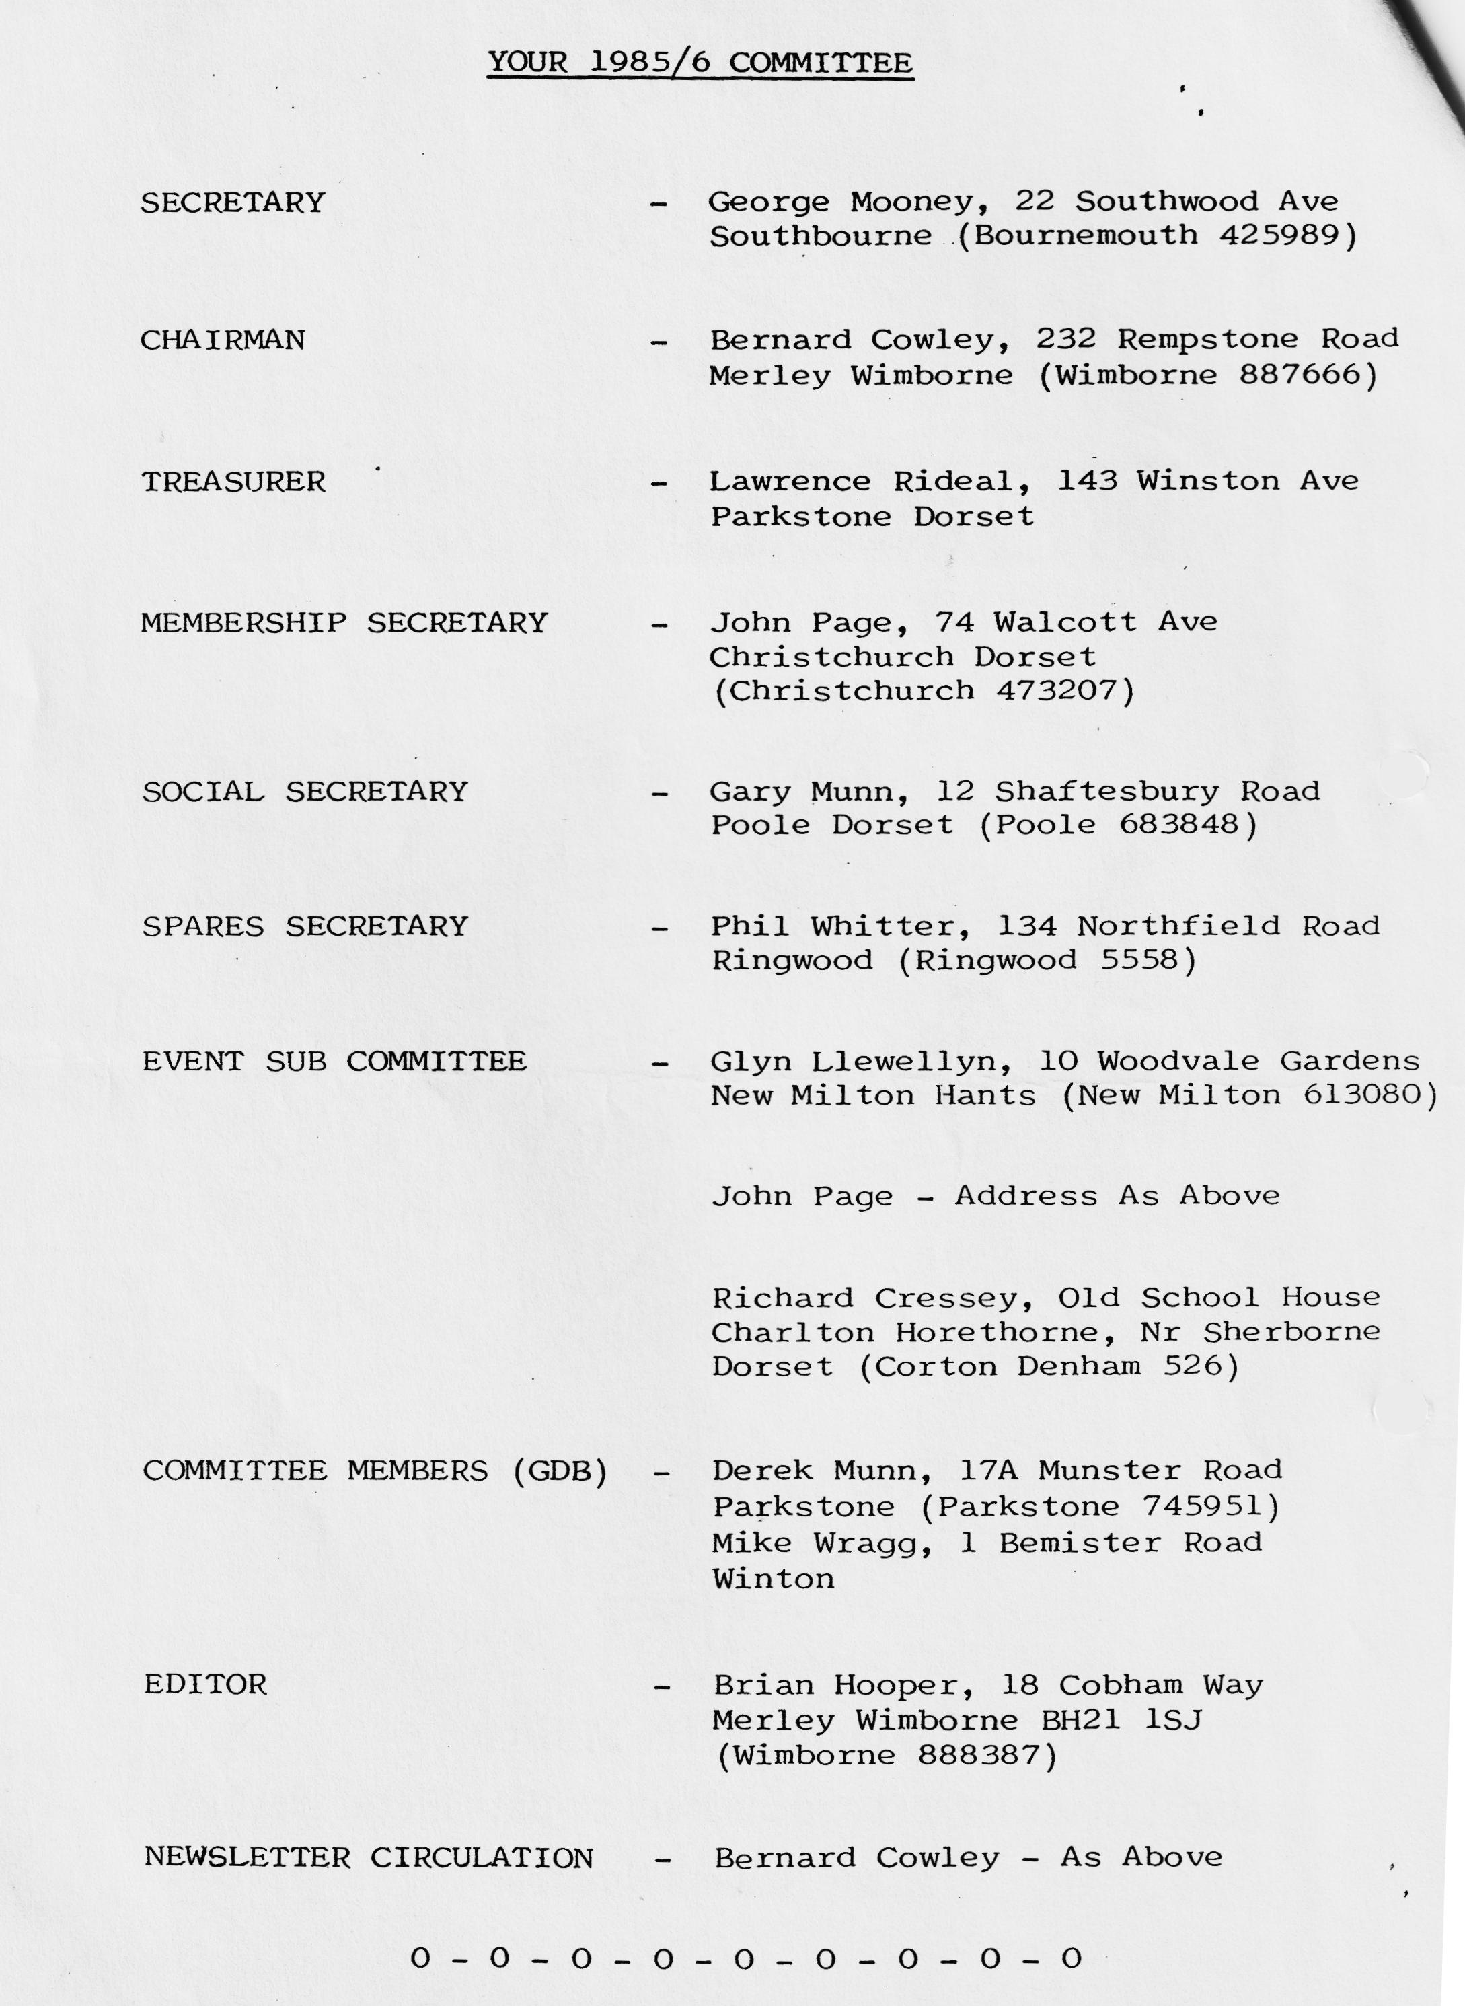

NEWSLETTER - FRONT COVER
This month's front cover shows an excellent sketch of "Bob's" Ruby as drawn by his girlfriend Jo Moss, who tells me that Bob's Austin is the "Bright Blue One". Jo submitted the sketch in response to the editorial appeal for photographs, many thanks Jo, you are obviously a very talented lady.
Editor
EDITORIAL FEBRUARY 1986
I'm writing this at that time of the year when everything seems to be virtually lifeless, the weather is lousy, Christmas seems long gone and it's little wonder that many creatures and vegetation choose this time of the year to hibernate - I could easily do the same.
However, when you receive this Newsletter, things should be livening up, for dependent on the postal delivery, the Barn Dance is about to happen, or has just happened. Speaking of postal deliveries, apologies to those members who received empty envelopes without the content Newsletter during December and January. Bernard (Newsletter Circulation) received a communication from the Post Office returning some Newsletters that had come adrift from their envelopes, and it would seem that either the Newsletter is too big for the envelopes, or that Bernard’s 'lick' isn't strong enough. I did notice at a recent committee meeting that Bernard had eased back on his traditional beverage intake, and had resorted to tomato juice, obviously resulting in a lower than normal blood alcohol level which may have adversely effected his 'lick':
As far as the Newsletter is concerned, it's nice to see a few new names on contributions, but I would welcome more for it's always a bit daunting at the beginning of the month trying to plan what is hoped to be an interesting communication between members, with very little material available.
Pat Llewelyn, the club fashion designer, who has so excellently kitted us out with club sweatshirts, is contemplating having club tee-shirts available, but in order to get some idea of the quantity required and price, Pat would appreciate you letting her know if you would be interested and approximately how many you would like. No commitment at this stage, but advice to Pat by/at next club night would.be helpful.
I'm advised that the Spray Finishers company in Poole whom we have featured on our Services page, no longer have capacity, and their ad is now withdrawn, hence you will see the block "space to let", if you have, or know of a service, not necessarily associated with motoring, which could be of assistance to our members, let me know and we will advertise it free of charge, albeit in return expect a preferential rate for the service to our members.
Here's to next month, please help me by providing a contribution if possible by Monday 3rd March.
Regards,
Brian Hooper
You all know that the club runs a raffle.at each club night, the revenue from which is used to purchase some of the prizes, pay for room hire, subsidize events, costs of film hire etc. Over the past few months, some members have very generously donated extra prizes to the benefit of both the club and winning 'punters' (last month a bottle of sherry appeared - thanks to the donor). The committee very much appreciate the help provided - a big thank you to those who provided the extras and to all members for buying tickets.
It is proposed to publish in a future Newsletter, a list of our members names and addresses, you never know there may be a member just around the corner from you! If any members have any personal reasons for not wishing their name and address to appear, please let any committee member know at next club night.
CLUB RUNS
Although Club runs have been well supported, concern was expressed at the last committee meeting regarding the return trip home. Generally, after doing whatever at the destination of our run, members are either left, or choose to leave on their own, to return to the Bournemouth area. Opinion was expressed that it might be more fun to return to 'near home' in convoy, with the added fact of there being 'safety in numbers'. If you have any views on this, let a committee member know, or write to the editor.
SECRETARIAL
Hello there,
For once ahead of the editor - at least he hasn't had cause to ring me yet for this copy. Looking forward to the Rally season, a few items for your attention:-
Firstly, there is the Andover Vintage Club Rally and show on 7th/8th June, and the organiser has a road run on Sunday 6th July of approximately 70 miles. Our support is requested, if interested write to Malcolm Treasure at 112 Colenzo Drive, Andover, Hants sending S.A.E.
Woodford Country Fair is on the 4th/5th May, there is a space for overnight camping, although as it is in the Salisbury area, it is quite local. It is a nice little show for which I have entry forms, closing date for entries - 24th March.
Henrietta has been asked to represent the DA7C at the Swanage Railway Pageant of Transport (see open letter this Newsletter), Joy was hotly pursued by the organiser and talked into it, and we have to wear period clothes.
The Old Wheels Exhibition, the first International Vehicle Restoration Exhibition is being held at Alexandra Palace on Friday 20th June until Sunday 22nd June. Anybody interested in visiting this, please contact me and if there is sufficient support, we may organise a coach, but please let me know before the end of March. Included in the exhibition are exhibits of Services and Products, Vehicle Auctions, Vintage Rally, Steam Engines, side shows etc. The coach trip and cost will depend on the numbers interested and I will tell you the cost before booking anything.
Phil Whitter and I attended the Association A.G.M., which I understand Phil has reported on in detail, but briefly, Chris Harvey's book on the A7 was given a good reception, although there are quite a few errors. A sports registrar is still sought - anybody out there who wants to have a go?
On the spares front, there are still some 400 x 17 tyres available from Howard Annett and new Crown Wheel and pinions 4.9, straight cut are available from Barrie Clarke.
I have the dates of the A7 Race Meetings, which will be published in our March Newsletter.
Phil Whitter told the group that G M Richardson of Grasshopper fame has been located in the Bournemouth area.
The cost of the A7CA quarterly magazine is to increase from 1986 B issue, and this will probably mean an increase to Club subscriptions for 1987.
Solent A7 Club have advised the Paultons rally has been arranged for Sunday 1st June and entry forms are promised in good time. Finally, it was suggested that we have a club run to the hill climb event near Salisbury. I will let you know more about this later.
See you soon.
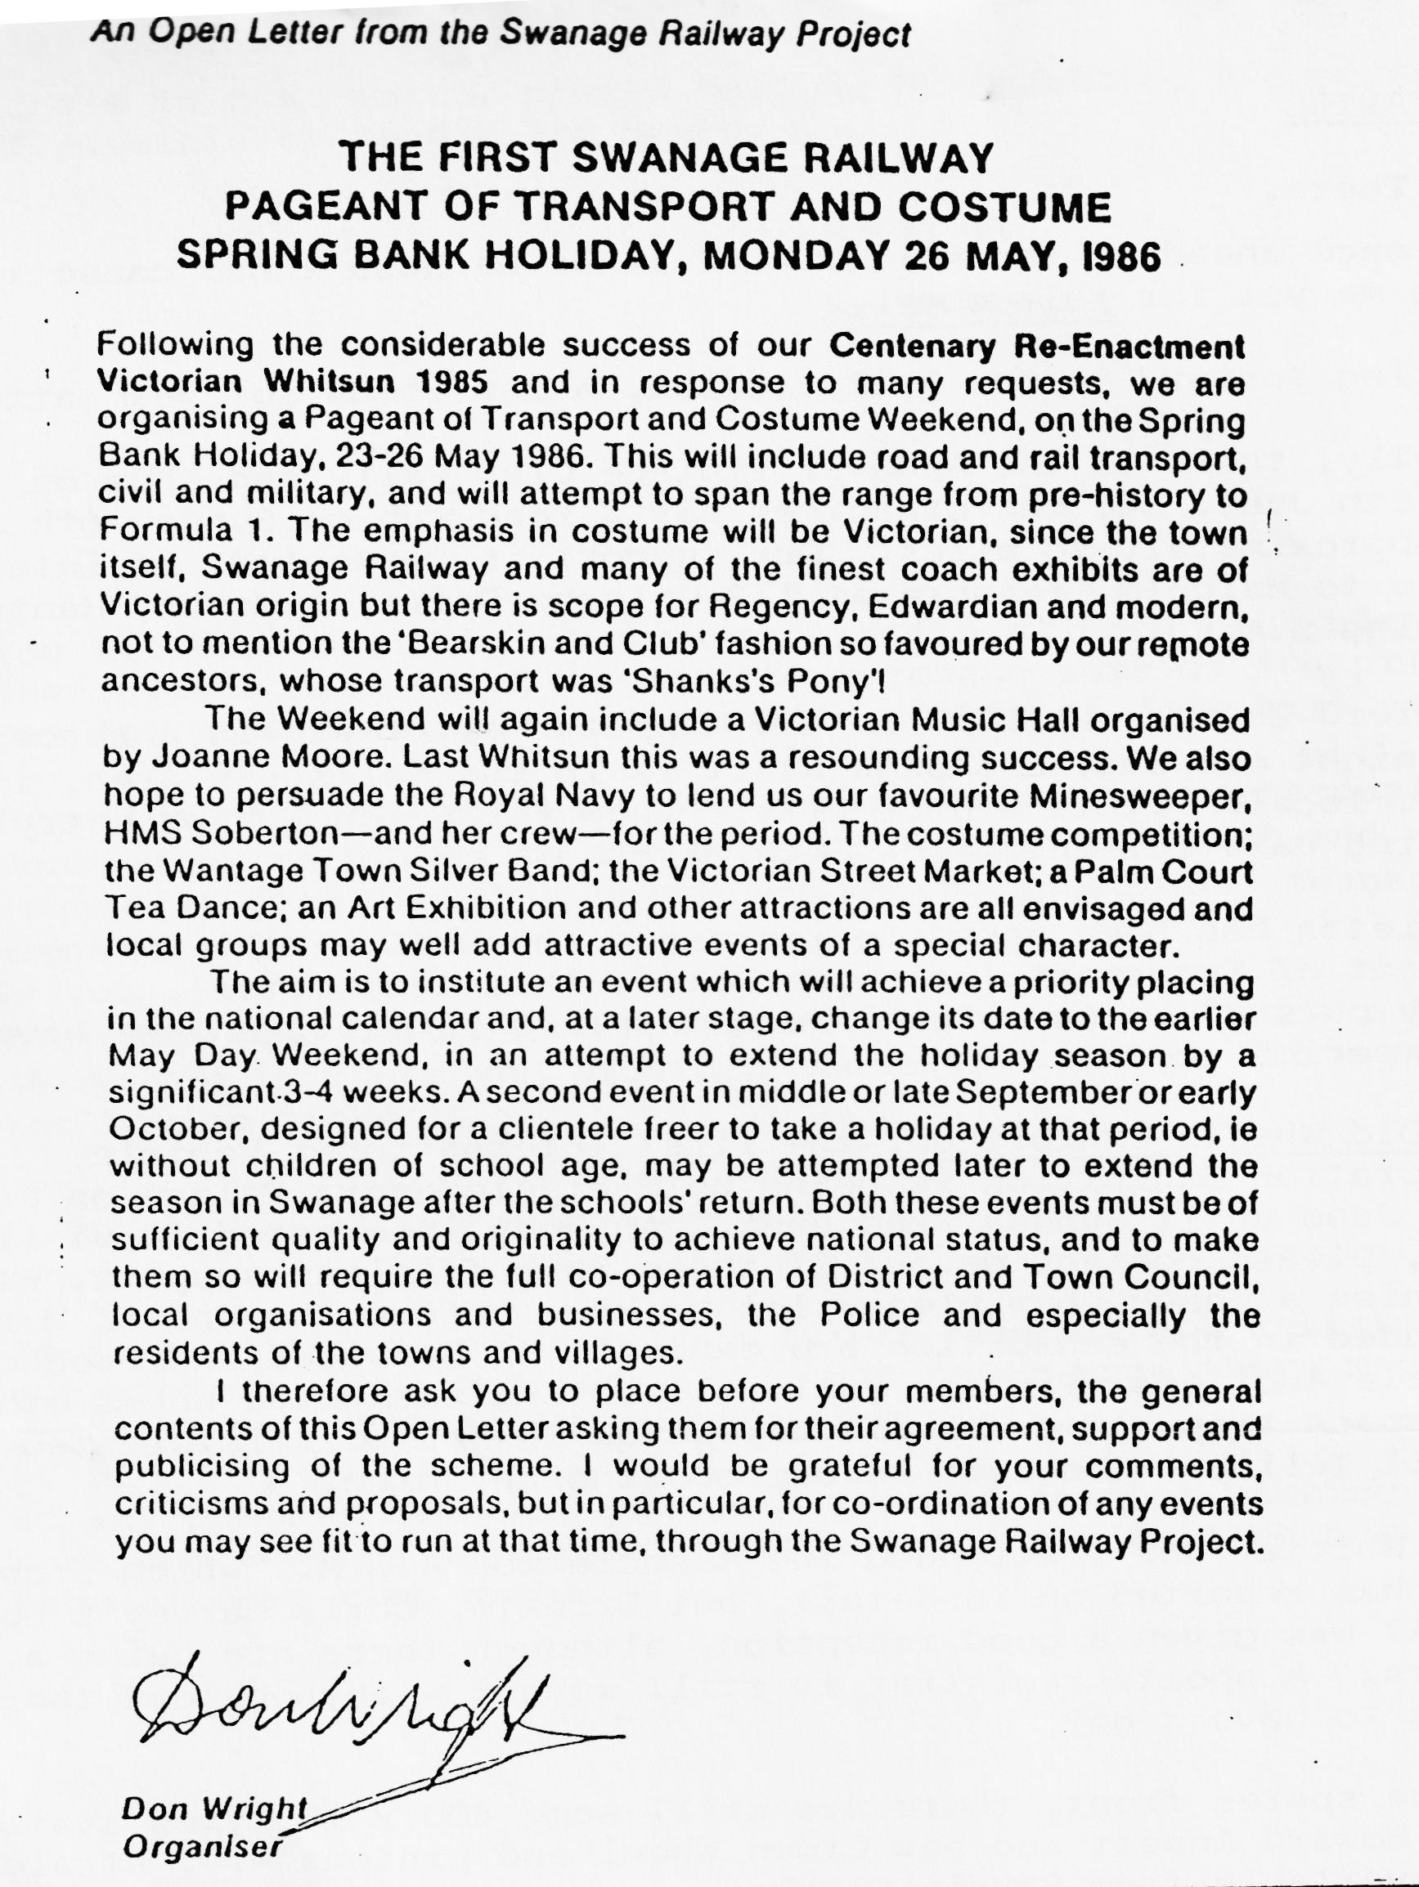
George
FOR SALE
1937 Austin Seven Ruby, Reg'd No DHW 804. Years M.O.T., Good Condition Generally, Very Original but interior trim needs some attention. New brakes, kingpins etc. Price £1295 o.v.n.o. Tel. Bournemouth (0202) 767705 evenings or (0202) 684141 Ext. 62, day.
WANTED Any and all parts for 2 Seater Sports, registered December 1932 including chassis, "Bent" sports front axle, engine etc. Tel. Bournemouth (0202) 767705 evenings or (0202) 684141 Ext. 62, day.
REPORT ON CLUBS ASSOCIATION MEETING - SUNDAY JANUARY 12TH
George and I travelled up to Oxford for the A7CA A.G.M. and this report gives brief detail on what I thought you would find interesting.
Howard Annett (Chairman) reported that he had attended a H.V.C.C. meeting (Historic Vehicle Clubs Committee) which exists to represent the old vehicle movement at the highest level and does have some influential members in touch with the government. The £60 road tax was apparently set by the Treasury with no thought of imposing future legislation but simply to get more cars on the road at £60 a time, and guess who was recognized as being the main lobby for cheap tax - Austin Seven owners! (so thanks are due to Ian Dunford and all the others who used to write to Swansea and get cheap tax!)
Did you know that if your car is over 50 years old and worth more than £16,000, you need an export licence to take it on a day trip to France!
The H.V.C.C. had concluded that public liability insurance was probably safer than being a limited company - this is the method used by Dorset to cover possible claims against the committee.
Finally, how about the military vehicle people who managed to convince Swansea that their amphibious DUKW's were capable of being used for burial at sea and so should be rated as a hearse when on dry land!
Next report came from Geoff Walker (Treasurer) who told us that the finances were in a fairly healthy position although in view of adverse reaction to a steep rise in advertising rates, it was possible that the cost of the A7CA magazine may have to be increased at a later date if it was necessary to set a lower increase of 10% in advertising costs.
On the question of advertising, the Automobile missed our copy date to plug their December 1985 issue which had an article by Mike Hodgson on OK 6807 (the earliest Seven). Some outstanding advert balances were written off including one for £225 from a company in the hands of the Receiver.
The editor was congratulated on maintaining a high standard and getting all four editions out on time. "Club Corner" had proved a useful input to the magazine. The Ken Warren Memorial Trophy was awarded to Gerald Walker of the Cambridge A7C for his articles on student escapades with Austin Sevens (see 85B).
There then followed some discussion on insurance when it was revealed that it would not be easy to get an alternative scheme in operation and really what was needed from the existing insurances was feedback on price changes and/or restrictions etc.
Next the archivist, Phil Baildon told us that the Chummy print was sold out and any reprint would need a new plate and cream paper. We were told to watch out for a cutaway drawing of a '25 Tourer in "The Car".
The Essex based "Bongtree A7C" was represented and their application to join the A7CA was supported by a postcard depicting Fred Eley's Austin posted in Morocco! Their application was successful, and their club venue was, like "The Wanderers", described as "various"! It is good to see a light-hearted view introduced into the A7CA movement!
Finally, Joe Spalter (Films) told us that a video of the Stanley Edge interview was available for hire and he also had received a film from New Zealand showing 1930/31 A7 production at Longbridge which would also be available for hire (16mm Silent).
Regards,
PHIL WHITTER
RUN REPORT - 19th January - Braemore House
No report has been received, which might indicate that no one went on it, although I have heard that five Austins were seen heading in that direction on that day. If you were on that run, have a guilty feeling you could have submitted a brief report.
Interesting to see in the Austin Seven Clubs association magazine, calendar of events for 1986, that they have shown our Barn Dance as "Barn Dance and Ringwood Run". They must have observed our attempts at Barn Dancing last year when a certain member always ended up at the wrong end of his group of eight and had to sprint to the other end before the sequence carried on!
A reminder that when you are out on a Club run, the convoy rule is to keep the member's car that is behind you in sight. The advantages are that no one gets lost, and the run is paced to a moderate speed (it stops the guy in front haring off at 60 plus!).
10th January, 1986
Dear Editor,
That was a great Christmas Party that was! Such functions necessitate a great deal of work and planning. The smoother they go the more effort has been put into them before the event. It also means getting involved on the night to ensure that all goes well. Poor Gary was constantly on his feet dealing with on the spot matters (must buy him a packet of Rennie's for the next time). Grateful thanks to all concerned with making it such a happy evening.
To show how much we appreciate their efforts, what about the rest of us organising a night out for the Committee? Should not be difficult as their needs are simple. A room at their favourite hostelry and free beer (probably have to provide an extra room for the three bearing types).
You gather from the above that Norma and I take a very good view of our hard-working Committee, but is this mutual we ask ourselves? A funny thing happened in our post before Christmas when we received an envelope correctly addressed in a well-known handwriting, but no Newsletter inside. Are we now to be cut off in our prime without a Newsletter just because we do not own a special, 3 bearing hokum, a saloon or even a four-legged friend of the short or long chassis variety but merely an open motor with no visible means of protection (if I can help it) and the fact that I actually like John Smith's. Further, we recall that after the very first meeting attended at Nag's Head, the club venue was changed to Dormers but still we found out for ourselves. Is it hoped that if we do not get a Newsletter, we shall get the message....or not it, if you see what I mean?
Is there anyone out there who dares tell us when and where we now meet? Please write and send S.A.E. if reply required plus 50p in stamps (or cash).
Very Happy New Year to all and may it be a healthy and peaceful one for you and your families and a breakdown free one as a result of the expertise of the Munwellyn boys (needless to say, I use the word "boys" very loosely).
Best wishes,
BILL QUAYLE
In the January Newsletter report on the Club run to Melbury Abbas, I now realise that reference was made to the "Choc Box". . If I had done my job properly, I would have edited this out and inserted "Gabrielle J" in line with John Weaver's article/request in the November Newsletter: Sorry John.
Editor
AN ODE TO AUSTIN SEVEN (The Competition)
In the post, words so fine
Adding up to Ninety Nine
From Glyn & Pat, the first received I only hope they're not too peeved
for from their words I excluded 'teat'•
cause that has two 'Ts', and had them beat.

In the rules it said only one
unless repeated in Austin Seven.
I know that Glyn enjoys a tipple
but really, no excuse for a rubber nipple!
The rest of their words OK, some rare
but one I expected just wasn't there.

The missing word should have come from Glyn,
not Whitbread, or Huntsman, but just plain "Inn"
However, thanks Pat & Glyn for always trying although for first place you'll not be tying. there's one on me next time we meet
and you won’t have to drink it through a rubber teat!

Brian Hooper
DECEMBER "WORDS" COMPETITION
Unlike the October competition, which only attracted two entries, the words competition proved very popular resulting in me receiving four entries, however as everything these days seems to be calculated in percentage terms, I can claim a 100% increase. If this trend continues (and if we have more competitions) four more competitions should provide 64 entries and require an increase to the club membership.
Thanks, however to those that entered, I'm sure that your investigations to find words taught you a thing or two, whoever would have known that 'anise/ was an umbelliferous plant, the seeds from which are aniseed! The four entries submitted 233 words, 176 words, 164 words and 155 words and in case you are wondering about Pat & Glyn's 100 words referred to in the Ode, they did increase it subsequently by adding in the plural of many of the words.
The winning entry was submitted by one of the club juniors - DEREK WHITTER, congratulations, Derek, your 233 words is the winner, even though you had kindly added them up and made the total 242!
Your English teacher will probably be proud of you, but don't say anything about the addition to your Mathematics teacher!
A prize will be on its way to you shortly. •
Editor
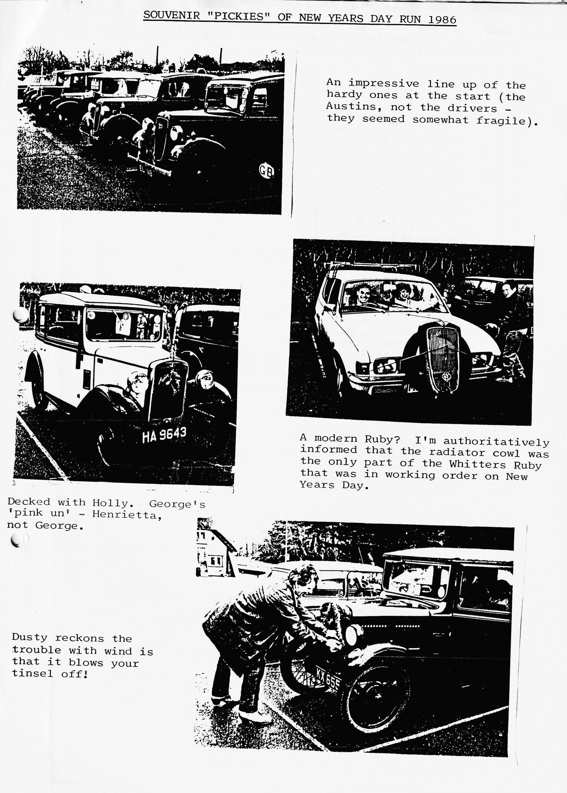

If you have purchased a copy of the Austin 7, by Chris Harvey, you may be interested in the following list of corrections and observations:-
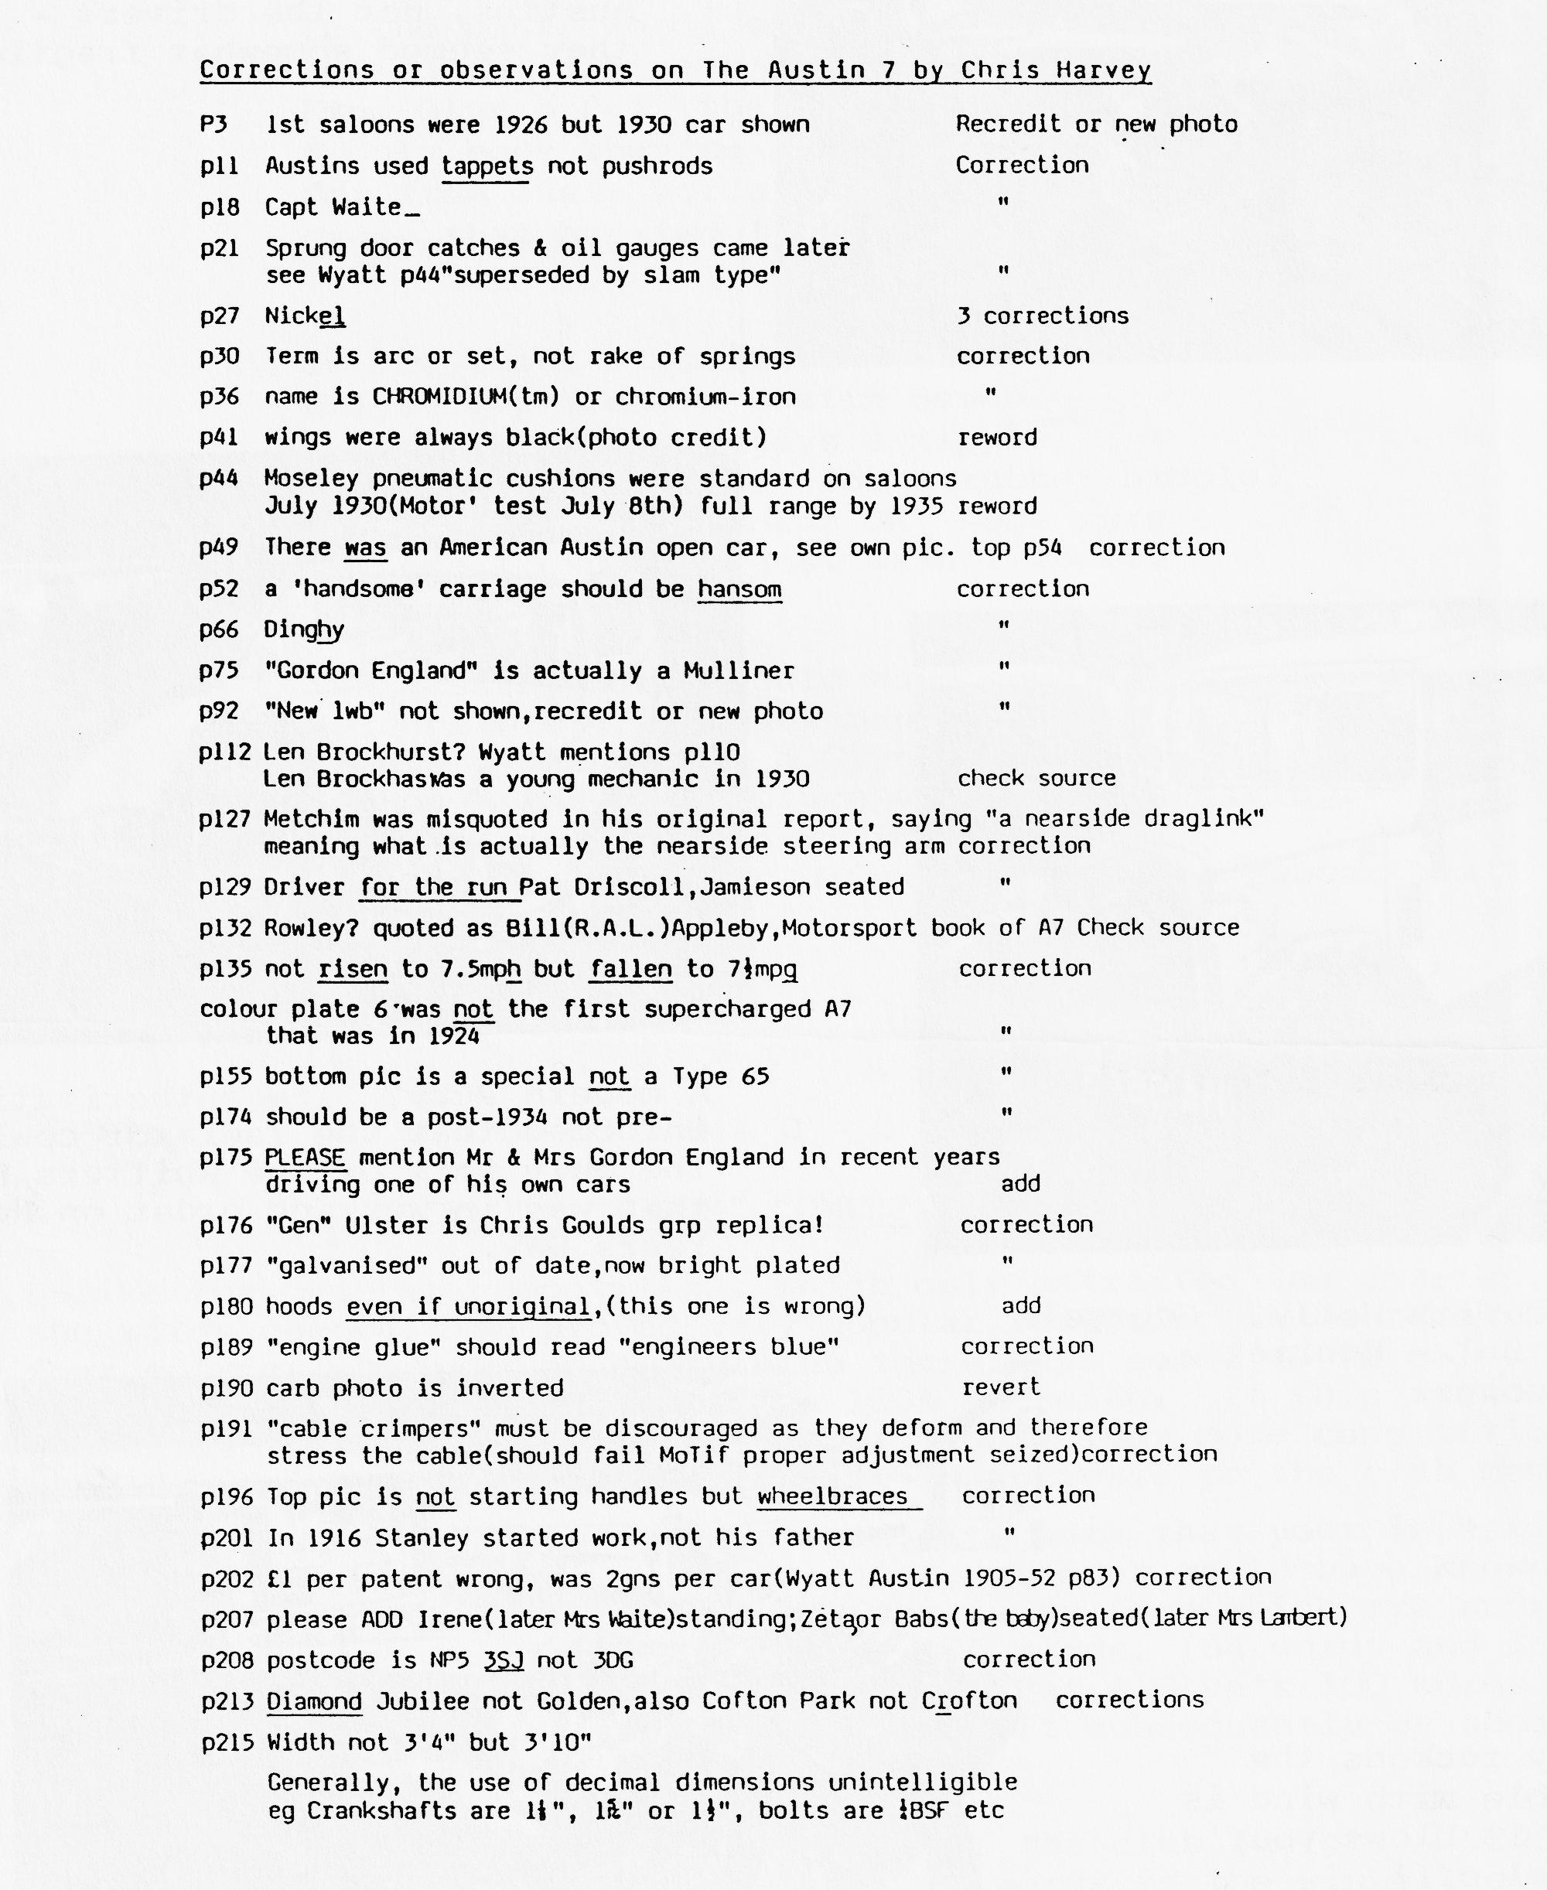

EVENTS CALENDAR
SATURDAY 15TH FEBRUARY Our Club 10th Anniversary Celebration Barn Dance.
THURSDAY 20TH FEBRUARY Club Night at the Elm Tree. This is 'Auction' Nite.
SUNDAY 23RD FEBRUARY Club Run to Powerstock, organised by Richard Cressey
SUNDAY 30TH MARCH THE MARCH HARE RUN - Meet at Co-Op Car Park, Christchurch (End of By-Pass at 10.45 a.m. for 11.00 a.m. start, for a visit to the Ealing Tide Mill.
THURSDAY 17TH APRIL Club Night
SUNDAY 20TH APRIL Club Run to Hawks Conservancy, Meet in Ringwood Cattle Market Car Park at 10.00 a.m. for 10.15 a.m. start.
SUNDAY 18TH MAY Club Run to Bath, (further details next month).
SATURDAY 7TH/SUNDAY 8TH JUNE - ANDOVER VINTAGE CLUB RALLY
NOTE
Thursday 20th February (Club Night) is 'AUCTION NITS'. Please bring along anything 'clean' that you no longer want, labelling with your name and a reserve price (if required). 10% to Club funds. Your support in bringing along items for sale, and buying) to make this a successful night would be appreciated.
FOR SALE
Older type, sound sectional concrete garage (loft x 8ft interior). Buyer to dismantle and remove in late March. Easily accessible for removal. A gift at £50. Enquiries to John Weaver B'mth 573899
