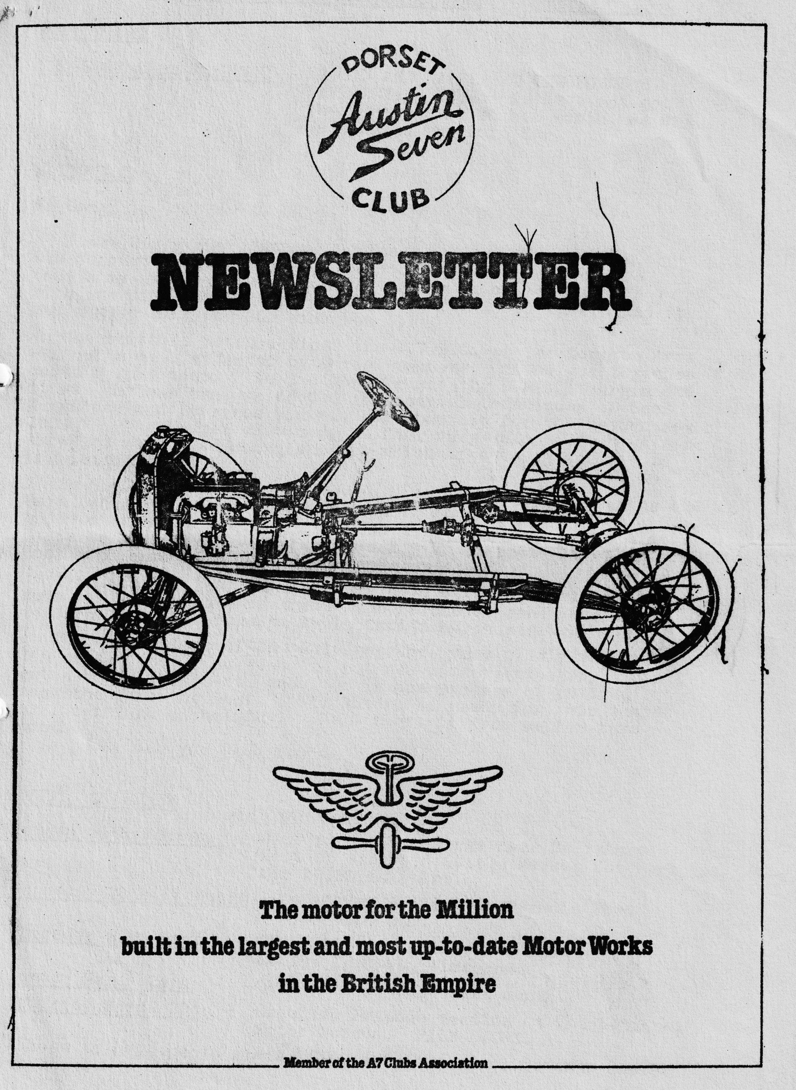

DORSET AUSTIN 7 CLUB NEWSLETTER FEBRUARY 1985
CLUB NIGHT
THURSDAY 21st FEBRUARY - NOGGIN AND NATTER AT THE DORMERS WIMBORNE. NOTE:- We have not got the room upstairs this month, we are meeting in the Barn Bar.
EDITORIAL
Hi Gang,
I was sorry that Pat and I missed last month’s meeting, but the forecast was really terrible and Pat got a bit worried (that's my excuse, anyway you try driving a rag top Austin 7 with one side screen missing in this weather!) I understand it was a good Quiz and our side won!
The skittles match against the W.V.P.C. at The Langton Arms was quite well attended by Dorset members, and we got together quite a good team. We did however lose by a small margin and it was obvious that we needed the special techniques of Geoff Kingsland and Lawrence Rideal, - how about it for the return match lads? The Wessex club made us feel very welcome, and we were supplied with a smashing supper, which Mike Wragg enjoyed in his -inimitable way!
By the time you get this month's ' Periodical-de-Genius, the Barn Dance will have come and gone, I hope that -everyone enjoyed it as an awful lot of work went into this year’s event. It is to be hoped that we can break even financially as it has cost much more to have a live band. I understand that some members have still not paid their subs. If you are one of those members please send your money to John Page, 74, Walcott Ave., Christchurch straight away.
The restoration of the Ruby goes on, very slowly in this weather I'm afraid, but I am about to put new timber (mahogany I can't get ash) in the doors, and I am in the process of putting back the sunshine roof. It’s got to be ready for this summer or I can't go on holiday. Well that’s it from me for this month.
See you Club Night, ''
Glyn
EVENTS CALENDAR
Sunday 24th February - Club run to Woodhenge near Salisbury Meet at Ringwood Cattle Market Car Park for 10.30 am start.
Thursday 28th February - Committee -Meeting at Tyrrells Ford, Avon 8.30 p.m.
Thursday 21st March - Club Night a talk by Swanage Railway. At The Dormers, Wimborne.
Sunday March 24th - Club Run. Details next month.
Saturday March 30th - Beaulieu Friends meeting at The National Motor Museum. FILM NIGHT.
I hope to have photo stets of A7 events to include this month, more next,
EDITORS REPLY to letter of last month
Whats all this in last month’s newsletter about three-wheeler Austins, punctures and shopping bags etc?? Had the author read the next evening’s 'Echo' all would have been clarity and light, as an article on the incident appeared there. It all happened like this you see. - Our one-finger typist took the Opal to Bournemouth to spend some (more) money, and parked the car in the Multi Story Car Park (more money, why she can't park in the road for free I don't know) On returning after many hours, and lots more DR's on my bank statement, she discovered that one of the tyres was flat. So out came the jack but she could not find the handle; that’s because there ain’t one, silly old moo, I would use a pair of pliers to turn it with (if I had been daft enough to have driven over a nail in the first place that is) Anyway, after a short time, a lady struggling with a huge Habitat shopping bag, or perhaps it was a huge lady with-a Habitat shopping bag, appeared at the shining new Volvo parked next to our rather Tatty Austin 7,
"Oh my poor dear" she exclaims, "Can I be of any assistance". Where upon Pat asks if she had a jack. Well to cut a long story short, between the, two of them and with the help of the lady’s two children they managed to change the wheel (if you had heard Pat carrying on when she got home you'd have thought they had changed the Axle!) (1 suppose you could have done that with a pair of pliers eh?.(1-fingered typist) After which the lady, oily hands and fur coat and all, drove off, leaving her Habitat shopping bag behind. All ended well however as she saw the article in the Echo and collected her shopping. bag from the Police Station the next day. Mind you, I've still got ear ache from the moaning.
Glyn
Secretarial
Here we are on a cold and frosty evening, crystal clear and fit only for supping Old Ale, faced with an overdue secretarial, as usual. Isn’t it great weather if you don’t have to go anywhere I and absolutely ideal for grovelling under 7's trying to get them fit for MOT scrutiny.
On Saturday we went with Ruby for the dreaded MOT after masses of rust were replaced with new panels and eager to explain about the new brake linings and kingpins/bushes. The great moment arrived only to be faced by the mechanic first not knowing how to start it, then to find the ramp wasn’t narrow enough to take the car! Roars of' laughter and back to the usual testing station on Monday to pass with flying colours. What a relief.
To Joy's surprise, a day or two ago a gentleman knocked on the door to see if we were the Austin 7 people. Upon confirmation he proudly presented to Joy a mint condition 78 rpm. record of "My Little Austin 7' how nice of him.
Solent A7 Club tell us that the Paulton’s Rally and Auto-jumble is now to be on June 30th to avoid clashing with Beaulieu. I missed it last year, but everybody said how good a rally it was. If anybody is particularly interested, I have a copy of the A7CA accounts for 1984. They are healthy enough at the moment but if we don’t succeed in getting a volunteer to fill the vital spot of Advertising Manager then the magazine price will have to double and it will be harder to fill. Any volunteers.?
It seems that the Solent French trip may not take place this year. If anybody is interested in making a trip to France in May, please contact Gary Munn with all haste and let him know, time is short but the bad news is that Townsend Thoreson are not prepared to offer discount rates for the cars this year.
I have had no correspondence of any particular interest except from Geoff:' and Daphne Canning who tell me they are members of 16 local motoring and other clubs, astounding the purpose of the letter to show the number of local motoring events you could go to details are published for your edification. I hope you can support some of them, plenty to choose from.
Well folks, a least for now that is all from me. See you around. Good to be back in the A7
Oh by the way, if you have been unhappy about the weather lately, don't complain. I went to Derbyshire yesterday, you should have seen the snow up there. I thought it had all gone but not so , and it sounds like there is more to come.
Keep warm. George
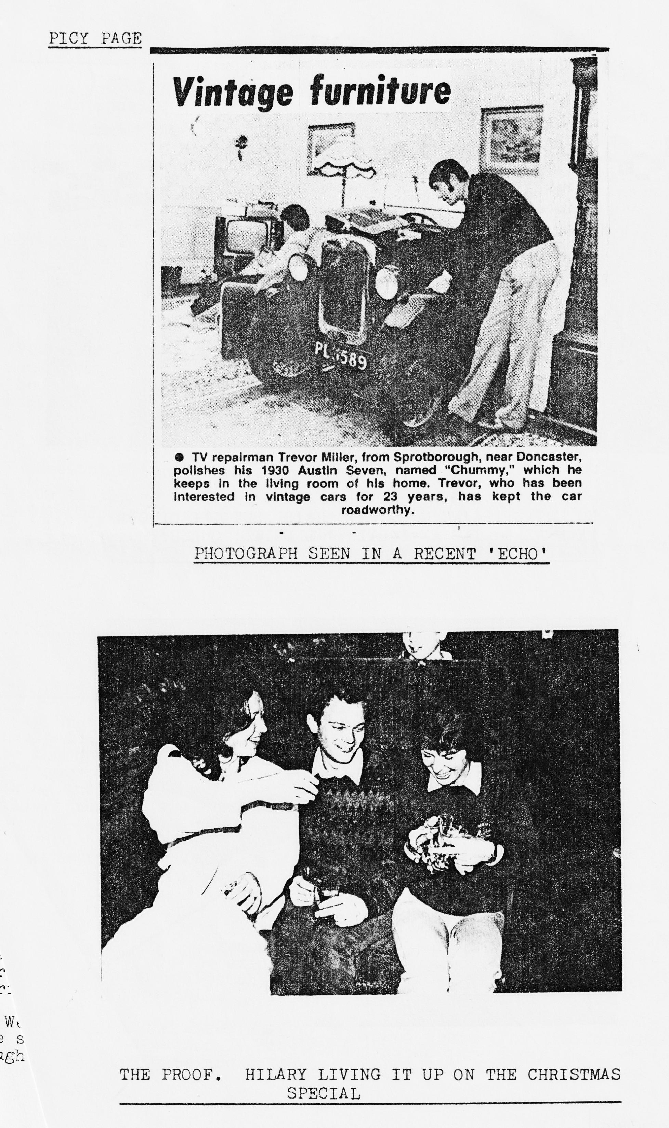

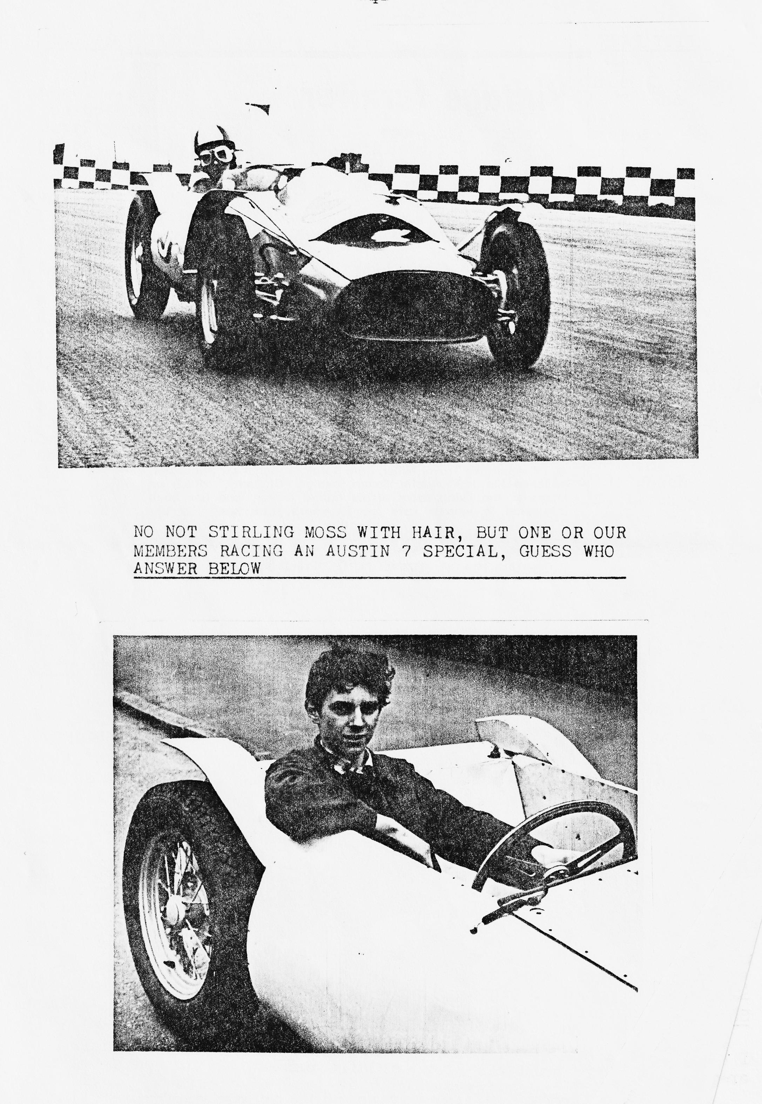
I hope you will support it and they are anxious to attract more Autojumble stalls, please contact me
The Life and Times of an Austin 7 owner 1958-1964
My brother first bought an A7 in 1955 - a SWB box which he still owns. So from the age of 13 I discovered Austin 7's-. The 50's were the heyday of the special builder as there were no cheap small cars to run, pre-war A7's could be bought for next to nothing and converted into a sophisticated-?? special. All builders thought they could build a perfect car out of a chummy! Most non-enthusiasts bought a Seven, ripped the body off and proceeded to buy a fibreglass body and plonk it directly on the chassis - most of them looked like modern prams - I remember a neighbour of mine building one exactly like that when he drove it instead of being in the car he was on top of it! Well, I bought my 1st Austin 7 in 1958 - it was the basis of my special – a 1934 Ruby which I still have the log book (any offers) from a scrap yard for £6. I. remember removing the running chassis and leaving. the body. The scrap yard in those days contained an early Morris Minor, Triumph Dolomite, a Singer Super 7 and various other -reasonable restorable cars.
Well, I now had a chassis which I hacked apart (for 750 formula the side members were only needed) and boxed in. I'd also bought an £25 Gamages Arc Welder.
In those days there were 3 places in and around. London where you could get spares for A7s –the best and cheapest being Northwood Motors by the Elephant & Castle - the others being Super Accessories who also sold special bodies and timing parts. They sold a very good ratio conversion for £14.10s.0d and the other was Cambridge Engineering. I think I never bought anything there, they seemed expensive - although their super Cambridge bodies were only £25. In those days to get information to build a special there were two meetings in London organised by the 750 MC. One was the H.Q. meeting at the Abbey Hotel on the North Circular Rd., near Hanger Lane. They were super meetings, the car park being full of all sorts of specials 750 and 1172 Ford. People even brought unfinished ones on trailers to show and talk to other members about. The other meeting was at Hammersmith solely for Special builders. I used to go in the 7 saloon with my brother - It was now tuned with large valves down-draft carb. and 4-branch exhaust. We had friends who had a similar car but with a tuned S.V. Ford engine in which we used to race through London on the way home. It was great fun. At these meetings various parts were bought and sold and I managed to get most of the suspension, Ford split axle and wheels through them.
There were no autojumbles in those days. I decided not to build a road car and go for a racing special. I built a space frame out of ½” square tubing and ½” round tubing for the side hoops and wrapped it in 18G Aluminium. The only problem I had was that the engine stuck out the top of the body so I had to make a rather large power bulge. I completed it in the early part of 1961 just before I luckily passed my driving test. That was in the February of that year and in April I entered a 750 practice day at Brands Hatch. The only problem was I hadn’t got the cooling sorted out. I was using a cross-flow rad. and a Ford Export water pump which didn't work very well so it kept boiling! I:had driven the car about 40 miles there boiling most of the .way . At Brands due to my lack of sorting out the hydraulic brakes properly, one front wheel locked on and I spun off, hitting the bank at Paddock Bend -.luckily there was someone in the pits to weld up my broken tubing so I was able to drive the car later on in the day around the circuit and home that evening. For the technical amongst us the engine had l 1/8” valves, double valve springs, Cambridge head, lightened flywheel, twin carbs. modified cam and tappet blocks. To save having another power bulge I fitted the distributor directly off the camshaft. The wheels were 15" off-set with Dunlop racing tyres, the front suspension was Ford ,Pop - cut in 'half to make a swing axle with Lotus coil spring dampers, the rear axle spring hangers were modified to lower the rear suspension.
It was raced with limited success in 1961/62 seasons by myself and a chap called Rod Mansfield (he had the trailer and tow car being a racing A35 Van). He is now chief of Advanced Vehicle Operations at Ford Motor Co.) With lack of funds and no tow car I decided to sell the special in-1963.
TO BE CONTINUED.
Bernard Cowley

Letters received Highdown Cottage,
Cliffe ray, Compton Down,
6th February, 1985 Nr. Winchester, Hants.
Dear George,
We enjoy going to rallies in the summer in our Ruby (hopefully this summer in an Open too). Altogether we belong to 16 clubs so get news of lot of events. Here are some:
April 6th 7th 8th Abbey Hill Steam Rally - The Secretary, Abbey Hill Steam Rally, Boundary Road, Yeovil, Somerset.
May 4th Cadnam Country Fair - Langford Farm, Bentley.
May 11th Vintage, Commercial end Bus Rally, Nr. Romney Station, Romney, Hythe. - J.E. Brice, 37, Swan Lane, Nr. Ashford, Kent. Tel. Sellindge 3394
May 18th Staverton Airport Steam and Vintage Show. - a.R. Reeves, 9 Osborne Ave., Tuffley, Gloucester. Tel. Glos 35410
May 25th Wessex Craft Show •
May 26th Braemore House, Fordingbridge.
May 26th 27th 28th Netley Marsh Steam Engine Rally - Ted King, 59 Rushton Ave., Totton.
June 1st Austin A30/A35 Owners Club., Longleat House Nr Warminster
June 8th 9th Andover Vintage Club Rally, Salisbury Road, Andover Mr. M. Treasure, 112 Colenzo Drive, Andover, Hants.
June 9th South Hants Vehicle Preservation Society Autojumble, Havant P. Hughes, 6 The Curve, Gosport.
June 15th 16th Parkhem Park, Storrington, Sussex - Steam/fair organs vintage vehicles, models, Elizabethan House and gardens.
June 22nd Band Championships rally - Grounds Alderman Quilley School Eastleigh. - Derek Doling, 148 The Crescent Eastleigh Tel. Eastleigh 642147
July 12th 13th 14th Southampton Show
July 20th 21st Animals and Mechanic is - Marwell Park, Owlesbury Derek Doling, 148 The Crescent, Eastleigh. Tel. Eastleigh 642147
July 20th 21st Bournemouth Central Station, Centenary Celebrations, Ted King, 59, Rushington Ave. Totton.
July 31st 1st Aug. New Forest Show, Nr. Brockenhurst.
August 3rd 4th Alderholt Steam at Plumley Farm, Somerley Nr. Ringwood Ron Hood, Fernlea, Camel Green, Alderholt. Tel. Fordingbridge 53703
August 9th 10th 11th Swanage Railway Centenary - J. Povey, 24a Hillary Road, (The Pines) Poole, Dorset.
August 10th 11th Knowle Hill Steam Rally, Nr. Reading - Ted King, 59, Rushington Ave. Totton.
August 29th 30th 31st Netley Marsh, Pageant cf Transport, Bartley Ted King.
Hope this may interest some of our members, Geoff and Daphne Canning.
SERVICES
Munwellyn's for all Austin 7 mechanical and electrical repairs \and restorations. Phone Gary on Poole 684838 or Glyn on New Milton 613080
Brake end Clutch Linings Phone Bernard Cowley Wimborne 887666 for 24 hour service, 8 Shoes £15.25 Clutch £8.50
Regard Engineering Columbia Road, Bournemouth for Crankshaft regrinding end Con rod remetaling. Blocks rebored and general machining.
Shot Blast and Stove Enamelling Spray Finishers, Nuffield Industrial Estate, Poole. £35 for A7 wheels (cash) I can recommend them. Mention the club.
Upholstery and Trimming Colin Morris, Bournemouth 524671
Radiators Repairs or your radiator re-cored. Hants and Dorset Radiator; 77, Stanley Road, Bournemouth 301277
Resprays George Mooney Bournemouth 425989
SWEAT SHIRTS
Regrettably the price of sweatshirts has had to be increased to £7(adults and £5.50 children.

That’s it for another month Gang, more copy please for next month to reach me by 12th March.
Happy Sevening.
Glyn.

