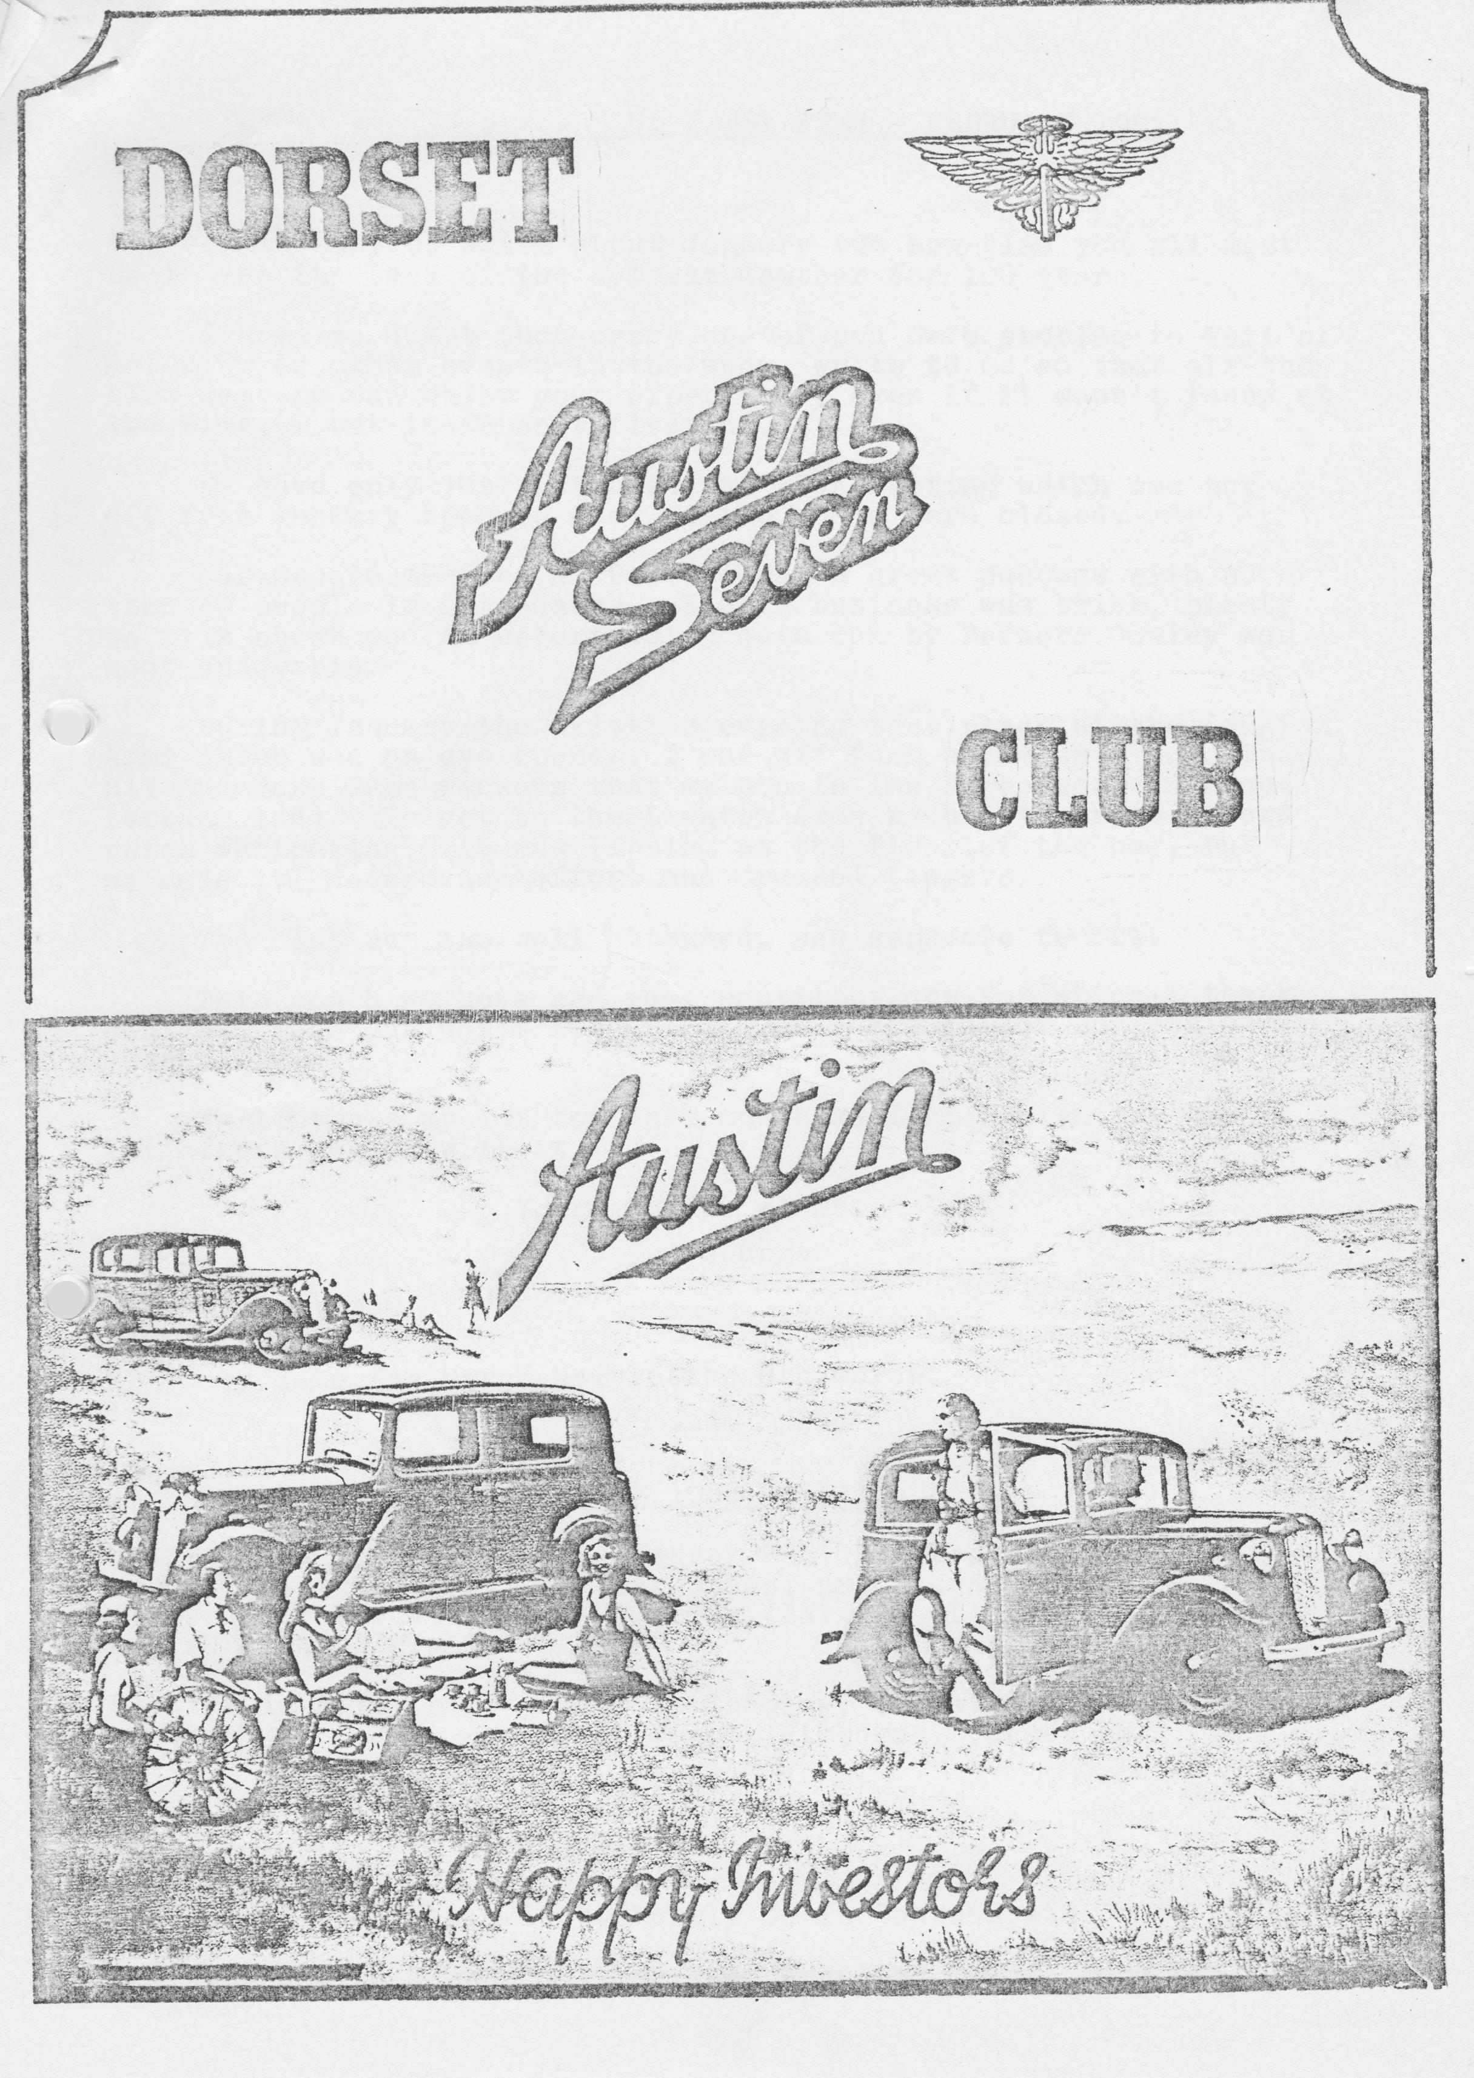

DORSET AUSTIN SEVEN CLUB NEWSLETTER FEBRUARY 1982

EDITORIAL
It is easy to write about January but how glad you all must be to see the back of the coldest weather for 100 years.
I have no doubt that every one of you have stories to tell of motoring or other events in the snow, write to me so that all the club members can enjoy your experience, even if it wasn't funny at the time, I bet it is on reflection.
We have only just attended the A7CA meeting which was put off from January because most of the roads were closed.
Our second meeting at Dormers was a great success with more than 40 people in attendance. Spares business was brisk, plenty to talk about and an entertaining quiz run by Bernard Cowley was most enjoyable.
During January, the Skittles evening took place at the Langton Arms which was an eye opener. I was off form and missed more than I hit and John Page reckons that my son in law to be was dangerous (strong lad). To get to the Langton Arms we had to cross a ford which was raging - it was lapping at the floor of the car, but we made it, determined effort and crossed fingers.
The club run was well attended, see separate report.
This month we have had some contributions for which I thank you very much but don't forget I am only the Editor so let’s have your letters.
Well, that my lot for this month so I will sign off and let others get on with it.
Yours on the wings,
George
NB Copy date for March Newsletter 8th March.

MOTORCADE 1982 - 13th JUNE
Entries are invited for the Wessex Vehicle Preservation Clubs annual Motorcade event at Bear Cross, nr. Bournemouth.
Classes for VETERAN, VINTAGE, POST VINTAGE, CLASSIC VEHICLES AND AUTOJUMBLE STALLS WELCOME.
Further details from: Mrs. B. Redding, 6 Heathfield Road, West moors, Wimborne, Dorset BH22 OBG

THIS AND THAT
The Eye of the Needle is currently on in Bournemouth.
The alternative Easter Holiday was cancelled due to lack of interest.

THREE MONTH CALENDAR
13th February. Saturday Barn Dance at the Scout Hut, Wimborne.
18th February. Thursday Club Meeting at Dormers, Wimborne. It is hoped to show some film of past club runs.
21st February. Sunday Club run to Hamble. Depart 10.30am from Ringwood cattle market carpark.
25th February. Thursday Committee Meeting
18th March. Thursday. Club Meeting. Dormers, Wimborne.
21st March. Sunday. Club Run to Corfe Castle and Kingston. Start at Wimborne Square 10.30am sharp. Luncheon at the Scott Arms, Kingston.
25th March. Thursday Committee meeting, Tyrells Ford.
10th - 14th April End to End Run. John 0' Groats to Lands End.
8th - 13th April French Trip - Thursday to Tuesday.
15th April. Thursday Club Night. Dormers, Wimborne.
18th April. Sunday Club Run
22nd April; Thursday Committee meeting, Tyrells Ford.

Other Notable Dates
13th June - Motorcade, Wessex Club.
12/13th June - Caldicot Castle Rally
19/20th June - Berkley Castle Rally
3rd July - Pre-Beaulieu Barbecue
4th July - National Rally Beaulieu
10th July - Silverstone VSCC Racing
11th July - Shelsley Walsh M.S. Hill Climb
(28th August Longbridge Diamond Jubilee Rally. Arrive
(29th August Saturday, book in, Barbecue
(30th August Sunday, Rally and Dinner. Monday Cavalcade.
* This must be the Rally of the Year.

MEMBERSHIP NEWS
We still have a few subs due, will members please note these should now be paid. Newsletters will resume upon receipt of subscription, thanks.
We extend a hearty welcome to two new members this month:
Mr. A, H. Marriot, 282 Herbert Avenue, Parkstone, Poole, Dorset.
Mr. Marriot has owned a 1929 Chummy since 1947.' -
Mr. Mervyn Frampton, Sutherland, Broad Oak, Sturminster Newton, Dorset.
Mr. Frampton has a 1934 Box saloon.

SALES/WANTS/SERVICES

Oil – good 30SAE oil £2 per gall.
ring Chris Smith Ringwood 78066

WANTED "Float on Air" front seat inners, two repairable specimens please. Ring George Mooney, B’mth- 425989

SERVICES: Austin 7 mechanical work undertaken. Reasonable rates, discount to Dorset A7 Club Members. Engines/gearboxes/axles. Phone New Milton 613080 or Ringwood 78795

***
Excerpt from Daily Telegraph:

Any Excuse is Better Than None by Henry Miller
"I collided with this stationary lorry coming the other way."
“An invisible car came out of nowhere, struck my vehicle, and vanished..."

These are two examples of accident reports filed by drivers to insurance companies and cited in New York City police depts. reports to show that motorists have unusual ways of describing mishaps while they are behind the wheel. Here are others:

"The guy was all over the road. I had to swerve a number of times before I hit him,"
“The telephone pole was approaching fast. I was attempting to swerve out of its path when it struck my front end."
Or this one: "I pulled away from the side of the road, glanced at my mother-in-law and headed over the embankment."
One of the best is: "The pedestrian had no idea which direction to go so I ran over him”

THE SHAFTESBURY RUN
Wimborne market square wasn't its normal sleepy Sunday morning self, when we arrived for the Shaftesbury run, kindly organised by John Page. We saw four administering angels in the guise of Joy, George, Glyn and his wife, (who needs wings when you have an Austin Seven) assisting an elderly Salvationist gentleman, an Angina sufferer, who had taken ill, and forgotten his pill. He was safely dispatched home, and so by this time the contingent of three Rubys, two Boxes, one Chummy and the United Nations lot comprising of one Citroen, one Mazda, one Mercedes and a British Sunbeam, hooray! set off on the pretty journey through the countryside to the Foresters at Donhead. Snow was still banked up by the side of the road, a reminder of that awful weather we've had this winter, but with buds on the trees, we decided this would by a super re-run for the late spring, or early summer. George had also got the spring feeling. He did his party piece by missing a gear up one of the steep hills. Peter Holmes also thought that it was his lucky day exclaiming “Cor, look who
I'm behind, the delectable Debbie, with her elegant hand signals, red nails and all, better view than a grubby car-worn hand."
Food, glorious food, I think everyone enjoyed their lunch at the pub, and one or two members had a roasting by the fire before we set off for Shaftesbury, John discovered a nail in one of his car tyres, but had speedily fixed it before anyone else had time to notice. There was also clan warfare in the car park with the tartan clad Westies and Sherlock Holmes, they were ready to do battle but fortunately we were ready for the off! We continued our run through some narrow lanes, and eventually reached Shaftesbury, after slight confusion at The Coombs. The party split up on our arrival, some taking to a hike down Gold Hill, only recommended for the energetic, or for those who have had their Hovis!
Other club members went for a stroll around the town, which is very quaint. We missed the highlight of the afternoon though, for Gary and Glyn in their flying machine zoomed up the same Gold Hill, just shows what wheatgerm does for you. We all congregrated at the cars again, and made our way in convoy to the Ashley Heath roundabout, where we split up and went our homeward ways.
Thanks John and Cynthia for planning the route, and thanks to the Austin Sevens for a very enjoyable and happy day.
Daphne Holmes
***

THE BREAD RUN (otherwise known as the Gold Rush!)
Twas the occasion of the Dorset Club run to Shaftesbury. Early afternoon found us exploring the town, when suddenly we came across Gold Hill. This is the famous and picturesque hill up which the little boy in the 'Hovis' advert struggles to the strains of Dvorak's New World symphony.
I think the idea formed in all of our minds at the same time, as we looked at the very steep, slippery cobbles culminating in an extremely steep and narrow footpath which led hack to the High Street. Then, someone, I'm not sure who, voiced all of our thoughts, could we get an Austin 7 up and through the treacherous grockle-infested narrows at the top?
That did it, the challenge was out, it had to be a Chummy, anything else would be too wide and fortunately Debbie Munn had bought Gary's 1926 Chummy on the run, also fortunately, Gary had partaken of a fair drop of liquid courage (only to the legal limit, Ed.) at lunch time, being in a similar state, and in a moment of brash foolhardiness, I agreed to accompany him on this the latest 'Dorset' escapade.
We walked to the car in silence, each of us thinking "Could we?" - "Would it?" The others hurried to their positions, some to divert the attention of the dreaded yellow banded traffic warden, others to keep the hoards of sightseers back.
We drove around the town to the base of the hill, and with no more than a glance at each other’s drawn but determined, faces Gary slammed the Chummy into first gear, the car leapt forward, eager to do its best, the engine roared, and we hurtled (hurtled!!! Ed.) up, past local residents who jumped back and stared in amazement. The air reverberated with the rumble of the rear main. I tried to whistle the 'Hovis' tune but my lips were bone dry. Was it fear? "What's that horrible smell?" I asked. Gary did not reply, his face was set in a steel-like look, determination and intoxication showed in his eyes as the car bucked over the cobbles, near the top now and the engine revs are dying. Oh, God. I'm sorry for pulling Tiddles tail when I was six, and for punching Harold Walkers ear when he wasn't looking. But look, there's the narrow section ahead, blimey, it's crowded with grockles: No it's alright, they are throwing themselves out of our way. Jim Cleneghan seems as though he can't decide which way to leap. We hurtle past, smoke pouring from our tortured tyres (that must have been what smelt!) We'd done it, anyone fancy the Monte Carlo Rally in a Seven next year?
Glyn
***
JOHN O'GROATS - LANDS END 1982
To date there have been some sixty entries received by the 750 MC for this event and Motorail train is being chartered from London to Inverness to carry those that can afford it (and don't want to use their cars!) Willie McKenzie and I are using my Ruby, travelling up on the Wednesday and Thursday prior to the event and then trying to get back in under 24 hours starting mid-day on Saturday. We will be travelling with Keith Roach and Pete Treliving and they will be using Keith's newly restored
Gordon England Cup model or his Chummy if the Cup is not completed and 'run in'.
Mark Rosenthal is intending to make the trip on a bare Ruby chassis so it will be full marks to Dorset for originality and spirit of adventure!
Mark Tudge is going with the Big Seven Register and several other members have expressed an interest in taking part.
Willie and I are arranging a certain amount of commercial sponsorship and will be raising money for local charities. The car will be as original as possible and an End to End in under 24 hours will be difficult as the Ruby is a lot heavier than a Box and most under-24-hour cars, including the 1972 fastest, were tuned, e.g. SU carb. and 14mm head.
If anyone needs more details please see me on club night when I will have all available entry forms and information etc.
Phil Whitter
***
SPARE'S REPORT
With Winter restorations in full swing the sale of spares has been quite active and my main problem has been meeting demands from existing stocks. I find that some of the time I am financing purchases from my own pocket to ensure a reasonable flow of spares availability. We are at present unable to purchase expensive items for stock such as exhaust systems and axle shafts and I have to ensure that we have a reasonable stock of popular items with other goods to special order.
Through the efforts of two of our members we have a regular pick up from John Platts and John Barlow and it is hoped that we can soon arrange something with Seven Workshop. I would like at least a further £50 from the club to enable me to maintain items in stock and increase the variety of spares and I will be taking this up with the committee.
I would like to thank those members who have kindly made items for the club to sell. We have had nylon fan belts, early brake shaft bushes and recently I was presented with some chassis rivets and five beautifully made flywheel pullers.
If members can give me their orders for spares and we do not have them in stock I would expect to be able to obtain the item within a month if not sooner.
Our suppliers are temporarily out of stock of spring pins, axle shaft keys and fabric couplings but new stock is expected soon. Additions to our stock include flywheel pullers at £2.75, early brake shaft bushes at £2 each, clutch levers, Chummy dynamo bushes, camshaft pulleys, double valve springs, shock absorber discs, radius arm ball socket bolt and spring, together with most felt oil
seals.
I see that John Barlow can now do front and rear wings for Rubies besides Chummies.
Phil Whitter
PS There is no truth in the rumour that I am taking all the spares on the End to End run at Easter!

***
HENRIETTA
She was born in 1934 and found by Joy and I in 1961 on a garage forecourt priced at the princely figure of £45.2s.0d.
HA 9643, registered and supplied in Smethwick, a RP Box Saloon and didn't we love her?!
Joy was expecting and motoring to work at Joseph Lucas in Birmingham on the Le Velocette was not ideal, we needed a car and Henrietta was our first. I had a company car but this little Box was magic.
The previous owner had done a great deal of tidying up but the car was quite non-standard in many respects.
I think that this article will merely be a potted history because as you must know, a 21 year period is too long to cover in anything short of a book.
Henrietta had late ruby axles, an electric petrol pump and the battery under the bonnet. She was equipped with 17 inch wheels and 4.50 tyres. Her colour was non-standard but was very striking and the car quickly became a talking point.
Soon after we bought her we moved to a new house in Tamworth and it was when we were in Tamworth that an alloy supaloy head was added, downdraft carburation and hydraulic brakes and she was very fast, hair raising, but fast.
The car was soon well known around Tamworth and Lichfield where Joy was working and it provided us with may carefree miles of motoring.
In 1965, we moved to a country cottage in Shropshire and Henrietta came too, very much part of the family but not part of the Movement i.e. had still joined nothing and we knew nobody in the movement, it never occurred to us that it was important.
Around about 1967 the car was getting a bit shabby and it was running rather rough so I decided to take it to pieces and restore it with an engine rebuild and a new coat of paint.
Henrietta came to pieces and Joy carried on using the Riley Pathfinder which we had acquired by this time.
Then followed a Wolseley 1500, two Daimler Conquests, one Triumph Mayflower, a Honda N360 saloon, a Hillman Imp van and a Land Rover all of which we used in the intervening years.
We had two children after we moved to Ellerdine, Salop, we extended the house, ran in and out of financial difficulties, I was promoted twice and we moved to a new house into Wellington in 1970 and the car was still in bits. Time seems to slip by doesn't it?
On holiday one year about 1970 we met John Tantum of the Pre--jar A7 Club and as a result we joined the movement. We had an immense amount of fun sharing many holidays with them mostly in the Land Rover and all the time wanting an A7 on the road.
In 1975, we bought EP 7002 the Ruby that we are currently running, it was really ropey but in six months we had it rebuilt and sold the Land Rover, petrol was heading for 90p a gallon!! so we were very relieved. (Wish it was 90p now!)
About 1976 work started on the Box but it was intermittent and had it not been for Stephen Fathers of PWA7C a complete job would never have been done at all.
The body came off with his help and encouragement and the whole car was rebuilt chassis upward, much of the work being done in the cellar of my house in Wellington.
In 1978 my work brought me to Bournemouth and the work stopped again but was restarted during 1980 then left off again until Summer 1981.
Progress was really made only when a friendly challenge was recently issued to Glyn Llewelyn who is also rebuilding a 1933 Box and since that time quite remarkable progress has been made.
The car must be ready for my daughter’s wedding on 1st May and of course it must be seen to be running in Jubilee year so Joy and I are really pleased to see it coming together fast.
It seems quite likely that Henrietta will be ready for Easter and on the road from 1st April so one more car for the club and I hope it still goes as quickly as it used to.
I have put Henrietta on 19 inch wheels this time but she is still snorting an Aluminium cylinder head and down draught carburettor.
Paint and trim are finished, the wings are going back on now and then there is the wiring and the thousand and one small jobs that always need doing. It would be nice to have it ready for the Daffodil Run but I will settle for 1st April.
See you on the road in the Spring and Summer in Henrietta.
George & Joy Mooney

***
BAD NEWS
A member of a vintage club in the west country has written to the DVLC Swansea to explain that they were wrong to accept Austin 7 cars as 7HP.
DVLC have checked with BL and written back to thank the informant. It is now impossible to use this loophole and several people have already had supplementary Road Tax demands. A stupid move which has removed a potential £20 per car saving on Road Tax. You explain why he did it, I can't, it's crazy!

***
CONGRATULATIONS
Belated congratulations to Rosemary and Roger Ballard on the birth of their son, Edward Nicholas (hope I have the names right, J.) on Christmas Day.

CHAIRMAN’S CHAT
Thanks once again to John Stone's expertise, the skittles evening at the Langton Arms was a great success. I'm still not sure which team won. With John's record, we are certain of a very enjoyable evening at the Barn Dance.
Well, on the home front Debbie has been offered the choice of four Veteran cars to be a passenger in on the next London to Brighton run. How the hell did she manage it, I'm still trying to figure it out!
Now for the commercial for this month. Gary and Glyn, those two boffins on your actual Austin Seven have decided to go into business on their own. If you want any major or minor mechanical work done on your evens get in touch with either of them. No job is too large or small, so I understand.
It’s all systems go for our trip to France at Easter. The booking forms have been sent off, the confirmation has been received on the phone but not in writing as yet. I think we are all looking forward to this break. Cor! all that food and wine!
Derek

That’s it for this month folks. Will the first A7 fitted with a C.B. write a newsletter and give us a big 10/4.
George.
